“Contextualizing Climate Change Deniers”

by
Wendy E. Scattergood & Angel Saavedra Cisneros
St. Norbert College
corresponding author: Wendy.scattergood@snc.edu

Abstract:
The partisan nature of climate change deniers has obfuscated the relationship between this form of science denial and other contributing factors. Much has been said about rejection of climate science as influenced by top-down processes that include political positioning and media campaigns by interest groups. In this paper however, we are interested in individual-level antecedents and correlates of climate change deniers. We find that psychological constructs such as authoritarianism, neuroticism, and existential worries are related to beliefs about climate change. Along with recent work on polarization, our findings suggest that broad factual education on climate change to counteract the top-down influence is individually incapable of changing minds on the topic. Efforts to reduce climate change denial must consider the antecedents related to existential fear, authoritarian tendencies, and dread of change, all of which are exploited politically by demagogues. We use The Wisconsin Survey data collected between 2007 and the fall of 2018 to explore these relationships among diverse samples of Wisconsin residents.

Paper prepared for the 2019 Annual Meeting of the Western Political Science Association
April 18-20, San Diego, California

Note: Many thanks to the Strategic Research Institute of St. Norbert College, and Dr. Jamie Lynch, director, for sponsoring the survey.

Introduction
Much of the climate skepticism research literature has focused on understanding the paradox between increased scientific knowledge about climate change and the contemporaneous increase in climate change skepticism in public opinion. Studying this paradox has become even more relevant after the election of Donald Trump to the US Presidency given his skepticism about climate change and his nominations of climate skeptics to key cabinet positions such as the EPA and the Department of Energy. The politicization of the issue of climate change has led to increasing overlap between partisanship and climate change denial. Science denial, depending on the particular issue, can however be non-partisan, as both liberals and conservatives can find reasons to decry the science of climate change, agricultural technologies, and vaccinations (Washburn & Skitka 2017).
In this paper we evaluate individual-level correlates of climate change denial in an effort to separate political predictors from trait and predispositional factors. In particular we look at propensities for worrying, neuroticism, belief in conspiracy theories and authoritarian propensities. Studying climate change skepticism in the state of Wisconsin is particularly pertinent as at least two state agencies have scrubbed information about climate change from their websites in recent years (The Department of Natural Resources and the Public Service Commission) and the state was one of the few key states securing a Trump victory in the recent election, despite having voted reliably Democratic the last couple of decades.
We use the Wisconsin Survey (conducted by St. Norbert College) to track changes in climate change skepticism across several years. The analyses are situated within a broader examination of beliefs in other conspiracy theories, authoritarian and traditionalist tendencies, as well as fears about economic growth, and technological and social change, as well as some basic measures of neuroses.
We next review relevant literature and relate the literature to the authors’ efforts to collect quality data in the electorally crucial state of Wisconsin. After presenting the theoretical motivations we propose a set of hypotheses that test the psychological determinants of climate change denialism. After discussing our results we conclude by exploring different avenues for future research given the increasingly relevant role of populist rhetoric and political polarization.
Climate change views and political polarization
In this paper, we will be focusing primarily on endogenous variables contributing to beliefs about climate change, but first, it is important to understand other variables that also contribute to these beliefs. Exogenous variables that drive polarized climate change beliefs have been identified as interest groups, corporations, and think tanks arguing against the science of climate change (see for example Oreskes and Conway, 2010), the media needing to present a “balanced” set of views puts unscientific skepticism on the same level as scientific findings (Chong, 2015), and the recession causing a new wave of anti-regulation sentiment and thus growing disbelief in climate change to legitimize it (Scruggs and Benegal 2012). More recently, the rise of elite deniers, e.g., all but one of the newly elected Republican Senators in 2010 were climate skeptics (Antonio and Brulle 2011) also externally affect one’s view of climate change.
However, in order for these exogenous variables to influence a person’s beliefs about climate change, there have to be internal receptors. The primary receptor being “motivated reasoning”. This theory suggests that information that challenges beliefs such as “we are moral” and that “we are optimistic about the future” tend to be discounted, while those that support one’s beliefs are accepted uncritically (Kunda 1990). This applies to climate change because it is a problem that everyone contributes to on a daily basis and could lead to a catastrophic future.
Motivated Reasoning Theory also relates to why people believe conspiracy theories. For example, an increased likelihood in belief in a conspiracy theory occurs when people find it difficult to believe that a significant event can be caused by mundane, ordinary actions. This is called the “proportionality bias” (Leman and Cinnerella 2007). For climate change, people don’t want to believe that their everyday actions are part of causing potentially catastrophic global climate change. This can lead them then to believe in climate change conspiracy theories as well as lead to more skepticism about climate change.
Another factor to consider is that climate science is complex and not easily understood by the lay public. As such, the public will rely on secondary sources to “translate” the science according to pre-existing beliefs and understandings (Weber 2010). Druckman and McGrawth (2019) suggest that both directional (motivated reasoning) and accuracy motivations drive individual’s Bayesian updating of information related to climate change, that is, when people encounter new information on climate change, they must weigh the new information against their existing beliefs. They argue that the types and quality of communication interact with motivational factors in the individual. Additionally, for a layperson with accuracy motivations, that is, to learn the facts on the issue, it might be almost impossible to discern the quality of the information to which they are exposed, possibly leading them to rely on heuristics about not only the information, but also the source (further relying on peripheral cues).
Another explanation at the individual level states “denial of climate change threat helps people cope with the debilitating anxiety, guilt and existential angst that it arouses.” (Crompton and Kasser 2009 in Connor and Higginbotham 2013 p. 1853). This theory highlights yet another motivation: reducing cognitive discomfort. Douglas and her colleagues (2017) find that individuals are driven to believe conspiracy theories in large part due to existential (safety considerations) and social (positive identity-related) motives, in addition to epistemic ones (finding causal explanations). These traits and predispositions correlate with stronger reactions to negative information as well as threat sensitivity and therefore are correlated to science denial and conspiracy theory acceptance. Therefore, we might expect that those who believe the conspiracy theories may also be skeptical about climate change. This role of emotion in beliefs is supported also by McDermott’s (2019) work on “post-truth” psychology. She finds that response to emotionally-based “news” compared to fact-based news enhances belief in things that aren’t true, so it stands to reason that those who feel anxious and worried about the status quo and near future would be more susceptible to conspiracy theories about climate change (which usually start with a nugget of fact, then grow wilder in speculation and emotion).
This is also reminiscent of theories posited by Hetherington and Weiler (2009) about the increasing popularity of authoritarian tendencies, as well as from the radicalization literature (see for example McCauley and Moskalenko 2011), and Hochshild’s work on rising US populism (2016). Those who feel dispossessed and alienated search for meaning, safety and identity in communities outside the mainstream. They seek strong leaders with alternative, often radical, beliefs to explain their dispossession and alienation caused by outside forces rather than their own failings. Jylhӓ (2016) tested directly (among other things) the relationship between authoritarianism, desire to maintain the status quo and climate change denial. She found that authoritarianism and desire for the status quo were moderately positively correlated (though others of her variables played a larger role) in determining climate change denial.
The variables described above present a question about the role of party identification and identity with a particular political ideology. On the one hand, motivated reasoning and the way we might search out news and respond to it suggests that new information about climate change would be fit into preconceived political ideas. Jost et al (2003) find that the preference for cognitive rigidity, system justification, and a lack of openness to experience in conservatives suggests that they are more likely to deny climate change in particular and science more broadly. Many other public opinion polls have consistently shown climate change skepticism to be more prevalent among conservatives and that beliefs about climate change are heavily driven by partisanship and have become an integral part of American political polarization (Pew 2010, Antonio and Brulle 2011, McCright and Dunlap 2011, and Guber, 2013).
On the other hand, existential worries and anxieties could be universal, and thus climate change denial could exist outside of partisan identification. For example, Washburn and Skitka (2017) recently conducted an experiment to test whether science denial was more prominent for political conservatives (asymmetrical) or prevalent across ideological lines. They find that the motivation to protect one’s beliefs are as common with liberals as they are with conservatives. The 2016 GSS shows quite a bit of skepticism for the scientific community among all partisan identities, though it is somewhat higher among conservatives (see figure 1 below).
Finally, looking at the link between conspiracy theories, climate change belief, and partisanship, Douglas and Sutton (2015) point out that what is somewhat unique about climate change conspiracy theories, is that there are theories on both the right and the left – that climate scientists and renewable energy investors overstate or even fake the data for their own monetary gain (right) and that oil companies, conservative politicians, and think tanks understate or deny climate change effects in order to boost their own pocketbooks (left). Uscinski and Parent (2014) show in their research that unlike the stereotype of conspiracy theories mainly being a right-wing phenomenon, most people believe in at least one conspiracy theory and that it’s equally likely on the left and the right (though perhaps at different points in time and over different issues).
Therefore, it may not be an “either/or” of whether partisanship affects beliefs about science and climate change, but rather that universal anxieties may manifest differently depending on one’s preconceived political leanings due to motivated reasoning, the desire to ease cognitive discomfort and the relative ease of forming opinions based on emotions and heuristics rather than on new and complicated scientific facts.
Figure 1. Confidence in Leaders of the Scientific Community 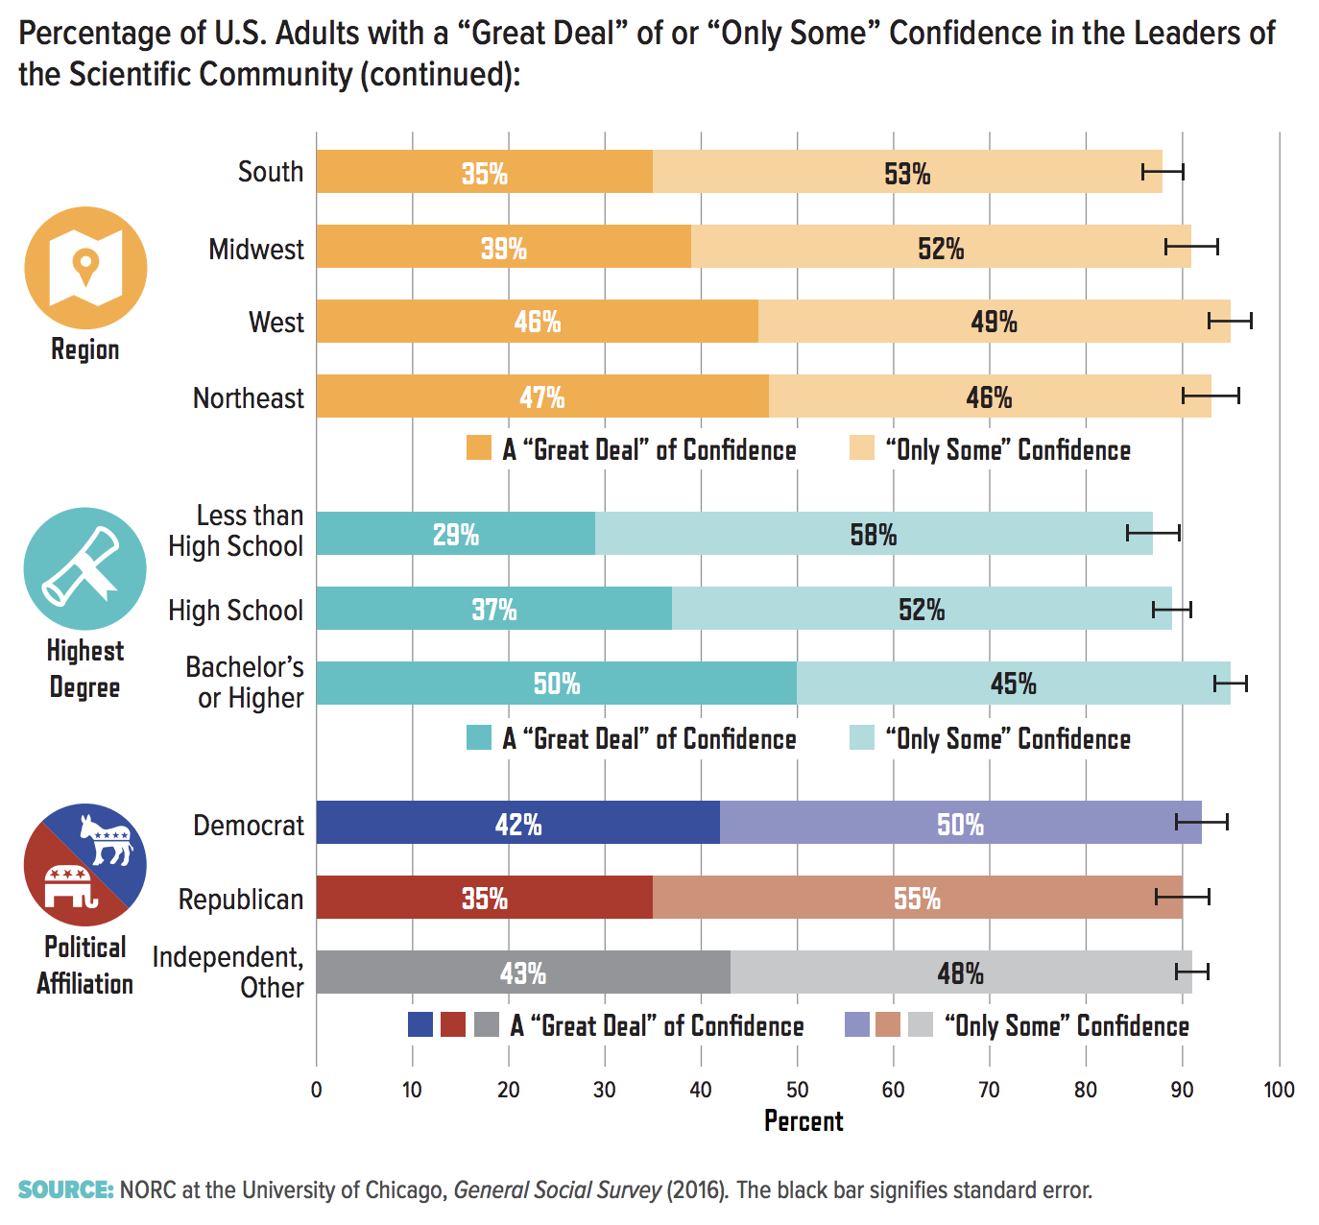
American Academy of Arts and Sciences. 2018.
Questions and Hypotheses
The literature review above shows us that motivated reasoning and the difficulty of understanding climate change science may lead us to rely on preconceived political leanings to interpret new information about climate change. As such, we would expect partisan exogenous influences on individual beliefs. The research also shows us that climate change may be a cause of existential anxiety and thus may lead to denial of its existence, while other existential, safety and social anxieties may also lead to the desire to deny human-caused climate change. The partisan issue here is whether conservatives have more of these kinds of anxieties than liberals. Finally, the research literature on conspiracy theories and authoritarianism have many of the same antecedent variables, suggesting a link between beliefs in conspiracy theories, authoritarianism and climate change skepticism.
First, for context, the link between partisan identification (PID) and beliefs about climate change will be examined over time to track changes in belief. We previously asked about this in the Spring of 2007 as well as the Spring of 2014. According to previous research, we would expect climate change skepticism to be growing, both as a trend of growing polarization, as well as influenced by the recent presidential election.
Second, we will test whether belief in climate change conspiracy theories are related to PID as well as to belief in climate change. According to previous research, we would expect Democrats to both be more likely to believe that climate change exists than Republicans and believe more that oil companies try to spread doubt about climate change. Conversely, we would expect Republicans to be more skeptical (either natural causes or not occurring) and be more likely to believe that climate scientists exaggerate the data and distrust climate scientists than Democrats do. In Wisconsin, I have found that Independents are very nearly right in between Democrats and Republicans in terms of beliefs and I use them as a barometer of the political climate – on which issues are they closer to Democrats or to Republicans and how does this change over time?
Third, to further test the partisan nature of conspiracy theories in general, as per Uscinski and Parent (2014), I would expect to see Democrats not only believe in their side of the climate conspiracy, but also that Russia tampered with the US election and we would expect that Republicans will believe climate scientists tamper with data as well as that President Obama ordered the wiretapping of President Trump. However, for any of these conspiracy theories, I don’t think that the percentages for either party will be particularly high (in general, percentages of conspiracy theory belief are low across large populations), but that there will be a significant difference between PID and which conspiracies some think are true. As part of this more general test of partisanship and conspiracy theories, we also looked at the vaccine conspiracy theories and expect this will also be partisan; that Republicans, given previous research showing them more skeptical of science in general, will be more likely to think that vaccine companies are hiding data about the safety of vaccines.
Finally, we will examine how anxieties - both about climate change, as well as more general social fears and personal anxieties, distrust of institutions, and authoritarian tendencies might be related to both climate change and climate change conspiracy theories beliefs. If theories about polarization, belief in conspiracy theories, and the rise of US populism are in fact related to beliefs about climate change and climate change conspiracies, then we should see the independent variables of fear, distrust of institutions, authoritarian tendencies, and various demographics also be related to climate change beliefs.

Measurement
The Wisconsin Survey has been conducted biannually since 1984 and is conducted and funded by the Strategic Research Institute of St. Norbert College. All of the surveys prior to 2018 were telephone surveys of randomly selected Wisconsin households. Likely voter only samples were done in fall of even years. Starting in 2012, the samples were a mix of cellphone and landline lists. The more recent surveys were weighted by age and gender based on the most recent Census data for Wisconsin. The full instrument with frequencies for all the questions, including all the demographics, is included in a separate file. Past Wisconsin surveys included here were conducted in a like fashion.
The most recent cellphone and landline survey was conducted between April 24 and May 8, 2017. Of adult Wisconsin residents, 303 were sampled, with a margin of error of +/- 5.6% at the 95% confidence level. The most recent sample, November 14-20, 2018, was an online sample of 636 registered Wisconsin voters. Because there are multiple methods of surveying here, comparison between the previous surveys and the 2018 survey must be done with caution.
Climate change belief is comprised of 3 related questions – how serious they think current climate change effects are, whether climate change is primarily human-caused or natural (or both or that it is not occurring), how certain they think the science is on climate change. In addition there is a question about how much people feel they can trust climate scientists to do the right thing. For climate change belief, I’ll see first whether the 3 questions (how serious the effects are, causes, and how certain the science is) are related. If they are highly related, I will add them together in an index to be used as the dependent variable to run all the independent variables together in a regression.
For conspiracy theories, questions were asked about the primary theories on both sides: whether they think climate scientists exaggerate the data for their own gains and as a second question, whether they think oil companies spread doubt about climate change. These questions were asked along with questions about President Obama ordering the wiretapping of President Trump, whether Russia interfered in the US elections, and whether the vaccine industry misrepresents or hides data on the safety of vaccines.
Various trust questions regarding the 3 levels of government, doctors, scientists, climate scientists, and mainstream media were asked. This not only allows Krosnick’s (2010) theory about lack of trust in climate scientists to be tested, it will also allow examination of the relationships between climate change belief, conspiracy theory belief and trust in government and the media.
For authoritarianism, while Hetherington and Weiler (2009) and others have used a series of questions about child-rearing that has been tested many times and deemed valid, I was frankly uncomfortable asking these type of questions on a political telephone survey. I felt that people would misinterpret what they were being used for and potentially harm response rates, so I decided to ask them slightly differently. First I asked about whether they thought the president should be allowed to push their agenda through or whether Congress should act as a stronger check, then I asked about which personality trait they think is better: someone who plays by the rules, or someone who is an independent thinker. After these results, which I could see probably had some validity issues, and because we were able to conduct the 2018 survey online, I reverted to use the standard measures of authoritarianism.
One of the things that I think connects all these various areas of research is fear/worry/anxiety, so I asked a series of questions asking how worried they were about air and water pollution, the pace of technological change, illegal immigration, climate change, school shootings, the country moving away from traditional values, the political climate in the US and the potential of the US losing its position in the world.
In addition to these, we also have our tracking questions – direction of the country and state, assessment of the state and national economies, and assessment of their own financial situations – compared to last year and looking forward to next year. These will also be used to assess peoples’ fear of being left behind by a rapidly changing society.
For the 2018 online survey, 2 questions about personal anxiety were added to the questionnaire. Responses to these were then added together for form our “neurosis” variable.
Finally, we have the demographics – partisan identification, urban/suburban/rural, age, education attainment, 2016 presidential vote choice, religiosity, income, gender, area code, and land/cell.

Findings
Change in Climate Change Belief and Polarization
When thinking about current effects of climate change or global warming, would you say that these effects around the world are currently
 | Fall '18 | Sp '17 | Sp '07
Very Serious | 41% | 53% | 44%
Somewhat Serious | 35% | 30% | 39%
Not Too Serious | 18% | 11% | 11%
Not At All Serious | 6% | 6% | 4%
Not Sure | 0% | 1% | 3%

When thinking about climate change over the last 50 years, do you think the effects are primarily due to human activities, primarily natural changes in the environment, both equally, or neither – that climate change has not been occurring?
 | Fall '18 | Sp '17 | Sp '07
Primarily Human Caused | 46% | 44% | 44%
Primarily Natural | 15% | 13% | 39%
Both Equally | 31% | 34% | 11%
Not Occurring | 4% | 8% | 4%
Not Sure | 4% | 4% | 3%

Would you say that the science about climate change is

 | Fall '18 | Sp '17
Very Certain | 34% | 38%
Somewhat Certain | 35% | 35%
Not Too Certain | 23% | 14%
Not At All Certain | 8% | 12%
Not Sure | 0% | 2%

For each of the following, please tell me how much of the time you think you can trust this group to do the right thing: All of the time, most of the time, some of the time, rarely, or never. … for Climate Scientists:
 | Fall '18 | Sp '17
All of the Time | 15% | 13%
Most of the Time | 36% | 39%
Some of the Time | 24% | 32%
Rarely | 14% | 10%
Never | 7% | 3%
Not Sure | 4% | 3%

Comparing the 2017 and 2007 surveys, for the seriousness and causation questions, the differences in percentages for very serious and human caused are just outside the error margins for the surveys and while we see a slight increase in percentages for not at all serious and not occurring, we can’t generalize this as a trend in the public.

Polarization
Seriousness
 | Fall '18 | Sp '17 | Sp '07
Very Serious
Democrats | 67% | 71% | 65%
Republicans | 14% | 17% | 17%
Independents | 32% | 57% | 39%
Somewhat Serious
Democrats | 28% | 27% | 29%
Republicans | 40% | 42% | 52%
Independents | 42% | 28% | 42%
Not Too Serious
Democrats | 5% | 1% | 3%
Republicans | 34% | 27% | 19%
Independents | 17% | 9% | 14%
Not At All Serious
Democrats | 0% | 0% | 2%
Republicans | 13% | 14% | 9%
Independents | 9% | 6% | 4%
Causation
 | Fall '18 | Sp '17 | Sp '14
Human-Caused
Democrats | 67% | 50% | 50%
Republicans | 23% | 16% | 20%
Independents | 43% | 55% | 35%
Natural
Democrats | 5% | 4% | 12%
Republicans | 28% | 24% | 33%
Independents | 14% | 19% | 15%
Both Equally
Democrats | 25% | 35% | 35%
Republicans | 36% | 49% | 35%
Independents | 34% | 23% | 38%
Not Occuring
Democrats | 1% | 10% | 1%
Republicans | 7% | 10% | 10%
Independents | 3% | 4% | 2%

Climate Science Certainty
 | Fall '18 | Sp '17
Very Certain
Democrats | 59% | 54%
Republicans | 10% | 9%
Independents | 25% | 44%
Somewhat Certain
Democrats | 36% | 30%
Republicans | 30% | 47%
Independents | 44% | 35%
Not Too Certain
Democrats | 4% | 3%
Republicans | 44% | 29%
Independents | 22% | 17%
Not At All Certain
Democrats | 1% | 12%
Republicans | 16% | 12%
Independents | 9% | 4%

Trust Climate Scientists
 | Fall '18 | Sp '17
All + Most of the Time
Democrats | 74% | 66%
Republicans | 27% | 31%
Independents | 53% | 70%
Some of the Time
Democrats | 21% | 23%
Republicans | 28% | 42%
Independents | 19% | 15%
Rarely
Democrats | 3% | 10%
Republicans | 25% | 14%
Independents | 18% | 8%
Never
Democrats | 1% | 0%
Republicans | 15% | 5%
Independents | 6% | 8%
Not Sure
Democrats | 2% | 1%
Republicans | 5% | 8%
Independents | 4% | 4%

Comparing the phone surveys (2007 and 2017), Democrats seem to be fairly stable in their beliefs over time, while Independents have moved toward stronger belief. Republicans do have some movement toward skepticism, but with the error margins, we cannot infer this to the population. One surprising difference is that there is no difference between Democrats and Republicans on climate change “not occurring” – 10% of each party said this.
If polarization is measured in the most simple manner – by subtracting the percentage of Democrats from the percentage of Republicans for a particular response on a question, we find the following for the questions above (consolidated in some categories for easier interpretation).
Polarization | Sp '17 | Sp '14/07
Human-Caused | 34% | 30%
Very + Somewhat Serious Effects | 39% | 25%
Very + Somewhat Certain Science | 28%
All+Most of the Time Trust Climate Scientists | 35%

From Causation and Seriousness of Effects questions, polarization has grown over time, particularly Seriousness, where the movement is primarily among Republicans, while Democrats have remained fairly steady. It is also the most polarized of the questions. This finding coincides with arguments made more generally by Mann and Ornstein (2012).
Climate Change Belief Continuum/Index – Dependent Variable
The questions on climate seriousness, causation, and certainty were combined to form a continuum of climate change belief. On causation, “both” was recoded to be in between human and natural and the not sures and refused were all coded as missing.
Correlation Coefficients for Climate Change DV Variables
 | Fall 18 | Sp 17
Serious x Certain | 0.8** | 0.530**
Serious x Cause | 0.668** | 0.454**
Certain x Cause | 0.643** | 0.640**
**. Correlation is significant at the 0.01 level (2-tailed).

For the 2017 data, a factor analysis on these variables shows they clearly load on a single factor, with this factor accounting for 66% of the total variance. In constructing this continuum of climate beliefs index, the range of scores would be from 4-17, where a 4 would mean that they are strong believers and 17 means denier. In the 2018 data, the range was from 3-12.

Climate Change Belief Index
 | 2017 | 2018
Range | 4 = High Belief - 17 = Denial | 3 = High Belief - 12 = Denial
Mean | 8.02 | 5.65
Median | 7.00 | 5.00
Mode | 5 | 5
Std Deviation | 3.09 | 2.4

For the 2017 data, given that the mean is larger than the median and that 91.5% of the distribution is between 4 and 12, there are a few “denier” outliers, ranging up to 17. Given the smaller standard deviation and range, this is even more true for the online sample in 2018

Climate Change Belief and Demographics
I ran a series of ANOVAs and T-Tests for these demographics to see whether any significantly affected belief in climate change.
- Significant IVs: Religiosity, Education
- Not Significant IVs: Income, Age, Urban/Suburban/Rural, Gender
Religiosity – how often respondent attends church services. The main difference is between those who said “never” and everyone else. Their mean of 6.8 (where 4 is the minimum – meaning strongest belief in climate change) was significantly lower on the climate change belief index than all others. Those who never attend church services are also very liberal and Democratic.
Education – Those with a technical or some college degree had the highest score (most skeptical) with a mean of 9.45 compared to those with high school degrees or college degrees (both had means of 7.7). Those with graduate degrees had the lowest mean (strongest belief in climate change) of 6.5. These also correspond with partisan identification.
Running both education and religiosity in a regression equation with partisan identification, religiosity is not statistically significant, though education is, albeit with a standardized beta much smaller than PID’s. It has a negative slope, so as education level attained goes up, climate change score goes down (meaning belief in climate change goes up with increases in education level).

Urban/Suburban/Rural – When run in an ANOVA, this is not statistically significant which is interesting given all the talk about the 2016 presidential election in Wisconsin, where most of the early research shows that it was rural areas that went strongly for Trump and caused the party change for the state overall. In the sample, rural respondents do have a higher mean (more climate skepticism) of 8.3 compared to 8.0 for urban and 7.5 for suburban respondents, but given the lack of statistical significance, these findings cannot be inferred to the Wisconsin population.

Conspiracy Theories (2017 data only)
- Conspiracy Theories and PID
Most climate scientists exaggerate claims about climate change for their own gain
 | Democrats | Republicans | Independents
Definitely + Probably True | 27% | 63% | 29%
Probably + Definitely NOT True | 73% | 34% | 69%

The oil industry and others purposely seed doubt about climate change in order to protect their companies
 | Democrats | Republicans | Independents
Definitely + Probably True | 92% | 64% | 81%
Probably + Definitely NOT True | 6% | 34% | 17%

While the chi-square tests show a statistically significant difference between party identifications, looking at the questions individually, you can say that Republicans are more likely to believe that climate scientists exaggerate their data than Democrats or Independents do and vice versa for the oil companies seeding doubt about climate change. However, looking at the two questions together, it’s apparent that Republican respondents think both are true equally, while it is the Democrats who have a partisan belief, with Independents siding with them. In looking at the unconsolidated answers, there is some difference between definitely and probably true for Republicans: they are slightly more likely to say that it’s definitely true that climate scientists exaggerate their data than oil companies seed doubt (17% versus 10% respectively).

- Conspiracy Theories and Belief in Climate Change
Climate Change Belief Index = Climate Scientists Conspiracy Theory + Oil Companies Conspiracy Theory
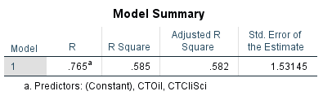
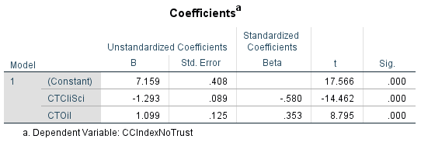
Running a regression with the climate change belief index as the dependent variable and PID, and the 2 climate conspiracy theories as independent variables, the adjusted R-squared is 64.3%. Running it without PID doesn’t change the adjusted R-squared much: 58.2%.
The slopes for the 2 conspiracy theories are as expected: negative for the one about the climate scientists, meaning the closer you get to definitely not true, the more belief you have in climate change. Similarly, the oil companies seeding doubt slope is positive – so the closer you get to saying this is definitely not true, the more skeptical you are about climate change.
Comparing the betas, the climate scientist conspiracy theory is much bigger than that of the oil companies (-0.618 compared to 0.352 respectively) indicating that the former has more influence over belief in climate change than the latter. However, it is also important to remember that Republicans believe the oil companies seed doubt almost as much as they think climate scientists fake their data, so here it’s interesting to note that even though they know oil companies are doing this, they still are skeptical about climate science. This gives credence to the ideas of motivated reasoning and repetition makes it “true.”
Part of the index is how much you can trust climate scientists to do the right thing, so it would make sense that this is highly correlated with the conspiracy theory about the climate scientists (in fact, the correlation coefficient is -0.624). I created a second climate belief index taking out the trust in climate scientists question and re-ran the regression. The adjusted R-squared is 58.2%, and while there is no change in the beta for oil companies (0.353), the beta for the climate scientists conspiracy theory drops a bit to -0.580.

- Correlation w/ Other Conspiracy Theories
 |  | CTCliSci | CTOil | CTWire | CTRussia
CTCliSci | Pearson Correlation | 1 | -.302** | .489** | -.406**
 | Sig. (2-tailed) |  | 0.000 | 0.000 | 0.000
 | N | 298 | 293 | 294 | 296
CTOil | Pearson Correlation | -.302** | 1 | -.320** | .443**
 | Sig. (2-tailed) | 0.000 |  | 0.000 | 0.000
 | N | 293 | 296 | 292 | 292
CTWire | Pearson Correlation | .489** | -.320** | 1 | -.638**
 | Sig. (2-tailed) | 0.000 | 0.000 |  | 0.000
 | N | 294 | 292 | 298 | 295
CTRussia | Pearson Correlation | -.406** | .443** | -.638** | 1
 | Sig. (2-tailed) | 0.000 | 0.000 | 0.000
 | N | 296 | 292 | 295 | 298
**. Correlation is significant at the 0.01 level (2-tailed).
Here, as expected, we find a correlation between the “partisan” conspiracy theories. Note: this survey was done prior to both the firing of FBI Director Comey and the leak that President Trump shared classified information about ISIS with the Russians. For comparison, the conspiracy theories about President Trump are more polarized than those of climate change; belief that Russia influenced the US election is strongly negatively correlated with the belief that President Obama ordered a wiretap on President Trump (-0.638). For climate change it is still a negative correlation between belief that oil companies are seeding doubt about climate change and belief that climate scientists exaggerate their data (-0.302), but it is a weaker relationship than the Trump conspiracies.
As hypothesized, comparisons between the Trump and the climate change conspiracy theories moderately fall along expected partisan lines; belief that President Trump was wiretapped by President Obama correlates positively with belief that climate scientists exaggerate their data (0.489), while belief in Russian influencing the US election is positively correlated with belief that oil companies seed doubt about climate change (0.443). The negative relationships are also significant, i.e., belief in the wiretap is negatively correlated with belief that oil companies seed doubt and the same for belief in Russian influence and climate scientists exaggerating their findings.
 |  | CTCliSci | CTOil | CTVaccine
CTCliSci | Pearson Correlation | 1 | -.302** | .298**
 | Sig. (2-tailed) |  | 0 | 0
 | N | 298 | 293 | 258
CTOil | Pearson Correlation | -.302** | 1 | 0.041
 | Sig. (2-tailed) | 0 |  | 0.517
 | N | 293 | 296 | 257
CTVaccine | Pearson Correlation | .298** | 0.041 | 1
 | Sig. (2-tailed) | 0 | 0.517
 | N | 258 | 257 | 262
** Correlation significant at 0.01 level
I put in the question about vaccines because I wanted to see how it compared in terms of overall belief with the climate change conspiracies. If previous research is confirmed, then we would expect to see a more general correlation between distrust in science 🡪 belief in the vaccine conspiracy should be positively related to belief that climate scientists exaggerate their data. As seen above, there is a positive correlation, though it is a fairly weak relationship (0.298).

The vaccine industry purposely misrepresented or hid data about the safety of vaccines
 | Definitely True | Probably True | Probably Not True | Definitely Not True | Not Sure
Democrats | 16% | 30% | 24% | 17% | 17%
Republicans | 11% | 42% | 20% | 10% | 13%
Independents | 15% | 31% | 29% | 12% | 14%

Looking at definitely true and probably true together, you can see that Republicans are more likely to believe in the vaccine conspiracy theory than Democrats, but not by a lot (and for the correlations, the “not sures” were coded as system missing).

Effects on Climate Change Belief of Worry/Fear, Authoritarian and Traditionalist Tendencies
- Worry and Fear
A number of articles have been published on the connection between worry and fear about economic issues, falling behind etc., and climate denial. However, when looking at assessments of the economy and even one’s own personal financial situation, over the years, I have seen these highly related to PID. As such, when I ran a regression of the climate change belief index as the dependent variable with economic worries as the independent variables, I added PID to it.

As seen above, many of the variables are not significant once PID is controlled for, but note the relatively strong relationship between direction of the country and belief in climate change: people who think the country is going in the wrong direction (coded as 1 in this dummy variable) have lower climate belief index scores – meaning they believe more in climate change. National economy rating is also significant – here those who think the national economy has gotten worse compared to a year ago are more likely to disbelieve climate change.
Correlations with Climate Change Belief Index
 | Corr Coeff
Worry about pace of tech change | NS
Worry about illegal immigration | -0.437**
Worry about a school shooting | 0.202**
Worry about the political climate | 0.115*
Worry about US losing its position in the world | NS
NS = not statistically significant ** sig 0.01 *sig 0.05

Here again, not a lot related to being worried about different political and social issues and belief in climate change. But note the positive coefficients. In these cases, a high worry score means you do not worry about that issue and a high climate belief score means you’re a skeptic – so in the example of the school shooting, those who worry less about this are more likely to be climate skeptics. Similarly, those who worry less about the political climate are more likely to be climate skeptics. Those who worry a lot about illegal immigration are more likely to be climate skeptics. I ran all of these as individual ANOVAs (because the worry variables are ordinal) and also ran them with the 2018 data. The results are the same as above but without the correlation coefficients. None of the partial eta squareds for the significant relationships were above 0.2, so they all have a small effect size - including immigration which had a partial eta squared of 0.181.
It appears here that worry is also related to partisan identification because worry about a shooting and the political climate are related to belief in climate change, while worry about immigration and moving away from traditional values are related to climate change skepticism.
- Trust
Correlations with Climate Change Belief Index
 | Corr Coeff
Trust Local Gov't | 0.148*
Trust State Gov't | -0.132*
Trust Federal Gov't | -0.14*
Trust Mainstream Media | 0.262**
NS = not statistically significant ** sig 0.01 *sig 0.05
As with the “worry” questions above, the “trust” questions are statistically significantly related to belief in climate change, but the relationships are relatively weak and related to PID. However, when a regression was run with these variables and PID was included, all but state government trust remained significant, though in comparing the betas, PID still had the most influence. The trust variables are coded such that a higher trust score means less trust, just as a higher climate change belief score means more skepticism. So, positive correlations would bear out the hypothesis that people who are less trusting of institutions are more likely to be climate skeptics. This holds for local government and mainstream media, but it is the opposite for federal and state government trust, e.g., the more trusting you are of them, but more skeptical you are about climate change. This may be related to having both a Republican president and governor in 2017.
Coefficientsª
Model |  | Unstandardized Coefficients |  | Standardized Coefficients | t | Sig.
 |  | B | Std. Error | Beta
1 | (Constant) | 4.147 | .975 |  | 4.254 | .000
 | PID3 | 1.642 | .218 | .461 | 7.545 | .000
 | TrustLocalGv | .942 | .206 | .279 | 4.577 | .000
 | TrustStateGov | .079 | .249 | .024 | .316 | .752
 | TrustFedGov | -.888 | .224 | -.241 | -3.972 | .000
 | TrustMedia | .308 | .163 | .118 | 1.894 | .059
a. Dependent Variable: CCIndex

Krosnick (2010) disputes the argument that there has been increasing skepticism of climate scientists and that this is causing a decline in belief in climate change. He found that 71% of respondents said they trusted climate scientists a moderate/a lot/or completely. In this study, we found that 84% of respondents said they trusted climate scientists all, most, or some of the time. In fact, climate scientists did much better than the federal government and the media. However, what Krosnik neglects to mention is the polarized divide on views of climate change between Republicans and Democrats (see table below).

Trust All or Most of the Time to do the right thing:
 | All | Democrats | Republicans | Independents
Medical doctors | 74% | 72% | 69% | 77%
Your local government | 61% | 58% | 66% | 60%
Scientists | 58% | 68% | 44% | 59%
Climate Scientists | 52% | 64% | 31% | 70%
Wisconsin state government | 47% | 32% | 66% | 47%
Mainstream media | 24% | 41% | 4% | 19%
The federal government | 23% | 29% | 17% | 23%

- Authoritarian Tendencies

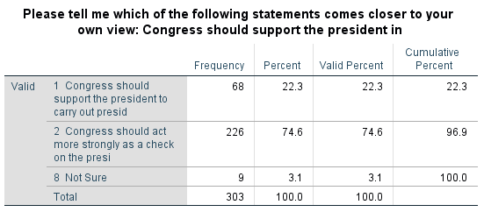
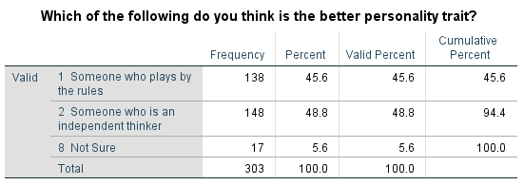

These variables were recoded into dummies, with “not sure” coded as system missing. Running the t-tests for the personality traits question, the mean climate change belief score for those who think someone who plays by the rules is a better personality trait was 7.3 compared to a mean of 8.8 for those who think being an independent thinker is the better trait. This means that those who think following the rules is better are more likely to believe in climate change than those who think independent thinking is the better trait.
There is a much bigger difference in the question about Congress checking the power of the president. The mean climate belief score for those who think Congress should support the president to carry out their agenda was 10.8 compared to a mean of 7.2 for those who think Congress should act as a stronger check on the president. Both t-tests were statistically significant (p<0.01). This means that a more authoritarian tendency is statistically significantly associated with an increase in climate change skepticism.
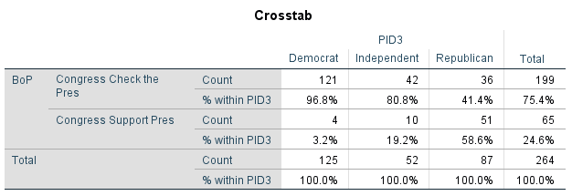
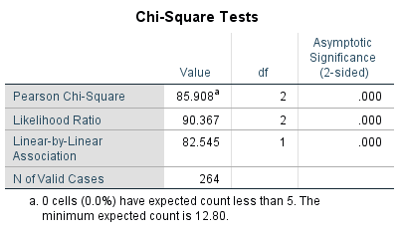

In the 2018 survey, we used the traditional variables of child traits to measure authoritarianism, then added them together in an index.

Correlations
 |  | CCIndex | AuthorIndex
CCIndex | Pearson Correlation | 1 | .295**
 | Sig. (2-tailed) |  | .000
 | N | 606 | 535
AuthorIndex | Pearson Correlation | .295** | 1
 | Sig. (2-tailed) | .000
 | N | 535 | 555
**. Correlation is significant at the 0.01 level (2-tailed).

To interpret this, an increased score on the authoritarianism index implies a higher preference for authoritarianism, and a higher score on the climate change belief index indicates more skepticism about climate change. So, the statistically significant and positive relationship between the 2 indicates that they are related, the mildly so. In controlling for PID, as seen in the tables below, authoritarian preference is still significant, though less influential than PID.

ANOVAª
Model |  | Sum of Squares | df | Mean Square | F | Sig.
1 | Regression | 1133.315 | 2 | 566.658 | 158.973 | .000^{b}
 | Residual | 1543.428 | 433 | 3.564
 | Total | 2676.743 | 435
a. Dependent Variable: CCIndex
b. Predictors: (Constant), AuthorIndex, PID_Dummy

Coefficientsª
Model |  | Unstandardized Coefficients |  | Standardized Coefficients | t | Sig.
 |  | B | Std. Error | Beta
1 | (Constant) | 1.882 | .433 |  | 4.342 | .000
 | PID_Dummy | 2.844 | .186 | .572 | 15.302 | .000
 | AuthorIndex | .399 | .070 | .212 | 5.681 | .000
a. Dependent Variable: CCIndex

Traditionalism
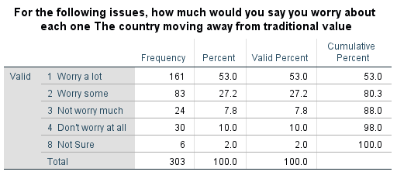
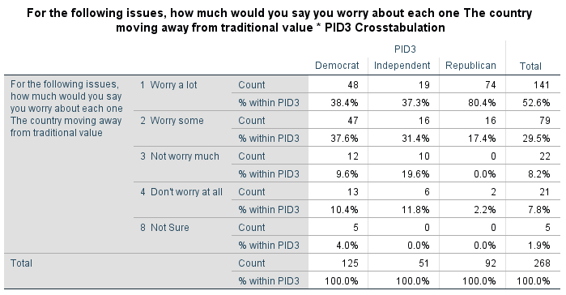
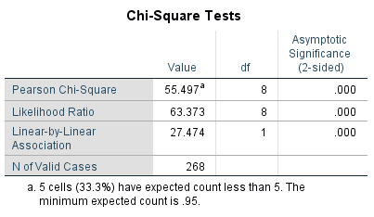
As expected, this is a highly partisan issue, though frankly I didn’t expect to see the numbers for Republicans be that high, or that for everyone (if you add the top two categories together), there is a lot of stress in Wisconsin about this.
The correlation coefficient between worrying about moving away from traditional values and climate belief was -0.377, so those who worry a lot that we are moving away from traditional values are more likely to be skeptical about climate change, though moderately so.

The Kitchen Sink
2017 data: Climate Change Index = PID + Climate Change Conspiracy Theories + Congressional Power + Worry About US Values + Distrust of Mainstream Media

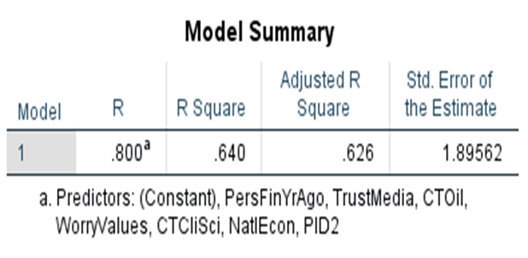
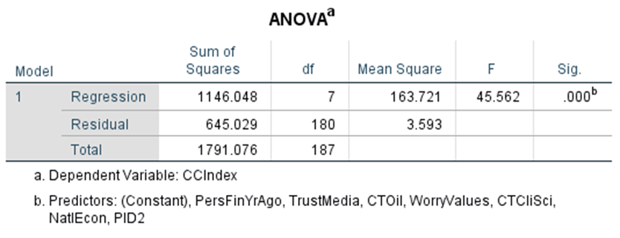
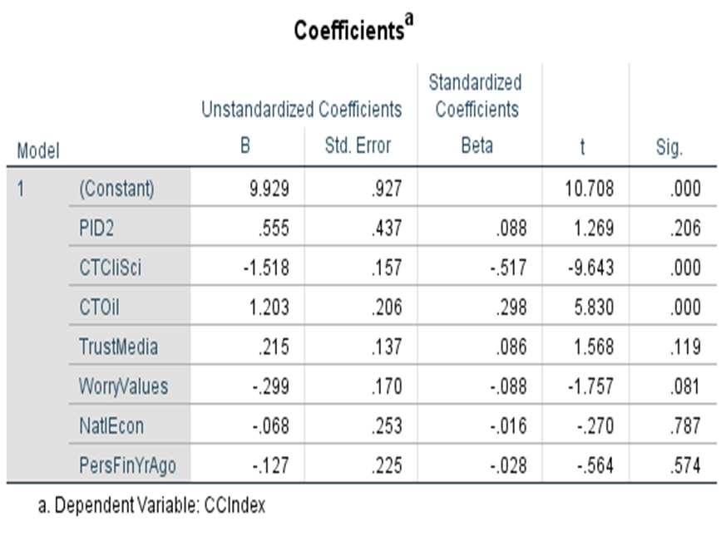

Adding these other variables to the conspiracy theories in the independent variable list, does little to increase the explained variance in climate change belief. Overall, 62.6% of the variance is explained by these variables. When comparing the betas, clearly belief in conspiracy theories about climate change are the biggest predictors of the variables measured here in predicting a person’s belief in climate change. It is also interesting to note that the dummy variable for PID is not significant.

2018 data:

Model Summary
Model | R | R Square | Adjusted R Square | Std. Error of the Estimate
1 | .658ª | .432 | .424 | 1.89314
a. Predictors: (Constant), Worry_Tradition, FinYrAgo, NeuroticIndex, AuthorIndex, NatEcon, PID_Dummy

ANOVAª
Model |  | Sum of Squares | df | Mean Square | F | Sig.
1 | Regression | 1129.947 | 6 | 188.325 | 52.546 | .000^{b}
 | Residual | 1483.763 | 414 | 3.584
 | Total | 2613.710 | 420
a. Dependent Variable: CCIndex
b. Predictors: (Constant), Worry_Tradition, FinYrAgo, NeuroticIndex, AuthorIndex, NatEcon, PID_Dummy

Coefficientsª
Model |  | Unstandardized Coefficients |  | Standardized Coefficients | t | Sig.
 |  | B | Std. Error | Beta
1 | (Constant) | 3.309 | .696 |  | 4.756 | .000
 | PID_Dummy | 2.363 | .241 | .473 | 9.813 | .000
 | AuthorIndex | .386 | .075 | .204 | 5.167 | .000
 | NatEcon | -.360 | .143 | -.115 | -2.512 | .012
 | FinYrAgo | .012 | .113 | .004 | .107 | .915
 | NeuroticIndex | -.036 | .034 | -.041 | -1.068 | .286
 | Worry_Tradition | -.137 | .097 | -.059 | -1.406 | .161
a. Dependent Variable: CCIndex

Here we find that personal anxiety levels were not significant, nor was an assessment of one’s own financial situation compared to a year ago. After controlling for other variables, the worry about moving away from tradition was also no longer statistically significant. What remains most significant is still PID, followed by authoritarian preference. Republicans and those who have a higher preference for authoritarianism are more skeptical about climate change.

Summary of Findings & Discussion
This project is an initial, very tentative look at climate change denial. There has been a lot of research on this topic and I have only begun to scratch the surface both of the literature as well as my own ideas about climate change belief and public opinion. In this first study, I set out to test the following ideas:

- Did climate change belief over time and has polarization has increased?

There has not been a lot of change. Democrats have held fairly steady, though Republicans have become slightly more skeptical on some of the measures. It will be interesting to compare this in another year. Similarly, there were small increases in polarization between Republicans and Democrats. Independents seem to be more convinced of climate change now than they were before.

- Do climate change conspiracy theories on the “right” and “left” correspond with PID?
Yes and no. While looking at the 2 different conspiracies separately, Republicans believe more than Democrats in the one that is supposed to be more right-wing (that climate scientists exaggerate their data) and Democrats believe more than Republicans that oil companies sow doubt about climate change. However, looking at the 2 questions together, nearly the same percentage of Republicans believe in both of the conspiracies, though there were some small differences in how strongly they believed them, which followed the hypothesized direction. Democrats were much more likely to follow the partisan split between the 2 theories.

- Is there a positive correlation between different “Democratic” conspiracy theories and positive correlations between “Republican” conspiracy theories as well as negative correlations between the two sides?
Yes. There was significant evidence that Democrats believed more than Republicans did that the oil companies are seeding doubt about climate change and that Russia tried to influence the election while Republicans were more likely to believe in both climate scientists exaggerating their data and that President Obama wiretapped President Trump than Democrats did. The polarization was much greater though between the Russia and wiretap questions than it was between the two climate conspiracy questions.

- Is the vaccine conspiracy theory related to the climate scientists conspiracy theory?
Yes, Republicans were more likely to believe both, but it was not a strong relationship.

- Is belief in climate change influenced by economic and societal fears?
Even after controlling for PID, there was still a relationship between people thinking the country is going in the right direction and increased skepticism about climate change (and therefore, people who think the country is going in the wrong direction were more likely to feel climate change is occurring and caused by humans). For those who thought the national economy was worse than last year, they were more likely to be climate skeptics.
In terms of worry about political and social issues, those less worried about the political climate and school shooting were actually more likely to be climate skeptics (though they are weak relationships). Only those who worry about illegal immigration were moderately more likely to be climate skeptics.

- Is belief in climate change influenced by trust/distrust of different levels of government and the media?
There is mixed evidence here and all of the relationship, though statistically significant were relatively weak. The strongest relationship (though still fairly weak) was distrust of mainstream media and climate skepticism.

- Is climate change belief influenced by authoritarian tendencies?
Yes, though mildly so. Those who have a higher preference for authoritarianism (using the traditional measures about personality qualities in children) are also more skeptical about climate change, giving credence to the idea that both climate beliefs and authoritarian tendencies share similar antecedents.

- Is climate change belief influenced by the worry that the country is moving away from traditional values?
Yes, those who worry more that the country is moving away from traditional values are more likely to be climate skeptics, though this is a weak to moderate relationship. In the 2018 data, when put in a regression model with other variables, the relationship was no longer statistically significant.

- Finally, how do all of these compare in their relative influence over belief in climate change?
In the “kitchen sink” regression for 2017, belief in the climate scientist data exaggeration conspiracy theory was the most influential variable on climate belief, followed by the belief that oil companies sow doubt about climate change. This was followed in importance by Congress’ check on the presidency and worry about moving away from traditional values. What’s most interesting about this model is that when these variables are in the mix, partisan identification is not statistically significant.
Overall, 81% of all respondents thought it was definitely or probably true that the oil companies were seeding doubt about climate change to further their own ends compared to 40% thinking that it was definitely or probably true that climate scientists exaggerate their data for their own gain. Put in perspective, 60% of all respondents thought that Russia tried to influence the US election and 33% believed (definitely or probably) that President Obama ordered the wiretap on President Trump. These beliefs are also polarized by partisan identification. Not only do the percentages of people believing in these conspiracy theories seem very high, but what struck me most about the whole survey was how much of the variation in climate change beliefs these climate conspiracies explain. I would love to hear your thoughts and recommendations for further study.

Works Cited
American Academy of Arts and Sciences. 2018. Perceptions of Science in America: The Public Face of Science, retrieved from: https://www.amacad.org/sites/default/files/academy/multimedia/pdfs/publications/researchpapersmonographs/PFoS-Perceptions/PFoS-Perceptions-Science-America.pdf

Antonio, Robert and Robert Brulle. 2011. “The Unbearable Lightness of Politics: Climate Change Denial and Political Polarization.” The Sociological Quarterly. 52: 95-202.

Chong, Dennis. 2015. “Explaining Public Conflict and Consensus on the Climate,” in Yael Wolinsky-Nahmias (ed) Changing Climate Politics. Los Angeles: Sage.

Connor, Linda and Nick Higginbotham. 2013. “Natural Cycles in Lay Understandings of Climate Change.” Global Environmental Change. 23: 1852-1861.

Douglas, Karen and Robbie Sutton. 2015. “Climate Change: Why the Conspiracy Theories are Dangerous.” Bulletin of the Atomic Scientists. 71 (2): 98-106.

Douglas, Karen M., Sutton, Robbie M. and Cichocka, Aleksandra (2017) “The Psychology of Conspiracy Theories.” Current Directions in Psychological Science. 26 (6) 538-542.

Druckman, James. N., & McGrath, Mary. C. (2019). The evidence for motivated reasoning in climate change preference formation. Nature Climate Change, 9, 111–119

Guber, Deborah. 2013. “A Colling Climate for Change? Party Polarization and the Politics of Global Warming.” American Behavioral Scientist. 57 (1): 93-115.

Hetherington, Marc and Jonathan Weiler. 2009. Authoritarianism and Polarization in American Politics. NY: Cambridge University Press.

Hochschild, Arlie Russell. 2016. Strangers in Their Own Land. NY: The New Press.
Jost, John H et al. 2003. Political Conservatism as Motivated Social Cognition. Psychological Bulletin. Vol 129, No. 3, 339-375
Jylhӓ, Kirsti Maria. 2016. Ideological Roots of Climate Change Denial: Resistance to Change, Acceptance of Inequality, or Both? Dissertation. Uppsala University.
Krosnick, John. 2010. “The Climate Majority”. New York Times. June 9, 2010. http://www.nytimes.com/2010/06/09/opinion/09kroshick.html <accessed 4/28/17>.

Leman P, and M Cinnirella. 2007. “A Major Event Has a Major Cause: Evidence for the Role of Heuristics in Reasoning about Conspiracy Theories.” Social Psychology. 9 (2): 18-28.

Mann, Thomas E.Ornstein, Norman J. 2012. It's even worse than it looks :how the American constitutional system collided with the new politics of extremism New York : Basic Books

McCauley, Clark and Sophia Moskalenko. 2011. Friction: How Radicalization Happens to Them and Us. NY: Oxford University Press.

McCright, Aaron and Riley Dunlap. 2011. “The Politicization of Climate Change and Polarization in the American Public’s Views of Global Warming, 20012010.” The Sociological Quarterly. 52: 155-194.

McDermott, Rose 2019. Psychological Underpinnings of Post-Truth in Political Beliefs.” PS: Politics & Political Science 52 (2): 218-222

Oreskes, Naomi and Erik Conway. 2010. Merchants of Doubt. NY: Bloomsbury Press.

Pew Research Center. 2010. “Wide Partisan Divide Over Global Warming.” Pew Research Center for People and the Press. October 27. (http://pewresearch.org/pubs/1780/poll-global-warming-scientists-energy-policies-offshore-tea-party) <accessed 4/28/17>.

Scattergood, Wendy E. 2004. “The Social Justice Implications of Global Warming,” in Globalization Redux Thomas Connor and Ikuko Torimoto (eds). Lanham, MD: University Press of America.
Scattergood, Wendy E. 2014. “Polarization in Wisconsin Public Opinion: 1984-2013” paper presented at the Western Political Science Association meeting, Seattle, Wa. March 2014.

Scruggs, Lyle, and Salil Benegal. 2012. “Declining Public Concern About Climate Change: Can We Blame the Great Recession?” Global Environmental Change. Doi: 10.1016/j.gloenvcha.2012.01.002.

Uscinski, Joseph and Joseph Parent. 2014. American Conspiracy Theories. NY: Oxford University Press.
Washburn, Anthony N. and Skitka, Linda J. 2017. “Science Denial Across the Political Divide: Liberals and Conservatives Are Similarly Motivated to Deny Attitude-Inconsistent Science.” Social Psychology and Personality Science.

Weber, E.U. 2010. “What Shapes Perceptions of Climate Change” Climate Change. 1 (3): 332-342.

