Educating for Civility
Teaching Intellectual Charity in a Hostile News Environment

Prepared for the 2014 Western Political Science Association Conference

Michael Artime, Ph.D.
St. Martin’s University

Educating for Civility
Teaching Intellectual Charity in a Hostile News Environment

Introduction

In the spring of 2011 Jack Stuef of the satirical news site Wonkette wrote an article entitled “Greatest Living American: A Children’s Treasury of Trig Crap on His Birthday”. In this article Stuef mocked the disability of former Alaskan Governor Sarah Palin’s son Trig Palin, who was born with Downs Syndrome. At the punch line of one of the article’s jokes Stuef called Trig “retarded.” After receiving criticism regarding the article the site eventually pulled the piece, but Stuef defended it as a response to the use of children as campaign props (Christopher 2011).
On the other side of the political aisle, a Republican Party official in the state of California in the spring of 2011 emailed a picture of President Obama’s face superimposed on the body of an ape. The party official claimed that this was not a racist email for it was meant to be satirical in nature (Madison 2011). These episodes are some of the many examples of the way that individuals on both ends of the political spectrum have started to use the media (both new and old) as a means of proliferating often negative, politically charged statements and images about their opponents.
As university professors, we must recognize that our students learn about politics in an environment that is increasingly partisan and overwhelmingly negative. Buss and Buss (2006), for example, indicate that the Internet has exacerbated all of the negative tendencies of political communication. How then should we approach the education of undergraduate students in our political science courses?
This paper is an imperfect first attempt at thinking through a pedagogical approach that can be used to combat this negativity. Specifically, I think that there is much to be gained by requiring students to think critically about intellectual virtues, such as intellectual charity. Successful integration of these virtues will force students to evaluate their approach to arguments, individuals, and policies that they disagree with.
The Literature on Virtue in the Classroom

The first hurdle in approaching this discussion concerning the integration of the intellectual virtues in university education is to address the supposition that the classroom ought to be an objective environment and any presentation of universal virtues is antithetical to that purpose. However, Abraham (2006) posits that to assume that the role of an educator is merely to objectively present the facts ignores the variety of ethical considerations that we tacitly endorse in the creation of our classes. For example, Abraham posits that we would scarcely expect to see classes in criminology programs that taught us how to better pursue a life of crime. He demonstrates that education is an inherently normative enterprise. While there should certainly be limits on the degree to which we teach students what to think, as opposed to how to think, it is reasonable that we construct our departments and our classes on the foundation of values which are important to the university and local, state, and global communities.
Additionally, it is important to demonstrate that the intellectual virtues are possible to impart in an educational setting. For example, Reid (1788) discussed the idea of “invincible ignorance” or the assumption that certain intellectual defects were essentially irreversible and, consequently, we could not hold individuals morally accountable for actions stemming from these defects. However, Bell (1965) carefully notes that if a person has the opportunity to address and reverse these intellectual vices then they are indeed morally blameworthy for actions that arise from said vices. As educators, we have a unique opportunity to study and assist students as they attempt to address these intellectual vices. Consequently, we help our students as they inevitably face questions of morality both in and out of university life.
Another charge against the promotion of intellectual virtues is that they are elitist in their assumption that there is a higher level of thinking that ought to be achieved. However, Putnam (1997) discusses the need for virtues to cross boundaries of skill, sex, social class, and level of education. In other words, intellectual virtues should be about an approach to learning that is accessible to all individuals. For example, a person can be intellectually charitable regardless of education level.
If we agree with the conclusion that the intellectual virtues ought to be taught in the classroom, how should a university professor prepare to present this material? Stutz and Tauer (2000) argue that it is imperative that professors practice the intellectual virtues if they are going to attempt to utilize these ideas in the classroom. This is a demanding task that requires, for many, a reexamination of the approach to their discipline. However, students and professors alike are then able to access to the benefits of thinking in a virtuous way.
Measuring a Virtue

Incorporating discussions of various intellectual virtues in the classroom is relatively easy. However, measuring the efficacy of these discussions on student performance is more challenging.
In this paper, I will first present some national-level data concerning the erosion of intellectual charity in university life. Following this discussion I will turn to an evaluation of a study that I performed in my political science classes during the fall semester of 2013.
This study represents pilot project for a larger study on the efficacy of different approaches for integrating the intellectual virtues into the university classroom. For this particular project I narrowed my focus to the study of intellectual charity. To help students understand the distinction between charity and its intellectual counterpart, I turned to Roberts and Wood (2007, p. 73) who posit that:
A person is not said to be charitable on account of loving and seeking intellectual goods. Charity is love of God and/or fellow human beings and such objects are not intellectual goods. No doubt, the person of full intellectual virtue will have not only charity, but also virtues that involve loving the intellectual goods and the means to achieve them. Charity becomes intellectual charity when it applies in the contexts of the intellectual life, so charity is an attitude toward, most notably, interlocutors and authors of texts. If one reads a text charitably, one is reading the text as coming from an author who would like to be treated with respect and goodwill. Such charity is an intellectual virtue because it (presumably) enhances the agent’s prospects of achieving the aims of the intellectual life.”

My working hypothesis in approaching this pedagogical project was that:

The current political media environment is an impediment to achieving the form of intellectual charity defined by Roberts and Wood.

At the start of the fall semester at Whitworth University students in each of my political science classes were asked to complete a simple survey asking them to identify their party affiliation, ideological-leanings, and attitudes toward the current immigration reform debate happening in Congress. Following this survey each student was assigned to watch a brief 5-minute news clip presenting a different perspective related to the issue of immigration. Half of the students were exposed to media from an expressly partisan media source (an Ann Coulter interview on Fox News critiquing plans for immigration reform or a Rachel Maddow video criticizing Republican opposition to the same reform proposals on MSNBC). The rest of the students received a media story about the same issue from a more neutral perspective (a PBS Newshour description of recent trends in immigration reform). After watching this material, students answered a post-test survey about their reaction to said material through an online survey tool. The literature would suggest that partisan news sources from any ideological perspective will strengthen existing partisanship (Taber and Lodge 2006). In other words, if a conservative watches a conservative news story that story will cause them to feel even more justified in their support of conservative principles. However, if a liberal individual watches the same conservative news story he or she will, through the process of internally arguing with the partisan commentary, find that their liberalism has only become more pronounced.
After completing the project I led a classroom discussion on the sometimes obvious and sometimes less obvious ways that a lack of intellectual charity has been shown to create divisions amongst people with regard to American politics. I then asked the students to write a personal reflection addressing the following questions:

- How do you typically react when presented with viewpoints that are decidedly different than your own? Provide an example.
- How could you incorporate the idea of intellectual charity into your personal life?
- How could you incorporate the idea of intellectual charity into your academic life?
- What challenges will you face as you attempt to integrate intellectual virtue into your personal and academic life?

I will discuss general conclusions drawn from this pedagogical approach and some thoughts about how this design could be improved and implemented on a larger scale.
Findings

While imperfect, the American National Election Studies datasets from 2008 and 2012 offer some measures which can speak to the state of intellectual charity amongst college-educated individuals. To evaluate whether or not a person can see both sides of a political debate, the ANES asks respondents to identify how often, in situations where there is a disagreement along partisan lines, it is possible that both parties are correct. In the following table from the 2008 ANES it is clear that the plurality of those with the highest level of education identify that in these situations that, at least half of the time, each side will have some claim to the truth. These findings are encouraging and demonstrate that, perhaps, our institutions of higher learning are already effectively promoting intellectual charity.
[Insert Table 1 about here]

However, if we compare these 2008 results to a similar analysis drawn from the 2012 ANES dataset things seem far less optimistic.
[Insert Table 2 about here]

Those with a BA in this analysis have grown increasingly less likely to find points of agreement with both sides during a partisan debate. College-educated individuals are slightly more intellectually charitable than their counterparts with lower levels of educational attainment, but that does not tell the whole story. Relative to those with a college education in 2008 it appears that those with the same level of education in 2012 are less likely, in a partisan debate, to identify each party in a conflict as having a claim to the truth. While it is the argument of this paper that trends in our coverage of political issues are, at least in part, responsible for this trend there must be a significant degree of added analysis before such a conclusion can be definitively argued. For example, it may be that these individuals have become rightly skeptical of political debate given the level of discourse on political talk shows, blogs, and social media sites. However, this data at least suggests that pursuing questions related to intellectual charity is necessary and justified.
My classroom results also confirmed that thinking critically about the integration of intellectual charity in political science courses is a worthwhile endeavor. There were 29 students who participated in both the pre-test and the post-test. In the pre-test survey students were asked to rank their level of support for the immigration proposal on a feeling thermometer (a scale from 0-100 where 0 would be the least supportive score and 100 would indicate the highest possible level of support for the proposal). These are the results of that initial survey:
[Insert Figures 1 and 2 about here]

Amongst liberals those exposed to a liberal-leaning news story became more likely to support the immigration reform proposal that had recently passed in the Senate. Liberals assigned to the moderate news group had a small increase in support for the proposal and, finally, those assigned to the conservative news source also became more supportive of the proposal.
With students who identified as conservative there were similar results as those assigned ideological news stories (whether liberal or conservative) became more conservative on the issue of immigration reform. Likewise, those assigned a moderate news story saw their support remain relatively constant.
The results suggest that Taber and Lodge (2006) in their article discussing motivated reasoning were correct. Specifically, those exposed to ideological news sources that they agree with will become more entrenched in their existing partisanship. Interestingly, those exposed to ideological news sources inconsistent with their own particular ideological disposition will also become more entrenched in their own partisanship as they engage in an internal debate with said news sources.
When presented with these results students were surprised and seemed to recognize the biases inherent in the way that they process news. In their subsequent reflections they presented thoughts about how they might combat a lack of intellectual charity and, also, expressed the difficulty that they had in accommodating perspectives different from their own. Their challenge is also our own. It is difficult for all of us who care deeply about politics and the political process to assume the best about those who have views that are diametrically opposed to our own. However, this is not a zero sum game. We have an opportunity to make small, important improvements toward increasing the civility of discourse in a hostile environment.
Conclusion

We live in an increasingly hostile and partisan news environment. In the face of these trends political science professors have the challenge of teaching students how to approach views that they vehemently disagree with. While teaching students to delineate between appropriate and inappropriate sources of information, we must simultaneously offer the intellectual skills necessary to fairly and accurately assess sources that hold different perspectives than the student and, perhaps, the professor.
Table 1: Education and Evaluating the Efficacy of Arguments in Political Debates, 2008

Source: 2008 American National Election Studies Dataset

Table 2: Education and Evaluating the Efficacy of Arguments in Political Debates, 2012

Source: 2012 American National Election Studies Data

Figure 1: Pre-Test Student Evaluations of Immigration Reform

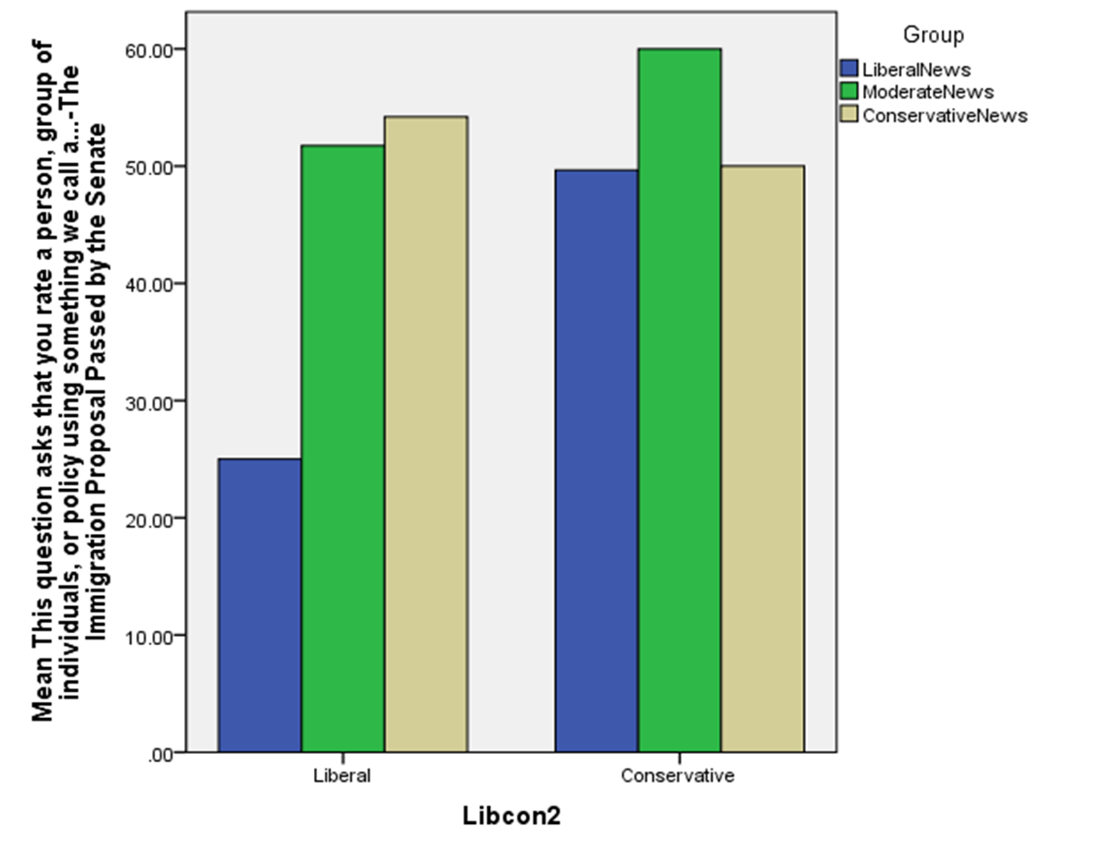

Figure 2: Pre-Test Student Evaluations of Immigration Reform

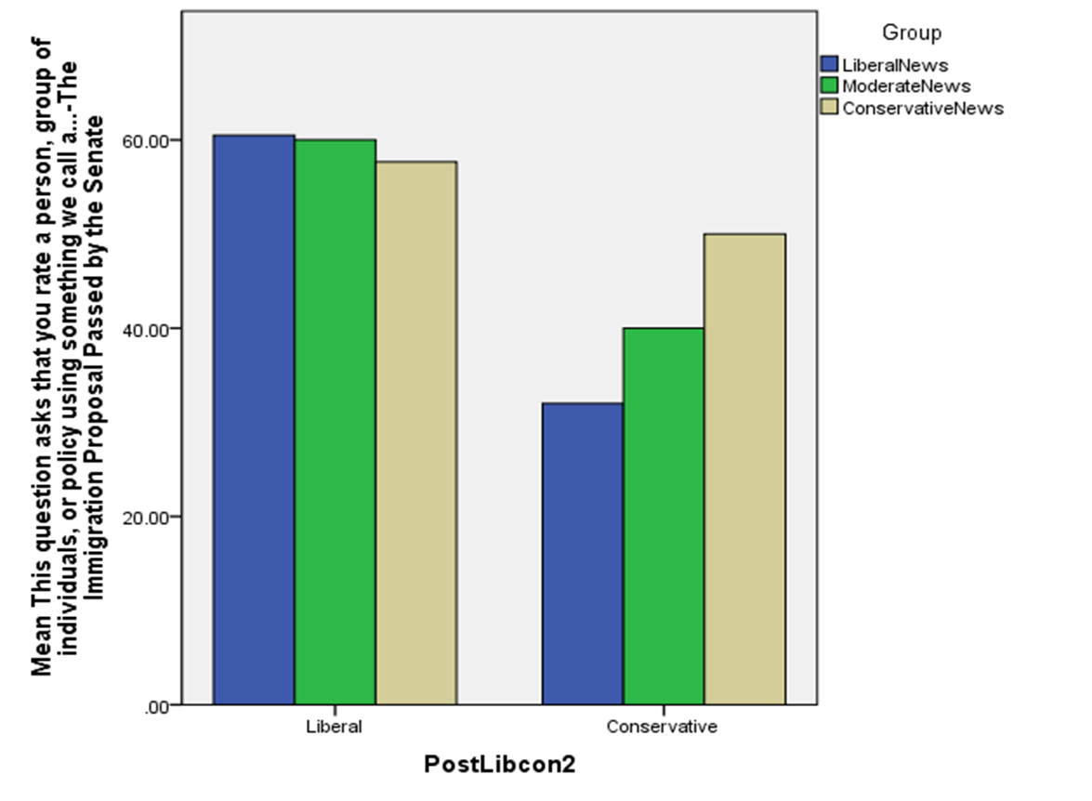

Appendix 1: Pre-Test Questionnaire
- How confident are you in your knowledge of the immigration proposal which has recently been passed in the Senate?
  - Very confident
  - Somewhat confident
  - Neither confident or unconfident
  - Somewhat unconfident
  - Very unconfident

- This question asks that you rate a person or a group of individuals using something we call a feeling thermometer. Ratings between 0 degrees and 50 degrees mean that you don’t feel favorable toward the person, group, or issue. You would rate the person or group at the 50 degree mark if you don’t feel particularly warm or cold toward the person, group, or issue. How would you rate President Obama? ("The ANES 2008 Time Series Study " 2008)
- How would you rate the current Congress?

- How would you rate the Democratic Party?

- How would you rate the Republican Party?

- How would you rate the immigration proposal passed by the Senate?

- Aside from weddings or funerals, how often do you attend religious services?
  - More than once a week
  - Once a week
  - Once or twice a month
  - A few times a year
  - Seldom
  - Never

- How would you categorize your personal religious affiliation?
  - Catholic
  - Protestant
  - Jewish
  - Muslim
  - Agnostic
  - Atheist
  - None or Other

- If you identify as a Christian, how much does your religion inform your understanding of social or political issues?
  - Some
  - Quite a bit
  - A great deal

- What is your gender?
  - Male
  - Female

- What is your current major? (students will have a space to type in their major)
- What classification best describes your academic standing at Whitworth University?
  - Freshman
  - Sophomore
  - Junior
  - Senior
  - Graduate student

- Are you:
  - Asian
  - Black/African American
  - Hispanic/Latino
  - White
  - Other

- Where would you place YOURSELF on this scale?
  - Extremely liberal
  - Liberal
  - Slightly liberal
  - Moderate; middle of the road
  - Slightly conservative
  - Conservative
  - Extremely conservative

- Please type your email address in the space provided.

Appendix 2: Post-Test Questionnaire
- How confident are you in your knowledge of the immigration proposal which has recently been passed in the Senate?
  - Very confident
  - Somewhat confident
  - Neither confident or unconfident
  - Somewhat unconfident
  - Very unconfident

- This question asks that you rate a person or a group of individuals using something we call a feeling thermometer. Ratings between 0 degrees and 50 degrees mean that you don’t feel favorable toward the person, group, or issue. You would rate the person or group at the 50 degree mark if you don’t feel particularly warm or cold toward the person, group, or issue. How would you rate President Obama? ("The ANES 2008 Time Series Study " 2008)
- How would you rate the current Congress?

- How would you rate the Democratic Party?

- How would you rate the Republican Party?

- How would you rate the immigration proposal passed by the Senate?

- Where would you place YOURSELF on this scale?
  - Extremely liberal
  - Liberal
  - Slightly liberal
  - Moderate; middle of the road
  - Slightly conservative
  - Conservative
  - Extremely conservative

- Please type your email address in the space provided.

Appendix 3: Virtues Reflection Assignment
Intellectual Charity
“A person is not said to be charitable on account of loving and seeking intellectual goods. Charity is love of God and/or fellow human beings and such objects are not intellectual goods. No doubt, the person of full intellectual virtue will have not only charity, but also virtues that involve loving the intellectual goods and the means to achieve them. Charity becomes intellectual charity when it applies in the contexts of the intellectual life, so charity is an attitude toward, most notably, interlocutors and authors of texts. If one reads a text charitably, one is reading the text as coming from an author who would like to be treated with respect and goodwill. Such charity is an intellectual virtue because it (presumably) enhances the agent’s prospects of achieving the aims of the intellectual life.”
Roberts, Robert C. and W. Jay Wood. 2007. Intellectual Virtues: An Essay in Regulative Epistemology. Oxford: Oxford University Press, p. 73
For this assignment I want you to reflect on the virtue of intellectual charity as described in the Roberts and Wood text above. This virtue is helpful in not only helping us to live happily in community with those who disagree with us, but it is also a necessary tool in assisting our search of truth as it relates to our intellectual pursuits. Please write a brief one page essay that addresses the following questions:
- How do you typically react when presented with viewpoints that are decidedly different than your own? Provide an example.
- How could you incorporate the idea of intellectual charity into your personal life?
- How could you incorporate the idea of intellectual charity into your academic life?
- What challenges will you face as you attempt to integrate intellectual virtue into your personal and academic life?

Bibliography

Abraham, William J. 2006. Education, Social Transformation, and Intellectual Virtue. Christian Higher Education 5: 3-19.

Bell, D.R. 1965. Impartiality and Intellectual Virtue. The Philosophical Quarterly 15 (60): 229-239.

Buss, Terry F., and Nathaniel J. Buss. 2006. "The Internet, Politics, and Democracy." In Modernizing Democracy: Innovations in Citizen Participation, eds. T.F Buss, F.S. Redburn and K. Guo. Armonk, NY: M.E. Sharpe.

Christopher, Tommy. 2011. "Update: Wonkette Deletes Trig Palin Post As Advertisers Leave Site." http://www.mediaite.com/online/wonkette-writer-apologizes-for-trig-post-as-advertisers-leave-site/ (February 16 2012).

Gallie, Roger D. 1998. Thomas Reid: Ethics, Aesthetics and the Anatomy of Self. Kluwer Academic Publishers: Norwell, MA.

Madison, Lucy. 2011. "California Republican refuses to resign from post after sending picture depicting Obama as ape." http://www.cbsnews.com/8301-503544_162-20054984-503544.html (February 16 2012).

[MichaelSavage4Prez]. (2013, June 22). Ann Coulter bashes immigration bill: GOP hoodwinked into legalizing millions of Democratic Voters. Retrieved from https://www.youtube.com/watch?v=VtobrDScdhg&feature=youtu.be

[PBS NewsHour]. (2013, June 27). Bipartisan Senate majority passes immigration reform. Retrieved from https://www.youtube.com/watch?v=gnf8BYTshwc

Putnam, Daniel. 1997. The Intellectual Bias of Virtue Ethics. Philosophy 72 (280): 303-311.

Stutz, Cathleen K., and Susan M. Tauer. 2000. The Awakening of Intellectual Virtue. Journal of Education 182 (2): 37-43.

Taber, Charles S., and Milton Lodge. 2006. Motivated Skepticism in the Evaluation of Political Beliefs. American Journal of Political Science 50 (3): 755-769.

Tomy, Jessy. (2013, June 20). House GOP in disarray on immigration. Retrieved from https://www.youtube.com/watch?v=fXtyX9KkNNc&feature=youtu.be

This project did not go through an Institutional Review Board process and is not meant to contribute to generalized knowledge.

