*[Developing Regulatory Capacity and Authority in the Brazilian States](http://kellogg.nd.edu/collier/papers/Cohon.pdf)*

Adam J. Cohon

University of Rochester

ABSTRACT: In developing countries, why do some regulatory bodies win sufficient resources and authority to carry out their mandate post-creation while others do not? In this paper I develop a theory for the post-creation development of regulatory agency capacity and authority at the subnational level in Brazil, arguing that particular policy outcomes allow local politicians to claim credit. Agencies’ initial focus on electorally-valuable sectors allows them to develop a reputation among local officials for competence and usefulness, and leverage this reputation to win more resources and authority from political principals. I argue that agency development is path-dependent. I illustrate the theory with a matched case comparison between agencies in the Brazilian states of Ceará and Rio Grande do Sul from 1997 to 2010.

Author contact: [acohon@ur.rochester.edu](mailto:acohon@ur.rochester.edu). Work currently under review; comments are welcome, but please do not cite or circulate.

Introduction

In the late twentieth century, countries across the developing world undertook a paradigmatic shift in the role of the state. Private concessionaires assumed contractual responsibility for public service provision and the state withdrew as a direct provider. Following international models, governments developed regulatory agencies to oversee new concessions. While scholars have extensively documented when and why governments created these institutions, we understand much less about how the agencies functioned afterward.[1]

Latin America stands out prominently in this regard. Many Latin American countries replaced the mid-century developmental state with a “thinner” regulatory state.[2] Private firms assumed responsibilities for services such as water, gas, telecommunications, and electricity. Privatization went farther in Latin America than in any other region after the post-communist bloc.[3] To oversee these new concessionaires, Latin American governments founded 118 national regulatory agencies after 1989.[4] Federal governments created multiple sector-specific agencies. At the subnational level, Argentine provinces, Mexican states, and Brazilian states followed the federal government’s lead by establishing sector-specific or multi-sector regulatory bodies.

In this new regulatory state, politicians delegated the authority to formally autonomous new agencies to set and adjust tariffs, set quality standards, auction concessions, arbitrate user and concessionaire disputes, and conduct inspections to ensure compliance with standards.

Accomplishing these tasks, however, requires high levels of capacity and the authority to act. Regulators must overcome an informational asymmetry; firms know their true compliance and costs, and can misrepresent these to an outside investigator. In Latin America, agencies risked becoming paper tigers, short on technical expertise to accomplish their delegated responsibilities or the power to force concessionaires to act. Only some agencies were able to hire or train expert staffers, win authority to punish noncompliance, or acquire additional sources of leverage over concessionaires. The latter were more able to check price increases and compel service improvements.

Regulators in Latin America faced these and other acute challenges. Public sectors in the region were much lower capacity than in countries where regulatory agencies first emerged.[5] Privatization was unpopular in many areas, which increased pressure for re-expropriation; populist politicians pressured regulators to favor users.[6] In several cases, politicians curtailed regulators’ authority or autonomy so they could directly confront or negotiate with concessionaires.[7] Formal institutions also incompletely bind politicians’ and bureaucrats’ actions, such that agents were unable to initially undertake all their delegated responsibilities.[8] Existing bureaus often declined to relinquish overlapping policy authority.

These outcomes shape state control. Low-capacity and low-authority agencies may be unable to check concessionaire abuses and more subject to capture. For example, improper cost estimates by the Brazilian federal energy regulator allowed firms to overcharge users by five billion dollars.[9] Under-funded agencies or those lacking adequate powers may also be unable to stop dangerous, abusive and illegal activity. However, scholars know little about changes in post-creation capacity and authority in developing world regulatory bodies.[10]

In this article I study the development of capacity and authority in subnational regulatory agencies in two Brazilian states. Between 1997 and 2010, twenty-one of twenty-seven Brazilian states created regulatory agencies to oversee public service concessions. State governments created agencies at roughly the same time they privatized utility firms. In doing so, they set agency structure and mandates using models from abroad. Following initial creation, however, agencies followed different paths. Some became robust while others were shuttered or understaffed.

Studying subnational level agencies improves analytic leverage. As institutions vary widely across countries, and shape regulator activities, comparisons of bureaus across Latin American countries are inapt.[11] However, in most federations, formal institutions’ homogeneity across states allows us to exclude explanations based on formal institutional environments.[12] Despite similar formal institutions in the Brazilian states agencies vary significantly.[13]

To explain this variation, I argue that regulators who undertook efficacious work in electorally-valuable policy areas enabled local officials to claim credit for service improvements. Agencies thereby developed reputations for usefulness among those important to political principals. Some agency directors leveraged this reputation into additional resources, power over concessionaires, and responsibilities. Below, I sketch out a theory and illustrate it with paired case studies of multi-sector agencies in the Brazilian states of Rio Grande do Sul and Ceará. I conclude by considering how my theory travels to other contexts, and how the experience of these agencies speaks to a broader debate on the role of the state after neoliberal market reforms.

To develop my explanation, I focus on institutions that govern politician behavior, decision-making by regulatory agency directors, and how decisions and policy outputs enable bureaucratic leaders to more successfully petition for more authority and capacity.

Outcomes under study

My study concerns two inter-related variables, *authority* and *capacity*. Both are inputs that allow regulators to perform their core functions, learn about concessionaire firms and services, and enforce standards and penalties.[14] *Authority* in these cases has both vertical and horizontal dimensions. Horizontally, greater authority is exercised when multisector agencies act in a greater number of policy areas. Greater authority is exercised vertically when agencies undertake more of economic regulation, standards-setting, enforcement, and other tasks within each policy area. *Capacity* refers to tangible resources such as staff, equipment, and technology as well as training, tenure and qualifications for staff members. Both concepts are prior to, but critical inputs for, bureaucratic autonomy. High capacity and high levels of authority help bureaucrats in weak institutional environments transform *de jure* autonomy into *de facto* autonomy. With adequate resources and the ability to learn and sanction, regulators can form goals independently and achieve their defined objectives, which together constitute autonomy.

Previous literature

Existing theories fail to explain how regulators might acquire adequate authority and capacity. Scholars agree that adequate resources and authority are necessary for high-quality regulation.[15] Economic models of regulation wherein an agency can expend some effort to learn about the true state of the world (e.g. Laffont 1994) do not discuss how agencies might acquire this expertise. Though multisector agencies may be less susceptible to regulatory capture, because agency directors can pool resources across tasks, scholars fail to account for varied outcomes among agencies regulating similar firms.[16]

Public administration theories fall short in explaining regulatory body development in Brazil. Scholars suggest that private regulators, self-regulation, or activist groups can complement underdeveloped state regulation and help monitor concessionaire activities. They require, however, that such groups are present and active.[17] Such groups are still absent at the subnational level for policy areas studied here. Similarly, models wherein regulators are subject to lobbying by opposed interests and build a reputation based on their responsiveness to interest group demands are of limited use.[18] There is little evidence that this process occurs in Brazil and other developing countries, where lobbying groups for users and traditionally less-organized groups are underdeveloped.

Theories concerning institutional endowment also help little. Scholars argue that the institutional environment shapes regulatory regime quality, or that institutions can substitute for each other in accomplishing regulatory tasks.[19] However, Brazilian state agencies operate in similar formal institutional environments with similar peer state bodies, but only some agencies remain limited and underfunded. Brazilian states are also weak institutional environments. Arguments that incumbents might lock-in bureaucratic features and powers across periods explain little.[20] Political principals in Brazil and other developing countries are able to extensively reshape bureaucratic institutions while in office.[21] Post-creation laws and decrees have modified agency powers. Finally, simple modernization explanations fail. I find no significant relation between civil society group density (measured as registered groups per million residents in 2005) or state 2000 HDI scores and outcome variables across all states and state agencies.[22]

To address the above shortcomings, I propose a theory grounded in institutions, policy outcomes, and actor incentives.

A Theory of Brazilian Subnational Agency Development

A. A New Organizational Form

Regulatory agency directors assumed command of a new organizational type in Brazil. As part of a state reform process, the center-right PSDB government of President Fernando Henrique Cardoso (1994-2002) created independent regulatory agencies to oversee private concessionaires and “thin” the state.[23] Most state governments emulated these reforms, and created multisector agencies to oversee both newly-privatized public services and state-controlled services.[24] State agencies had primary responsibility to monitor **piped natural gas**, **intercity transportation**, and **intercity highway** concessions. They could monitor **electrical energy distribution** through an agreement with the federal energy regulator Aneel, and oversee **water and sanitation** by contract.[25]

State executive branch staff received help from international lending agencies, North American universities, and private firms in designing agencies.[26] These consultants emphasized regulator independence from political principals foremost, and the need to maintain equidistance among users, concessionaires, and political authorities.[27] Creation laws assigned agency directors fixed, staggered terms and prohibited immediate post-term employment by concessionaires, and formally, permanent staff positions.[28] Consultants never discussed the political payoffs of regulatory work.

1. Appointment Decisions

In choosing directors, governors sought to resolve a dilemma: they needed new private concessionaires to invest in infrastructure, and they needed to assuage consumer fears that privatization would increase costs or worsen services. Appointees were therefore chosen to bring prestige and technical knowledge to an untested state body; their personal views on the distribution of surpluses to concessionaires or consumers were largely orthogonal to their sector-specific experience.[29] Agency directors largely came from administrative positions in state politics and previously state-owned firms.

Gubernatorial choice of directors had an indirect effect on initial agency orientation. Agency creation laws envisioned broad responsibilities that available resources could not match, and no law specified how to allocate resources if not all tasks could be addressed. Creation laws either listed mulitple policy areas, or required the agency to oversee undefined “public services.”[30] Consultants instructed agencies on how to set prices, draft standards, and perform inspections.[31] Directors had to decide how to allocate scarce resources among these areas in implementing the agency.

C. Initial Agency Orientation

Initial directors allocated resources among the five policy areas based on their personal backgrounds and the contractual requirements they encountered. Devoting significant resources to regulating particular policy areas subsequently produced measurable changes in service delivery.

Directors arrived with temporary staff and resources sufficient to address a few policy areas mentioned above; permanent staff members could enter only after a future public service examination. Directors filled temporary positions with workers with whom they had professional and social ties from prior positions. These staffers began work employing sector-specific knowledge of tariff-setting and service quality standards. Directors also encountered contractual obligations to begin work in areas where new concessions contracts mandated regulatory oversight.

We might measure the key variable **initial agency orientation** as a proportion of resources allocated across policy sectors, with resources operationalized as a number of staff, staff hours, resolutions and decrees, or visits or hearings.

1. Credit-claiming and agency reputation

Efficacious agency work in specific sectors allowed local politicians – mayors and city council members – to claim credit for service improvements. Local politicians could claim credit for improvements in **electorally valuable** sectors but not for changes in non-valuable sectors. In valuable sectors, improvements occur in a space in which municipal politicians can claim credit because such services – piped natural gas, electrical energy, and water and sanitation – lie within the city gate. Local officials could point to improvements for citizens’ homes and businesses: fewer disruptions, higher quality, or lower tariffs. Other public service concessions in highways and intercity transportation serve populations across a number of cities, and are non-excludable for many citizens that will not vote for officials of any given city. As a result, local officials were far less able to claim credit for improvements in intercity transportation or highways with one stop in their bailiwick. Agencies whose work focused on these services, *even if successful at improving service quality or lowering tariffs*, very rarely enabled credit-claiming. Literature on city governments and elections shows the assumption that mayors claim credit for services provided at another level; local officials place themselves as key problem-solving intermediaries between voters and higher levels of government. Voters make largely retrospective evaluations of mayoral terms.[32]

Efficacious regulatory work took multiple forms. Efficacious regulators set the state’s first quality standards for generally low-quality services and compelled compliance with these standards. An active agency punishing lags in service improvements could be seen championing ordinary citizens against private or state firms. Concessionaires complied by undertaking visible public works projects to do so. Second, greater regulatory transparency might stop or limit tariff increases. Worry that private operators would increase tariffs (kept low in high-inflation years) was widespread, and agency leaders who countered concessionaire requests with competing cost estimates and arbitrated lower rates might be seen working on citizens’ behalf.[33] Third, agencies provided greater awareness of user rights. Users and elected officials were largely unaware of what they might demand from concessionaires, but they learned from agency publicity campaigns.[34]

1. Reputation development among local officials

Regulators who significantly changed service quality in valuable sectors developed reputations for competence and usefulness, which they could use to win additional capacity and authority.

Regulatory work generated a multifaceted reputation. Concessionaires, users, and government officials observed regulatory work, and interacted with agency staff. These outside actors developed opinions of the agency, which jointly formed its *organizational reputation*, “a set of symbolic beliefs held by audience networks about the actual performance of an organization, as well as its capacities, roles, and obligations to accomplish its primary organizational mission.”[35] The agency’s performative and technical reputations – its skill and success in accomplishing stated goals – matter most when considering an agency with police and price-setting powers.[36]

Elected officials encountering the state attach instrumental values to its parts. Some state bodies offer resources useful to elected officials’ careers. Other bureaus provide little for particular constituents or officials. Local officials formed opinions about the agency’s ability to control price increases and compel service improvements, and how agency work might help them claim credit for service improvements in their bailiwick. To the extent that regulatory agencies’ work helped further officials’ careers, the latter valued the agency positively. Reputation also emerged from the institutional context in which the agency formed; a body enforcing an unpopular policy would develop a negative reputation even if its work was efficacious or skilled.

Local officials’ beliefs about agency efficacy mattered most in winning additional resources. Local politicians formed a key base for statewide politicians.[37] They provided governors with vote networks and campaign resources unavailable from Brazil’s weak parties. Local officials could, either through personal charisma or clientelist networks, deliver votes to allied statewide candidates. They also had common interests in improved services and lower prices for valuable policy areas. Consumers, by contrast, were not organized enough to effectively lobby political principals on the agency’s behalf. Their varied experiences with public services – due to geographic and socioeconomic differences – further undermined their ability to act. Concessionaires’ beliefs about the agency varied. Large public corporations that owned highway, energy, gas, and sanitation concessions preferred transparent regulation while family-owned firms with precarious legal claims to transportation concessions preferred that the regulator be inactive.[38] All concessionaires preferred higher prices, but feared controversy that might arise from allowed sharp tariff increases.

Governors relied on local officials for credible information about bureaucratic quality. They managed complex systems, in which bureaucratic managers had incentives to misrepresent their accomplishments and relative worth. Executives also operated under severe fiscal constraints and sought to allocate discretionary funds to areas or bureaucratic bodies that could provide electoral returns. Governors therefore relied on analytical shortcuts and reliable agents in allocating discretionary funds. Specifically, they evaluated state bodies’ worth according to messages received from actors whose opinions mattered.

Regulatory directors, and all bureaucratic leaders, had to communicate their value to the governor because the latter was the *de facto* sole political principal. Governors controlled resources and legislative pen needed for greater capacity and authority. State executives’ powers far outstrip those of state legislators or courts in almost all states.[39] Legislators play few policymaking roles.[40]

Initial reputations remained stable due to fiscal constraints, staff specialization, and intra-bureaucratic conflict. An agency whose initial orientation produced a low-quality reputation would be less successful subsequently at winning additional resources from the governor to re-allocate toward electorally-valuable policy sectors. Employees specialized in their tasks as they gained more experience. Resources became less fungible, and the agency’s ability to reshape its reputation by re-allocating resources became more difficult. Finally, an agency’s poor reputation hindered its ability to win new jurisdictional claims against other state bodies. Staking a jurisdictional claim over additional policy areas was insufficient to expand work because other state bodies maintained and guarded roles in these areas.[41]

Reputational stability locked agencies into low, medium, or high quality paths. Outside actors formed policy networks and relationships in which they chose to favor, fund, or engage, or ignore, bypass, isolate, or shutter the agency. Agencies with high-quality reputations won funds to offer higher salaries and add workers, which in turn increased their technical reputation. Agencies with reputations as low-quality bodies failed to increase staffer salaries and faced high turnover. Their reputation led principals not to trust them with additional responsibilities; governors declined to spend more discretionary funds on bureaus that would not help them in future elections.

In summary, organizations with reputations for efficacy and electoral usefulness used their reputation to win additional resources and responsibilities.

Paired case studies

I pair similar cases with divergent outcomes to illustrate the causal link from **initial agency orientation** to the outcomes of agency **capacity** and **authority**. The Rio Grande do Sul and Ceará state governments created multisector regulatory agencies in January and December 1997, respectively. I end my studies in December 2010, when new federal sanitation laws changed state regulatory agency roles.[42] By 2010, the more developed southern state of Rio Grande do Sul had a less active and less well-funded agency than did the poor northeastern state of Ceará. While the agency AGERGS in Rio Grande do Sul suffered high staff turnover and limits on its authority, the agency ARCE in Ceará had well-paid employees and active work in multiple areas. I attribute their divergence to ARCE’s initial efficacious work in electorally-valuable policy areas and AGERGS’s initial heavy focus on less-valuable transportation and highway regulation.

The two cases are comparable. AGERGS and ARCE were created contemporaneously by center-right governors in President Cardoso’s neoliberal reformist coalition under similar conditions. Authors borrowed developed world agency models in their formal design, with World Bank and IFC assistance.[43] Both agencies had mandates to act in multiple policy areas, and began work within a year of their creation. Public and private concessions operated under federal guidelines in both states.[44] The states have middle range population and economic indicators for Brazil, and have single state-owned water and gas companies. Both governors privatized energy firms after creating regulatory agencies, but before the agency began work.

The cases vary slightly in contemporary political context and formal design at creation; neither variable significantly undermines the pairing. First, Rio Grande do Sul has two private electricity distribution concessions and privatized toll roads, while Ceará has only one private electricity distributor and no toll roads. However, private energy concessionaires demanded greater transparency in regulation in order to protect their investments. Regulators overseeing multiple sectors might also be less susceptible to capture.[45] Rio Grande do Sul’s greater variety of sectors should therefore advantage AGERGS. Separately, overseeing many firms might hinder AGERGS’s oversight of any single firm.[46] Theories thus point in contradictory directions. Second, political competition was higher in Rio Grande do Sul, where no governor won re-election. However, major conflicts in each case *followed* elections and every governor reconciled to normal agency functioning. Higher competition did not lead governors to seek greater redistribution to users as Murillo predicts.[47] Third, ARCE’s formal design should have disadvantaged organization leaders relative to counterparts at AGERGS. Directors at AGERGS had longer fixed terms (four years) with a four-year presidency than did directors at ARCE serve three years with a one-year rotating presidency. AGERGS has seven directors to ARCE’s three. AGERGS’s design should have helped reputation building among outside actors. Instead, I find that ARCE directors better developed an agency reputation for competency and leveraged it. Finally, Correa et al. score AGERGS higher in autonomy, decision-making, and accountability mechanisms than ARCE, while ARCE has more advanced “decision tools” in their “regulatory governance index.” AGERGS scored above the mean (0.5946) for state agencies while ARCE scored below the mean (0.5226), but neither agency is an outlier. [48]

AGERGS did have lesser police powers relative to ARCE. AGERGS could not fine or punish statutory violations; instead, the agency passed violations to the state public prosecutor’s office.[49] ARCE, meanwhile, issued fines and compelled compliance independent of the state public prosecutor. However, I find no evidence for the competing explanation that AGERGS developed a reputation for ineffectual punishments. AGERGS passed along multiple substantive violations for successful resolution.[50] Regulated company annual reports show fines for violations in both states.[51]

However, original design was not destiny. Other state governments revised agency legal authority to add resources and new responsibilities. AGERGS directors were unable to win changes to correct features in the agency’s design.

Finally, both agencies received equal initial amounts of funding, but ARCE enjoys greater financial autonomy. Both agencies began work reliant on state funding, but were later funded by a percentage of concessionaire receipts. (Neither agency profits from fines.) However ARCE received concessionaire fees directly, while in Rio Grande do Sul, since 1991, the state government centralizes all public tax and fee collection before dispersal to state bodies according to their needs.[52] State executives collected AGERGS revenues, but dispersed funds only at their discretion.[53] AGERGS lacked funds to expand its activities, but it performed core tasks and delivered regulatory services. Other state bodies in Rio Grande do Sul also outperformed their analogous counterparts in Ceará (and other poorer states) despite being subject to similar constraints.[54]

In short, no part of its formal design constrained AGERGS to low-quality outcomes.

A. Initial Agency Orientation

1. Director background and contracts

Prominent political figures and technical experts filled leadership roles in both agencies.

In Rio Grande do Sul, Governor Antonio Britto (PMDB) created AGERGS and selected directors among prominent former elected officials and technocrats. Superior Council seats were legally assigned to interest group representatives to provide ready-made societal links for the agency and create a diversity of viewpoints. Concessionaires appointee Guilherme Socias Villela, former president of the state energy company CEEE, former state secretary of transportation, former mayor, and author of the 1994 state concessions law, assumed the presidency. Consumer rights liaisons, state attorneys, electrical engineers, and university professors filled other slots.[55]

In Ceará, Governor Tasso Jeiressati (PSDB) signed ARCE’s creation law and chose a retired federal judge and two former directors of the privatized state energy company Coelce as first directors. Both former Coelce directors Jurandir Picanço and José Bonifácio de Sousa Filho worked as engineers and prepared the firm for auction, while Judge Hugo Brito de Machado lacked sector-specific experience.[56] The engineers brought former Coelce staff members to begin regulatory work; Machado brought no one.

Directors’ backgrounds guided their allocation of agency resources. Initial directors specialized primarily in energy and transportation. Villela had worked in both transportation and energy at the state level, while his colleagues Capelleto and Abreu worked at CEEE. Staffers borrowed from the Transportation Secretariat oversaw private toll highway implementation, and former CEEE employees supervised temporary field staff conducting electricity inspections.[57] In Ceará, directors Picanço and Sousa Filho were formerly Coelce administrators. Picanço brought former Coelce staffers to begin agency work, and led the agency’s initial focus on energy.[58] ARCE directors declined the opportunity to engage in transportation regulation. The agency decided against usurping state transportation body DER’s supervision of bus transportation. ARCE began work in energy alone, before signing a delegation agreement with Aneel.

Legal requirements associated with new concessions also shaped initial agency orientation. Governor Britto auctioned off for federal highways within Rio Grande do Sul as fifteen-year concessions to private operators, contractually requiring a regulator to monitor contractual build-out obligations and approve toll adjustments.[59] Three ferry concessions were re-organized as concessions. Ceará had none of these concessions; only the state energy firm was transferred to private operation. However, the Ceará government added sanitation experts to ARCE in anticipation of privatizing the state water company Cagece, which never occurred.[60]

AGERGS also chose to regulate inter-city transportation operators that were already monitored by Daer, the incumbent state transportation body.[61] AGERGS directors opted to begin minimal work in electorally-valuable sectors comprising the state gas and water and sanitation firms, Sulgás and Corsan.

B. Initial Work

AGERGS directors initially focused on highway concessions, transportation, and energy distribution, in that order. In its first on-site activity in September 1997, the agency studied user satisfaction with intercity ferries; its first resolution approved a bus station concession in November 1997.[62] Its official acts in 1998 concerned setting up the agency or approving new transportation regulations and tariffs. In energy regulation, AGERGS began inspections in cooperation with Aneel in 1999, but issued few warnings to energy concessionaires. Work in natural gas regulation was indirect and infrequent, focused on approving tariffs calculated correctly.[63]

ARCE spent its initial resources overseeing energy concessions. ARCE began transportation oversight only in 2002. ARCE expanded its role in 2001 by regulating the state water company Cagece.

The graphs below illustrate **initial agency orientation** using the first four years of agency resolutions, coded by policy area. AGERGS issued many resolutions in transportation and highways while ARCE issued mostly resolutions in energy. Institutional resolutions concerned internal processes and personnel matters.

[Graphs 1 and 2 approximately here]

Both agencies began work with directors deeply focused on agency autonomy and not on sector-specific political value. The three Rio Grande do Sul planning secretariat employees who drafted AGERGS’s creation law named AGERGS a special autarky, mandated multiple, diverse directorships, and made it multisector to promote autonomy. [64] Authors cited economists Mitnick and Kahn and United States Supreme Court casesto explain regulatory indepdence.[65] In their flagship publication *Marco Regulatório*, AGERGS directors discussed the concept of regulation, regulatory agencies’ roles, their limitations, and calibrating standards and prices.[66] No author mentioned sector focus or winning allies. Consultants at Maxwell Stamp PLC designed ARCE for the Ceará state government, and emphasized autonomy by giving the executive director broad powers and preventing her removal from office.[67] Directors received no guidance on prioritizing work in specific policy areas.

C. Valuable work wins allies

AGERGS’s work in electricity, highways, and transportation won it few allies while ARCE’s work in electricity and sanitation changed outcomes and won allies.

AGERGS’s first work on highway and transportation concessions comprised economic regulation, approving toll plazas, and setting tariffs for vehicle classes and highway segments, often in defense of user interests. AGERGS did not develop a negative reputation due to tariff increases; the agency issued six, sixteen, seven, and five resolutions on tariffs yearly from 1998 to 2001, yet denied many concessionaire tariff increase requests.[68]

Highway regulation generated controversy. Governor Olívio Dutra (PT), elected in 1998, campaigned on a promise to end toll highway concessions.[69] Entering office in 1999, Dutra asked the Federal Supreme Court (STF) to nullify AGERGS, alleging that directors’ fixed terms contravened the executive branch’s policymaking authority.[70] In April 1999, Dutra decreed a tariff reduction of 20% for cars and 28% for trucks, claiming that concessionaires enjoyed excessive profits.[71] Concessionaires sued, arguing that only AGERGS could legally change tolls, and the case deadlocked.[72] Dutra returned to the STF in July 1999 questioning the constitutionality of delegating tariff-setting authority from the executive branch to an independent agency.[73]

The agency’s focus on highways won it few allies. Though the STF ruled in favor of the agency twice, the agency endured multiple negative effects.[74] Highway tariffs were highly unpopular, and AGERGS lacked the authority to adjust tariffs downward or benchmark concessionaires. Second, as part of his fight with highway concessions, Dutra delayed the entrance of permanent staff members to AGERGS until January 2000.[75] Many qualified high-scoring candidates never joined AGERGS in 2000, or left the agency quickly in search of higher-paying jobs.[76] Third, the controversy marked AGERGS as a defender of unpopular and controversial neoliberal reforms.

AGERGS’s inattention to energy and sanitation hurt its reputation. In September 1999, the private concessionaire AES-Sul unilaterally raised residential tariffs without prior approval.[77] AGERGS reacted by suspending any increases, but, on review, Aneel decided the new tariff calculations valid; it later granted AES-Sul an increase of 18.21% in 2001.[78] AGERGS’s inspections of energy distribution turned up few problems and violations, and its only fine charged the independent producer Uhenpal R$3,950 for violations in 1998. AGERGS did not fine another energy distributor until 2006. [79] In short, AGERGS did not stop rate increases and did little to distinguish itself in energy oversight. AGERGS also responded tardily and ineffectively to sanitation company activities. The state sanitation company Corsan in September 1999 also raised residential prices without notice or agency approval.[80] AGERGS inquired into Corsan adjustments with Resolution 50 in October; Corsan obfuscated the events.[81] AGERGS asked the state public prosecutor to block the increase and issued resolutions freezing rates, which Corsan ignored.[82] The state association of municipal governments FAMURS and state politicians also requested the public prosecutor’s help.[83] The public prosecutor did pursue Corsan, but also effectively marginalized AGERGS in sanitation regulation. FAMURS launched lawsuits and concession renegotiations without AGERGS’s involvement.[84] Corsan continued to ignore AGERGS, refusing to send representatives to a hearing on water tariffs in 2000 and again raising water prices without notice in 2001.[85] Only in 2004 did AGERGS finally win a role in sanitation, signing an agreement with FAMURS offering water facility inspections for any interested city. However, no city was interested until September 2007, when a federal law required regulatory oversight.[86] In short, the agency did little to distinguish itself in energy or sanitation regulation, or change outcomes.

ARCE’s initial work regulating energy and sanitation won allies by producing tangible improvements.

ARCE’s early energy inspections produced conflict. When privatized Coelce began repairing and installing energy meters to improve collection, ARCE forbid retroactive billing in cases of previous fraud and mandated reconnecting formerly delinquent accounts.[87] ARCE’s actions, committed without authorization from Aneel, may have been illegal, but were allowed.[88] Aneel balked, but ultimately upheld ARCE’s prohibition.[89] Following an August 1999 agreement with Aneel, ARCE began inspections in 2000. Staffers found numerous problems: Coelce had kept R$2 million worth of overcharges, had dreadful customer service (340,000 complaints in 1999), had closed customer service agencies, had not resolved service-related injuries, and improperly classified low-income residents.[90] ARCE also found problems in distribution operations, energy conservation, maintenance, and worker safety.[91] ARCE issued Coelce a record R$6.9 million fine in April 2000 for five omnibus infractions.[92] Shortly after the fine was issued, however, Aneel authorized a scheduled electricity tariff increase.[93] Aneel moved to reconsider Coelce’s performance after reading an ARCE report that detailed Coelce’s failures and suggested ending the concession.[94] Aneel directors, the federal energy minister, and even President Cardoso threatened to rescind Coelce’s concession contract.[95] Aneel began administrative proceedings against Coelce in May 2000, requiring the distributor to correct sixty-two errors cited in ARCE’s report.[96] Coelce paid the fine, made reforms, and kept its concession, but majority owners also agreed to exit the consortium.[97] In sum, ARCE successfully positioned itself as a hawkish regulator against the energy concessionaire early in its tenure.

ARCE’s sanitation regulation was equally aggressive. Ten sanitation specialists entered ARCE in March 2001. Cagece was profitable and considered a well-run state water company.[98] ARCE’s new team drafted quality standards and signed an agreement with Cagece and the Infrastructure Secretariat to begin inspections in September 2001.[99] During 2001-02 inspections, however, ARCE found Cagece in violation of 265 quality standards.[100] ARCE staff found problems in water quality, supply, reservoirs, treatment plants, and commercial services.[101] Furthermore, Cagece’s own performance indicators were unreliable. Cagece had certified itself in compliance with all standards; ARCE inspectors found less than ten percent compliance.[102] The revelations embarrassed Cagece, whose leadership dismissed staffers and made reforms.[103] Arce continued to find Cagece in violation of standards (with 229 tickets in 2003 and 364 tickets in 2004).[104] Under the terms of the agreement, all problems were reported to Cagece and then the Secretary of Infrastructure; ARCE could levy no fines.[105]

ARCE developed a reputation for using expertise on behalf of users and municipalities against unreliable firms.

Outside of energy and sanitation, ARCE performed few regulatory tasks at its start. It began transportation regulation in 2002, helping develop intercity bus route concessions.[106] ARCE workers collected and analyzed concessionaire bids in 2003, but never directly regulated transportation operators.[107] Ceará also had minimal demand for piped natural gas in ARCE’s first years. Agency work on gas in late 2003 comprised developing service delivery standards for eventual customers.[108] ARCE first approved Cegás natural gas tariffs in 2004.[109]

D. Service Changes

AGERGS’s early regulatory work did not accompany significant changes in service quality in valuable sectors to the extent that ARCE’s more aggressive work did.

Energy services improved less from 1998 to 2010 in Rio Grande do Sul than they did in Ceará. Electricity service measures indirectly capture the efficacy of electricity regulation. Service quality is a product of a) energy company investments in physical plant and staff, b) oversight of the physical plant, and c) exogenous natural events. Unfortunately, I cannot measure the first or third factor well. No concession contract in either state specified investment requirements. Input prices are unavailable. No major weather events differentiate states in the period under study. I measure service quality using FEC, the average frequency of service interruptions per year, and DEC, the average duration of outages. Concession contracts and revisions define FEC and DEC ceilings by concessionaire and municipality. I use population-weighted absolute measures for FEC and DEC, allowed FEC and DEC ceilings, and the difference between FEC and DEC ceilings and measured levels. The last difference estimates the efficacy of energy inspections in each state, and of concessionaire investments. Allowed ceilings should fall as service improves.

[Energy graphs here.]

The figures show that FEC and DEC ceilings fell at roughly equal rates for both states, but measured FEC and DEC fell faster in Ceará. The initial steep drop in Ceará measures closely followed ARCE’s first inspections of Coelce. A greater difference between allowed and measured indicators suggests that energy quality in Ceará was consistently better than contractually required, relative to Rio Grande do Sul. In Rio Grande do Sul, measured DEC stayed roughly constant and measured FEC declined modestly from 2000 to 2010.

Water and sewage treatment levels remained stable in Rio Grande do Sul but improved slightly in Ceará. I measure the proportion of water treated to water produced by the utility, and the proportion of sewage treated to sewage collected. Higher indicators represent improved sanitation. Because Brazilian water utilities cross-subsidize within states finance service to poorer municipalities, price and billing comparisons are inapt. The data come from the national SINS database maintained by the federal Ministry of Cities.

[Sanitation graphs here.]

Rio Grande do Sul saw stable proportions of water and sewage treated in the period under study. Water treatment improved steadily in Ceará since the beginning of regulation in 2001, and sewage treatment remained high.

Agencies could develop reputations for competency with steady improvements in services for which local officials could claim credit. That regulation might not have *directly* improved services is immaterial if an agency projected an image of aggressive regulation and services improved after regulation began. The agency could plausibly claim to an audience that its work improved outcomes.

E. Reputation Development

Below, I show that AGERGS’s primary work failed to develop a positive reputation, while ARCE won support among local elected officials.

AGERGS’s work in transportation regulation early in the agency’s tenure directly affected few cities, while energy inspections covered many cities. Mayors generally opposed the toll highway system AGERGS helped install. At a state assembly hearing on May 8, 1998, three mayors and a FAMURS representative argued that toll highways would hurt local economies.[110] Later work allowing toll highways won little acclaim. AGERGS began inspections of intercity ferry transportation in 1998, but only in two ports, Pelotas and Rio Grande, and two ferry routes, Rio Grande to São José do Norte and São Jerônimo to Triunfo.[111] These ferry routes directly serve fewer than ten of 475 cities in the state, Rio Grande being the most populous (and tenth-largest in the state with 1.83% of the state population). Mayors and city councilmembers of adjacent cities attended and spoke at public hearings on tariff revisions and service quality. No mayor or city council official spoke at any public hearing on long-distance transportation (such as buses or highways) from 2007 to 2010. [112] Concessionaires and agency staff instead dominated transportation hearings. In addition, AGERGS inspectors visited randomly selected bus stations. However, by AGERGS’s fifth year of operation, staffers had only visited bus stations in nineteen of 490 total cities.[113] In short, transportation regulation reached few cities. By contrast, energy regulation affected every city in the state. By 2002 energy inspections covered all distribution concessionaires, twelve CEEE substations, and thirteen rural electricity cooperatives.[114] As shown above, however, AGERGS’s work in energy regulation gave local elected officials little reason to evaluate the agency positively.

City officials’ reluctance to engage AGERGS for sanitation regulation suggests local officials’ beliefs about the agency. The state government developed a sanitation plan in 2003, with an oversight role for AGERGS, but FAMURS and state water company Corsan delayed cooperation until 2007.[115] FAMURS did nothing to encourage members to assign AGERGS tasks.

ARCE’s energy and sanitation work reached multiple cities. Energy inspections began in 1999, and by 2002 inspectors had visited energy distribution stations in thirty of 184 cities, seventeen generation plants, and twenty-one customer service centers.[116] Sanitation inspections in 2001 and 2002 covered nineteen cities, with eight cities’ inspections only partially complete at the end of 2002.[117] Inspections for energy and sanitation covered Ceará’s ten most populous cities and 40% of the state’s population by 2002. As sanitation concessions are municipal, visits involved reports back to municipal governments on agency activities.[118]

Local officials valued the agency for its work. As noted above, local officials might have claimed credit both for service improvements and users’ financial windfalls from ARCE’s work in energy. ARCE’s early work exposing Cagece reporting fraud, described above, embarrassed water company directors then trying to renegotiate expiring municipal concessions, and led new governor Lúcio Alcântara to not re-appoint Picanço as director in 2003. The Secretary of Infrastructure and Cagece devised new municipal concessions contracts that locked ARCE out of its inspections role and set lower standards. ARCE responded with an alternative contract model sent to all mayors. The Ceará municipal governments interest group APRECE warned mayors not to sign the anti-ARCE contracts. Under state government pressure, pproximately one hundred cities did. The largest and third-largest cities of Fortaleza and Juazeiro do Norte, and more than eighty other cities, however, chose to sign ARCE’s version.[119] APRECE’s opinion and the split municipal response speaks to early high esteem for ARCE’s work.

By contrast, ARCE’s transportation regulation never benefited specific cities. In 2002, the agency began hearing users’ transportation service complaints and studying tariff adjustments and concession auctions under a cooperation agreement with other state bodies.[120] Its work largely involved overseeing projects developed by other bodies, primarily new intermunicipal transportation concessions issued in 2003.[121] State transport body Dert handled direct inspections.[122]

Unfortunately, no survey data on local elected official opinions in either state exists.

F. Leveraging the agency reputation

Below, I describe successful and unsuccessful attempts to win resources and powers for each agency, which I trace back to the agency’s reputation.

AGERGS directors frequently tried to correct flaws in its formal organization by lobbying for funds and new legislation. Each year, the agency publicly presented its previous budget and requested additional funds for the coming year.[123] The agency president met with each new governor after elections to explain AGERGS’s role.[124] The agency’s directors requested legislative fixes for budgetary and police power shortcomings, a more current public examination to add permanent staff, a salary adjustment for current staff, and ending rules requiring staff to get gubernatorial permission to travel outside the state on business.[125] Legislation might also have reduced bureaucratic conflict over intercity transportation oversight between AGERGS and the state highway department DAER.[126]

AGERGS was largely unable to expand its responsibilities and win additional funds in the period under study. It never won funds to increase permanent staffers or member salaries. Almost all other state workers in Rio Grande do Sul received salary adjustments within the same period.[127] The agency suffered staffing shortages, with high turnover.[128] Governors delayed appointing new top-level managers in order to conserve personnel costs.[129] Second, Governor Yeda Crusius only proposed legislation allowing AGERGS to directly fine violators after losing her bid for re-election; it failed.[130] Similar proposals under her predecessor also failed.[131] Third, DAER continues to overlap with AGERGS in transportation regulation, with DAER assuming most functions. The state auditing agency criticized this arrangement as wasteful in 2009.[132] Fourth, after 2001 the agency never received all the funds to which it had a claim. Finally, only in 2007 were staff members able to leave the state on business without permission.[133]

I approximate AGERGS’s reputation in 2010 with media mentions of the agency. Media coverage helps or hinders the agency in framing its appeals and exercising its authority. I collected all mentions of AGERGS in *Zero Hora*, the largest newspaper in Rio Grande do Sul and sixth-largest circulation newspaper in Brazil, and all online media mentions of AGERGS, collected weekly, from sources in Rio Grande do Sul.[134] I scored *positive* mentions of AGERGS disclosing concessionaire malfeasance or error, or giving technical reasons for addressing concessionaire or consumer complaints. In *neutral* articles, AGERGS’s activities are mentioned without any value judgment or the agency is mentioned in passing. *Negative* articles highlight problems with services and agency inactivity, or agency errors. For the year 2010, I tallied three positive articles, seven negative articles, and twenty-nine neutral articles. This score is significantly more negative than the score for ARCE assessed below.

ARCE agency directors successfully lobbied the state government for additional authority and capacity.

ARCE won additional authority across policy areas. After 2001, ARCE gained progressively wider activities in transportation regulation.[135] Conflict with the state transport body DETRAN over concessionaire fees led to a 2007 law clarifying responsibilities and fee-sharing.[136] In 2004, directors convinced Governor Alcântara to give ARCE oversight and tariff-setting roles in the scheduled concession contract revision for natural gas provider Cegás.[137] Finally, directors negotiated roles for ARCE in city sanitation contracts.[138] In contrast to AGERGS, whose responsibilities stayed constant or slightly declined between 1998 and 2010, ARCE added its work in sanitation in 2001 and 2009, and began additional work in sanitation tariff-setting, gas regulation, and transport regulation. By 2010, the agency had far greater authority than it did in 1998.

ARCE directors also successfully appealed for additional funds. Initial staff salaries were low and the agency had difficulty recruiting specialists; directors successfully appealed to Governor Alcântara for higher salaries and a second public examination to add staff in 2006.[139] By July 2010, the agency had secured funds and permission for a third public examination and additional staff.[140] In 2009, Governor Cid Gomes allocated ARCE funds (from Cagece receipts) to draft sanitation oversight agreements with municipalities.[141] The agency has never had its proposed budget rejected, and never lacked funding.[142]

ARCE is well-respected. It advises other state agencies on sanitation and transportation regulation.[143] Work with Cagece reduced consumer complaints about water quality significantly.[144] When regular transportation operators wanted illegal operators closed, they complained to ARCE rather than to Dert or DETRAN, and ARCE persuaded the governor to crack down and re-concession lines.[145] ARCE designed the bidding process for the new concessions. These distinct episodes illustrate the influence of ARCE’s reputation.

Finally, I measure state media coverage of ARCE in 2010. I apply the same coding and caveats used above for AGERGS, but in Ceará I use mentions in the second-largest newspaper *O Povo* and online within-state mentions of ARCE, collected weekly.[146] (The family of incumbent Governor Gomes’s political rival Tasso Jereissati owns the largest-circulation newspaper, *Diário do Nordeste*, so I excluded it.) I found eleven positive articles, two negative articles, and twenty-nine neutral articles. Media coverage of ARCE in Ceará was much more positive than coverage of AGERGS was in Rio Grande do Sul.

The following graph illustrates agencies’ relative ability to win more funds. It records AGERGS and ARCE’s spending and the money annually withheld from AGERGS.

[Budget graph here.]

While AGERGS’s funding has grown more slowly and has been unable to withdraw from the accumulated surplus. In addition, ARCE in 2010 spent more per state resident than did AGERGS.

I illustrate agencies’ ability to expand authority with charts of activities covered in annual reports and agency acts and resolutions. I divided agencies’ activities into inspections, standard-setting, tariffs, and ombudsman, for all sectors in which activity is possible. To not unfairly bias the chart against AGERGS, I exclude a category for police power. In each year in which the agency performed a function at least once, I shaded the box corresponding to the year and category. .

[Agency activity graphs here.]

The chart shows that AGERGS actually lost or stopped performing some functions, and added little authority, while ARCE expanded acitvities, over the period under study.

Outcome Variables

I use data from a multi-state mail and online survey conducted in December 2010 and interview data from 2009 and 2010 to measure authority and capacity.

AGERGS in 2010 remained an agency of low capacity and medium authority.

AGERGS’s general director in December 2010 in my survey responded that the agency lacks sufficient resources and police power. All but two prior directors completed their mandate, indicating stability within the agency. However, the respondent indicated that salaries and opportunities at the agency were insufficient to keep staffers there. He volunteered that the agency does not rely on outside funds, that AGERGS receives all funds due to it, and that it has no problem collecting fees, but his reported budget of R$13 million suggested that these responses pertained to the total collection of AGERGS’s funds.[147] The respondent reported sixty-four staffers, seventy-eight percent of whom entered via public examination. While the agency works in five policy areas, it continues to lack police power.

Interview evidence paints a more nuanced picture of inadequate resources and an underactive agency. Current staffers in interviews complained that salaries were low, not adjusted since the 1990s, and that turnover was high.[148] Governors continue to withhold agency funds.[149] Bus concessionaires complain about funding AGERGS, as it has “zero influence.”[150] Highway concessionaires consider the agency too weak to punish violators.[151] Finally, AGERGS has not begun work in sanitation. In fall 2009 an agency director listed municipalities that had signed agreements with AGERGS to regulate sanitation concessions.[152] By the end of 2010 the agency had held public hearings to explain its role, but oversight had not begun, as the agency lacked staff.[153]

ARCE in 2010 was well-financed and active.

An assistant to ARCE’s president responded to my survey in January 2011 that the agency had adequate resources with regulatory functions and police power in all possible areas. All forty of ARCE’s staff members entered the agency via public examination, and there are almost always sufficient salaries and opportunities to keep workers in the agency. The agency almost never depends on outside funds, never has problems collecting regulatory fees from concessionaires, and always receives the revenues it is due. The last public examination in 2006 was followed by an examination approved in 2010 (finally held in 2012). The agency spent its entire R$11.5 million budget. It exercises police power in gas, bus transport, sanitation, and electricity distribution.

Interview materials and documents support the above assessment. Eight staff members have terminal degrees in their field and earn the maximum salary for state bureaucrats.[154] The agency has only a slight difficulty in retaining attorneys, but otherwise has no problem with staff turnover.[155] ARCE sponsors a book series on regulatory practices, and staff members are regularly hired to consult in other states. It is active in all possible sectors. In sum, ARCE scores high on the two outcome variables.

Conclusion

In this article I have shown that, in line with the proposed theory, early efficacious work in electorally-valuable sectors allowed ARCE to develop and leverage a reputation for excellence and usefulness among local elected officials into increased capacity and authority. In Rio Grande do Sul, by contrast, early contentious work in non-valuable sectors and tardy, inefficacious work in electorally-valuable sectors led to AGERGS’s poorer reputation. AGERGS had little leverage in petitioning the state executive for greater authority or for greater capacity.

The theory has broader applications. I have supposed that regulatory agencies have no natural constituency, except perhaps when used as cudgels to extract rents for consumers or concessionaires (see Murillo 2009:42-49). Yet regulatory work might produce concrete changes in public services for which politicians can claim credit. Regulatory directors might thereby justify their claims on scarce fiscal resources. In short, regulatory bodies may produce policy outcomes that allow them to build reputations for value and competency and thereby win additional capacity and authority from political principals. While my theory concerns multi-sector agencies in which directors allocate resources among policy areas, we might expect to see variation among sector-specific bodies according to the electoral value of improvements in particular sectors.

National and sub-national level institutions largely determine how politicians are able to claim credit for service improvements and how bureaucratic reputations develop. The theory detailed above rests on exaggerated credit-claiming; mayors and city councilmembers claim credit for services that are mostly provided at the state level. In other contexts, voters might be better able to credit different politicians or even the regulatory bodies themselves for changes they see or experience. In unitary systems with centralized regulation, politicians with local support bases may have difficulty claiming credit. Further, reputations, as scholars have noted, are embedded in specific audiences. I argue that governors care about local officials’ beliefs for electoral reasons; my theory rests on scholarly work on the weakness of parties and “reverse coattails” in Brazil. One might modify the theory according to key audiences – campaign contributors, pivotal or swing constituencies, partisan bases – that political principals respond to or rely upon. Modifying these assumptions and institutions for other countries and subnational units might produce different “valuable” sectors and lead scholars to focus on different regulatory policy outputs.

Scholars might also expand the theory to better understand how bureaucratic bodies exercising police powers in areas such as environmental conservation win needed resources and a broader mandate. The underlying logic to my theory places attention on agents’ decision-making, and doing so might help scholars understand more on the development of state capacity in the developing world.[156]

WORKS CITED

Abers, Rebecca and Margaret Keck. 2013. *Practical Authority: Agency and International Change in Brazilian Water Politics*. New York: Oxford University Press.

Abrucio, Fernando L. 1998. *Os Barões da Federação: Os Governadores and a Redemocratização Brasiliera* [Barons of the Federation: Governors and Brazilian Redemocratization]. São Paulo: USP/Editora Hucitec.

AGERGS. *Marco Regulatório.* Various issues (1998-2010). Porto Alegre.

AGERGS. *Relatório Anual* [Annual Report]. Various issues (1999-2010). Porto Alegre.

Alston, Lee, Marcus André Melo, Bernardo Mueller, and Carlos Pereira. 2008. “On the Road to Good Governance: Recovering from Economic and Political Shocks in Brazil,” in Ernesto Stein and Mariano Tommasi, eds. *Policymaking in Latin America: How Politics Shapes Policies*. Washington, DC: IADB/DRCLAS. 111-153.

Amengual, Matthew. 2009. “Complementary Labor Regulation: The Uncoordinated Combination of State and Private Regulators in the Dominican Republic”. *World Development* 38:3 (March): 405-414.

Ames, Barry. 1994. “The Reverse Coattails Effect: Local Party Organization in the 1989 Brazilian Presidential Election”. *The American Political Science Review* 88:1 (March): 95-111.

Amora, Dimmi. 2012. “Erro na conta de luz pode superar R$11 bi,” *Folha de São Paulo*. August 8.

Andrés, Luis, J. Luis Guasch, and Vivien Foster. 2008. *The Impact of Private Sector Participation in Infrastructure: Lights, Shadows, and the Road Ahead.* Washington, D.C.: The World Bank.

ARCE. *Relatório Anual* [Annual Report]*.* Various issues (1999-2010). Fortaleza.

Avelino, George, Ciro Biderman, and Leonardo Barone. 2012. “Articulações intrapartidárias e desempenho eleitoral no Brasil,” *Dados* 55(4): 987-1013.

Ayres, Ian, and John Braithwaite. 1992. *Responsive Regulation: Transcending the Deregulation Debate*. New York, N.Y.: Oxford University Press.

Baker, Andy. 2009. *The Market and the Masses: Policy Reform and Consumption in Liberalizing Economies*. New York, N.Y.: Cambridge University Press.

Banerjee, Sudeshna G., Jennifer Oetzel, and Rupa Ranganathan. 2006. “Private Provision of Infrastructure in Developing Markets: Do Institutions Matter?” *Development Policy Review* 24, no. 2:175-202.

Basile, Juliane. “Governo do RS volta a questionar Agergs,” Gazeta Mercantil, November 4.

Berg, Sanford. 2000. “Sustainable Regulatory Systems: Laws, Resources, Values,” *Utilties Policy* 9, no. 4: 159-170.

Braithwaite, John. 2006. “Responsive Regulation and Developing Economies”. *World Development* 34, no. 5: 884-898.

Calvo, Ernesto and Juan Pablo Micozzi. 2005. “The Governor’s Backyard: A Seat-Vote Model of Electoral Reform for Subnational Multiparty Races,” *Journal of Politics* 67, no. 4: 1050-1074.

Cançado, Vera L., Moema Miranda de Siqueira, Fernanda Sue Watanabe, and Marcus Vinícius G. da Cruz. 1998. “Capacidade gerencial e habilidade política dos empresários de transporte por ônibus de Belo Horizonte: mito ou realidade?” *Revista de Administração Pública* 32, no. 3:209-235.

Capeletto, Gilberto José. 2000. “Regulação de serviços públicos e seus pontos importantes,” *Marco Regulatório* 3: 5-18. Porto Alegre: AGERGS.

Cárdenas, Mauricio. 2010. “State Capacity in Latin America,” *Economía* 10, no.2: 1-45.

Carpenter, Daniel. 2001. *The Forging of Bureaucratic Autonomy: Networks, Reputations, and Policy Innovation in Executive Agencies, 1862-1928*. Princeton, N.J.: Princeton University Press.

Carpenter, Daniel P. 2010. *Reputation and Power: Organizational Image and Pharmaceutical Regulation at the FDA*. Princeton, N.J.: Princeton University Press.

Carpenter, Daniel P. and George A. Krause. 2012. “Reputation and Public Administration,” *Public Administration Review* 72, no.1: 26-32.

Chong, Alberto and Florencio Lopez-de-Silanes. 2004. “Privatization in Latin America: What Does the Evidence Say?” *Economía* 4, no. 2: 37-111.

Christensen, Tom, and Per Lægreid. 2006. *Autonomy and Regulation*. Northhampton, Mass.: Edward Elgar.

Cordeiro, Roberto. 2000. “Aneel abre processo contra a Coelce,” *Estado de São Paulo*, May 30.

Correa, Paulo, Marcus Melo, Bernardo Mueller, and Carlos Pereira. 2008. “Regulatory Governance in Brazilian Infrastructure Industries”. *The Quarterly Review of Economics and Finance* 48, no. 2: 202-216.

Dartsch, Cristiano. 1999. “AGERGS, a agência pioneira no Brasil,” *Marco Regulatório* 1. 55-57.

de Figueiredo Jr., Rui. J.P. 2002. “Electoral Competition, Political Uncertainty, and Policy Insulation”. *American Political Science Review* 96, no. 2. 321-333.

Domah, Preetum, Michael Pollitt, and Jon Stern. 2002. *Modelling the Costs of Electricity Regulation: Evidence of Human Resource Constraints in Developing Countries*. Cambridge Working Papers in Economics. Faculty of Economics. Cambridge, UK: University of Cambridge.

Domingos, João. 2001. “Modelo de gestão de água em estuda,” *Gazeta Mercantil*, January 5.

Furtado, Antonio. 1998. “Agência anula cobrança da Coelce,” *Gazeta Mercantil*, November 26.

Galvão Junior, Alceu de Castro, Eveline Alves de Queiroz, Alexandre da Silva, and Geraldo Basílio Sobrinho. 2004. “Fiscalização da Qualidade dos Serviços de Água e Esgoto no Brasil – Um Estudo de Caso.” Paper presented at the XXIX Congreso Interamericano de Ingeniería Sanitaria y Ambiental, San Juan, P.R., August 22-27.

Gilardi, Fabrizio, Jacint Jordana, and David Levi-Faur. 2006. “Regulation in the Age of Globalization: The Diffusion of Regulatory Agencies Across Europe and Latin America.” In Graeme Hodge, ed. *Privatization and Market Development: Global Movements in Public Policy Ideas.* Northampton, Mass.: Edward Elgar Publishing.

Howell, William and David Lewis. 2002. “Agencies by Presidential Design,” *Journal of Politics* 64, no. 4: 1095-1114.

IBGE. 2000 [Brazilian Institute for Geography and Statistics]. *Censo Demográfico 2000.*  Rio de Janeiro.

IBGE. 2008. *As Fundações Privadas e Associações sem Fins Lucrativos no Brasil 2005*. Rio de Janeiro.

IBGE. 2011. *Censo Demográfico 2010.*

Jaillian, Hossein, Colin Kirkpatrick, and David Parker. 2007. “The Impact of Regulation on Economic Growth in Developing Countries: A Cross-Country Analysis,” *World Development* 35, no. 1:87-103.

Jordana, Jacint and David Levi-Faur. 2005. “The Diffusion of Regulatory Capitalism in Latin America: Sectoral and National Channels in the Making of a New Order,” The Annals of the American Academy of Political and Social Sciences 598, no. 1: 102-124

Júnior, Janary. 2001. “Lucro da Coelce cresceu 12%,” *Gazeta Mercantil*, April 5.

Krause, Eduardo Battaglia. 2001. *Agências de Regulação – Conceito, Legislação e Prática no Brasil* [Regulatory Agencies – Conception, Legislation, and Practice in Brazil]*.* Porto Alegre: Editora Mercado Aberto.

Krause, Eduardo Battaglia. 2005. *Agências Reguladoras no Cenário Brasileiro* [Regulatory Agencies in the Brazilian Scene]. Porto Alegre: Livraria do Advogado Editora.

Kuschnir, Karina. 2000. *Eleições e Representação no Rio de Janeiro* [Elections and Representation in Rio de Janeiro]. Rio de Janeiro: Relume Dumará.

Laffont, Jean-Jacques. 1994. “The New Economics of Regulation Ten Years After”. *Econometrica* 62, no. 3: 507-537.

Lavareda, Antônio, ed. 2011. *Como o Eleitor Escolhe Seu Prefeito: Campanha e Voto nas Eleições Municipais* [How the Voter Selects Her Mayor: Campaign and Vote in Municipal Elections]. São Paulo: Editora FGV.

Levi-Faur, David. 2005. “The Global Diffusion of Regulatory Capitalism,” *The Annals of the American Academy of Political and Social Science* 598, no. 1: 12-32.

Levy, Brian and Pablo Spiller. 1994. “The Institutional Foundations of Regulatory Commitment: A Comparative Analysis of Telecommunications Regulation,” *Journal of Law, Economics, and Organization* 10, no. 2: 201-246.

López, Felix. 2004. “A Política Cotidiana dos Vereadores e as Relações Entre Executivo e Legislativo em Âmbito Municipal: O Caso do Município de Araruama,” *Revista de Sociologia e Política* 22: 153-177.

Mainwaring, Scott. 1999. *Rethinking Party Systems in the Third Wave of Democratization: The Case of Brazil.* Stanford, Calif.: Stanford Univ. Press.

Maor, Moshe. 2010. “Organizational Reputation and Jurisdictional Claims: The Case of the U.S. Food and Drug Administration,” *Governance* 23, no. 1: 133-159.

Maxwell Stamp PLC. 1998. *State of Ceará, Brazil: Design Phase for the Establishment of a Multi-Sectoral Regulatory Agency*. *Final Report*. Prepared for International Finance Corporation. January.

Mazey, Sonia and Jeremy Richardson. 2001. “Institutionalizing Promiscuity: Commission-Interest Group Relations in the European Union.” In Alec Stone Sweet, Wayne Sandholtz, and Neil Fligstein, eds. *The Institutionalization of Europe*. New York, N.Y.: Oxford University Press.

McAllister, Leslie, Benjamin Van Rooij, and Robert Kagan. 2010. “Reorienting Regulation: Pollution Enforcement in Industrializing Countries,” *Law and Policy* 32, no. 1:1-13.

Melo, Marcus André. 2001. “A Política da Ação Reguladora: Responsabilização, Credibilidade e Delegação,” *Revista Brasileira de Ciências Sociais* 16, no. 46:55-68.

Melo, Marcus Andre, Carlos Pereira, and Carlos Figueiredo. 2009. “Political and Institutional Checks on Corruption: Explaining the Performance of Brazilian Audit Institutions,” *Comparative Political Studies* 42, no. 9: 1217-1244.

Mendes, Marcos and C. Alexandre Rocha. 2004. “O Que Reelege um Prefeito?” Textos Para Discussão 7, Brasília: Consultoria Legislativa do Senado Federal.

Moe, Terry M. 2006. “Political Control and the Power of the Agent”. *Journal of Law, Economics, and Organization* 22, no. 1: 1-29.

Murillo, M. Victoria. 2009. *Political Competition, Partisanship, and Policy Making in Latin American Public Utilities.* New York, N.Y.: Cambridge University Press.

Murillo, M. Victoria and Cecilia Martínez-Gallardo. 2007. “Political Competition and Policy Adoption: Market Reforms in Latin American Public Utilities,” *American Journal of Political Science* 51, no. 1:120-139.

Nellis, John. 2006. “Privatization: A Summary Assessment,” Working Paper No. 87. Washington, D.C.: Center for Global Development.

Nicolau, Jairo. 2006. “O Sistema Eleitoral de Lista Aberta no Brasil,” *Dados* 49, no. 4:689-720.

Pacheco, Regina. 2013. “Arm’s Length Bodies in Brazil: Contradictions and Challenges,” *Public Organization Review* 13, no. 2: 131-141.

Peci, Alketa and Bianor Cavalcanti. 2000. "Reflexões sobre a autonomia de órgão regulador: análise das agências reguladoras estaduais." *Revista de Administração Pública* 34, no. 5: 99-118.

Pires, Roberto Rocha C. 2009. “Enforcement Styles and Public Policy Outcomes: Labor Inspectors and Compliance with Labor Regulations in Brazil”. *Dados* 52, no. 3: 734-769.

Poli de Figueiredo, Pedro Henrique. 1999. *A regulação do serviço público concedido* [Regulation of Concessioned Public Services]. Porto Alegre: Síntese Editora.

Post, Alison. 2014. *Foreign and Domestic Investment in Argentina: The Politics of Privatized Infrastructure.* New York, N.Y.: Cambridge University Press.

Prado, Mariana Mota. 2006. “Accountability mismatch: as agências reguladores independents e o Governo Lula.” In Gustavo Binenbojm, ed. *Agências Reguladoras e Democracia* [Regulatory Agencies and Democracy]. Rio de Janeiro: Lumen Juris. 225-251.

Quintana, Marco. 2012. “Schumacher critica falta de poder de sanção da Agergs para punir,” *Jornal do Comércio*, May 11.

Rhodes, Sybil. 2005. *Social Movements and Free-Market Capitalism in Latin America*. Albany: SUNY Press.

Richardson, Jeremy. 2000. “Government, Interest Groups and Policy Change,” *Political Studies*. 48, no. 5: 1006-1025.

Rodríguez-Garavito, César A. 2005. “Global Governance and Labor Rights: Codes of Conduct and Anti-Sweatshop Struggles in Global Apparel Factories in Mexico and Guatemala,” *Politics & Society* 33, no. 2: 203-333.

Sabóia, Luís Alberto Aragão. 2007. “Desafios para a Consolidação da Regulação de Serviços Públicos no Estado do Ceará: O caso da ARCE”. M.A. diss., Universidade Federal do Ceará.

Samuels, David. 2000. “Concurrent Elections, Discordant Results: Presidentialism, Federalism, and Governance in Brazil,” *Comparative Politics* 33, no. 1: 1-20.

Samuels, David. 2002. “Park Barreling is Not Credit Claiming or Advertising: Campaign Finance and the Sources of the Personal Vote in Brazil,” *Journal of Politics* 64, no. 3: 845-863.

Santos, Fabiano, ed. 2001. *O Poder Legislativo nos Estados: Diversidade and Convergência* [Legislative Power in the States: Diversity and Convergence]. Rio de Janeiro: FGV Editora.

Schwarz, Tim and David Satola. 2000. *Telecommunications Legislation in Transitional and Developing Economies*. Washington, D.C.: The World Bank.

Smith, Warrick. 1997. “Utility Regulators - The Independence Debate” Public Policy for the Private Sector, Note No. 127. Washington, D.C.: The World Bank.

Synder, Richard. 2001. “Scaling Down: The Subnational Comparative Method,” *Studies in Comparative International Development* 36, no. 1: 93-110.

Spilki, Marcelo. 2012. “Public-Private Partnerships and the Role of Internal Control in the State of Rio Grande do Sul in Brazil,” unpublished paper, Minerva Program, George Washington University.

Spiller, Pablo T., and Mariano Tommasi. 2005. “The Institutions of Regulation: An Application to Public Utilities”. In *Handbook of New Institutional Economics*, Eds. Claude Menard and Mary Shirley, 515-543. Berlin/Heidelberg: Springer-Verlag.

Stern, Jon. 1997. “What Makes An Independent Regulator Independent?” *Business Strategy Review* 8, no. 2: 67-74.

Stern, Jon. 2000. “Electricity and Telecommunications Regulatory Institutions in Small and Developing Countries,” *Utilities Policy* 9, no. 3: 131-157.

Stern, Jon, and J. Cubbin. 2006. “The Impact of Regulatory Governance and Privatization on Electricity Industry Generation Capacity in Developing Economies”. *World Bank Economic Review* 20, no. 1:115-141.

Tomio, Fabricio and Paolo Ricci. 2008. “Conexão Eleitoral, Processo Legislativo e Estratégias Parlamentares nas Assembléias Legislativas Estaduais,” Paper presented at the 6th Meeting of the Brazilian Political Science Association (ABCP), Campinas, S.P., July 30.

Turolla, Frederico A. 2002. *Política de Saneamento Básico: Avanços Recentes and Opçoes Futuras Para Políticas Públicas*, Working Paper 922. Brasília: IPEA.

Weyland, Kurt. 1998. “Swallowing the Bitter Pill: Sources of Popular Support for Neoliberal Reforms in Latin America,” *Comparative Political Studies* 31, no. 5: 539-568.

Weyland, Kurt. 2002. “Limitations of Rational-Choice Institutionalism for the Study of Latin American Politics,” *Studies in Comparative International Development* 37, no. 1:57-85.

Wood, B. Dan, and John Bohte. 2004. “Political Transaction Costs and the Politics of Administrative Design”. *Journal of Politics* 66, no. 1: 176–202.

Author Interviews: Subjects

CE1 – Director at Arce, Fortaleza, CE, May 5, 2010

CE3 – Former Arce Director, Fortaleza, CE, May 5, 2010

CE4 – Director at Arce, Fortaleza, May 7, 2010

CE5 – Staff member [anonymous] at Arce, Fortaleza, CE, May 8 and 14, 2010.

CE6 – Former Vice Governor of Ceará and former State Secretary, May 10, 2010

CE7 – Former Federal Deputy (PSDB-CE) and former State Secretary of Urban Development, May 10, 2010

CE8 – Former Director at Arce, Fortaleza, CE, May 11, 2010

CE9 – Former Director at Arce, Fortaleza, CE, May 11, 2010

CE10 – Staff member [anonymous] at Arce, Fortaleza, CE, May 12, 2010

MS9 – Former Director at Agepan, Campo Grande, MS, October 22, 2009

MT12 – Director at SETROMAT, Cuiabá, MT, June 1, 2010.

PA3 – Former State Secretary of Public Works and of Transport, Belém, PA, April 14, 2010.

RJ1 – State Attorney for Rio de Janeiro, Rio de Janeiro, RJ, September 14, 2009

RJ8 – Former Director at Arsep-RJ, Rio de Janeiro, December 9, 2009

RS1 – Former AGERGS Staff Attorney and Director, Porto Alegre, RS, September 22 and October 1, 2009.

RS2 – [anonymous] at AGERGS, Porto Alegre, RS, September 23, 2009.

RS3 – Director at AGERGS, Porto Alegre, RS, September 23, 2009.

RS4 – Director at AGERGS, Porto Alegre, RS, September 23, 2009

RS5 – State Attorney for Rio Grande do Sul, former staff at Secretariat of Planning, Porto Alegre, RS, September 28, 2009.

RS6 – [anonymous] at AGERGS, Porto Alegre, RS, September 29, 2009.

RS7 – Staff [PT] at State Assembly, Porto Alegre, RS, September 29, 2009

RS8 – Attorney for Highway Concessionaires, Porto Alegre, RS, September 29, 2009

RS9 – Former State Planning Secretary, Porto Alegre, RS, October 1, 2009

RS10 – State Attorney for Rio Grande do Sul, former staff at Secretariat of Planning, Porto Alegre, RS, October 1, 2009

RS11 – Former Director at AGERGS and CEEE, Porto Alegre, RS, October 2, 2009

RS12 – Former Director of AGERGS, Porto Alegre, RS, June 14, 2010.

RS13 – Director at ABCR-RS, Porto Alegre, RS, June 15, 2010

RS14 – Directors of RTI and former ANTT Director, Porto Alegre, RS, June 16, 2010.

RS15 – Former State Secretary of Finance, Porto Alegre, RS, June 17, 2010

RS16 – Former Director at AGERGS, Porto Alegre, RS, June 19, 2010

RS17 – Former Governor of Rio Grande do Sul, São Paulo, SP, July 19, 2010

SP4 – Former Director of CSPE, Campinas, SP, July 7, 2010.

Websites for state agencies:

arce.ce.gov.br

agergs.rs.gov.br

APPENDIX

Graph 1

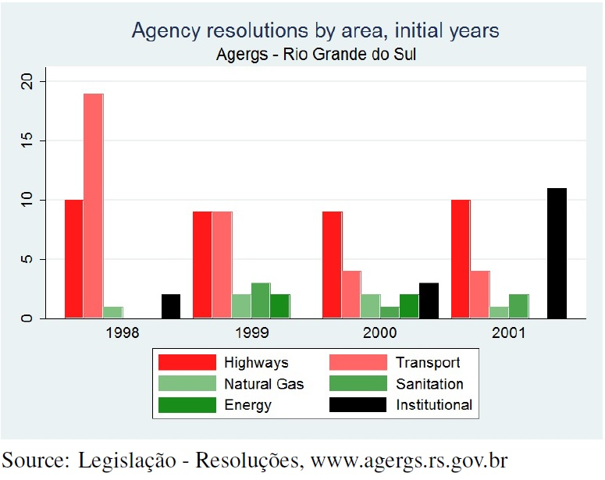

Graph 2

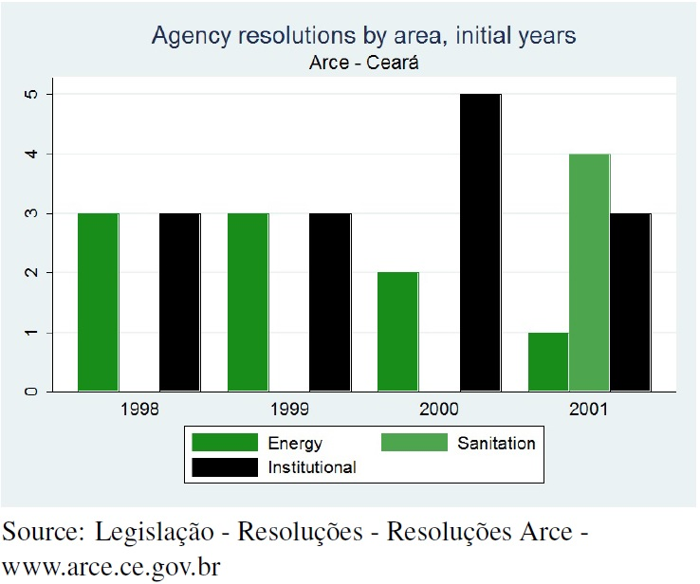

Energy Graphs

FEC

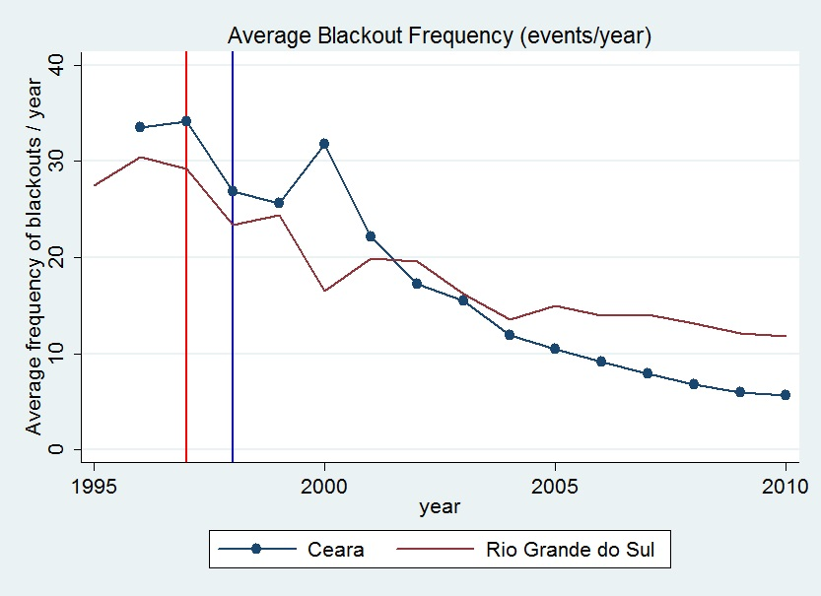

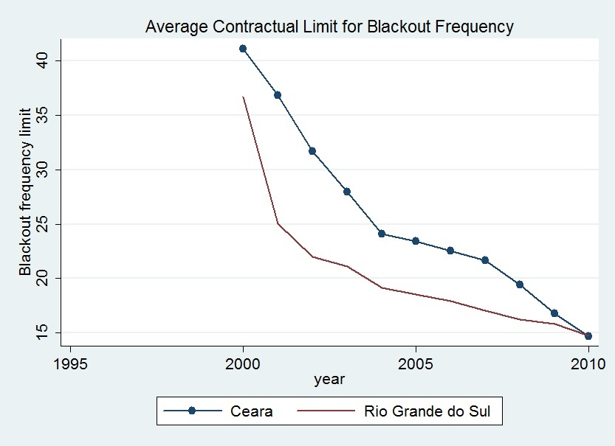

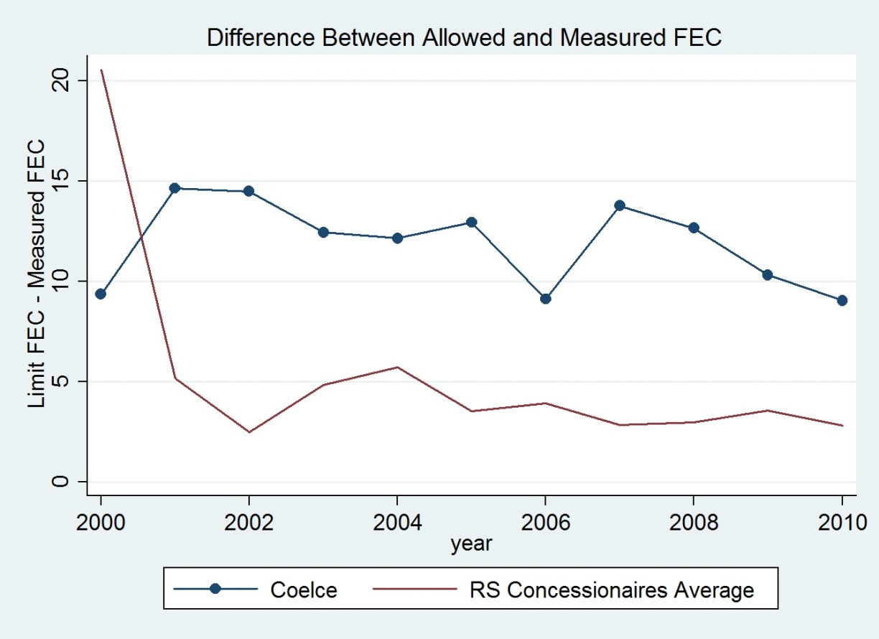

DEC

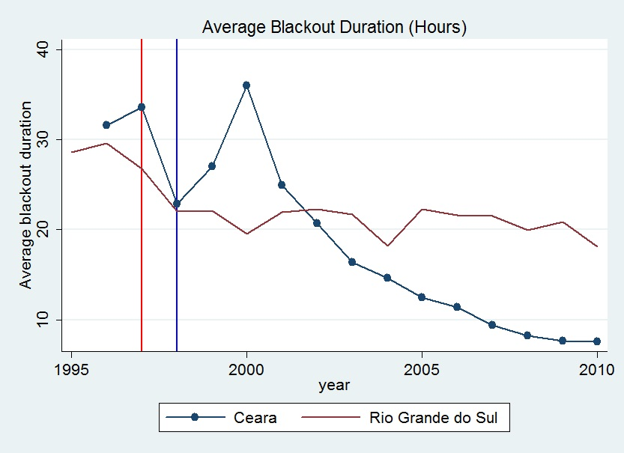 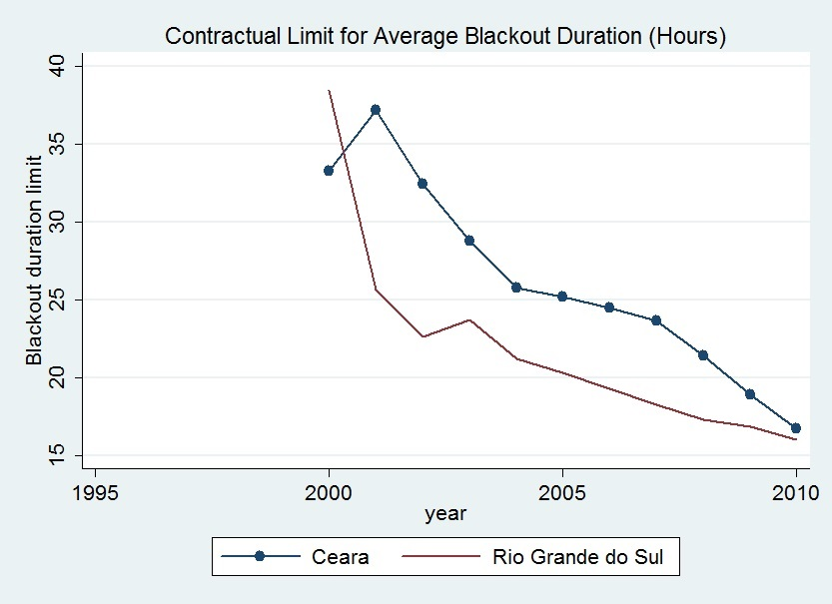

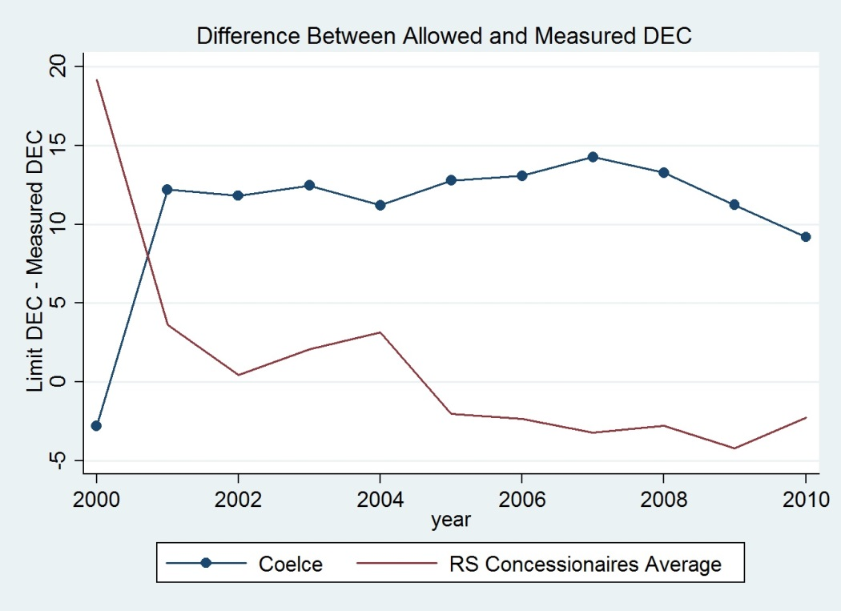

Sanitation Graphs

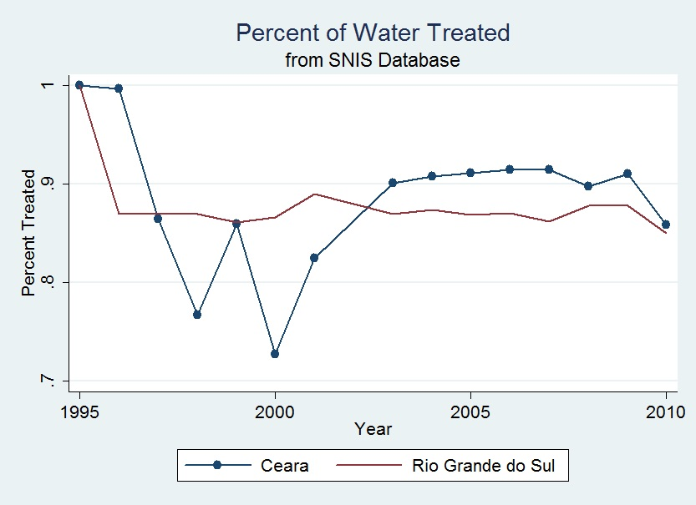

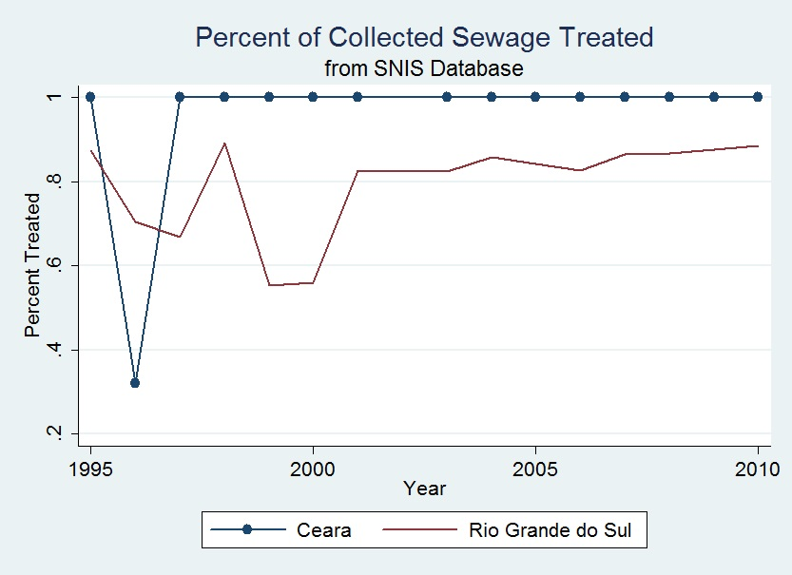

Graph: Agency Budgets



Agency Activity Tables

AGERGS

|  |  |  |  |  |  |  |  |  |  |  |  |  |  |  |  |  |
| --- | --- | --- | --- | --- | --- | --- | --- | --- | --- | --- | --- | --- | --- | --- | --- | --- |
|  |  |  | 1997 | 1998 | 1999 | 2000 | 2001 | 2002 | 2003 | 2004 | 2005 | 2006 | 2007 | 2008 | 2009 | 2010 |
| **Energy** | | **Inspections** |  | X | x | x | x | x | x | x | x | x | x | x | x | x |
| **Ombudsman** |  | X | x | x | x | x | x | x | x | x | x | x | x | x |
| **Sanitation** | | **Standards** |  |  |  |  |  |  |  |  |  |  |  |  | x | x |
| **Inspections** |  |  |  |  |  |  |  |  |  |  |  |  |  |  |
| **Tariffs** |  |  | x |  | x |  |  |  |  |  |  | x | x | x |
| **Gas** | | **Standards** |  |  |  |  |  |  |  |  |  |  |  |  |  |  |
| **Inspections** |  |  |  |  |  |  |  |  |  |  |  |  |  |  |
| **Tariffs** |  | X | x | x | x | x |  |  |  |  |  |  |  |  |
| **Highways** | | **Standards** |  |  | x | x | x | x | x | x | x | x | x | x | x | x |
| **Inspections** | x | X | x | x | x | x | x | x | x | x | x | x | x | x |
| **Tariffs** |  |  | x | x | x | x | x | x | x | x | x | x | x | x |
| **Transport** | **Buses** | **Standards** |  |  |  |  |  |  |  |  |  |  |  |  |  |  |
| **Inspections** |  |  |  |  |  |  |  |  |  |  |  |  |  |  |
| **Tariffs** |  |  | x | x | x | x | x | x | x | x | x | x | x | x |
| **Ferries** | **Standards** |  |  | x | x |  |  |  |  |  |  |  |  |  |  |
| **Inspections** |  |  |  |  |  |  |  |  |  |  |  |  |  |  |
| **Tariffs** |  | X | x | x | x | x | x | x | x | x | x | x | x | x |
| **Bus stations** | **Inspections** |  |  | x | x | x | x | x | x | x | x | x | x | x | x |
| **Ombudsman** | |  |  | X | x | x | x | x | x | x | x | x | x | x | x | x |

|  |  |  |  |  |  |  |  |  |  |  |  |  |  |  |  |  |
| --- | --- | --- | --- | --- | --- | --- | --- | --- | --- | --- | --- | --- | --- | --- | --- | --- |
| ARCE |  |  |  |  |  |  |  |  |  |  |  |  |  |  |  |  |
|  |  |  | 1997 | 1998 | 1999 | 2000 | 2001 | 2002 | 2003 | 2004 | 2005 | 2006 | 2007 | 2008 | 2009 | 2010 |
| Energy | | Inspections |  | x | X | x | x | x | x | x | x | x | x | x | x | x |
| Ombudsman |  | x | X | x | x | x | x | x | x | x | x | x | x | x |
| Sanitation | | Standards |  |  |  |  | x | x | x | x | x | x | x | x | x | x |
| Inspections |  |  |  |  | x | x | x | x | x | x | x | x | x | x |
| Tariffs |  |  |  |  |  |  |  | x | x | x | x | x | x | x |
| Gas | | Standards |  |  |  |  |  |  |  | x | x | x | x | x | x | x |
| Inspections |  |  |  |  |  |  |  |  |  |  | x | x | x | x |
| Tariffs |  |  |  |  |  |  |  |  | x | x | x | x | x | x |
| Transport | Bus | Standards |  |  |  |  |  |  | x | x | x | x | x | x | x | x |
| Inspections |  |  |  |  |  |  |  |  |  |  |  |  |  |  |
| Tariffs |  |  |  |  |  |  |  |  |  |  |  |  | x | x |

1. Murillo 2009, Murillo and Martínez-Gallardo 2007; Gilardi et al. 2006; Levi-Faur 2005.
2. Weyland 1998.
3. Chong and López-Silanes 2004, 38.
4. Jordana and Levi-Faur 2005, 104.
5. Cárdenas 2010, 7-10.
6. Nellis 2006, 3-4; Baker 2009, 10-12.
7. This happened in Rio de Janeiro state in 1999 and in Salta, Argentina, for example (Post 2014, 182-183).
8. Abers and Keck 2013, 9-10.
9. Amora 2012.
10. By contrast, scholars attribute autonomy in the developed West to bureaucratic entrepreneurship, reputation development, and levels of formal authority (Carpenter 2001, 2010; Howell and Lewis 2002).
11. Levy and Spiller 1994.
12. Snyder 2001; Argentine elections are exceptional (Calvo and Miccozi 2005).
13. Correa et al. 2008 also find variation in agency design and operations.
14. Berg 2000.
15. Stern and Cubbin 2006; Domah et al. 2002.
16. Schwarz and Satola 2000, 30-32; Smith 1997.
17. Ayres and Braithwaite 1992; Braithwaite 2006; Amengual 2009; Rodríguez-Garavito 2005; Pires 2009.
18. Mazey and Richardson 2001; Richardson 2000.
19. Spiller and Tommasi 2005, 521-525; Andrés et al. 2008; Christensen and Lægried 2006; McAllister et al. 2010; Jaillian et al. 2006; Banerjee et al. 2006.
20. De Figueiredo 2002; Weyland 2002, 66-68; Wood and Bohte 2004.
21. Samuels 2000, 243-244.
22. Data are from IBGE 2000, 2008.
23. Prado 2006, 125-127.
24. Correa et al. 2008.
25. Ibid, 209.
26. Sabóia 2007, 100; Interviews RS5, PA3, RJ1, MS9
27. Pacheco 2013, 133; Peci and Cavalcanti 2000.
28. Prado 2006, 132-135.
29. *Contra* Murillo 2009, 26-29.
30. E.g., Article 4, Law 7101 (Mato Grosso, 1999) and Article 2, Law 7463 (Rio Grande do Norte, 1999).
31. Sabóia 2007; Melo 2001.
32. López 2004; Lavareda 2011, 296-298; Mendes and Rocha 2004, 6-7; Kuschnir 2000.
33. Baker 2009, 195-197.
34. Interview CE7.
35. Maor 2010, 134.
36. Carpenter and Krause 2012, 27.
37. Ames 1994; Avelino et al. 2012; Mainwaring 1999, 156-157; Nicolau 2006, 696-697.
38. Interviews MT12, RS8, SP4.
39. Abrucio 1998; Santos 2001, 289-293.
40. Tomio and Ricci 2008.
41. *Contra* Maor 2010.
42. Law 11,445 (2007); Presidential Decree 7217 (2010).
43. Interviews RS5, CE10.
44. Regulated sector ownership cannot explain divergence, as in Murillo 2009.
45. Schwarz and Satola 2000, 30-32.
46. Stern 2000, 143.
47. Murillo 2009, 42-43.
48. Correa et al. 2008, 209.
49. Interview RS1.
50. See, e.g., AGERGS Superior Council Act 508, July 21, 2002; Act 074, October 11, 2005.
51. Annual reports for distributors list expenditures for regulatory penalties.
52. State Decree 33,959, May 31, 1991.
53. Interviews RS2, RS4.
54. See Melo et al. 2009, 1226 on state auditing bureaus.
55. Dartsch 1999. The seventh spot for an agency staffer was not initially filled.
56. Interview CE9; Machado specialized in tax law.
57. Interviews RS3, RS4.
58. Interview CE3.
59. Interview RS3.
60. ARCE, *Relatório Anual* [Annual Report] *2001*, 5; Interview CE5. The auction never happened.
61. Daer was and is not a regulatory body, but instead a state hybrid construction/maintenance/oversight body without statutory independence from the executive.
62. Krause 2005, 44.
63. Resolutions 14 (1998), 45 and 49 (1999).
64. Interviews RS5, RS10.
65. Poli de Figueiredo 1999. STF decisions on agencies cited *Humprey’s Executor* (295 U.S. 602, 1935).
66. *Marco Regulatório* 1, 2, 3 (1999, 2000). They also discussed AGERGS’s STF cases.
67. Sabóia 2007, 100-104; Maxwell Stamp PLC 1998.
68. AGERGS rejected tariff increases with Resolutions 3,4, 19, 29 (1998) 42, 51, 55, 56, 57, 58, 59 (1999), 68 (2000), 94, 96, 103 (2001); and approved tariff increases with Resolutions 14, 20 (1998), 45, 49 (1999), 64, 65, 69, 71, 73, 75 (2000), 83, 95 (2001) .
69. Interview RS13.
70. “Governo gaucho volta ao STF,” *Jornal do Commércio do Rio de Janeiro*, 19 February 1999.
71. Decree 39,407, 15 April 1999, Rio Grande do Sul.
72. “Pedágios/Justiça/RS,” *Jornal do Brasil*, 20 April 1999.
73. Basile 1999.
74. Krause 2001, 54-59.
75. Interviews RS2, RS6.
76. Ibid. Wages set in December 1998 eroded after the January 1999 Brazilian currency devaluation.
77. “Mais um susto com as contas de água e luz,” *Zero Hora,* 22 October 1999, 18.
78. “Agers [sic] suspende cobrança de AES,” *Zero Hora*, 22 October 1999, 22; “Consumidores criticam reajuste da conta de luz,” *Zero Hora*, 19 April 2001, p. 22.
79. Capeletto 2000, 9; Resolution 70 (2000); author search of resolution, media, and agency annual reports.
80. “Usuários pedem explicações a Corsan,” *Zero Hora*, 7 October 1999, 30.
81. Krause 2001, 64-65.
82. Krause 2001, 63; Resolutions 54, 57 (1999); “Agergs pede explicações a Corsan,” *Zero Hora*, 7 December 1999, 30.
83. “Famurs debate concessões com prefeitos,” *Zero Hora*, 14 November 1999, 29.
84. “Deputados questionam indice de reajuste adotado pela Corsan,” *Zero Hora*, 29 March 2000, 20.
85. “Corsan foge da Agergs,” *Zero Hora*, 30 October 2000, 10; AGERGS Resolutions 102, 103 (2001).
86. “Mirante,” *Zero Hora,* 6 July 2004, 10; AGERGS annual reports, 2003-2007.
87. Resolutions 4-6 (1998), 17 (2000); Furtado 1998.
88. Furtado, ibid.
89. “Curto-circuito no Ceará,” *O Globo*, 25 November 2000, 30.
90. ARCE, *Relatório Anual 2000*, 11.
91. Ibid, 11.
92. “Coelce é multada em R$6,9 milhões,” *Gazeta Mercantil*, 4 April 2000. This fine was over 5% of Coelce’s 2000 profit of R$83.9 million (Júnior 2001).
93. “Energia eletrica sobe 9,6 pct no sábado no Nordeste – Aneel,” *Reuters Focus*, 19 April 2000; Interview CE8.
94. Ibid.
95. “FHC pode cassar concessão da Coelce,” *Jornal do Commércio do Rio de Janeiro*, 27 May 2000.
96. Cordeiro 2000.
97. Coelce, *Relatório Anual 2000*, 26.
98. Domingos 2001.
99. ARCE Resolutions 24, 25, 26 (2001); ARCE, *Relatório Anual 2001*, 15.
100. ARCE, *Relatório Anual* *2002*, 13.
101. Ibid., 13-14.
102. Interview CE5; ARCE, *Relatório Anual 2002*, 14.
103. “CEF assina contrato para saneamento no Ceará com recursos do FGTS,” *Valor Online*, 15 October 2002.
104. ARCE Annual Reports 2003, 25, and 2004, 27.
105. Interview CE5.
106. ARCE, *Relatório Anual 2002*, 15.
107. ARCE, *Relatório Anual 2003*, 32.
108. Ibid., 22.
109. ARCE Resolution 47 (2004).
110. State Assembly of Rio Grande do Sul. 1998. “CCJ analiza a cobrança de pedágio,” May 8. <http://www.al.rs.gov.br/diario/diarios_anteriores/980508/ccj.htm>, accessed August 10, 2014.
111. Resolutions 3, 5, 7, 18 (1998). Regulation of the Taquari to General Câmara ferry began with Resolution 124 (2002).
112. Hearing transcripts are only available from 2007 onward, at AGERGS’s website.
113. AGERGS*, Relatório Anual 2002*, 37.
114. Ibid., 45-52.
115. Interview RS6
116. ARCE annual reports, various years.
117. ARCE, *Relatório Anual*, 2000-2002.
118. ARCE, *Relatório Anual 2003*, 14.
119. Interview CE5; Galvão Júnior et al. 2004; ARCE, *Relatório Anual 2004*, 29-31.
120. ARCE, *Relatório Anual* *2001*, 18.
121. ARCE, *Relatório Anual 2004,* 33; 2003, 32.
122. Resolutions 41 (2003), 45 and 56 (2004)
123. Interviews RS2, RS3.
124. Interview RS2.
125. Interviews RS2, RS3, RS4, RS11.
126. Interview RS14.
127. Interview RS2.
128. Ibid. AGERGS did hold a public examination for additional staffers in 2006, but the winners never entered the agency (AGERGS *Relatório Anual 2006*, 16).
129. Interviews RS1, RS2, RS12.
130. State of Rio Grande do Sul. “Autorizado projeto de lei que disciplina sanções da Agergs,” October 11, 2010. http://www.estado.rs.gov.br/noticias/1/87457/Autorizado-projeto-de-lei-que-disciplina-sancoes-da-Agergs
131. Quintana 2012.
132. Spilki 2012, 29.
133. Gubernatorial Decree 44,861 (2007), Rio Grande do Sul.
134. Circulation measures are from the Associação Nacional de Jornais. That RBS Media, the state Globo distributor, owns *Zero Hora* is not problematic; the incumbent governor was from the center-right PSDB and the newspaper was not hostile toward private concessions in 2010. Online mentions come from *Jornal do Coméricio*, *Jornal Agora, Gazeta do Sul, Correio do Povo,* and *Pioneiro.*
135. Law 13,904 (2001), Article 63.
136. State Law 14,024 (2007).
137. Interview CE3; Ceará State Government, *Primeiro Termo Aditivo ao Contrato de Concessão para Exploração do Gás Canalizado*, First Clause, Section 1.1 (2004).
138. C.f. Municipal Law 2,761 (2003), Juazeiro do Norte, CE.
139. Interview CE3; State Law 13,743 (2006).
140. State Law 14,394, July 7, 2009.
141. Ibid.
142. Interviews CE1, CE10.
143. Interviews CE3, CE5, CE10.
144. ARCE, *Relatório Annual* 2010, 55, 61.
145. Interview CE10.
146. Additional articles came from *Tribunal do Ceará* and *Direito CE*.
147. AGERGS in 2010 only spent R$9.5 million of its revenue (*Relatório Anual 2010*, 43).
148. Interviews RS2, RS3, RS4, RS16.
149. Interviews RS1, RS2, RS3, RS4.
150. Interview RS14.
151. Interview RS13.
152. Interview RS3.
153. AGERGS, *Relatório Anual 2010*, 16-17; Interview RS3.
154. Interview CE5.
155. Interview CE10.
156. Following Moe 2006.