The Effects of Climate Change Belief and Denial on Dating Preferences: A U.S. Survey

Abstract
This study aims to understand the effects that climate change beliefs have on dating preferences. Many individuals interested in forming romantic relationships have a vested interest in understanding their date’s preferences, political leanings, interests, and worldviews, but a mismatch in values could be undesirable or “non-negotiable.” For example, individuals are more likely to look for serious relationship partners who have similar political leanings as themselves. Because the issue of climate change is highly politicized within the United States, we assess whether climate change beliefs similarly impact the one’s willingness and openness to date another. We specifically measure whether respondents are open to dating individuals with various climate change beliefs and whether they become more or less interested when they become aware of their date’s beliefs. Findings from a large survey administered in the United States (n=505) suggest that political ideology is predictive of willingness and openness to dating people of various climate beliefs. This, as well as other findings and implications will be discussed. These and other results are discussed along with implications for dating and future research.
KEYWORDS: dating; climate change beliefs; climate change denial; survey; assortive mating
- Introduction
Do ‘birds of a feather flock together,’ or do ‘opposites attract?’ While both sayings are popular, one is largely supported by research of assortive mating. research supports the idea that humans tend to form relationships through assortative mating. That is, those with similar traits tend to be attracted to each other (Buss, 1985; Pearson, 1903; Thiessen & Gregg, 1980; Vandenberg, 1972; Watson et al., 2004). For example, strong similarities in age (Schwartz & Graf, 2009; Van de Putte et al., 2009) and attitudes and values such as religious and political orientations have been found between romantic couples (Bacon et al., 2014; Feng & Baker, 1994; Gaunt, 2006; Watson et al., 2004). In fact, political similarity has shown to be one of the strongest positively correlated traits among couples (Alford et al., 2011; Huber & Malhotra, 2017; Klofstad et al., 2013).
This would seem to be particularly true in the United States, where values surrounding political ideology has grown increasingly partisan. This has important implications for the future of American politics, but also has consequences in perhaps a less obvious arena: dating and relationships. Individuals across the aisle are becoming less and less likely to be open to dating across the aisle. Vetting potential partners in this manner has the capacity to further reinforce polarization of subgroups as well as cut us off from opportunities to engage with people of diverse backgrounds and ideas. The current study is interested in uncovering to what extent climate change, another increasingly political issue within the United States, is considered an important value when deciding whether or not to go on a date. We specifically measure whether climate change beliefs affect an individual’s willingness and openness to going on a date with another and if they become more or less willing to go on a date after finding out one’s beliefs on climate change. To do this, a nationally representative survey of single and recently coupled individuals (n=505) was administered across all major geographical areas within the United States in the Fall of 2022.
- Background
Politics and Climate Change
Politics within the United States have become increasingly polarized in recent decades compared to decades previous. For example, in 1994, 16% of Democrats reported having “very unfavorable” views of the Republican party; this increased to 38% by 2014. Similarly, 17% of Republicans had “very unfavorable” views of the Democratic party in 1994, which by 2014 increased to 43% (Pew Research Center, 2014). This doubling of unfavorable views towards the opposing party exemplifies the polarization of recent political sentiments within the U.S. Democrats and Republicans are now more ideologically divided than any time in the past two decades, with over twice as many Americans identifying with consistently liberal or consistently conservative opinions, respectively (Pew Research Center, 2014). The average thermometer rating of one’s out-party (indicating how “cold” (0) or “warm” (100) one feels towards the out-group) dropped 15 points between 1988-2012, illustrating that “partisans [are] lik[ing] their opponents less and less” (Iyengar et al., 2012, p. 412-413). The proportion of respondents who rated the out-group with a thermometer rating of under 50 increased from 40% in the 1980s to 63% in 2008 (Iyengar et al., 2012).
Because climate change is an international, multifaceted issue, it makes sense that it has also become one of political importance. As politics have become increasingly polarized within the United States, so has public opinion on climate change (Kennedy & Johnson, 2020; Pew Research Center, 2018; Weber & Stern, 2011). Within the United States, political ideology is strongly correlated to belief in climate change, belief in its anthropogenic causes, and recognition of it as a serious problem (Pew Research Center, 2013, 2015, 2016). Liberals tend to be more in support of climate change than their conservative counterparts. For example, while only 15% of conservative Republicans trust climate scientists, 70% of liberal Democrats do (Pew Research Center, 2016). Further, about 8 in 10 liberal Democrats believe in anthropogenically caused climate change, whereas only 6 of 10 moderate/conservative Democrats, 2 of 10 moderate/liberal Republicans, and 1 of 10 conservative Republicans do so (Pew Research Center, 2016).
Dating in Politicized Times
It should be of no surprise that a growing general dislike of one’s opposing political party has also impacted Americans’ dating preferences. According to Dating.com, 84% of singles would not consider dating someone with opposing political views, and 67% admitted to ending a relationship specifically because of clashing political views (Dating.com, 2020). Pew Research Center found that 43% of Democrats would not date a Republican, and 24% of Republicans would not date a Democrat (Brown, 2020). Further, 71% of Democrats would not consider being in a relationship with someone who voted for Donald Trump (Brown, 2020).
Even politicized issues have become dating ‘deal breakers.’ Consider COVID-19, for example. While the global pandemic of COVID-19 was largely a medical and scientific issue, it quickly became politicized, especially within the United States (Hart et al., 2020). As such, COVID-19 found itself a topic of interest in the dating world, impacting singles’ dating preferences and expectations. According to Match’s annual Single in America study, 54% of singles were unlikely to consider dating an unvaccinated person, 53% would not go on a second date with an unvaccinated person, and 48% believed unvaccinated people to be selfish (Match, 2021). Not only did vaccination status become a vetting mechanism for dating, but almost half of survey respondents ascribed negative character traits to those who were unvaccinated. Accordingly, one’s political ideology as well as stance on hot button political issues has an impact on who one chooses to date, openness to going on a date, and the preconceived ideas one has about another previous to or during the date.
Climate change, being a similarly hot button issue, has also been used as a kind of ad hoc vetting mechanism by which one can judge a potential suitor. In 2019, for example, the dating website OkCupid saw a 240% increase in mentions of the term climate change in its users’ profiles, with 97% of its users reporting that they believe in climate change, and 82% reporting to be actively concerned about climate change (Kibbe, 2020). Further, 9 out of 10 users indicated that they wanted to date someone who cares about the environment (Yale Climate Connections, 2021). This led the site to create a new filter question in which users are given the option to hide potential matches that do not share similar climate change beliefs (Kibbe, 2020). Users can also add a badge to their profile to indicate they are a climate change advocate (Yale Climate Connections, 2021). Tinder, one of the most popular dating apps, has seen similar trends, with “climate change,” “environment,” and “social justice” being three of the top four causes cared about among Gen Z in 2019 (2019 Year in Swipe, 2019).
Hypotheses
We predict that climate change beliefs and preferences are valued in the dating process similarly to how political preferences are valued and interpreted. Because climate change beliefs can be seen as political beliefs, and because climate change is a politicized issue in the United States, those that are liberal will likely be more open to dating a climate change believer and conservatives will likely be more open to dating climate change deniers. Therefore, the following hypotheses are proposed:
H₁: The more politically liberal someone is, the more likely they are to be open to dating someone who believes in climate change.
H₂: The more politically conservative someone is, the more likely they are to be open to dating someone who does not believe in climate change.
- Materials and Methods
The survey for this study, “Climate Change and Relationships,” was created using Qualtrics software and was administered in the United States by the survey company Dynata LLC in the Fall of 2022. It was classified as exempt by the Institutional Review Board (IRB) protocol number 2022.103. No personally identifying information was collected during the survey, and no known risk or discomforts were associated with participant involvement. Survey respondents were required to be at least 18 years of age and living in the United States during the time of the survey. An attention check question was included to improve the likelihood that respondents were authentically and completely reading through the questions. The survey was administered online and took respondents approximately 5-8 minutes to complete. It is nationally representative across several common demographic variables. A random sample of individuals from all major U.S. regions were collected (N=788). Only those that correctly answered the attention check were included in analysis. Of the 788 respondents that completed the survey and correctly answered the attention check question, 505 respondents indicated that they were single or just recently started dating someone (within the last six months). Only those 505 individuals were analyzed for this particular study because the main questions of interest pertain to understanding how climate change belief and denial factor in to one’s dating preferences.
Tests
Multiple linear regression was performed on the variables of interest.
Dependent Variables
The four dependent variables of the study measure how likely respondents would be open to dating individuals who are (1) climate believers and (2) climate deniers, as well as if they become more or less interested once they find out that a potential date is a (3) climate believer or (4) climate denier (Table 1). The first question (open to dating a believer) asks: “In general, would you be open to dating someone who believes in climate change?" Response options were (1) definitely not, (2) probably not, (3) might or might not, (4) probably yes, and (5) definitely yes. Open to dating a believer was coded as an ordinal variable with (1) definitely not being the lowest coded number and (5) definitely yes being the highest coded. The second question (open to dating a denier) asks: “In general, would you be open to dating someone who doesn’t believe in climate change?” Response options were (1) definitely not, (2) probably not, (3) might or might not, (4) probably yes, and (5) definitely yes. Open to dating a denier was coded as an ordinal variable with (1) definitely not being the lowest coded number and (5) definitely yes being the highest. The next question (interested then believer) asks: “If you were interested in going on a first date with someone and then found out that they believe in climate change, would you be more or less interested in going on a date with them?” Response options were (1) less interested, (2) same amount of interest, and (3) more interested. Interested then believer was coded as an ordinal variable with (1) less interested being the lowest coded number and (3) more interested being the highest coded. The last dependent variable (interested then denier) was phrased as: “If you were interested in going on a first date with someone and then found out that they don’t believe in climate change, would you be more or less interested in going on a date with them?” Interested then denier was coded as an ordinal variable with (1) less interested coded as the lowest number and (3) more interested as the highest.
Predictor Variables
The predictor variable of the study is political ideology. The survey asks: “In general, would you describe your political views as…” and response options were (1) strongly conservative, (2) conservative, (3) slightly conservative, (4) moderate, middle of the road, (5) slightly liberal, (6) liberal, (7) strongly liberal. Political ideology was coded as an ordinal variable with (1) very conservative being the lowest coded number and (7) very liberal being the highest.
Predictor variables (Table 3) included in the study were existence/cause of climate change as well as perceived importance of the issue of climate change. The first of these questions asks “Which of these three statements about climate change comes closest to your view?” Response options were (1) current climate change is mostly human caused, (2) current climate change is mostly naturally caused, and (3) climate change is not currently happening. Response options were randomized. The climate change existence variable is nominal, where “current climate change is mostly human caused” was coded as the omitted base category and compared to the two other response options in linear regression.
Perceived importance of the issue of climate change was measured with the question: “How important is the issue of climate change to you?” Response options were (1) not at all important, (2) slightly important, (3) moderately important, (4) very important, and (5) extremely important. Climate change importance was coded as an ordinal variable with (1) not at all important coded as the lowest number, and (5) extremely important coded as the highest.
A standard set of predictors from the public opinion literature were also controlled for, including age, gender, education, income, race, ethnicity (Hispanic/non-Hispanic), religion (Christian/non-Christian), and religiosity. Pearson correlations for the independent variables of the study can be found in Appendix 2, and frequencies and valid percents in Table 2.
- Results
Political Ideology, Climate Change Beliefs and Openness to Dating
Survey results (N=505) show that 66.5% of respondents would probably/definitely be interested in dating a someone who believes in climate change and 6.8% of respondents would probably/definitely not be interested. When it comes to respondents’ interest in dating someone who doesn’t believe in climate change, 30.3% of respondents would probably/definitely be interested, and 27.7% would probably/definitely not be interested (Table 2, Figure 1). While 28.7% of respondents would be more interested in going on a date after finding out someone was a climate believer, only 6.3% would be less interested. And although 8.5% of respondents would be more interested in dating someone after finding out they are a climate denier, 34.9% would be less interested.
Results from linear regression analysis show interesting findings as well, and hypotheses were supported by statistical analysis (Tables 4-7). For a one unit increase in political ideology, there is a 0.086 point increase in agreement with the dating a believer question (p≤0.001). This supports H₁: The more politically liberal someone is, the more likely they are to be open to dating someone who believes in climate change. For a one unit increase in political ideology (from conservative to liberal) there was a 0.175 point decrease in agreement with the dating a denier question (p≤0.001). This supports H₂: The more politically conservative someone is, the more likely they are to be open to dating someone who does not believe in climate change.
Overall, many more respondents were willing and open to dating a climate believer over a climate denier. Four in 10 respondents would “definitely” be open to dating a climate believer, compared to only 1 in 10 for a denier. That being said, almost half (42%) of respondents said they “might or might not” be interested in dating a denier. Over four times as many respondents were “definitely not” interested in dating a denier (11.9%) versus those who were “definitely not” interested in dating a believer (2.6%).
When comparing conservative to liberal respondents, a more complex narrative emerges (Figure 1). Politically, liberals are much less open to dating climate deniers than conservatives are to dating climate believers. For example, about 9 in 10 (88.0%) liberals and 5 in 10 (52.3%) conservatives are at least “probably” open to dating a believer. Comparatively, only 2 in 10 (17.8%) liberals and 5 in 10 (46.8%) conservatives are at least “probably” open to dating a climate denier. Further, 5 in 10 (50.0%) liberals and 1 in 10 (14%) conservatives are probably/definitely not open to dating someone who does not believe in climate change, while only about 4 in 10 (38%) liberals and 2 in 10 (22.7%) conservatives would be more interested in a prospective date after finding out they believe in climate change. About 14.8% of conservatives would be less interested in dating someone after finding out they believe in climate change, but this is the same percent of conservatives (14.1%) that would be less interested in dating someone after finding out they do not believe in climate change. On the other hand, 6 in 10 (60.1%) liberals would be less interested in dating someone after finding out they did not believe in climate change. Only 4.4% of liberals and 14.8% of conservatives would be more interested in someone after discovering the individual did not believe in climate change.
Statistical results are illustrated on a spectrum to show trends and offer a digestible understanding of results: namely, what type of person is more likely to be open to dating believers/deniers, and what type of person would be more/less interested in a date after finding out said potential date was a believer/denier (Figure 2). Both findings that support the hypotheses as well as more exploratory results are included in this figure.
- Discussion
Climate change is a pressing environmental issue that warrants an immediate response, but we must also continue to understand how and to what degree this issue is shaping our social landscape and interpersonal relationships, as it can have reverberating effects. Based on the findings of this study, we see that one’s climate change beliefs can affect how open and interested others are in dating them. This study highlights the importance of understanding how environmental issues such as climate change can factor into one’s interest in dating another. Because climate change is a politicized issue, it makes sense that political ideology is predictive of dating preferences related to climate change. The more liberal someone is, the more likely they are to be open to dating a climate believer (p≤0.001), the more conservative they are, the more likely they are to be open to dating a climate denier (p≤0.001). The more conservative someone is the more likely they are to become more interested in someone after learning they don’t believe in climate change (p≤0.001). Contrastingly, the more liberal someone is the more likely they are to become less interested in someone after learning they don’t believe in climate change. While this study found support for these statements, it remains that the majority of conservatives (and respondents overall) are probably or definitely open to dating a climate believer. Conservatives are much more open to dating a believer, therefore, than liberals are to dating a denier. This makes sense because, as the majority of climate scientists will support, climate change is currently happening and is mostly human caused. That most people are open to dating a climate believer is encouraging and should come as little surprise, as it is just accepting scientific consensus. When it comes to dating a climate denier, the majority of respondents indicated they “might or might not.” There are other values and characteristics an individual looks for in a potential mate beyond similar views on climate change, (religious orientation, age, and geographical location might be a few), so perhaps climate change is not a deal breaker. Climate change might be too weighty of a topic to discuss or even think about on a first date for some. This would align with social penetration theory, which explains that as relationships develop and mature, conversations typically move from shallow and topical to more deep and personal (Altman & Taylor, 1973).
The field of environmental psychology considers how we as humans shape the environment, but also how the environment shapes us. Assortive mating is “the tendency of two partners' characteristics to be matched in a systematic manner, usually in the form of similarity” (Luo, 2017). If we are using an environmental issue such as climate change to decide who we want to enter into interpersonal relationships with, this has social as well as perhaps environmentally important implications. Entering into an interpersonal relationship with similar-minded people can create a microcosm of an echo chamber, where one encounters beliefs similar to their own, insulated from opposing views or diverse ideas. This has the potential to amplify confirmation bias as well as social and political polarization. That being said, it might not be the case that paired couples have similar climate change views. In fact, Goldberg et al. (2022) found that although climate change beliefs and behaviors are oftentimes different between romantic couples, one's “perceptions of their partner's beliefs/behaviors are predicted by their own beliefs and behaviors (assumed similarity).” While there could be many reasons for assumed similarity, a strong hypothesis is that people use their own beliefs and behaviors as a proxy for predicting their partner’s beliefs (Marks & Miller, 1987). Couples may also not talk about climate change enough to have a full grasp on their partner’s views.
- Conclusion
Limitations and Future Research
There are notable limitations to this study that should be considered. Demographic information such as disability status, occupation, sexual orientation, and in-depth gender identity were not collected. The study also only considered individuals in the United States, rather than other countries where preferences and openness to dating could differ. Even within the United States there is much cultural diversity, and this was not quantified in the current study. Additional probing questions measuring the importance of other potentially relevant dating criteria was not included, and therefore how much of a factor climate change beliefs are to dating cannot be fully quantified or compared to other potentially relevant values. That is, climate change beliefs seem to matter when choosing someone to date, but it is unclear how much they matter compared to other values an individual might be looking for in a mate. Survey respondents were not asked if they were more interested in a long-term relationship or a casual, short-term relationship, so it is unclear with what mindset respondents were answering the survey questions. As answers could differ between the two groups, future research should include this measure. Lastly, there is always the potential that people are lying on self-reported dating apps, so future research should additionally include measures to determine the extent to which one might lie on dating apps.
Additionally, future research should include additional single-item indicators that measure other values that people care about when determining whether to go on a date. It should be determined whether this line of inquiry into assortive mating and political homophily created a measurable effect on the further polarization of issues like climate change. Research shows that there is opportunity for couples to influence each other’s ideas on climate change through conversations (Goldberg et al., 2022). As such, continued research should be pursued to understand how climate advocacy is being conducted on the most intimate of levels.
Contributions and Final Remarks
The current study hypothesized that political ideology would be correlated to willingness to date individuals of varying climate change beliefs. Specifically, it was hypothesized that the more politically liberal someone is, the more likely they would be open to dating someone who believes in climate change and the more politically conservative someone is, the more likely they would be open to dating someone who does not believe in climate change. Both hypotheses were supported at the (p≤0.001) level. This study offers a modest effort to further understand how environmental issues such as climate change matter when forming interpersonal relationships, adding to the areas of environmental psychology and assortive mating.

Data Availability
The datasets generated and analyzed during the current study are available in the Mendeley Repository, DOI: 10.17632/8yckgfhz2x.1.

Disclosure Statement
No potential conflict of interest was reported by the authors.

Funding
This research did not receive any specific grant from funding agencies in the public, commercial, or not-for-profit sectors.

References
2019 Year in Swipe. (2019). Tinder Newsroom. https://www.tinderpressroom.com/tinders-2019-year-in-swipe-r
Alford, J. R., Hatemi, P. K., Hibbing, J. R., Martin, N. G., & Eaves, L. J. (2011). The politics of mate choice. Journal of Politics, 73(2), 362–379. https://doi.org/10.1017/S0022381611000016
Allport, G. W., & Ross, J. M. (1967). Personal Religious Orientation and Prejudice. Journal of Personality and Social Psychology, 5(4), 432–443.
Altman, I., & Taylor, D. A. (1973). Social penetration: The development of interpersonal relationships. Holt, Rinehart & Winston.
Bacon, P. M., Conte, A., & Moffatt, P. G. (2014). Assortative mating on risk attitude. Theory and Decision, 77(3), 389–401.
Bobowik, M., Kanyangara, P., Klein, O., Liu, J. H., Valencia, J., & Van Der Linden, N. (2010). Beliefs About History, the Meaning of Historical Events and Culture of War. Revista de Psicologia, 28(1), 111–146.
Botwin, M. D., Buss, D. M., & Shackelford, T. K. (1997). Personality and mate preferences: Five factors in mate selection and marital satisfaction. Journal of Personality, 65(1), 107–136.
Brown, A. (2020). Most Democrats who are looking for a relationship would not consider dating a Trump voter. Pew Research Center. https://www.pewresearch.org/fact-tank/2020/04/24/most-democrats-who-are-looking-for-a-relationship-would-not-consider-dating-a-trump-voter/
Buss, D. M. (1985). Human mate selection: Opposites are sometimes said to attract, but in fact we are likely to marry someone who is similar to us in almost every variable. American Scientist, 73(1), 47–51.
Dating.com. (2020). Dating.com reveal sharing your political party might be a dating deal-breaker. PR Newswire. https://www.prnewswire.com/news-releases/datingcom-reveals-sharing-your-political-party-might-be-a-dating-deal-breaker-301073270.html
Feng, D., & Baker, L. (1994). Spouse similarity in attitudes, personality, and psychological well-being. Behavior Genetics, 24(4), 357–364.
Gaunt, R. (2006). Couple similarity and marital satisfaction: Are similar spouses happier? Journal of Personality, 74(5), 1401–1420.
Goldberg, M. H., Carmichael, C. L., Lacroix, K., Gustafson, A., Rosenthal, S. A., & Leiserowitz, A. (2022). Perceptions and correspondence of climate change beliefs and behavior among romantic couples. Journal of Environmental Psychology, 82(November 2021). https://doi.org/10.1016/j.jenvp.2022.101836
Hancock, J. T., Toma, C., & Ellison, N. (2007). The Truth about Lying in Online Dating Profiles. Proceedings of the SIGCHI Conference on Human Factors in Computing Systems, 449–452.
Hart, P. S., Chinn, S., & Soroka, S. (2020). Politicization and polarization in COVID-19 news coverage. Science Communication, 42(5), 679–697.
Huber, G. A., & Malhotra, N. (2017). Political homophily in social relationships: Evidence from online dating behavior. Journal of Politics, 79(1), 269–283. https://doi.org/10.1086/687533
Iyengar, S., Sood, G., & Lelkes, Y. (2012). Affect, not ideology: A social identity perspective on polarization. Public Opinion Quarterly, 76(3), 405–431. https://doi.org/10.1093/poq/nfs038
Kennedy, B., & Johnson, C. (2020). More Americans See Climate Change as a Priority, but Democrats are Much More Concerned Than Republicans. Pew Research Center. https://www.pewresearch.org/fact-tank/2020/02/28/more-americans-see-climate-change-as-a-priority-but-democrats-are-much-more-concerned-than-republicans/
Kennedy, C., Mercer, A., Keeter, S., Hatley, N., McGeeney, K., & Gimenez, A. (2016). Evaluating Online Nonprobability Surveys.
Kibbe, K. (2020). Dating App OkCupid Lets Users Filter Out Climate Change Deniers. Inside Hook. https://www.insidehook.com/daily_brief/internet/dating-app-okcupid-lets-users-filter-out-climate-change-deniers
Klofstad, C. A., McDermott, R., & Hatemi, P. K. (2013). The Dating Preferences of Liberals and Conservatives. Political Behavior, 35(3), 519–538. https://doi.org/10.1007/s11109-012-9207-z
Kurpis, L., Beqiri, M., & Helgeson, J. (2008). The Effects of Commitment to Moral Self-improvement and Religiosity on Ethics of Business Students. Journal of Business Ethics, 80(3), 452.
La Barbera, P. A., & Gürhan, Z. (1997). The Role of Materialism, Religiosity, and Demographics in Subjective Well-Being. Psychology and Marketing, 14(1), 71–97.
Luo, S. (2009). Partner selection and relationship satisfaction in early dating couples: The role of couple similarity. Personality and Individual Differences, 47(2), 133–138.
Luo, S. (2017). Assortative mating and couple similarity: Patterns, mechanisms, and consequences. 12337. Social and Personality Psychology Compass, 11(8), e12337.
Markey, P. M., & Markey, C. N. (2007). Romantic ideals, romantic obtainment, and relationship experiences: The complementarity of interpersonal traits among romantic partners. Journal of Social and Personal Relationships, 24(4), 517–533.
Marks, G., & Miller, N. (1987). Ten years of research on the false-consensus effect: An empirical and theoretical review. Psychological Bulletin, 102(1), 72–90.
Match. (2021). Singles in America. https://www.singlesinamerica.com/
McDaniel, S. W., & Burnett, J. J. (1990). Consumer Religiosity and Retail Store Evaluative Criteria. Journal of the Academy of Marketing Science, 18(2), 101–112.
Pearson, K. (1903). Assortative mating in man. Biometrika, 2, 481–498.
Pew Research Center. (2013). Keystone XL Pipeline Draws Broad Support: Continuing Partisan Divide in Views of Global Warming. Pew Research Center. https://www.pewresearch.org/politics/2013/04/02/keystone-xl-pipeline-draws-broad-support/
Pew Research Center. (2014). Political Polarization in the American Public. Pew Research Center. https://www.pewresearch.org/wp-content/uploads/sites/4/2014/06/6-12-2014-Political-Polarization-Release.pdf
Pew Research Center. (2015). Public and Scientists’ Views on Science and Society. Pew Research Center. https://www.pewresearch.org/science/2015/01/29/public-and-scientists-views-on-science-and-society/
Pew Research Center. (2016). The Politics of Climate. Pew Research Center. https://www.pewresearch.org/internet/wp-content/uploads/sites/9/2016/10/PS_2016.10.04_Politics-of-Climate_FINAL.pdf
Pew Research Center. (2018). Majorities See Government Efforts to Protect the Environment as Insufficient. Pew Research Center. https://www.pewresearch.org/science/wp-content/uploads/sites/16/2018/05/PS_2018.05.14_energyclimate_FINAL.pdf
Rice, S., & McAuliffe, D. (2009). Ethics of the Spirit: Comparing Ethical Views and Usages of Spiritually Influenced Interventions. Australian Social Work, 62(3), 403–420.
Schwartz, C. R., & Graf, N. L. (2009). Assortative matching among same-sex and different-sex couples in the United States, 1990–2000. Demographic Research, 21, 843.
Thiessen, D., & Gregg, B. (1980). Human assortative mating and genetic equilibrium: An evolutionary perspective. Ethology and Sociobiology, 1(2), 111–140.
Van de Putte, B., Van Poppel, F., Vanassche, S., Sanchez, M., Jidkova, S., Eeckhaut, M., Oris, M., & Matthijs, K. (2009). The rise of age homogamy in 19th century Western Europe. Journal of Marriage and Family, 71(5), 1234–1253.
Vandenberg, S. G. (1972). Assortative mating, or who marries whom? Behavior Genetics, 2(2), 127–157.
Watson, D., Klohnen, E. C., Casillas, A., Simms, E. N., Haig, J., & Berry, D. S. (2004). Match makers and deal breakers: Analyses of assortative mating in newlywed couples. Journal of Personality, 72(5), 1029–1068. https://doi.org/10.1111/j.0022-3506.2004.00289.x
Weber, E. U., & Stern, P. C. (2011). Public Understanding of Climate Change in the United States. American Psychologist, 66(4), 315–328.
Yale Climate Connections. (2021). How OkCupid matched people who love the climate. Yale Climate Connections. https://yaleclimateconnections.org/2021/08/how-okcupid-matched-people-who-love-the-climate/

Table 1. Exact wording of the four dependent variables of the study and respective response options.
Dependent Variables | Response Options
In general, would you be open to dating someone who believes in climate change? | (1) definitely not, (2) probably not, (3) might or might not, (4) probably yes, (5) definitely yes
In general, would you be open to dating someone who doesn’t believe in climate change? | (1) definitely not, (2) probably not, (3) might or might not, (4) probably yes, (5) definitely yes
If you were interested in going on a first date with someone and then found out that they believe in climate change, would you be more or less interested in going on a date with them? | (1) less interested, (2) same amount of interest, (3) more interested
If you were interested in going on a first date with someone and then found out that they don’t believe in climate change, would you be more or less interested in going on a date with them? | (1) less interested, (2) same amount of interest, (3) more interested

Table 2. Dependent variable frequencies and valid percents.
In general, would you be open to dating someone who believes in climate change? M = 3.98, SD = 1.039
 | Frequency | Valid Percent
(1) Definitely not | 13 | 2.6
(2) Probably not | 21 | 4.2
(3) Might or might not | 135 | 26.7
(4) Probably yes | 128 | 25.3
(5) Definitely yes | 208 | 41.2
In general, would you be open to dating someone who doesn’t believe in climate change? M = 3.02, SD = 1.130
 | Frequency | Valid Percent
(1) Definitely not | 60 | 11.9
(2) Probably not | 80 | 15.8
(3) Might or might not | 212 | 42.0
(4) Probably yes | 96 | 19.0
(5) Definitely yes | 57 | 11.3
If you were interested in going on a first date with someone and then found out that they believe in climate change, would you be more or less interested in going on a date with them? M = 2.22, SD = 0.549
 | Frequency | Valid Percent
(1) Less interested | 32 | 6.3
(2) Same amount of interest | 328 | 65.0
(3) More interested | 145 | 28.7
If you were interested in going on a first date with someone and then found out that they don’t believe in climate change, would you be more or less interested in going on a date with them? M = 1.74, SD = 0.604
 | Frequency | Valid Percent
(1) Less interested | 176 | 34.9
(2) Same amount of interest | 286 | 56.6
(3) More interested | 43 | 8.5

Table 3. Frequencies of Predictor Variables
 |  | Frequency | Valid Percent
Cause of CC (n=505) | Anthropogenically caused | 332 | 65.7
 | Naturally caused | 119 | 23.6
 | No evidence | 54 | 10.7
CC issue importance (n=505) | Not at all important | 50 | 9.9
 | Slightly important | 58 | 11.5
 | Moderately important | 127 | 25.1
 | Very important | 125 | 24.8
 | Extremely important | 145 | 28.7
Gender (n=505) | Male | 251 | 49.7
 | Female | 249 | 49.3
 | Non-binary | 2 | 0.4
 | Prefer not to say | 3 | 0.6
Age (n=504) | 18-29 | 124 | 24.6
 | 30-39 | 102 | 20.2
 | 40-49 | 101 | 20.0
 | 50-64 | 123 | 24.4
 | 65+ | 54 | 10.7
Race (n=493) | White | 315 | 63.9
 | Black | 101 | 20.5
 | American Indian or Alaska Native | 9 | 1.8
 | Asian or Pacific Islander | 34 | 6.9
 | Middle Eastern or North African | 2 | 0.4
 | Other | 22 | 4.5
 | Prefer not to say | 10 | 2.0
Hispanic/Latino (n=503) | Yes | 90 | 17.9
 | No | 413 | 82.1
Ideology (n=504) | Strongly conservative | 34 | 6.7
 | Conservative | 53 | 10.5
 | Slightly conservative | 41 | 8.1
 | Moderate, middle of the road | 218 | 43.3
 | Slightly liberal | 46 | 9.1
 | Liberal | 59 | 11.7
 | Strongly liberal | 53 | 10.5
Education (n=485) | Less than high school | 5 | 1.0
 | Some high school, no diploma | 17 | 3.5
 | High school graduate or GED | 129 | 26.6
 | Some college, no degree | 118 | 24.3
 | 2-year associates degree | 65 | 13.4
 | 4-year degree | 92 | 19.0
 | Some graduate school | 17 | 3.5
 | Graduate/professional degree | 42 | 8.7
Income (n=481) | Less than $15,000 | 101 | 21.0
 | $15,000-$34,999 | 136 | 28.3
 | $35,000-$49,999 | 93 | 19.3
 | $50,000-$74,999 | 83 | 17.3
 | $75,000-$99,999 | 34 | 7.1
 | $100,000 or more | 34 | 7.1
Religiosity (n=482) | Not at all important | 140 | 29.0
 | Slightly important | 74 | 15.4
 | Moderately important | 106 | 22.0
 | Very important | 90 | 18.7
 | Extremely important | 72 | 14.9
Religion Type (n=505) | Christian | 269 | 53.3
 | Non-Christian religion | 35 | 6.9
 | Not religious | 201 | 39.8

Table 4. Results from a two-tailed multiple regression analysis to respondent answers to the question “In general, would you be open to dating someone who doesn’t believe in climate change?”

Open to dating a denier
 | Unstandardized Coefficients |  |  | 95.0% Confidence Interval
 | B | Std. Error | Sig. | Lower Bound | Upper Bound
(Constant) | 4.999 | 0.296 | <0.001 | 4.417 | 5.581
Sex | -0.379 | 0.093 | <0.001 | -0.562 | -0.195
Age | -0.093 | 0.036 | 0.010 | -0.164 | -0.022
Ideology | -0.175 | 0.031 | <0.001 | -0.236 | -0.113
Education | -0.061 | 0.031 | 0.050 | -0.122 | 0.000
Income | 0.013 | 0.033 | 0.690 | -0.052 | 0.079
White dummy=0 | 0.012 | 0.095 | 0.901 | -0.175 | 0.199
Hispanic dummy=0 | -0.047 | 0.122 | 0.700 | -0.286 | 0.192
Christian dummy=0 | -0.057 | 0.093 | 0.542 | -0.239 | 0.126
Religiosity | 0.042 | 0.034 | 0.216 | -0.025 | 0.109
CC anthropogenic dummy=0 | 0.132 | 0.112 | 0.238 | -0.088 | 0.352
CC importance | -0.190 | 0.041 | <0.001 | -0.271 | -0.109
R² | 0.244
N | 505

Table 5. Results from a two-tailed multiple regression analysis to respondent answers to the question, “In general, would you be open to dating someone who believes in climate change?”

Open to dating believer
 | Unstandardized Coefficients |  |  | 95% Confidence Interval
 | B | Std. Error | Sig. | Lower Bound | Upper Bound
(Constant) | 2.308 | 0.24 | <0.001 | 1.837 | 2.780
Sex | -0.034 | 0.076 | 0.651 | -0.183 | 0.114
Age | -0.059 | 0.029 | 0.042 | -0.116 | -0.002
Ideology | 0.086 | 0.025 | <0.001 | 0.036 | 0.136
Education | 0.008 | 0.025 | 0.749 | -0.041 | 0.058
Income | 0.100 | 0.027 | <0.001 | 0.046 | 0.153
White dummy=0 | -0.019 | 0.077 | 0.809 | -0.170 | 0.133
Hispanic dummy=0 | 0.157 | 0.099 | 0.111 | -0.037 | 0.351
Christian dummy=0 | -0.107 | 0.075 | 0.158 | -0.254 | 0.041
Religiosity | -0.032 | 0.028 | 0.248 | -0.086 | 0.022
CC anthropogenic dummy=0 | -0.316 | 0.091 | <0.001 | -0.494 | -0.138
CC importance | 0.370 | 0.033 | <0.001 | 0.305 | 0.436
R² | 0.403
N | 505

Table 6. Results from a two-tailed multiple regression analysis to respondent answers to the question, “If you were interested in going on a first date with someone and then found out that they don’t believe in climate change, would you be more or less interested in going on a date with them?”

Interested then finds out they're a denier
 | Unstandardized Coefficients |  |  | 95.0% Confidence Interval
 | B | Std. Error | Sig. | Lower Bound | Upper Bound
(Constant) | 2.865 | 0.153 | <0.001 | 2.564 | 3.166
Sex | -0.072 | 0.048 | 0.136 | -0.167 | 0.023
Age | -0.046 | 0.019 | 0.013 | -0.083 | -0.01
Ideology | -0.085 | 0.016 | <0.001 | -0.117 | -0.053
Education | -0.045 | 0.016 | 0.006 | -0.076 | -0.013
Income | -0.015 | 0.017 | 0.374 | -0.049 | 0.019
White dummy=0 | 0.016 | 0.049 | 0.741 | -0.081 | 0.113
Hispanic dummy=0 | -0.047 | 0.063 | 0.454 | -0.171 | 0.077
Christian dummy=0 | -0.055 | 0.048 | 0.253 | -0.149 | 0.039
Religiosity | 0.03 | 0.018 | 0.089 | -0.005 | 0.064
CC anthropogenic dummy=0 | 0.164 | 0.058 | 0.005 | 0.050 | 0.278
CC importance | -0.129 | 0.021 | <0.001 | -0.17 | -0.087
R² | 0.305
N | 505

Table 7. Results from a two-tailed multiple regression analysis to respondent answers to the question, “If you were interested in going on a first date with someone and then found out that they believe in climate change, would you be more or less interested in going on a date with them?”

Interested then finds out they're a believer
 | Unstandardized Coefficients |  |  | 95.0% Confidence Interval
 | B | Std. Error | Sig. | Lower Bound | Upper Bound
(Constant) | 1.625 | 0.149 | <0.001 | 1.332 | 1.917
Sex | 0.039 | 0.047 | 0.400 | -0.053 | 0.132
Age | -0.039 | 0.018 | 0.031 | -0.075 | -0.004
Ideology | 0.030 | 0.016 | 0.059 | -0.001 | 0.061
Education | 0.002 | 0.016 | 0.92 | -0.029 | 0.032
Income | 0.007 | 0.017 | 0.661 | -0.026 | 0.04
White dummy=0 | 0.033 | 0.048 | 0.49 | -0.061 | 0.127
Hispanic dummy=0 | -0.027 | 0.061 | 0.654 | -0.148 | 0.093
Christian dummy=0 | -0.018 | 0.047 | 0.702 | -0.11 | 0.074
Religiosity | 0.013 | 0.017 | 0.430 | -0.02 | 0.047
CC anthropogenic dummy=0 | -0.06 | 0.056 | 0.289 | -0.170 | 0.051
CC importance | 0.154 | 0.021 | <0.001 | 0.113 | 0.195
R² | 0.197
N | 505

Figure 1. Bar charts depicting the percent of total respondents and comparison of conservative (slightly conservative to very conservative v. liberal (slightly liberal to very liberal) percents.

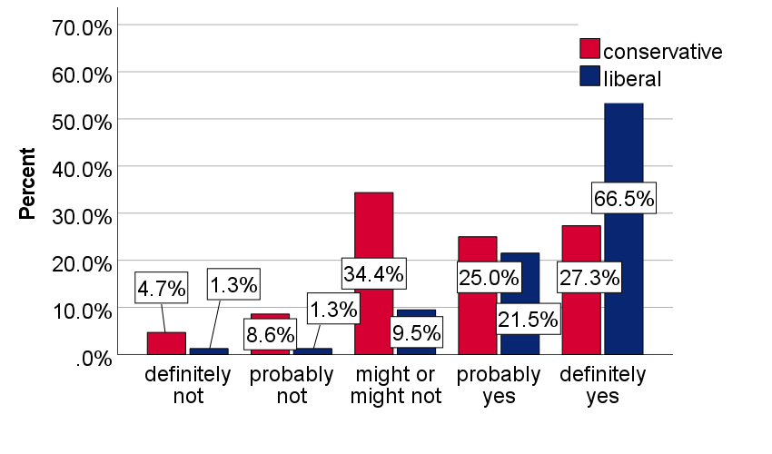
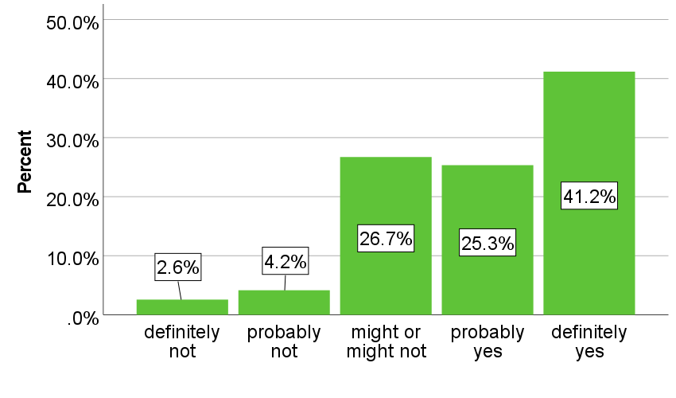
In general, would you be open to dating someone who believes in climate change?

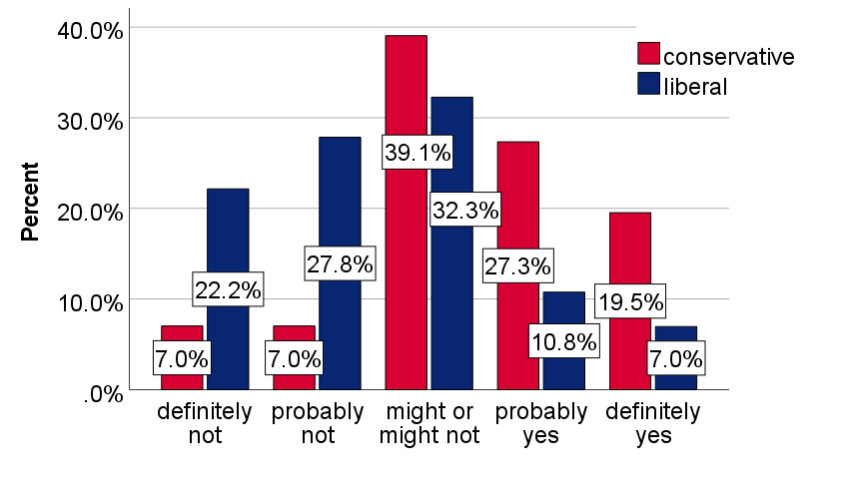
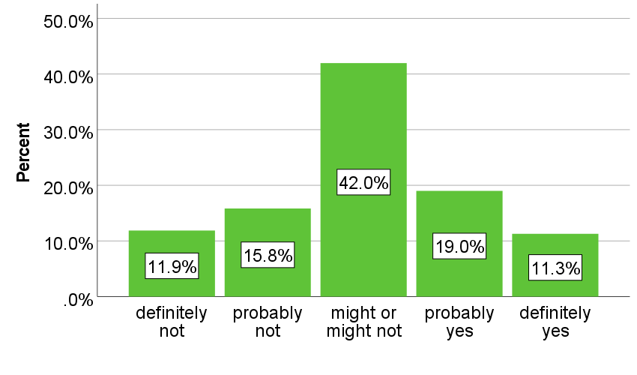
In general, would you be open to dating someone who doesn’t believe in climate change?

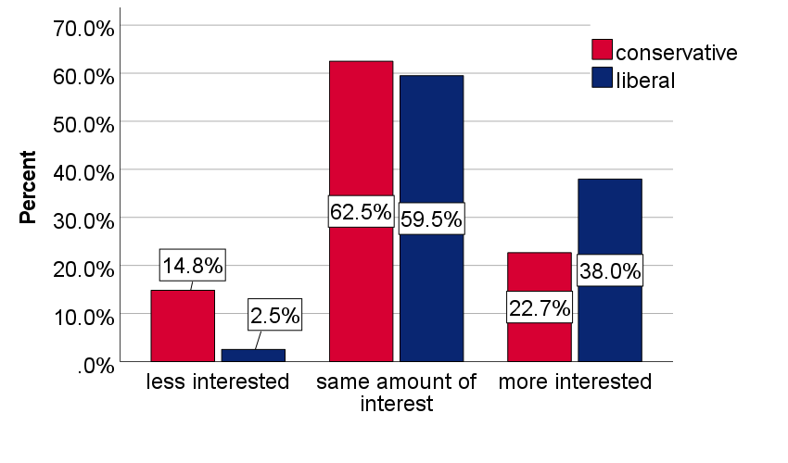
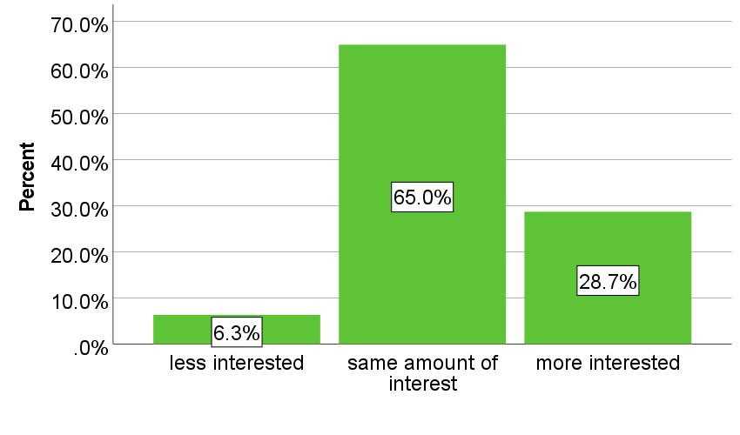
If you were interested in going on a first date with someone and then found out that they believe in climate change, would you be more of less interested in going on a date with them?

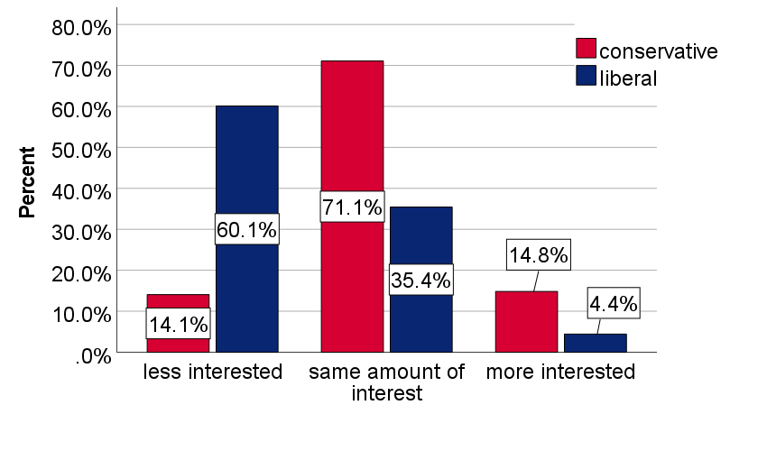
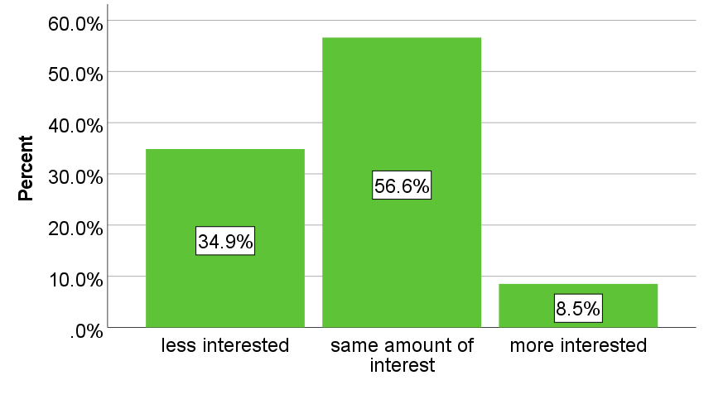
If you were interested in going on a first date with someone and they found out that they don’t believe in climate change, would you be more or less interested in going on a date with them?

Figure 2. Visual depiction of spectrum of those who are more/less likely to be open to dating a climate believer/denier, as well as who is likely to be more/less interested in someone once they find out they are a climate believer/denier.
Would you be open to dating a climate denier?
Once you find out they’re a CC denier, you’re…
Less likely
More likely
Less interested
More interested
Female
Liberal
More formal education
CC important
Male
Conservative
Less formal education
CC not important
Conservative
Less formal education
CC not important
CC not anthropogenic
Liberal
More formal education
CC important
CC anthropogenic

Would you be open to dating a climate believer?
Once you find out they’re a CC believer, you’re…
Conservative
Lower income
CC not important
CC not anthropogenic
More interested
Less likely
More likely
Less interested
Liberal
Higher income
CC important
CC anthropogenic
CC not important
CC important

p≤0.05 or better

Appendix 1. Census data used by Dynata LLC
Gender | Male | 48.5%
 | Female | 51.5%
 |  | 100.0%
Age | 18-24 | 13.1%
 | 25-34 | 17.5%
 | 35-44 | 17.5%
 | 45-54 | 19.2%
 | 55-64 | 15.6%
 | 65+ | 17.2%
 |  | 100.0%
Ethnicity | Hispanic Yes | 14.8%
 | Hispanic No | 85.2%
 |  | 100.0%
Race | Black | 11.4%
 | Asian | 5.3%
 | White | 76.1%
 | Native American | 0.9%
 | Other/Bi-racial | 6.3%
 |  | 100.0%
Region | Midwest | 21.7%
 | Northeast | 18.1%
 | South | 36.9%
 | West | 23.3%
 |  | 100.0%

Appendix 2. Pearson Correlations of Predictor Variables
Pearson correlation coefficients with significance levels. Calculated variance inflation factors are ≤1.362.
 | age | ideology | education | income | religiosity | Cc anthro-pogenic dummy | Cc issue importance | White dummy | Latino dummy | Christian dummy
sex | -.051 | .070 | .022 | -.102* | .126** | -.052 | .080 | -.005 | .024 | .016
age | - | .003 | .238** | -.040 | .040 | -.016 | -.043 | -.114* | .173** | -.016
ideology | - | - | .051 | .002 | -0.268** | -.315** | .301** | .003 | -.022 | .083
education | - | - | - | .351** | .008 | -.128** | .068 | -.055 | .065 | .047
income | - | - | - | - | -.028 | -.062 | .060 | -.052 | -.012 | -.034
religiosity | - | - | - | - | - | -0.178** | -0.036 | -.014 | -.033 | -.117**
Cc anthro-pogenic | - | - | - | - | - | - | -.452** | .077 | .042 | -.074
Cc issue importance | - | - | - | - | - | - | - | -.028 | -.130** | -.117**
White dummy | - | - | - | - | - | - | - | - | -.066 | .034
Latino dummy | - | - | - | - | - | - | - | - | - | .021
**. Correlation is significant at the 0.05 level (2-tailed).
*. Correlation is significant at the 0.01 level (2-tailed).

For an overview of assortive mating, see Luo (2017).
Findings on similarity in personalities among couples is mixed with some studies showing weak positive trends (Botwin et al., 1997; Luo, 2009; Watson et al., 2004), and others showing negative correlations (Markey & Markey, 2007).
This is oft attributed to individuals intentionally seeking partners with similar political leanings, rather than other types of induced homophily such as post-choice convergence, restricted partner markets, or sorting on non-political factors (Huber & Malhotra, 2017).
That is, from 10% to 21%.
While it is well known that individuals can lie on dating apps (up to 57% of online daters lie, 80% in the U.S.), (Hancock et al., 2007), it is usually a particular set of information that they lie about, which typically includes appearance, age, location, name, relationship status, and occupation. It is less common for individuals to lie about their political preferences or social issues that they care about.
Attention check question: “Research shows that people, when making decisions and answering questions, prefer not to pay attention and minimize their effort as much as possible. Some studies show that over 50% of people don't carefully read questions. If you are reading this question and have read all the other questions, please select the box marked 'other.' Thank you for continuing to read through the questions carefully!” Answer Options: (1) Dating, (2) Relationships, (3) Climate change, (4) Other.
See Appendix 1. Census data used by Dynata LLC
The phrasing of this variable was taken from Pew Research Center (for example, see C. Kennedy et al., 2016). The current study only diverges in using a 7-point scale for greater specificity instead of the 5-point scale of “very conservative,” “Conservative,” “Moderate,” “Liberal,” “Very liberal.”
Because respondents were asked to indicate which age group they were in (i.e.: aged 18-24, 25-29, 30-34, etc.) rather than their exact age, a precise mean, median, standard deviation and range cannot be obtained. The age range is from 18-70+, the mean resides in age group 40-44, the median is in age group 40-44, and the standard deviation is 2.579 among the ten age group options.
The term religiosity most popularly refers to how important religion is in one’s life. Alternative definitions include belief in God, following the principles one believes to have been set by God (McDaniel & Burnett, 1990), and “the personal practice of religion” (Allport & Ross, 1967: 432). The survey of this study offered: “How important is religion in your life?” which is a commonly phrased question for gauging this variable (Bobowik et al., 2010; Kurpis et al., 2008; La Barbera & Gürhan, 1997; Rice & McAuliffe, 2009).
Respondents who indicated they were “strongly conservative,” “conservative,” or “somewhat conservative” were grouped as conservative. Those who indicated they were “strongly liberal,” “liberal,” or “slightly liberal” were grouped as liberal. Clustered bar charts comparing conservatives to liberals have a total N less than 505 because those that answered “might or might not” to the dependent variables were excluded from the political ideology clustered bar charts. They were not excluded from the overall total respondents bar charts.
Results relating to the age variable were not included in Figure 2.
It is therefore unknown how many students took the survey.
While respondents had answer options of (1) male, (2) female, (3) other (specify)—to which answers such as non-binary were collected—and (4) prefer not to say, a more in-depth and inclusive list should be included in follow-up studies for better inclusion as well as specificity of data.

