Mapping the Emergence of the Demand to Defund Police on Twitter
Abstract
How did the demand to defund police go from being a relatively obscure articulation of Black radical politics to a prominent feature in mainstream political discourses? I map the process by which collective action frames come to be resonant by examining the specific trajectory of the demand to defund police. Based on findings from a computational and qualitative text analysis of tweets about defunding police from 2013 to 2020, I demonstrate that the consolidation of this demand in BLM movement discourse came about largely through a decentralized, idiosyncratic process catalyzed by the actions and rhetoric of radical early risers and amplified through the digital counterpublic of Twitter. Prior to the actions of early risers, support and opposition to the demand to defund police was found across the ideological spectrum. Once a resonant movement frame was coalesced around the demand, it became increasingly engaged by other movement actors in the BLM movement, years before going viral with the 2020 uprisings. The trajectory of the demand to defund police in the BLM movement is an illuminating case study that contributes to literatures on the resonance of collective action frames, the role of digital counterpublics in social movements, and the power of early risers in the creation and spread of movement rhetoric, as well as to the history of Black radical movements to abolish the white supremacist, capitalist carceral state.
Introduction
According to polls and expert analysis, the largest mass mobilization in US history happened in the summer of 2020. By mid-June, polls estimated that between 15 to 26 million people located across nearly half of all U.S. counties reported participating in demonstrations protesting the killing of George Floyd by Minneapolis Police Officer Derek Chauvin (Buchanan, Bui, and Patel 2020). Protesters flooding into the streets chanted, marched with signs, faced off against violent police suppression, and posted on social media with many familiar phrases and tactics—such as “Black Lives Matter,” “I Can’t Breathe,” the naming of victims of police violence—but also new slogans and demands, particularly to defund and abolish police. A rough indicator of the novelty and popular traction of this demand was the increase in June 2020 from 0 to 100% for Google web and news searches of the phrase “defund police” (Google Trends). A recent study of the George Floyd protests finds that the expected daily volume of tweets mentioning “defund police” increased by 370,000% during August to December 2020 as compared to the same period in 2019 (Dunivin, Yan, Ince, and Rojas 2022).
Another telling indicator of changing attention was variable support for defunding police in contemporaneous polling based on how the survey item was framed. While polls querying respondents on policies to defund police found low support, when framed with an explanation of the many non-criminal justice services police are expected to perform, a majority of respondents supported reallocating taxpayer dollars from police to other non-police emergency services (North 2020). The variable response based on the framing of the concept of defunding police indicates that the public debate about policing in the US was still being defined, and the 2020 mass mobilization created increased popular attention and opportunity for learning and position-taking on this issue.
By these accounts, public attention to demands to defund police had never been higher. Yet the concept of shifting resources from police and prisons to material resources under community control has long been featured in Black radical thought (Davis 2005; Hooker 2016). To understand how this long-standing political argument gained widespread traction in June 2020, I examine the framing and engagement with the concept of defunding police on a key vector for the spread of information: social media, where the demand would go viral. Indeed, the social media site Twitter has been a central platform for the rapid spread of information related to the Black Lives Matter (BLM) movement since 2014 (Tillery 2019). In this study, I will investigate the discourses on Twitter around defunding police prior to the demands’ meteoric rise in popular awareness. To do so, I examine how tweeted rhetoric related to defunding police changed since the inception of the BLM movement: in frequency, framing, resonance, topic, engagement, type of user, and relation to external events.
In the following sections, I first consider the history of contestations of the carceral state in Black radical movements and how this has informed contemporary demands to defund police and the trajectory of the BLM movement. I then summarize existing research on the BLM movement with a focus on the role of social media and collective action frames. I detail the current study and the mixed methods I use to examine Twitter data before turning to the results of this analysis. I organize the results according to three primary findings, that also follow a temporal sequence. First, I show that from 2013 to 2014, tweeted rhetoric both supporting and opposing defunding police was decentralized, idiosyncratic, and promulgated across the political spectrum. Then, in late 2015 through 2016, a series of radical actions and accompanying rhetoric by early risers in the BLM movement triggered the consolidation of a set of discourses about defunding police. Finally, I examine how these discourses acquired resonance, clarity, and pushback from opponents in the years leading up to 2020. I conclude by considering the implications of this research for future scholarship on collective action frames, the role of early risers, and internet counterpublics in movement discourse.

Protest and Public Discourse
Much of the work of social movement scholars is concerned with the relationship between protests, public attention, and political change. For instance, studies have found that increased Vietnam War protests were associated with more congressional hearings and that the reporting of minority-group protests in major newspapers influences congressional voting behavior on racial and ethnic minority concerns (McAdam and Su 2002; Gillion 2012). Additionally, movement scholars have demonstrated that movement demands gain popular traction in large part due to how demands are framed. Collective action frames or movement frames diagnose social problem and propose solutions that can be achieved by collective action tactics (Snow and Benford 1992). Collective action frames are effective when they identify the victims and perpetrators of grievances, provide convincing reasons for why action is necessary, and assure participants that action will be efficacious (Tarrow 2011). Resonant collective action frames change how an issue is perceived and what values, beliefs, and rhetorical arguments it is connected to, such that it becomes an accepted topic for political debate and position-taking, thereby achieving “political acceptance” (Chong and Druckman 2007; Woodly 2015).
Collective action frames are produced by key actors that mobilize early around movement issues, termed “early risers” (Tarrow 2011) or “prime movers” (McAdam 1986). Groups of early risers co-construct and disseminate collective action frames, which, if resonant, catalyze a cycle of contention and attention that leads to increased movement activity (Tarrow 2011). Social media introduces new dynamics into collective action framing in how meaning is derived, who can access the discursive field, and the tools available to early risers to boost political opportunities. Through social media platforms, early risers can use hashtags and other types of digital indexing to engage in “networked framing” which is crowdsourced and arrived at through dispersed and iterative discussion (Graeff, Stempeck, and Zuckerman 2014). These new mechanisms for framing circumvent the work otherwise done by leaders or formal organizations to create communities of shared meaning about issues, strategies, and solutions (Ince, Rojas, and Davis 2017). Additionally, social media provides a potential route for movement frames to enter mainstream news media especially during exceptional events, such as moments of mass protest.
However, social media is not an egalitarian panacea for movement coordination. By organizing on a publicly accessible platform, social movements risk counter-narrativization and co-optation, dis- and misinformation, as well as harassment and targeted attacks from countermovements (Tufekci 2017). Furthermore, which social media narratives gain mainstream traction are subject to the filtering decisions of political and media elites (Graeff, Stempeck, and Zuckerman 2014). While networked movements may be able to reach a large audience through social media and boost the number of people who mobilize in support, the weak ties of a community that only exists online may not allow for the movement to be sustained over time (Gladwell 2010; Granovetter 1973). In fact, research suggests that movement early risers are better aided by dense, offline social networks than by online networks (Leenders and Heydemann 2012). Despite these limitations, social media remains an important site of movement meaning-making and transmission of collective action frames.

Black Liberation and Carceral Contestation
Contemporary BLM movement actors demanding to defund and abolish police build upon the well-established politics of contesting racialized, carceral-capitalist systems—including police and prisons—in the Black radical tradition and the American political left. Lineages of abolitionist thought stretch back through historical contestations against slavery and imperialism as well as forward into contemporary fights against their afterlives and ongoing manifestations in the carceral state (Heynen 2018). Neither the anti-Black violence of policing and prisons nor Black liberation struggles against these carceral institutions are new phenomena. The anti-Black origins of modern U.S. police in antebellum slave patrols is borne out in the overwhelming evidence of systemically racist policing in civilian stops, predatory fines, excessive use of force, and killings (Kaba 2021; Turner, Giacopassi and Vandiver 2006; Spruill 2016; Woodly 2022). Angela Davis has convincingly argued that mass incarceration represents “the persistence of some of the deep structures of slavery” as a feature of unequal freedom in U.S. democracy and therefore that must be dismantled (2005, 110).
A similar argument is taken up by the campaign to defund the Chicago Police Department which presents “the abolition movement of today as directly building on the legacy of abolishing slavery” (Defund CPD Community Conversation Toolkit 2020). This framing creates a narrative of an American abolitionist tradition and imbues historical significance to the contemporary effort to defund police. Indeed, the BLM movement is a recent iteration of an ongoing response to limited social change and increased repression of Black communities that has been ongoing since Emancipation. For instance, the Black Panther Party in Chicago contested the carceral state, called for community control of police, and reimagined what safety looked like for Black communities in the 1970s. Given this history, the 2013 acquittal of the murderer of Black high schooler Trayvon Martin was far from surprising. However, in the supposed post-racial era inaugurated by the Obama presidency, this was a politically shocking instantiation of continued state-sanctioned vigilante violence and Black death (Tesler 2016; Woodly 2022).

The Black Lives Matter Movement
#BlackLivesMatter was first posted on Twitter in July 2013 by Alicia Garza, Opal Tometi, and Patrisse Cullors—three Black feminist activists—who created the hashtag as a response to systemic, death-dealing anti-Blackness exemplified by the acquittal of Trayvon Martin’s murderer (Garza 2014). Discourses about Black identity, racism, policing, and systemic violence coalesced around this hashtag, which gained further attention as “Black Lives Matter” became the central refrain of social media responses to a series of high-profile police killings of Black men and women (Freelon, McIlwain, and Clark 2018; Tillery 2019). The phrase surged into widespread national consciousness through amplification in the chants and signs of protestors flooding the streets after the police killing of Mike Brown in Ferguson in 2014 (Bonilla and Rosa 2015; Taylor 2016).
Both the murders of Trayvon Martin and Mike Brown caused political shocks which, when amplified through social media, created a window of political opportunity for movement mobilization. Woodly (2022) argues that Ferguson became the catalyst for the consolidation of the BLM movement due to four characteristics: (1) the recursive trauma that Mike Brown’s killing incurred on Black Americans, (2) the starkly visible racial and economic injustices in Ferguson, (3) local organizations that provided resources for mobilizations, and (4) the national influx of material and human resources to support the protests. Key to this last characteristic was the engagement of organizations such as the Black Youth Project 100 (BYP100), Million Hoodies Movement, and Dream Defenders, which had been using the language of “Black Lives Matter” and organizing against systemic anti-Black police violence prior to the Ferguson uprisings (Ransby 2018). The characteristics of the political opportunity in Ferguson enabled the demands of protesters to enter public discourse (Akbar 2020; Ince, Rojas, and Davis 2017; Taylor 2016). As Ferguson became the epicenter of the first wave of mass BLM demonstrations, BLM became a viral phenomenon on social media and garnered extensive coverage on cable news.
After the Ferguson protests waned, organizations and activists involved on the ground and from afar gathered in Cleveland in July 2015 for the first convening of “the Movement for Black Lives,” which became one coalitional home of the movement (Ransby 2018). The Movement for Black Lives, or M4BL, includes the Black Lives Matter Global Network (BLMGN) which was founded by Khan-Cullors, Tometi, and Garza and consists of dozens of BLM chapters around the world. However, the BLM movement is even more expansive than the constellation of grassroots organizations, activists, and supporters represented by M4BL. Here, I refer to the BLM movement as not only as a coalition (of individuals and groups) but also as a set of political discourses that contests the racialized violence of the carceral state and acts as an immediately intelligible framework for decentralized mobilizations.
Following the first wave of national protests, BLM provided both organizational and discursive vehicles for local collective mobilizations in response to the police killings of Black people including Philando Castile, Freddie Gray, Laquan McDonald, Sandra Bland, and many others through mid-2020. The BLM discourse in this period expanded to include discussions of structural racism in the US, such as the systemic marginalization, exploitation, and disposal of Black life across arenas of public life including housing, healthcare, mass incarceration, jobs and education (Dunivin et al. 2022). Then, amid a pandemic that disastrously exacerbated inequality, the police killings of George Floyd and Breonna Taylor sparked unprecedented mass uprisings in 2020 that once again took up the chant and rhetoric of Black Lives Matter (Buchanan, Bui, and Patel 2020). This second wave of mass uprisings/attention and mobilization featured repertoires from the prior wave, such as use of the phrase “Black Lives Matter,” outrage at disproportionate anti-Black violence, and the intentional naming and remembrance of the names and lives of victims of police killings. Unlike the first wave, however, this second wave of protests prominently featured the novel demand to defund and abolish police in social media discourse and mainstream news coverage (Akbar 2020; Florido 2020; Kaba 2021).

Early Riser Abolitionists in the BLM Movement
Demands to defund police and abolitionist politics were not centered in the rhetoric of BLMGN founders and was absent from news coverage of the first wave of BLM protests (Clark, Dantzler, and Nickels 2018; Leopold and Bell 2017; Dunivin et al 2022). However, the demand to divest from carceral systems and instead invest in social and economic resources for Black communities—sometimes abbreviated as “divest-invest”—was certainly present in the 2015 BYP100 campaigns and hashtags #StopTheCops and #FundBlackFutures. BYP100 organizer Charlene Carruthers describes a civil disobedience action protesting the conference of the International Association of Chiefs of Police in Chicago in October 2015 as having the goal “to call out the systemic violence of policing in the world and to demand investments in Black communities (and defunding of police)” (Carruthers 2018, 115). This action and its associated rhetoric demonstrate BYP100 organizers as movement early risers engaging in collective action framing of abolitionist demands, specifically by demanding the defunding of police and funding of Black communities.
Subsequently, the demand to defund police as a policy goal was taken up in other areas of the BLM movement. In 2016, M4BL released a policy demands report which called for “a defunding of the systems and institutions that criminalize and cage us” with frameworks for reparations via “a reallocation of funds at the federal, state and local level from policing and incarceration [...] to long-term safety strategies such as education, local restorative justice services, and employment programs” (The Movement for Black Lives 2016). Similar demands also appeared in media reports of protests in Chicago calling attention to the police murders of Laquan McDonald and Rekia Boyd. For example, organizer Page May was quoted, “We are abolitionist in our politics [...] We are fighting for a world in which the police are obsolete” (Austen 2016). Meanwhile, a study interviewing Minneapolis-based BLM movement activists found that, beginning in 2017 and 2018, some abolitionist organizers were beginning to split away from other areas of the BLM movement calling for incremental police reform due to the increasing resonance of demands for police abolition (Phelps, Ward, and Frazier 2021).

Twitter and BLM
Twitter is an important location to study the BLM movement and associated discourses not only because it is a useful location to measure public attention but also because it was one of the critical spaces in which the movement came into being. Twitter remains a prominent platform for activists to make representations about the movement and introduce movement frames into the public sphere (Tillery 2019). Marc Lamont Hill draws on evidence from the Ferguson uprising to argue that Black Twitter serves as a “digital counterpublic,” where Black people engage in forms of pedagogy that “reorganize relations of surveillance, reject rigid respectability politics, and contest the erasure of marginalized groups within the Black community” (2018, 287).
Prior empirical research has examined how social movement actors affiliated with the BLM movement have leveraged social media tools like hashtags to crowdsource the framing of the movement (Bonilla and Rosa 2015; Freelon, McIlwain, and Clark 2016; Ince, Rojas, and Davis 2017), drive mainstream coverage of police brutality and elicit elite responses (Freelon, McIlwain, and Clark 2018; Graeff, Stempek, and Zuckerman 2014), mobilize participants and expand coalitions (Mundt, Ross, and Burnett 2018), and express emotional responses and urge political action (Tillery 2019). These studies generally found that the dominant framings of BLM movement discourse are of expressive remembrance, emotive solidarity, and claiming of rights. They found little in the way of policy demands or action-oriented strategic goals.
Additionally, this body of research does not include the most recent mobilizations and discourses in the BLM movement—such as the demand to defund police—as the empirical timelines do not extend past 2016. One exception is a recent study that finds that BLM protest waves drive increased public attention to a broad swathe of anti-racist concepts, including prison abolition (Dunivin et al. 2022). However, there remains a lacuna in understanding how the specific demand to defund police was constructed and framed in digital counterpublics before becoming broadly resonant and going viral. Previous research also does not appear to have considered abolitionist demands as policy demands, perhaps because they were not significantly featured in the studied period or perhaps because abolitionist demands may fall outside what is considered traditional policy preferences and thus not recognized as such.
In light of these gaps, the motivating questions of the current study asks: what is the process by which collective action frames become resonant and gain mainstream political traction? I consider the demand to defund police as an illustrative case to understand how such a demand in the struggle against anti-Black police violence went from apparent obscurity to viral explosion into mainstream politics. How did these demands begin to resonate in online counterpublic spaces of political discourse? I look to Twitter discourse to probe how rhetoric related to defunding police changes over time: in frequency, framing, resonance, engagement, type of user, and relation to external events.

Methods
I implement a mixed methods approach, taking Twitter as my site of investigation. I use inductive, longitudinal computational text analysis to examine the types of topics represented in tweets about defunding police from 2013 to 2020 as well as data from the associated Twitter user profiles. I then triangulate these findings with a qualitative content analysis of the highest engagement tweets during the months with the greatest number of tweets about defunding police. I also hand-code a sample of the tweet dataset to help validate both the computational and qualitative findings.
Data collection
To study the trajectory of the demand to defund police, I used the Twitter API for Academics and associated R software package to scrape all public tweets that mentioned “defund” and “police” (or its cognates) or tweets with the hashtag “#defundpolice” or “#defundthepolice” from January 1, 2013 to July 1, 2020. I chose the start date for data collection because the first Twitter account for Black Lives Matter (@BlkLivesMatter) was created in 2013. The end date was chosen to capture the initial surge in movement rhetoric about defunding police during the summer of 2020 uprisings against police brutality following the killing of George Floyd. In addition to scraping the content of the tweets, engagement statistics, and metadata such as timestamps and locations, I scraped the user profile information for all the accounts associated with the tweets in the primary dataset.
The initial dataset included 777,725 tweets of which 753,138 tweets (96.8%) occurred after May 25, 2020. Figure 1A shows the daily frequency of tweets that mention defunding police from January 2013 through June 2020. The red dotted line indicates May 25, 2020, the date that George Floyd was murdered by Minneapolis Police Department Officer Derek Chauvin. Protests began in Minneapolis the next day, May 26th, as did the accompanying police action such as firing rubber bullets and teargas at protesters. Due to the enormous increase in tweets at the end of May 2020, Figure 1A does not capture the variation prior to May 25th. Therefore, Figure 1B shows the daily frequency of tweets about defunding police prior to this date and reveals more variation from January 2013 to May 2020, allowing for a fuller view into the contours of this discourse and its evolution on Twitter.
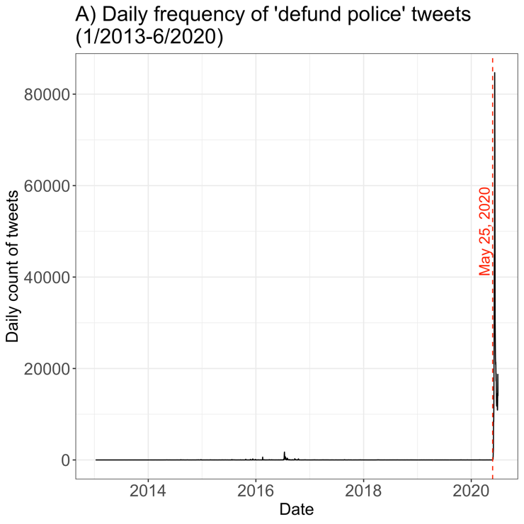
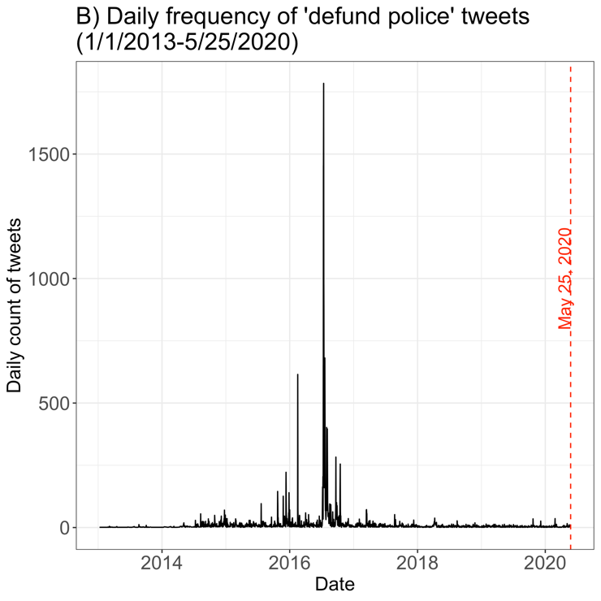
FIGURE 1: A) The daily frequency of all tweets that mention both “defund” and “police” from 1/1/2013 to 6/30/20. B) The daily frequency of all tweets that mention both “defund” and “police” from 1/1/2013 to 5/25/20. The red dotted line marks May 25, 2020.

Computational approaches
For the computational portion of the analysis, I focus on the period prior to May 25, 2020, which consists of a smaller dataset of 24,587 tweets and 9,518 unique users. This allows me to capture the variation in discourses around defunding police before the phrase went viral during the 2020 uprisings. To analyze the collected data, I implemented Structural Topic Models (STM), a machine learning algorithm designed to detect underlying topics based on word co-occurrence (Roberts, Stewart, and Tingley 2020). STM, which is available as a software package in R, allows the estimation of relationships between topics and covariates by embedding a regression model within the topic model. Regressing on month allows for tracking the change in topic prevalence over time. This approach is well-suited for the longitudinal analysis of corpora of short documents such as tweets (Curry and Fix 2019). STM is analogous to inductive methods of qualitative content analysis as both feature a bottom-up approach in which topics are discovered from the data rather than set as predetermined categories (Pak 2019). For this study, I conducted an STM with fifteen topics on the dataset of all tweets about defunding police from January 1, 2013 to May 25, 2020, using a spectral initialization and regressing on the month-year during which the tweet was created.
Before running the standard STM pre-processing on the dataset of tweets which includes removing case, punctuation, stop-words, and numbers and stemming the words, I first removed all mentions of “defund” or “police” from the tweets as these were the key search terms used to compile the dataset. In addition to calculating the expected proportions for each topic over time, the STM also outputs the most frequent and exclusive (FREX) words, the most probable words, and the most representative tweets within each topic. Based on these outputs, I hand-labeled each topic descriptively (see Appendix C). I conducted the same process, except with only the standard pre-processing, to run an STM regressed by month for the dataset of user profiles descriptions associated with each tweet about defunding police from January 1, 2013 to May 25, 2020 to yield a twenty-topic model of user profile descriptions.

Qualitative approaches
The qualitative portion of the analysis consisted of two approaches. First, I divide the filtered dataset of all tweets about defunding police into three time periods, based on the overall daily volume of tweets, to capture variation before, after, and during periods of increased volume. These periods are: 2013 to 2014, 2015 to 2016, and 2017 to May 25, 2020 (see Table 1). In each of these periods, I examine the top twenty tweets with the most engagement (calculated as summed counts of retweets, replies, likes, and quote tweets), associated username, and user profile description for further analysis (see Appendix A). This allows for analysis of high-impact tweets that were influential in shaping awareness around the demand to defund police. Second, I validated the results of the structured topic model by hand-coding a sample of the dataset for themes. I sampled every fiftieth tweet from the dataset of all tweets about defunding police from January 1, 2013 to May 25, 2020, yielding a sample size of 492 tweets. Taking an inductive approach, I categorized each sampled tweet according to a set of evolving codes to capture the themes, frames, and communicative functions represented in the tweet. This mixed method approach allowed me to use computational modeling to map the longitudinal periodization of the major themes in the dataset and qualitative analysis to closely examine the defund rhetoric that is most representative of these topic areas over time.

Time Period | Tweet Count | Unique Users | Mean Engagement
Jan 2013–Dec 2014 | 980 | 522 | 4.05
Jan 2015–Dec 2016 | 17,945 | 6,792 | 27.50
Jan 2017–May 25, 2020 | 5,662 | 2,425 | 15.53
TABLE 1: Number of tweets, number of unique users, and mean engagement per tweet for each of the three time periods.

Results
In this section, I first provide an overview of the findings from the computational text analysis, then proceed to examine STM data in conjunction with qualitative evidence by time period. In so doing, I map out how the demand to defund police went from a relatively loose and cross-ideological collection of discourses to a set of distinct, politicized frames. I trace the key role played by radical early risers and the ripple effects among BLM movement allies and counter-movement opposition.

Overview of Computational Text Analysis
Figure 2 shows the overall expected proportion for each of the fifteen topics in the dataset as a whole, labeled with the five most frequent and exclusive (FREX) words for each topic. These fifteen topics are determined by the STM for all tweets that mentioned “defund” and “police” from January 1, 2013 through May 25, 2020. Of the fifteen topics, three were relatively incoherent and were removed from further analysis. In order to examine the temporal variation of topics produced by the STM, I calculated and plotted the expected proportion of each of the twelve remaining topics by month (see Appendix D). When the topics are graphed together, it is apparent that the period from late 2015 to late 2016 features many definite spikes in various expected topic proportions while the topic variation in the time periods before and after this is less distinct. To see the variation over time, Figure 3 shows the monthly expected proportion of seven selected topics that represent notable and distinctive categories of tweets.
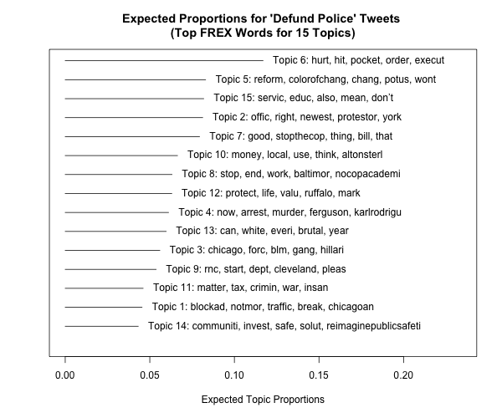
FIGURE 2: The expected proportion of each of the fifteen topics modeled on the dataset of tweets that contain both “defund” and “police” from 1/1/13 to 5/25/20. Each topic is labeled with the top 5 words calculated to be both the most frequent and exclusive (FREX) to the topic.

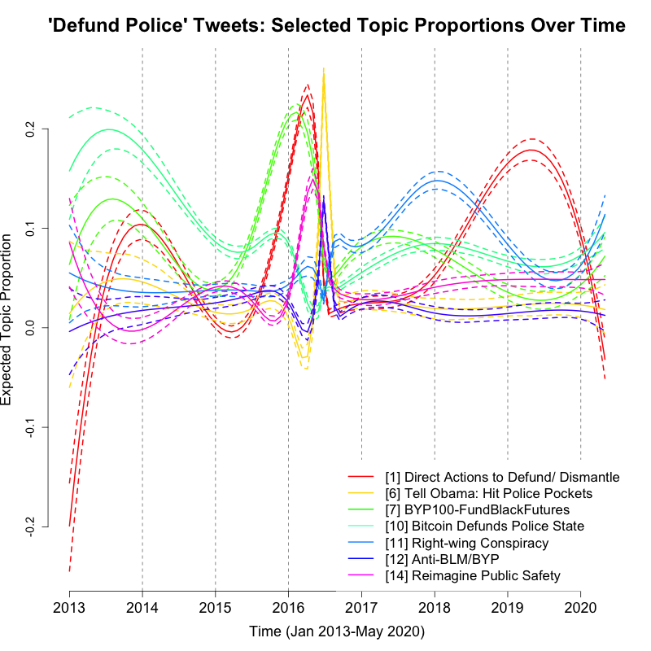
FIGURE 3: Selected hand-labeled topics from the ‘defund police’ tweets structured topic model graphed over time.

I created a supplementary structured topic model of the Twitter user profile descriptions in the dataset (see Appendix E). However, this modeling was done on user profile descriptions from the time that the data was collected rather than the profile descriptions from the time that a tweet associated with a user was made. Therefore, this provides a projection of current user profile content onto past Twitter activity. Figure 4 shows the monthly expected proportion of five selected, hand-labeled topics representing notable categories of user profiles. As with the tweet data, the user profiles fall into three time periods featuring a specific dominant user profile topic. Prior to 2016, the largest proportion of users mentioning defunding police identify with patriotic and pro-small government beliefs. This shifted to Black-identified organizers and activists in 2016, then to users identifying as pro-police abolition and pro-Palestine from 2017 to 2019.
These computational text analysis methods indicate trends over time in the discourse around defunding police on Twitter prior to the summer of 2020 that can be further illuminated by qualitative analysis of the content of tweets. Based on the trends shown in Figure 3, I split the timeline of the Twitter discourse on defunding police into the period before the flurry of STM topic spikes (2013-2014), the period during the topic spikes (2015-2016), and the period after the topic spikes (2017-May 25, 2020). Taking each topic spike as a starting point, I draw from the STM data about representative words and tweets for the topic as well as exemplary tweets from the top twenty highest-engagement tweets in each period to examine the evolution of the rhetoric of defunding police over time. I also include an analysis of the high-engagement tweets in the week after George Floyd’s murder as a coda to illustrate how the rhetoric of defunding police became mainstreamed into political discourse at this time.
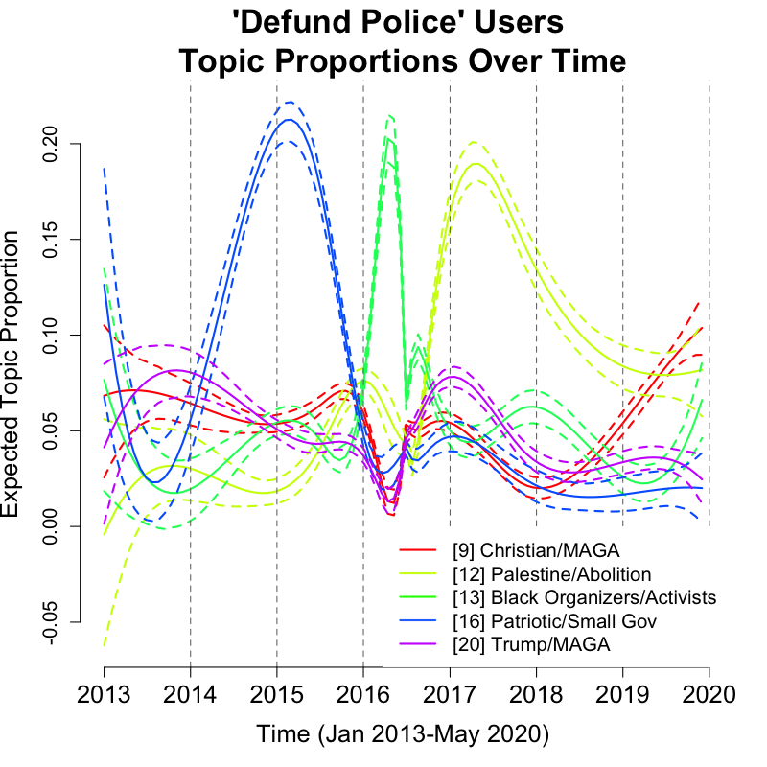
FIGURE 4: Selected hand-labeled topics from the ‘defund police’ user profiles structured topic model graphed over time.

Period 1: Pre-Resonant Defund Discourse (2013- 2014)
From 2013 through 2014, the demand to defund police was not exclusive to any one political ideology or movement. In fact, it was leveraged by accounts supporting the BLM movement as well as by accounts espousing libertarian rhetoric, including the argument that switching to Bitcoin will get rid of big government and police control. This is clear in Figure 3, as the highest expected tweet topic is Topic 10: “Bitcoin Defunds Police State” in 2013-2014. This topic largely refers to tweets about an article that argues that moving from the federal, centralized monetary system towards the decentralized digital currency of Bitcoin will remove funds for police and reduce police militarization and power. The second highest expected topic during this time is Topic 7: “BYP100-FundBlackFutures," which represents espousals of Black radical politics. During this period, conversations about defunding police on Twitter were relatively sparse, with 980 tweets which is only 4% of all tweets about defunding police from January 2013 to May 25, 2020 (see Table 1). The top 20 tweets with the most engagement in this period had engagement counts ranging from 10 to 88, a relatively low level of engagement compared to later years.
Two early tweets illustrate the mixture of political ideologies around defunding police during this time (see Appendix A for a complete tabulation of the top twenty highest engagement tweets from each period with the corresponding date, username, and current user profile, from which I draw specific examples throughout this section). The first is by user @HouseCracka who tweets in July 2013, “I don't want future generations of Americans to grow up in a POLICE STATE. DEFUND & ABOLISH THE NSA & THE FISA COURT NOW!!!! #DefundNSA.” In their contemporary Twitter profile, this user features the Trump-supporter slogan “Make America Great Again!” The second tweet is by @blogdiva whose profile identifies the user as a “proud afroboricua. antifa, socialista & #PRExit'ista.” In May 2014, this user tweets, “DEFUND THE POLICE STATE PRISON SYSTEM WAR MACHINE RAPE CULTURE WALL STREET OLIGARCHY and fund all the #reparations.” While both tweets call for defunding “the police state,” the first tweet is concerned with government surveillance and overreach, representing a right-wing suspicion of the state and a desire for individuals to be free of surveillance. Meanwhile, the second tweet joins the call to defund “the police state,” among other oppressive systems, with a demand to fund reparations, which commonly refers to the call for reparations for Black Americans for the harms of slavery and past and present racial discrimination and violence. In centering concerns around government overreach from the perspectives of the left and right, these two tweets are representative of the ideological porosity of the discourse about defunding police from 2013 to late 2014.
The second half of 2014 marked the start of the first wave of the BLM movement, sparked by events unfolding in Ferguson, New York City, and across the country following the police murders of Mike Brown, Eric Garner, Akai Gurley, and Tamir Rice and subsequent
failures to indict the responsible police officers. In parallel, tweets about defunding police, while still relatively infrequent, trended away from libertarian talking points and towards expressions of support for the BLM movement. For instance, in December 2014, the user @adv_project whose profile reads “Next generation racial justice, civil rights org” tweets, “The U.S. should invest in #RestorativeJustice to promote peace & defund the militarization of police to end brutality. #FergusonAction.” This tweet calls for defunding the militarization of police rather than calling for removing or abolishing police altogether. It is an early instance of the use of the language of defund in the BLM movement to suggest reforms to reduce police violence without calling for wholesale abolition.
Another tweet from December 2014 poses the concept of defunding police as a question, albeit a potentially rhetorical question. The author, @MoreAndAgain, whose profile identifies the user as an “anarchist,” writes, “If municipalities can vote against money going to public schools, I want to vote against my money going to police. Can we defund police?” The discursive work being done in this tweet is to show that the political power to reduce the funding of public schools is the same power that could be used to defund another government service—police. By posing it as a question, the tweet’s author frames defunding the police as a natural answer to arrive at for their audience, who may not have encountered this rhetoric previously.
Among the high-engagement tweets from this period, two distinctive strands of right-wing rhetoric related to defunding police are also represented in tweets from December 2014. On one hand, @dailypaul, a user that appears to be an unofficial fan account for libertarian US Senator Rand Paul, tweets, “Sen. Rand Paul Introduces Bill to Defund Federal Programs Supporting the Militarization of Police http://t.co/7ojPPUiA8C #Love.” This tweet represents a libertarian-inflected support for defunding police. On the other hand, Trump supporter @LovelyGigi33 tweets, “@Scarlett210 @SMolloyDVM: This Adm.is on a mission 2discredit,defund&destroy our first line of defense 🇺🇸❤&Support; Military, CIA, FBI&Police.” This user voices strong opposition to the (Obama) administration for allegedly wanting to defund all military and police. These qualitative findings generally support the indications from the computational analysis that the period leading up to late 2015 was one of relative variation in the types of politics espoused by Twitter users using the language of defunding police.

Period 2: The Emergence of Defund Police as a Resonant Frame (2015- 2016)
In 2015 and 2016, Figure 3 shows a series of spikes in expected topic proportions for the following topics: Topic 7: “BYP100-FundBlackFutures,” Topic 1: “Direct Actions to Defund/Dismantle,” Topic 14: “Reimagine Public Safety”, Topic 6: “Tell Obama: Hit Police Pockets,” and Topic 12: “Anti-BLM/BYP.” This cluster of spikes is triggered by disruptive direct actions taken by BYP100 organizers in Chicago, followed by a series of related reactions and responses. I proceed chronologically, illustrating each sequential spike with representative, high-engagement tweets that provide insight into the topic-specific discourse on defunding police. This period features the most tweets of any of the three periods prior to May 25, 2020, with 17,945 tweets (73%) in the dataset originating in 2015 or 2016 (see Table 1). The top twenty tweets with the most engagement in this period had engagement counts ranging from 119 to 2046, considerably higher than engagements in 2013 to 2014.
The first topic spike begins with the BYP100 action to Fund Black Futures by demonstrating at the International Association of Chiefs of Police (IACP) conference in October 2015. A contemporaneous, highly engaged tweet from the organization’s account, @byp100, reads “We demand local, state and federal budgets to defund the police&invest those dollars and resources in Black futures.” This moment is significant because it represents when the hashtag and demand to defund police was strategically tweeted in conjunction with protests of anti-Black police violence for the first time. Also important is that BYP100 paired the specific demand of defunding police in government budgets with investing funds into Black communities, specified further in a tweet from November 2015 by @byp100: “We want quality public schools. We want good jobs. We want healthcare. We want to defund the police and #FundBlackFutures. #LaquanMcDonald.” The use of the hashtag #FundBlackFutures in this campaign represents a framing strategy to emphasize that defunding police must be tied to a reimagination of what could be possible for Black people if resources were to be channeled away from police and into Black communities. Meanwhile the hashtag #LaquanMcDonald, referring to a Black teen killed by Chicago police, emphasizes that the violence and death that Black people face at the hands of police motivates the demand to defund them.
This spike continues through February 2016, when BYP100 organizers in collaboration with Organized Communities Against Deportation once again disrupted and blockaded traffic, calling to defund police, dismantle ICE, and instead invest government resources in social programs and material resources for Black and Latinx communities. In addition to the spike in Topic 7: BYP100, this also drives the spike in Topic 1: Direct Actions, which peaks in early 2016. Closely following is the next spike in Topic 14: “Reimagining Public Safety.” This topic largely centers around an April 2016 tweet by @BLMLA, the account of the BLM LA chapter, which reads: “Police don't make communities safe, resources do. Invest in community solutions. #DefundThePolice #ReimaginePublicSafety #BlackLivesMatter.” Amplifying the rhetoric of BYP100 early risers, this represents an uptake in the broader BLM movement of the demand to redirect funds away from police towards community resources. Additionally, this tweet does important framing of the demand as means for reimagining public safety by contending that resources, rather than police, make communities safe.
The next, sharp spike is for Topic 6: “Tell Obama: Hit Police Pockets.” This refers to a set of tweets featuring a petition circulated by the organization Color of Change in July 2016, calling for supporters to sign a letter addressed to President Obama arguing that federal funding should be reduced for delinquent, racist police departments. This campaign went viral in large part due to actor Mark Ruffalo whose tweet got 2046 engagements, becoming the most engaged tweet to date: “Defund bad cops and police departments. Tell Obama: We need an executive order! https://t.co/rpRepf9fAT #DefundPolice.” Topic 6 features uptake from the actions and rhetoric of the BYP100 organizers into a different subset of the BLM movement constellation. It represents a more moderate, conventional approach in terms of its demands, by calling for reforms and selective defunding of delinquent departments, and its tactics, by circulating an online petition rather than engaging in direct disruption.
The final, notable spike during this period, which is contemporaneous with Topic 6 is Topic 12: “Anti-BLM/BYP.” Tweets in this topic include denial, ridicule, shock, derogatory comments, and racial slurs in response to the idea that Black organizers are calling for police to be defunded. A July 2016 tweet from conservative politician and pundit Joe Walsh (@WalshFreedom) directly responds to Mark Ruffalo, “"The Hulk" Actor @MarkRuffalo says President Obama should defund police departments. Wrong.” This indicates that the actions and demands of BYP100, Color of Change, and other BLM movement early risers had rippled across the online political spectrum and into conservative pockets of Twitter, eliciting reactions and backlash by mid-2016.

Period 3: Increasing Engagement with Resonant Demands (2017-May 2020)
After late 2016, the frequency of tweets dramatically reduces leading up to May 25, 2020 (as shown in Figure 1B). The decrease in the amount of rhetoric related to defunding police on Twitter is shown in Table 1, with only 5,662 tweets (23%) in the period from 2017 to May 25, 2020—which represents 47% of the seven and a half-year total data collection period. However, despite the lower frequency, the amount of engagement received by the top 20 highest-engagement tweets in this period (see Appendix A) ranges from 342 to 6,611, the highest level of engagement compared to earlier periods. Despite the lower frequency of tweets, the discourses around defunding police in this period are much more clearly framed than they were prior to 2015; these frames follow from the rhetoric of early risers in late 2015 and 2016.
The first major spike in this period occurs in 2018, depicted in Figure 3 as an increased proportion of Topic 11: "Right-wing Conspiracy." This topic includes tweets related to the Clinton email leak scandal as well as Islamophobic and anti-immigration tweets by right-wing accounts, which primarily concern the need to defund sanctuary cities and police Muslim people. The other major spike is in 2019, when the topic with the highest proportion is Topic 1: “Direct Actions to Defund/Dismantle.” This is largely due to a flurry of tweets in 2018–2019 about protests by Anti-Police Power Surrey, an organization seeking to defund the police in Surrey, Canada (CBC News 2018).
However, tweets in these topics did not receive the highest engagement numbers. Rather, prominent celebrity, political, and activist accounts participating in the rhetoric around defunding police garnered the most engagement. For instance, NSA whistle-blower Chelsea Manning (@xychelsea) tweeted in January 2018, “the reign of terror must end 🛣️👮‍♀️🚔🏙️ disarm, defund, dismantle, and abolish @icegov and @customsborder as an unchecked national police force 😎🌈💕 #WeGotThis #NoNationalPolice.” This high-engagement tweet focuses specifically on Immigration and Customs Enforcement (ICE) and Customs and Border Patrol (CBP). Here, the language of defund and abolish is applied to these national police forces, which had been receiving negative press and decreased popularity on the left in reaction to harsh Trump era border control policies. The demand to defund CBP and ICE, therefore, might be more appealing to police reformists than the wholesale demand to defund and abolish local police.
Meanwhile, on the right, Republican Governor Ron DeSantis (@RonDeSantisFL) tweeted in October 2018, “Do you want a governor who will stand with law enforcement or one like @Andrewgillum who signed a pledge to defund police in FL because he thinks they “have no place in justice”? That’s the choice you have. A vote for me is a vote for safe communities.” This highly-engaged tweet demonstrates that conservative politicians made a concerted effort to position themselves against the demand to defund police and in support of law enforcement and safety, while associating the opposite stance with Democratic politicians like Florida gubernatorial candidate Gillum.
A final instance of a high-engagement tweet with a well-framed rhetoric is from @BreeNewsome, who identifies in her Twitter profile as “artist – grassroots organizer – free black woman.” In December 2019, she tweeted “Abolish & defund the police and put the money toward guaranteeing housing, living wages and healthcare for the communities police regularly terrorize.” This very clearly reiterates the abolitionist demand to defund police as originally disseminated by BYP100 and other early risers in the BLM movement. Newsome lays out the demand for the government to take funds away from policing and put them towards tangible social and economic programs to benefit communities that bear the brunt of police violence.
Period 3 thus features engagement with defund-related rhetoric from individuals with varying political inclinations— that is, the divest-invest philosophy underlying the demand to defund police, responses such as Manning’s that advocate for federal law enforcement reforms, and smear tactics like DeSantis' use of defund demands to weaken his Democratic opponent. This complex context is what lays the groundwork for the viral uptake of defund demands during the George Floyd uprisings.

Coda: May 26, 2020-June 4, 2020
The STM topic analysis ends after May 25, 2020, the date of the police killing of George Floyd. The enormous spike in tweets about defunding police after this event limits the capability of the temporal topic model to capture variation. However, it is important to examine the discourse during this spike to understand what kinds of framings were resonating and going viral. I use a qualitative analysis to examine the Twitter discourse from May 26, 2020 through June 4, 2020 to capture the spike in tweets about defunding police at the very beginning of the protest wave. There are 78,264 tweets in the dataset during these ten days and the top twenty highest engaged tweets during this time range from engagement counts of 24,630 to 177,229 (see Table 1). These high engagement tweets contain resonant framings of the demand to defund police that resemble and respond to the radical framing of early risers.
During this period, the highest engagement tweets center around ongoing mass mobilizations, police violence against protestors, and calls for political action. On May 26, abolitionist lawyer and author Derecka Purnell (@dereckapurnell) tweets, “abolish the police. defund them. fire the cops. divest. take their toys. stop them from killing black people. stop them from killing all people. just stop calling for justice when they kill us. Courts benefit from the violence of policing. Don't expect them to give you justice.” Purnell calls for a change in tactics towards making direct interventions that take away the police’s resources and ability to enact violence at the source, rather than calling for justice after Black people have been killed. This signals a break with the tactics of calling for post-facto justice that were prominent in the first wave of the BLM movement. Occurring the day after George Floyd’s murder and two days before the Minneapolis Police 3rd precinct was burned down, this tweet links the call to defund police to a broader agenda calling for abolition, demilitarization, ending police violence, and disrupting the common perception of the court system's capability to enact justice. This echoes the early riser frame (of BLM LA) calling for reimagining public safety by rejecting the carceral state.
On May 29, Rep. Alexandria Ocasio-Cortez (@AOC) tweeted, “Now @VICE reporting that @CBP is sending predator drones over #GeorgeFloyd protests in Minneapolis. This is what happens when leaders sign blank check after blank check to militarize police, CBP, etc while letting violence go unchecked. We need answers. And we need to defund.” This demonstrates that by this point, the demand to defund police had entered national-level political discourse among progressive elected officials. Furthermore, Ocasio-Cortez mentions CBP, indicating that among national progressive politicians, there may be more appetite for defunding federal law enforcement than local police. Then on May 31, the national Black Lives Matter organizational account (@Blklivesmatter) tweets, “We call for an END to systemic racism that allows this culture of corruption to go unchecked and our lives to be taken. See the demands. Sign the petition. #DefundThePolice #blacklivesmatter.” This injunction closely resembles the 2016 Color of Change petition campaign, both in rhetoric which is primarily expressive and in tactics which seek to channel the swelling outrage into political action through a petition campaign.
On June 4, Turning Point USA founder and conservative activist Charlie Kirk (@charliekirk11) tweeted, “Democrats want to defund police but not Planned Parenthood. Remember that this November.” Similar to DeSantis a few years prior, right-wing media figures reacted to calls to defund police as a means to smear Democrats. By contrasting funding for police with Planned Parenthood, Kirk contributes to politicizing the issue to become another culture war topic that increases partisan polarization. Thus, ten days after George Floyd was killed, the demand to defund police had proven to be a resonant and adaptable movement frame, to call for direct action or awareness raising, for abolitionist or incremental reforms, and for right-wing reactions.

Discussion
Mixed computational and qualitative analysis of tweets that mention defunding police suggests that the actions of and reactions to movement early risers contributed to the transformation of an ideologically porous, malleable concept into a delineated set of movement frames engaged by radical, reformist, and right-wing actors years before 2020. In particular, disruptive actions paired with radical rhetoric spearheaded by BYP100 in late 2015 and early 2016 were critical in shaping the trajectory of the demand to defund police. While the tweets about these actions and demands received only modest attention at the time, these early risers laid the groundwork for the eventual virality of “defund police” by triggering at least three types of response. The first is from other abolitionist organizers in the broader BLM constellation, such as BLM LA, who took up the demand of transferring resources from policing to social services for communities of color coupled with a radical reframing of the criminal justice system as a source of a violence rather than safety. The second is from online racial justice organizations like Color of Change, also affiliated with the BLM movement, who took a more incremental approach and framed defunding police as a means to punish delinquent police departments by severing federal funds, decreasing police arsenals, and implementing reforms such as body cameras and implicit bias trainings to make policing more responsive to public safety. The third response is right-wing backlash that simultaneously ridicules and fears the idea of defunding police, seeks to increase the power of law enforcement over marginalized populations, and incites suspicion of Democratic elites' collusion with radical activists.
However, mobilization drives attention and attention drives mobilization. These frames did not become more publicly attended to beyond BLM movement spaces (and occasional counter-movement reactions) in the years of reduced mobilization prior to 2020. The summer of 2020 was a period when unpredictable changes to the political opportunity structure created the opening for often incomplete movement demands to gain mainstream traction. A critical feature of this political opportunity was a long history of organizing against racist police violence, particularly in the recent BLM movement, in which attempts at incremental police reform and other policies to address structural racism had failed to reduce the vulnerability of communities of color. Also critical was the backdrop of a historic global pandemic, accompanying economic slowdown, and four years of a right-wing, norms-shredding Trump presidency with the possibility of another term on the horizon. When these demands did explode into public awareness in summer 2020, variable framings often led to incomplete and misleading take-up that decontextualized the idea of defunding police from the accompanying divest-invest framework of reimagining public safety as a function of community resources rather than police.
The current study's primary focus on Twitter data places inherent limitations on understanding the trajectory of the demand to defund police. In particular, this study does not capture the internal communications, publications, meetings, and private thoughts of movement and countermovement actors. However, Twitter remains an important site of investigation as it is a critical location for the viral uptake of the demand to defund police. This is illustrated by the tweet that received the highest engagement (dated June 8, 2020; 761,988 total engagements) in the whole dataset in which user @hannah_unlost writes, “I joined twitter because of One Direction and now I want to defund and abolish police.” This is a tongue-in-cheek commentary about the crucial role of Twitter in changing the understanding and politicization around policing of many who previously were uninformed, unaware, and using the social media platform for wildly different reasons (such as following celebrities like the band One Direction).
Future work on this subject would benefit from incorporating additional sources of data such as interviews with organizers and movement participants, public opinion and survey data, and news media content related to the demand to defund police. Furthermore, the computational text analysis of tweets or other corpora could also be improved with tools such as keyword-assisted topic models, word embedding models, and network analysis. The present data contains indications that right-wing calls for the defunding of other areas of government such as Planned Parenthood, sanctuary cities, and welfare programs may have led some anti-policing platforms to subvert this logic to instead argue for defunding police. Similarly, there are also indicators that the role of influential movement platforms on Twitter, such as the national BLMGN organization’s account (@BlkLivesMatter), the umbrella M4BL account (@M4BL), the accounts of local BLM chapters, and other affiliated accounts act as local news sources to spread information among movement supporters and amplify the resonant frames that are introduced by early risers. To substantiate these possibilities, it would be worthwhile to examine how the language of defund spread across various networks of Twitter users.
The virality of the demand to defund police is an illustrative case of early riser movement actors leveraging social media counterpublics like Twitter to put forward resonant movement frames that politicize an issue or demand. In this instance, the resonant frame was reimagining safety to no longer mean police but to instead be about access to material resources and social services, accompanied by the demand to organize government funding priorities accordingly. An implication of this research is that early rising movement actors can plant the seeds of radical resonant frames which may spread across counterpublics and take root among other key actors, lying seemingly dormant until erupting in growth under the right set of environmental conditions.

References
Akbar, Amna A. 2020. “Demands for a Democratic Political Economy.” Harvard Law Review 134 (December): 29.
Austen, Ben. 2016. “Chicago After Laquan McDonald.” The New York Times, April 20, 2016, sec. Magazine. https://www.nytimes.com/2016/04/24/magazine/chicago-after-laquan-mcdonald.html.
Benford, Robert D., and David A. Snow. 2000. “Framing Processes and Social Movements: An Overview and Assessment.” Annual Review of Sociology 26 (1): 611–39. https://doi.org/10.1146/annurev.soc.26.1.611.
Bennett, W Lance, and Alexandra Segerberg. 2016. “Communication in Movements.” In The Oxford Handbook of Social Movements. Oxford, UK:, 367–82. Oxford, UK: Oxford University Press.
Bonilla, Yarimar, and Jonathan Rosa. 2015. “#Ferguson: Digital Protest, Hashtag Ethnography, and the Racial Politics of Social Media in the United States.” American Ethnologist 42 (1): 4–17. https://doi.org/10.1111/amet.12112.
Buchanan, Larry, Quoctrung Bui, and Jugal K. Patel. 2020. “Black Lives Matter May Be the Largest Movement in U.S. History.” The New York Times, July 3, 2020, sec. U.S. https://www.nytimes.com/interactive/2020/07/03/us/george-floyd-protests-crowd-size.html.
Calhoun, Craig. 1993. “‘New Social Movements’ of the Early Nineteenth Century.” Social Science History 17 (3): 44.
Carruthers, Charlene A. 2018. Unapologetic: A Black, Queer, and Feminist Mandate for Radical Movements. Boston: Beacon Press.
Carty, Victoria. 2015. Social Movements and New Technology. Place of publication not identified: Routledge.
CBC News. 2018. “'Homes not cops,' chants Surrey group concerned over police spending.” CBC News, November 25, 2018. https://www.cbc.ca/news/canada/british-columbia/homes-not-cops-surrey-protest-1.4919835
Chong, Dennis. 1991. Collective Action and the Civil Rights Movement. American Politics and Political Economy Series. Chicago: University of Chicago Press.
Chong, Dennis, and James N. Druckman. 2007. “A Theory of Framing and Opinion Formation in Competitive Elite Environments.” Journal of Communication 57 (1): 99–118. https://doi.org/10.1111/j.1460-2466.2006.00331.x.
Civiqs. 2021. “Black Lives Matter.” Accessed December 10, 2021. https://civiqs.com/results/black_lives_matter?annotations=true&uncertainty=true&zoomIn=true
Clark, Amanda D., Prentiss A. Dantzler, and Ashley E. Nickels. 2018. “Black Lives Matter: (Re)Framing the Next Wave of Black Liberation.” In Research in Social Movements, Conflicts and Change, edited by Patrick G. Coy, 42:145–72. Emerald Publishing Limited. https://doi.org/10.1108/S0163-786X20180000042006.
Clifton, Derrick. 2016. “How Protests in Ferguson Inspired the Occupation of ‘Freedom Square.’” Chicago Reader. August 9, 2016. http://chicagoreader.com/columns-opinion/how-protests-in-ferguson-inspired-the-occupation-of-freedom-square/.
Cohen, Jean. 1985. “Strategy or Identity: New Theoretical Paradigms and Contemporary Social Movements.” Social Research, 663–716.
Crowder, Chaya. 2021. “When #BlackLivesMatter at the Women’s March: A Study of the Emotional Influence of Racial Appeals on Instagram.” Politics, Groups, and Identities 0 (0): 1–19. https://doi.org/10.1080/21565503.2021.1908373.
Davis, Angela Y. 2005. Abolition Democracy: Beyond Empire, Prisons, and Torture. https://www.hoopladigital.com/title/13306241?utm_source=MARC.
Downs, Anthony. 1957. “An Economic Theory of Democracy,” 321.
Du Bois, William E. B. 1998. Black Reconstruction in America: 1860 - 1880. 1. ed. New York, NY: The Free Press.
Dukmasova, Maya. 2016. “Abolish the Police? Organizers Say It’s Less Crazy than It Sounds.” Chicago Reader. August 25, 2016. http://chicagoreader.com/news-politics/abolish-the-police-organizers-say-its-less-crazy-than-it-sounds/.
Dunivin, Zackary Okun, Harry Yaojun Yan, Jelani Ince, and Fabio Rojas. "Black Lives Matter protests shift public discourse." Proceedings of the National Academy of Sciences 119, no. 10 (2022): e2117320119.
Entman, Robert M. 1993. “Framing: Toward Clarification of a Fractured Paradigm,” 10.
Florido, Adrian. 2020. “These Are The Minneapolis Activists Leading The Push To Abolish The Police.” NPR, June 26, 2020. https://www.npr.org/2020/06/26/882001628/these-are-the-minneapolis-activists-leading-the-push-to-abolish-the-police.
Freelon, Deen, Charlton McIlwain, and Meredith Clark. 2016. “Beyond the Hashtags: #Ferguson, #Blacklivesmatter, and the Online Struggle for Offline Justice.” Washington D.C.: Center for Media and Social Impact.
———. 2018. “Quantifying the Power and Consequences of Social Media Protest.” New Media & Society 20 (3): 990–1011. https://doi.org/10.1177/1461444816676646.
Gamson, William A. 1992. Talking Politics. Cambridge [England] ; New York, NY, USA: Cambridge University Press.
Gamson, William A., and David S. Meyer. 1996. “Framing Political Opportunity.” In Comparative Perspectives on Social Movements: Political Opportunities, Mobilizing Structures, and Cultural Framings, edited by Doug McAdam, John D. McCarthy, and Mayer N. Zald, 275–90. Cambridge Studies in Comparative Politics. Cambridge: Cambridge University Press. https://doi.org/10.1017/CBO9780511803987.014.
Garza, Alicia. 2014. “A Herstory of the #BlackLivesMatter.” The Feminist Wire (blog). October 7, 2014. https://thefeministwire.com/2014/10/blacklivesmatter-2/.
Gilmore, Ruth Wilson. 2007. Golden Gulag: Prisons, Surplus, Crisis, and Opposition in Globalizing California. American Crossroads 21. Berkeley: University of California Press.
Google Trends. (n.d.) Accessed on June 1, 2022. https://trends.google.com/trends/explore?date=2013-01-01%202021-11-09&geo=US&q=%22defund%20police%22,%22black%20lives%20matter%22
Gorz, Andre. 1968. Strategy for Labor: A Radical Proposal. Translated by Martin Nicolaus and Victoria Ortiz. Boston: Beacon Press.
Graeff, Erhardt, Matt Stempeck, and Ethan Zuckerman. 2014. “The Battle for ‘Trayvon Martin’: Mapping a Media Controversy Online and off-Line.” First Monday, January. https://doi.org/10.5210/fm.v19i2.4947.
Gross, Kimberly. 2008. “Framing Persuasive Appeals: Episodic and Thematic Framing, Emotional Response, and Policy Opinion.” Political Psychology 29 (2): 169–92. https://doi.org/10.1111/j.1467-9221.2008.00622.x.
Hall, Stuart. 1980. “Encoding/Decoding.” In Culture, Media, Language, edited by Stuart Hall, D Hobson, A Lowe, and P Wills, 128–38. London: Hutchinson.
“Herstory.” n.d. Black Lives Matter. Accessed December 10, 2021. https://blacklivesmatter.com/herstory/.
Heynen, Nik. 2018. “Toward and Abolition Ecology,” 9.
Hooker, Juliet. 2016. “Black Lives Matter and the Paradoxes of U.S. Black Politics: From Democratic Sacrifice to Democratic Repair.” Political Theory 44 (4): 448–69. https://doi.org/10.1177/0090591716640314.
Horowitz, Juliana Menasce, and Gretchen Livingston. 2016. “How Americans View the Black Lives Matter Movement.” Pew Research Center (blog). July 8, 2016. https://www.pewresearch.org/fact-tank/2016/07/08/how-americans-view-the-black-lives-matter-movement/.
Horowitz, Juliana Menasce. “Support for Black Lives Matter Declined after George Floyd Protests, but Has Remained Unchanged Since.” Pew Research Center (blog). Accessed December 10, 2021. https://www.pewresearch.org/fact-tank/2021/09/27/support-for-black-lives-matter-declined-after-george-floyd-protests-but-has-remained-unchanged-since/.
Ince, Jelani, Fabio Rojas, and Clayton A. Davis. 2017. “The Social Media Response to Black Lives Matter: How Twitter Users Interact with Black Lives Matter through Hashtag Use.” Ethnic and Racial Studies 40 (11): 1814–30. https://doi.org/10.1080/01419870.2017.1334931.
Iyengar, Shanto. 1991. Is Anyone Responsible? How Television Frames Political Issues. American Politics and Political Economy Series. Chicago: University of Chicago Press.
Kaba, Mariame. 2021. We Do This ’til We Free Us: Abolitionist Organizing and Transforming Justice. Edited by Tamara Nopper K.
Kilgo, Danielle K., Rachel R. Mourao, and George Sylvie. 2019. “Martin to Brown: How Time and Platform Impact Coverage of the Black Lives Matter Movement.” Journalism Practice 13 (4): 413–30. https://doi.org/10.1080/17512786.2018.1507680.
King, Desmond S., and Rogers M. Smith. “Racial Orders in American Political Development.” American Political Science Review 99, no. 1 (February 2005): 75–92. https://doi.org/10.1017/S0003055405051506.
Lane, Kimberly, Yaschica Williams, Andrea N. Hunt, and Amber Paulk. 2020. “The Framing of Race: Trayvon Martin and the Black Lives Matter Movement.” Journal of Black Studies 51 (8): 790–812. https://doi.org/10.1177/0021934720946802.
Leopold, Joy, and Myrtle P. Bell. 2017. “News Media and the Racialization of Protest: An Analysis of Black Lives Matter Articles.” Equality, Diversity and Inclusion: An International Journal 36 (8): 720–35. http://dx.doi.org.proxy.uchicago.edu/10.1108/EDI-01-2017-0010.
Leenders, Reinoud, and Steven Heydemann. 2012. “Popular Mobilization in Syria: Opportunity and Threat, and the Social Networks of the Early Risers.” Mediterranean Politics 17(2): 139–159.
McAdam, Doug. 1982. Political Process and the Development of Black Insurgency 1930-1970. University of Chicago Press.
Mcadam, Doug, Sidney Tarrow, and Charles Tilly. 2001. Dynamics of Contention. Cambridge University Press.
McCarthy, John D, and Mayer N Zald. 1977. “Resource Mobilization and Social Movements: A Partial Theory.” American Journal of Sociology, 30.
McLeod, Allegra M. 2018. “Envisioning Abolition Democracy.” Harvard Law Review 132: 37.
Morris, Aldon D. 1986. The Origins of the Civil Rights Movement: Black Communities Organizing for Change. 1. Free Press paperback ed., 12. print. New York: The Free Press.
Mourão, Rachel R, Danielle K Kilgo, and George Sylvie. 2021. “Framing Ferguson: The Interplay of Advocacy and Journalistic Frames in Local and National Newspaper Coverage of Michael Brown.” Journalism 22 (2): 320–40. https://doi.org/10.1177/1464884918778722.
Movement for Black Lives. n.d. “Vision for Black Lives: Policy Platforms.” M4BL (blog). Accessed December 10, 2021. https://m4bl.org/policy-platforms/.
Mundt, Marcia, Karen Ross, and Charla M Burnett. 2018. “Scaling Social Movements Through Social Media: The Case of Black Lives Matter.” Social Media + Society 4 (4): 205630511880791. https://doi.org/10.1177/2056305118807911.
North, Anna. “Do Americans Support Defunding Police? It Depends How You Ask the Question.” Vox, June 23, 2020. https://www.vox.com/2020/6/23/21299118/defunding-the-police-minneapolis-budget-george-floyd.
Opp, Karl-Dieter. 2013. “Rational Choice Theory and Social Movements.” In The Wiley-Blackwell Encyclopedia of Social and Political Movements, edited by David A Snow, Donatella della Porta, Bert Klandermans, and Doug McAdam, 3:1051–58. London: Blackwell Publishing.
Parker, Kim, and Kiley Hurst. “Growing Share of Americans Say They Want More Spending on Police in Their Area.” Pew Research Center (blog). Accessed December 10, 2021. https://www.pewresearch.org/fact-tank/2021/10/26/growing-share-of-americans-say-they-want-more-spending-on-police-in-their-area/.
Polletta, Francesca, and James M. Jasper. 2001. “Collective Identity and Social Movements.” Annual Review of Sociology 27 (1): 283–305. https://doi.org/10.1146/annurev.soc.27.1.283.
Purnell, Derecka. 2021. Becoming Abolitionists: Police, Protests, and the Pursuit of Freedom.
Ransby, Barbara. 2018. Making All Black Lives Matter: Reimagining Freedom in the Twenty-First Century. Oakland, California: University of California Press.
Rohlinger, Deana A., Ben Kail, Miles Taylor, and Sarrah Conn. 2012. “Outside the Mainstream: Social Movement Organization Media Coverage in Mainstream and Partisan News Outlets.” In Research in Social Movements, Conflicts and Change, edited by Jennifer Earl and Deana A. Rohlinger, 33:51–80. Emerald Group Publishing Limited. https://doi.org/10.1108/S0163-786X(2012)0000033006.
Simonson, Jocelyn. 2020. “Police Reform through a Power Lens.” Yale Law Journal 130 (4): 778–861.
Snow, David A. 2011. “Framing Processes, Ideology, and Discursive Fields.” In The Blackwell Companion to Social Movements, edited by David Snow, S. A. Soule, and Hanspeter Kriesi, Nachdr., 380–412. Blackwell Companions to Sociology. Malden, Mass: Blackwell.
Snow, David A, and Robert D. Benford. 1992. “Master Frames and Cycles of Protest.” In Frontiers in Social Movement Theory, edited by Carol Mueller, 133–55. Yale University Press.
Snow, David, and Robert Benford. 1988. “Ideology, Frame Resonance and Participant Mobilization.” International Social Movement Research 1 (January): 197–217.
Staggenborg, Suzanne. 2011. Social Movements. Rev. ed. New York: Oxford University Press.
Steinberg, Marc W. 1998. “Tilting the Frame: Considerations on Collective Action Framing from a Discursive Turn.” Theory and Society 27 (6): 845–72.
Tarrow, Sidney G. 2011. Power in Movement: Social Movements and Contentious Politics. Rev. & Updated 3rd ed. Cambridge Studies in Comparative Politics. Cambridge ; New York: Cambridge University Press.
Taylor, Keeanga-Yamahtta. 2016. From #BlackLivesMatter to Black Liberation. Haymarket Books.
Tesler, Michael. "Post-racial or Most-racial?." In Post-Racial or Most-Racial?. University of Chicago Press, 2016.
The Movement for Black Lives. 2016. “A Vision for Black Lives: Policy Demands for Black Power, Freedom, & Justice.”
Tillery, Alvin B. 2019. “What Kind of Movement Is Black Lives Matter? The View from Twitter.” The Journal of Race, Ethnicity, and Politics 4 (2): 297–323. https://doi.org/10.1017/rep.2019.17.
Tilly, Charles. 1978. From Mobilization to Revolution. Reading, Mass: Addison-Wesley Pub. Co.
Tufekci, Zeynep. 2017. Twitter and Tear Gas: The Power and Fragility of Networked Protest. New Haven ; London: Yale University Press.
Turner, K. B. , Giacopassi , D. , & Vandiver , M. (2006) . Ignoring the Past: Coverage of Slavery and Slave Patrols in Criminal Justice Texts. Journal of Criminal Justice Education, 17: (1), 181–195.
Woodly, Deva, Rachel H. Brown, Mara Marin, Shatema Threadcraft, Christopher Paul Harris, Jasmine Syedullah, and Miriam Ticktin. 2021. “The Politics of Care.” Contemporary Political Theory 20 (4): 890–925. https://doi.org/10.1057/s41296-021-00515-8.
Woodly, Deva R. 2015. The Politics of Common Sense: How Social Movements Use Public Discourse to Change Politics and Win Acceptance. New York, NY: Oxford University Press.

Hi Pumpkin Pie,

As mentioned already, what an absolutely fascinating and impressive study <3 Thanks so much for sharing it again with me.

Here are some responses to the notes you shared with me over email mixed in with overall thoughts of mine (some of which might be repeated in my line-by-line comments):

- Re: word count
  - I think most of the word count reduction can happen in your background sections on Black radical thought/praxis and the genesis of BLM.
  - Also, I think you repeat your focus on studying the evolution/emergence/trajectory of defund rhetoric on Twitter to demonstrate how early risers have contributed to the current state of affairs perhaps more than you need to – see where you can cut down on this reiteration.
- Re: methods and organization of results
  - I think your 4-part periodization of the overall dataset makes sense since they hinge on the crucial opportunity structures you describe.
  - I'm still confused by 1 of your qualitative approaches, namely the one about every 20th tweet and the themes/codes your derive from this dataset.
- Discussion
  - Summary of overall argument up front is good
  - Mention of limitations of study is good
  - Here are the things that deserve the most mention or follow up in the discussion 🡪 hope they can help guide you towards tightening things in the discussion
    - Your discovery of the fact that the earliest defund discourse on Twitter came from those on the right rather than the left.
    - While defund discourse and its uptake as transformed in significant ways that you demonstrate in the paper, a major through line can be identified linking early riser defund demand rhetoric to the more delineated, radical resonant frame that has entered into the (more) public sphere and popular consciousness
    - Regarding defund in particular, previous studies neglect how the particular policy demand to defund the police was constructed and framed in digital counterpublics before becoming broadly resonant and going viral. Thus, this study fills a crucial gap in the literature on the emergence of resonant movement frames by recognizing (or even valorizing) the agency of heretofore underacknowledged digital counterpublic actors -> one particular shoutout/discovery you give which Cathy appreciated is your note on BYP100 being the first to strategically tie defund to anti-Black violence -> v important work.
    - It thus follows that a focus on digital platforms is essential (though not exclusively relevant) to any study on recent/contemporary counterpublic rhetorics, given the popularity of digital platforms (such as Twitter) among counterpublics. And given the link between counterpublic rhetoric and it's mainstream delineation and uptake, digital platforms are a crucial vector for tracing the emergence of mainstream social-political discourse today.
    - The way in which defund demands are framed in mainstream discourse has a major impact on popular perceptions and uptake of defund demand rhetoric. In its transformation from early movement riser rhetoric into delineated resonant movement frames, defund demands are often decontextualized in mainstream discourse (particularly among neutral/right-wing actors) by omitting the divest-invest framework that critically contextualized prior counterpublic defund demand rhetoric. As you mention, polls demonstrate that when individuals are presented with defund demands contextualized within the divest-invest framework of early movement risers, they are more likely to support defund/abolish.

Okie, my brain is so scattered and pooped so gonna stop here for now, but am super excited to chat laterz,

Loveee,
Tomal

Poll estimates of protest turnout turnout are derived from nationally representative samples: Kaiser Family Foundation - 10% or 26 million, Civis Analysis - 9% or 23 million, NORC - 7% or 18 million, Pew - 6% or 15 million. Polls were fielded between June 4th to June 22nd (Buchanan, Bui, and Patel 2020).
​​A HuffPost/YouGov poll conducted June 8-10 2020 found that 27% of respondents supported “defunding police'' as a police reform policy. An ABC/Ipsos poll conducted June 10-11 2020 found that 39% of respondents supported shifting funding from police departments to mental health, housing, and education programs. A PerryUndem poll conducted June 15-17 2020 first provided the framing statement: “Right now, taxpayer dollars for police departments go to all kinds of things police officers are responsible for — from writing up traffic accident reports for insurance companies to resolving disputes between neighbors to investigating murders.” Then, respondents reported 72% support for reallocating some police funding to help mental health experts, rather than armed officers, respond to mental health emergencies. Each poll was nationally representative (North 2020).
“Political opportunities” are “consistent [...] sets of clues that encourage people to engage in contentious politics.” (Tarrow 2011, 32).
I refer to the “carceral state” as Weaver and Lerman’s formulation as a punishment- and surveillance-oriented criminal justice system characterized by “involuntary, intrusive, absolute power over citizens” (2010, 818).
As Turner, Giacopassi and Vandiver (2006:186) remark, “the literature clearly establishes that a legally sanctioned law enforcement system existed in America before the Civil War for the express purpose of controlling the slave population and protecting the interests of slave owners. The similarities between the slave patrols and modern American policing are too salient to dismiss or ignore. Hence, the slave patrol should be considered a forerunner of modern American law enforcement.”
However, I want to note that despite the interrelations between what Davis terms “the prison of slavery and the slavery of prison,” these are distinct arrangements (1998). Contemporary mass incarceration is not directly equatable with antebellum slavery. Mass incarceration today has become a system to warehouse surplus populations, which includes non-Black people (Gilmore 2006). In addition to racial capitalism, the carceral system is also contingent on regimes of indigenous dispossession and settlement, global militarism and empire, and border fortification.
For the purposes of this research, I split the trajectory of the BLM movement into three time periods. I consider 2014-2016 to be the first time period and the first BLM protest wave, 2016-2019 the second time period and one of reduced visible activity and public attention but much ongoing work, and the year of 2020 as the start of the third time period and second wave of heightened protest activity and attention. This is based on my analysis of the yearly frequency of BLM protests from July 2014 until the present day, based on news coverage data collected by Alisa Robinson on the site Elephrame: https://elephrame.com/textbook/BLM/.
Contemporary abolitionists who seek to dismantle carceral state apparatus including police and prisons often contrast incremental reforms with non-reformist reforms. For Ruth Wilson Gilmore, non-reformist reforms are “changes that, at the end of the day, unravel rather than widen the net of social control through criminalization” (2007, 242). The key criteria for non-reformist reforms is that they must advance a radical vision for a transformation of political systems and they must push to shift power away from elites and towards organized popular politics (Simonson 2020). According to Amna Akbar (2020), the demand to defund police as featured in the 2020 uprisings represents a non-reformist framework in motion.
I chose fifteen topics after both diagnostic statistical tests and manual evaluation for coherence of different numbers of topics (ten, fifteen, twenty, twenty-five, and thirty), as recommended by Roberts and co-authors (2014).
The three topics that were removed for incoherence were: Topic 2, Topic 4 and Topic 15.
The seven most distinct topics were selected to graph because when all twelve were plotted together, the number of topics made it difficult to distinguish individual patterns.
Amanda B. Johnson. August 9, 2014. “De-Fund the Police State: Use Bitcoin.” CopBlock. https://www.copblock.org/63369/de-fund-the-police-state-use-bitcoin/

