Legacies of Sexual Violence: The Gendered Impact on Post-Conflict Social Capital

William Favell – Graduate Student
Washington State University

Prepared for panel 28.4 - gender, representation, and violence at the Western Political Science Association meeting San Francisco, California. April 6th – 8th 2023

*Do not cite without author’s permission*

Abstract:
A body of scholarship examines the relationship between legacies of conflict and social capital; however, a puzzle remains regarding the intersection of conflict events and identities, namely gender. Sexual violence is a weapon of conflict that disproportionately impacts women, with little research undertaken to examine the lasting impact such violence has on levels of social capital according to gender. This study asks: What is the social legacy of sexual violence within conflict? Furthermore, what are the effects on post-conflict social capital? Moreover, given the prevalence of gender-based sexual violence and the impact of this on women in conflict zones as expressed within the literature: Do legacies of sexual violence disproportionately impact social trust in accordance with gender? Using geocoded Sexual Violence in Armed Conflict (GEO-SVAC) data, Armed Conflict Location Event Data (ACLED), and Afrobarometer survey data, this study finds that exposure to sexual violence within conflict induces increased social capital and pro-social behavior. Gender, however, is found to be a mitigating factor, with women indicating lower levels of social capital.

Key Words:
Conflict, Social Capital, Trust, Sexual Violence, Women, Gender.
Introduction
Understanding the lasting psychological impacts of violence post-conflict remains an important research area within political psychology. Post-conflict literature often focuses on conditions that both aid and inhibit the rebuilding of communities and states following violence. Central to this is social capital, involving civic engagement, associational membership, and trust (Putnam, 2001; Uslaner, 1998, 1999, 2013). Studies attempting to analyze these impacts are often centered around one particular condition, social trust. However, the impact of different conflict events on social processes requires further examination to understand the impacts of conflict on those whom we know to exist but empirically know little about.
A key area of focus is that of sexual violence within conflict. Comparative gender and feminist conflict scholars have developed literature that puts women at its core and engages with previously overlooked gendered aspects of conflict (Cohen, 2013a, 2016; Leatherman, 2011; Wood, 2006, 2009). By bringing the social capital and comparative gender literature together, this study aims to take a further step in solving this puzzle by analyzing the legacies of conflict. Legacies of violence are to be understood in this context as the lasting impact of past conflicts on individuals and communities. This study attempts to answer the question: What is the social legacy of sexual violence within conflict? And what are the effects of such legacies on post-conflict social capital? Furthermore, given the prevalence of gender-based sexual violence and the impact of this on women in conflict zones: Do legacies of sexual violence disproportionately impact social trust in accordance with gender?
We have a strong understanding of exposure to violence, and its psychological implications, especially regarding post-conflict trust. Building on this, I seek to expand our understanding of how conflict events affect these psychological responses differently. This paper provides insight into the interaction between sexual violence in conflict and social capital. The following empirical analysis of this interaction highlights the importance of acknowledging conflict event diversity when examining post-conflict social capital, its constituent parts, and developing democratic peacebuilding policies in conflict-affected communities. By answering such questions, this paper attempts to add a further layer to our understanding of the psychological impacts of exposure to violence and the intersection between this and our identities.
The Importance of Social Capital
Social capital forms a critical component of democracy, with multiple approaches producing similar but discordant outcomes. A relational, experienced-based approach emerges within the work of Coleman (1998) and has been popularized in the American context by Robert Putnam (2001). Putnam (2001) focuses on networks and ties between individuals and the norms built by these interactions, which contain reciprocity and trust. Civic engagement and associational memberships result in social capital being framed as a public good, increasing and decreasing in its presence as associations and ties to fellow citizens break down (Putnam, 2001). Uslaner proposes a contrasting moral predisposition interpretation (1998, 1999, 2013). Uslaner (1998) found that optimism increased trust, with the two running in a cyclical pattern around transformative experience. In turn, pessimism and distrust are logical reasons for rejecting civic activism and thus reducing social capital. Furthermore, Uslaner (1999) found in favor of social capital's portrayal of a moral trust, as opposed to a rational interpretation based on expectation and experience, with increased trust in the social capital frame leading to the endorsement of stronger moral behaviors. Uslaner (2002; 2013) continued to reinforce this link between morality and trust, a key component of social capital.
The notion of social capital has been carried into the post-conflict literature, with a body of scholarship analyzing the relationship between violent conflict and post-conflict social capital (Dinesen et al., 2013; Alcorta et al., 2020). This literature has begun to examine both individual and community exposure to and involvement in violence alongside the legacies left by conflict. Within this scholarly debate, we see the emergence of contrasting findings dependent on the conflict context, with a puzzling emergence of some post-conflict cases indicating increased social capital and others seeing the inverse (Krakowski, 2021). Legacies of violence are significant to understand to piece this puzzle together, as community members across the globe face post-conflict reconciliation efforts while dealing with their histories (Wayne & Zhukov. 2022; Jennings, Stoker, & Bowers. 2009).
Legacies of Violence: Contrasting Impacts
Diminishing Social Capital
A body of literature suggests that conflict negatively affects social capital, damaging associational memberships and reducing social trust. Rothstein and Uslaner (2011) analyze the relationship between trust and social and economic inequalities, arguing that increasing inequalities erode trust in both a social and institutional sense. De Luca and Verpoorten (2015) directly tied social capital to civil war within Uganda using Afrobarometer data, finding decreasing trust and associational membership in areas where violence was recorded.
Similarly, Werner (2016) reports reduced levels of trust due to indirect conflict exposure, and Weidmann and Zürcher (2013) find the damaging effects of conflict on community social ties within Northern Afghanistan. Cassar et al. (2013) focus on exposure, applying this to trust and economic markets, with similarly damning findings. The comparative nature of this literature has enabled a focus on social capital across global conflicts and periods. Findings from post-conflict Kosovo (Kijewski & Freitag, 2018) and Bosnia and Herzegovina (Muminovic & Efendic, 2022) provide further evidence for the negative post-conflict legacy of war on social capital in the form of trust. Conflict's lasting psychological effects are sometimes tied to the remanence of wartime trauma and distress (Blattman & Annan, 2010; Daphna‐Tekoah & Harel‐Shalev, 2017). Terror Management Theory (TMT) is a valuable tool for understanding the lasting impact of trauma, centering on the notion of mortality. TMT ties to social capital as awareness of mortality impacts psychological behaviors and engagement with oneself and the wider community (Solomon et al., 2004; Leary, 2004). Seeberg and Meinert (2020) note the potential impacts of legacies of violence in the spread of trauma within Northern Uganda. It is also notable that conflict may not necessarily impact social capital directly; rather, it can be seen to damage other important social factors such as education, economic stability, information accessibility, and informal norms and institutions, which in turn reduce social capital (Krakowski, 2012; Blattman & Annan, 2010; Blattman & Miguel, 2010).
Altruistic Behaviors and Social Capital Growth from Conflict
Blattman (2009) leads scholarship in suggesting a link between trauma and increased political engagement, indicating the possibility of pro-social reactions. In several cases, war is found to trigger pro-social behaviors and increase social cohesion and cooperation (Bauer et al., 2016; Stage & Uwera, 2018). Bellows and Miguel (2009) used household-level data to establish a link between exposure to intensive conflict and increased likelihood of community engagement. Gilligan et al. (2014) lab-in-the-field findings suggest increased pro-social and trusting behaviors, providing evidence for a mechanism of bonding together in the face of threat. Hartman and Morse's (2018) analysis of Liberia suggests that conflict can lead to inter-group cooperation, with those experiencing greater violence exhibiting more pro-social behaviors towards refugees. Hall and Werner (2022) report a positive relationship between increased conflict exposure and social trust while negatively impacting institutional trust among refugees. Throughout this line of study is the notion that altruism builds among common victims (Lewis & Topal, 2022; Gilligan et al., 2014). Wayne and Zhukov (2022) suggest that not only those directly exposed to violence in the Holocaust but also those socialized in environments whereby it was regularly discussed were more likely to support out-groups facing similar victimization.
Conflict-Induced In-Group Growth and Out-Group Decline
A body of work by Muzafer Sherif (1958, 1967; Sherif et al., 1988) in the mid-20th century led to the development of Realistic Conflict Theory (RCT), stipulating that group battles for resources lead to negative out-group perceptions and increased in-group favoring (Sherif, 1958, 1967; Sherif et al., 1988; Jackson, 1993; McKenzie & Gabriel, 2017). This collapse of inter-group ties proposed by this theory indicates a reduction in social capital (Sherif, 1958, 1967; Sherif et al., 1988). Bauer et al. (2014) find evidence of strengthening in-group cooperation in response to threat, with strengthened in-group egalitarian motives, but not out-group. Mironova and Whitt (2016) examine group divisions through lab-in-the-field experiments in Kosovo. The findings indicate that conflict effects may be linked to salient group norms, highlighting the importance of group dynamics (Mironova & Whitt, 2016). Ali et al. (2022) find similar results in Pakistan, providing evidence of increasing in-group trust and decreasing trust with the out-group.
A puzzle emerges from this scholarly debate: Why, in some cases of exposure to legacies of conflict, do we see an increase in-post conflict social capital, and why, in other cases, do we see a reduction? Given the contrasting theoretical puzzle and context's importance in post-conflict social capital, further questions arise: What are the roles of different conflict events? Moreover, do event differences matter? These existing research paths could be strengthened by accounting for critical within-conflict variables, such as gender and the nature of conflict events. Allowing for the type of violent legacies individuals and communities are exposed to enables an understanding of disproportionate impacts on those holding different salient identities, such as race, ethnicity, sexuality, or gender.
Sexual Violence Within Conflict
Sexual violence is not gender specific; within the comparative politics of gender and feminist literature, both female perpetrators and male victims of sexual violence are noted (Cohen, 2013b, 2016; Sivakumaran, 2007; Leiby, 2012; Traunmüller, Kijewski & Freitag 2019), yet women are disproportionately targeted and affected in most cases (Cohen, 2016; Aroussi, 2017; Brownmiller, 1975). When examining gender-based sexual violence, it is notable that sexual violence is not the only form of gender-based violence emerging within conflict (Huyé, 2018). However, sexual violence is of central importance due to the diverse experiences of victims and differing post-conflict conditions (Report of the United Nations Secretary General, 2019).
The UN defines conflict-related sexual violence as:
“rape, sexual slavery, forced prostitution, forced pregnancy, forced abortion, enforced sterilization, forced marriage, and any other form of sexual violence of comparable gravity perpetrated against women, men, girls or boys that is directly or indirectly linked to a conflict” (Report of the United Nations Secretary General, 2021, p. 4-5).
Acts of sexual violence do not require simply physical force; coercion and non-physical means are also included (Huyé, 2018; Gaggioli, 2014). Convention on the Elimination of all Forms of Discrimination Against Women (CEDAW) General Recommendation 19 distinguishes between gender-based violence and sexual violence, adding that gender-based violence is discrimination against women, inhibiting equality with men (CEDAW, 1992; Huyé, 2018). Furthermore, sexual violence in peacetime should be considered separately as different contexts and mechanisms are at play (Cohen, 2016). Therefore, gender-based, conflict-related sexual violence is a widespread conflict event to which women specifically are exposed and targeted.
Existing Literature
A large swathe of scholarship focuses on understanding why some armed groups commit sexual violence, and others do not (Cohen, 2013a, 2016; Leatherman, 2011; Wood, 2006, 2009). Within the notion of sexual violence, rape is at the forefront, with this itself split into different forms, from individual perpetrators to gang rape, sexual slavery, and mass rape events (Cohen, 2013a, 2016; Schneider et al., 2015; Stiglmayer, 1994; Buss, 2009; Matusitz, 2017; Leatherman, 2011; Baaz & Stern, 2009). A large body of literature focuses on rape as a weapon of war, analyzing the strategic use of sexual violence ranging from cultural and ethnic cleansing to a sanctioning or punishment technique (Benard., 1994; Matusitz., 2017; Schneider et al., 2015; Buss, 2009). Brownmiller's (1975) seminal work highlights the gendered element of sexual violence during conflict, focusing not only on violence against an enemy but a focused attack on women, bringing the additional gender-based element to her sexual-violence analysis (Buss, 2009). The gendered targeting associated with sexual violence is likely to increase perceptions of threat among women, as supported by the disproportionate reports of women victims. The use of sexual violence adds another layer to the burden of conflict, which disproportionately impacts women, who face a threat not only due to their group association but their gender identity (Brownmiller., 1975)
Rape is not universally ordered as a tactic; Cohen (2013a, 2016) argues that gang rape provides a form of group socialization linked to low cohesion group combatant recruitment strategies, a notion supported by Nagel and Doctor (2020). Johansson and Sarwari (2019) argue that uneven military interventions changing the inter-group dynamics lead less supported groups to have a higher likelihood of committing rape, changing the cost-benefit trade of how such violence would be viewed. Informal group institutions (see Waylen, 2017) in the shape of gendered group norms are found to be of further significance (Leatherman., 2007, 2011; Baaz and Stern., 2009).
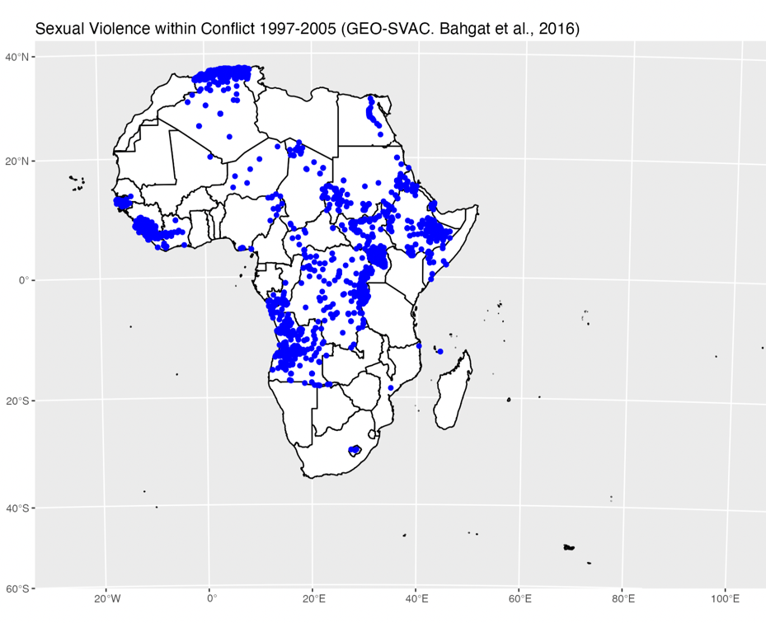
Alongside norms, the broader context remains relevant. There are competing patterns of thought regarding the avoidance of sexual violence in civil or ethnonational conflicts (Hayden, 2000) versus the presence of such violence (Cohen, 2013a, 2016). Furthermore, certain groups with stronger top-down sanctions did not show signs of engaging in sexual violence (Wood, 2009; Cohen, 2016; Viterna, 2013). This emerging lack of uniformity in the presence of sexual violence, coupled with the gendered nature of this violence, further suggests that we cannot understand the lasting impacts of such events by analyzing conflict as a whole; our understanding would benefit by accounting for such differentiation in our models.

Forging a Link to Social Capital
A prominent stream of scholarship on the interaction between conflict and social capital regards women's mobilization in conflict. Kreft (2019) proposes a mechanism for women's mobilization directly linked to the threat of conflict-based sexual violence and finds evidence of a link between higher recorded sexual violence within conflict and increased protest and associational memberships to international women's organizations. Viterna (2013) provides an in-depth, qualitative study of gendered micro-mobilization processes in El Salvador, Mama and Okazawa-Rey (2012) develop a feminist perspective on activism and militarism, and Ikelegbe (2005) analyze the role of women in civil society within Nigerian oil-orientated resource conflicts. A large body of work also looks at the role of gender, women's mobilization, and limitations faced in post-conflict peacebuilding and reconstruction processes (Manchanda, 2005; Abdullah et al., 2010; Korac, 2006). These studies all account for component parts of social capital, showing a link to conflict without directly acknowledging this.
More directly, Koos (2018) finds that sexual violence can result in increased civic engagement to avoid exclusion, with potential reconciliation pathways available within communities (Greiner, 2022). Koos & Traunmüller (2022) find further in favor of increased civic engagement and participation; however, it is still essential to consider social exclusion and retaliation towards victims and communities, which inhibit social capital growth (Greiner, 2022). Such studies interact with the aforementioned research paths emerging within existing non-gendered social capital and conflict literature, such as perceptions of the threat of exclusion driving prosocial behavior through mobilization (Gilligan et al., 2014; Bauer et al., 2014). However, much of the focus in these studies is on direct exposure, with a need to supplement this with our understanding of the violent legacies' impact on community social capital over time. This study aims to make this contribution, tying these strands of scholarship together and examining their link empirically by utilizing approaches taken within the broader conflict events literature to further our understanding of the lasting psychological impacts of sexual violence within conflict on post-conflict social capital.
Theoretical Framework
Integrating the effects of exposure to legacies of sexual violence on post-conflict social capital through associational memberships and trust would deepen our understanding of the post-conflict effects of sexual violence and what this means for post-conflict peace, rebuilding, and democracy. The first step in answering these questions and engaging with this puzzle is to include the role of gender and exposure to legacies of sexual violence in our analysis to investigate and compare the trends with traditionally gender-blind and conflict event diversity-blind studies. These additional layers will provide a foundation from which to unpick the micro-level mechanisms. From the existing literature, competing theories emerge, which will be tested within this study.
As a result of the scholarship portraying trust and exposure to conflict tied to issues of threat perception (Solomon et al., 2004; Leary, 2004; Bauer et al.,2014) and damaged social institutions and networks (Krakowski, 2012; Blattman & Annan, 2010; Blattman & Miguel, 2010) a theory emerges that; as a result of exposure to legacies of sexual violence, post-conflict social capital will decrease, as to be tested by Hypothesis 1.
H1: As a result of exposure to legacies of sexual violence, social capital will decrease.
Literature suggesting the inverse is equally compelling, with emerging altruism, pro-social behavior, and civic engagement born out of violence (Blattman, 2009; Bauer et al., 2016; Stage & Uwera, 2018; Bellows & Miguel, 2009), sexual violence (Koos. 2018; Greiner, 2022; Koos & Traunmüller, 2022) and legacies of violence (Wayne & Zhukov, 2022). The theory emerges that as a result of exposure to legacies of sexual violence, post-conflict social capital will increase, as to be tested by Hypothesis 2.
H2: As a result of exposure to legacies of sexual violence, social capital will increase.
The gender-based nature of much of this violence is theorized to have an effect. Testing for the gendered impacts of exposure is necessary, as from scholars such as Brownmiller (1975), the theory emerges that due to the identity-based nature and interpretation of sexual violence in many cases and the impact of this on perceptions of threat, post-conflict social capital will be lower among women exposed to legacies of sexual violence. This theory does not go as far as to suggest that this will decrease, as evidence from studies such as Koos (2018) and Koos & Traunmüller (2022) have noted an increase. However, I theorize women's levels will be lower than those of men, even in the case of an increase.
H3: Self-identifying women exposed to an area with a legacy of sexual violence will exhibit lower levels of post-conflict social capital than men at the same exposure level.
Finally, due to the nature of localized legacies of violence and exposure to information transfer, access, and socialization within affected areas (Wayne & Zhukov, 2022; Jennings, Stoker, & Bowers, 2009), the theory emerges that as a proximate exposure to legacies of sexual violence decreases, so will the effect of the legacy on post-conflict social capital, as represented by hypothesis 4.
H4: As proximate exposure to legacies of sexual violence decreases, we will see a decrease in the impact of the legacy of sexual violence on post-conflict social capital.
Methods
The methodology used is primarily based on that of Lewis and Topal (2022), who used spatial modeling to analyze exposure to conflict and trust. The methodology for this paper will employ a multilevel logistic regression within spatial buffers to establish the impact of proximity on the impact of legacies of violence. This method has been selected due to its ability to tie together geographical and psychological factors to analyze post-conflict social capital. The available GEO-SVAC (Bahgat et al., 2016) and ACLED (Raleigh et al., 2010) data contain the necessary exposure measures to fit into these models, allowing for a direct comparison of nuanced sexual violence events data and more generalized conflict events data. I will also employ a cumulative linked mixed model (CLMM) to account for the unclear boundaries between the ordinal categorizations of the social trust responses, enabling a more precise analysis of respondents moving between categories.
Spatial Model
In this study, proximate exposure to areas with a legacy of sexual violence will be ordinally coded, with spatial buffers of 25, 50, and 100 kilometers around conflict events. Calculating such buffers enables an in-depth, granular analysis of spatial decay in the effect of sexual violence as those exposed grow further from the event. Geocoded responses are coded at a unit level and will be entered into a multilevel logistic regression to enable both sampling unit and country-level data to be analyzed. The distance can also be held constant and used to test for interaction to see the broader impact of the legacies of sexual violence exposure on communities. Accounting for permeable borders, the cross-national data enables measurement of cross-border exposure. Lewis and Topal (2022) note that the exposure within the ACLED data is distributed along a Poisson distribution and, therefore, use the natural log of proximate exposure as the primary independent variable. This same strategy will be applied to account for the data skew.

Dependent Variable: Social Capital
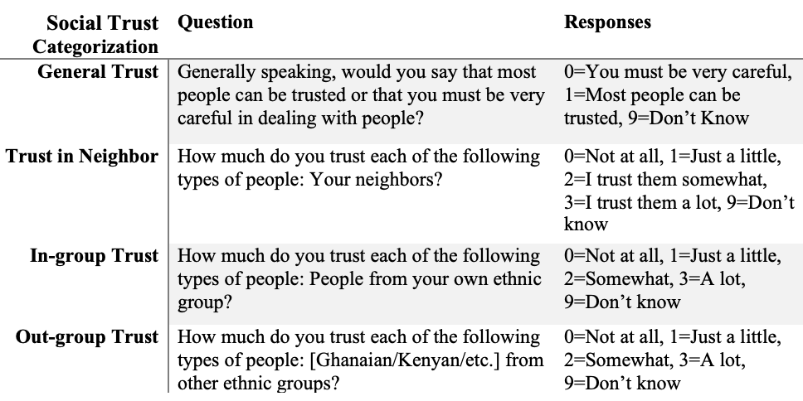
This study relies upon the geocoded Afrobarometer data, providing social trust, associational membership, and civic engagement measures across multiple African countries and years. Round 3 data provides group-based trust measures for in-group and out-group preferences, through a Likert scale of trusting responses (Afrobarometer, Round 3, 2005). A limitation is that this measure is only included in round 3 of the Afrobarometer data. The generalized trust measure used within this study will be taken from a series of Afrobarometer rounds to enable overtime measurements. The same generalized trust measure appears in the geocoded Afrobarometer rounds 1, 3, 5, and 6. A descriptive analysis of generalized trust within round 3 data suggests that this form of social trust is the lowest, with only 3,986 out of 25,397 responses indicating trustworthiness. These round 3 trust variables are coded per the labels shown in table 1.
Table 1.
Similarly, the Afrobarometer data measures associational memberships by variations of group ties alongside civic engagement via measurements of social contact points. These measures are available in different iterations across survey rounds. Round 3 associational membership measurements are taken using the following question: “Let’s turn to your role in the community. Now I am going to read out a list of groups that people join or attend. For each one, could you tell me whether you are an official leader, an active member, an inactive member, or not a member”. Measured through a 5-point Likert scale, the responses include “Not a Member,” “Inactive Member,”, “Active Member,” “Official Leader” and “Don’t Know”.
Finally, civic engagement is measured via the question, “During the past year, how often have you contacted any of the following persons for help to solve a problem or to give them your views”. Potential responses include “Never,” “Only once,” “A few times,” “Often,” and “Don’t Know”.
Independent Variable: Proximate Exposure to Areas with a Legacy of Sexual Violence During Conflict
This measure for the proximate exposure to a legacy of sexual violence within conflict is calculated using the GEO-SVAC data (Bahgat et al., 2016). GEO-SVAC contains granular event-level data, including location and date where reported. The SVAC dataset provides data points of sexual violence categorized according to three actor types: state forces, rebel groups, and pro-government militias (Cohen & Nordås, 2014a, 2014b). Due to the nature of data collection, the dataset is limited to actions of physical force, excluding elements of the broader definition such as coercion (Cohen & Nordås, 2014a, 2014b). The SVAC dataset (Cohen & Nordås, 2014a, 2014b) also provides recordings of the type of sexual violence committed where possible. The difficulty in measuring sexual violence in such data, especially among men, should be noted due to cultural taboos and a reluctance to report (Leiby, 2012). GEO-SVAC and Afrobarometer data points will be plotted according to longitude and latitude. Spatial buffers of 25, 50, and 100 km will then be drawn around each survey response point, with the conflict events within each buffer counted. Those survey respondents exposed to legacies of sexual violence will be surrounded by spatial buffers containing past sexually violent conflict events within each proximal distance.
Covariates
Gender as self-identified within the Afrobarometer data will be a central covariate within the model, as the gender-based element of sexual violence targeting women is crucial to the theoretical framework applied (Brownmiller, 1975; Cohen, 2016; Aroussi, 2017). Ethnic diversity, which is especially important in the African context, will be accounted for on a subnational level using the ethnic diversity index of Lewis and Topal (2022). Per the literature, especially the work of Rothstein and Uslaner (2011), economic inequality will be included, as drawn from the Afrobarometer's living conditions measures. Furthermore, to account for realistic conflict theory (Sherif, 1958, 1967; Sherif et al., 1988) and relative deprivation theory (Cederman, 2013; Gurr, 1970; Buhaug et al., 2014), measures of the respondent's group as being either "dominant" or "discriminated" will be employed, drawn from the EPR dataset (Lewis & Topal, 2022; Vogt et al., 2015). A central element of understanding exposure is related to information consumption; therefore, Afrobarometer news consumption data will be included. To account for regime type, the Varieties of Democracy (V-Dem) polyarchy measure will be included (Coppedge et al., 2021).
Additional Robustness Checks
The applied strategy is to include as much relevant and diverse data as is openly available, such as generalized trust measures across multiple rounds of data. However, it remains notable that further data is not readily available for group trust measures. To provide robustness to the initial Afrobarometer and GEO-SVAC models, a second model containing the Afrobarometer and ACLED sexual violence data will be developed (Kishi, 2019; Raleigh et al., 2010). This data will contain a series of different conflict events around which buffers will present trends to be compared to the initial model. Kishi (2019) reports that as of April 2019, within the ACLED data, 95% of reported events containing gender measures pertained to women and girls as victims. This figure again highlights the gendered nature of sexual violence within conflict and the disproportionate effect on women and highlights the value of including the ACLED data (Cohen, 2016; Aroussi, 2017; Brownmiller, 1975). Ideally, additional geocoded social capital data would be available, such as the World Values Survey (Haerpfer et al., 2020; Inglehart et al., 2020) and the Eurobarometer (European Commission, 2017). However, this data is not available in the geocoded form. Nevertheless, a rich body of data can be accessed.
Results
Social Trust
The results from this preliminary analysis provide consistently strong evidence to support theories suggesting that exposure to violence increases social capital (H2). For example, as shown in figures 1 and 2, the predicted probabilities that an individual will indicate increased out-group or in-group trust increase within all three buffer distances as exposure to areas with a legacy of sexual violence increases from 1 event to 10 sexually violent conflict events. Furthermore, in all regression models, there is a statistically significant co-efficient indicating that the impact of exposure to legacies of sexual violence within a conflict has an impact on increasing social trust to the 99% confidence interval for generalized trust at 25 km exposure (see appendix table 2.1) and to the 99.9% confidence interval for all further exposure measures (see appendix tables 2.2, 2.3 & 2.4).
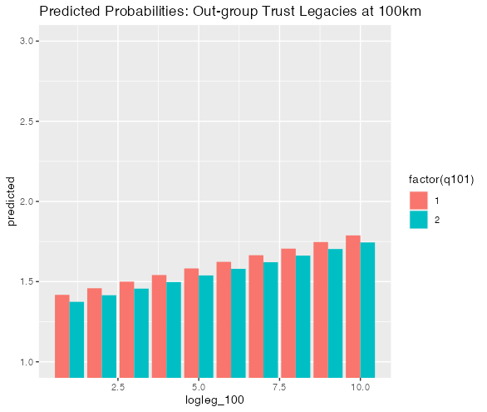
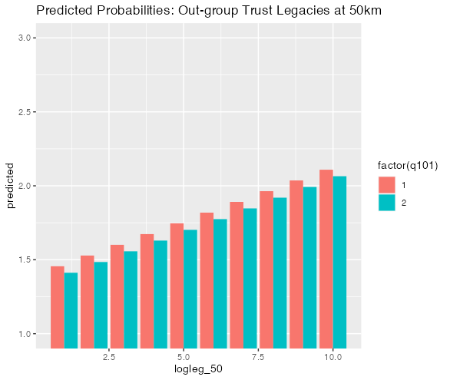
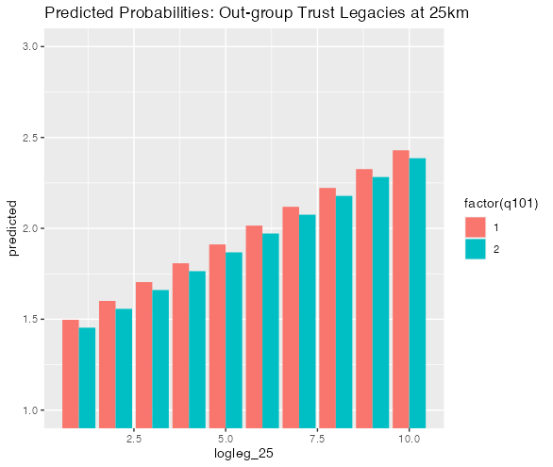
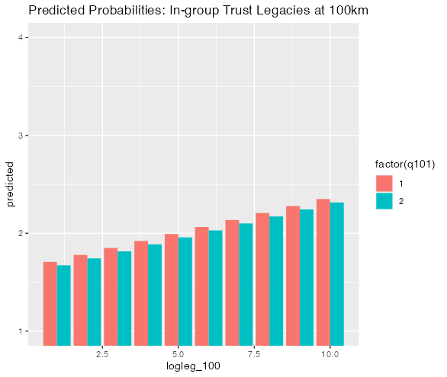
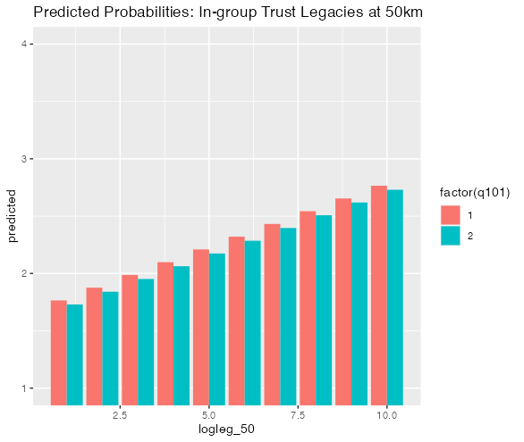
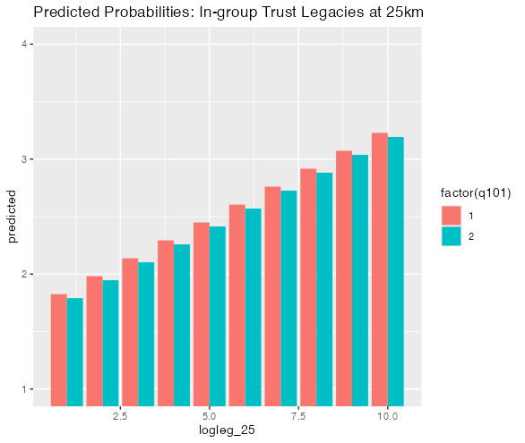
Furthermore, we find statistically significant evidence of a lower trust level in three of the four models in accordance with gender, supporting hypothesis 3. However, the exception to this finding is the measure of generalized trust, which does not indicate a statistically significant gendered impact on the level of trust. The largest and most statistically significant correlation is seen in the measure of trust in a neighbor (see appendix, table 2.2). A female respondent is likely to respond 0.059 units less trusting than a male at the same exposure level of 25 km, with a similar trend across the exposure buffers. Figures 1 and 2 demonstrate support hypothesis 3 through predicted probabilities indicating that while self-identifying female respondents also demonstrate a likelihood to show increased in-group and out-group trust as exposed to a legacy of more sexually violent conflict events, this level of trust remains lesser than that of men at the same level of exposure.
Fig 1. Predicted Probability of Out-group Trust
Fig 2. Predicted Probability of In-group Trust
Similarly, to the relationship of gender with social trust, we find evidence of spatial decay in three of our four social trust models, supporting hypothesis 4. While proximal exposure to areas with a legacy of sexual violence remains significant across all four models, the generalized trust measure does not indicate a clear pattern of decay. This, however, is not the case for the in-group, out-group, or trust-in-neighbor multivariate regression models. In all three cases, as the distance from the area with a legacy of sexual violence increases, the impact of exposure on increased trust is lessened (see appendix tables 2.2, 2.3 & 2.4). Figures 1 and 2 depict this correlation with predicted probabilities for group-based trust, indicating that while a likely increase in trust remains according to increasing numbers of sexually violent conflict events, the relationship between this increase and increasing trust is lessened as distance increases. Regarding our additional covariates added as another measure of exposure, it is notable that in three out of four models, television and newspaper news consumption correlate with decreased social trust through group-based measures and trust in neighbors.
Furthermore, radio consumption indicates the inverse response of increased trust in these cases. The findings from all models run counter to theoretical suggestions of decreasing social trust as a result of proximate exposure to legacies of sexual violence within conflict (H1); however, from these findings, further investigation is needed to examine the importance of news consumption as a proxy for exposure to violence. These preliminary results are drawn from 12 multivariate models to incorporate results across the spatial buffers.
Limitations
The potential endogeneity issue must be noted: sexual violence within conflict may occur where low social capital exists. The only measure available in earlier rounds of the Afrobarometer data is the generalized trust measure, which will be included. However, it is impossible to measure previous social capital levels, especially those before the initial violence breaks out. The GEO-SVAC data contains further events post-2005, allowing a model alongside pre-conflict social capital levels from the round 3 data (BenYishay et al., 2017). This additional analysis enables a further understanding of the emergence of sexual violence within conflict in low social capital areas. A further challenge and critique of exposure measures is community dispersion and movement during and post-conflict, which cannot be accounted for in this data. As a result, individuals and groups who may have moved due to legacies of sexual violence within conflict cannot be analyzed within this study. We may also see individuals move into these areas post-conflict. However, as we are not measuring an individual's direct exposure to the conflict event but rather their exposure to the legacies of such violence, this is less of an issue. One of the more significant limitations is the availability of geo-coded data. While it would be worthwhile to include temporal buffers as a further measure, more available data should be available. Finally, the geographic scope of this study is to be noted. This study is centered on post-conflict social capital within Africa and does not account for or test alternative regions. As a result, until additional research is conducted elsewhere, this study does not claim to be generalizable. Nevertheless, these findings correlate with existing conflict analysis across the region and further afield (Koos & Traunmüller, 2022; Koos, 2018; Kreft, 2019; Gilligan et al., 2014; Bellows & Miguel, 2009).
Conclusion & Next Steps
This study’s geospatial methods test whether exposure to legacies of observed events of sexual violence within conflict impact levels of social capital and the association of such impacts with gender. These preliminary results harnessed Afrobarometer round 3 individual-level survey data alongside observed incidents of sexually violent conflict within the GEO-SVAC dataset. Testing competing theories on the impact of conflict on social capital, these preliminary findings suggest that exposure to sexually violent conflict induces increased social trust. However, gender is a mitigating factor, with self-identifying women reporting statistically significant lower levels of social trust than men in three out of four measurement categories, suggested here as a result of an attack on gender identity, trauma, and increased perceptions of threat. Nevertheless, women are still found to show increased trust, supporting theories that to avoid exclusion and repercussions, women in communities affected by such violent turn to others and exhibit pro-social behaviors (Koos & Traunmüller, 2022; Koos, 2018). While this study finds mixed support for the hypotheses regarding generalized trust, the three alternate social trust measures provide strong support for our second, third, and fourth hypotheses concerning increasing trust with a gendered difference and spatial decay. This research aims to contribute to a growing body of literature on post-conflict social capital due to its importance in strengthening democracy, peacebuilding, and scholarship analyzing conflict diversity and how this intersects with identity.
A series of sequential steps are needed to complete this study. Following these preliminary findings, I will present a white paper to Afrobarometer as requested to access the additional rounds of geo-coded data. This step will include the additional models of round 3 data for civic engagement and associational membership. This additional data will add robustness and enable additional analysis, including rounds of data over time, to analyze the persistence of these impacts of violent legacies. Furthermore, I will add the additional covariates to this total body of data and complete the thorough, multivariate spatial analysis. Alongside this and per the Lewis and Topal (2022) approach, I will test legacy exposure specifically within country, as the current models allow for buffers to cross land borders. This has been useful due to the nature of cross-border movement across Africa; however, controlling for country-specific legacies will enable us to analyze if respondents are more impacted by legacies within their own country. Additionally, as a further endogeneity measure, I will conduct matching analyses on the regression models.
Finally, as I gain access to data over time, I will be conducting analyses on the amount of development aid within exposed communities, especially on projects centered around social cohesion, in order to test if this is further impacting the post-conflict trust-building processes apparent within these preliminary results. This research will provide a pathway to additional questions. The relationship between social capital and conflict-related information consumption warrants further attention. Furthermore, following the quantitative establishment of such trends, the impacts raised in this analysis require further qualitative study to thoroughly understand the causal processes leading to these changes within individual and community attitudes.
References
Abdullah, H. J., Ibrahim, A. F., & King, J. (2010). Women's voices, work and bodily integrity in pre‐conflict, conflict and post‐conflict reconstruction processes in Sierra Leone. IDS bulletin, 41(2), 37-45
Alcorta, L., Smits, J., Swedlund, H. J., & de Jong, E. (2020). The ‘Dark Side’of social capital: A cross-national examination of the relationship between social capital and violence in Africa. Social Indicators Research, 149(2), 445-465.
Ali, M., Khan, K., & Meo, M. S. (2022). Trust in post‐conflict life: Evidence from a conflict zone in Pakistan. Journal of Public Affairs, 22(2), e2403.
Amnesty International (2005) Women, violence and health. AI Index: ACT 77/001/2005. Accessed 11.20.2022, via; https://www.amnesty.org/en/wp-content/uploads/2021/08/act770012005en.pdf
Aroussi, S. (2017). Women, peace, and security and the DRC: time to rethink wartime sexual violence as gender-based violence? Politics & Gender, 13(3), 488-515
Baaz, M. E., & Stern, M. (2009). Why do soldiers rape? Masculinity, violence, and sexuality in the armed forces in the Congo (DRC). International studies quarterly, 53(2), 495-518
Balcells, L., & Stanton, J. A. (2021). Violence against civilians during armed conflict: Moving beyond the macro-and micro-level divide. Annual Review of Political Science, 24, 45-69
Bauer, M., Blattman, C., Chytilová, J., Henrich, J., Miguel, E., & Mitts, T. (2016). Can war foster cooperation?. Journal of Economic Perspectives, 30(3), 249-74
Bauer, M., Cassar, A., Chytilová, J., & Henrich, J. (2014). War’s enduring effects on the development of egalitarian motivations and in-group biases. Psychological science, 25(1), 47-57
Bellows, J., & Miguel, E. (2009). War and local collective action in Sierra Leone. Journal of public Economics, 93(11-12), 1144-1157
Benard. Cheryl (1994) Rape as terror: The case of Bosnia, Terrorism and Political Violence, 6:1, 29-43, DOI: 10.1080/09546559408427242
Blattman, C. (2009). From violence to voting: War and political participation in Uganda. American political Science review, 103(2), 231-247
Blattman, C., & Annan, J. (2010). The consequences of child soldiering. The review of economics and statistics, 92(4), 882-898
Blattman, C., & Miguel, E. (2010). Civil war. Journal of Economic literature, 48(1), 3-57.
Brownmiller, Susan. (1975). Against our will: Men, women and rape. New York: Simon and Schuster.
Buhaug, H., Cederman, L.-E., & Gleditsch, K. S. (2014). Square Pegs in Round Holes: Inequalities, Grievances, and Civil War. International Studies Quarterly, 58(2), 418–431.
Buss, D.E. Rethinking ‘Rape as a Weapon of War’. Fem Leg Stud 17, 145–163 (2009). https://doi.org/10.1007/s10691-009-9118-5
Cassar, A., Grosjean, P., & Whitt, S. (2013). Legacies of violence: trust and market development. Journal of Economic Growth, 18, 285-318.
Cederman, L.-E., Gleditsch, K. S., & Buhaug, H. (2013). Inequality, grievances, and civil war. Cambridge University Press.
Cohen, D. K. (2013a). Explaining rape during civil war: Cross-national evidence (1980–2009). American Political Science Review, 107(3), 461-477
Cohen, D. K. (2013b). Female combatants and the perpetration of violence: Wartime rape in the Sierra Leone civil war. World Politics, 65(3), 383-415.
Cohen, D. K. (2016). Rape during civil war. Cornell University Press.
Cohen, D. K., & Nordås, R. (2014a). Sexual violence in armed conflict: Introducing the SVAC dataset, 1989–2009. Journal of peace research, 51(3), 418-428
Coleman, James S. (1988). “Social Capital in the Creation of Human Capital.” American Journal of Sociology 94:95–120.
Daphna‐Tekoah, S., & Harel‐Shalev, A. (2017). The politics of trauma studies: what can we learn from women combatants' experiences of traumatic events in conflict zones?. Political Psychology, 38(6), 943-957
De Luca, G., & Verpoorten, M. (2015). Civil war, social capital and resilience in Uganda. Oxford economic papers, 67(3), 661-686
Dinesen, C., Ronsbo, H., Juárez, C., González, M., Estrada Méndez, M. Á., & Modvig, J. (2013). Violence and social capital in post-conflict Guatemala. Revista panamericana de salud publica, 34(3), 162-168
Gaggioli, Gloria. (2014). “Sexual Violence in Armed Conflicts: A Violation of International Human Rights and International Humanitarian Law,” International Review of the Red Cross 96, no. 894 503–538.
Gilligan, M. J., Pasquale, B. J., & Samii, C. (2014). Civil war and social cohesion: Lab‐in‐the‐field evidence from Nepal. American Journal of Political Science, 58(3), 604-619.
Greiner, Alina. (2022). Social Legacies of Civil War : Gendered Consequences of Conflict. Universität Konstanz
Gurr, T. R. (1970). Why Men Rebel (40th Anniv). Paradigm.
Hall, J., & Werner, K. (2022). Trauma and Trust: How War Exposure Shapes Social and Institutional Trust Among Refugees. Frontiers in psychology, 13
Hartman, A.C., & Morse, B.S. (2018). Violence, Empathy and Altruism: Evidence from the Ivorian Refugee Crisis in Liberia. British Journal of Political Science, 50, 731 - 755.
Hayden, R. M. (2000). Rape and rape avoidance in ethno‐national conflicts: sexual violence in liminalized states. American Anthropologist, 102(1), 27-41
Huvé, S. (2018). The use of UN Sanctions to address conflict-related sexual violence. Georgetown Institutes for Women, Peace and Security. Accessed 11.20.2022 via; http://giwps.georgetown.edu/wp-content/uploads/2018/03/Use-of-UN-Sanctions-to-Address-Conflict-related-Sexual-Violence.pdf
Ikelegbe, A. (2005). Engendering civil society: Oil, women groups and resource conflicts in the Niger Delta region of Nigeria. The Journal of Modern African Studies, 43(2), 241-270
Jackson, J. W. (1993). Realistic group conflict theory: A review and evaluation of the theoretical and empirical literature. The Psychological Record, 43(3), 395
Jennings, M. Kent, Stoker, Laura, and Bowers, Jake. 2009. “Politics Across Generations: Family Transmission Reexamined.” Journal of Politics 71, no. 3: 782–99.
Johansson, K., & Sarwari, M. (2019). Sexual violence and biased military interventions in civil conflict. Conflict Management and Peace Science, 36(5), 469-493
Kijewski, S., & Freitag, M. (2018). Civil war and the formation of social trust in Kosovo: Posttraumatic growth or war-related distress?. Journal of conflict resolution, 62(4), 717-742
Koos, C. (2018). Decay or resilience?: the long-term social consequences of conflict-related sexual violence in Sierra Leone. World Politics, 70(2), 194-238
Koos, Carlo, & Richard Traunm¨uller. 2022. The social and political consequences of wartime sexual violence: New evidence from list experiments in three conflict-affected populations. Working Paper, WIDER Working Paper 11/2022. Helsinki, Finland: United Nations University. Accessed March 18, 2023. https://www.wider.unu.edu/ sites/default/files/Publications/Working-paper/PDF/wp2022-11-social-political-consequences-wartime-sexual-violence.pdf
Korac, M. (2006, September). Gender, conflict and peace-building: Lessons from the conflict in the former Yugoslavia. In Women's Studies International Forum (Vol. 29, No. 5, pp. 510-520). Pergamon.
Krakowski. Krzysztof. (2021). The Social Legacies of Conflict: Unexpected Relationship Between Political Violence and Pro-Social Behavior. In Interpretar sociedades (1st ed., p. 191–). Editorial Universidad del Norte.
Kreft, A. K. (2019). Responding to sexual violence: Women’s mobilization in war. Journal of Peace Research, 56(2), 220-233
Leary, M. R. (2004). The Function of Self-Esteem in Terror Management Theory and Sociometer Theory: Comment on Pyszczynski et al. (2004). Psychological Bulletin, 130(3), 478–482. https://doi.org/10.1037/0033-2909.130.3.478
Leatherman, J. (2007). Sexual violence and armed conflict: Complex dynamics of re-victimization. International Journal of Peace Studies, 53-71
Leatherman, J. (2011). Sexual violence and armed conflict. Polity.
Leiby, M. (2012). The promise and peril of primary documents: documenting wartime sexual violence in El Salvador and Peru. Understanding and proving international sex crimes, 343
Mama, A., & Okazawa-Rey, M. (2012). Militarism, conflict and women's activism in the global era: Challenges and prospects for women in three West African contexts. Feminist Review, 101(1), 97-123.
Manchanda, R. (2005). Women's agency in peace building: Gender relations in post-conflict reconstruction. Economic and Political Weekly, 4737-4745
Matusitz, J. (2017). Gender communal terrorism or war rape: ten symbolic reasons. Sexuality & Culture, 21(3), 830-844
McDermott, R. (2020). The role of gender in political violence. Current Opinion in Behavioral Sciences, 34, 1-5
McKenzie, J., & Gabriel, T. (2017). Applications and extensions of realistic conflict theory: moral development and conflict prevention. In Norms, groups, conflict, and social change (pp. 307-324). Routledge.
Mironova, V.N., & Whitt, S. (2016). Social Norms after Conflict Exposure and Victimization by Violence: Experimental Evidence from Kosovo. British Journal of Political Science, 48, 749 - 765.
Muminovic, A., & Efendic, A. (2022). T`he long-term effects of war exposure on generalized trust and risk attitudes: evidence from post-conflict Bosnia and Herzegovina. Southeast European and Black Sea Studies, 1-18
Nagel, R. U., & Doctor, A. C. (2020). Conflict-related sexual violence and rebel group fragmentation. Journal of Conflict Resolution, 64(7-8), 1226-1253
Nordås, R., & Cohen, D. K. (2021). Conflict-related sexual violence. Annual Review of Political Science, 24, 193-211.
Putnam, R. (1993). The prosperous community: Social capital and public life. The american prospect, 13(4)
Putnam, R. (2001). Bowling alone: The collapse and revival of American community. Simon & Schuster.
Report of the United Nations Secretary General (2019) Conflict related sexual violence. Office of the Special representative of the secretary-general on sexual violence in conflict. Accessed 11.20.2022 via; https://peacekeeping.un.org/sites/default/files/annual_report_of_the_sg_on_crsv_2018.pdf
Report of the United Nations Secretary General (2021) Conflict related sexual violence. Office of the Special representative of the secretary-general on sexual violence in conflict. Accessed 11.20.2022 via; https://www.un.org/sexualviolenceinconflict/wp-content/uploads/2022/04/auto-draft/SG-Report2021for-web.pdf
Rothstein, B., & Uslaner, E. M. (2011). All for all: Equality, corruption, and social trust. World Politics, 58(1), 41-72. https://doi.org/10.1353/wp.2006.0022
Schneider, G., Banholzer, L., & Albarracin, L. (2015). Ordered rape: A principal–agent analysis of wartime sexual violence in the DR Congo. Violence against women, 21(11), 1341-1363
Seeberg, Roepstorff, A., & Meinert, L. (2020). Legacies of Violence: The Communicability of Spirits and Trauma in Northern Uganda. In Biosocial Worlds. UCL Press.
Sherif, M. (1958). Superordinate goals in the reduction of intergroup conflict. The American Journal of Sociology, 63, 349–356.
Sherif, M. (1967). Group Conflict and Co-operation: Their Social Psychology (1st ed.). Psychology Press
Sherif, M., Harvey, O. J., White, B. J., Hood, W. R., & Campbell, D. T. (1988). The Robbers Cave experiment: Intergroup conflict and cooperation. Wesleyan University Press.
Sivakumaran, S. (2007). Sexual violence against men in armed conflict. European journal of international law, 18(2), 253-276
Solomon, S., Greenberg, J., & Pyszczynski, T. (2004). The Cultural Animal: Twenty Years of Terror Management Theory and Research. In J. Greenberg, S. L. Koole, & T. Pyszczynski (Eds.), Handbook of Experimental Existential Psychology (pp. 13–34). Guilford Press.
Stage, J., & Uwera, C. (2018). Social cohesion in Rwanda: Results from a public good experiment. Development Policy Review, 36(5), 577-586
Stiglmayer, Alexandra (ed.). (1994). Mass rape: The war against women in Bosnia-Herzegovina. Lincoln, NE: University of Nebraska Press.
Traunm¨uller, Richard, Sara Kijewski & Markus Freitag. (2019). “The Silent Victims of Sexual Violence during War: Evidence from a List Experiment in Sri Lanka.” Journal of Conflict Resolution 63 (9): 2015–2042.
UN Committee on the Elimination of Discrimination Against Women (CEDAW), (1992). CEDAW General Recommendation No. 19: Violence against women. Accessed 11.25.2022 via; https://www.refworld.org/docid/52d920c54.html
Uslaner, E. M. (1998). Social capital, television, and the “mean world”: Trust, optimism, and civic participation. Political psychology, 19(3), 441-467
Uslaner, E. M. (1999). Trust but verify: Social capital and moral behavior. Social Science Information, 38(1), 29-55
Uslaner, E. M. (2002). The Moral Foundations of Trust. Cambridge University Press
Uslaner, E. M. (2013). Trust as an alternative to risk. Public Choice, 157(3), 629-639
Viterna, J. (2013). Women in war: The micro-processes of mobilization in El Salvador. Oxford University Press.
Vogt, M., Bormann, N.-C., Ruegger, S., Cederman, L.-E., Hunziker, P., & Girardin, L. (2015). Integrating data on ethnicity, geography, and conflict: The ethnic power relations dataset family. Journal of Conflict Resolution , 59(7), 1327– 1342.
Waylen, G. (Ed.). (2017). Gender and informal institutions. Rowman & Littlefield.
Wayne, C., & Zhukov, Y. (2022). Never Again: The Holocaust and Political Legacies of Genocide. World Politics, 74(3), 367-404.
Weidmann, N. B., & Zürcher, C. (2013). How wartime violence affects social cohesion: the Spatial–Temporal gravity model. Civil Wars, 15(1), 1-18
Werner, K. (2016). Whom do people trust after a violent conflict? Experimental evidence from Maluku, Indonesia (Vol. 73, No. 16). Passauer Diskussionspapiere-Volkswirtschaftliche Reihe.
Wood, E. J. (2006). Variation in sexual violence during war. Politics & Society, 34(3), 307-342.
Wood, E. J. (2009). Armed groups and sexual violence: When is wartime rape rare?. Politics & Society, 37(1), 131-161
Datasets:
Afrobarometer Data, 12 countries, Merged Round 1, 1999-2001, available at https://www.afrobarometer.org/data/merged-data/
Afrobarometer Data, 18 countries, Merged Round 3, 2005, available at https://www.afrobarometer.org/survey-resource/merged-round-3-data-18-countries-2005/
Afrobarometer Data, 34 countries, Merged Round 5, 2011-13, available at https://www.afrobarometer.org/data/merged-data/
Bahgat, Karim; Ragnhild Nordås, and Gudrun Østby (2016). Geocoded SVAC Dataset (GEO-SVAC) version 1.0. Peace Research Institute Oslo (PRIO). Accessed 11.21.2022, via; https://www.prio.org/data/8
BenYishay, A., Rotberg, R., Wells, J., Lv, Z., Goodman, S., Kovacevic, L., Runfola, D. (2017). Geocoding Afrobarometer Rounds 1 – 6: Methodology & Data Quality. AidData. Available online at http://geo.aiddata.org.
Cohen, Dara Kay & Ragnhild Nordås. (2014b). Sexual Violence in Armed Conflict Dataset. Accesses 11.21.2022 via; the Sexual Violence in Armed Conflict Dataset website: http://www.sexualviolencedata.org
Coppedge, M., Gerring, J., Knutsen, C. H., Lindberg, S. I., Teorell, J., Altman, D., Bernhard, M., Cornell, A., Fish, M. S., Gastaldi, L., Gjerløw, H., Glynn, A., Hicken, A., Lührmann, A., Maerz, S. F., Marquar, K. L., & Ziblatt, D. (2021). V-Dem Codebook v11.1. Varieties of Democracy (V-Dem) Project. https://www.v-dem.net/media/filer_public/6b/53/6b5335f9-cb2b-4bc8-a05c-3790ce1b7af4/codebook_v111.pdf
European Commission (2017). Eurobarometer 87.3: Standard Eurobarometer 87, May 2017. Ann Arbor, MI: GESIS [distributor], Inter-university Consortium for Political and Social Research [distributor], 2017-12-22. https://doi.org/10.3886/ICPSR36876.v1
EVS (2021). EVS Trend File 1981-2017. GESIS Data Archive, Cologne. ZA7503 Data file Version 2.0.0, https://doi.org/10.4232/1.13736.

Haerpfer, C., Inglehart, R., Moreno, A., Welzel, C., Kizilova, K., Diez-Medrano J., M. Lagos, P. Norris, E. Ponarin & B. Puranen et al. (eds.). (2020). World Values Survey: Round Seven – Country-Pooled Datafile. Madrid, Spain & Vienna, Austria: JD Systems Institute & WVSA Secretariat. doi.org/10.14281/18241.1
Inglehart, R., Haerpfer, C., Moreno, A., Welzel, C., Kizilova, K., Diez-Medrano J., M. Lagos, P. Norris, E. Ponarin & B. Puranen et al. (eds.). (2020). World Values Survey: All Rounds – Country-Pooled Datafile. Madrid, Spain & Vienna, Austria: JD Systems Institute & WVSA Secretariat [Version: http://www.worldvaluessurvey.org/WVSDocumentationWVL.jsp].
Kishi, Roudabeh. (23 April 2019) “Sexual Violence in the ACLED Dataset”. Armed Conflict Location & Event Data Project (ACLED). Accessed 11.21.2022, via; https://acleddata.com/2019/04/23/sexual-violence-in-the-acled-dataset/#_ftn3
Raleigh, C., Linke, A., Hegre, H., & Karlsen, J. (2010). “Introducing ACLED: An armed conflict location and event dataset: Special data feature”. Journal of Peace Research, 47(5), 651-660. https://doi.org/10.1177/0022343310378914

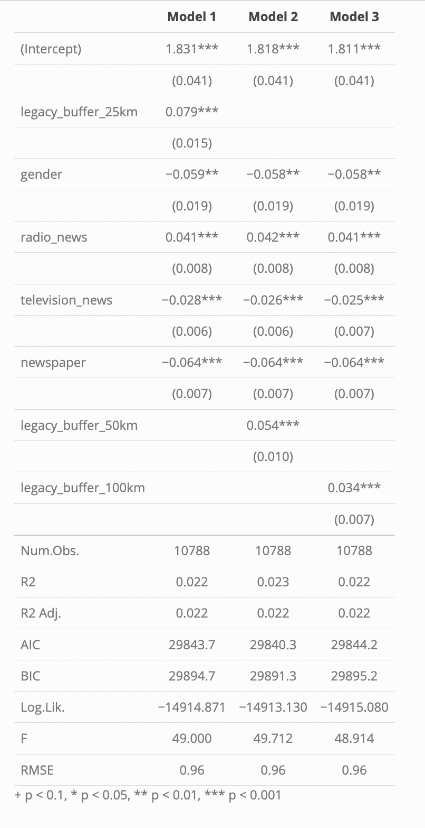
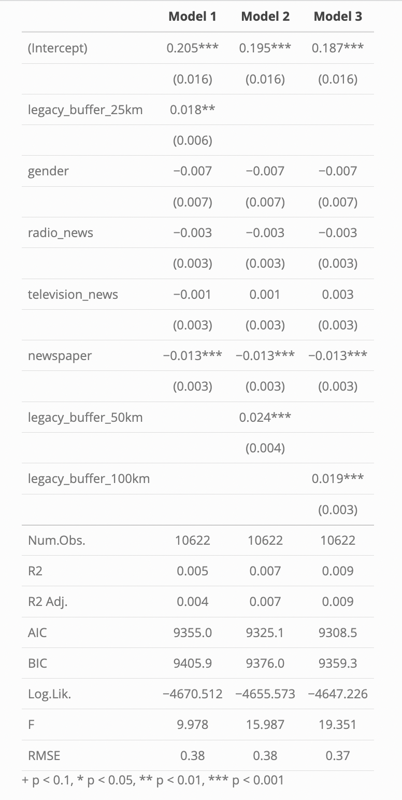
Appendix
Table 2.2: Trust in Neighbor
Table 2.1: Generalized Trust

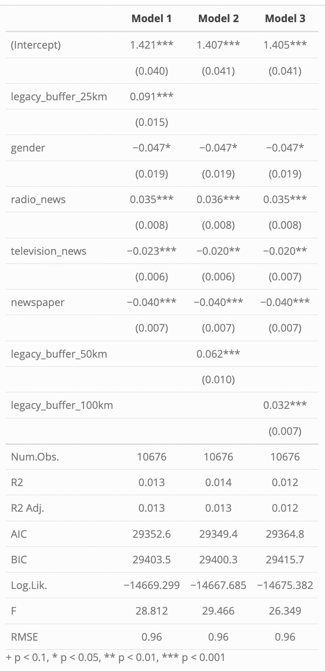
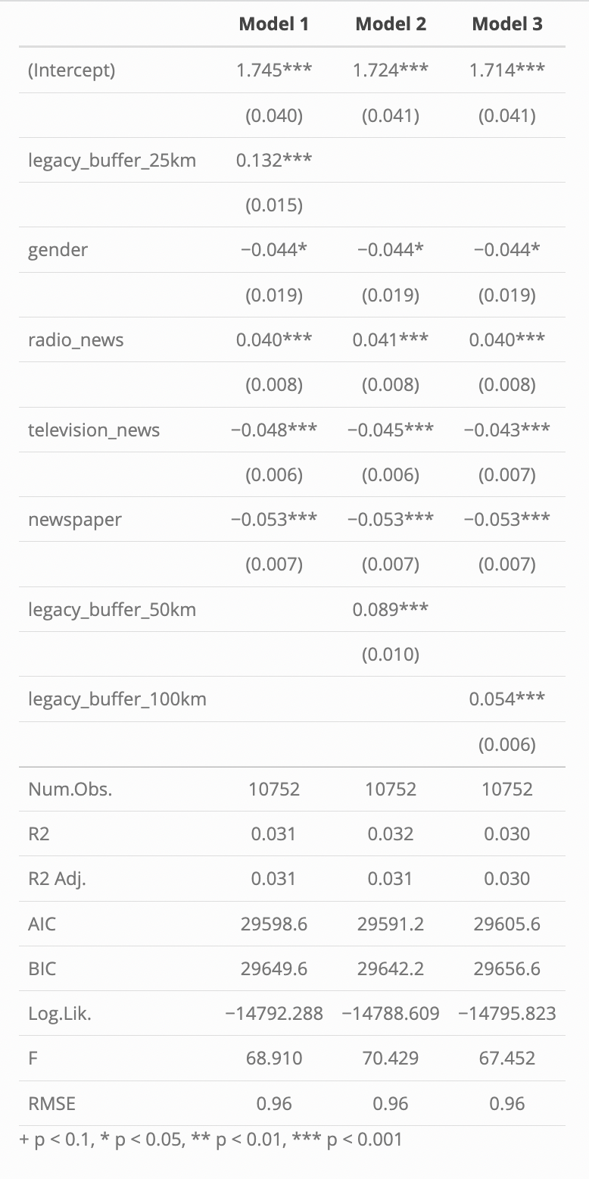
Table 2.3: Out-Group Trust
Table 2.4: In-Group Trust

