Double Jeopardy and the Northern Spotted Owl: A New Challenge for the Endangered Species Act?

Abstract

The primary mechanism the Endangered Species Act employs, habitat protection, has been critical to the Act’s current success, and scholarly consensus acknowledges habitat protection is the largest indicator for species’ survival (National Research Council, 1995). This paper, however, posits that this strength may become the structural downfall of the ESA. Double jeopardy in forest management literature refers to the interaction effect of invasive species competition and climate change as an explanation for the acceleration of biodiversity loss. As suitable habitats continue to shrink due to anthropocentric factors, invasive species will be pushed to ecological reserves set aside for threatened and endangered species without any suitable alternative. Though this phenomenon is not yet seen on a large scale, this article leverages the case study of the Northern spotted owl (NSO) and barred owl (BO). As barred owls have migrated to the old-growth forests of the Pacific Northwest due to the effects of climate change and anthropocentric activity in its native habitat, this has placed barred owls and Northern spotted owls in direct competition. This has caused Northern spotted owl populations to decline despite previously being on target for federal recovery plans in the 1990s. Using this as a case study to understand the double jeopardy principle and the Endangered Species Act, this paper addresses if there is a causal link between Endangered Species Act intervention (listing) and population decline of Northern spotted owls. Without the protection of the Endangered Species Act, this paper finds that the Northern spotted owl populations in British Columbia experience slower population decline. This suggests that setting aside ecological reserves through habitat protection mechanisms may in fact produce the opposite effect to the one desired for cases where double jeopardy is in play.

Introduction

In the Anthropocene, it is unsurprising that anthropocentric activity and resulting habitat loss have dramatically altered biodiversity. While the Endangered Species Act and other biodiversity conservation policy regimes have had historical success with habitat protection, this paper interrogates if this operating assumption that habitat protection is the necessary and sufficnet condition for species survival can remain true in the future. There are two threats that seek to challenge this assumption: invasive species and climate change.

I turn to two foundational questions to frame this emerging research agenda concerned with biodiversity policy structural integrity in the face of both climate and invasive threats. Is habitat protection alone enough anymore? Will it be sufficient in fifty years, or does the threat posed by invasive species require something more? These questions dive into the heart of biodiversity scholarship. If habitat protection is no longer a necessary and sufficient condition for conservation, we must re-evaluate what conditions collectively are. In the context of this paper, I narrow these questions to investigate if there is merit for the theoretical concerns raised here in the case of the Northern spotted owl.

Put in empirical terms, this paper evaluates the following question: is there a causal link between Endangered Species Act intervention (listing) and population decline of Northern spotted owls? I make the argument that Northern spotted owl is a double jeopardy case study, so if the answer to the question above is yes, this supports the theoretical concern that habitat protection alone may be insufficient to address endangered species meeting the climate and invasive criteria for double jeopardy.

Habitat Protection and Endangered Species Survival

Though it is difficult to pinpoint a definitive start date, the conservation movement has acknowledged habitat protection as an effective mechanism for species conservation efforts at least since the mid-19th century. The earliest recorded formal conservation program was critically dependent on habitat protection based off experimental data generated by a research group headed by Alexander Gibson (Stebbing 1922). This program began in India in 1842 and pioneered a model of species conservation that diffused to other parts of the British Empire and eventually the United States. The United States in turn created its own national parks system and own conservation law based on this earlier model developed in India.

The Endangered Species Act operates on the same assumption that there is an inherent link between habitat protection and species survival. In fact, the body of the law provides us with several explicit statements of this assumption; the first statutory consideration under (16 U.S.C. 1533) is “the present or threatened destruction, modification or curtailment of its habitat or range". Sections 4 and 7, where the Act derives most of its power, are also critically dependent on this assumption. The National Research Council (1995) noted, “Habitat has become the central ingredient, and the ESA, in emphasizing habitat, reflects the current understanding of the crucial biological role habitat plays for species”.

Given that habitat protections and provisions directly related to habitat protection have played such a crucial role in the ESA regime, there is clearly some success to be had with habitat protection alone. Greenwald et al. (2019) present an alternative measurement for ESA efficacy through extinction rates. To date, only four species have gone extinct following protection, though there are an additional 23 that are possibly extinct after listing (ibid). 40 species have fully recovered according to their federal recovery plans, including over two dozen in the last decade (ibid).

Certainly, there are a great many success stories that directly resulted from critical habitat protection such as those of the California least tern, Inyo California towhee, Atlantic piping plover, or the Steller sea lion (Suckling et al. 2012). All of these cases were dramatically impacted by human activity, development, recreational crowding of critical breeding/nesting areas, hunting and so on. It follows that these cases should be ESA success stories given that humans were the largest predictor of population decline for these cases. But what happens when that isn’t the case?

Theory and Double Jeopardy Framework

Indeed, some species face threats that are related to, but not directly caused by, anthropocentric activities. In many cases, climate change plays a leading role in the decline of a species. A recent example of this type of threat can be seen in Alaska. The Alaska Department of Fish and Game (ADF&G) have had to call off the 2022/23 Bering snow crab season for the first time due insufficient stock. As recently as 2018, NOAA estimated there were approximately 8 million crabs in the Bering Sea region (NOAA 2022). Startlingly, in 2021, their estimate plummeted to 1 billion (ibid). Miranda Westphal of the ADF&G cites particularly warm water in the Bering Sea in the 2018, 2019, and 2021 seasons as major contributing factors (Wetzel 2022).

Another type of threat related to anthropocentric activity that often impacts species listed on the ESA are those posed by invasive species. A recent review of endangered and threatened species under the Endangered Species Act found evidence of invasive species threat in 85 of the 116 tested cases (Duemas 2018). The overwhelming consensus indicates that these effects are the most exacerbated on islands and in marine environments. Another key takeaway to consider is that the main culprits are usually the same across invasive species. Feral cats and rats are the largest threats to terrestrial vertebrates (Duemas 2018). However, the mechanisms invasive species impact endangered species through may be less clear.

Take the example of the European green crab for a demonstration of how invasive species often outcompete and subsequently alter the habitat to be unsuitable for native endangered species. Take Washington state as a more specific case study on the devastating impact these crabs can pose. Originally seen in Washington in 1996, the crab’s population gains have been staggering in just the past few years; populations along Washington’s coast and Puget Sound have increased 5,500% from 2019 to 2021 (Sobieszczyk & Lawrence 2022). The crab has eroded critical salmon habitat by eating and living in eelgrass in addition to disturbing areas of sediment which create further obstacles for adult salmon to return upstream to spawn (ibid). There has been little success in invasive removal, and salmon species are projected to remain stagnant or decrease despite more aggressive breeding and recovery plans (ibid). From this example, we can derive the three major categories of threats imposed by invasive species: (1) accelerating competition for resources in the habitat as the invasive population outstrips the native populations (out-populating and out-competing), (2) erosion of habitat due to invasive species use, and (3) direct consumption of critical resources such as food sources or habitat (out-consuming).

Obviously, the threats posed by climate change and invasive species can be devastating on their own, but this is nothing compared to the devastation in cases where both are present. Double jeopardy in forest management literature refers to the interaction effect of invasive species competition and climate change as an explanation for the acceleration of biodiversity loss (Mainka and Howard 2010). Put simply, the double jeopardy principle argues that invasive species fleeing climate change in their native habitats pose an increasingly accelerated threat to species with critical habitat protection typically already facing the effects of climate change themselves.

Climate change and resulting increases in wildfires, extreme warming events, changes in rainfall, etc. cause invasive species to seek out new habitats. Meanwhile, these effects of climate change also impact the protected habitat’s carrying capacity, dwindling the habitat’s ability to support the endangered species already living in the habitat. Add increased invasive competition into these protected areas due to climate change and other anthropocentric factors pushing the invasive species away from their native ranges and into these protected areas, and some species may be paradoxically better off in unprotected habitat with higher concentrations of anthropocentric activity. This is double jeopardy in action.

Functionally, the habitat protection under Section 4 forms a bioreserve “island”, rich in resources to support the recovery plan of the endangered species in that habitat (Suckling et al. 2012). As invasive species are pushed out of their native ranges by climate change, these islands present an oasis of sorts, and the invasive species push in (Gallardo and Aldridge 2013). Their numbers and adaptability allow for them to outcompete the protected species the habitat was set aside for, making the protected species worse off than if the land hadn’t been managed in the first place (Mainka and Howard 2010). This makes the species listed under ESA protection particularly vulnerable to the effects of double jeopardy as climate change and the associated invasive threat continue to accelerate and exacerbate one another accordingly.

As addressed in the literature review, habitat protection as an intervention has worked for many species under ESA protection. As the argument goes, habitat protection and mitigating (and in some cases, outright eliminating) anthropocentric causes of population decline should eliminate the two biggest drivers of biodiversity loss: habitat loss and interaction with humans. However, this fails to address if this is a one-size-fits all strategy. In cases where interactions with humans do play a large role in species decline, it follows that intervening to mitigate human contact should result in a steady population increase.

Marine sea turtles are a great success story here; all seven species are listed as Threatened or Endangered but have steadily regained population following the mandatory installation of turtle excluder devices on shrimp boats in the Gulf (one of the primary reasons for population decline) and protection of nesting grounds (Suckling et al. 2012). In this case, habitat and human-focused interventions are necessary and sufficient conditions for species recovery because habitat and anthropocentric activities were primary factors in population decline. However, what about cases with mixed anthropocentric and environmental drivers of population decline?

Take the Steller Sea Lion for example. NOAA Fisheries identify five main causes for species population decline: effects of fisheries on prey, climate change, disease and parasites, toxic substances, and human-caused injury and mortality (NOAA 2021). Since its listing as endangered, the western distinct population segment has slowly increased its population largely through the mechanism of habitat protection. Commercial fishing operations used to kill many western DPS sea lions each year as did entanglement in fishing line and toxic waste exposure from maritime industries. The listing intervention in 1990 (notably, at the same time as the Northern spotted owl) have resulted in a slow increase in population due to the elimination of many human-caused injuries in the sea lion’s habitat. However, ocean acidification, harmful algal blooms and climate-change-related shifts in distribution of other species that carry parasites and disease the sea lions cannot ward off still remain large threats. It is unlikely that this species will ever meet the criteria for full recovery due to these environmental threats posed by ocean warming events and associated risks.

Thus, we should theoretically expect lower population growth rates for species listed with both anthropocentric and environmental factors of decline compared to those with only or primarily anthropocentric factors of decline. Furthermore, in cases where the scale is tipped opposite to cases like marine sea turtles (more environmental factors drive population decline than anthropocentric factors), we can extrapolate this argument. It would suggest that these populations will stagnate or continue to decline even after listing as the intervention methods used, habitat protection and the limitation of anthropocentric activity, are not addressing the root cause of the decline.

Case Study: The Northern Spotted Owl

The spotted owl case is particularly salient in the literature surrounding the Endangered Species Act given its political past . However, this is not the motivation for leveraging the spotted owl case for this analysis. Originally listed under ESA protection as threatened in June 1990, the NSO faces several challenges in meeting its federal recovery plan including, but not limited to, the conditions necessary for a double jeopardy case (explained below). Beyond meeting these necessary conditions, this case lends itself to causal analysis for double jeopardy possibly posing a structural threat to ESA success rates.

The vast majority of this species resides in the United States between the Cascades and Pacific Coast, but its native range also extends into Canadian British Columbia. Canadian northern spotted owls have been left relatively alone, comparatively speaking, from the time the owls were listed as threatened under ESA protection in 1990 to the present day. Outside of establishing the British Columbia Northern Spotted Owl Breeding Program and Special Resource Management Zones, there is no overarching policy regime designed to mitigate biodiversity loss at a federal level, nor are there any management mechanisms designed to prevent habitat incursion of barred owls onto NSO territory. Furthermore, there are very few designated habitat areas under protection specific to the NSO in Canada. Hence, these Canadian owls serve as a control group for this analysis. This counterfactual comparison is the motivation for the case study of the northern spotted owl.

The literature identifies barred owls as the primary threat to Northern spotted owl survival. How then do barred owls threaten the Northern spotted owls? And do they do so as a result of climate change? Using the three categories of invasive mechanisms defined previously, let us explore how this case qualifies as a double jeopardy example from the invasive perspective and then proceed to the climate perspective.

Out-Populating, Out-Consuming and Out-Competing

Franklin et al. (2021) identify eleven census areas of breeding pairs for NSO habitat and gauge the rate of relative decline of the local population with respect to barred owl influx. The findings are staggering; there is a significant inverse proportional association with barred owl population and northern spotted owl population over time (ibid). This can also be seen in several breeding studies; NSO breeding pairs are on the decline largely as a result of barred owl breeding behaviors discussed below. Barred owls, therefore, are out-populating NSOs.

It follows that with larger populations, the barred owl will place an increasingly greater strain on limited resources such as food in the habitat. Northern spotted owls’ diet largely consist of Northern flying squirrels, red tree voles, and woodrats. Conversely, barred owls tend to be less choosy, but still largely depend on those small mammals, though their diet may also include some small crustaceans and fish (Jenkins et al. 2021). Barred owls also tend to eat more given their larger size. Furthermore, many of these small rodents are found under the protective forest canopy, which barred owls tend to push spotted owls out of for reasons discussed below (ibid). In short, the barred owls consume more of the small rodents spotted owls depend on and then push them to areas where even fewer of those rodents live (ibid).

Furthermore, Diller et al. (2016) conducted a meta-analysis on barred owl removal programs in southern and central Oregon, and concluded that these programs can lead to successful rehabilitation for local NSO populations. Put another way, there is a demonstrated strong positive association with barred owl removal and NSO population in a given census area. Ergo, the barred owls must be out competing the NSOs due to their larger population. Otherwise, the removal of barred owls would have little effect on the NSO population.

Erosion of Habitat

In this case, the erosion of habitat is largely induced by limiting habitat via barred owl behaviors. This primary reason behind these behaviors is because barred owls (which are significantly larger than spotted owls) are incredibly territorial once they establish a nest, even more so upon rearing chicks (Jenkins et al. 2021). Barred owls are known to chase away intruders by aggressively hooting or attacking competitors directly, and have even been theorized to cause human deaths (Bargmann 2016). Barred owls force spotted owls from their territories, or in rare cases where the spotted owl is allowed to stay, barred owls are known to breed with spotted owls, limiting breeding pair opportunities for the NSO partner as barred owls mate for life (Carey 2016).

In cases where the spotted owl is simply pushed out of its habitat, the likelihood of that individual reproducing plummets (Jenkins et al. 2021). This is due to a stopping of mating-inducing behaviors like vocalizing, which makes it difficult for other members of their species to find them (Carey 2016). The Environmental Protection Information Center hypothesized this to be a survival behavior to prevent the individual becoming easy prey for larger raptors outside the protective canopy the spotted owls rely on (ibid).

Barred Owl Migration and Climate Change

Barred owls have been seen consistently in the Pacific Northwest since the mid-1980s, but this is not their native range. Sobieszczyk (2021) details the migration of barred owls to the West Coast from the Southeast to the Great Lakes region before resettlement largely on the West Coast. This migratory behavior started in the 1950s as the owls followed new forest corridors across the Great Plains due to increasingly warm summers which pushed them north and west (ibid). Eventually, the owls resettled in the Pacific Northwest in the 1980s, increasing their population logarithmically after a jump in the mid-1990s.

Northern Spotted Owls and Climate Change

Endangered species, particularly those in cooler climates, are already experiencing disproportionate effects of climate change through the increased prevalence in wildfires or warming events. The National Interagency Fire Center compiles annual wildland fire statistics for federal and state agencies, which are communicated through Situation Reports. In the time series visualization below, there is a noticeable departure in annual acreage burn cycles in the early 2000s. This change from two to three-year cycles cresting in a peak burn to every year at least matching historic peak burn levels with drastic new heights every other year is startling.
The new peak of these post-2005 wildfire burn cycles now include massive jumps in peak burn years an order of magnitude greater than what burned in the 1980s and 1990s.

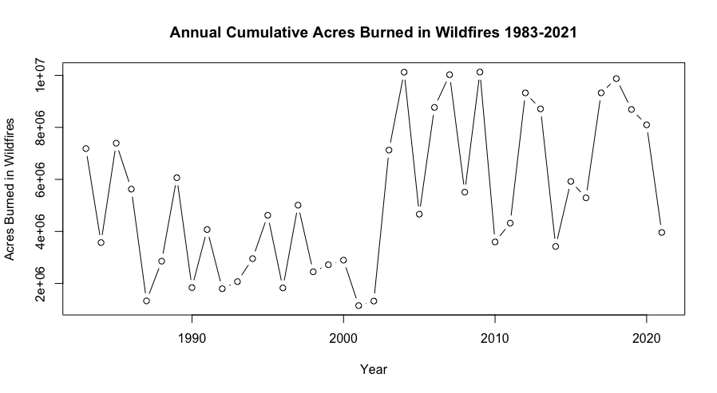
Fig. 1, “Annual Cumulative Acres Burned in Wildfires 1983-2021, United States”

However, if we compare this federal time series plot to just examine California, we see a relatively stable five year average burn cycle from the 1980s, 1990s and into the 2000s. In the mid 2000s, there was a wave of higher burn years followed by a relative stabilization until the mid 2010s when another wave of high burns hit. The stable cycles of the past are long gone; each season is extremely volatile, culminating in a record breaking 2020 season, a year when the federal time series reflects a downturn. However, California accounts for nearly half of all acreage burned by wildfires that year. This is true for 2021 as well and is projected to be true for 2022.
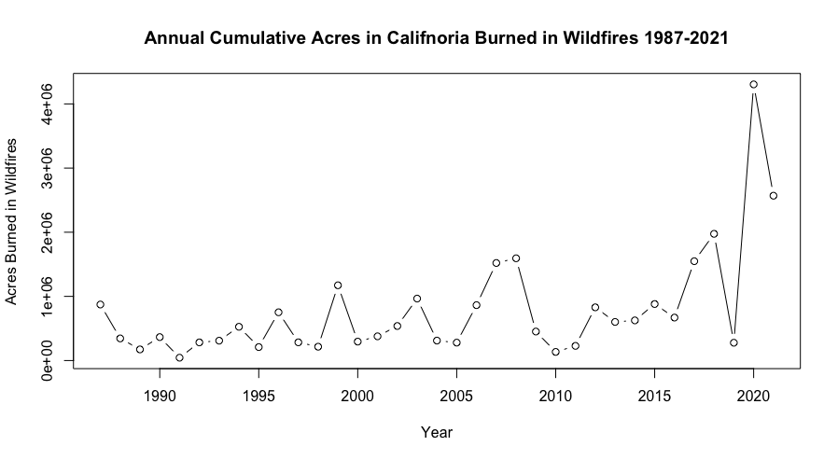
Fig. 2, “Annual Cumulative Acres Burned in California in Wildfires, 1987-2021”
Though the trends are not as drastic, Washington and Oregon have also experienced increasingly volatile and longer fire seasons (Nagy et al. 2018). These trajectories are not expected to improve in any significant way in the near future (ibid). Wildfires are taking more acreage proportionately per year from the Northern spotted owl’s habitat (old growth coastal forests) than at any time in the past. Though there are a multitude of factors that contribute to wildfires each year, anthropocentric activities play an increasing role. Nagy et al. (2018) note humans ignited four times as many large fires as lightning from 1992 to 2015, accounting for approximately 65% of fires in the western United States, where the Northern spotted owl resides.

Application to Theory

Applying the double jeopardy framework to the Northern spotted owl, the factors of population decline are as follows: habitat loss, barred owl incursion, and climate change associated threats (ie..wildfires and warming events). After its listing in June of 1990 and subsequent ceasing of timber activities in its protected habitat, there is a small increase in population and modest growth rate through the early 1990s. However, as noted in Franklin et al. 2021, beginning in 1994, the second year barred owls are included in the dataset, this modest growth stops and then reverses all together. This suggests that barred owl incursion is the primary factor in spotted owl decline, which is supported in the literature (Franklin et al. 2021; Sobieszczyk 2o21; Dupuis 1998; Weins 2021). This mismatch in intervention type (habitat protection) against an environmental factor (barred owl incursion) fails to address the root cause of the problem.

This goes hand in hand with the double jeopardy argument to explain continued species decline. Double jeopardy explains initial decline and suggests a multiplicative effect between invasive and climate threats while factor and intervention type mismatch explain stagnation and continued decline. It is unsurprising that the effects of double jeopardy are felt even more so for a species type that does not have adequate intervention. Therefore, this paper theorizes that the double jeopardy principle poses a greater threat to ESA-protected spotted owls compared to non-ESA protected spotted owls.

Methodology

The population of interest, Northern spotted owls, is our outcome of interest in the model design. This is the dependent variable used in our analysis. The unit of analysis in this paper is the state-year, or in the case of British Columbia, the province-year. Data is aggregated to this level due to aggregation of historic interaction counts being on an annual basis largely as a function of ESA-related reporting.

My dependent variable, Northern spotted owl population, is approximated through historical observational data from 1985-2021 (Anderson and Burnham 1992; Forsman et al. 1996; Franklin et al. 1999; Anthony et al. 2006; Forsman et al. 2011; Dugger et al. 2016; Franklin et al. 2021). American population measurement is captured through total annual interactions with Northern spotted owls across eleven geographic census areas as seen in Fig. 9 from Franklin et al. 2021 (see Appendix). These interactions include banding, site visits, auditory monitoring, and hobbyist reporting of individuals. Past researchers were careful to exclude repeat sightings of the same individual in that year, which is reflected in this dataset. Fecundity researchers also aggregated estimates of broods and survivability for 1993-1998. Given survival rates of each census area, brood estimates are added to total interactions with a one-year lag when data is available (Franklin et al. 1999). For British Columbia spotted owls, the population is approximated through estimated breeding pairs. These estimates originate from the Committee on the Status of Endangered Wildlife in Canada (COSEWIC) assessment and status reports from 2004 and 2009 for the Northern spotted owl. Figure 3 below depicts the estimated NSO population over time.

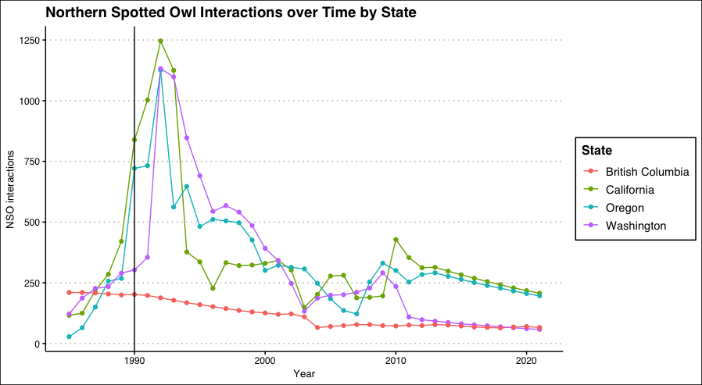
Fig. 3, “Northern Spotted Owl Interactions 1985-2021 by State with Cutpoint at List Date”

Covariates include Endangered Species Act treatment, barred owl population in Northern spotted owl territory, critical habitat area, area burned by wildfire, temperature, and precipitation. Though there are some debates amongst fecundity scholars, barred owls overwhelmingly appear time and time again as the covariate with the largest effect size on NSO population. This also applies to this paper’s overarching framework as invasive threats should be accounted for in a double jeopardy-based model. Furthermore, this analysis controls for critical habitat area to account for variation in NSO observation based on size of range in each state.

The key covariate, Endangered Species Act treatment, is captured as a dummy variable. British Columbia obviously takes a 0 value, as do the observations from 1985-1989 when the NSO was not yet listed. Additional controls include barred owl population in Northern spotted owl territory, critical habitat (in acres), area burned by wildfire (in acres), temperature, and precipitation. Barred owl population in Northern spotted owl territory is captured from Franklin et al. (2021)’s estimation of barred owl proportional occupancy of each census area. These are then multiplied by the census area’s Northern spotted capacity. Figure 4 below depicts the estimated barred owl population over time.

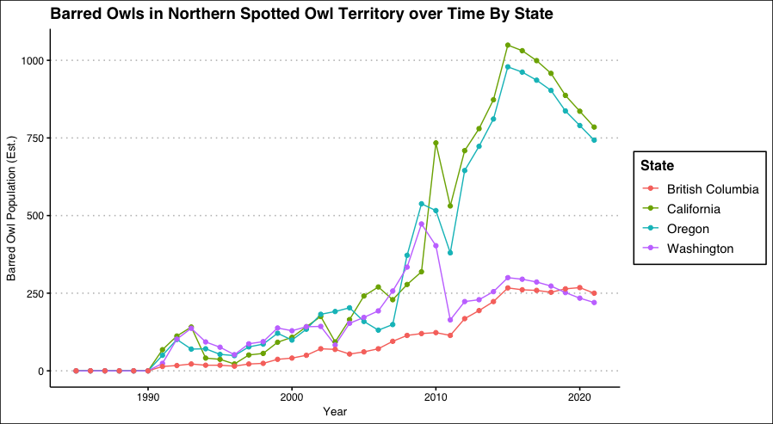
Fig. 4, “Barred Owl Population in Northern Spotted Owl Territory over Time by State”

Critical habitat is captured under Critical Habitat Units (CHUs). These Units were designed to protect the metapopulation (not individuals) across Washington, Oregon and California. Each CHU was designated around clusters of 20 or more owls (approximately 1.6 km radius from inner cluster circle). Then, connecting corridors were added to link clusters within 12 miles of one another. CHU area by state is captured in millions of acres from the federal recovery plans for the Northern spotted owl (1990, 2008 and 2011) and the Northwest Forestry Management Plan (1994) (U.S. Department of Agriculture, Forest Service 1992, 1994, 2003, 2008, 2011). There are no such formal protections in British Columbia, so this measurement is captured as 0. This is also true for years prior to habitat implementation (1992).

To account for the climate change mechanism affecting NSOs in this double jeopardy framework which states that climate change will impact species in their native habitat in addition to pushing invasive species in, this analysis includes total area burned by wildfire, temperature and precipitation. These three climate factors should impact Northern spotted owl population the most. Wildfires directly threaten individual survival and lead to habitat loss. Temperature is used as a proxy for relative warming of climate by state. Finally, precipitation is used as a proxy for drought conditions at the state level. Drought can affect the owls in several ways, though most importantly, drought can reduce prey supply and reduce drinkable water.

Area burned by wildfire is captured in acres from the Canadian National Fire Database (CNFDB) and the National Interagency Fire Center (NIFC) respectively. Data is supplemented for the United States from state fire agencies and the National Park Service prior to 1988 when available and added to state-year estimates. Canadian data is supplemented from Stocks et al. (2002) for fires prior to 1998. Temperature is captured as average state monthly high temperatures in July from NOAA’s ​​Statewide Time Series for American units and Canadian Climate Normals 1981-2010 Station Data for Canadian units. Both are measured in degrees Fahrenheit. Precipitation is captured through annual precipitation gathered from the same respective sources, though Canadian data has been converted to inches.

Findings

Evaluating a DID design in this case can be somewhat tricky given the control (British Columbia) and experimental groups (Washington, Oregon and California) are unbalanced. Prior to European settlement, only 500 breeding pairs of Northern spotted owls are estimated to have inhabited British Columbia annually (Blackburn et al. 2002). In contrast to the Northern spotted American range, the Canadian subset only makes up approximately 5-10% of the total population and range of the NSO. Though a larger habitat area provides more opportunities for the NSO to breed, This is to say that if the regression coefficients for ESA treatment and Critical Habitat Unit Area are both significant and positive, this would imply that ESA treatment has a positive effect on NSO populations. However, as discussed in the Model 1 analysis, this analysis finds this is not the case.

This paper leverages British Columbia as a control group as the Endangered Species Act is only in effect in the United States (the treatment). Given our unit of analysis is the state-year (panel data), this lends itself to a difference in differences (DID) analysis. This analysis leverages a within-panel regression model with state fixed effects and the controls described previously with four cut points based on changes in critical habitat protection area (1990, 1994, 2008, and 2011) to test H₀:

H₀: βᵢ (regression coefficient for DID estimator) = 0
H₁: βᵢ (regression coefficient for DID estimator) ≠0

If βᵢ is 0 and significant, this implies that ESA treatment has no effect on population. If βᵢ is not 0 and significant, this implies that ESA treatment has an effect on population. A positive βᵢ indicates that ESA treatment is positively associated with Northern spotted owl population. Likewise, a negative βᵢ indicates that ESA treatment is negatively associated with Northern spotted owl population. Based on the double jeopardy framework, theory predicts a negative βᵢ.

Before diving into the model results, it is worthwhile to contextualize the output with a discussion of average treatment effect (ATT). This is computed within-period by finding the difference in averages of the outcome (NSO population) between treated (American) and control (Canadian) groups, then averaging those to get that period’s ATT. For this framework, we should expect an initial temporary spike in population for American units directly after ESA implementation due to the elimination of anthropocentric factors driving population loss as discussed in the theory section (see Fig. 3). Then, we should expect a continual decrease in the ATT by period as the double jeopardy takes over with barred owls moving in beginning in the early 1990s shortly after ESA listing. As we can see in the ATT matrix shown below in Table 1, this is exactly the case for the dataset at hand. Given the relatively small proportion of Canadian owls in the total population, the decline demonstrated in Table 1 is still cause for concern.
Eventually, we should expect the average treatment effect to become negative as double jeopardy continuously accelerates population loss.

Average Northern Spotted Owls by Period
Period | British Columbia | California | Oregon | Washington | ATT between control and treated units
Pre-1990 | 205.67 | 233.83 | 248.17 | 227.17 | 30.720
1990-1994 | 183 | 937.75 | 766.75 | 858 | 671.167
1994-2007 | 114.4615 | 277.92 | 335 | 346.93 | 205.489
2008-2010 | 74.67 | 271.33 | 295.33 | 251.33 | 197.993
2011-2021 | 70.72 | 271 | 245.9 | 79.09 | 127.943
Table 1, Average Treatment Effect Matrix

With this context in mind, let us now interpret Model 1’s results as seen in Table 2 below. As expected, critical habitat unit area is statistically insignificant. This means that the ESA’s mechanism for population loss intervention is a null finding and subsequently does not have an effect on the NSO population. Yet, the effect size of the coefficient estimate for ESA treatment is quite substantial. However, as contextualized through the discussion of average treatment effect, the effect size regression coefficient associated with ESA treatment may only convey the demography of NSOs (90-95% of the species’ native range is in the United States) and does not necessarily imply that the presence of ESA protection is associated with NSO population increase. This is a mixed finding and may be inconsistent with the double jeopardy framework, but this is indiscernible from this analysis.

There are a few other interesting results of note. First, the coefficient for barred owl population in Northern spotted territory is positive and significant. However, the effect size is quite small. Why is that? This dataset contains structural zeroes in barred owl in northern spotted owl territory estimates because the barred owl was not sighted in NSO territory until 1991 in the Coos Bay census area. This is actually consistent with the double jeopardy framework; barred owls did not move in until after ESA habitat protections. However, if we compare Fig. 3 and Fig. 4, there appears to be an inversely proportional relationship over time between the two populations as described in the literature on Northern spotted owl demography (Anderson and Burnham 1992; Forsman et al. 1996; Franklin et al. 1999; Anthony et al. 2006; Forsman et al. 2011; Dugger et al. 2016; Franklin et al. 2021).

Climate indicators also present a mixed bag. Though annual acres burned in wildfires do have a negative and significant effect on the NSO population, the effect size is essentially zero. Similarly, precipitation appears to have a significant positive effect on the NSO population but has a small effect size. Finally, average high July temperature, the proxy for warming climate, is insignificant. Taken all together, there could be a few reasons for this besides climate having no effect on NSO populations. First, due to the level of aggregation of this data, there may be extraneous variation captured at the state level. For example, California had average July temperatures well over 100 degrees largely as a function of Death Valley and areas surrounding Los Angeles, all hundreds of miles south from NSO territory. Second, the effect wildfires are having on NSOs may be significant for the most recent period, but not for others. As we can see in Fig. 2, wildfire burned acreage has increased nearly an order of magnitude in the past decade alone. There may not be enough of a lag between this spike in severity of wildfire seasons and my data collection timeframe to see this effect in longitudinal analysis just yet. The effect of climate change on many endangered species is an ongoing debate and requires further research for many years to come.

In contrast to the mixed narrative for the barred and climate coefficients, period resolutely has a significant negative effect on Northern spotted owl population. That is to say as time progresses, the population is in decline. Eventually, this time effect will outstrip the ESA treatment. This reaffirms the narrative described in Fig. 3. After listing, there was an initial spike in population due to the elimination of anthropocentric causes of species decline (largely through timber and logging activities), breeding programs, and other resources dedicated to the Northern spotted owl. However, as critical habitat protections went into place, this is also when barred owls began their incursion into Northern spotted territory (Fig. 4).

Finally, the most critical indicator, the regression coefficient for the DID estimator, is significant, negative, and has a large effect size. This means that as time progresses, this analysis projects that ESA treatment will have an increasingly negative effect on the NSO population. Over time, this analysis expects for Canadian owls to fare better than their American counterparts. Therefore, this analysis in this paper rejects H₀ and accepts H₁.

Model 1 Results
Covariate | β Estimate | Std. Error | t value | P(>|t|) | Significance
Period | -54.85 | 4.46 | -12.29 | <.0001 | ***
ESA Treatment | 714.7 | 124.29 | 5.75 | <.0001 | ***
Barred Owl Pop in NSO Territory | 0.416 | 0.05 | 8.31 | <.0001 | ***
Annual Acres Burned | -0.00073 | 0.000022 | -3.35 | 0.001 | **
Average High Temp July | 4.37 | 3.6 | 1.21 | 0.2281
Annual Average Precipitation | 1.42 | 0.63 | 2.27 | 0.025 | *
Critical Habitat Unit Area in Millions of Acres | 15.43 | 44.5 | 0.35 | 0.729
DID Coefficient (Period:ESA Treatment) | -155.25 | 16.21 | -9.96 | <.0001 | ***
Table 2, Model 1 Results

Even without controls, the sign and significance of the DID estimator remain relatively stable. This can be seen in Model 2, which is the same design as Model 1 but without controls in Table 3 below to perform a specification check.

Model 2 Results
Covariate | β Estimate | Std. Error | t value | P(>|t|) | Significance
Period | -34.4 | 0.009 | -3781.53 | <.0001 | ***
ESA Treatment | 625.41 | 25.67 | 24.36 | <.0001 | ***
DID Coefficient (Period:ESA Treatment) | -106.65 | 13.2 | -8.07 | <.0001 | ***
Table 3, Model 2 Results

H₁ still holds for Model 2. There is a significant, negative effect on Northern spotted owl population caused by ESA listing over time.

While there are no compelling results that definitively support double jeopardy in this analysis, there is enough uncertainty from the interpretation of the analysis results in context that suggests this model should be re-examined across other case studies that satisfy double jeopardy conditions. The DID estimate is cause for concern for the Northern spotted owl. Though this analysis cannot directly attribute double jeopardy mechanisms to this decline for ESA-treated individuals, this may be in part due to the recent changes in some climate indicators. Further research is needed to understand the nature of why ESA listing is expected to have a negative impact on this species’ population over time.

Conclusion

Though empirical and theoretical support for the Northern spotted owl as a double jeopardy case is mixed, the DID analysis conducted in this paper should still give biodiversity policy researchers cause to pursue this research agenda further. If listing on the ESA is associated with population decline, the mechanisms that interact with listing should be explored to understand where, if any, structural vulnerabilities pose a threat to species survival under current policy. In the case of the Northern spotted owl, barred owl nest removal has had some experimental success (see Weins et al. 2021), as have breeding programs. This suggests that invasive removal may be an effective supplement to habitat protection for the Northern spotted owl’s continued survival.

Furthermore, research should turn to other case studies to replicate this finding for other species that meet the double jeopardy criteria and/or are experiencing population loss as a function of primarily environmental factors before any species meeting these criteria become extinct. The current period is a critical window to establish causal inference under this framework; if there is a chance to support species survival with new intervention methods like invasive species removal, this is something policymakers must know now to be given sufficient time to implement the strategies.

Alternatively, isolating the mechanisms of double jeopardy may lend itself to a better understanding of the ESA policy regime and these new threats on their own. Other cases like the polar bear (listed in May 2008) may be prime test cases for examining climate threats and ESA effectiveness, as the analysis conducted for the spotted owl does not provide a clear causal narrative. Polar bear habitat, situated in a drastically warming Arctic, has shrunk considerably as the sea ice it depends on forms later and melts earlier each year. This pushes the bears towards land and centers of human population. So, habitat protection (and by extension, ESA listing) should have a positive effect. Polar bears are predators and are not currently understood in the relevant demography literature to be threatened by any invasive species.
Isolating each double jeopardy mechanism in isolation may be a fruitful avenue for further research under this model. Similarly, we may examine another species with only an invasive threat but minimal climate threats to understand how this part of the double jeopardy mechanism affects ESA success rates.

There is also a need for further research to account for Northern spotted owl population centers beyond experimental census areas to determine the true nature of the relationship between ESA listing and NSO local populations given the mixed findings in Model 1 with critical habitat area (null result) and ESA treatment (large positive significant result). With increased efforts at data collection, this case study could be re-evaluated and provide greater insight into Northern spotted owl longevity. This could also be aided by temperature, precipitation, and wildfire monitoring data specific to NSO territory to examine the effects of climate change as it relates to this species in its territory specifically, not at the state level. Similarly, barred owl observations in Northern spotted owl territory should be collected and aggregated uniformly across Washington, Oregon, and California instead of being reported as a proportion of barred owl occupancy of past NSO sites.

Another avenue for research among biodiversity scholars examining invasive species may be in competitive population modeling. Given the structural zeroes in barred owl population estimates used in this data set, there may be a need to include a two-species competitive model as described in Franklin et al. 2021 for further analysis of this case.

The effectiveness of the Endangered Species Act (ESA) has been called into question many times by political pundits and scholars alike. Overwhelmingly, the scholarship supports that listed species fare better than they would have if not listed at all when proper funding is attached yet finds the reverse to be true when a listing is not accompanied by funding (Ferraro et al. 2007; Stokstad 2005). Furthermore, the literature notes that prior to 1982 listing rule reforms, listing was based on many non-scientific variables (Metrick and Weitzman 1996). Indeed, there are broader theoretical issues in studies of efficacy due to selection process for listing on the ESA which creates challenges in measuring the effect it may have on species recovery.

However, it is undeniable that the Endangered Species Act is in many ways a success story; it is commonly cited as the strongest biodiversity policy regime in the world (Bean and Rowland 1997). A recent proceeding of the National Academy of Sciences found that the criticism levied against the Endangered Species Act, Section 7 in particular, the source of much of the Act’s protections, was either totally or relatively unfounded (Malcom and Li 2015). Most criticism of the Act is not based on scholarship at all; media narratives and pundit framings often challenge the Act’s validity without acknowledging its unprecedented 99% species survival rate (Suckling et al. 2012). This paper questions the possibility of continued success given the drastically accelerating nature of climate change, particularly as it relates to the principle of double jeopardy. Is habitat protection alone enough anymore? Will it be enough in fifty years?

The answers to these questions are speculative, but the results presented in this analysis suggest that there may be credence to a negative answer to the second question posed. Though invasive species removal experiments provide some tentative hope for the future of the Act’s survival, steps must be taken to alter the scope of the ESA to counter invasive threats. This preliminary analysis calls for an expansion of the scope of the ESA to ensure that non-human factors do not threaten critical habitat as anthropocentric activity has in the past.

Works Cited

Anderson, D. R., & Burnham, K. P. (1992). Demographic analysis of northern spotted owl populations. Draft final recovery plan for the northern spotted owl. US Fish and Wildlife Service, Portland, Oregon, 319-328.

Anthony, R. G., Forsman, E. D., Franklin, A. B., Anderson, D. R., Burnham, K. P., White, G. C., ... & Sovern, S. G. (2006). Status and trends in demography of northern spotted owls, 1985–2003. Wildlife Monographs, 163(1), 1-48.

Bargmann, J. (2016, November 12). Was an owl the real culprit in the peterson murder mystery? Audubon. Retrieved from https://www.audubon.org/news/was -owl-real-culprit-peterson-murder-mystery

Bean, M. J., & Rowland, M. J. (1997). The evolution of national wildlife law. Greenwood Publishing Group.

Blackburn, I. R., & Harestad, A. S. (2002). Supplement To The Population Assessment Of The Northern Spotted Owl in British Columbia, 1992-2001. Ministry of the Environment. Retrieved from https://www.canada.ca/en/environment-climate-change/services /species-risk-public-registry/cosewic-assessments-status-reports/spotted-owl/ chapter-7.html#shr-pg0

Buchananan, J. B. (2016). “Periodic Status Review for the Northern Spotted Owl”. Washington Department of Fish and Wildlife. https://wdfw.wa.gov/sites/default/files/publications/ 01752/wdfw01752.pdf

CAL Fire (2022). Stats and Events. [Data set].Retrieved from https://www.fire.ca.gov/media/ 11397/fires-acres -all-agencies-thru-2018.pdf and https://www.fire.ca.gov/stats-events/

Carey, J. (2016, September 9). Northern spotted owls bullied onto California's threatened species list. Audubon. Retrieved from https://www.audubon.org/news/northern-spotted -owls-bullied-californias-threatened-species-list

COSEWIC: Committee on the Status of Endangered Wildlife in Canada. (2014). Spotted owl (Caurina subspecies) COSEWIC assessment and status report: chapter 7. Retrieved from https://www.canada.ca/en/environment-climate-change/services/ species-risk-public-registry/cosewic-assessments-status-reports/spotted-owl.html

COSEWIC: “. (2008). COSEWIC Assessment and Update Report on the Spotted Owl in Canada. COSEWIC.https://www.registrelep-sararegistry.gc.ca/virtual_sara/files/cosewic/ sr_spotted_Owl_0808_e.pdf

Department of Agriculture, Forestry Service. (1994). Northwest Resouce Plan: Standards and Guidelines for Management of Habitat for Late-Successional and Old-Growth Forest Related Species Within the Range of the Northern Spotted Owl. Forestry Service. https://www.fs.usda.gov/Internet/FSE_DOCUMENTS/fseprd479477.pdf

Diller, Lowell V., Keith A. Hamm, Desiree A. Early, David W. Lamphear, Katie M. Dugger, Charles B. Yackulic, Carl J. Schwarz, Peter C. Carlson, and Trent L. McDonald. "Demographic response of northern spotted owls to barred owl removal." The Journal of Wildlife Management 80, no. 4 (2016): 691-707.

Duenas, M. A., Ruffhead, H. J., Wakefield, N. H., Roberts, P. D., Hemming, D. J., & Diaz-Soltero, H. (2018). The role played by invasive species in interactions with endangered and threatened species in the United States: a systematic review. Biodiversity and Conservation, 27(12), 3171-3183.

Dugger, K. M., Forsman, E. D., Franklin, A. B., Davis, R. J., White, G. C., Schwarz, C. J., ... & Sovern, S. G. (2016). The effects of habitat, climate, and Barred Owls on long-term demography of Northern Spotted Owls. The Condor: Ornithological Applications, 118(1), 57-116.

Dupuis, L. (1998, March). The Northern Spotted Owl in British Columbia. Forest Renewal British Columbia. Retrieved December 2021, from https://www2.gov.bc.ca/assets/gov /environment/plants-animals-and-ecosystems/species-ecosystems-at-risk /brochures/northern_spotted_owl.pdf.

Fish and Wildlife Service; Endangered and Threatened Wildlife and Plants; Endangered and Threatened Wildlife and Plants; Determination of Threatened Status for the Northern Spotted Owl 55 Fed. Reg. 26114 (June 26, 1990), (50 CFR Part 17).

Fish and Wildlife Service; Endangered and Threatened Wildlife and Plants; Endangered and Threatened Wildlife and Plants; Determination of Critical Habitat for the Northern Spotted Owl 57 Fed. Reg. 1796 (January 15, 1992), (50 CFR Part 17).

Fish and Wildlife Service; Endangered and Threatened Wildlife and Plants; Designation of Critical Habitat for the Marbled Murrelet (Brachyramphus marmoratus), Designation of Critical Habitat for the Northern Spotted Owl (Strix occidentalis caurina), Draft Recovery Plan for the Northern Spotted Owl 72 Fed. Reg. 50929 (September 5, 2007), (50 CFR Part 17).
Fish and Wildlife Service; Endangered and Threatened Wildlife and Plants; Revised Designation of Critical Habitat for the Northern Spotted Owl 76 Fed. Reg. 38575 (July 1, 2011), (50 CFR Part 17).

Fish and Wildlife Service; Endangered and Threatened Wildlife and Plants; Revised Designation of Critical Habitat for the Northern Spotted Owl 86 Fed. Reg. 6206 (November 10, 2021), (50 CFR Part 17).

Ferraro, P. J., McIntosh, C., & Ospina, M. (2007). The effectiveness of the US endangered species act: An econometric analysis using matching methods. Journal of Environmental Economics and Management, 54(3), 245-261.

Forsman, E. D Anderson, D. R.,.Franklin, A. B, Burnham, K. P., & Wagner, F. W. (1996). Methods for collecting and analyzing demographic data on the northern spotted owl. Studies in avian Biology, 17, 12-20.

Forsman, E. D. (2011). Population demography of northern spotted owls: published for the Cooper Ornithological Society (No. 40). Univ of California Press.

Franklin, J. F., North, M. P.,Carey, A. B., Forsman, E. D., & Hamer, T. (1999). Forest stand structure of the northern spotted owl's foraging habitat. Forest Science, 45(4), 520-527.

Franklin, A. B., Dugger, K. M., Lesmeister, D. B., Davis, R. J., Wiens, J. D., White, G. C., & Wise, H. (2021). Range-wide declines of northern spotted owl populations in the Pacific Northwest: A meta-analysis. Biological Conservation, 259, 109168.

Gallardo, B., & Aldridge, D. C. (2013). Evaluating the combined threat of climate change and biological invasions on endangered species. Biological Conservation, 160, 225-233.

Greenwald, N., Suckling, K. F., Hartl, B., & Mehrhoff, L. A. (2019). Extinction and the US endangered species act. PeerJ, 7, e6803.

Gurevitch, J., & Padilla, D. K. (2004). Are invasive species a major cause of extinctions?. Trends in ecology & evolution, 19(9), 470-47

Gutiérrez, R. J., Cody, M., Courtney, S., & Franklin, A. B. (2007). The invasion of barred owls and its potential effect on the spotted owl: a conservation conundrum. Biological Invasions, 9(2), 181-196.

Hellmann, J. J., Byers, J. E., Bierwagen, B. G., & Dukes, J. S. (2008). Five potential consequences of climate change for invasive species. Conservation biology, 22(3), 534-543.

Herter, D. R., & Hicks, L. L. (2000). Barred owl and spotted owl populations and habitat in the central Cascade Range of Washington. Journal of Raptor Research, 34(4), 279-286.

Jenkins, J. M., Lesmeister, D. B., Forsman, E. D., Dugger, K. M., Ackers, S. H., Andrews, L. S., & Wiens, J. D. (2021). Conspecific and congeneric interactions shape increasing rates of breeding dispersal of northern spotted owls. Ecological Applications, 31(7), e02398.

Lesmeister, D. (2016). “Demographic characteristics of northern spotted owls (Strix occidentalis caurina) in the Olympic National Forest, Washington, 1987–2015.” US Department of Agriculture Forest Service, retrieved from https://www.fs.usda.gov/r6/ reo/monitoring/downloads/reports/OLY%20FS%20nso%20demog%20annual%20 report%202015.pdf

Lint, J. (2005). Northwest Forest Plan—the First 10 Years (1994–2003): Status and Trends of Northern Spotted Owl Populations and Habitat. U.S. Department of Agriculture, Forest Service. General Technical Report PNW-GTR-648. Retrieved from https://www.fs.usda.gov/pnw/pubs/pnw_gtr648.pdf

Ministry of Environment and Natural Resources (2022). Canadian Climate Normals 1981-2010 Station Data [Dataset] https://climate.weather.gc.ca/climate_normals/results_1981_ 2010_ e.html?stnID=155&autofwd=1

Ministry of Environment and Natural Resources (2022). Monthly Climate Summaries.[Data set] https://climate.weather.gc.ca/prods_servs/cdn_climate_summary_e.html

Mainka, S. A., & Howard, G. W. (2010). Climate change and invasive species: double jeopardy. Integrative Zoology, 5(2), 102-111.

Malcom, J. W., & Li, Y. W. (2015). Data contradict common perceptions about a controversial provision of the US Endangered Species Act. Proceedings of the National Academy of Sciences, 112(52), 15844-15849.

Marcot, B. G. (1997). "Of spotted owls, old growth, and new policies: a history since the Interagency Scientific Committee report" (Vol. 408). US Department of Agriculture, Forest Service, Pacific Northwest Research Station.

Metrick, A., & Weitzman, M. L. (1996). Patterns of behavior in endangered species preservation. Land Economics, 1-16.

Nagy, R. C., Fusco, E., Bradley, B., Abatzoglou, J. T., & Balch, J. (2018). Human-related ignitions increase the number of large wildfires across US ecoregions. Fire, 1(1), 4.

National Interagency Fire Center (2021). Total Wildland Fires and Acres (1983-2021) [Data set]. NICC. https://www.nifc.gov/fire-information/statistics/wildfires

National Research Council. (1995). The Role of Habitat Conservation and Recovery Planning. In Science and the Endangered Species Act. National Academies Press (US).

Natural Resources Canada (2022). Canadian National Fire Database (CNFDB) Historical Fire Data [Data set]. Natural Resources Canada https://cwfis.cfs.nrcan.gc.ca/ha/nfdb

NOAA Fisheries. (2022). Stock SMART data records:Snow crab-Bering sea. Retrieved from www.st.nmfs.noaa.gov/stocksmart.

NOAA Fisheries. (2021). Species directory: Steller Sea Lion. Retrieved from https://www. fisheries.noaa.gov/species/steller-sea-lion#overview.

NOAA National Centers for Environmental information, Climate at a Glance: Statewide Time Series, published November 2022 [Data set] from https://www.ncei.noaa.gov/access/ monitoring/climate-at-a-glance/statewide/time-series

Oregon Fish and Wildlife Office. (2019). Northern Spotted Owl (Strix occidentalis caurina)
Species Status Report. U.S. Fish and Wildlife Service.

Rossman, S., Yackulic, C., Saunders, S., Reid, J., Davis, R., Zipkin, E. 2016. Dynamic No- Occupancy models: estimating demographic rates and local abundances from detection non detection data. Ecology 97:3300-3307

Scott, J. M., Goble, D. D., Wiens, J. A., Wilcove, D. S., Bean, M., & Male, T. (2005). Recovery of imperiled species under the Endangered Species Act: the need for a new approach. Frontiers in Ecology and the Environment, 3(7), 383-389.

Sobieszczyk, S. (2021, October 4). Barred owl movement west . Forest and Rangeland Ecosystem Science Center, USGS. Retrieved December 1, 2021, from https://www.usgs.gov/media/images/barred-owl-movement-west.

Sobieszczyk, S. & Lawrence, B. (2022, March 3). Invasive green crabs pose threat to Washington's shellfish industry and tribal culture: U.S. geological survey. Invasive Green Crabs Pose Threat to Washington's Shellfish Industry and Tribal Culture | U.S. Geological Survey. Retrieved from https://www.usgs.gov/news/science-snippet /invasive-green-crabs-pose-threat-washingtons-shellfish-industry-and-tribal

Stebbing, E.P. (1922). The Forests of India. Vol 1, pp. 72-81

Stocks, B. J., Mason, J. A., Todd, J. B., Bosch, E. M., Wotton, B. M., Amiro, B. D., ... & Skinner, W. R. (2002). Large forest fires in Canada, 1959–1997. Journal of Geophysical Research: Atmospheres, 107(D1), FFR-5.

Stokstad, E. (2005). What's wrong with the Endangered Species Act?. Science, 309(5744), 2150-2152.

Suckling, K., Greenwald, N., & Curry, T. (2012). On Time, On Target: How the Endangered Species Act Is Saving America’s Wildlife. Center for Biological Diversity. https://www.esasuccess.org/pdfs/110_REPORT.pdf.

The Canadian Spotted Owl Recovery Team. (2004). RECOVERY STRATEGY FOR THE NORTHERN SPOTTED OWL. Minister of the Environment of Canada. Retrieved from https://www.sararegistry.gc.ca/virtual_sara/files/plans/rs_spotted_owl_caurina_ 1006_e.pdf

Wiens, J. David, Robert G. Anthony, and Eric D. Forsman. "Competitive interactions and resource partitioning between northern spotted owls and barred owls in western Oregon." Wildlife Monographs 185, no. 1 (2014): 1-50.

Wiens, J. D., Dugger, K. M., Higley, J. M., Lesmeister, D. B., Franklin, A. B., Hamm, K. A., & Sovern, S. G. (2021). Invader removal triggers competitive release in a threatened avian predator. Proceedings of the National Academy of Sciences, 118(31), e2102859118.

Westphal, M. & Nichols, E. Alaska Department of Fish and Game. (2022). 2022/23 Bering Sea Snow Crab Season Closed. Division of Commercial Fisheries.

Wetzel, C. (2022, October 17). Miranda Westphal, “Why have billions of snow crabs disappeared from Alaskan waters?”. NewScientist. https://www.newscientist.com/article/ 2342806-why-have-billions-of-snow-crabs-disappeared-from-alaskan-waters/

Yaffee, S. L. (1994). The wisdom of the spotted owl: policy lessons for a new century. Island Press.

Appendix

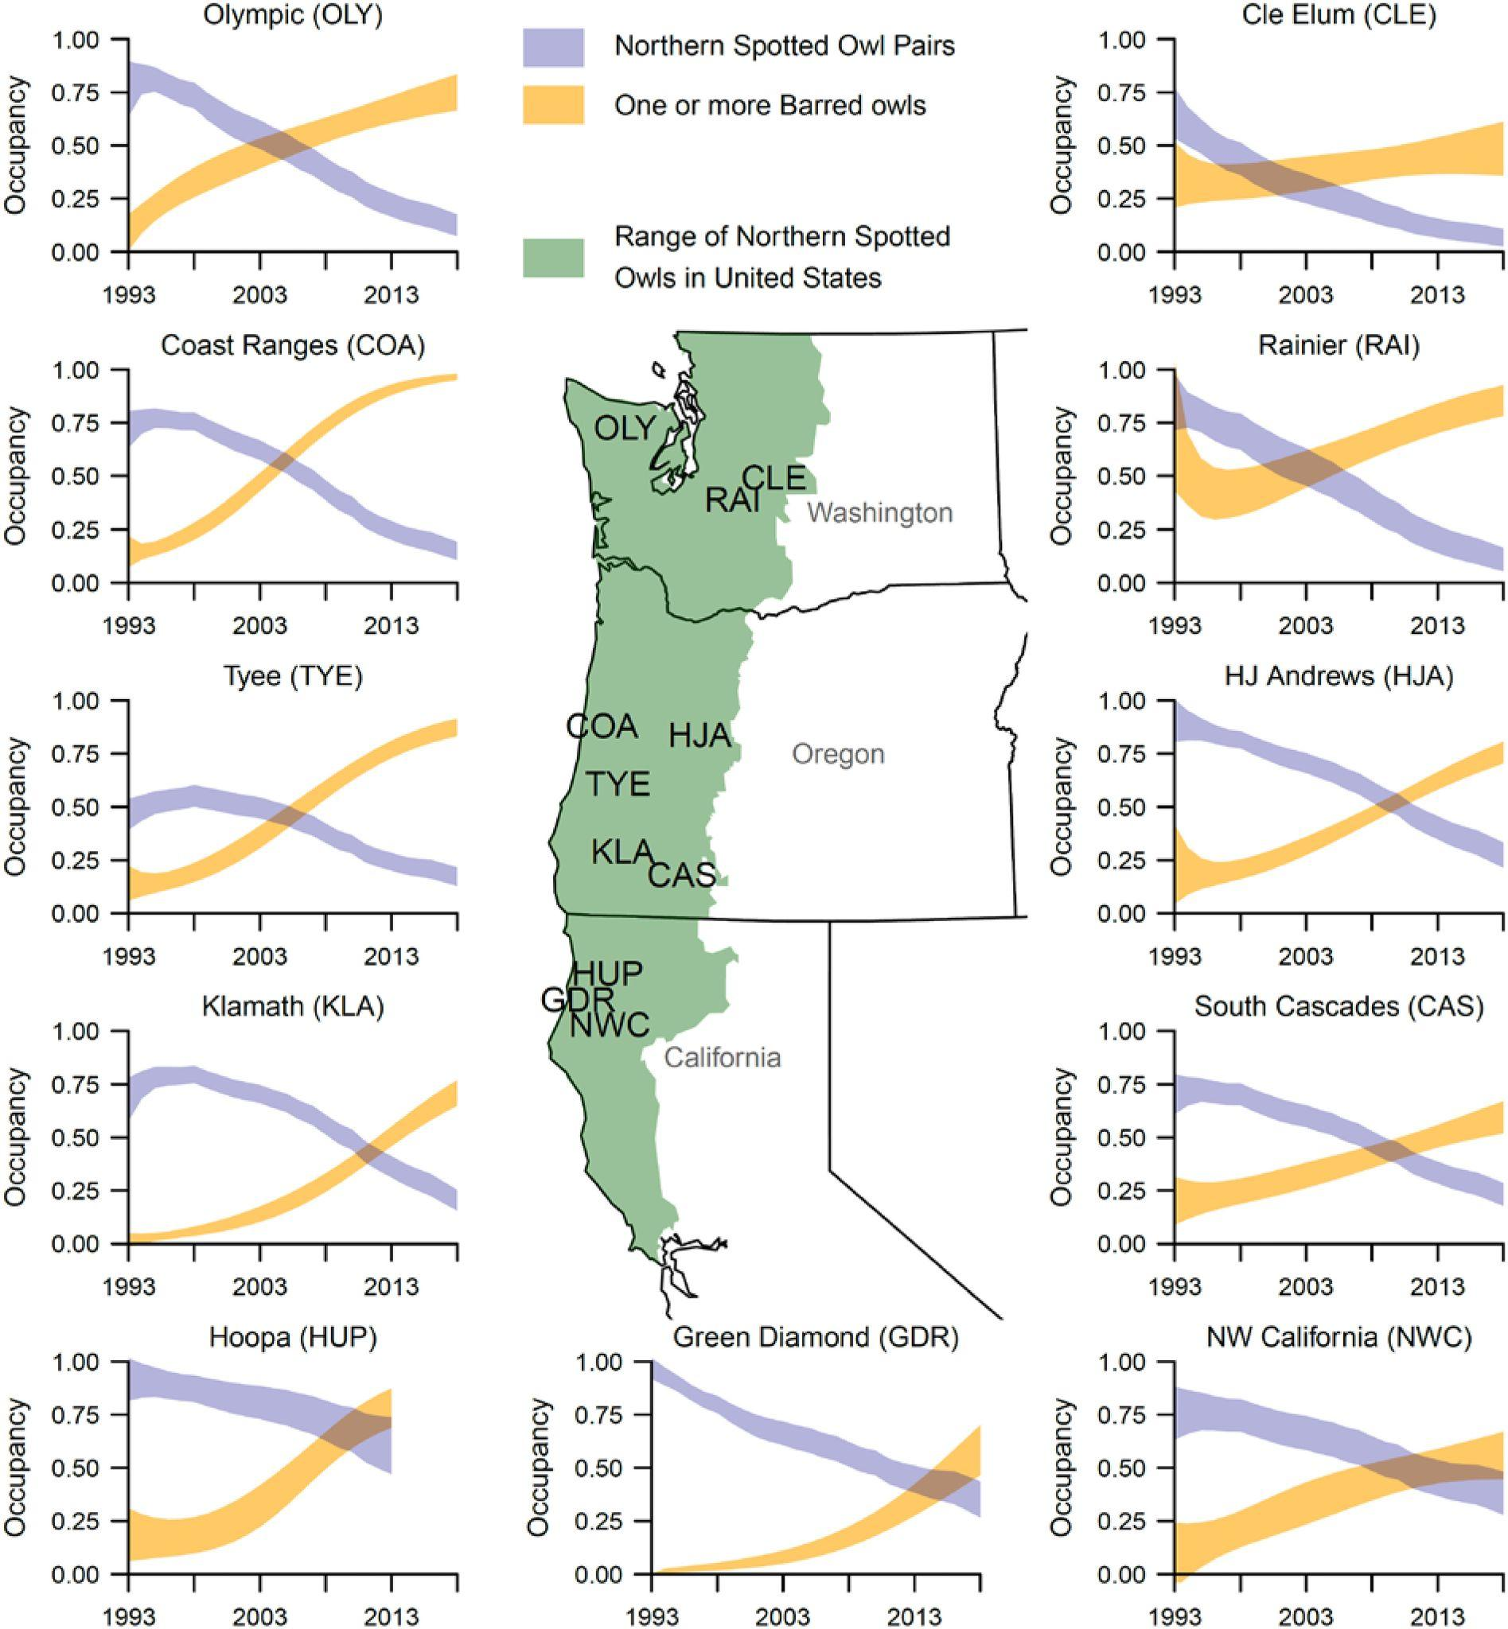

Fig. 9 from Franklin et al. 2021

The 1991 Judge Dwyer decisions ruled that the owl must stay on the threatened list with the requisite habitat set aside in its federal recovery plan in compliance with Section 4 of the Endangered Species Act. The original lawsuit which sought the 4(b)(2) critical habitat exclusion rule in Washington state NSO habitats as a timber industry interest was largely a result of the media narrative around the listing of the owl as a tone-deaf progressive encroachment on blue collar workers (Yaffee 1994).
There is significant ongoing scholarly debate about this case being on the Threatened list given that the NSO is considered endangered in Washington, Oregon and British Columbia. The threatened designation does not afford the NSO as rigorous protective resources as endangered, and is oftentimes motivated by budgetary constraints, interagency conflict, and exogenous considerations (Scott et al. 2005; Marcot 1997). For the purposes of this analysis, any listing under the ESA is considered to be an intervention.
The most significant intervention made on behalf of the owls is a 1997 (lapsed since 2001) forest management plan for the establishment of Special Resource Management Zones, each maintaining 2 to 13 breeding pairs of owls, in the Chilliwack and Squamish Forest Districts (Dupuis 1998).
Note that this analysis does not make a causal argument for barred owls being pushed out of the Great Lakes region by climate. This has been done in demographic studies of the barred owl (see Rossman et al. 2016), which find that barred owls were able to migrate to the Pacific Northwest using new forest belts to cross the Great Plains, a traditional barrier to forest-dwellers like the barred owl. This migration is argued to have taken place due to extreme weather events in the Great Lakes region beginning in the 1970s.
Note: in a DID analysis, we are interested in the treatment and time interaction. This is called the DID estimator. In this case, there are five periods of time.
Barred owls take on a population count of 0 prior to 1991 when the first barred owls were sighted in an Oregon (Coos Bay) census area for Northern spotted monitoring.

