“Patterns of Conflict in the Georgia State House” Matthew Gunning
Georgia Gwinnett College mgunning@ggc.edu

Prepared for presentation at the Annual Meeting of the Western Political Science Association, March 28-30th, 2018. This is a draft chapter of book manuscript The Georgia State House: Sixty Years of Change and Conflict.

Abstract:
This paper examines how Georgia politics have changed over the last 50 years as Republicans emerged in the south and eventually became the majority party within the region and the state of Georgia. The party then looks at coalition patterns inside the Georgia State House. How did the development of a competitive two party system change legislative majorities? This paper examines conflict along partisan, racial and urban/rural cleavage lines. And it also looks at which sub-groups were most often on the winning side when the conflict existed within the State House.

Georgia Politics in 1960
Between 1960 and 2010 politics in the state of Georgia underwent a tremendous political transformation. The state was governed by a group of politicians who were entirely white, overwhelmingly male and almost entirely members of the Democratic Party. Georgia’s laws effectively prevented black voter registration and participation across the state and as a consequence there were no elected black politicians in the state government. Representation in the State Assembly had a heavy structural bias against urbanized areas and greatly over-represented the least populated rural areas. In partisan politics Democratic Party dominance was so great that no Republican Party candidate for governor had won more than 20% of the vote since the Reconstruction Era ended in 1876.
Political Power in the Segregation Era
As V.O. Key (1949) noted, Democratic dominance of state, federal and local elections across the American South was a tool for the systematic exclusion of black voters and also poor white voters. The creation of the “solid south” controlled by the Democratic Party was accomplished by excluding voters who had voted for the Republican during Reconstruction or Populist Party in the Progressive Era (Kousser 1974). Across the American South the Democratic Party erected legal barriers to voter registration and voter participation which greatly diminished registration by black voters and also curtailed participation by poor whites. These rules were invented to preclude a potential class based alliance between poor whites and black voters against the elite planters and business interests that dominated southern politics in the post-Civil War period. In most southern states blacks were banned from participating in the crucial Democratic Party Primary by explicitly racist “white-only” eligibility rules. Barriers to voter participation were so effective that turnout even for the most intensely contested races in the Democratic Party seldom rose above 30% voting age population.
This system effectively conveyed great structural advantages on white voters and the economic elites that ruled state politics. The exclusion of black voters from the Democratic Party Primary ensured that only white voters would select the nominees for the dominant party in the South. The implementation of voter registration barriers were intended to curtail any possibility of a rival party defeating the Democratic Party nominees in the generation election.
Constraining Ambition
The system of laws that were designed to prevent any challenge to the segregated elite-led political class came at a price. A political system that was designed to prevent challenges to white supremacy and the economic elite needed to have an effective mechanism for channeling political ambition among candidates. If candidates felt that they had been cheated or treated unfairly they could bolt the Democratic Party and run as an independent or as a member of a rival party. If a popular candidate switched parties it might facilitate a risk to the entire system which advanced white planters and businessmen.
In order to preclude disaffected losing candidates from bolting the party and creating genuine choices in the general election, a series of institutional limitations were developed. Democratic Party Primary elections across the south typically held run-off elections if no candidate obtained a majority of votes cast in the initial balloting. This run-off provision guaranteed that the two most popular candidates in the first round advanced and whichever candidate won the second round had the endorsement of a majority of voters within the Democratic Party.
Increasing the opportunities for politicians was another tactic used to channel ambition. Governors were limited to two consecutive terms in Georgia and most other southern states. In some southern states the length of a single term was only two years which ensured that any politicians who had been thwarted in a recent contest had only to wait a short amount of time before another opportunity to run for governor would present itself.
A third element of constraining ambitious white politicians to stay inside the Democratic Party were the adoption of “sore-lower” laws which banned any candidate who had run and lost a party primary election from filing to get on the general election ballot in the same election cycle. Once an ambitious politician chose to run within the Democratic Party Primary bolting to run as 3rd party or independent candidate in the fall was removed as a strategic choice.
The political system that carefully protected the interests of elite whites by blocking any potential lower-class coalition between poor whites and blacks was quite effective at preventing competitive election contests in the generation election. The diversion of real political competition to within the Democratic Party Primary effectively channeled that ambition of white politicians. However, this shifting of real choice from the general to the primary election also meant that primary contests lacked the structure and organization typically seen in systems with enduring competitive political parties.
The disorganization of one-party politics
In his study of southern politics, V.O. Key (1949) noted that within the Democratic Party itself there was little organization or structure to political contests. Across the South primary elections for governor and other state-wide offices were often wild every-man-for-himself affairs in which five, six or seven candidates battled it out for the mantle of Democratic nomination. The initial goal of every candidate was simply to survive the first round balloting and qualify for run-off election between the top two finishers. There were many candidates and many ambitious politicians; however the system of white supremacy and the dominance of economic elites were effectively removed as potential issues. With many of the most important aspects of politics ineligible for debate within the party primary elections often turned on questions of local allegiances, personality, gimmicks or outrageous behavior. The prominence of such non-issue elements in campaigns speaks to a lack of policy differences between the candidates. In the feature film “Oh Brother Where Art Thou?” we see an election in Mississippi between one candidate who has uses a littler person as a stage prop and another candidate who has the endorsement of the singers known as the Soggy Bottom Boys.
Narrowing our focus from the American South to the state of Georgia we find the same patterns in that state. Here is Georgia we also see focus on personalities, props and gimmicks by candidates as a means of distinguishing themselves when few policy disagreements were present. The substitution of personality for policy issues resulted in elections in which voters would find it almost impossible to make choices when voting for governor and the legislature that would move public policy in a desired direction. There was almost no continuity that connected election contests up and down the ballot and there was little continuity of issues that organized voters temporally. If issues were discussed in one particular contest there was little chance that other candidates further down the ballot would address that issue or that candidates in the next election would focus on that particular issue. The vast majority of elections were one-off personality battles and voters who wanted to select candidates to achieve some policy change were left with little capacity to do so.
The most prominent political force across elections in Georgia was supplied by the Talmadge family, which offered itself as a champion of small town southern values against the emerging urban areas of the state (Key 1949). In some Georgia elections, the state divided into pro- and anti-Talmadge factions but this division was a weak substitute for political parties. Factional rivalries were not strongly linked to policy differences and thus factionalism did not provide divergent policy platforms for primary voters. Nor was there any systematic link between gubernatorial candidates and the legislative candidates. Democratic Party dominance within the south ensured the preservation of the “banker-merchant-farmer-lawyer-doctor governing class” (Shannon 1949) and the exclusion of blacks and poor whites, but the price of tis social control was the lack of political organization within the Democratic Party.
County Unit System
Not only were elections in Georgia largely unorganized around issues, they were also structurally biased towards rural interests. In 1917 the Democratic Party of Georgia adopted the County Unit System for determining the winner of statewide nomination contests. Initially the Unit System only applied to Democratic Party elections for statewide nomination contests but shortly after it was invented the allocation of Unit Votes was used to determine the allocation of seats in the Georgia State House.
The unit votes functioned much like electors in the US electoral college system—the winner of a county received the unit votes from that county. Unlike the US electoral college, the county unit system is extremely punitive towards high population areas. The unit system essentially treated all counties as equals with only a small bonus votes granted to the most populous 38 counties in the state.
When the County Unit System was first made permanent in 1917, the eight most populous counties received 12% of the total unit votes, the next thirty counties received 29% and the remaining rural counties 59% (Table 5-1). How much did this Unit System discriminate against more populous areas? In 1920 the largest 8 counties received only 12% of the Unit Votes while those counties contained 21% of the population. The most rural 123 counties held 53% of the population but held 59% of the Unit Votes.
The degree of bias only increased with each passing decade as the urban counties outpaced the rural areas of the state (Table 5-2). By 1960, the eight largest counties in the state accounted for nearly half the state’s population (44%) yet received only 12% of the total unit votes under this scheme (See Tables 5-1 and 5-2). A vote in these urbanized counties was worth just worth only about a 1/3 of the state average in Georgia. In contrast, the least populated counties contained just 31% of the population but received nearly 59% of the unit votes which effectively doubled their influence in 1960. A vote in these counties was worth nearly double the state average. Fulton County, the most populous county with in Georgia received only 3 State House seats when it would have received 15 State House seats if they were apportioned by population.
In the State Senate an entirely different system of apportionment was utilized but it too was deeply biased against urban areas of the state. Senate districts were comprised of 3 counties (regardless of population) and the ability to select the State Senator rotated every two years between the three counties. Typically each county would prefer to elect a person from their own county to hold the State Senate seat when it was their turn in the rotation so this meant that in practice almost all State Senators were limited to just a single term in the Senate. Nearly the entire membership of the Senate had not served in the State Senate the previous term (although some had served in prior State Senates and a proportion had served in the State House). The one exception to the three counties per Senate district was Fulton which was counted as a single Senate district due to its large population.
Institutionally Weak State Assembly
Just as Georgia was unique for using the County Unit System for elections, it also differed from other states in terms of the allocation of authority within the state government. Despite being a formally distinct branch, in practice, the legislature lacked institutional independence and autonomous leadership. The part-time legislature, which met for just forty legislative days each year, was actually organized by the executive branch. The governor of Georgia routinely chose the Speaker of the House, designated floor leaders, made committee assignments and laid out the legislative agenda in the State of the State address. Legislators who crossed the governor could find it very difficult to obtain items for their county or find themselves deprived of a desired committee assignment in the following legislative session (Hyatt 1999, 50-51).
In 1960 the political structure of Georgia devised a partition of power. The system was constructed to prevent voter participation by black citizens and also lower class whites. The electoral system was contrived to keep the true decision making process within the Democratic Party Primary. The allocation of power within the Democratic Party Primary was heavily stacked in favor or rural areas at the expense of urban areas. Within the state government the executive branch dominated with the governor setting the agenda and formally organizing the legislature for each session. The result was a political system that intentionally skewed to attend to the interests of rural white economic interests.

Georgia Politics in 2010
Fifty years later, almost every salient feature of politics in the state of Georgia has changed substantially. On the electoral side, barriers to voting were removed by the 1965 Voting Rights Act and court decisions. The impact of the new law was dramatic as voter registration among black Georgians jumped from 27% in March 1965 to 53% in September 1967 and among white voters registration increased from 63% to 82% during the same time period (Fleishmann and Pierannunzi 1997, 86). In 1963 the first black State Senator was elected to the State Assembly and in 1965 seven black members were elected to the State House.
The enormous rural bias in the allocation of political power was greatly reduced with the defeat of the county unit system. A series of legal challenges forced the legislature to redistrict itself on four separate occasions between 1964-1974 because apportionment maps were overly favorable to rural areas of the state. The 1963 Supreme Court decision Sanders v. Gray struck down the use of the unit system for primary nominations. The Georgia State Senate was forced to redraw districts with equal population in 1963 and in 1965 (Toombs v. Fortson) the Court invalidated the county unit apportionment of the Georgia State House (McDonald 2003).
Over time, the state legislature has become more representative in terms or race, ethnicity, gender and region. As barriers to black voter participation fell the first black representatives took their seats in the State Assembly. However, their numbers remained rather small. In some cases white incumbent Democrats held seats in majority black districts and were effective at cultivating their black constituents. In other cases, district lines were drawn to split majority black neighborhoods into districts which remained majority white. These majority white districts with sizeable black minority populations almost always elected a white Democrat to the State Assembly.
The size of the Black Caucus increased dramatically after the 1990s redistricting cycle. Revisions to the Voting Rights Act in the 1980s had included language restricting the dilution of minority voting blocks. A cross-party coalition of Republicans and the Black Caucus pressed for an increased number of majority-black State House and Senate districts to be created. This happened again in the 2000 redistricting cycle. By 2005 Black representatives held about one fifth of the total membership of the State House. In 2002 the first Latino legislator was elected to the State House. Later in 2010 decade the first Asian-American member would be elected as well.
Partisan Realignment
In 1960 there was just a single Republican in the State Assembly from Fannin County This county bordered eastern Tennessee which was a rare Republican stronghold in an otherwise Democratic South. Republicans simply didn’t contest seats outside of a few Appalachian counties near the Tennessee and North Carolina border.
Republicans began to compete with in Georgia beginning with the 1964 election. In the mid-1960s Republicans appeared to be emerging as a viable political party within the state. In 1964 Barry Goldwater carried the state and Republican candidates won several US House districts. When the State House was forced to have a special election in 1965 after court mandated redistricting Republicans won several seats in several suburban districts. In 1966 the Republican candidate for Governor Bo Callaway actually received more votes than the Democratic nominee Lester Maddox (a former governor running as an independent split the Democratic vote). But because Callaway failed to win a majority of all votes cast, the State Assembly had the power to select the winner and it chose the Democratic nominee, thwarting Republican ambition.
Despite this initial Republican success in the 1960s, Republicans remained very weak in Georgia politics for three decades. Republican candidates successfully won southern states in presidential elections, but down ballot Democrats continued to flourish. Despite Republican presidential candidates carrying Georgia, in the State Assembly Republicans never even won as many as 20% of the seats between 1964-1991 (Figure 5-1).
Several factors contributed to this delayed party realignment. Republicans lacked experienced candidates who could avoid elementary campaign mistakes. When Republicans were elected to office they lacked the ability to exploit the powers of incumbency. The most skilled Republican candidates were often Democrats who switched parties, but those candidates had to carry the reputation as party traitors. A new generation of Democrats succeeded the segregation era generation and they were able to build a bi-racial coalition that stabilized the party. At the state level this generation of politicians worked hard to avoid having their coalition split apart by Republican wedge issues. For example, as share of Republicans within the State Assembly began in rise in the 1990s Democratic Speaker Tom Murphy went to great lengths to build coalitions between white Democrats and the Black Caucus rather than see his conservative white Democrats work with other conservative Republicans.
In the 1990s Republicans began to experience more success as their share of seats in the legislature finally rose above the one-fifth threshold. Majority status would finally be realized in the 2000s almost forty years after Goldwater carried the state. In 2002 the incumbent Democrat Roy Barnes saw his coalition collapse as rural counties switched allegiance and he was defeated for reelection by Sonny Perdue. Republicans made significant gains in the State Senate in 2002 but were several votes short, but a number of rural Democratic State Senators switched parties giving the Republicans their first governor since Reconstruction and their first State Senator majority since Reconstruction. Republicans ambitions to win the State House were restrained by a very artful gerrymander that helped the Democrats retain their majority. That gerrymander was struck down the by the courts and with a more equitable map in 2004 Republicans won the State House for the first time since Reconstruction. Since obtaining majority status in 2002-2004 elections Republicans have retained the governorship by comfortable margins and in the State Assembly the Republican margin risen to about two-thirds in each chamber.
Reassertion of Legislative Independence
The state legislature regained its institutional independence in the mid-1960s with the election of Lester Maddox as Governor. As a candidate Maddox had declared in favor of legislative independence. Because no candidate won a majority in the governor’s election of 1966 there was no governor-elect prior to the meeting of the legislature. Thus Democrats met in caucus and selected their own leadership and committee chairs. Speaker George L. Smith was chosen Speaker of the House and he would retain that office for seven years. He emerged as a particular strong organizational leader and ensured that the State House maintained independence from the executive branch. After his death, Speaker Smith was succeeded by Tom Murphy who would hold that office for thirty years (1973-2003). He was one of the longest serving and most powerful Speakers in the nation during his tenure in office.

Patterns of Party Conflict
Given the significant changes which have occurred in Georgia since the 1960s how have legislative coalitions changed over time? Who had power when nearly every member belonged to the same (Democratic) Party? As membership in the Black Caucus increased did those larger numbers translate into success in legislative decision making? Exactly when the Republican Party emerge as an important group inside the legislature?
Partisan Conflict
Because Democrats held nearly every seat in the Georgia State House for many decades and it is not practical to calculate the presence of party conflict until the mid-1960s when
Republican numbers reach the double digits. Prior to 1966 Republicans represented fewer than
3% of the total chamber and their numbers were so small that collectively they did not even meet the minimum number of members needed to request a roll call vote (if one was not mandated by the state constitution). Furthermore, this study only considers “contested” roll calls, those votes where at least 5% of the chamber is dissenting and the Republicans as a group did not exceed this number until 1966. The first data point for this study begins with the 1969 State House session when the Republicans held 27 seats.
Figure 6-1 demonstrates that there are three partisan eras in the recent history of the Georgia House. First is the One-Party Era, which began with the death of the Populist Party at the turn of the 19th century lasted until 1966. During this period the Democrats held nearly every seat in the State Assembly and Republicans were either entirely absent or a rare curiosity.
Second, the Democratic Dominance Era (1966-1992) which saw the emergence of a consistent Republican Party presence within the chamber. However, the Republican share of seats was so small (between 10% and 20%) that they could not hope to be decisive unless the Democratic majority was badly fractured. Third, the Partisan Era began in 1993 as both parties possessed a significant number of seats and a robust electoral competition flourished across the state. Both parties possessed at least 40% of the seats in the chamber and internal party unity became more crucial in determining who would govern inside the chamber.
To what degree was party an important factor in contested roll call votes over this forty-five year time period? A traditional measure of partisan tension is party conflict frequency, which measures how often a majorities of both parties are opposed to one another in roll call voting (see Figure 6-2). During the Democratic One-Party Era political party labels were of little practical meaning inside the chamber since almost every legislator was a Democrat. Following the arrival of a significant number of Republicans in the late 1960s, partisanship appeared in roughly one-third of all contested roll calls in 1969. As time passed partisan conflict appeared less frequently during the Democratic Dominance Era (1969-1991). In fact, the share of roll calls in which a majority of each party opposed each other receded from the one-third mark established in 1969 and would not be surpassed that number again until the Partisan Era (1993). Partisan conflict was not a central feature of voting during the Democratic Dominance Era since it only appeared in between one-quarter and one-third of all contested votes. Once the state entered the Partisan Era (1993-2005) party conflict votes grew steadily over time from 40% of all votes (1993) to well over half (2005). In summary, party labels were of no importance prior to 1966 and even after that date partisan conflict was infrequent until the Partisan Era.
If parties are to exercise some degree of influence they must hold together in moments of conflict. Observers have long noted that party unity on roll call votes in the U.S. Congress is much lower than that found in many other parliamentary legislatures. However, if a party holds a significant number of seats only a modicum of unity is required to ensure that the majority party will prevail. In the case of the Georgia State House the evidence shows that party unity during the Democratic Dominance Era was exceedingly low (Figure 6-3). Republican unity on party conflict votes generally exceeded 70% but Democratic “unity” is nearly non-existent in the early years. Party unity scores can range from 50.1% to 100% and in the late 1960s and 1970s the Democratic Party unity tended toward the minimum.
This low level of Democratic Party unity during the Democratic Dominance Era could be a behavioral relic of the One-Party Era in which Democrats could disagree with one another without having to consider the effect of an opposition party. It is also evident that despite exercising a near monopoly on political party, Democrats scarcely marched in lock step. If anything the lack of party unity in the early decades conforms to Key’s observation that politics without parties tended to be disorganized. It could also be evidence of constituency pressures mattering more than party in the absence of a polarized electorate that could act as a filter in the nomination phase of the election.
With the passage of time Democratic Party unity on party conflict votes gradually increased but not until the Partisan Era (1993-2005) did unity surpass 80%. With the arrival of the Partisan Era both parties’ unity scores steadily increase. Democratic unity reached a high of 85% in 2001 and Republicans exceeded that high in 2005. The last two data points show that the two parties exchanged places following a change in party control in the State House as Republicans appear much more unified and Democrats more divided on party votes with a partisan shift in agenda control. The reversal may reflect a shift in agenda control as long time Democratic Speaker Tom Murphy preferred to build majorities within his own party and eschewed cross-party coalitions even though such an alliance may have been natural on many issues.
Another way of measuring partisan conflict is to consider competition for institutional power and resources. Cox and McCubbins have pointed out that the adoption of chamber rules at the beginning of the session is an act that fundamentally skews power away from the median member and puts it into the hands of party leaders (1993). Aldrich and Rohde (2000) have also highlighted the asymmetrical allocation of chairmanships, committee assignments, staff, office space and other legislative resources to the benefit of the majority party.
By definition an “opposition party” should put forth some effort to gain institutional resources for itself. However, during the One-Party and Democratic Dominance Eras the Republican Party did not behave in this manner. Often the party cooperated with the majority in order to obtain some legislative goods for their constituents. In the State Senate the Lt. Governor appointed committee chairs and inter-party relations were sufficiently warm that Democratic Lt. Governors appointed some Republican Senators to chair committees.
Relations were less cordial on the House side yet the Republican Caucus did not begin formally competing for the office of Speaker and Majority Leader until 1985 (Table 6-1). In part, this may reflect the harsh reality that Republicans remained a very small minority, but the choice to begin contesting those elections in 1985 does reflect an attitudinal shift in the part of the Republicans toward the end of the Democratic Dominance Era. One thing that is noteworthy about Speaker elections is that members cross party lines much more often than in leadership elections of the U.S. Congress. For example, Billy McKinney chose to vote for the Republican candidate rather than support Democratic Speaker Tom Murphy. In 2005 when Republicans became the majority party several Democrats voted for the Republican nominee for Speaker but did not switch parties and won re-election as Democrats in the 2006 House election.
The data show that party conflict votes were infrequent and that party unity was often quite low in the early decades. As an organizational unit party does not appear to be a consistent force in structuring roll call coalitions. Constituency influence may have played a more significant role.
Did the high level of Democratic disunity open the door for Republican influence? When the two parties were opposed which party prevailed? Is there any evidence of a cross-partisan alliance such as the sometime “conservative coalition” between Republicans and southern Democrats at the national level?
The evidence shows (see Figure 6-4) that even when Democratic Party unity was extremely low in the late 1960s and early 1970s Republicans seldom were on the winning side of party conflict votes. The Democrats prevailed on nine out of every ten partisan votes during the Democratic Dominance Era. Even as Republican numbers increased in the 1990s, Democratic success remained high because party leadership was successful at building majorities even as their share of seats within the chamber declined.
Smith (2007) has argued that asymmetric win rates in Congress are evidence of party influence because if the median chamber were entertaining bids from both sides the minority party should be able to have a higher win rate. Republicans win rates inched up to 20% in 1993 and 1997 as their share of seats exceeded 40% but in the 2001 session Democrats responded with even greater unity and Republican success fell once again. With the advent of Republican Party control of the chamber in 2005, the win rate reversed and Republicans prevailed more than 80% of the time when the two parties came into conflict. The dramatic increase in partisan behavior inside the State House coincides with a sharp increase in partisanship among the electorate (See Figure 5-2).
In summary, the data show three distinct periods exist in the recent history of the Georgia State House. Beginning in the 1990s, party conflict steadily increased and party cohesion climbed, and the majority party members have prevailed in conflict situations. Party is strongly associated with roll call voting patterns during the 1990s and 2000s and majority status in this legislative chamber and winning are strongly related. However in the earlier One-Party Era and the Democratic Dominant eras partisanship simply was not an important element in terms of structuring conflict and organizing voting coalitions. In the earlier years the prevalence of bipartisan and cross-partisanship is consistent with a models of constituency driven legislators who are tend to favor large distributive coalitions which ensure benefits to all members. As the legislature enters the Partisan Period, the size of the winning coalitions becomes much more tightly bound with party identity and size the winning coalition moves more towards the Minimal Winning Coalition model which fits with a cartel model that seeks to bias benefits to cartel members in an asymmetrical fashion.
Who exercises power before the rise of party conflict in the 1990s? In 1949 V.O. Key wrote: “The critical question is whether the substitution of factions for parties alters the outcome of the game of politics. The stakes are high. Who wins when no parties exist to furnish popular leadership” (299)? Who controlled legislative outcomes in the pre-partisan period? Clearly party competition was not the main dynamic at work in contested roll call votes prior to the 1990s. Was there an alternative group or cleavage line that governed the state in a systematic fashion?
In the absence of political party as a dominant structuring device in legislative decision making, the history of politics in Georgia points to other possible cleavage lines which might provide the basis for an alternative legislative governing coalition. The history discussed in Chapter Five emphasized the centrality of race and the importance of rural-urban divisions. If race and rural-urban conflict do not provide the foundation for stable voting alignments within the legislature other possibilities exist such as regionalism which is frequently found in the “friends and neighbors” voting patterns of factional Democratic Party Primary elections or the importance of unifying personality of the governor who exercised significant influence over legislative organization and the set the agenda. Can any of these notable historical cleavages provide fill the void left by the absence of parties?

Patterns of Racial Conflict
Race has been a central to southern politics since the conclusion of the Civil War. During the Reconstruction Era, thirty-three black representatives were elected in 1868 to the Georgia State Assembly and were subsequently expelled by the white majority. White Republicans joined white Democrats in voting in favor of their expulsion even though their removal would switch partisan control over to the Democratic Party. Pressure from the federal government led to their reinstatement, but the white majority relentlessly utilized both legal and extra-legal means to reduce black voter participation and the number of black representatives. These barriers to participation become so effective that from 1907 to 1963 there were no black representatives elected to either the State House or State Senate (McDonald 2003).
The passage of the Voting Rights Act of 1965 resulted in the elimination of most barriers to black voter registration and participation increased sharply. This growth of the black electorate in combination with federally mandated legislative redistricting led to the creation of a small number of majority black State House districts. In the special election to fill the newly redistricted State House in 1965, six black Representatives won seats. However, only five were seated in 1966. A majority of the chamber voted to exclude Julian Bond from his seat on the basis of remarks he had made in opposition to the Vietnam War. The courts later overturned this decision of the House and he took his seat. Growing black participation and legislative redistricting following the 1970 census resulted in an increase in the number of black House members to 17 by 1973. Although blacks continued to be underrepresented compared to their share of the population by the mid-1980s the Georgia Black Caucus was the largest in percentage terms in the entire nation (Holmes 2000, 770) and steadily increased over time (Figure 6-5).
In 1975 the black members of the legislature began formally to organize themselves led by political science professor and State House member Robert Holmes. The policy goals of the Georgia Legislative Black Caucus included: 1) increased black appointments to commissions and the judiciary; 2) creation for Office of Fair employment Practices; 3) increased payments to
AFDC recipients; 4) state funds for Morehouse School of Medicine and historically black colleges and; 5) increased minority involved in state contracts; 6) more majority black seats in reapportionment for Congress and the State Assembly (Holmes 2000).
The creation of a formal Black Caucus organization produced only modest success initially. The black caucus and black community supported veteran legislator George Busbee for governor in 1974 but did not obtain firm commitments from him in advance and were disappointed in his decision not to expand minority set asides and the number of blacks appointed by the governor. Black legislators did achieve continued support for black colleges and the Morehouse Medical school and obtained a majority back U.S. House seat in lower Fulton County (that re-elected the white incumbent Democrat Wyche Fowler until he ran for U.S. Senate) that eventually elected John Lewis as Georgia’s first black U.S. House member.
The 1980s were a more successful decade for the Black Caucus as they supported the winning candidate for Governor Joe Frank Harris early on and he gave them assurances of cooperation in the future. The Governor choose Black Caucus member Calvin Smyre to act as the Governor’s Assistant Floor Leader in 1983 and he was promoted to Floor Leader in 1987. Harris followed through on his promise to appoint blacks to state offices and commissions in proportion to their percentage of the population.
The Black Caucus also begin to experience greater legislative success during the 1990s with expanded funding to combat illiteracy, increased funding for AFDC, greater assistance to Black farmers and funding to Morehouse School of Medicine was doubled. Legislative disappointments included lower than desired funding levels for Atlanta University and Grady Hospital. However the Black Caucus was able to use their clout to strike a deal with Speaker Murphy in which they would support the gas tax bill in exchange for more minority business enterprise set-asides and triumphed over the governor’s objection. Finally, a high profile victory during this period was the passage of the Martin Luther King, Jr. State Holiday. Previous attempts to establish a holiday had been rejected by the legislature. The governor and Black Caucus leaders were instrumental in building support for the legislation.
Despite these successes Black legislators still faced significant obstacles in passing legislation. A matched pair study of bills sponsored by black and white legislators showed the average white State House member was successful in passing 69% of bills introduced while only 33% of bills introduced by blacks were passed (Holmes 2000, 786). Racial tension within the chamber still rose to the surface at times. One of the more extreme examples occurred in 1981 when Republican House Member Dorothy Felton spoke to Democrat Joe Mack Wilson, chairman of the committee responsible for redistricting: “He said if there was anything he hated worse than blacks—and he didn’t use that word blacks—he said, it was Republicans”
(McDonald, 2003, 170). Clearly, race remained a potentially divisive matter beyond the 1960s.
The Black Legislative Caucus has organized within the chamber and as an organization it competes with others for resources and legislative goods. How frequently does a racial divide appear in the roll call voting patterns within the State House? History would suggest that race is a potentially powerful cleavage line within the chamber. Like party conflict, a racial conflict vote occurs when a majority of the Black Caucus is opposed to a majority of white legislators within the chamber.
During the late 1960s and 1970s a racial divide was present in roughly one-third of all votes with a declining trend line that resulted in a low of 28% in 1989 (Figure 6-6). In sessions between 1969-1989 racial conflict votes were more numerous than party conflict votes. Race conflict votes have appeared in every session on a significant number of roll call votes. Since the 1989 session racial conflict votes have slightly increased but remained below the level of the 1960s and early 1970s. However, after Republicans won majority status in 2005, the appearance of race conflict in roll call votes jumped up to almost half of all votes. As the Back Caucus has grown as a share of the Democratic Caucus, race conflict votes have become increasingly enmeshed with part conflict since all Republican members comprise more than half of the white legislator members.
Leaders of the Black Caucus noted that unity and cooperation within the caucus grew during the 1980s compared to the 1970s. Fragmentation was a problem in the early days according to Representative Holmes who notes: “A continuing problem area was the “cowboy” instinct of some Black legislators—namely, the tendency to promote themselves rather than the caucus agenda” (2000, 787). The empirical evidence is mixed on this question (Figure 6-7). Overall the Black Caucus was consistently more united and cohesive on racial conflict votes than the white majority. However the overall secular pattern is one of random fluctuation without a strong direction. The same can be said for white unity on race conflict votes for most of this time period. White unity is extremely low in the early sessions but whites also had over 80% of the sets and could still win when divided. The low level of white unity suggests that white voters are either not strongly cohesive in opposition to the Black Caucus or that some factor other than race is in operation here.
The reapportionments of the 1990s and 2000s increased the number of elected black representatives as the courts and the Justice Department enforced the requirement that redistricting maps no longer dilute minority voting strength. The share of seats held by Black Caucus members gradually increased to almost one-fifth of the chamber by 2005.
At the same time the number of rural white Democrats declined precipitously during the
1990s and 2000s as the fast growing Atlanta metropolitan area greatly reduced the number of rural seats and increased the number of Republican-friendly suburban districts. The Republican Party was also able to win an increasingly large number of metropolitan seats in the 1990s and rural seats after the year 2000. The dwindling number of rural white Democrats left Speaker Tom Murphy with a strategic choice. He could construct a moderate-conservative cross-party alliance with Republicans on key issues and abandon the more liberal Black Caucus or he could concentrate on building a moderate-liberal biracial coalition within his own party. Given the importance of the biracial coalition for Democratic electoral politics party leadership chose the direction of greater internal cooperation between black Democrats and white Democrats from both rural and metro areas (Wielhouwer and Middlemass 2005, 100).
The historical evidence suggests that over time the Black Caucus became more adept at achieving their stated goals within the chamber. Furthermore, the decline of white rural Democrats left them in an enhanced strategic position in the 1990s and early 2000s as the growing number of Republicans made each Democrat vote more valuable.
In the early years, white legislators won nearly every vote in which racial conflict is apparent (Figure 6-8). As the Black Caucus grew the win rate for this group actually diminished despite their increased numbers from 1969 to 1981. However, this pattern sharply reverses itself in the 1980s and the Black Caucus wins a steadily increasing share of racial conflict votes. By the 2001 session, the Black Caucus is winning four out of every ten racial conflict votes. This trend illustrates the increased solidarity between the Black Caucus and the white Democrats within the chamber and the growing number of white Republicans voting in opposition. After the Republicans win control of the chamber in 2005, this pattern is dramatically reversed and the Black Caucus win rate essentially collapses on racial conflict votes—which accounted for nearly half of all votes that year.
In summary racial conflict did appear with substantial frequency and began gradually to ebb over time as the Black Caucus become a more integral part of the majority party in the State House. Over time racial conflict appears to have become subsumed with the larger pattern of party conflict that predominates in the last decade and a half. The growing influence of the Black Caucus was largely contingent upon their role as a vote bloc within the majority party coalition. At first the growth of the Republican Party in the House enhanced the rise in Black Caucus but ultimately, Republicans electoral success resulted in an enormous loss of influence. In 2007 the Black Caucus reached a record high of 37 members but the ability to translate those numbers into influence has been curtailed by the minority status of the Democrats within the chamber.

Rural Versus Urban Conflict
V.O. Key titled his chapter on pre-World War II Georgia politics “Rule of the Rustics” because of the prominent role rural-urban conflict has played within the state. The county unit system provided an enormous bias in favor of rural counties and greatly penalized booming metropolitan counties. The system essentially created a rural veto power in the selection of candidates for state-wide office and within the State House.
Ready and willing to exploit this rural electoral advantage was the Talmadge family. Father Eugene Talmadge and son Herman Talmadge campaigned as plain country folk and famously proclaimed that they had no interest in carrying any county with a city big enough to contain a trolley car. Key’s analysis of Georgia elections shows that the Talmadge family and
Talmadge-endorsed candidates did best in the black belt region located in southern and middle Georgia and did poorly in metropolitan counties and even some counties with even modest sized towns. At least in electoral politics, emphasizing rural-urban tension appeared to be a winning tactic for the winning candidates.
The federal courts shattered the rural stranglehold on political power within the state during the 1960s as the “one man, one vote” principle led to the demise of the county unit system in state elections and massive changes in legislative districts. The Atlanta metropolitan region which in 1961 held only 13 seats under the county unit system quickly jumped to 52 seats in 1966. The other metropolitan areas of the state are much smaller in size and realized only very modest increases. The Atlanta area however continues to grow and expand at a rate far above the national average and the number of seats allocated to the metropolitan region has steadily climbed with each U.S. Census. By 1993 the Atlanta region held almost one-half of all seats in the State House (Figure 6-9)
Simply put, the roll call vote record of the Georgia State House suggests that the ruralurban divide so often discussed in Georgia’s electoral politics is present in a limited form within the state legislature (Figure 6-10). In the forty-five year period between 1961 and 2005 direct conflict between urban and rural members is comparatively rare. Urban-rural splits appear in roll call voting about half as often as partisan conflict and racial splits. Tension it appears to peak immediately after the court-ordered reapportionments of the late 1960s shifted a significant number of seats to the Atlanta metropolitan area. Since then conflict has generally edged downward.
When splits between urban and legislators do appear, the unity within each group is generally weak (Figure 6-11). Unity within the urban or rural members never crests the 70% threshold. At least 50% of the group must vote together so the level of unity above this baseline is not great. Group unity rates for the urban and rural cleavage are lower than those found on racial or partisan divisions. The infrequent appearance of such splits and the lower level of cohesion when they do appear suggest that the literature perhaps over states the importance of this particular cleavage line. Or if this division was important it faded out in the early 1960s or perhaps was only important on the electoral side of state politics but very weak in terms of roll call coalitions.
When there is conflict between rural and metropolitan representatives there is no clear pattern for most of the time period. Group win rates show that rural representatives clearly had an advantage in the first decade (Figure 6-12). Rural win rates declined until the mid-1980s when they begin to rise between 1985 and 2001. This revival of rural success is likely more a product of the increasingly partisan divide within the chamber. Republican gains in metropolitan areas resulted in a Democratic Party that was increasingly composed of rural whites and urban black representatives. Because the Democratic Party remained unified, both rural areas and blacks show a rise in win rates during the Partisan Era because they are heavily tilted toward the majority party. With the capture of the State House by the Republicans the rural win rate on conflict votes declines abruptly.

Conclusion: Winners and Loser in the Georgia State House
The empirical evidence from roll call voting in the Georgia State House broadly supports Key’s conclusion that political parties organize political conflict to a degree unmatched by other forms of factional organization. Analysis of voting shows that once partisan competition fully emerges in the state, party voting becomes the dominant floor voting coalition (Figure 6-13). In the Democratic Dominance Era neither party, nor race nor rural-metro provided a strong and enduring basis for structuring power within the legislative chamber.
In the absence of strong parties it would appear that neither racial conflict nor rural-metro divisions provided an adequate substitute. This evidence would seem to suggest that legislative decision-making in the pre-partisan period tended toward the inclusive distributive model. In order to assess who was a part of the governing coalition within the chamber it is important to examine whether some all factions or groups were equally likely to win or if one group was clearly dominant on the chamber floor.
In order to discover which groups where winners and losers, a smaller subset of votes was selected in which at least one-fifth of those voting were dissenting. This is a subset of votes with a higher degree of conflict and reduces the weight of very lopsided votes. Using this subset of more closely divided chamber votes the overall win rate for each group was calculated (Figure 6-14). If the minimal winning coalition predicted by the exclusive distributive cartel is present, these data should show a set of winners and losers. On the other hand, if the legislature operated under the more inclusive distributive model than there should be no clear pattern of winners and losers on these more intensely contested roll call votes.
The data clearly favor the inclusive model of legislative organization. During the pre-partisan period even minority Republicans are on the winning side on most of the intensely contested votes. The other historical “out” group of Georgia politics, black representatives are also consistently on the winning side during the pre-partisan period. Somewhat surprisingly rural white Democrats and metropolitan white Democrats are approximately equally successful in these closer roll call vote situations. In light of the historical primacy given to rural white Democrats their small win rate advantage essentially vanishes in the 1970s.
Only during the Partisan Era of Georgia politics do these roll call votes begin to show a clear pattern of winners and losers. As the Republicans increase in number and become more active as an opposition party they are increasingly excluded from the distribution of policy benefits. At this point in time, the Georgia House appears to transition from an inclusive nonpartisan distributive coalition into a partisan exclusive coalition consistent with the party cartel model. With the shift of party control that takes place in 2005 the list of winners and lowers starkly reverses itself with the Republicans now winners and metropolitan white Democrats and the Black Caucus are now consistent losers. Rural white Democrats are less successful but it appears that many of them form a de facto cross-party alliance with the new Republican majority. Some of these rural white Democrats will switch parties in the following elections.

Tables and Figures
Table 5-1
Allocation of Representation under the Georgia Unit System

Year 8 Largest Next 30 Counties Remaining Counties
1917 12% 29% 59%

Table 5-2
Actual Distribution of Population in Georgia, 1900-1960

Year 8 Largest Counties Next 30 Counties Remaining Counties
1910 21% 27% 53%
1920 24% 28% 49%
1930 30% 27% 45%
1940 32% 26% 43%
1950 38% 26% 38%
1960 44% 26%

Figure 5-1
Republican Share of Seats in the Georgia Assembly, 1959-2011
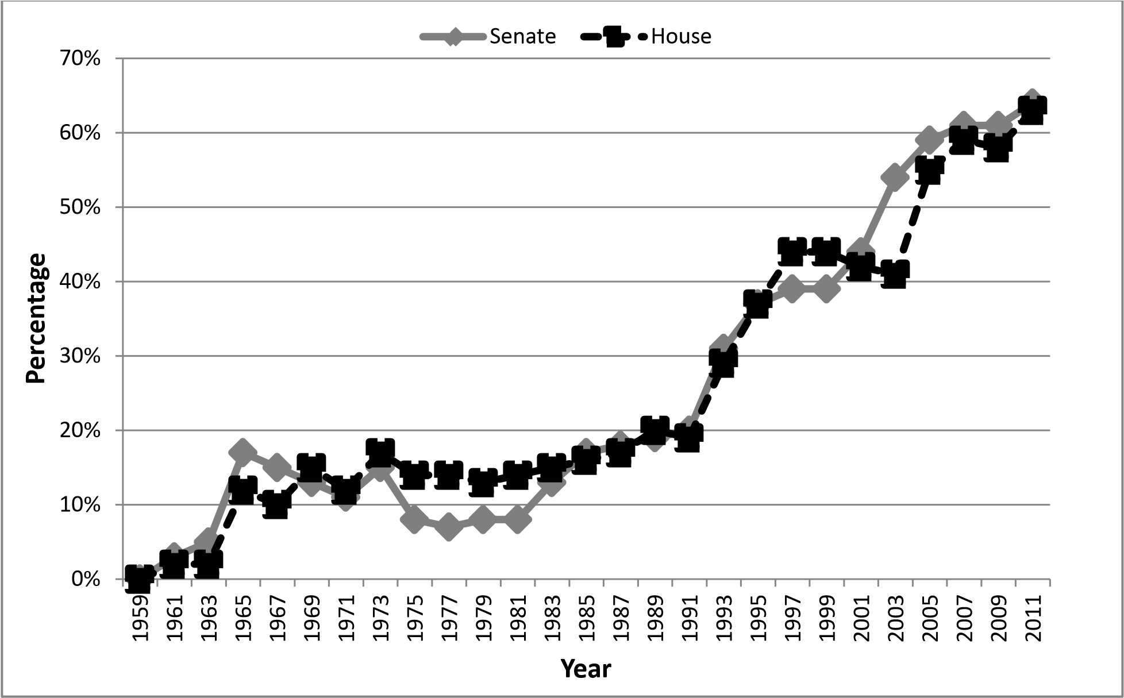

Figure 5-2
Emergence of Republican Party in Georgia State House Elections, 1966-2002
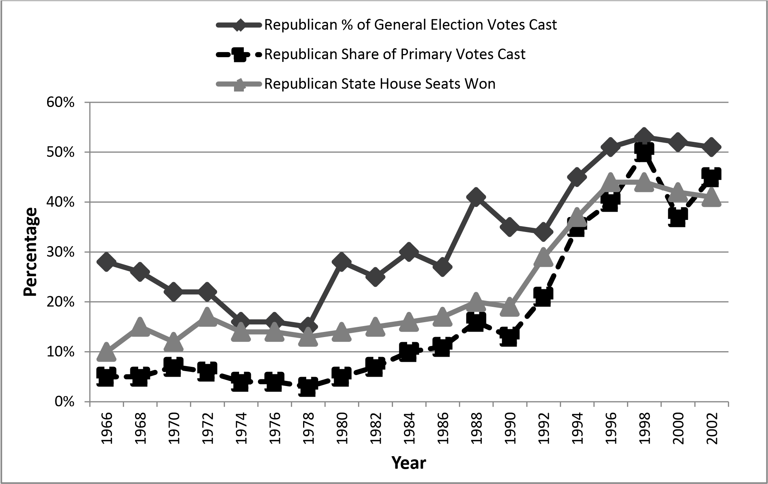

Table 5-3
Black Representatives in the Georgia House of Representatives

Year House Seats Percentage of All Seats
1959 0 0%
1961 0 0%
1963 0 0%
1965 0 0%
1967 7 3%
1969 8 4%
1971 11 6%
1973 12 7%
1975 14 8%
1977 20 11%
1979 21 12%
1981 21 12%
1983 20 11%
1985 19 11%
1987 19 11%
1989 20 11%
1991 23 13%
1993 27 15%
1995 31 17%
1997 32 18%
1999 32 18%
2001 33 18%
2003 33 18%

Table 5-4
Geographical Distribution of State House Seats by Region, 1960-2000

Year Atlanta Metro Other Metros Non-Metropolitan Areas
1962 6% 8% 86%
1966 22% 17% 62%
1968 26% 18% 56%
1972 33% 21% 46%
1982 42% 20% 38%
1992 49% 17% 34%

Republican Share of Seats in the Georgia Assembly, 1959-2011

Party Conflict Appearance in Contested Roll Call Votes, 1969-2005

0
%
10
%
%
20
%
30
40
%
50
%
60
%
1969
1973
1977
1981
1985
1989
1993
1997
2001
2005
Percentage of All Roll Call Votes

Year

Party Unity in Party Conflict Votes, 1969-2005

%
50
55
%
%
60
65
%
70
%
75
%
%
80
%
85
%
90
%
95
%
100
1969
1973
1977
1981
1985
1989
1993
1997
2001
2005
Percentage

Year
Republican
Democrat

Table 6-1
Speaker Elections, Georgia State House
Year Democrat |  | Votes |  | Republican | Votes
1985 Murphy | 152 |  |  | Isackson | 26
1987 Murphy | 151 |  |  | Isackson | 27
1989 Murphy | 141 |  |  | Isackson | 35
1991 Murphy | 146 |  |  | Heard | 32
1993 Murphy | 123 |  |  | Stancil | 49
1995 Murphy | 112 |  |  | Irvin | 65
1997 Murphy | 106 |  |  | Irvin | 73
1999 Murphy | 104 |  |  | Irvin | 76
2001 Murphy | 104 |  |  | Westmoreland | 74
2003 Coleman | 103 |  |  | Westmoreland | 70
2005 Porter | 60 |  |  | Richardson | 117
2007 Porter | 66 |  |  | Richardson | 113
Note: Democratic Nominee elected by unanimous voice vote 1961-1983.
Source: Journal of the Georgia State House, various years.

Win Rates on Party Conflict Votes, 1969-2005

%
0
10
%
%
20
30
%
40
%
50
%
%
60
%
70
%
80
%
90
%
100
1969
1973
1977
1981
1985
1989
1993
1997
2001
2005
Percentage

Year
Republican
Democrat

Figure 6-5
Voting Block Strength in Georgia State House, 1961-2007
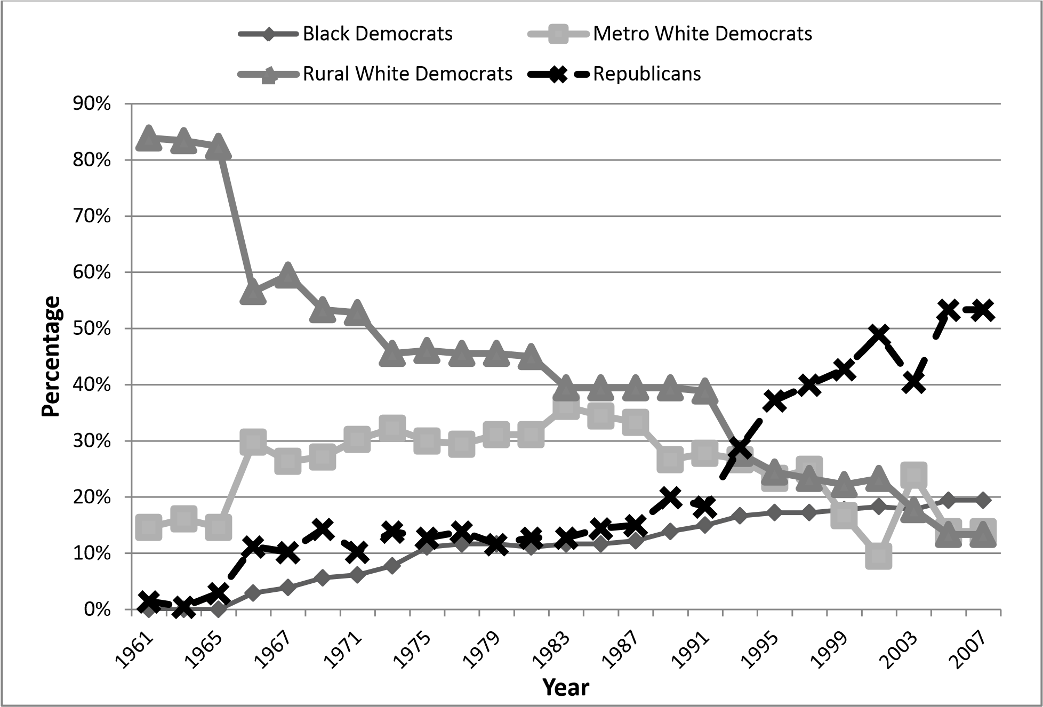

Race Conflict as a Share of All Contested Roll Call Votes, 1969-2005

%
-10
%
0
%
10
%
20
30
%
%
40
50
%
%
60
1969
1973
1977
1981
1985
1989
1993
1997
2001
2005
Percentage

Year

Figure 6-7
Group Unity on Racial Conflict Votes, 1969-2005
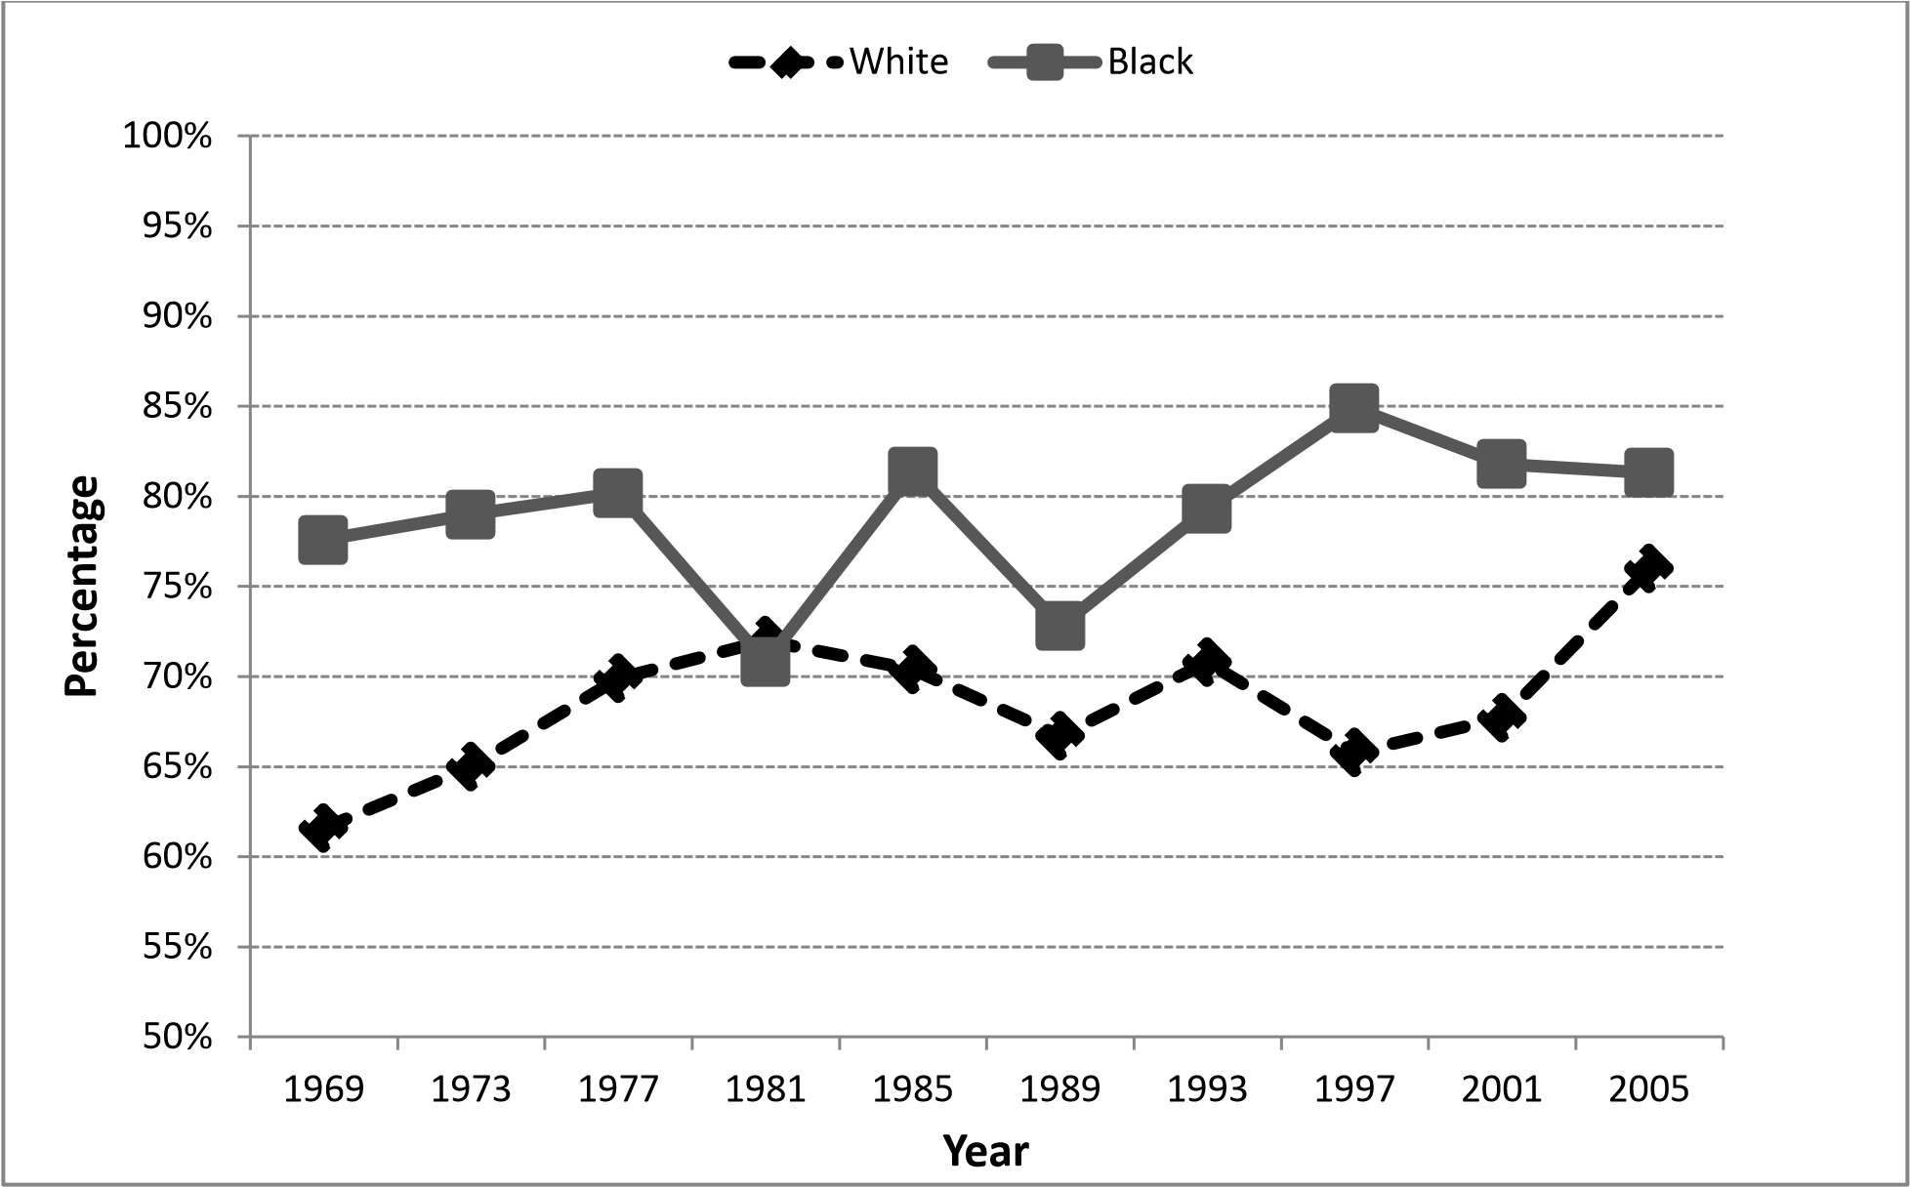

Group Win Rates on Race Conflict Votes, 1969-2005
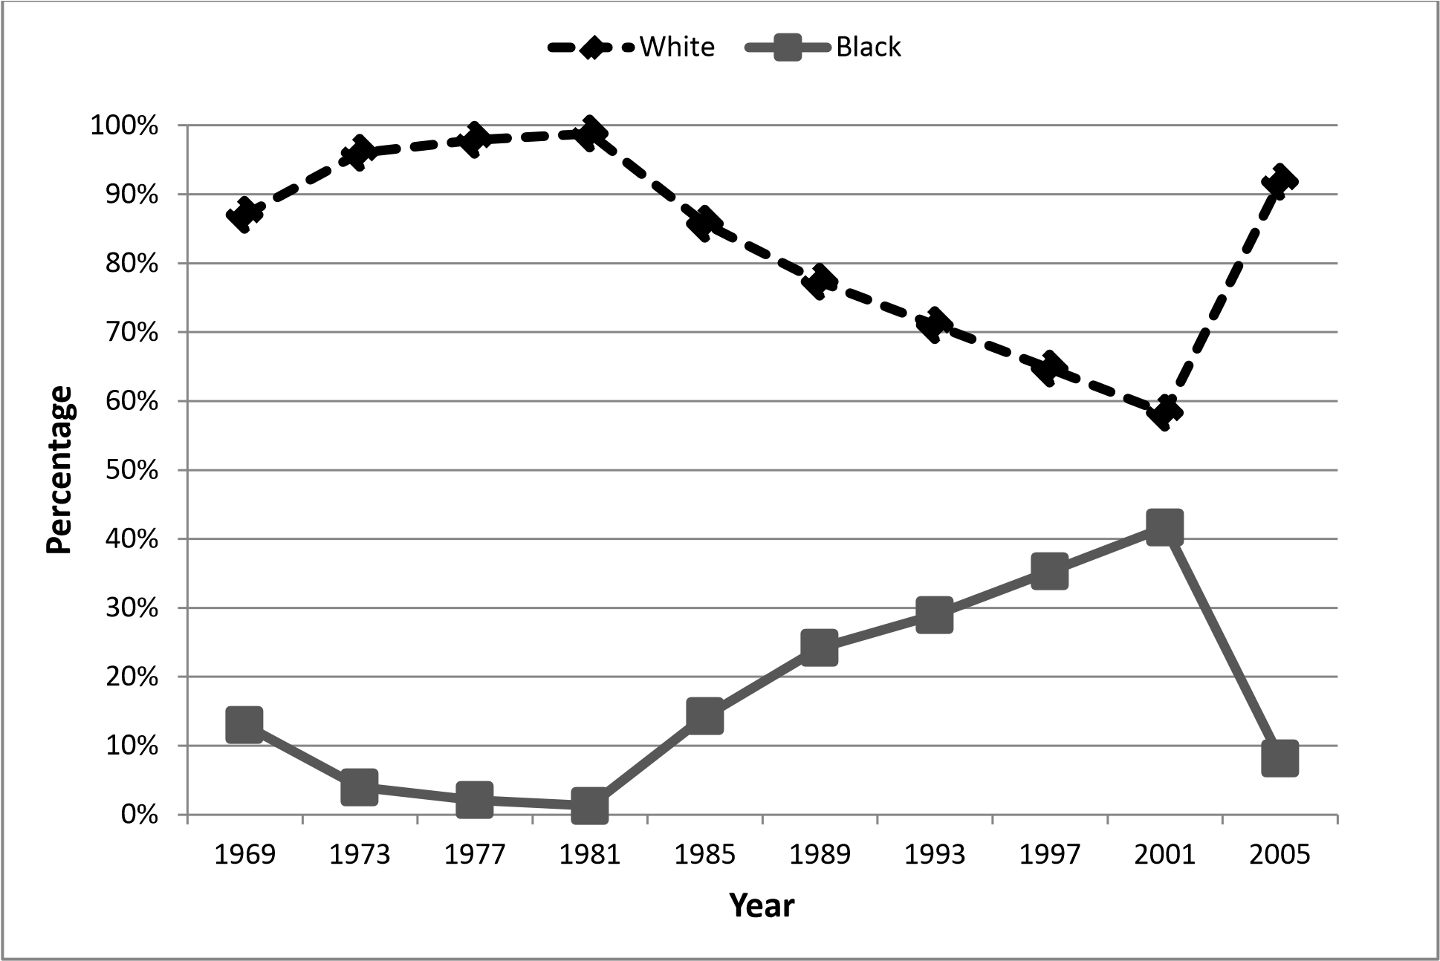

Metropolitan Representation in the Georgia State House, 1961-2005
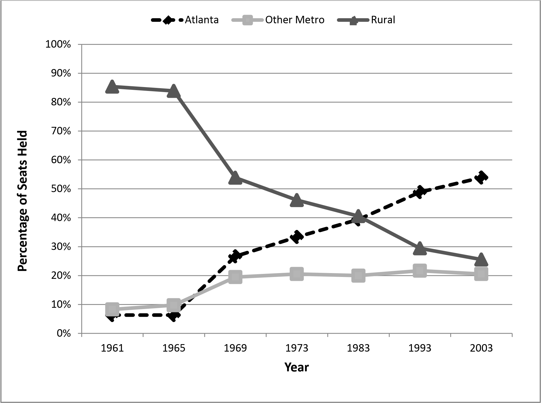

Urban-Rural Conflict Appearance Rate

%
-10
%
0
%
10
%
20
30
%
%
40
50
%
%
60
1969
1973
1977
1981
1985
1989
1993
1997
2001
2005
Percentage

Year

Urban-Rural Unity on Conflict Votes, 1961-2005

Urban-Rural Win Rates on Conflict Votes, 1961-2005

Roll Call Conflict by Group Type, 1969-2005
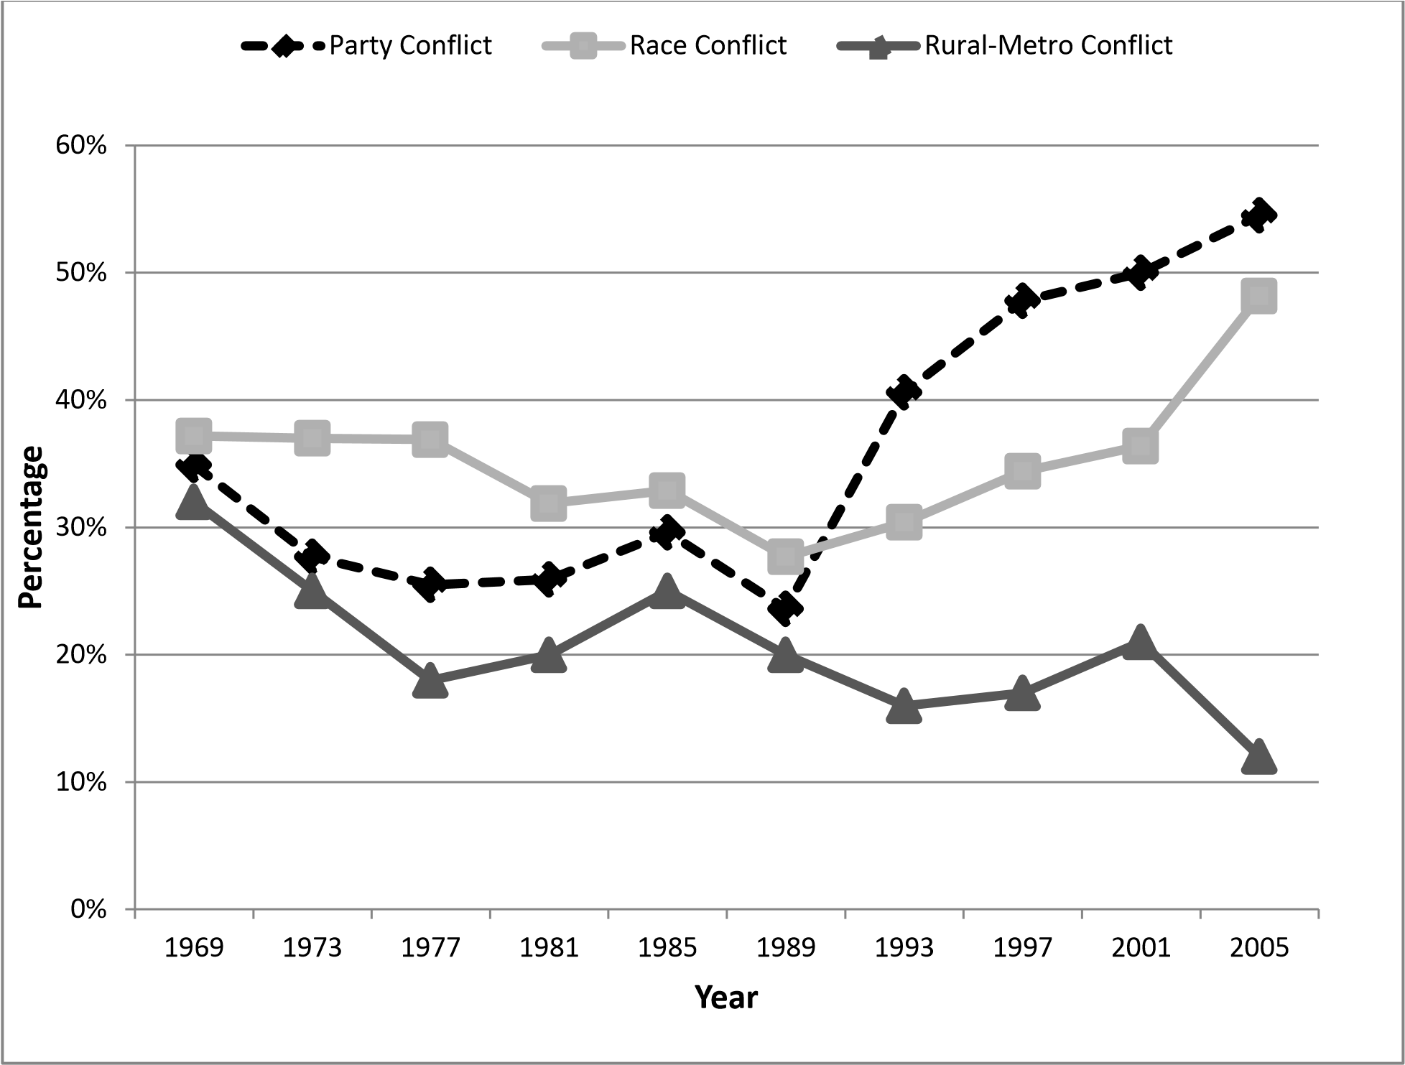

Group Win Rates on Votes with 20% Dissenting
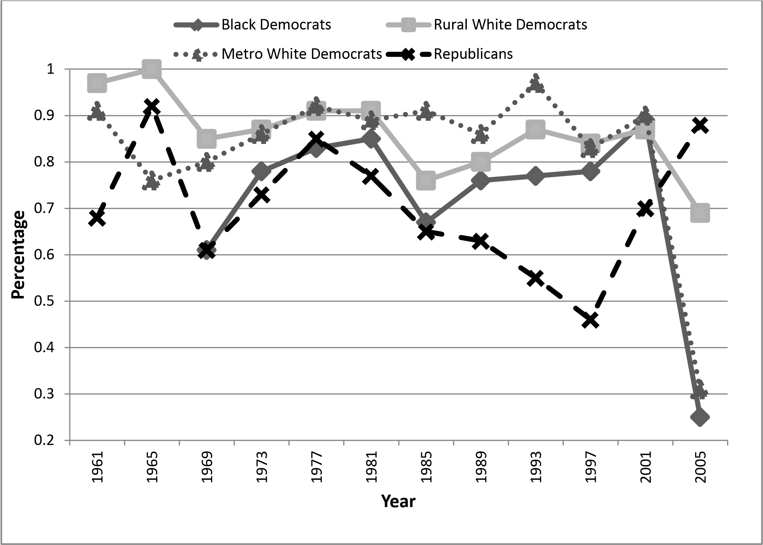

Figure 7-6
Percentage of Centrist Legislators in Georgia State House, 1961-2005

%
0
10
%
20
%
30
%
%
40
%
50
60
%
1961
1965
1969
1973
1975
1981
1985
1989
1993
1997
2001
2005
Percentage

Year

Appendix A Case Selection and Data
The evidence presented in this chapter looks at a single southern state and a single legislative chamber over a long period of time. The data will consist of contested roll call votes from the Georgia State House between 1961 and 2005. The Georgia Constitution requires roll call votes to be recorded on any measure that expends public funds. There are many unanimous or nearly unanimous roll call votes listed in the legislative journals. For this study analysis is restricted to roll call votes where at least 5% of those voting are opposed to the majority (typically eight or nine members out of nearly two hundred).
The state of Georgia was selected in part because the competitive party system arrived later than in some other parts of the south. The decade of 1965-1975 was a period of great social and political change within the region, and southern states where partisan competition appears early (Tennessee, Florida and Virginia) are less useful because it is difficult to distinguish effects caused by the party system from effects that may be caused by other contemporaneous factors. On the other hand, some Deep South states still lack fully developed two-party competition in state legislative elections (Mississippi, Arkansas and Alabama). Louisiana has a completely unique primary system which does not hold constant key institutional variables. Of the remaining states North Carolina had very low levels of roll call voting during the one-party period which made it unsuitable. Of the remaining three southern states Georgia had the advantage of sufficient variation in terms of party development, and the presence of other key independent variables such as race and a history of rural-urban politics which could potentially out weight party as important cleavages lines that organize politics.
The Georgia House also had the attractive quality of a very large number of members. Over time the number of members in the Georgia State House declined from 205 in 1961 to 195 in 1969 and the number was further reduced to 180 in 1973 and has remained fixed at that size. A chamber with a large number of legislators reduces the granularity of the data and facilitates a more fine grained analysis of spatial change. In a legislative chamber that has few members, the small population size limits the degrees of freedom available for hypotheses testing and with a small number of cases a single randomly generated error looms much larger. The larger number of legislators found within the Georgia State House enables not only the comparison of the behavior of white and black Democratic Representatives but also the potential to divide further each group into additional subgroups such as rural white Democrats and metropolitan white Democrats and still supply a sufficient number of cases for analysis.
The empirical evidence regarding legislative decision-making in the Georgia State House is derived from roll call vote data gathered across forty-five years (1961-2005) at four-year intervals. The votes have been collected from State House sessions that take place during the third year of the governor’s term, which also is the year immediately following the mid-term State House elections in the state. This year was selected so as to provide a degree of isolation from short-term state electoral considerations since the purpose of this study is to discover long-term trends within this state.
All contested roll call votes were gathered to provide a picture of voting coalitions. A contested roll call is defined as one in which at least 5% of those casting votes dissented from the chamber outcome. For example, if all one-hundred eighty members of the State House cast ballots on a roll call, then at least nine of them must dissent for the vote in order for it to be coded.
Each roll call vote was scanned individually and the legislator names were read electronically by the Omnipage Pro optical character recognition software. The list of legislators was then checked for errors or omissions and converted into a numerical dataset in which the yeas, neas and not voting were replaced with the values of 1, 6 and 9 respectively (this coding is required to operate the NOMINATE scaling program used in chapter seven). The original journals contained some errors prior to the use of electronic voting in 1975. The most common error in the journals involved listing the same legislator twice on the same roll call vote. A legislator’s name would be listed among those voting “yea” and also among those “not voting” on that particular roll call. These duplicate entry errors appeared approximately once every fifty roll calls—which is fairly insignificant given the large number of legislators. Cases of duplicate legislator entries on the same roll call were treated as missing data since it is not possible to know which of the duplicate listings is correct.
Other variables such as party affiliation, race and metropolitan region were also coded. Party affiliation was gathered from official election returns published by the Secretary of State from 1966-2005. Party affiliations for the 1961 and 1965 sessions were coded from the biographies found in the official State Register published by the Georgia Secretary of State on an annual basis. Racial data was obtained from the Georgia Legislative Black Caucus. Metropolitan region classifications were drawn from the county classifications found in the U.S. Census Bureau City and County Data Books for each decade. When State House districts contained parts of both metropolitan counties and rural counties, election returns were used as a guide. House Districts in which a majority of the votes cast came from metropolitan counties were classified accordingly and if the majority of votes cast came from non-metropolitan counties the district was considered to be rural or small town.
The empirical evidence presented in this chapter is descriptive in nature, inferential statistical analysis will be presented in Chapter Seven. Roll call vote patterns are summarized using both traditional and new measures. Traditional party conflict scores and Rice cohesion scores are presented so as to illustrate broad voting patterns. Party conflict scores simply count the percentage of votes in which a majority of one party opposes a majority of another party. This technique is also applied to racial conflict and rural-metropolitan conflict over time. Party unity scores simply measure the average percentage of party members who vote with their own party on party conflict votes. Cohesion scores are also calculated for racial conflict and ruralmetropolitan conflict.
Another measure of party or group success is win rates (Lawrence, Maltzman and Smith 2006) which measure of the percentage of roll call votes in which a party (or group) are on the winning side in relationship to the distribution of member preferences. This chapter will consider only simple win rates which is the frequency with which one group prevails over another, when the two groups are in conflict on a roll call vote. Simple win rates will be examined with respect to partisan divisions, racial divisions and rural-metropolitan conflict. In addition, in the conclusion of the chapter I examine the win rates of key voting blocs within the House chamber on a subset of more competitive roll call votes.

Bibliography
Aistrup, Joseph 1996. The Southern Strategy Revisited. Lexington KY: University Press of Kentucky.
Aldrich, John. R. 1995. Why Parties: The Origin and Transformation of Political Parties in American. Chicago: University of Chicago Press.
Aldrich, John R. and David W. Rohde. 1997. “The Transition to Republican Rule in the House: Implications for the Theories of Congressional Politics.” Political Science Quarterly 112: 541-567.
Aldrich, John R. and David W. Rohde. 1998. “Measuring Conditional Party Government.” Paper presented at the annual meeting of the Midwest Political Science Association, Chicago.
Aldrich, John R. and David W. Rohde. 2001. “The Consequences of Party Organization in the House: The Role of the Majority and Minority Parties in Conditional Party Government.” In Polarized Politics: Congress and the President in a Partisan Era, edited by J.R. Bond and R. Fleisher. Washington, DC: CQ Press
Aldrich, John H., Mark Berger, and David W. Rohde. 2002. “The Historical Variability in Conditional Party Government, 1877-1994.” In Parties, Procedure and Policy:
Essays on the History of Congress, edited by D. Brady and M. McCubbins. Stanford:
Stanford University Press.
Black, Earle. 1976. Southern Governors and Civil Rights.. Cambridge, MA: Harvard University Press.
Black, Earle and Merle Black. 1987. Politics and Society in the South. Cambridge, MA:
Harvard University Press.
Black, Earle and Merle Black. 1993. The Vital South: How Presidents are Elected.
Cambridge, MA: Harvard University Press.
Black, Earle and Merle Black. 2002. The Rise of Southern Republicans. Cambridge: Harvard
University Press.
Clausen, Aage. 1973. How Congressmen Decide. New York: St. Martins Press.
Clinton, Joshua, Simon Jackman and Douglas Rivers. 2004. The Statistical Analysis of Roll Call Data: A United Approach. American Political Science Review 98:355-70.
Council of State Governments. 1948-1998. The Book of the States. Lexington, KY:
Council of State Governments.
Cox, Gary W. and Matthew McCubbins. 1993. Legislative Leviathan: Party Government in the House. Berkeley: University of California Press.
Downs, Anthony. 1957. An Economic Theory of Democracy. New York: Harper and Row.
Fleischmann, Arnold and Carol Pierannunzi. 1997. Politics in Georgia. Athens GA:
University of Georgia Press.
Fiorina, Morris. P. 1974. Representatives, Roll Calls, and Constituencies. Lexington, MA: Lexington Books.
Harvard, William 1972. The Changing Politics of the South. Baton Rouge: Lousisana State University Press.
Hepburn, Lawrence. 1992. Contemporary Georgia. Athens, GA: Carl Vinson Institute of Government, University of Georgia.
Holmes, Robert A. 2000. “The Georgia Legislative Black Caucus: An Analysis of a Racial Legislative Subgroup.” Journal of Black Studies. 30: 768-790.
Hyatt, Richard. 1999. Mr. Speaker: The Biography of Tom Murphy. Macon GA: Mercer University Press.
Key, V.O. 1949. Southern Politics in State and Nation. New York: Alfred A. Knopf.
Key, V.O. 1959. “Secular Realignment and the Party System.” Journal of Politics 21:
198-210.
Kousser, J. Morgan. 1974. The Shaping of Southern Politics: Suffrage Restriction and the Establishment of the One-Party South, 1880-1910. New Haven: Yale University Press.
Lilley, William III, Laurence J. DeFranco, and William M. Diefenderfer III. 1994. The Almanac of State Legislatures. Washington, D.C.: CQ Press.
Martorano, Nancy, R. Bruce Anderson, and Keith E. Hamm. 2000. “A Transforming South: Exploring Patterns of State House Seat Contestation.” Paper presented at the 2000 Biennial Citadel Symposium on Southern Politics, Charleston, SC.
Manley, John F. 1973. “The Conservative Coalition in Congress.” American Behavioral Scientist. 17:223-47
MacRae, Duncan. 1958. Dimensions of Congressional Voting: A Statistical Study of the
House of Representatives in the Eighty-first Congress. Berkeley: University of California Press.
McDonald, Laughlin. 2003. A Voting Rights Odyssey: Black Enfranchisement in
Georgia. Cambridge, UK: Cambridge University Press
Parsons, Malcolm. 1963. “Quasi-Partisan Conflict in a One-Party State Legislative
System: The Florida Senate, 1947-1961” American Political Science Review
Patterson, Samuel. 1962. "Dimensions of Voting Behavior in a One-Party Legislature." Public Opinion Quarterly 26: 185-200.
Pitkin, Hannah. 1967 The Concept of Representation. Berkeley, CA: University of California Press.
Poole, Keith and Howard Rosenthal. 1997. Congress: A Political-Economic History of Roll Call Voting. New York: Oxford University Press.
Rohde, David W. 1991. Parties and Leaders in the Post-Reform Congress. Chicago:
University of Chicago Press.
Schelley II, Mack C. 1983. The Permanent Majority: The Conservative Coalition in the United States Congress. University of Alabama Press.
Shannon, Jasper Berry. 1949. Toward a New Politics in the South. Knoxville: University of Tennessee Press.
Sturrock, David. 1997. “Out of the Phone Booths: Republican Primaries in the Deep South.” In Southern Parties and Elections. Robert Steed, Laurence Moreland and Tod Baker eds. Tuscaloosa, AL: University of Alabama Press.
Ware, Alan 1996. Political Parties and Party Systems. New York: Oxford University Press.
Welch, Susan and Eric Carlson. 1973. "The Impact of Party Voting Behavior in a Nonpartisan Legislature."
Wielhouwer, Peter W. and Keesha Middlemass. 2005. “Black Representation in Georgia. In Politics in the New South:Representation of African-Americans in State Legislatures,
Charles E. Menifield and Stephen D. Shaffer. Albany: State University of New York Press.

Please consult Appendix A for more information regarding the collection of roll call votes used in this analysis.

