Hydropower: The Human Security Conundrum
Dr. Amber Aubone and Adam Bishop
Western Political Science Association Annual Conference
April 2, 2015

INTRODUCTION

Mother Nature’s Network, a community webpage covering environmental news and issues, provides a glimpse of some eco-disaster movies, reflecting concerns about human-induced climate change and resource depletion (www.mnn.com). The film The Day After Tomorrow portrays the horrifying effects of a new ice age brought on by global warming. Other such movies illustrate how human attempts to alter nature at the micro level can have devastating repercussions for local ecological systems and human security. For example, in the comedic, animated film Madagascar: Escape 2 Africa, a local watering hole used by native wildlife is dried up when stranded tourists create a dam, primarily to secure their own water source. While the humans in this film have selfish motives, numerous examples indicate that even altruistic motives and their corresponding “solutions” have consequences for human security. In the documentary Darwin’s Nightmare, scientists address overfishing in Lake Victoria by introducing the non-native Nile perch, ironically leading to a food security crisis for locals.
Human efforts to slow climate change and enhance energy security present similar dilemmas. Consider the exponential increase in the number of intergovernmental and national initiatives intended to identify and develop renewable energy sources. Currently, the greatest share of renewable energy is that produced by hydropower. Thousands of hydroelectric dams span the globe, and many are in various phases of construction. However, while water is presumably a renewable resource, hydroelectric dams have considerable negative effects on wildlife and the security of those living near dams, specifically by displacing thousands and subjecting others to the dangers of flooding or decreased food security. In this study, we use the framework of global governance to suggest means for assessing both the tangible and intangible costs and benefits of such hydroelectric dams, incorporating multiple levels of analysis.
The global governance concept suggests a more complex depiction of global decision-making, including who is involved, and whom is affected by said decisions (Finnemore 2014). Likewise, it suggests a complex form of policymaking, focusing not just on what we refer to as “vertical” (top-down and bottom-up) development of environmental policy, but also “horizontal.” The latter incorporates interaction between actors at the same level of analysis, including that between: international organizations, states, municipalities, multinational corporations, and various sectors of civil society.
The goals of this paper are both theoretical and practical: (1) to gauge whether a vertical-horizontal framework is an adequate depiction of global governance, comparing it to a more traditional framework used to develop global initiatives; (2) to identify who is (and should be) involved in the decision-making process if using a model that complies with the global governance framework; and (3) to determine if the aforementioned vertical-horizontal framework is useful in assessing the effectiveness of global governance for enhancing human security at the micro level. We aim to complete said goals by examining the decision-making process and corresponding effects of constructing hydroelectric dams.
ENVIRONMENT AS PUBLIC GOOD
In IR literature, scholars often treat the environment as a public good, presenting the well-known collective-action problem. The traditional understanding of a public good is that it benefits all and is not excludable, thus giving any private entity little to no incentive to produce it, in turn resulting in a Pareto-suboptimal outcome (Olson year; Nash year). In order to address this dilemma, traditional political theorists and more contemporary game theorists identify the state as one to take on the responsibility of providing public goods (cite). However, some public goods, such as those related to the environment, are not limited to Westphalian territorial boundaries, making the state an inadequate solution to this dilemma. We will return to this depiction later.
The most commonly accepted recommendation for mitigating the effects of climate change specifically is to augment reliance on renewable energy sources relative to their nonrenewable counterparts. Increasing the share of renewable energy production is primarily the purview of states, as development projects require physical space confined by sovereign, territorial boundaries. Yet, energy usage, renewable or not, has global effects. Thus, there is global interest in encouraging the development of renewable energy sources, particularly for rising states whose domestic energy demand is expected to increase exponentially.

THE HUMAN SECURITY CONUNDRUM

Introduction of the “human security” concept in the 1994 UN Human Development Report resulted in a stream of scholarship that shifted traditional understandings of security primarily focused on the state to a focus on the individual. That is, the expanded concept of human security suggests the need for a more comprehensive corresponding measure; not only must it assess physical security in the form of protection from external and internal threats, but also socioeconomic well-being, access to healthcare and education, among other goods and services. To the surprise of some who question the representation, accountability, and effectiveness of international institutions, some human development goals have been realized, perhaps as a result of increased attention to human development issues and cooperation among states within international fora.

Not only has the emphasis on human security altered traditional understandings of security; it has also transformed the understanding of economic development, with yet another stream of literature calling for more refined, valid measurement of development at the micro level. That is, traditional economic development studies and initiatives primarily focused on development at the national level, but some political economics scholars have called for a more comprehensive measure assessing individual wellbeing (Sen 1994?). This resulted in the development of measures such as the Human Development Indicator (HDI) and Multidimensional Poverty Index (MPI) (Alkire and Santos 2013: 239). One such indicator included in the MPI is that of individual access to energy and electricity, working under the assumption that access to electricity improves the individual or household’s standard of living.

INTERNATIONAL INSTITUTIONS

The means for resolving the collective-action problem described in an earlier section – namely, having a state provider and enforcer of a public good -- does not apply as well to the global commons, given that there is no world government. Rather, when treated as a global issue, conserving the environment is considered the purview of international organizations (IGOs). In the role of environmental conservator, IGOs develop goals and templates for national governments and multinational corporations to follow, educational initiatives, and the like. Said templates often involve regulation of industry and their respective emissions, as well as campaigns to encourage environmental responsibility among citizens. Yet, as many have noted, IGOs may suggest policy and oversight mechanisms, but they do not have the same authority as a state to enforce them.

The effectiveness of IGOs in addressing global issues has been debated by scholars and policymakers for decades, with many describing IGOs as toothless and crippled by interstate politics. These statements ignore the progress and organizational learning that has taken place over the years (Finnemore 2014). Thus, it is worth acknowledging and commending attempts by international organizations to protect the environment and slow climate change.

One such IGO is the Intergovernmental Panel on Climate Change (IPCC), a scientific body formed by the UN Environment Programme (UNEP) and the World Meteorological Organization (WMO) in 1988. In recognizing that it is not too late to reverse the negative human actions that precipitate climate change, the IPCC in 2014 assembled a thorough plan for states to independently start the process. According to the IPCC, “CO₂ emissions from fossil fuel combustion and industrial processes contributed about 78% of the total Greenhouse Gas (GHG) emission increase from 1970 to 2010” (Edenhofer et al., 2014, p. 6). Emphasizing that a unified response is the most crucial aspect of addressing climate change, they state, “International cooperation is… required to effectively mitigate GHG emissions and address other climate change issues. Furthermore, research and development in support of mitigation creates knowledge spillovers. International cooperation can play a constructive role in the development, diffusion and transfer of knowledge, and environmentally sound technologies” (Edenhofer et al., 2014, p. 5).

The IPCC further supports this perspective in asserting that existing and proposed international climate change cooperation arrangements vary in their focus and degree of centralization and coordination, so it is beneficial to have both “multilateral agreements, harmonized national policies and decentralized but coordinated national policies, as well as regional and regionally-coordinated policies” (Edenhofer et al., 2014, p. 32).

Another IGO that was instrumental in providing an enduring framework for a cost-benefit analysis of hydroelectric dams is the World Commission on Dams (WCD) formed in 1998. Comprised of individuals in government, academia, and the private sector, 59 countries and every stakeholder group were represented in its exhaustive study. The WCD spent years collecting empirical and theoretical evidence regarding the environmental, social, and economic impacts of large dams and ultimately determined that these three dimensions of development must be integrated into any decision-making process aimed at ensuring energy and water security (2000, p. xxviii).

While acknowledging that “dams have made an important and significant contribution to human development...” they also concluded that “in too many cases an unacceptable and often unnecessary price has been paid to secure those benefits, especially in social and environmental terms, by people displaced, by communities downstream, by taxpayers and by the natural environment” (2000, p. xxviii). The process of globalization, therefore, has the ability to both help and harm, from a local to the international level.

When assessing effectiveness for addressing global issues, we are thus left with the question, effective for whom? Finnemore argues that the effectiveness of global initiatives should be assessed in terms of how they improve the livelihood of individuals (2014). Yet, member-country delegates of international organizations are not elected officials, are not democratically accountable, and thus may not adequately represent those negatively affected by development projects, even if these institutions are working within democratic norms (Goodhart 2011). Focusing on global governance broadly rather than IGOs specifically provides opportunities for a more refined understanding of global initiative effectiveness. A comparison of these approaches is roughly sketched in the table below.

 | Traditional | Global governance
Vertical | - IGOs and state actors develop and implement renewable energy initiatives  - Top-down  - Macro level | - IGOs, states, provincial/municipal governments, MNCs, civil society (NGOs, affected individuals)  - Both top-down and bottom-up
Horizontal | IGOs, interaction between states | Interaction between actors and their external counterparts:  IGOs, states, provincial/municipal governments, MNCs, civil society (NGOs, affected individuals)
Goal | - Increase share of energy produced by renewable sources  - Increase energy production overall | - Increase share of energy produced by renewable sources  - Increase in energy production that benefits individuals

As this applies to hydroelectric dams, consider that traditional international and national authorities focus primarily on the effects said dams have for (a) energy production overall and (b) enhancing the share of energy generated by hydropower. Emphasis on the first outcome assumes that increased energy production improves the living standard of citizens by granting greater access to electricity. Yet, while publicly available data allow one to compare energy production to energy usage per-capita, it is unclear whether it is domestic industrial and financial sectors or the individual citizen who benefits from increased energy production or industry. Likewise, some energy is exported to neighboring states, suggesting that energy production is not reserved for citizens of a state whose leadership has pursued and implemented dam construction.

The contemporary concept of global governance illustrates the shift in focus from states, both in terms of national governance and membership in international organizations, to various transnational actors. Given emphasis on human security, the effectiveness of global initiatives should be assessed by how they affect the living standard of individuals. As Finnemore argues, if we do not assess effectiveness with a focus on how an initiative affects individuals, we are left with international organizations and states assessing the success of one initiative or another based on their own predetermined criteria (Finnemore 2014).

DECISION-MAKING PROCESS COMPLIANT WITH GLOBAL GOVERNANCE FRAMEWORK

There have been praiseworthy attempts to incorporate stakeholders at various levels, to address multiple areas that might be affected by dam construction. Specifically, we will focus on the efforts of the International Hydropower Association (IHA) in developing the Hydropower Sustainability Assessment Protocol (HSAP). With this protocol, the International Hydropower Association sought to develop criteria for evaluating the overall sustainability of a dam at each phase of its life cycle: early stage, preparation, implementation, and operation (2011, p. 7). At each stage, the assessment relies on “objective evidence to support a score for each topic, which is factual, reproducible, objective and verifiable” (International Hydropower Association, 2011, p. 5). In doing so, this proposed protocol strives to eliminate the possibility of bias on the part of any state seeking to build a dam. Furthermore, the protocol calls the use of independent “accredited assessors,” who will oversee and control the quality of assessments (2011, p. 6).

Comprehensive Assessment of Effects

The table below identifies the various areas that could be affected by dam construction, and project plans are assessed in how well their plans account for effects. This is a more comprehensive approach than examining effects on national-level energy production and share of renewable energy.

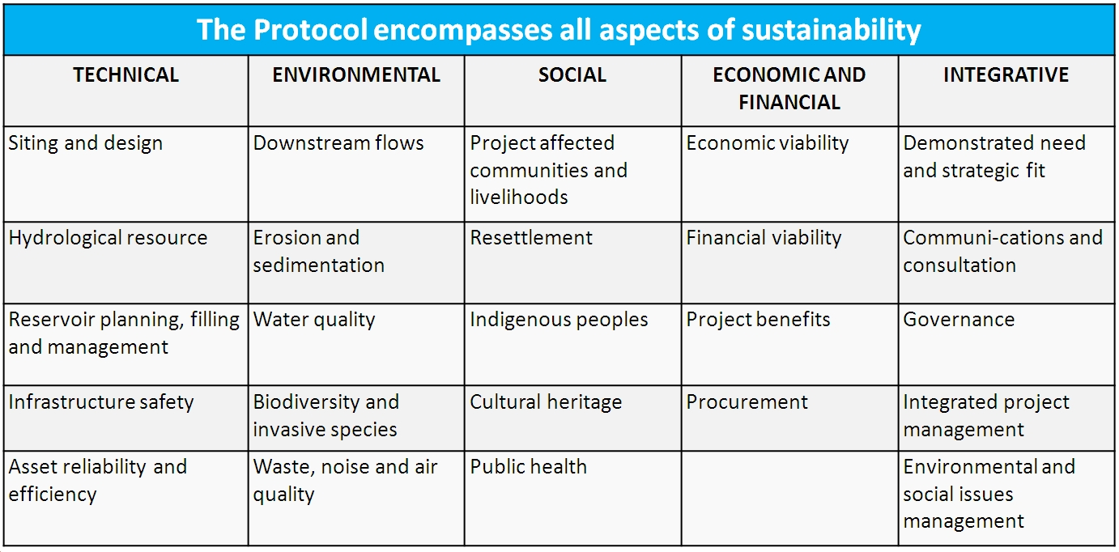
Source: http://www.hydrosustainability.org/Protocol.aspx

Who Should Be Involved in Decision-making Process

As stated on the Governance webpage, “The Council expands on the multistakeholder approach used to develop the Protocol. The Council consists of a series of Chambers, each representing a different segment of hydropower stakeholders, these are:
- Hydropower consultants, contractors or equipment suppliers.
- Hydropower operators or developers.
- Environment or conservation organisations.
- Social impacts, project affected communities, and indigenous peoples' organisations.
- Development, public or commercial banks, financial organisations, and private investors/ investment funds.
- Emerging and developing economy country governments (as classified according to the most recent publicly-available International Monetary Fund World Economic Outlook).
- Advanced economy country governments (as classified according to the most recent publicly-available International Monetary Fund World Economic Outlook).”
Each hydroelectric dam project is assessed and reflected using a spider diagram, such as that depicted below. With guidelines from the aforementioned protocol implemented, the desired end state is that the assessment of overall effectiveness of a hydroelectric dam will consider human security factors that states may not, when left to their own devices. By including affected communities as well as other stakeholders in the decision-making body, there is greater potential for mitigating, or balancing, the negative effects dam construction will have on the local population. Again, assessment is of the plans to incorporate these affected populations and representatives in civil society, not of the actual incorporation of these actors. However, it is expected that the IHA will want to compare plans to actuals to identify where changes might need to be made. Still, using this decision-making model allows for some optimism.
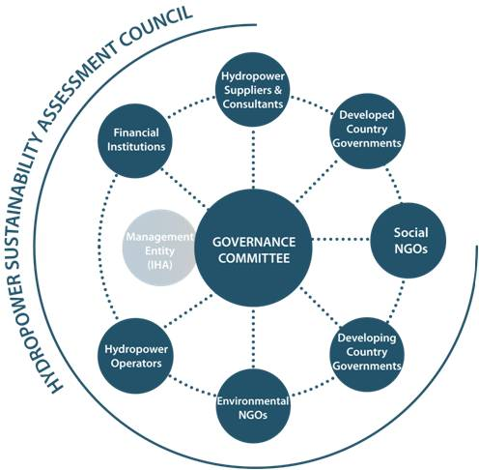
Source: http://www.hydrosustainability.org/Governance.aspx
After project plans have been assessed, the results are provided in a report and depicted visually using the sample spider diagram below.
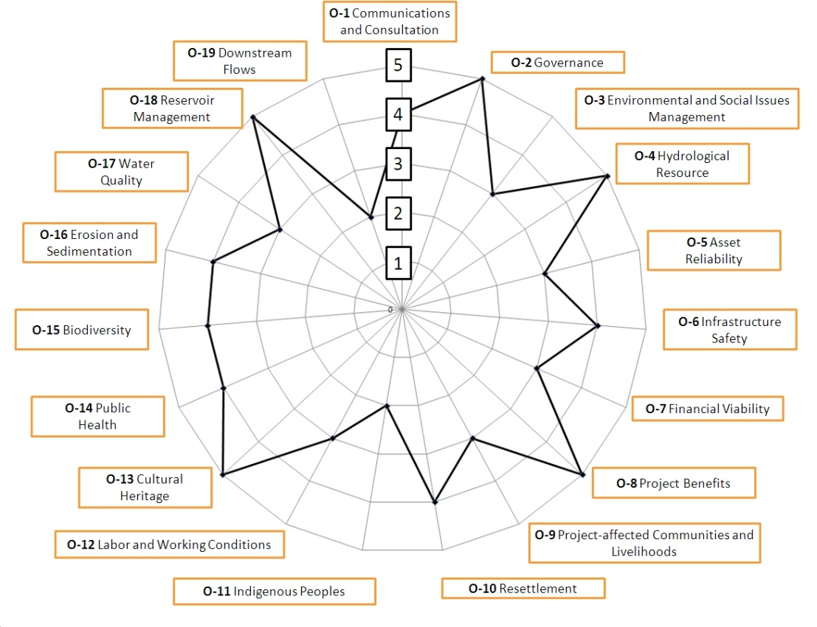
Source: http://www.hydrosustainability.org/Protocol.aspx

After giving a cursory look at the spider diagrams for the publicly accessible projects listed below, it should be noted that where projects tend to score lowest is in their plans to incorporate and consult with affected populations (where applicable). Thus, while the protocol suggests incorporation of these actors, it appears this is still a weakness in the planning stage. If plans do not include details regarding inclusion of affected populations, it is unlikely they will be adequately incorporated into the decision-making process or that their feedback will strongly considered when the project is implemented. Accordingly, without including feedback from affected groups, dams may have significant negative consequences for affected populations. If brushing these concerns aside in pursuit of national economic and energy goals, achieving national goals might be at the expense of human security.

Project name | Report date | Region | Protocol stage | Project size (MW)
Semla IV | 27 Jan 2015 | Europe | Preparation | 3
Kabeli A | 06 Dec 2014 | Asia | Preparation | 38
Program Sava | 25 Sep 2014 | Europe | Early Stage | 156
Santo Antônio | 09 Sep 2014 | The Americas | Implementation | 3568
Blanda | 11 Dec 2013 | Europe | Operation | 150
Romanche-Gavet | 18 Sep 2013 | Europe | Implementation | 94
Keeyask | 18 Jul 2013 | The Americas | Preparation | 695
Jirau | 17 May 2013 | The Americas | Implementation | 3750
Hvammur | 10 May 2013 | Europe | Preparation | 82
Jostedal | 10 May 2013 | Europe | Operation | 288
Walchenseekraftverk | 10 May 2013 | Europe | Operation | 124
Trevallyn | 04 Apr 2012 | Oceania | Operation | 96
Source: http://www.hydrosustainability.org/Protocol-Assessments.aspx

One example of this can be seen in the Grand Inga dam system along the Congo River. According to Showers, the original benevolent vision for the dam regressed over time from “infrastructure-for-development to producer-of-commodity as electricity was deregulated and regional power pools created” (2009, p. 32). As the recognized potential for hydroelectric power grew in the early twenty-first century, “the utilities of five southern African nations— Democratic Republic of Congo (DRC), Angola, Namibia, Botswana and South Africa—formed the Western Power Corridor Project (WESTCOR) to construct and operate several hydroelectric projects, culminating in Grand Inga” (Showers, 2009, p. 32).

However, realizing the economic boom such a project would bring to the region, DRC dropped out of WESTCOR and decided to pursue private investors to complete construction of the Grand Inga on its own. This decision would have come as a relief to the other members of WESTCOR, particularly South Africa, as they could still benefit from exports of the electricity produced without incurring the financial burden of investing in the massive undertaking. Using existing power transmission lines, hydroelectric power produced by the dam could then be exported across Africa; a prospect that was also heavily supported by international corporations involved in the mining industries of sub-Saharan Africa, particularly from South Africa’s Eskom and central African mines. Moreover, as early as 2002, it was determined both feasible and economically viable to export electricity to Europe and the Middle East (Showers, 2009, p. 46).

It is not clear, however, how this project is affecting local populations. It is also unclear whether increasing shares of energy produced by renewable sources are better for the environment, as uncertain increasing of the share of hydropower may not necessarily lead to a decrease in energy produced from non-renewable resources. For example, consider that [5] watts of energy are produced by non-renewable resources, and [2] by hydropower. If the following year, [4] watts are produced by hydropower, this increases the share of energy produced by hydropower, but if the amount of energy produced by non-renewable sources remains the same (5 watts), increasing hydropower results in no discernable change for the amount of energy produced by nonrenewable sources.

ASSESSING GOALS OF PAPER

In returning to the original goals of the paper, the HASP suggests that (1) a vertical-horizontal framework is an adequate depiction of global governance addressing multiple levels of analysis; and (2) it is feasible to include actors at various levels in the decision-making process if using a model that complies with the global governance framework. Finally, despite the fact that the actuals of projects following the HSAP have not yet been assessed, the planning model itself suggests a means for assessing the effectiveness of global governance using the same categories and levels of analysis, including at the micro level.

These assessments based on the HASP manifest themselves in how states attempt to publically acknowledge and mitigate the negative impacts of hydroelectric dams or justify mass displacement. It also points to a number of factors that could lead to determining a quantifiable answer as to whether or not a dam should be deemed successful, and economically sustainable. These include ethically refined resettlement methods for IDPs, numerous intergovernmental research panels that provide strategic priorities, standards, and guidelines for future dams, and social impact studies that show positive impacts in the long run outweigh negatives in the short term.
One example of the aforementioned intergovernmental panel is the United Nations High Commissioner for Refugees (UNHCR). They released a report in the spring of 2014 that exclusively focuses on planned and unplanned relocation (United Nations High Commissioner for Refugees, 2014). It covers who, what, where, when, why, and how to deal with displacement and relocation.

To try and quantify the impacts that development-induced displacement has on human security, the World Commission on Dams reported that the global level of physical displacement resulting from dam construction could range from 40 to 80 million, with 26-58 million of those coming from India and China alone (WCD, 2000, p. 104). The Three Gorges Dam located in the Chinese province of Hubei, for example, provides enough power to supply one-tenth of the country’s energy needs yet resulted in the displacement of nearly 1.5 million people. It is also somewhat ironic that the World Bank, whose top two goals include ending extreme poverty and boosting shared prosperity, admitted that large dams they funded account for 63% of the displacement among all infrastructure projects (WCD 2000:104). Depending on the severity of their displacement, they could now potentially be deprived of school, nutrition, and possibly all six of the living standard indicators (electricity, improved sanitation, improved drinking water, flooring, cooking fuel, and assets ownership) under MPI, which we will go over in more detail later. Furthermore, it is well known that natural disasters and many of the negative impacts of dams affect impoverished people far more than the rest of a population so it becomes a health and security issue as well.

In additional to international organizations, citizens affected by development projects are also underrepresented by their own respective governments. As a result, some have argued that only global civil society and organized social movements can pressure governments to consider the effects of development projects on communities.

All development projects have ‘winners’ and ‘losers,’ but displacement, particularly of thousands, results in multiplicative effects on way of life, individual “disarticulation,” and psycho-social feelings of disillusionment. While dams lead to displacement, displacement in turn produces tangible and intangible effects for the respective population, and thus insinuates the need for careful comparison of the relative benefits of political, economic, and social costs associated with dam construction. While a pessimistic view has been presented thus far, there has been observable progress in government attempts to mitigate the negative effects of development projects.

ACCESS TO ENERGY
The United Nations Development Programme conducts numerous types of studies to determine a country’s development; the one that considers the most negative effects that a dam could bring about is the Multidimensional Poverty Index (MPI). The MPI was developed in response to the lack of a comprehensive methodology for determining a country’s poverty level and it could be used to explain the causal relationship between the construction of a hydroelectric dam and changes in a country’s MPI (Alkire and Santos, p. 239, 2013). It uses “information from ten indicators which are organized into three dimensions: health, education, and living standards, following the same dimensions and weights as the Human Development Index (HDI)” (Alkire, Conconi and Seth, p. 4, 2014). When a respondent takes the MDI survey, he or she will indicate whether or not each member of his or her household meets certain deprivation cutoffs (i.e. the household has no electricity). If a deprivation is identified, it is assigned a weight of either 1/6 or 1/18. The sum of all weighted indicators equals 1. Finally, a cutoff of 33.33% is designated and people who meet or exceed this threshold are considered multidimensional poor (Alkire, Conconi and Seth, p. 4, 2014). Before states can begin to quantify their needs for increased development and human security, they must first understand how they currently fare and MPI aids in that discovery process. Once a state’s MPI has been calculated, a cursory look at the individual variables comprising it could inform a new, or revised, direction in policy aimed toward improving national development. One assumes that increased energy production resulting from a hydroelectric dam should be accessible to the general population and thus improve their standard of living accordingly. However, it is not always clear if and how the development of renewable energy sources affects energy access for a country’s general population.

If this concept is then applied across the 50,000 people displaced by the hydroelectric development of three dams on the Se San River in Cambodia and Laos, it is easy to see how a few small localized projects can have large-scale impacts on locals and the state (Polimeni, Iorgulescu, and Chandrasekara, p. 81, 2014). For instance, if none of those 50,000 were deprived in any of the ten indicators before, but now displacement has caused all 50,000 people to meet those eight characteristics of deprivation mentioned above, then there is a far greater average increase in the MPI of that region.

Taking this even further, the challenges in attempting to calculate the change in MPI before and after the construction of the Three Gorges Dam when 1.5 million people were displaced from the immediate area and around 10 million people were removed from the Yangtze Valley would be immeasurable (WCD, 2000, p. 104). Of course the larger the scale of the project, the more polarizing the benefits and downsides may become. To ensure an accurate index is used to comprehensively evaluate the development or poverty of a country, it would be important to expand the scope of the MPI to include more variables, some of which IDPs are more likely to be deprived of, such as human security, environment, and measures of happiness or satisfaction.

Yet, the goal of enhancing national development and human security in terms of energy production, usage, and independence has, ironically, diminished human security, not just for future generations and wildlife, but for human security today. The already visible effects of climate change brought on by the usage of fossil fuels emitting carbon emissions have intensified debates regarding the normative reasoning behind shifting to renewable energy sources (Mittler 2014). Another twist, however, is that renewable energy sources have their own environmental costs (Terminski 2013).

CONCLUSION
Governments often subsidize the construction and management of dams, and may not see the economic benefits of this project for decades. Tying up government funds, even if they receive loans and grants from the World Bank to fund such projects, seems to further compromise economic development, if not compromise the political survival of the leadership overseeing dam projects and management. Thus, the addition of renewable energy sources presents yet another ethical conundrum for the international community and domestic governments, and the costs and benefits of renewable energy initiatives are difficult to assess.

In this study, we used the framework of global governance to examine hydroelectric dam construction, noting both the tangible and intangible costs and benefits for the surrounding population, as well as for the state. We argued that the HSAP provides the best way of evaluating criteria deemed to ensure a dam is socially, environmentally, and economically sustainable at each phase of the dam’s life cycle. Through an analysis of the impacts of preexisting dams, using the 19 criteria in the Protocol, indicators of poverty and development can be isolated individually to identify those that contribute most to bringing about a measurable change in the MPI or HDI of a state. Simultaneously, the Protocol allows one to identify weaknesses in the dam plan in order to revise or refine it in coordination with the affected stakeholders.
The results of the former comprehensive study above has implications for environmental policy, as well as our understanding of the broader socio-economic causes and effects of displacement, both domestically and internationally. The ability for policy-makers to access a holistic databank, like the HSAP, that enables their understanding of the impacts of dams will also help to minimize degradation of the environment and human security. It would also allow for a faster and more thorough analysis of the types of social, economic, and environmental issues that a government could potentially face when deciding which energy technology to use when expanding their state’s power production capacity. Finally, for those countries which have been building large dams for decades, as well as those looking to tap into the energy potential held within their waters, it will be vital to remember that in today’s rapidly changing world, the policies of yesterday may no longer accurately prioritize the full dimensions of triple bottom line sustainability.
Moving forward, it will also be beneficial to apply the general framework of the HSAP to other forms of renewable energy, such as wind and solar PV. The US Energy Information Administration has identified that the cumulative levelized costs of investment, power generation, and operation and maintenance for wind ($80.30/MWh) have fallen below that of hydro ($84.50/MWh). Furthermore, the investment costs of solar PV are decreasing every year and could surpass the efficiency of wind and hydro in the next decade. According to the International Energy Agency, the technical potential for solar is virtually unlimited.
References
Alkire, S., and Santos, M. (2013). A Multidimensional Approach: Poverty Measurement & Beyond. Social Indicators Research, 112(2), 239-257.
Alkire, S., Conconi, A., and Seth, S. (2014). Multidimensional Poverty Index 2014: Brief Methodological Note and Results. The Oxford Poverty and Human Development Initiative.
Edenhofer, O. R., Pichs-Madruga, Y., Sokona, E., Farahani, S., Kadner, K., Seyboth, A., … J.C. Minx (Eds.). (2014). Mitigation of Climate Change Summary for Policymakers 2014: Contribution of Working Group III to the Fifth Assessment Report of the Intergovernmental Panel on Climate Change. New York, NY: Cambridge University Press.
International Energy Agency. (2009). Renewable Energy Essentials: Concentrating Solar Thermal Power. OECD. www.iea.org.
International Hydropower Association. (2011). Hydropower Sustainability Assessment Protocol. London, UK: International Hydropower Association.
(Mittler, 2014)
Polimeni, J. M., Iorgulescu, R. I., & Chandrasekara, R. (2014). Trans-border public health vulnerability and hydroelectric projects: The case of Yali Falls Dam. Ecological Economics, 9881-89. doi:10.1016/j.ecolecon.2013.12.013
Showers, K. (2009). Congo River’s Grand Inga hydroelectricity scheme: linking environmental history, policy and impact. Water History, 1(1), 31. doi:10.1007/s12685-009-0001-8
(Terminski 2013)
United Nations Development Programme. (2014). Human Development Report 2014. New York, NY.
United Nations High Commissioner for Refugees. (2014). Planned Relocations, Disasters and Climate Change: Consolidating Good Practices and Preparing for the Future. Geneva, Switzerland: Ferris, Elizabeth.
U.S. Energy Information Administration. (2014). Levelized Cost and Levelized Avoided Cost of New Generation Resources in the Annual Energy Outlook 2014. Retrieved from http://www.eia.gov/forecasts/aeo/index.cfm.
World Commission on Dams. (2000). Dams and Development: A New Framework for Decision-Making. Sterling, VA: The World Commission on Dams.

http://www.mnn.com/earth-matters/climate-weather/photos/top-10-eco-disaster-movies

