MEASURING OMAN’S FOOD SECURITY OUTLOOK FOR CRISIS AVERSION
by

Midshipman 1/C Andrea R. Howard
United States Naval Academy
Annapolis, Maryland

Insecurity of food and water supplies in the Arabian Gulf is an important concern for stability in the region, where national security policy and food security policy interrelate. Even with three wars in Libya, Yemen, and Syria and several government overthrows in 2011—a year marked by doubled world grain prices—Arabian Gulf nations, other than Qatar, appear hesitant to publically declare the severity of impending food and water insecurity. In Oman, population growth at 4.98% between 2003 and 2013, an expatriate community comprising 44% of the total population, salinization issues and sinking groundwater tables, rising obesity, a culture of overindulgence, an overreliance on imported food, and instability in the international marketplace threaten the adequacy of the food and water supply.
This project endeavors to quantify the sensitivity of Oman’s food security strategy to various shocks with a Bayesian belief network (BBN). A BBN is a model that estimates changes in conditional probability, given assumptions about the causal relationships between variables. In this present study, the probability that the daily energy supply (DES) exceeds a healthy lower bound, estimated at 2100 kilocalories/person/day, serves as the primary output of the BBN. The inputs to the BBN are eighteen variables organized into four categories: energy, trade, domestic agriculture, and human factors. Statistical analyses connect each of these input variables to historical effects on the output variable, DES.
The BBN is then used to test the sensitivity of DES in possible future scenarios. Example scenarios include (1) an international refusal to sell cereals to Oman, (2) a plummet in the price of oil, and (3) the mass emigration of the expatriate workforce from Oman. By focusing on DES, the model meets the standard international definition of a food secure nation and provides an indication of how possible future events could affect the food security of Oman. Beyond the specific model results, this effort also serves as a template and model for building future studies that could help identify—and avert—crises before they happen.
I. Constructing the Bayesian Belief Network
Eighteen variables were included as eighteen nodes in the Bayesian belief network. This section presents each variable in three portions: (1) establishing the causal relationships of the node to its surrounding nodes, (2) defining the dataset and binning for the variable, and (3) presenting the conditional probabilities for the node, where each column in the conditional probability tables sums to 1. The variables are further clustered by the four aforementioned categories: (1) energy, (2) trade, (3) domestic agriculture, and (4) human factors. The entire network is presented in Figure 1 with categorization. 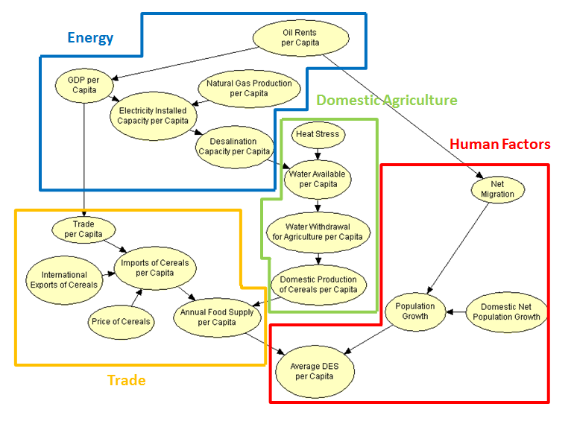
Figure 1. Full Bayesian Belief Network with Categorization
- Energy Nodes
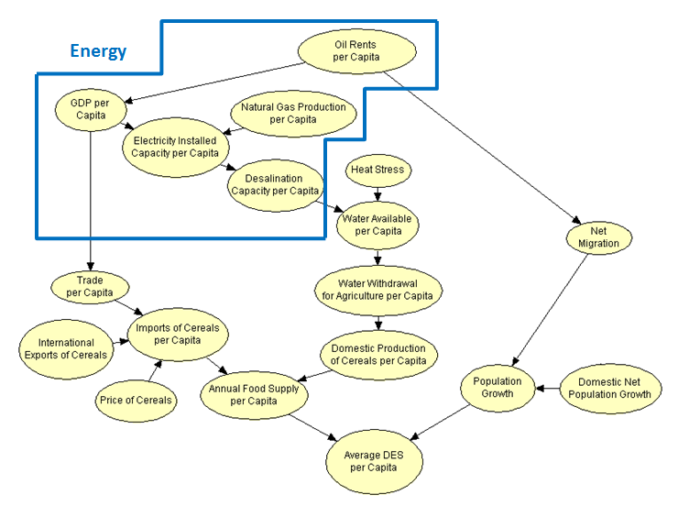
Figure 2. The Five Energy Variables
- Oil Rents per Capita
Although the Bayesian belief network was constructed from the bottom upward, it is more easily explained from the top downward. In relation to the energy variables in Figure 2, oil rents per capita—defined as “the difference between the value of crude oil production at world prices and total costs of production”—impact two child nodes: GDP per capita and net migration. In regards to Gross Domestic Product (GDP), Oman’s oil production accounts for 37.2% of Oman’s GDP, and this relationship has remained strong throughout Oman’s history. Furthermore, Oman is considered a rentier state, wherein “rent”—in this case oil—“enters into the composition of the price of commodities in a different way from wages and profit…and is generally a reward for ownership of all natural resources.” As for the net migration node, Middle Eastern dictatorships defy the general trend for non-democracies, which claims that more migrants typically leave than enter; instead, oil-rich Gulf states, which have the largest variation in net migration in the world, attract more migrants for entrance than exit. This phenomenon is largely based on the availability of oil revenues and the opportunity for work among the small domestic population.
The World Bank provided the data for the oil rents per capita variable, converted from percent of GDP to constant 2005 U.S. dollars per capita by multiplying the original data by GDP per capita (in constant 2005 U.S. dollars). The data spanned from 1970 to 2012, a total of 43 years, for the four countries: Oman, the United Arab Emirates, Saudi Arabia, and Kuwait. This compilation of information produced 172 data points. Three bins were applied to this dataset, $5,000 per capita as the lower split point and $10,000 per capita as the higher split point. Because the oil rents per capita variable has a special role as the first parent node in the network, these split points were selected in order to generate an even probability distribution among its three bins. The emphasis on evenness is acceptable because these Arabian Gulf nations all fall in the same category of having high oil rents per capita relative to the rest of the world; Oman, for instance, produces more than twice as many barrels of oil per capita, 222.88 barrels per day per 1,000 people, than Canada or Venezuela.
Since the oil production node lacked parent nodes, the probability distribution in Figure 3 was generated by merely dividing the number of cases per bin by 172, the number of data points.

Oil Rents per Capita (Constant 2005 $U.S. per Capita)
Bin | Probability
<5000 | 0.331395
(5000, 10000) | 0.331395
>10000 | 0.337209

Figure 3. Probability Table for Oil Rents per Capita

- GDP per Capita
Gross Domestic Product (GDP) per capita, preceded by the oil rents per capita parent node, connects down to the electricity installed capacity per capita node in the energy block and the trade per capita node in the trade block of nodes. The causal relationship between GDP per capita—“the sum of gross value added by all resident producers in the economy divided by midyear population”—and electricity installed capacity per capita represents the notion that a nation’s revenues can purchase durable infrastructure, like Oman’s Main Interconnected System (MIS) and the Salalah system of electrical grids. In regards to the GDP and trade, the rise of income encourages the rise of global supply chains and an increase in the crossing of goods across borders.
The World Bank provided the GDP per capita in constant 2005 U.S. dollars for Oman, the United Arab Emirates, Saudi Arabia, and Kuwait for the years ranging from 1970 to 2012. Represented in 172 data points, this variable utilized two bins. The bins were split by the $22,818 per capita mark, the World Bank’s classification between a high income and upper middle income nation.
The first table in Figure 4a shows that most of the years (55.23%) in the data set had a GDP per capita below $22,818, in the upper middle income category, and Figure 4b displays the conditional probabilities distribution between oil rents per capita and GDP per capita.

(a) Simple Probability Table
GDP per Capita (Constant 2005 $U.S.)
Oil Rents per Capita | <5000 | (5000, 10000) | >10000
<22818 | 0.929825 | 0.561404 | 0.172414
>22818 | 0.070175 | 0.438596 | 0.827586

(b) Conditional Probability Table
Figure 4. Tables for GDP per Capita

- Natural Gas Production per Capita
Natural gas production per capita has no parent nodes, but it links down to the electricity installed capacity per capita node. This causal relationship is supported by the fact that Oman produces electricity primarily from natural gas, although some diesel and distillate generation also occurs. Natural gas, though, provides 7.2 GW of Oman’s 8.8 GW generating capacity. In the past, the rise in natural gas usage supported the doubling of Oman’s electricity capacity between 2000 and 2010.
Natural gas production per capita, converted from billion cubic feet to cubic feet per capita, was documented by the U.S. Energy Information Administration. The annually recorded data spanned from 1980 to 2012, a total of 33 years, for Oman, the United Arab Emirates, Saudi Arabia, and Kuwait. The 132 data points separated into two bins, divided by an 84,000 cubic feet per capita split point; this value was the average of the four countries’ natural gas production per capita in the year 2000, when natural gas production became a major impetus for the increase in electricity capacity in the Middle East.
Because the natural gas production node lacked parent nodes, the probability distribution in Figure 5 was generated by merely dividing the number of cases per bin by 132, the number of data points.
Natural Gas Production per Capita (Cubic Feet per Capita)
Bin | Probability
<84000 | 0.3182
>84000 | 0.6818

Figure 5. Probability Table for Natural Gas Production per Capita

- Electricity Installed Capacity per Capita
The electricity installed capacity per capita node receives input from the GDP per capita and natural gas production per capita nodes, and it propagates downward into the desalination capacity per capita node. In regards to desalination capacity, high salinity water from the Arabian Gulf requires more energy capacity and, consequently, a higher cost for desalination; desalination cannot occur without an electrical infrastructure. Multi-stage flash (MSF) plants in the region demand U.S. $0.84 per cubic meter, while multi effect distillation (MED) and seawater reverse osmosis (SWRO) plants require U.S. $1.21 and $1.23 respectively.
As documented by the U.S. Energy Information Administration, electricity capacity, converted from gigawatts to watts per capita, had 33 years of data from 1980 to 2012 for Oman, the United Arab Emirates, Saudi Arabia, and Kuwait. 1300 watts per capita and 1600 watts per capita served as the split points for three bins. These values were derived from the CIA World Factbook’s country comparison for electricity installed generating capacity, where Oman ranks 79, the United Arab Emirates 34, Saudi Arabia 20, and Kuwait 50; since the countries of focus range from 20 to roughly 80, the two split points were the converted calculations of the capacity per capita for the countries a third and two-thirds down this range, Kazakhstan at 40 with a recorded 18,730,000 KW and North Korea at 60 with 9,500,000 KW.
The first table in Figure 6a shows that the data was spread fairly evenly between the bins: 31.58% for the lowest, then 23.35%, and 45.08% for the highest bin. The table in Figure 6b displays the conditional probabilities between the GDP per capita and natural gas production per capita inputs and the electricity installed capacity per capita output.

(a) Simple Probability Table

Electricity Installed Capacity (Watts per Capita)
GDP per Capita | <22818 |  | <22818
Natural Gas Production per Capita | <84000 | >84000 | <84000 | >84000
<1300 | 0.9 | 0.4 | 0.01 | 0.018182
(1300, 2600) | 0.025 | 0.457143 | 0.01 | 0.181818
>2600 | 0..075 | 0.142857 | 0.98 | 0.8

(b) Conditional Probability Table

Figure 6. Tables for Electricity Installed Capacity per Capita

- Desalination Capacity per Capita
Desalination capacity per capita, as facilitated by a nation’s electricity capacity, has a causal relationship with the water available per capita node. Rising from a total production of 34 million cubic meters of water per year in 1995 to 109 million cubic meters of water per year in 2006, desalination in Oman contributed to 80 percent of the water supply in 2010. Oman began its program in the early 1970s with the Ghubrah plant’s 7 multi-stage flash (MSF) units and another plant in Muscat. Although trailing behind Saudi Arabia as the world’s largest producer, with 17% of the global desalinated water capacity, and the United Arab Emirates as the second largest producer, Oman has made strides in expanding its program; the Sohar complex today combines an MSF plant with smaller reverse osmosis (RO) and multiple-effect distillation (MED) plants to singlehandedly supply 208,000 cubic meters of water per day.
As extrapolated from the Economic and Social Commission for Western Asia’s paper on Strengthening Development Coordination among Regional Actors in the ESCWA Region, Oman, the United Arab Emirates, Saudi Arabia, and Kuwait have all experienced tremendous growth in desalination since the early 1970s. This dataset, however, tracked all four countries’ progress over 33 years from 1980 to 2012, and it split the values into two bins at 0.3 cubic meters (or 300 liters) per capita per day; this value is double the global average daily water consumption of 150 liters, or 0.15 cubic meters, and 230 million people around the world rely solely on desalination to provide this water.
The table in Figure 7a indicates that most of the historical desalination capacities in the Arabian Gulf are above the 0.3 cubic meters per capita per day mark, and Figure 7b uses conditional probability to quantitatively relate electricity installed capacity per capita with desalination capacity per capita.

(a) Simple Probability Table

Desalination Capacity per Capita (Cubic Meters per Capita per Day)
Electricity Installed Capacity per Capita | <1300 | (1300, 2600) | >2600
<0.3 | 0.843137 | 0.222222 | 0.01
>0.3 | 0.156863 | 0.777778 | 0.99

(b) Conditional Probability Table
Figure 7. Tables for Desalination Capacity per Capita

- Domestic Agriculture Nodes
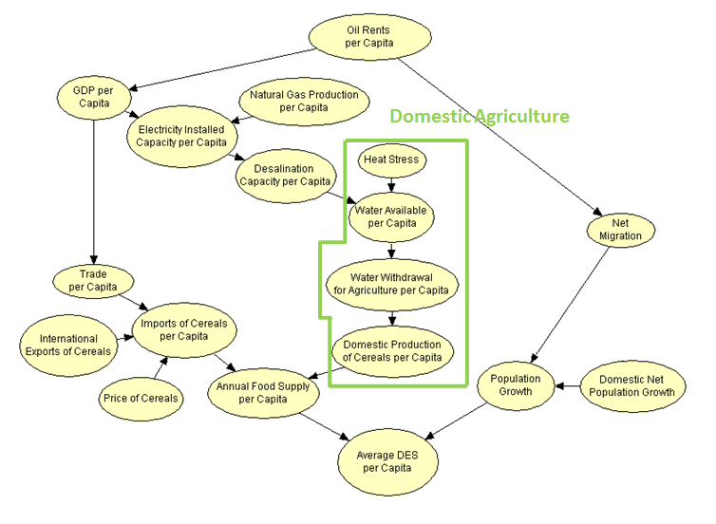
Figure 8. The Four Domestic Agriculture Variables

- Heat Stress
When analyzing the domestic agriculture nodes in Figure 8, the heat stress node lacks a parent node, but it feeds into the water available per capita node. In the Arabian Gulf, the high temperatures and lack of rainfall make the region water insecure. If present trends with heat stress continue, two-thirds of the global population, including the Arabian Gulf, will live in water-stressed conditions by 2025. Heat stress, therefore, severely affects water availability.
In generating a dataset for the heat stress variable, measured in degrees Celsius, this study referenced the National Oceanic and Atmospheric Administration (NOAA) National Climatic Data Center. The dataset included only 43 points, one yearly from 1970 to 2012, because each point was measured as an anomaly in respect to the 20th century average global land temperature; the data was not country specific. The heat stress data was placed into two bins with a 0.5°C split point, halfway to the 1°C point at which stressed plants may begin to emit carbon dioxide, instead of absorbing it; land-based emissions sustained over long periods can further increase heat stress.
Figure 9 displays the probability distributions for the heat stress variable.
Heat Stress (Degrees Celsius)
Bin | Probability
<0.5 | 0.5349
>0.5 | 0.4651

Figure 9. Probability Tables for Heat Stress
- Water Available per Capita
The water available node has two parent nodes, and it also has one child node, water withdrawal for agriculture per capita. In terms of water consumption, 86 percent of Oman’s water supply is used for agriculture, split evenly between industry and domestic use; the water supply subsequently affects the amount of water that can be withdrawn and consumed for agriculture.
Water available per capita, measured in cubic meters per capita per year through the metric of total renewable resources, had data available for 43 years from 1970 to 2012 within the FAO AquaStat database. This node included the four countries of Oman, the United Arab Emirates, Saudi Arabia, and Kuwait to create 172 data points. In order to allow for a wider range of distribution, three bins were utilized with split points of 212 cubic meters per capita per year and 425 cubic meters per capita per year. These values from the World Resources Institute delineate when the nations have a year of extremely low availability (the lowest bin for this dataset) or low availability (the middle bin) of water.
The table in Figure 10 demonstrates the heavy skew of water available towards low bins, and the bottom table shows the conditional probability relating heat stress and desalination capacity per capita to water available per capita.

(a) Simple Probability Table

Water Available per Capita (Cubic Meters per Capita per Year)
Desalinaiton Capacity per Capita | <0.3 |  | >0.3
Heat Stress | <0.5 | >0.5 | <0.5 | >0.5
<212 | 0.32 | 0.56 | 0.880952 | 0.836364
(212, 425) | 0.26 | 0.04 | 0.01 | 0.072727
>425 | 0.42 | 0.4 | 0.119048 | 0.090909

(b) Conditional Probability Table

Figure 10. Tables for Water Available per Capita

- Water Withdrawal for Agriculture per Capita
The water withdrawal for agriculture per capita node, linked above to the water available per capita node, connects to a child node of domestic production of cereals per capita. When the global population increases by about 3 billion people in the next 40 years, the food demand should also increase around 70% by 2050. Since most of Oman’s domestic water consumption is devoted to domestic agricultural production, water withdrawal will become devoted to rising domestic agriculture demands in Oman and elsewhere.
Water withdrawal for agriculture per capita, converted from billion cubic meters per year to cubic meters per capita per year, had 43 data points for each of the four countries, Oman, the United Arab Emirates, Saudi Arabia, and Kuwait. The 172 data points were found within the FAO AquaStat database, and two bins were subsequently generated. The split point was 682 cubic meters per capita per year; this study estimates this value as half of the average amount of water withdrawn for agriculture in each Middle East and North Africa country, which average a total availability of 1,429 cubic meters per capita and vary in withdrawal for agriculture. Oman therefore uses nearly half as much water for agriculture than most other MENA states.
The table in Figure 11a represents the distribution of the variable’s data points within its own bins, and the conditional probabilities in Figure 11b demonstrate the causal relationship between water available per capita and water withdrawal for agriculture per capita.

(a) Simple Probability Table

Water Withdrawal for Agriculture per Capita (Cubic Meters per Capita per Year)
Water Available per Capita | <212 | (212, 425) | >425
<682 | 0.539823 | 0.277778 | 0.536585
>682 | 0.460177 | 0.722222 | 0.463415

(b) Conditional Probability Table

Figure 11. Tables for Water Withdrawal for Agriculture per Capita

- Domestic Production of Cereals per Capita
Connected above with water withdrawal for agriculture per capita and below with annual food supply per capita, the domestic production of cereals per capita node demonstrates causality with Oman’s food supply. Although Oman imports 80% of its food products, the nation domestically produces the remainder of its food supply. Subsequently, domestic production does affect the amount of food and, therefore, calories available to Omanis.
Domestic production of cereals per capita was measured through data on the production of cereals, listed by FAOSTAT in tons and then converted to tons per capita. The focus on cereals proved appropriate because cereals provide the greatest number of calories to Omanis. Accordingly, the data spanned from 1970 to 2012, or 43 years, for Oman, the United Arab Emirates, Saudi Arabia, and Kuwait. 0.0045 tons, or 450 kilograms, per capita acted as the split point between two bins, and the Food and Agriculture Organization notes this value as the average per capita food production in the poorest regions of the world; this 450 kilograms per capita per year is doubled to 900 kilograms per capita per year for rich countries.
The tables below in Figure 12 demonstrate the typically low domestic agriculture within Oman (with 60.01% of the data points below 0.0045 tons per capita), and the conditional probability table relates water withdrawal for agriculture per capita to domestic production of cereals per capita.

(a) Simple Probability Table

Domestic Production of Cereals per Capita (Tons per Capita per Year)
Water Withdrawal for Agriculture per Capita | <682 | >682
<0.0045 | 0.295455 | 0.928571
>0.0045 | 0.704545 | 0.071429

(b) Conditional Probability Table

Figure 12. Tables for Domestic Agricultural Production

- Trade Nodes
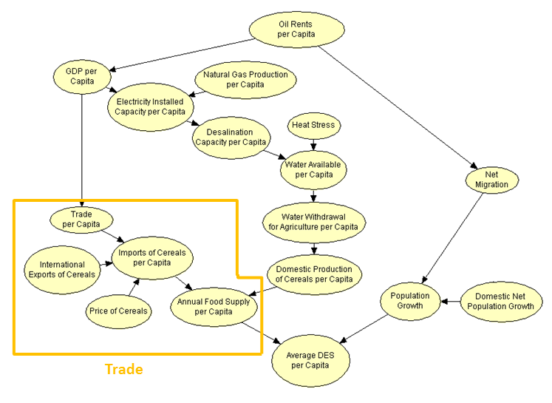
Figure 13. The Five Trade Variables

- Trade per Capita
When observing the five trade nodes in Figure 13, the trade per capita node receives input from the GDP per capita node from the energy category of nodes, and it influences the imports of cereals per capita child node. A Food and Agriculture Organization study on food security and trade found that the international dimension in food security is significant; “trade policy influences both global food availability (in the case of a major importer or exporter), and national food availability (through both imports and production).” Consequently trade, defined by the World Bank as “the sum of exports and imports of goods and services,” impacts the amount of food available for import.
With this in mind, trade per capita in this study was measured in constant 2005 U.S. dollars per capita, converted from percent of GDP by multiplying the original data by GDP per capita. Spanning from 1970 to 2012, the data, supplied by the World Bank, spanned 43 years for Oman, Saudi Arabia, and Kuwait; no data was available for the United Arab Emirates. The 129 data points were divided into three bins; the lower split point was $10,000 per capita and the higher split point is $30,000 per capita. While not grounded in past studies, these split points appear as points of concavity on the line graphs of the data change, suggesting that the imports of food per capita starts to increase in variability around those points.
The table in Figure 14a shows a bell-curve-like distribution, with 28.07% of the data points in the lowest bin, 49.22% in the middle, and 22.71% in the highest. The table in Figure 14b links GDP per capita to trade per capita through a conditional probability.

(a) Simple Probability Table

Trade per Capita (Constant 2005 $U.S. per Capita)
GDP per Capita | <22818 | >22818
<10000 | 0.505263 | 0.01
(10000, 30000) | 0.494737 | 0.5
>30000 | 0.01 | 0.5

(b) Conditional Probability Table

Figure 14. Tables for Trade per Capita

- International Exports of Cereals
When analyzing the trade variables, international exports from nations outside of the Arabian Gulf, affected by oil production in the oil-for-food trade, impact one child node, imports of cereals per capita. From the standpoint of economics, the international exports node acts like supply while the food imports per capita node acts like demand; as the 2008 cereal crisis demonstrated, an unwillingness of foreign exporters to sell food can severely limit the amount available for importation.
FAOSTAT provided the data for the international exports of cereals variable, measured in tons of cereal exports. Cereals were chosen as the main crop because rice, flour, and wheat serve as the top three providers of energy to Omanis. For this node, the data spanned 43 years from 1970 to 2012, and three foreign countries were examined: Pakistan, Thailand, and India. These countries were selected because they serve as Oman’s three most significant providers of cereals, accounting for 99% of Oman’s rice. The two bins were split at the 5,000,000 ton mark, which this study interprets as the value that can incite a modern crisis of cereal unavailability; the 2008 crisis occurred when Pakistan and India dropped close to or below this mark.
Because the international exports of cereals node lacked parent nodes, the probability distribution in Figure 15 was generated by merely dividing the number of cases per bin by the number of data points.
International Exports of Cereals (Tons)
Bin | Probability
<5,000,000 | 0.6357
>5,000,000 | 0.3643

Figure 15. Probability Table for International Exports of Cereals

- Price of Cereals
The price of cereals node does not have any parent nodes, but it propagates downward into the import of cereals per capita node. Price connects to demand, represented by cereal imports in this model, in macroeconomics because a high price drives down demand, whereas a low price encourages buying and increases demand. In 2008, the food price spike contributed directly to the collapse of demand and, subsequently, the global market.
In this model, price was measured for cereals, the main energy supplier in Omanis’ diets, in constant 2005 U.S. dollars per metric ton. The data spanned 43 years from 1970 to 2012, but the data was not country specific and, therefore, required only 43 data points. The United States Department of Agriculture Economic Research Service presented the data at a monthly interval, so the average of the twelve months’ prices represented the year as a whole. $140 per metric ton served as the split point for the two bins, appearing as a recurring point of concavity on the line graph of the data; this concavity suggests that the prices change at a faster rate around $140 per metric ton and therefore produce greater variability in cereal imports.
Without a parent node, the probability distributions in Figure 16 simply represented the number of cases per bin for price divided by 43, the number of data points.
Price of Cereals (Constant 2005 $U.S. per Capita per Metric Ton)
Bin | Probability
<140 | 0.6977
>140 | 0.3023

Figure 16. Probability Table for Price of Cereals

- Imports of Cereals per Capita
The food imports per capita node receives data from three parent nodes, trade per capita, international exports of cereals, and prices of cereals, and it connects to the annual food supply per capita node beneath it. In contributing to the total amount of food available for consumption by the population, food imports account for 90% of the Gulf Cooperation Council’s food supply and 80% of Oman’s food supply. Furthermore, these imports are expected to grow to $4.8 billion and over 3.2 million tons, a 5.3 percent increase from 2011, by 2020.
FAOSTAT contributed 43 years of data from 1970 to 2012 on the import of cereals, converted from tons to tons per capita by dividing by population. 172 data points were aggregated from four countries, Oman, the United Arab Emirates, Saudi Arabia, and Kuwait, and cereals were the focus in order to stay consistent with the rest of the nodes in the trade category. The split point for the two bins was 0.25 tons per capita, the value that this study anticipates would result in insufficient cereal imports, as in 2004 when China’s cereal stocks hit their lowest point since the early 1980s and when the United States and European Union began their two-year decline in wheat and maize production.
The table in Figure 17a demonstrates a skew towards imports of cereals under 0.25 tons per capita, enabling better observation of the recent rise in imports. The table in Figure 17b shows the conditional probabilities between trade per capita, international exports of cereals, price of cereals, and imports of cereals per capita.

(a) Simple Probability Table

Imports of Cereals per Capita (Tons per Capita)
Price of Cereals | <140 |  |  |  |  |  | >140
International Exports of Cereals | <5 |  |  | >5 |  |  | <5 |  |  | >5
Trade per Capita | <10000 | ( , ) | >30000 | <10000 | ( , ) | >30000 | <10000 | ( , ) | >30000 | <10000 | ( , ) | >30000
<0.25 | 0.813953 | 0.763158 | 0.925926 | 0.294118 | 0.159091 | 0.333333 | 0.8125 | 0.8 | 0.99 | 0.25 | 0.142857 | 0.1
>0.25 | 0.186047 | 0.236842 | 0.074074 | 0.705882 | 0.840909 | 0.666667 | 0.1875 | 0.2 | 0.01 | 0.75 | 0.857143 | 0.9

(b) Conditional Probability Table

Figure 17. Conditional Probability Tables for Imports of Cereals per Capita

- Annual Food Supply per Capita
The annual food supply per capita node has two parent nodes, imports of cereals per capita and domestic production of cereals per capita, and one child node, the network’s final node. Since average Daily Energy Supply (DES) is measured as kilocalories per person per day, its two parent nodes divide according to that unit of measurement. Consequently, the population growth node contributes to the “person” measurement while the annual food supply node covers the “kilocalories,” shifting from the weight of food available to the caloric intake available to people; not all of the food supply reaches human consumption because, for instance, livestock and camels consume fodders and cereal feed. Additionally, the government diverts cereals to strategic storage sites, creating the most developed storage system in the GCC; in 2010, Oman stored the equivalent of one year of rice, six months of edible sugar, oils, and milk, and five months of wheat, and Oman has plans to amplify wheat storage up to 17 months at the ports of Sohar and Salalah.
Annual food supply per capita is measured in kilograms per capita per year. The data was available through FAOSTAT for 43 years for Oman, the United Arab Emirates, Saudi Arabia, and the UAE, combining into 172 data points. The split point used for the two bins was 150 kilograms per capita per year. This value is equivalent to the amount of wheat needed for a low-level consumption diet, where the wheat provides a daily caloric value of about 1,200 and supplementary foods provide additional caloric intake.
As the table in Figure 18a demonstrates, the data favors the lower bin of less than 150 kilograms per capita per year. The table in Figure 18b shows the conditional probabilities between imports of cereals per capita, domestic production of cereals per capita, and annual food supply per capita.

(a) Simple Probability Table

Annual Food Supply per Capita (Kilograms per Capita per Year)
Imports of Cereals per Capita | <0.25 |  | >0.25
Domestic Production of Cereals per Capita | <0.0045 | >0.0045 | <0.0045 | >0.0045
<150 | 0.863636 | 0.611111 | 0.5 | 0.53125
>150 | 0.136364 | 0.388889 | 0.5 | 0.46875

(b) Conditional Probability Table

Figure 18. Tables for Annual Food Supply per Capita

- Human Factor Nodes
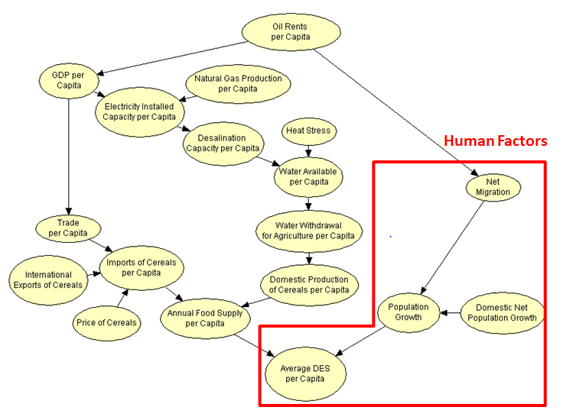
Figure 19. The Four Human Factor Variables

- Net Migration and Domestic Net Population Growth
In regards to the four human factors variables in Figure 19, net migration and domestic net population growth represent the various ways a person can enter or leave a nation or contribute to the population within the country. Subsequently, they contribute to the rate of change in their population growth child node.
Net migration data, measured in the unit of people per year, was compiled from the World Bank. Domestic net population growth, calculated by subtracting the death rate from the birth rate and measured per 1,000 people, came from the same World Bank source. 43 data points were recorded for each variable for each of the four countries: Oman, the United Arab Emirates, Saudi Arabia, and Kuwait. In regards to the 172 total points for each variable, net migration was divided into three bins split at 20,000 and 100,000 people per year; 100,000 people per year serves as the lowest value for annual net migration for the top ten Muslim countries (where Oman and the United Arab Emirates currently fall), and 20,000 is the lower bound for the top fifteen (where Saudi Arabia and Kuwait currently reside). The domestic net population growth had two bins, split at 20 per 1,000 people, considered a high rate; one-sixth of the world’s population experiences this high rate, predominantly in countries in Africa, Latin America, and Western and Southern Asia.
The table in Figure 20a shows the bell-curve-like shape of the net migration data within its bins, and Figure 20b is the conditional probability distribution between oil rents per capita and net migration. Figure 20c indicates a left-skewed probability distribution for the parentless domestic net population growth variable.

(a) Simple Probability Table for Net Migration

Net Migration (per Year)
Oil Rents per Capita | <5000 | (5000, 10000) | >10000
<20000 | 0.666667 | 0.175439 | 0.01
(20000, 100000) | 0.122807 | 0.45614 | 0.87931
>100000 | 0.210526 | 0.368421 | 0.12069

(b) Conditional Probability Table for Net Migration

Domestic Net Population Growth (per 1,000 people)
Bin | Probability
<20 | 0.34302
>20 | 0.65698

(c) Probability Table for Domestic Net Population Growth

Figure 20. Probability Tables for Net Migration, Birth Rate, and Death Rate

- Population Growth
The population growth node has two parent nodes and the network’s final node as its child node. Since average Daily Energy Supply (DES) is measured as kilocalories per person per day, its two parent nodes divide according to that unit of measurement. As mentioned before, the population growth node provides the “person” measurement while the annual food supply per capita node covers the “kilocalories” in the form of food supply.
Population growth was based off data from the World Bank. Available for 43 years for Oman, the United Arab Emirates, Saudi Arabia, and Kuwait, the data combined into 172 points, measured as percentiles. The one split point used for the two bins was 4%, representing high population growth during two different phenomena: 1) the decrease in death rates after the 1960s in the developing world, which preceded the decline of birth rates and 2) modern economic growth and human development in developing countries.
As the table in Figure 21a demonstrates, the Arabian Gulf population has grown significantly in recent years, and the table in Figure 21b shows the conditional probabilities between net migration, domestic net population growth, and total population growth.

(a) Simple Probability Table
Population Growth (Percentile)
Net Migration | <20000 |  | 20000, 100000 |  | >100000
Domestic Net Population Growth | <20 | >20 | <20 | >20 | <20 | >20
<4 | 0 | 0.589744 | 0.6 | 0.092593 | 0.25 | 0.2
>4 | 0.01 | 0.410256 | 0.4 | 0.907407 | 0.75 | 0.8

(b) Conditional Probability Table

Figure 21. Conditional Probability Tables for Population Growth

- Average Daily Energy Supply (DES)
The choice of daily energy supply as the final node of the Bayesian belief network requires explanation. Return first to the FAO’s definition of food security: “Food security exists when all people, at all times, have physical, social and economic access to sufficient, safe and nutritious food to meet their dietary needs and food preferences for an active and healthy life." In order to consistently maintain a healthy daily energy supply, individuals will require stable access to nutritious foods. Furthermore, meeting daily standards for energy supply will enable both expatriates and nationals in Oman to perform necessary tasks in an active lifestyle. Consequently, DES meets the FAO definition’s demands for access and a healthy life. By averaging out the daily energy supply of all Oman’s inhabitants, too, the threshold set for DES will indicate whether or not a satisfactory portion of the population has become food secure.
The dataset for Average DES came from the Food and Agriculture Organization of the United Nations Statistics Division (FAOSTAT). Unfortunately there was no data specifically for Oman for this variable, measured in kilocalories per person per day, so the 129 included data points spanned from the years 1971 to 2012 for the three Arabian Gulf countries listed in the FAOSTAT database: the United Arab Emirates, Saudi Arabia, and Kuwait. Due to data constraints, this project operates with the assumption that other nations’ data can serve as an estimated values for Oman. In fact, the GRM International Report indicates a close correlation between Oman and Kuwait. The node utilized four different bins, and the lowest split point was the comfortable lower bound for DES established in the GRM International Report, 2,100 kilocalories per person per day. The second split point was 3,000 kilocalories per person per day, which is a high boundary for caloric intake for children, the recommended intake for women with heavy work, and the recommended value for moderately active men. The third split point was 3250 kilocalories per person per day, the average food intake in the world’s developed countries. And the highest split point, 3,500 kilocalories per person per day, obesity becomes more of a threat because 3,500 kilocalories comprise one pound of fat. With these split points, the data adopted a bell-shaped structure for the purpose of sensitivity testing.
Figure 22a shows the skew toward high DES, and Figure 22b shows the conditional probabilities relating annual food supply per capita, population growth, and average DES.

(a) Simple Probability Table
Average DES (Kilocalories per Person per Day)
Annual Food Supply per Capita | <150 |  | >150
Population Growth | <4 | >4 | <4 | >4
<2100 | 0.038462 | 0.08642 | 0.01 | 0.01
(2100, 3000) | 0.346154 | 0.333333 | 0.289474 | 0.074074
(3000, 3250) | 0.230769 | 0.283951 | 0.342105 | 0.444444
(3250, 3500) | 0.346154 | 0.259259 | 0.315789 | 0.333333
>3500 | 0.038462 | 0.037037 | 0.052632 | 0.148148

(b) Conditional Probability Table

Figure 22. Tables for Average Daily Energy Supply (DES)

II. Testing for Crisis Aversion
After finishing the construction of the Bayesian belief network, the project then endeavored to measure the sensitivity of DES in possible crises. This testing involved fixing the values of certain parent nodes and calculating the change in probability distribution for the final node, average DES. The change for each bin in the probability distribution was derived by subtracting the final probabilities from the originals, displayed in Figure 23. Note that average DES had an initial distribution of 4.84% for its lowest bin, 27.67% for the next, 30.98% in the middle, 30.30% in the second highest, and 6.20% in the highest bin.
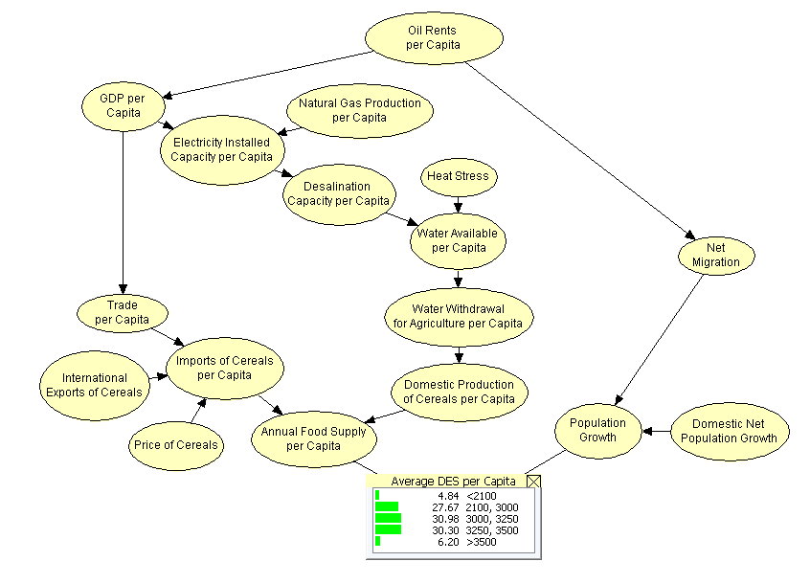
Figure 23. Original Probability Distribution for Average Daily Energy Supply (DES)

1. International Refusal to Sell Cereals
The first crisis for observation attempted to emulate the 2008 global food price spike. That year, the price of cereals nearly tripled from $180 per ton in 2007 to $386 per ton. International exporters reduced availability from 4,309,986 tons in 2007 to 3,204,774 tons in 2008. The effects of these changes propagated into Oman’s ability to import cereals, subsequently obtaining only 646,160 tons of cereals in 2008. Accordingly, the scenario involving the international refusal to sell cereals fixed the probability distributions of two nodes: international exports of cereals was fixed to its lower bin of less than 5,000,000 tons, and the price of cereals node was set to its higher bin of greater than $140 per metric ton. Figure 24a displays the subsequent changes in the Bayesian belief network, and Figure 24b calculated the changes in probability distribution for each bin in average DES. In this scenario, the likelihood of Oman having a lower average DES increased, as the lowest bin and second lowest bin respectively increased 0.36% and 1.13% in probability. All bins in excess of 3,000 kilocalories per person per day decreased in probability. The middle bin dropped 0.84%, the second highest by 0.19%, and the highest by 0.44%.
Bin | Change
<2100 | +0.36%
(2100, 3000) | +1.13%
(3000, 3250) | -0.84%
(3250, 3500) | -0.19%
>3500 | -0.44%
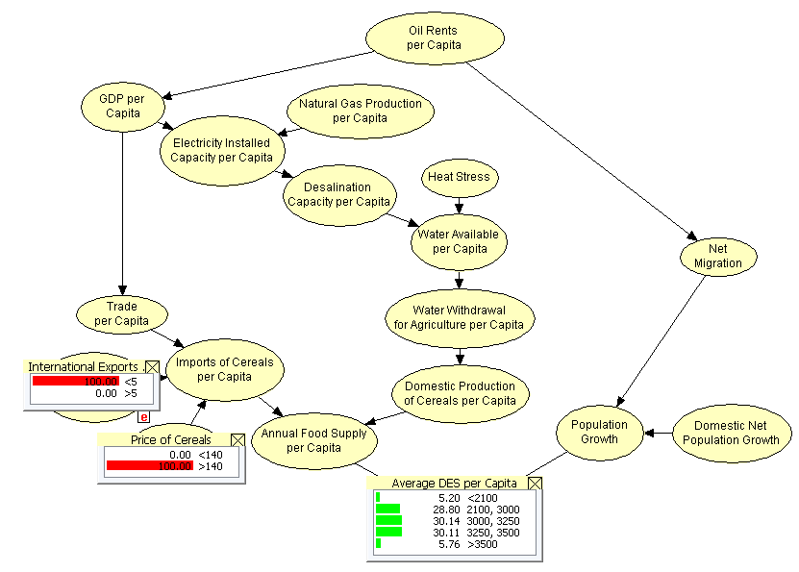
- Changes in the Network (b) Difference in Average DES
Figure 24. Change in Probability Distribution During an
International Refusal to Sell Cereals

2. Plummet in the Price of Oil
A second crisis scenario focuses on the importance of oil in the global exchange of food. As oil rents per capita act as the first node in the Bayesian belief network, a dramatic shift in the price of oil affects the entire network, all the way down to average DES. Since June 2014, oil prices have more than halved from $110 a barrel to below $50 a barrel, sitting at their lowest level since May 2009. These low prices strain Arabian Gulf economies, as Kuwait needs a long-term price of $79 per barrel to balance its budget, the UAE $81, and Saudi Arabia $104. To emulate these effects in Figure 25a, oil rents per capita was fixed to its lowest bin of less than $5000 per capita. In this scenario, the change in probability distribution for average DES produced less conclusive results in Figure 25b, as the lowest bin decreased 0.58% while the second lowest increased 1.38% in probability. The middle bin and highest bin also decreased while the second highest bin increased in probability. Unaccounted for external factors may account for the inconclusiveness of the results, or alternatively, a decrease in oil rents may have short-term positive and negative effects on food security; while higher oil prices and oil rents, for instance, bolster the buying power of Arabian Gulf nations and increase the annual food supply, the economic boom may attract more expatriates and create unstainable population growth.

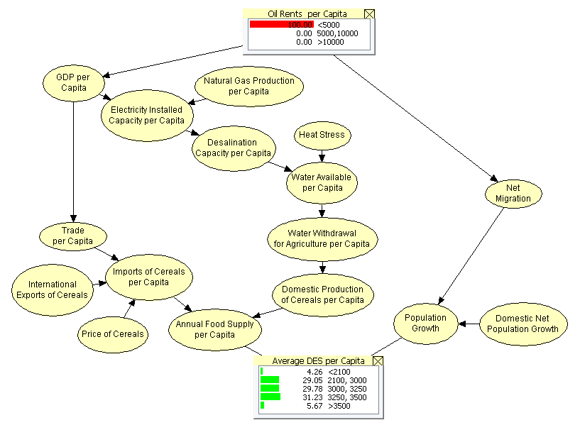

Bin | Change
<2100 | -0.58%
(2100, 3000) | +1.38%
(3000, 3250) | -1.20%
(3250, 3500) | +0.93%
>3500 | -0.53%

- Changes in the Network (b) Difference in Average DES

Figure 25. Change in Probability Distribution During a
Plummet in the Price of Oil

3. Mass Emigration of the Expatriate Workforce
In February 2014, the expatriate population in Oman reached 1.7659 million to comprise 44.2 percent of the nation’s entire population. Of the 1.7659 million, 1.5345 million provide crucial work in the Omani economy, but especially construction and infrastructure projects. Therefore, if, for instance, the Omani government dramatically cuts its 3.2 billion Omani riyal allocation, 24 percent of overall public expenditure, for investment expenditure, the lack of work could encourage a mass emigration of the expatriate workforce from Oman. The effects of this population shift could cripple the economy and food security situation. To simulate this scenario in Figure 26a, net migration was fixed to its lowest bin of less than 20,000 people, wherein the value for a given year could be negative. The resulting change in probability distribution for average DES produced unclear results in Figure 26b, but there was a greater shift towards the lower, food-insecure bins. Although the lowest bin decreased 1.10%, the second lowest bin increased more than the second highest bin in probability, respectively 2.72% and 1.77%. The middle bin and highest bin both decreased at 2.34% and 1.04%. One possible explanation for the inconclusive results is the duality of the short-term effects of mass emigration. With less people in Oman, the remaining people would have a greater caloric share per person, but the economic vitality Oman needs to obtain the food would become diminished.

Bin | Change
<2100 | -1.10%
(2100, 3000) | +2.72%
(3000, 3250) | -2.34%
(3250, 3500) | +1.77%
>3500 | -1.04%
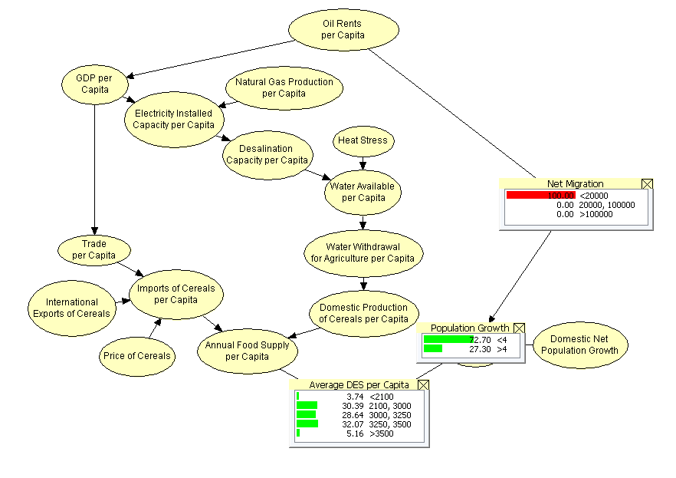
- Changes in the Network (b) Difference in Average DES
Figure 26. Change in Probability Distribution During a
Mass Emigration in the Expatriate Workforce

4. Drought
Drought is one of the most damaging natural disasters, causing millions of deaths and hundreds of billions of dollars worldwide since 1967. In the Arabian Peninsula, increasing global temperatures, decreasing soil moisture, and rising evapotranspiration threaten the already arid land, which indirectly affects the domestic production of cereals per capita. This scenario measures the effects of a decrease in water available for any reason, fixing the lowest bin in Figure 27a of less than 212 cubic meters per capita in the water available per capita node. With negative 0.10% as the largest change of probability for a bin in average DES in Figure 27b, the small changes in the probability distribution indicate that drought may have less severe effects than the other crises. This conclusion appears cogent because Arabian Gulf nations have taken measures since 2000 to manage water resources, combat desertification, and reuse wastewater.
Bin | Change
<2100 | +0.03%
(2100, 3000) | -0.10%
(3000, 3250) | +0.09%
(3250, 3500) | -0.05%
>3500 | +0.05%
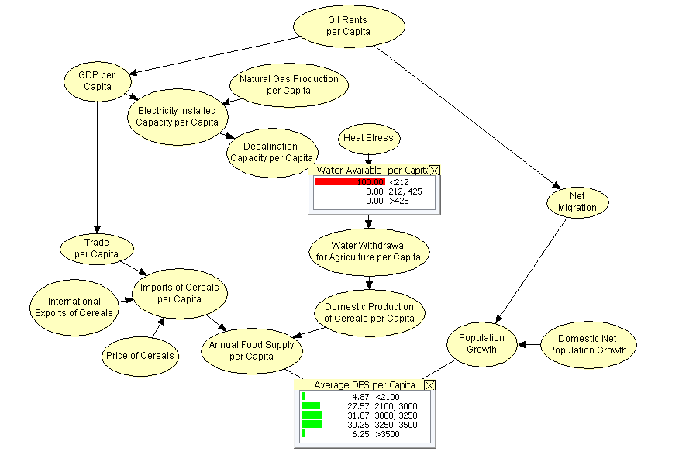
- Changes in the Network (b) Difference in Average DES
Figure 27. Change in Probability Distribution During a Drought
Attack on Strategic Storage Sites
As previously discussed, Oman’s Public Authority for Stores and Food Reserve has established warehouses to stockpile minimum thresholds of food commodities. Another potential crisis would be the destruction of strategic warehouses through enemy attack, natural disaster, or another means of compromising the stored food. To simulate this scenario in Figure 28a, or any other massive loss in food supply through transportation and storage issues, the annual food supply per capita node was fixed to its lower bin of 150 kilograms per capita per year, indicating that food availability may drop below this mark. Figure 28b calculated the changes in probability distribution for each bin in average DES, greatly increasing the likelihood of Oman having a lower average DES and becoming more food insecure. The lowest bin and second lowest bin respectively increased 1.96% and 6.16% in probability. The bins with split points greater than 3,000 kilocalories per person per day each decreased in probability. The middle bin dropped 4.45%, the second highest by 1.03%, and the highest by 2.44%.
Bin | Change
<2100 | +1.96%
(2100, 3000) | +6.16%
(3000, 3250) | -4.45%
(3250, 3500) | -1.03%
>3500 | -2.44%
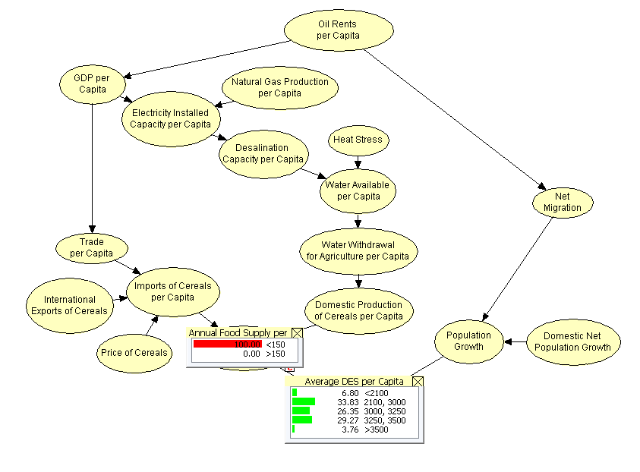
- Changes in the Network (b) Difference in Average DES
Figure 28. Change in Probability Distribution During an Attack on Strategic Storage Sites
II. Conclusion
Of the five scenarios explored in this study, the two greatest threats appear to come from an attack on strategic storage sites, which would drastically decrease Oman’s annual food supply, and an international refusal to sell crops, which would also indirectly diminish annual food supply. These two crises produced clear, one-directional movement towards more food insecure probability distributions in average Daily Energy Supply.

Works Cited
Al-Alawi, Othman. “Drought Conditions and Management Strategies in Sultanate of Oman.”
Ministry of Agriculture and Fisheries. 2014. http://www.ais.unwater.org/
ais/pluginfile.php/605/mod_page/content/22/Oman.pdf (accessed March 3, 2015).

Al-Mashakhi, Mohammed, and El-Hag Koll. “Oman: Country Pasture/Forage Resource
Profiles.” Food and Agriculture Organization of the United Nations. April 2007.
http://www.fao.org/ag/agp/AGPC/doc/Counprof/oman/oman.htm (accessed
March 2, 2015).

Beblawi, Hazem. “The Rentier State in the Arab World.” Arab Studies Quarterly Vol. 9, No. 4
Fall 1987, 383 – 384.

Berrens. “A Degree by Degree Explanation of What Will Happen When the Earth Warms.”
March 20, 2015. http://globalwarming.berrens.nl/globalwarming.htm (accessed
March 20, 2015).

Bowler, Tim. “Failing Oil Prices: Who are the Winners and Losers?.” BBC News.
January 19, 2015. http://www.bbc.com/news/business-29643612 (accessed
February 28, 2015).

Centers for Disease Control and Prevention. “Losing Weight.” August 17, 2011.
http://www.cdc.gov/HEALTHYWEIGHT/LOSING_WEIGHT/INDEX.HTML (accessed November 27, 2014).

Cohen, Joel. How Many People Can the Earth Support?. New York: W.W. Norton, 1995.

Damerow, Harold. “Population Geography.” Union County College. January 2015.
http://faculty.ucc.edu/egh-damerow/population_geography.htm (accessed
March 2, 2015).

De Haen, Hartwig, David Wilcock, Simon Chater, Brenda Townsend-Hall, Richard Markham,
and Christel Blank. “The State of Food Insecurity in the World.” Food and Agriculture
Organization Economic and Social Development Department. http://www.fao.org/
economic/en/#.UtNbmdJDtgg (accessed December 02, 2013).

Economic and Social Commission for Western Asia.“ESCWA Water Development Report 3.”
United Nations (2009).

Food and Agriculture Organization AquaStat. “Oman.” AquaStat.
2008.http://www.fao.org/nr/water/aquastat/countries_regions/oman/index.stm (accessed November 30, 2014).

Food and Agriculture Organization Economic and Social Development Department, Trade
Reforms and Food Security: Conceptualizing the Linkages. Rome, 2003.

Food and Agriculture Organization Global Agro-Ecological Zones. “GAEZ.” International
Institute for Applied Systems Analysis. 2014. http://gaez.fao.org/Main.html# (accessed
November 19, 2014).

Food and Agriculture Organization Statistics Division. “Browse Data.” Food Security. 2014.
http://faostat3.fao.org/browse/T/TP/E (accessed November 20, 2014).

Food and Agriculture Organization Statistics Division. “Updating the Minimum Dietary Energy
Requirements.” Food and Agriculture Organization Methodology for the Measurement of
Food Deprivation (2008).
http://www.fao.org/fileadmin/templates/ess/documents/food_security_statistics/metadata/un
dernourishment_methodology.pdf (accessed December 18, 2013).

Food and Agriculture Organization of the United Nations, “Cutting Food Waste to Feed the
World,” May 11, 2011, http://www.fao.org/news/story/en/item/74192/icode/ (accessed March 2, 2015).

Food and Agriculture Organization of the United Nations. “Food Imports by Oman Set to Grow
to $4.8bn.” Regional Office for the Near East and North Africa. November 9, 2011. http://neareast.fao.org/Pages/NewsDetails.aspx?lang=EN&id=2402627&I=0&DId=0&CId=0&CMSId=21 (accessed November 19, 2014).

Food and Agriculture Organization of the United Nations. “Food Security Indicators.” Food and
Agriculture Organization of the United Nations. 2015. http://www.fao.org/economic/ess/
ess- fs/ess-fadata/en/#.UtOYntJDtgg (accessed November 29, 2013).

“GDP and Trade Growth.” The Economist. May 26, 2011.
http://www.economist.com/node/18744587 (accessed February 20, 2015)

“The Global Market and Developing Nations.” Pearson Education.
2015.http://www.infoplease.com/cig/economics/production-income-classifications.html
(accessed March 2, 2015).

GRM International. “Phase 1 Report: Study to Develop Food Security Strategy and Master Plan
for the Sultanate of Oman.” Sultanate of Oman’s Authority for Stores and Food Reserve
(2010).

Hartwick, John. “Oil Rents, Infrastructure Investment and Sustainable Development.” Center of
Economic Research at ETH Zurich. 2010. http://www.cer.ethz.ch/sured_2010/
keynote_lectures/SURED-10_Keynotes_Hartwick.pdf (accessed March 9, 2015).

Hutton, Sue. “ Saving the Future – Water in Oman.” Oman Economic Review. March 2003.
http://www.suehutton.co.uk/articles/save_water.php (accessed November 28, 2014).

Institute of Medicine of the National Academies. “Dietary Reference Intakes for Water,
Potassium, Sodium, Chloride, and Sulfate.” Food and Nutrition Board. 2005. http://www.nal.usda.gov/fnic/DRI/DRI_Water/water_full_report.pdf (accessed November 18, 2014).

James, A.E. “Oman Expatriate Population Touches 1.766 Million.” Times of Oman. April 6,
2014. http://bluecodedesoft.timesofoman.com/news/32073/Article-Oman-expatriate-
population-touches-1%20766-million (accessed November 5, 2014).

Kechichian, Joseph. Oman and the World. California: RAND, 1995.

Lardy, Nicholas. Agriculture in China’s Modern Economic Development. Cambridge:
Cambridge University Press, 1983.

Library of Economics and Liberty. “Supply and Demand, Markets and Prices.” Econlib
Resources, 2012. http://www.econlib.org/library/Topics/College/supplyanddemand.html
(accessed November 20, 2014).

Mittal, Anuradha. “The 2008 Food Price Crisis: Rethinking Food Security Policies.” G-24
Discussion Paper Series no. 56 (2009). http://unctad.org/en/docs/gdsmdpg2420093_en.pdf
(accessed December 10, 2013).

National Oceanic and Atmospheric Administration. “Climate at a Glance.” National Climatic
Data Center. 2014. http://www.ncdc.noaa.gov/cag/time-series/global (accessed November 18, 2014).

NationMaster, “Net Migration: Countries Compared,” 2005, http://www.nationmaster.com/
country-info/stats/People/Migration/Net-migration (accessed March 12, 2015)

NationMaster. “Oil Production per Capita: Countries Compared.” 2007.
http://www.nationmaster.com/country-info/stats/Energy/Oil/Production/Per-capita (accessed
March 12, 2015).

Prakashan, Nirali. A Text Book of Nutrition for Nurses. Mumbai: Pragati Books, 2008.

Reig, Paul, Andrew Maddocks, and Francis Gassert. “World’s 36 Most Water-Stressed
Countries.” World Resources Institute. December 12, 2013. http://www.wri.org/blog/2013/
12/world%E2%80%99s-36-most-water-stressed-countries (accessed December 1, 2014).

Sinha, Rajiv and Rasik Ravindra. “Earth System Processes and Disaster Management.” Springer
Science & Business Media, August 13, 2012.172.

Soubbotina, Tatyana. “Beyond Economic Growth: An Introduction to Sustainable
Development.” The World Bank Institute, September 2004, http://www.worldbank.org/
depweb/beyond/beyondco/beg_03.pdf (accessed November 28, 2014).

UNESCO. “United Nations World Water Development Report 4, Managing Water under
Uncertainty and Risk.” World Water Assessment Programme (2012).

United States Department of Agriculture. “Wheat Data.” Economic Research Service, November
20, 2014. http://www.ers.usda.gov/data-products/wheat-data.aspx#25278 (accessed
November 20, 2014).

U.S. Energy Information Administration. “Oman.” Independent Statistics & Analysis. October
10, 2013. http://www.eia.gov/countries/country-data.cfm?fips=MU#pet (accessed November 19, 2014).

Veolia Water Technologies. “FAQ.” Sidem. 2014. http://www.sidem-desalination.com/
en/Process/FAQ/ (accessed March 8, 2015).

Von Braun, Joachim. “The World Food Situation: New Driving Forces and Required Actions.”
International Food Policy Research Institute. December 2007. http://www.ifpri.org/sites/
default/files/publications/pr18.pdf (accessed March 1, 2015).

Woertz, Eckart. Oil for Food: The Global Food Crisis and the Middle East. Oxford: Oxford
University Press, 2015.

The World Bank. “Oil Rents.” The World Bank Development Indicators. 2015.
http://data.worldbank.org/indicator/NY.GDP.PETR.RT.ZS (accessed November 20, 2014).

The World Bank. “Oman: Data.” The World Bank Development Indicators. 2015.
http://data.worldbank.org/country/oman (accessed November 29, 2013).

The World Bank. “Renewable Energy Desalination.” MENA Development Report. 2012.
http://water.worldbank.org/sites/water.worldbank.org/files/publication/water-wpp-Sun-Powered-Desal-Gateway-Meeting-MENAs-Water-Needs_2.pdf (accessed November 18, 2014).

The World Factbook. “Country Comparison: Electricity-Installed Generating Capacity.” Central
Intelligence Agency. 2013. https://www.cia.gov/library/publications/the-world-factbook/rankorder/2236rank.html (accessed March 3, 2015).

World Health Organization. “Environmental Impact on Health: Children in the New
Millennium.” Water Sanitation Health. 2002. http://www.who.int/water_sanitation_health/
hygiene/settings/millennium/en/ (accessed November 20, 2014).

World Health Organization. “Global Database on Body Mass Index.” Detailed Country Data.
2014. http://apps.who.int/bmi/index.jsp (accessed November 24, 2014).

Wright, Joseph. “Exit During Crisis: How Openness, Migration, and Economic Crisis Affect
Democratization.” Kellogg Institute. May 2010. https://kellogg.nd.edu/publications/
workingpapers/WPS/367.pdf (accessed March 15, 2015).

Joseph Kechichian, Oman and the World (California, RAND, 1995), Chapter 9.
GRM International, “Phase 1 Report: Study to Develop Food Security Strategy and Master Plan for the Sultanate of Oman,” Sultanate of Oman’s Authority for Stores and Food Reserve (2010): 11.
The World Bank, “Oil Rents,” The World Bank Development Indicators, 2015, http://data.worldbank.org/indicator/NY.GDP.PETR.RT.ZS (accessed November 20, 2014).
Ibid.
Hazem Beblawi, “The Rentier State in the Arab World,” Arab Studies Quarterly Vol. 9, No. 4 (Fall 1987), 383
Joseph Wright, “Exit During Crisis: How Openness, Migration, and Economic Crisis Affect Democratization,” Kellogg Institute, May 2010, https://kellogg.nd.edu/publications/workingpapers/WPS/367.pdf (accessed March 15, 2015).
U.S. Energy Information Administration, “Oman,” Independent Statistics & Analysis, October 10, 2013, http://www.eia.gov/countries/country-data.cfm?fips=MU#pet (accessed November 19, 2014)
NationMaster, “Oil Production per Capita: Countries Compared,” 2007, http://www.nationmaster.com/country-info/stats/Energy/Oil/Production/Per-capita (accessed March 12, 2015)
John Hartwick, “Oil Rents, Infrastructure Investment and Sustainable Development,” Center of Economic Research at ETH Zurich, 2010, http://www.cer.ethz.ch/sured_2010/keynote_lectures/SURED-10_Keynotes_Hartwick.pdf (accessed March 9, 2015)
“GDP and Trade Growth,” The Economist, May 26, 2011, http://www.economist.com/node/18744587 (accessed February 20, 2015)
The World Bank, “Oman: Data,” The World Bank Development Indicators, 2015, http://data.worldbank.org/country/oman (accessed November 29, 2013)
“The Global Market and Developing Nations,” Pearson Education, 2015, http://www.infoplease.com/cig/economics/production-income-classifications.html (accessed March 2, 2015)
U.S. Energy Information Administration, “Oman.”
Ibid.
Ibid.
The World Bank, “Renewable Energy Desalination,” MENA Development Report, 2012, http://water.worldbank.org/sites/water.worldbank.org/files/publication/water-wpp-Sun-Powered-Desal-Gateway-Meeting-MENAs-Water-Needs_2.pdf (accessed November 18, 2014).
U.S. Energy Information Administration, “Oman.”
The World Factbook, “Country Comparison: Electricity-Installed Gereating Capactiy,” Central Intelligence Agency, 2013, https://www.cia.gov/library/publications/the-world-factbook/rankorder/2236rank.html (accessed March 3, 2015).
Food and Agriculture Organization AquaStat, “Oman,” AquaStat, 2008, http://www.fao.org/nr/water/aquastat/countries_regions/oman/index.stm (accessed November 30, 2014).
Economic and Social Commission for Western Asia, “ESCWA Water Development Report 3,” United Nations (2009): 12.
Ibid.
Veolia Water Technologies, “FAQ,” Sidem, 2014, http://www.sidem-desalination.com/en/Process/FAQ/ (accessed March 8, 2015).
World Health Organization, “Environmental Impact on Health: Children in the New Millennium,” Water Sanitation Health, 2002, http://www.who.int/water_sanitation_health/hygiene/settings/millennium/en/ (accessed November 20, 2014).
National Oceanic and Atmospheric Administration, “Climate at a Glance,” National Climatic Data Center, 2014, http://www.ncdc.noaa.gov/cag/time-series/global (accessed November 18, 2014).
Food and Agriculture Organization Global Agro-Ecological Zones, “GAEZ,” International Institute for Applied Systems Analysis, 2014, http://gaez.fao.org/Main.html# (accessed November 19, 2014).
Berrens, “A Degree by Degree Explanation of What Will Happen When the Earth Warms,” March 20, 2015, http://globalwarming.berrens.nl/globalwarming.htm (accessed March 20, 2015).
Institute of Medicine of the National Academies, “Dietary Reference Intakes for Water, Potassium, Sodium, Chloride, and Sulfate,” Food and Nutrition Board, 2005, http://www.nal.usda.gov/fnic/DRI/DRI_Water/water_full_report.pdf (accessed November 18, 2014).
Food and Agriculture Organization AquaStat, “Oman.”
Paul Reig, Andrew Maddocks, and Francis Gassert, “World’s 36 Most Water-Stressed Countries,” World Resources Institute, December 12, 2013, http://www.wri.org/blog/2013/12/world%E2%80%99s-36-most-water-stressed-countries (accessed December 1, 2014).
UNESCO, “United Nations World Water Development Report 4, Managing Water under Uncertainty and Risk,” World Water Assessment Programme (2012).
Ibid.
Food and Agriculture Organization AquaStat, “Oman.”
Sue Hutton, “ Saving the Future – Water in Oman,” Oman Economic Review, March 2003, http://www.suehutton.co.uk/articles/save_water.php (accessed November 28, 2014).
Food and Agriculture Organization of the United Nations, “Food Imports by Oman Set to Grow to $4.8bn,” Regional Office for the Near East and North Africa, November 9, 2011, http://neareast.fao.org/Pages/NewsDetails.aspx?lang=EN&id=2402627&I=0&DId=0&CId=0&CMSId=21 (accessed November 19, 2014).
Food and Agriculture Organization Statistics Division, “Browse Data,” Food Security, 2014, http://faostat3.fao.org/browse/T/TP/E (accessed November 20, 2014).
GRM International, “Phase 1 Report.”
Food and Agriculture Organization of the United Nations, “Cutting Food Waste to Feed the World,” May 11, 2011, http://www.fao.org/news/story/en/item/74192/icode/ (accessed March 2, 2015).
Food and Agriculture Organization Economic and Social Development Department, Trade Reforms and Food Security: Conceptualizing the Linkages (Rome, 2003), Chapter 1.
The World Bank, “Oman: Data.”
Ibid.
Ibid.
Anuradha Mittal, “The 2008 Food Price Crisis: Rethinking Food Security Policies,” G-24 Discussion Paper Series no. 56 (2009). http://unctad.org/en/docs/gdsmdpg2420093_en.pdf (accessed December 10, 2013).
Food and Agriculture Organization Statistics Division, “Browse Data.”
GRM International, “Phase 1 Report.”
Ibid.
Food and Agriculture Organization Statistics Division, “Browse Data.”
Library of Economics and Liberty, “Supply and Demand, Markets and Prices,” Econlib Resources, 2012, http://www.econlib.org/library/Topics/College/supplyanddemand.html (accessed November 20, 2014).
Anuradha Mittal, “The 2008 Food Price Crisis: Rethinking Food Security Policies.”
United States Department of Agriculture, “Wheat Data,” Economic Research Service, November 20, 2014, http://www.ers.usda.gov/data-products/wheat-data.aspx#25278 (accessed November 20, 2014).
Ibid.
Food and Agriculture Organization of the United Nations, “Food Imports by Oman Set to Grow to $4.8bn.”
Food and Agriculture Organization Statistics Division. “Browse Data.”
Joachim von Braun, “The World Food Situation: New Driving Forces and Required Actions,” International Food Policy Research Institute, December 2007, http://www.ifpri.org/sites/default/files/publications/pr18.pdf (accessed March 1, 2015).
Mohammed Al-Mashakhi and El-Hag Koll, “Oman: Country Pasture/Forage Resource Profiles,” Food and Agriculture Organization of the United Nations, April 2007, http://www.fao.org/ag/agp/AGPC/doc/Counprof/oman/oman.htm (accessed March 2, 2015).
Eckart Woertz, Oil for Food: The Global Food Crisis and the Middle East (Oxford: Oxford University Press, 2015), 214.
Food and Agriculture Organization Statistics Division, “Browse Data.”
Nicholas Lardy, Agriculture in China’s Modern Economic Development (Cambridge: Cambridge University Press, 1983), 170.
The World Bank, “Oman: Data.”
NationMaster, “Net Migration: Countries Compared,” 2005, http://www.nationmaster.com/country-info/stats/People/Migration/Net-migration (accessed March 12, 2015)
Harold Damerow, “Population Geography,” Union County College, January 2015, http://faculty.ucc.edu/egh-damerow/population_geography.htm (accessed March 2, 2015).
The World Bank, “Oman: Data”
Tatyana Soubbotina, “Beyond Economic Growth: An Introduction to Sustainable Development,” The World Bank Institute, September 2004, http://www.worldbank.org/depweb/beyond/beyondco/beg_03.pdf (accessed November 28, 2014)
Hartwig de Haen and others, “The State of Food Insecurity in the World,” Food and Agriculture Organization Economic and Social Development Department, http://www.fao.org/economic/en/#.UtNbmdJDtgg (accessed December 02, 2013).
Food and Agriculture Organization Statistics Division, “Browse Data.”
GRM International, “Phase 1 Report.”
Nirali Prakashan, A Text Book of Nutrition for Nurses (Mumbai: Pragati Books, 2008), 4.
Joel Cohen, How Many People Can the Earth Support? (New York: W.W. Norton, 1995), 219.
Centers for Disease Control and Prevention, “Losing Weight,” August 17, 2011, http://www.cdc.gov/HEALTHYWEIGHT/LOSING_WEIGHT/INDEX.HTML (accessed November 27, 2014).
The World Bank, “Oman: Data.”
Tim Bowler, “Failing Oil Prices: Who are the Winners and Losers?,” BBC News, January 19, 2015, http://www.bbc.com/news/business-29643612 (accessed February 28, 2015).
Ibid
A.E. James, “Oman Expatriate Population Touches 1.766 Million,” Times of Oman, April 6, 2014, http://bluecodedesoft.timesofoman.com/news/32073/Article-Oman-expatriate-population-touches-1%20766-million (accessed November 5, 2014).
Rajiv Sinha and Rasik Ravindra, “Earth System Processes and Disaster Management,” Springer Science & Business Media, August 13, 2012, 172.
Ibid.
Othman Al-Alawi, “Drought Conditions and Management Strategies in Sultanate of Oman,” Ministry of Agriculture and Fisheries, 2014, http://www.ais.unwater.org/ais/pluginfile.php/605/mod_page/content/22/Oman.pdf (accessed March 3, 2015).
Woertz 214.

