How identity shaped perceptions of disproportionate health impact during the early stages of the COVID-19 pandemic

Ginger Alonso

University of California, Davis

Spring 2023

Introduction
Studies indicate a higher incidence of COVID-19 related mortality among racial/ethnic minorities early in the pandemic (Alcendor 2020; Gramlich and Funk 2020; Reyes et al. 2020). Social determinants of health (Vahidy et al. 2020) are primary factors behind this, including: increased exposure to the virus,¹ inadequate access to care and preexisting comorbidities (Alendor 2020). Disproportionate social and economic burdens also emerged during the crisis (Vargas and Sanchez 2020). Given that previous work indicates increased fusion between race/ethnicity and partisanship for both major political parties (Mason 2016; Mason and Wronski 2018), I question whether perceptions are consistent with epidemiological data on community health impact by race/ethnicity and partisanship. I report findings that suggest these relationships are worth considering, and suggest that more research needs to be done at the intersection of public health and identity politics in the pandemic context.
It is clear that the pandemic was politicized and racialized (Motta et a. 2020; Kazemian et al. 2021; Jamieson et al. 2021). Social distancing and other voluntary precautions were guided by partisan identity (Algara et al. 2021; Bello-Pardo and Nayak 2020). Willingness to follow state and local laws (Algara et al. 2021; Grossman et al. 2020), and elite rhetoric diverged along political lines (Green et al. 2020). The salience of race was also elevated for several reasons. First, elite rhetoric spread xenophobia beginning with the president. Second, the Black Lives Matter (BLM) movements intersected with the pandemic in the summer of 2020 just months before the Views of the Electorate Research (VOTER) Survey was taken (Buchanan et al. 2020). Third, pre-existing institutional and structural factors exposed racial inequality. I investigate perceptions of disproportionate impact across minority communities to see how they vary in a politicized and racialized public health crisis. While others have looked at partisanship and individual perception of health risk and even general population health risk (Jamieson et al. 2021; Vargas et al. 2021; Wolaer and Doces 2022), no one has explored perception of health impact by race/ethnicity and partisanship across different groups. It has not yet been established whether perceptions juxtapose onto the actual data, and whether other factors play a role in perception.
I make two contributions. First, I report partisan effects which are conditional on ethnicity. Second, I investigate the often overlooked role of ethnic linked fate. Beyond the self, ethnic linked fate describes shared values that translate into a group consciousness, unity and solidarity (Dawson 1994). Extant literature indicates that ethnic linked fate is associated with perceptions of threat and discrimination in addition to actual experiences (Lu and Jones 2019). Since experiences varied by race/ethnicity and gender, perhaps the pandemic heightened shared experiences with the shelter in place orders and reminders of existing structural inequities. Given this, I explore the role of ethnic linked fate in the pandemic context.
I demonstrate that perceptions of pandemic health burden are related to partisanship and race/ethnicity. Republican perceptions of pandemic burden, regardless of the community in question, are lower. In addition, white perceptions are shaped by partisanship to a larger degree than their Hispanic counterparts. Most importantly, I find robust effects in terms of Hispanic linked fate and perceptions of coethnic pandemic burden among males.
These findings further our understanding of the relationship between the interpretation of epidemiological data and political-social identity during the pandemic. Because I am the first to employ a survey measure of early perceptions of collective health impact stratified by race/ethnicity, I contribute to existing knowledge by exploring the role of identity in the early COVID-19 pandemic context for both in-group and out-group respondents.

COVID-19: Partisan Divergence and Disproportionate Health Impact
From the patchwork of state responses to media framing, partisanship shaped the pandemic. Members of Congress politicized the crisis as early as February 2020 (Green et al. 2020). State officials were no exception, translating polarized rhetoric into policy. In June of 2020, Florida Governor Ron DeSantis announced his decision to not implement a statewide mask mandate while California’s Governor Gavin Newsom instituted one in response to the COVID-19 state of emergency. Among the American public, voluntary precautions, rhetoric, official guidelines, and even willingness to follow state and local laws varied by partisan identity as well (Algara 2021; Green et al. 2020; Grossman et al. 2020). Media consumption (Zhao et al. 2020) and overall levels of concern (Vargas et al. 2021) correlated with ideology, contributing to deepening lines of conflict around this public health crisis.
Risk perception also varied by partisanship. In a nationally representative survey conducted early in the pandemic, both individual risk and collective risk were associated with partisanship (Wolaver and Doces 2022). Democrats, higher income earners, and women had greater levels of concern regarding pandemic guidelines and the risks of infection (Fan et al. 2020). Early on, health impacts were linked to partisanship in some areas, as mortality rates in urban areas were higher in the early stages of the pandemic due to population density leading to more rapid transmission as well as limited medical resources. Subsequently, there was a reversal, likely based on local guidelines and individual behaviors, leading to significantly higher COVID-19 death rates in Republican counties (Chen and Karim 2021). While urban areas and Democratic counties struggled to gather the resources and knowledge to manage the pandemic early on, it was in rural areas that the politicization of precautionary measures such as social distancing and wearing a mask occurred.
A long line of political science research indicates that Americans use partisanship to filter their interpretations of the political world (Bartels 2002). It has already been demonstrated that partisans have different perceptions deriving from the same set of facts (Campbell et al. 1960). Fundamental behind the perceptual screen hypothesis is the idea that partisans see different realities. Contemporary experimental evidence supports this, indicating that voters adopt legislator positions with no evidence or justification for doing so (Broockman and Butler 2015). Standing literature indicates that partisan identities have fused together with other social identities such as race, ethnicity, and culture, leading to stronger overall sense of identity (Mason 2016; Mason and Wronski 2018). Individuals identify with a party because they see themselves as a part of the social group that is the party (Green et al. 2002). In addition, identity fusion with partisanship is more pronounced for Republicans due to higher levels of alignment, reduced cross-pressures, and overall homogeneity (Mason and Wronski 2018). Mason and Wronski (2018) provide evidence that partisan identity fusion is more pronounced for Republicans due to less within-party heterogeneity. The pandemic context is not immune to this phenomena. In a study that was limited to California voters, liberal whites had lower levels of concern than their conservative non-white counterparts (Vargas et al. 2021). These findings suggest that Republicans and Democrats might have different perceptions of the disproportionate health impact.
There are two main reasons why this study is highly relevant to identity politics and health policy. First, divergent perceptions can impact the policy process and ultimately the policy response. Second, divergent perceptions precede precautionary behavior in the pandemic context. Subsequent work has shown that political behavior is based on group identity and membership and voters will overlook factual information in order to avoid cognitive dissonance (Achen and Bartels 2016). Alignment across partisan, racial, religious, ethnic, and ideological identities could weaken the connection between actual public health data on disparities and individual perceptions of that data during the COVID-19 pandemic. This is particularly true if the data contradicts copartisan messaging. Likewise, personal experiences of the crisis, which were related to race/ethnicity and socioeconomic status (Vargas and Sanchez 2020) could have enforced or weakened partisan perceptions of the pandemic depending on how greatly actual experience differed for copartisans.
Since perceptions often precede behavior, perceptions are important for political scientists to understand in contemporary times (Fan et al. 2020). If perceptions of the impact of COVID-19 on the health of minorities in the U.S. are independent of partisanship, I expect an absence of systematic variation in across categories of self-identified party identification. If partisanship alters perceptions, I expect that perceptions of pandemic severity will be conditioned by partisanship. Building on the work of Mason and Wronski (2018), I expect that Republicans will be more likely to underestimate the health impact of the pandemic relative to their fellow Democrats.

Race, Ethnic Linked Fate, and Perceptions
Longstanding racial inequality across U.S. institutions restricts the contours of individual opportunity, belonging, social mobility, and even health status (Brown 2018; Golash-Boza 2016) . The COVID-19 pandemic is no exception. Low wage minority community members were unable to shelter in place, often living in high density housing. In addition to pre-existing variation in social determinants of health and reported disproportionate impact, studies show elevated risk perception among racialized minorities (Vargas et al. 2021; Jamieson 2021). These findings correlate with epidemiological trends (Reyes et al. 2020; Tai et al. 2021; Vahidy et al. 2020; Yancy 2020). The disproportionate impact of the pandemic on minorities was predictable and predicted (Bibbins-Domingo 2020; Corbie-Smith et al. 2002) due to existing policies and institutions.
Extant literature indicates that shared community experiences of threat can shape perceptions in contemporary times (Lu and Jones 2019). For example, levels of ethnic linked fate were elevated among Hispanics as a result of the 2006 immigration protests that began in Chicago and spread nationwide in response to proposed federal policy changes (Marsh and Ramirez 2019). Linked fate can vary by gender (Stout et al. 2022), time period (Smith et al. 2019), demographic context (Maltby et al. 2020), discrimination experience (Lu and Jones 2019) and policy environment (Maltby et al. 2020). During the pandemic, policy environment varied by state, but the salience of race was high across the nation. Previous studies show that levels of ethnic linked fate are elevated by experiences and perceptions of discrimination and xenophobic rhetoric (Lu and Jones 2019; Perez 2015).
Ethnic linked fate is a key factor in this study because the Black Lives Matter (BLM) movements intersected with the pandemic in the summer of 2020 just months before the VOTER survey was taken (Buchanan et al. 2020). Police brutality had the attention of the American public at this time, a concern among many minority populations. My survey measure was taken when the BLM movements were salient and discussions of institutional racism quickly emerged later in 2020. The pervasive lack of trust in health institutions dominated media coverage. It was after the September 2020 VOTER survey that the media participated in discussions of institutional racism and the pervasive lack of trust in health institutions due to historical medical racism.
Taking all of this into account, the pandemic was situated in a context where race/ethnicity was a source of cohesion and context for many. Not only was there a higher incidence of COVID-19 related mortality among racial/ethnic minorities (Alcendor 2020; Gramlich and Funk 2020; Reyes et al. 2020), variation in economic burden was disproportionate (Vargas and Sanchez 2020). At the same time, news consumption varied by ethnicity among the Spanish speaking community. Not only was Spanish-language news perceived to be more credible among the Hispanic community during the pandemic, it was associated with satisfactory assessments of government officials across the entire federal system (Gomez-Aguinaga et al. 2021).
In this case, racial/ethnic identity and partisan identity may have been complementary — particularly for in-group perceptions of pandemic severity. Like partisans, those with high levels of linked fate tend to favor in-group members and discriminate against out-group members.
The BLM movements context is likely associated with elevated and politicized levels of ethnic linked fate among minorities. In addition, there is overlap between partisan identity and ethnic identity for the Latinx community (Cain et al. 1991). The link between partisan identity and ethnic identity naturally leads to the question of perceptions of disproportionate health burden. I expect to see that the political and epidemiological salience of race surrounding data on community health impact strengthens the relationship between linked fate and perceptions. If racial/ethnic community cohesion contributed to pandemic perceptions, ethnic linked fate will be a strong predictor of pandemic perceptions among the minority community.

Gendered Perceptions
Drawing from social identity theory, we know that gender identity becomes group consciousness with commonalities and gender salience. Because of this, the strength of gender identity is often reinforced by experiences of gender inequality. Politicized gender identity predicts political behavior at times (Campi and Junn 2019), and often reinforces rather than competes with other group identities. For example, identifying as both Hispanic and female leads to identity reinforcement in both attributes (Harnois 2015). Discrimination and forms of inequality outside of gender enhance identities for women (ibid.). Since gender can shape ethnic linked fate among minority communities (Masuoka 2006), the pandemic presents a unique opportunity to explore this intersectionality in a new context. I argue that social identities such as gender, race, ethnicity, and sexuality collided during the pandemic. As a result, gender identity came into conflict in a way that challenges previous findings (Harnois 2015).
It is clear that women experienced gender inequality due to pandemic-driven economic disruption (Stout et al. 2022; Collins et al. 2020). There were several reasons for this. Women had higher levels of gender linked fate when they were subject to major employment changes to care for their families (Stout et al. 2022). Women were more likely to voluntarily limit work-related travel, avoid socializing and adopt precautionary measures (Algara et al. 2021). Relative to men, women tended to rely more heavily on health risk data to guide perceptions and actions (ibid.) , and had a measurably lower risk tolerance (Fan et al. 2020). Loss of childcare support was linked to risk of unemployment for mothers (Petts et al. 2021), and mothers of young children lost hours of work as a result of day care and school closures (Collins et al. 2020).
While women in general faced disruption and hardship, minority women faced additional economic and health challenges. For Hispanic females with families, the pandemic experience was more severe. Not only were Hispanics more likely to face COVID-19 infection and mortality, levels of economic adversity were greater. Families postponed health treatment, drained emergency funds, and had difficulty with payments and housing, along with experiencing elevated job loss (Vargas and Sanchez 2020).
Existing literature leaves this puzzle unanswered: did gender inequality alter ethnic linked fate for minority females enough to impact their perceptions? I suggest that gender linked fate outweighed ethnic linked fate during the pandemic for Hispanic females. As a result, I expect to see that there is a stronger relationship between ethnic linked fate and perceptions for Hispanic males.
Since the pandemic experience was uniquely burdensome for Hispanic females, I question the role of gender in perceptions of coethnic health impact for Hispanic women. I address this puzzle by examining early pandemic perceptions among the survey subset of Hispanics to see if gender and ethnic linked fate shape female and male Hispanic assessments of the severity of the pandemic on their community equally.
In summary, standing literature reports distinct gender differences during the pandemic. These differences highlight economic inequality as a gendered experience. Previous work on the intersectionality of race and gender suggests that overlapping identities such as race and gender can reinforce each other among minority women. I question whether that finding will hold in this context. I explore whether gender was more salient than racial/ethnic identity for Hispanic women in the context of a health crisis. I expect to see that ethnic linked fate has a different relationship with perceptions for Hispanic women relative to Hispanic men.

Theoretical Expectations
We know that racial, ethnic, and ideological identities have begun to overlap with partisanship in the US (Mason 2016; Mason and Wronski 2018). Identity has a central role in American politics. With the pandemic being contextualized in a highly polarized and racialized context, I explore hypotheses around these overlapping of identities and how they impact perceptions of the pandemic.
Building off of Mason and Wronski’s (2018) finding on identity fusion with partisanship, I expect partisans to underestimate or overestimate pandemic health impact on minorities, depending on their partisan identification. Not only this, but insulation, homogeneity and white privilege will lead to a greater reliance on partisanship in shaping perceptions for non-Hispanic whites. Likewise, I expect that racial/ethnic minority perceptions will be based on personal experience which more closely correlates with data on disproportionate disease burden. The pandemic also highlighted gender differentiation and gender-based inequality (Collins et al. 2020; Petts et al. 2021; Stout et al. 2022). Among Hispanics, I expect to see that the intersectionality of race and gender will result in ethnic linked fate being closely correlated with male perceptions.
I address gaps in the literature by first testing for differences in perception across partisan and ethnic lines. I then investigate the role of ethnic linked fate and gender in shaping perceptions. There are valid reasons provided in standing literature to support the role of all of these identity factors in shaping perception. My hypotheses are as follows:

H1: Democrats (Republicans) will be more (less) likely to perceive a greater pandemic health impact on Hispanics.
H2: Partisan identity will be a weaker (stronger) predictor of Hispanic (non-Hispanic white) perceptions of pandemic health impact.
H3a: Hispanic males (females) will be less (more) likely to perceive a greater health impact on Hispanics.
H3b: Hispanic males with high levels of ethnic linked fate will be more likely to perceive a greater pandemic health impact on Hispanics than their female counterparts.

Data and Measurement
To assess my hypotheses and evaluate whether partisanship, race/ethnicity, and gender impact perceptions, I rely on the September 2020 VOTER survey (n = 5,900). The VOTER survey, funded by the Democracy Fund, is conducted in partnership with YouGov (DFVSD 2021). Although the Voter Study Group gathers information on a large number of American voters over time, the September survey, in particular, included questions on the severity of the COVID-19 impact. Respondents were asked about several racial/ethnic categories including: Hispanics, Blacks, non-Hispanic whites and Asians. Given that the primary predictors in this analysis are partisanship and race, I exclude Blacks, Asians, and other minorities due to small sample size of Republicans. Once I remove less numerous racial groups, the dataset includes a total of 4,490 respondents (Hispanic, n = 630, White, n = 3,860).
The survey is composed of a sample drawn from YouGov’s online panel. Relative to other methodologies using online samples, YouGov’s approach shows less bias across a series of criteria (Ansolabehere and Rivers 2013). The Voter Study Group aims to collect a representative cross section of the American voter population using a combination of respondent age, gender, and racial characteristics. These characteristics are initially stratified and responses are then matched, primarily using select U.S. Census Bureau’s American Community Survey demographic and non-demographic variables. The wave used in this analysis was conducted between August 28th and September 28th, 2020. This sample is made up of a large majority of respondents who had previously participated in a prior wave of the VOTER Survey but there were some respondents who had never participated before.
The dependent variable is the perception of group health impact of COVID-19, and ranges from “none at all” to “a lot”. I begin with three main predictors: partisan identification, race/ethnicity and ethnic linked fate. Partisanship is coded as a categorical variable where Democrat identifiers are the baseline. To measure linked fate, I rely on the traditional measure of the concept which asks how much they think what happens to the larger group will impact them as an individual. This ranges from “none” to “a lot”. The item is coded such that higher scores indicate greater endorsement of linked fate. Lastly, racial identification was based on the survey question: “What racial or ethnic group best describes you?” Because my research centers on ingroup/outgroup perceptions of COVID-19 on the white and Hispanic community, I restrict my analyses to these subgroups. I control for a series of covariates, including birth year, education, and gender. Age is numeric, ranging from approximately age 20 to 97; education is measured by a six-category response variable (1 = No High school, 6 = Post-graduate degree).
To examine perceptions of the severity of COVID-19, I first estimate a linear regression model with several interaction terms. I selected this particular approach since it allows me to estimate all relevant relationships within a single model. Alternatively, if I had employed a separate model approach, I would not be able to test differences across groups, and thus would be limited in my ability to test the specific hypotheses. I explore the impact of partisanship and race on perceptions by including a number of two-way interactions, controlling for several covariates. Lastly, I target what is most important by employing an alternative dependent variable. This dependent variable is the difference between perceived impact on non-Hispanic whites and Hispanics. I do this to predict individual differences in perception across racial groups. This approach allows me to predict the most compelling measure in the pandemic context which is the disproportionate impact of COVID-19 on minorities. Survey weights are included for all regressions.

Results
My general proposition is that identities such as partisanship, race, gender, and linked fate play an important role in shaping perceptions of the disproportionate health impact of COVID-19. Turning first to partisanship, I expect that Democrats will perceive a greater pandemic health impact on Hispanics relative to Republicans. A simple examination of the dependent variable, grouped by partisanship, suggests this is the case. When asked about the impact on Hispanics, Democrats have a mean rating of 3.85. When asked about whites, Democrats have a mean rating of 3.24. The reported difference in means is significant (t = 23.69, p < 0.0001). In contrast, I find that Republican perceptions are almost indistinguishable across the groups. When asked about impact on Hispanics, Republicans have a mean rating of 2.76, while the same question about whites yielded a mean rating of 2.70 (t = −1.88, p = 0.06). This indicates that, among Republicans, there are no significant differences when asked about minority impact. It is already apparent that there are clear partisan differences regarding the impact of COVID-19.
Democrats view non-Hispanic white and Hispanic health impact very differently, while Republicans, on average, do not. So far, the differences suggest that Democrat identifiers have perceptions that more closely align with early pandemic data on the disproportionate minority health impact, and Democrats tend to perceive a greater pandemic impact overall. Given this summary information, I further investigate the validity of my hypotheses with regression modeling.
In order to test my first three hypotheses in a multivariate context, I construct a model of perception by regressing the perception of impact scale on partisanship and linked fate. I use this model with two different outcomes: perceptions of impact on the white community and perceptions of impact on the Hispanic community. Both models include the series of seven controls described above and eight interaction terms. I strategically chose this methodological approach in order to estimate all relevant relationships within a single model. A single model allows me to test differences across groups and specifically address the hypotheses at hand. The model specifications are shown in equation one.

$\hat{O}$g = β₀ + β₁Gender + β₂Linked fate + δ₀Race + β₃Independent
+β₄Republican + β₅Age + β₆Education

+δ₁Independent × Race + δ₂Republican × Race

+δ₃Education × Race + δ₄Gender × Race

+δ₅Age × Race + δ₆Linked fate × Race

+γ₁Linked fate × gender + γ₂Linked fate × gender × race

(1)

$\hat{O}$g is the outcome measure indexed by the group (Hispanic or non-Hispanic white). In this model, β₀ indicates the baseline estimates for white respondents, while all β_{k} are the estimates for
party, education, gender, age, and linked fate for whites. The parameter δ₀ gives the offset for Hispanics, and the δ_{k} gives the differences in estimates for each of the covariates for Hispanics. In total then, estimates of the impact of COVID-19 on both communities for white and Hispanic respondents can be fully estimated by equation one. Both race and gender are dummy variables with values of 0 and 1, with Democrat as the baseline category for partisanship.
The expectations are all linked to identity and ingroup/outgroup dynamics. If partisanship dominates, we would expect that perceptions will vary distinctly by partisan identity. At the same time, the realities of disproportionate impact across communities will do little to shape American perceptions. If gender plays a dominate role, we would expect that perceptions will vary by gender identification. I expect that race and gender moderate Hispanic perceptions. If Hispanic perceptions are conditional on gender, we will likely see no relationship between gender and perception in the aggregate, but instead there will be significant interaction effects.
There are four main findings of interest in Table 1. First, American perceptions follow the expected pattern predicted in hypothesis 1 for both for whites and Hispanics. Republican perceptions are reliably lower relative to Democrats for both groups. Relative to the baseline perception, the coefficient for Republican is significant and negative. This finding is further illustrated in Fig. 1, which plots the predicted values of perception, when the Hispanic community is in reference, by party and race/ethnicity, along with the 95 % confidence intervals. The dominant role of partisanship is clear, but Democrats are different.

Table 1: OLS Predictors of Perception of Health Impact for In-group and Out-group Respondents
 | Hispanic (1) | White (2)
Female | 0.060 | 0.083
Linked Fate | (0.064)  0.224∗∗∗ | (0.059)  0.210∗∗∗
Hispanic | (0.074)  −0.830∗∗∗ | (0.068)  −0.377∗∗∗
Independent | (0.150)  −0.682∗∗∗ | (0.138)  −0.405∗∗∗
Republican | (0.041)  −1.104∗∗∗ | (0.038)  −0.613∗∗∗
 | (0.041) | (0.038)
Age | 0.119 | 0.077
Education | (0.073)  0.127∗∗ | (0.067)  −0.318∗∗∗
Hispanic×Independent | (0.056)  0.394∗∗∗ | (0.052)  0.177∗∗
Hispanic×Republican | (0.092)  0.391∗∗∗ | (0.085)  0.357∗∗∗
 | (0.097) | (0.090)
Hispanic×Education | −0.086 | −0.032
Female×Hispanic | (0.138)  0.364∗∗ | (0.127)  −0.137
 | (0.155) | (0.143)
Hispanic×Age | 0.545∗∗∗ | 0.007
Linked Fate×Hispanic | (0.181)  1.128∗∗∗ | (0.167)  0.531∗∗∗
 | (0.167) | (0.154)
Female×Linked Fate | 0.123 | 0.039
 | (0.105) | (0.097)
Female×Linked Fate×Hispanic | −0.553∗∗ | 0.076
Constant | (0.240)  3.534∗∗∗ | (0.221)  3.241∗∗∗
 | (0.067) | (0.062)
Observations | 4,488 | 4,490
Adjusted R² | 0.202 | 0.087
Residual Std. Error | 0.982 (df = 4472) | 0.906 (df = 4474)
Note: VOTER Survey September 2020 | ∗p<0.1; | ∗∗p<0.05; ∗∗∗p<0.01

This leads to the second important finding. Although Democrats have elevated perceptions relative to Republicans, Hispanics across all categories of partisan identification perceive greater severity. Even Hispanic Republicans tend to view the impact as slightly more severe than white Republicans. Table 1 models 1 and 2 indicate that the coefficients for partisanship in the opposite direction and larger in magnitude for whites. But ultimately, there is no racial gap in perception among Democrats, thus only lending partial support to hypothesis 2. In Fig. 1 we see the predicted values by partisanship and race with the 95 % confidence intervals. There is a smaller range in perception across categories of partisanship for Hispanics.
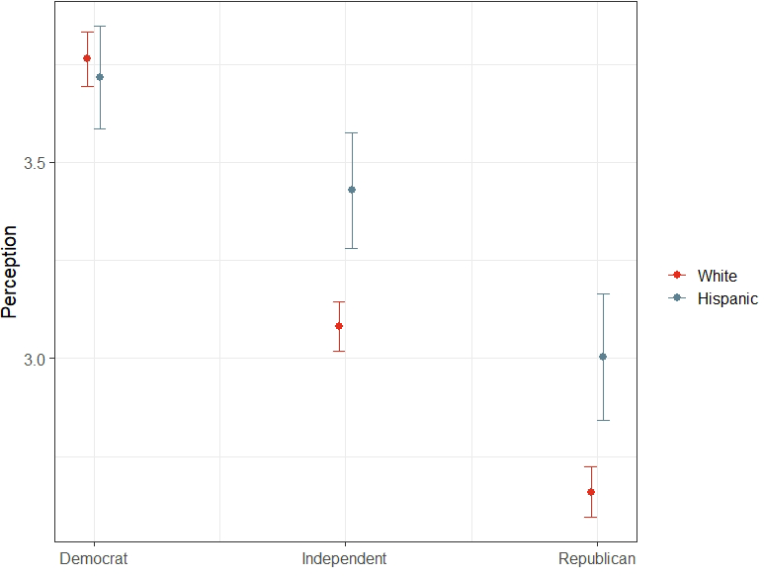

Figure 1: Predicted Values of Perception of Hispanic Health Impact by Party and Race
Source: VOTER Survey September 2020

The main takeaway here is that there is no systematic racial difference among Democrats, and overall, Hispanics tend to view the pandemic as more severe. Hispanic perceptions of the impact of COVID-19 on their community do not reflect elite partisan rhetoric to the degree seen among whites, although they do follow the same trend. Thus far, the first two hypotheses are both supported, with the exception of those who identify as Democrats. The results provide evidence of partisan bias, but there are significant differences due to ethnicity among partisans. Thus far, in exploring the question of whether white and Hispanic Republicans tend to perceive the pandemic as being less severe on the Hispanic community, it is clear that Republicans do, on average and regardless of race, support this prediction. We see a racial gap among Republicans and Independents. White Republicans downplay the impact of COVID-19, while Hispanic Republicans do also, but to a lesser degree. This finding holds invariant to the group in reference. Recall earlier epidemiological trends in September 2020 indicated a disproportionate impact on racial and ethnic minorities (Alcendor 2020; Gramlich and Funk 2020;Kazemian et al. 2021; Reyes et al. 2020; Vahidy et al. 2020; Yancy 2020).
This reality is important because the impact of the COVID-19 pandemic can be understood with non-political information, such as the advice of medical experts and public health officials, but these findings suggest that partisanship influenced American perceptions differently, depending on race/ethnicity. White Republican perceptions are more aligned with partisan rhetoric surrounding the pandemic, and white Republicans are less likely to perceive a disproportionate impact relative to non-Republicans. Ultimately, members are aligned with the party line for both parties, but whites demonstrate this to a greater degree than Hispanics.
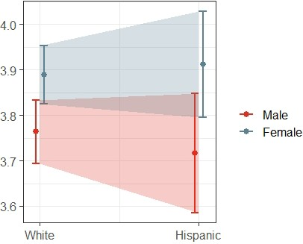
The third main finding is the unique effect of gender for Hispanics. If the impact of gender on perception is conditional on race, I expect to see a significant interaction effect between gender and ethnicity. Table 1 indicates that, in the aggregate, gender is not driving perceptions in a meaningful way. This was expected. However, we do see that Female × Hispanic in model 1 is significant. This is further illustrated in Fig. 2, which is a plot of the predicted values of perception by gender and race, including the 95% confidence intervals. The predicted value for Hispanic males is lower than any other category in Fig. 2, and the opposite is true for Hispanic females. This lends support

Figure 2: Predicted Values of Perception of Hispanic Health Impact by Gender and Race
Source: VOTER Survey September 2020

to hypothesis 3a. Although the confidence intervals overlap for Hispanic males and females, this gender difference is significant. As a next step, I explore the role of linked fate in moderating this interaction. I suspect that, even though female perceptions are, on average, reliably higher than males when asked about the Hispanic health impact, the effect of linked fate will be stronger for males.

The last main finding provides evidence to support this conclusion. Among Hispanics, the moderating effect of linked fate is weaker for females. If perception is conditional on race, gender, and linked fate, so we would expect to see significant interaction effects between race and gender, and linked fate. The pandemic highlighted gender differentiation and gender-based inequality (Collins et al. 2020; Petts et al. 2021; Stout et al. 2022), so I expect to see that the intersectionality of race and gender will result in ethnic linked fate being closely correlated with male perceptions. In other words, I expect that, relative to females, Hispanic males with high levels of ethnic linked fate will be more likely to perceive a greater pandemic health impact on their community. Notice that linked fate stands out in both model 1 and model 2 as a significant and positive predictor of perception among Hispanics and whites, regardless of the community in reference, yet is more closely tied to perceptions of minority health impact. The three-way interaction term in Table 1 (gender × linked fate× race) lends support for hypothesis 3b. The Female × LF × Hispanic interaction in model 1 is negative and statistically significant when the Hispanic community is in reference. This indicates that the moderating effect of gender on linked fate is distinct by race/ethnicity. We can see this relationship visualized in Fig. 3, indicating that Hispanics are largely driving the interaction effect.
Among whites in Fig. 3, we observe no meaningful gender difference at the baseline. Focusing in on Hispanics, we see the opposite is true. Only at the highest levels of linked fate do the two gender categories converge. Males generally viewed the pandemic impact as less severe than their female counterparts. For Hispanics, females are less responsive to linked fate than males. We also see a meaningful racial gap in the baseline in Fig. 3. Whites see the pandemic as generally more severe on the Hispanic community, relative to Hispanics, but are much less responsive to linked fate. In summary, linked fate impacts perceptions differently across racial categories, and baseline perceptions vary by race/ethnicity.
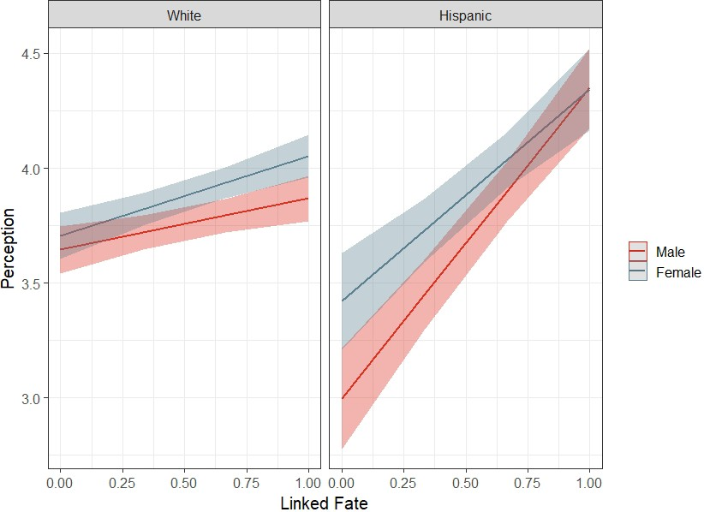

Figure 3: Predicted Values of Perception of Hispanic Health Impact by Gender and Race across values of Linked Fate. Source: VOTER Survey September 2020

These findings are important since they suggest that Hispanic perceptions of co-ethnic community impact are not only shaped by partisanship, but they are also meaningfully impacted by gender and linked fate. This evidence that challenges hypothesis 3b, since Hispanic males and females overlap at the highest levels of linked fate.
The data indicate that, for Hispanic females, concerns about Hispanic health impact may have been less connected to their racial/ethnic identity during the COVID-19 pandemic. Hispanic female perceptions were different, in part, because of the salience of gender during this economically difficult time. Previous findings indicate that women had higher levels of gender linked fate when they were subject to major pandemic changes (Stout et al. 2022) and, given the findings thus far, Hispanic perceptions are of their own community uniquely impacted by linked fate and gender, but the analysis has been lacking in a comparative judgment that will adequately address the question of disproportionate impact.

Perceptions of Disproportionate Impact
One factor we have yet to consider specifically is the difference in perception across groups. I build upon the previous models by focusing on the difference in Hispanic perceptions when asked about the two different communities. By introducing this dependent variable, I am specifically measuring respondent perceptions of disparity and moving beyond the simple measure of perception alone. This measure will capture the evident discrepancies in health impact among whites and Hispanics. This new dependent variable targets individual differences in perception across racial groups. This allows me to specifically predict perceptions of the disproportionate impact of COVID-19 on the minority Hispanic community. I calculate the difference between the perceived the impact on whites and the perceived impact on Hispanics. This allows me to capture the difference between individual perceptions of co-ethnic impact and their perception of out-group impact. Equation 2 indicates the model specifications.

$\hat{C}$_{D} = β₀ + β₁Gender + β₂Linkedf ate + δ₀Race + β₃Independent
+β₄Republican + β₅Age + β₆Education

+δ₁Gender × Race + δ₂Gender × Linked f ate

+γ₁Race × Linked fate × Gender (2)

$\hat{C}$_{D} is the outcome measure of the difference in perception. The model includes the 7 original controls along with the interactions shown in equation two. I include three two-way interactions: Female × Linked Fate, Female × Hispanic, and Linked Fate × Hispanic. In doing this, I can discern the difference that the female, Hispanic, and linked fate terms are contributing relative to the baseline category, since all of the variables included in the interaction values range from 0 to 1. In particular, I can further explore the role of linked fate and gender in predicting perceptions of disparity across groups. Lastly, I include the same three-way interaction that was in the first model to see if Hispanic perceptions are uniquely impacted by linked fate and gender using the new dependent variable.
The new model in Table 2 includes all whites and Hispanics. The dependent variable is the difference in perception (range: −4 to +4, mean: −0.4, standard deviation: 0.88). Along with linked fate, the previous controls are included: gender, party identification, birth year and education. Because I am no longer stratifying by race, I add an additional control for race/ethnicity and include survey weights.

Table 2: OLS Predictors of Difference in Perception for all Respondents

(1)

Female 0.019
(0.052)
Linked Fate −0.020
(0.061)
Hispanic 0.189∗∗
(0.090)
Independent 0.239∗∗∗
(0.030)
Republican 0.484∗∗∗
(0.030)
Age −0.126∗∗
(0.054)
Education −0.436∗∗∗
(0.042)
Female×Linked Fate −0.080
(0.086)
Female×Hispanic −0.507∗∗∗
(0.127)
Linked Fate×Hispanic −0.557∗∗∗
(0.136)
Female×Linked Fate×Hispanic 0.668∗
(0.196)
Constant −0.242∗∗∗
(0.052)
Observations 4,488
Adjusted R² 0.097
Residual Std. Error 0.804 (df = 4476)
Note: VOTER Survey September 2020 ∗p<0.1; ∗∗p<0.05; ∗∗∗p<0.01

An important finding in Table 2 is the gender gap among Hispanics. Linked fate has a much weaker effect for females. While being female, alone, appears to have no independent effect (the Female × Linked Fate interaction in Table 2 indicates that there is no difference between males and females across levels of linked fate), the three-way Female × Linked Fate × Hispanic interaction is positive and significant. The interaction is visualized as predicted values in Fig. 4.

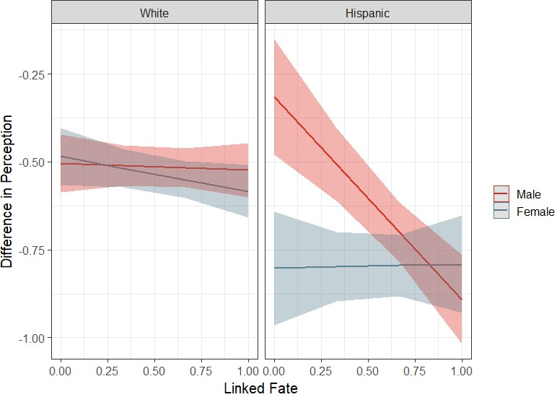

Figure 4: Predicted Values of Difference Perception by Gender and Race across values of Linked Fate. Source: VOTER Survey September 2020

Fig. 4 allows us to easily see what is driving the relationship in the model predicting the perception of disproportionate impact. First, for accuracy of interpretation, note that the top values on the y-axis represent smaller differences in perception. Likewise, the lower y-axis values represent larger differences in perception across groups. Drawing attention to whites on the left side, we see that white males and females are almost indistinguishable when it comes to the impact of linked fate on a gap in perception across groups. This pattern is similar to the pattern seen among whites in the previous model.
Next, we find the central finding in this study. Hispanic women tended to perceive a greater difference in impact than any other category, since Hispanic females have the highest baseline difference in perception. They tended to view the health impact on Hispanics and whites very differently. Ethnic linked fate, however, has no impact on the difference in perceptions of Hispanic women. This provides that challenges previous findings: evidence of gender weakening the effect of ethnicity. The weak impact of linked fate among Hispanic females sharply contrasts with males, and the difference in baseline between white and Hispanic females is even more striking. At the same time, while linked fate has no impact on the difference in perceptions of Hispanic women, it has a dramatic effect on Hispanic males. This reveals important finding that was missed with the original dependent variable. At the lowest values of linked fate the gender gap in perception of severity is very large. Hispanic men with weak levels of linked fate tend to have a smaller gap in perception. Hispanic men with strong levels with linked fate tend to report a larger gap in perception across the two communities. Ultimately, Fig. 3 provides strong support for hypothesis 3b which states that Hispanic males with high levels of ethnic linked fate will be more likely to perceive a greater pandemic health impact on Hispanics. As was seen in the original model, the gender gap does not exist for whites.
The difference in baseline between white and Hispanic females is also striking. Hispanic females have the highest baseline difference in perception. As was previously mentioned, Hispanic families faced economic adversity during the COVID-19 pandemic, with the females bearing a disproportionate burden. These findings suggest that linked fate was not nearly as salient for females, likely because the economic pressures activated gender identity in a unique way. In contrast, male ethnicity correlates with health impact for the Hispanic community.

Discussion
Despite the polarized U.S. political system, a global pandemic is an issue of medical and scientific importance in which partisan divisions should be ostensibly irrelevant. Against this backdrop, the impact of the COVID-19 pandemic can be understood with non-political information, such as the advice of medical experts and public health officials. The COVID-19 pandemic provides an opportunity to study the relationship between partisanship identity and perceptions of non-political disproportionate health impact.
Instead, the COVID-19 pandemic was highly politicized in the US. Not only is there evidence of partisan bias, but there are significant differences in perception associated with ethnicity among partisans. In general, the results support theories of identity politics and their applicability in a global health crisis. Not only were there behavioral and epidemiological outcomes, but perceptions were altered by this partisan-dominated event. My work suggests that in order to promote health equity, public health messaging needs to be tailored to reach different audiences. Perception of interdependence and vulnerable populations is key to containment. In this work, I am furthering established work on Hispanic linked fate, challenging theories around the complementary nature of gender and ethnic linked fate, and bridging gaps between political science and public health research. Perceptions are key to understanding pandemic response since perceptions impact public health outcomes via behavioral mechanisms.
These findings suggest that personal experience and partisan information both contributed to American perceptions. Even in the aggregate, the salience of these factors depended on the self-reported identity of the individual. Not only do citizens generally see the pandemic as a partisan issue, they perceive the health impact across racial/ethnic groups differently based on their party identification and race. In general, white Republicans viewed the pandemic as less severe, indicating more alignment with conservative Republican rhetoric.
Partisanship is more aligned with race for non-Hispanic whites, indicating that partisanship was a more salient social identity early in the pandemic. With identity fusion, elite rhetoric downplayed severity and the need for precautions. Alternatively, it could be that non-Hispanic whites are, on average, more removed from the nonwhite experience of the pandemic, leading to a reliance on party identification for perceptions of pandemic impact.
For Hispanics, partisanship shaped perception in a different way. The congruence seen among white Republicans and white Democrats is not observed among Hispanics. Instead, gender is a meaningful factor behind perception. The most central findings in this study concern the out-sized impact of linked fate among Hispanic males. First, males with a strong sense of ethnic unity were much more aware of the disproportionate burden on their community. The relationship was non-existent for females, however. Most important, despite the lack of a relationship between linked fate and perception for females, they perceive the pandemic as more severe for Hispanics in general, relative to their white female counterparts. These findings make sense, given the context of the pandemic. Hispanic families faced economic adversity during this time, with the females bearing a disproportionate burden. Financial crises and job loss were high (Vargas and Sanchez 2020). This work underscores the idea that, for Hispanic females, experiences of gender inequality defined the pandemic experience. The findings suggest that the pandemic experience was uniquely burdensome for Hispanic caretakers. These findings highlight economic inequality and the intersectionality of race and gender. In the pandemic context, race and gender were not complementary for Hispanic women. These findings suggest that gender was more salient than racial/ethnic identity for Hispanic women in the context of a health crisis.
Moving forward, we begin to understand how far perceptions stray from actual data measures. While the results of this study should be interpreted with caution due to discrepancies in sample size and the cross-sectional nature of the analysis, they shed some light on the conditions under which racial, gender and partisan identities dominate. They also underscore the need for more research centered on minority experiences of the pandemic.

References

Achen, Christopher H. and Larry M. Bartels. 2016. “Democracy for Realists: Why Elections Do Not Produce Responsive Government.” Princeton University Press, Princeton NJ

Alcendor, Donald J. 2020. “Racial Disparities-Associated COVID-19 Mortality Among Minority Populations in the US.” Journal of Clinical Medicine 9 (8): 2442

Algara, Carlos, Sam Fuller, Christopher Hare, and Sara Kazemian. 2021. “The Interactive Effects of Scientific Knowledge and Gender on COVID-19 Social Distancing Compliance.” Social Science Quarterly 102 (1): 36

Ansolabehere, Stephen and Douglas Rivers. 2013. “Cooperative Survey Research,” Annual Review of Political Science 21: 1-23

Bartels, Larry. 2002. “Beyond the Running Tally: Partisan Bias in Political Perceptions.” Political Behavior 24 (2): 117-50

Bello-Pardo, Emily D., Monica Nayak, and John Ray. 2020. “New coronavirus polling shows Americans are responding to the threat unevenly.” YouGov Blue. Medium. March 18

Bibbins-Domingo, Kirsten. 2020. ”This Time Must Be Different: Disparities During the COVID-19 Pandemic.” Annals of Internal Medicine Aug 4; 173 (3): 233-234

Broockman, David E. and Daniel M. Butler. 2015. ”The Causal Effects of Elite Position-Taking on Voter Attitudes: Field Experiments with Elite Communication.” American Journal of Political Science 61 (1): 208-221

Brown, Tyson. 2018. “Racial Stratification, Immigration, and Health Inequality: A Life Course
Intersectional Approach.” Social Forces 96 (4): 1507-1540

Buchanan, Larry, Quoctrung Bui and Jugal K. Patel. 2020. “Black Lives Matter May Be the Largest Movement in U.S. History.” The New York Times. July

Democracy Fund Voter Study Group. 2021. Views of the Electorate Research Survey
December. Washington, D.C. url: https://www.voterstudygroup.org/

Cain, Bruce E., D. Roderick Kiewiet, and Carole J. Uhlaner. 1991. “The Acquisition of Partisanship by Latinos and Asian Americans.” American Journal of Political Science 35 (2): 390

Campbell, Angus, Philip E. Converse, Warren E. Miller and Donald E. Stokes. 1960. “The American Voter.” John Wiley and Sons, New York NY

Campi, Ashleigh, and Jane Junn. 2019. “Racial Linked Fate and Gender in U.S. Politics.” Politics, Groups, and Identities 7 (3): 654–62

Chen, Hsueh-Fen and Saleema A. Karim. 2021. Relationship Between Political Partisanship and
COVID-19 Deaths: Future Implications for Public Health. Journal of Public Health. 37: 1-8

Collins, Caitlyn, Liana Christin Landivar, Leah Ruppanner, and William J. Scarborough. 2020.
“COVID-19 and the Gender Gap in Work Hours. Feminist Frontiers. Gender Work Organ. 28 (S1): 101-112

Corbie-Smith, G. Thomas SB, George, DMMS. 2002 Distrust, Race, and Research. Archives of Internal Medicine. 162 (21): 2458-2463

Dawson, Michael C. 1994. “Behind The Mule.” Princeton: Princeton University Press.

Fan, Ying. A., Yesim Orhun, and Dana Turjeman. 2020. “Heterogeneous Actions, Beliefs, Constraints and Risk Tolerance During the COVID-19 Pandemic.” NBER Working Paper No. 27211 (May) JEL No.D81,D84,D91,H41,I12,I18

Golash-Boza, Tanya. 2016. “A Critical and Comprehensive Sociological Theory of Race and Racism.” 2 (2): 129-141

Gomez-Aguinaga, Barbara, Ana L Oaxaca, Matt A Barreto; Gabriel R. Sanchez. 2021. “Spanish-Language News Consumption and Latino Reactions to COVID-19”. International Journal of Environmental Research and Public Health 18: 9629

Gramlich, John and Cary Funk. 2020. “Black Americans Face Higher COVID-19 Risks, Are More Hesitant to Trust Medical Wcientists, Get Vaccinated.” June 4. Pew Research Center. Washington, DC.

Green, Donald, Bradley Palmquist, and Eric Schickler. 2002. “Partisan Hearts and Minds: Political Parties and the Social Identities of Voters.” New Haven, CT: Yale University Press

Green, Jon, Jared Edgerton, Daniel Naftel, Kelsey Shoub and Skyler J. Cranmer. 2020. “Elusive
Consensus: Polarization In Elite Communication on the COVID-19 Pandemic. Science Advances 6: eabc2717

Grossman, Guy, Soojong Kim, Jonah M. Rexer, and Harsha Thirumurthy. 2020. “Political Partisanship Influences Behavioral Responses to Governor’s Recommendations for COVID-19 Prevention in the United States.” The Proceedings of the National Academy of Sciences. 117: 39

Harnois, Catherine E. 2015. “Race, Ethnicity, Sexuality, and Women’s Political Consciousness of Gender.” Social Psychology Quarterly 78 (4): 365-386

Jamieson, Thomas, Dakota Caldwell, Barbara Gomez-Aguinaga and Christian Dona-Reveco. 2021. “Race, Ethnicity, Nativity and Perceptions of Health Risk during the COVID-19 Pandemic in the US.” International Journal of Environmental Research and Public Health 18:11113

Kazemian, Sara, Sam Fuller and Carlos Algara. 2021. “The Role of Race and Scientific Trust on Support for COVID-19 Social Distancing Measures in the United States.” PLoS ONE 16 (7): e0254127

Lu, Fan, and Bradford Jones. 2019. “Effects of Belief Versus Experiential Discrimination on
Race-Based Linked Fate.” Politics, Groups, and Identities 7 (3): 615–24

Maltby, Elizabeth, Rene R. Rocha, Bradford Jones, and David L. Vannette. 2020. “Demographic
Context, Mass Deportation, and Latino Linked Fate.” Journal of Race, Ethnicity and Politics 5 (3):509–36

Marsh, Wayde Z. C., and Ricardo Ram´ırez. 2019. “Unlinking Fate? Discrimination,
Group-Consciousness, and Political Participation among Latinos and Whites.” Politics, Groups, and Identities 7 (3): 625–41

Mason, Lilliana. 2016. “A Cross-cutting Calm: How Social Sorting Drives Affective Polarization.” Public Opinion Quarterly 80 (S1) 351-377

Mason, Lilliana and Julie Wronski. 2018. “One Tribe to Bind Them All: How Our Social Group
Attachments Strengthen Partisanship.” Advances in Political Psychology (39)257-277

Masuoka, Natalie. 2006. “Together They Become One: Examining the Predictors of Panethnic Group Consciousness among Asian Americans and Latinos.” Social Science Quarterly 87 (5): 993–1011

Motta, Matt, Dominik Stecula, and Christina Farhart. 2020. “How Right-Leaning Media Coverage of COVID 19 Facilitate the Spread of Misinformation in the Early Stages of the Pandemic in the US.” Canadian Journal of Political Science/Revue Canadienne de Science Politique (May)

Mude, William, Victor M Oguoma, Tafadzwa Nyanhanda, Lillian Mwanri, and Carolyn Njue. 2021. “Racial Disparities in COVID-19 Pandemic Cases, Hospitalisations, and Deaths: A Systematic Review and Meta-Analysis.” Journal of Global Health (11) 05015

Pérez, Efrén O. 2015. “Xenophobic Rhetoric and Its Political Effects on Immigrants and Their
Co-Ethnics.” American Journal of Political Science 59 (3): 549–64

Petts, Richard J. Daniel L. Carlson, and Joanna R. Pepin. 2021. “A Gendered Pandemic: Childcare, Homeschooling, and Parents’ Employment During COVID-19.” Gender Work, and Organization 28 (S2): 515-534

Reyes C, Husain N, Gutowski C, St Clair S, Pratt G. 2020. “Chicago’s Coronavirus Disparity: Black Chicagoans are Dying at Nearly Six Times the Rate of White Residents, Data Show.” Chicago Tribune (April 7)

Smith, Candis Watts, Tehama Lopez Bunyasi, and Jasmine Carrera Smith. 2019. “Linked Fate Over Time and across Generations.” Politics, Groups, and Identities 7(3): 684–94

Stout, Christopher, Kelsy Kretschmer and Leah Ruppanner. 2022. “The Link Between Familial Care, the Covid Pandemic and Gender Linked Fate.” Journal of Women, Politics and Policy

Tai, Don Bambino Geno Tai. Aditya Shah,Chyke A. Doubeni,Irene G. Sia, and Mark L. Wieland. 2021. “The Disproportionate Impact of COVID-19 on Racial and Ethnic Minorities in the United States.” Viewpoints. Clinical Infectious Diseases 72 (15 February): 705-708

Turner, John C., Penelope J. Oakes, S. Alexander Haslam, and Craig McGarty. 1994. “Self and
Collective: Cognition and Social Context. Personality and Social Psychology Bulletin 20: 454-63

Vahidy Farhaan S., Juan Carlos Nicolas, Jennifer R. Meeks, Osman Kahn, Alan Pan, Stephan L. Jones, Faisal Masud, H Dirk Sostman, Robert Phillips, Julia D Andrieni, Bita A Kash, Khurram Nasir. 2020. “Racial and Ethnic Disparities in SARS-CoV-2 Pandemic: Analysis of a COVID-19 Observational Registry for a Diverse US Metropolitan Population.” BMJ Open 2020; 10

Vargas, Edward D. and Gabriel R. Sanchez. 2020. “COVID-19 Is Having A Devastating Impact on the Economic Well-being of Latino Families.” Journal of Economics, Race, and Policy 3:262-269

Vargas, Nicholas. G. Cristina Mora and Shannon Gleeson. 2021. “Race and Ideology in a Pandemic: White Privilege and Patterns of Risk Perception during COVID-19.” Social Problems 00:1-19

Wolaver, Amy and John Doces. 2022. “Whistling Through the COVID-19 Pandemic: Optimism Bias and Political Beliefs in the United States.” American Politics Research 50 (3): 396-415

Yancy, Clyde W. 2020. “COVID-19 and African Americans.” JAMA ;323 (19): 1891–1892

Zhao E., Qiao Wu, Eileen M. Crimmins, Jennifer A. Ailshire. 2020. “Media Trust and Infection Mitigating Behaviors During the COVID-19 Pandemic in the USA.” BMJ Global Health 5 (1
List of visuals

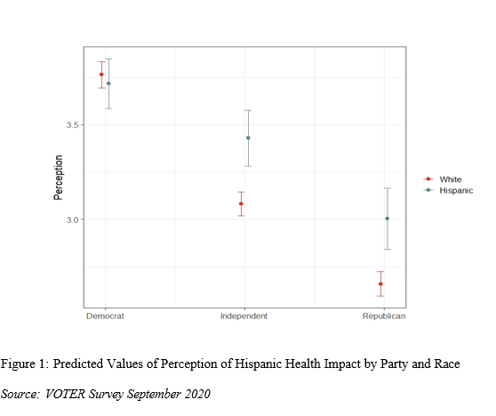

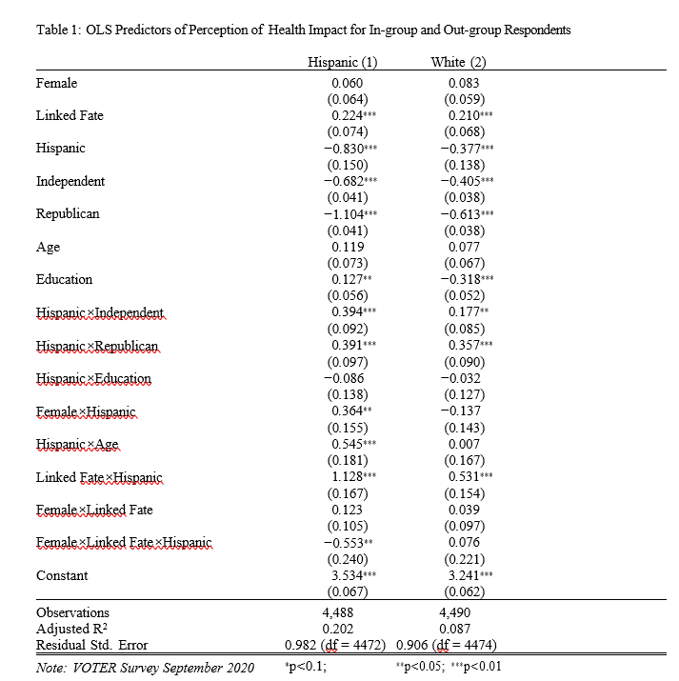

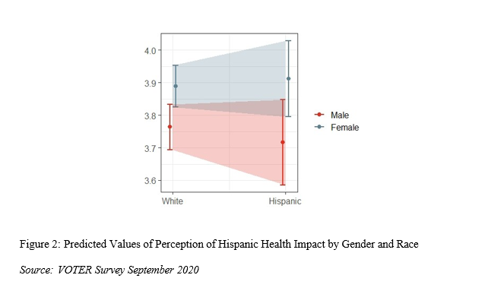

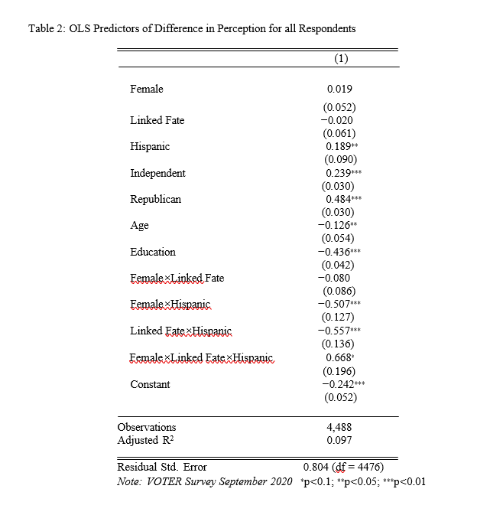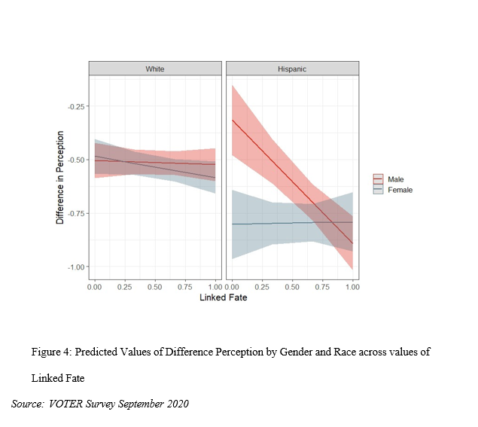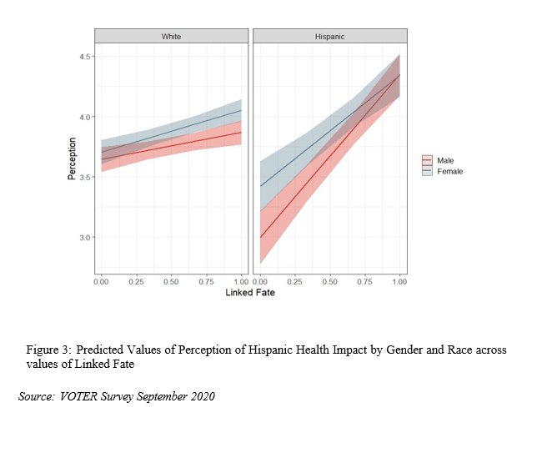

For Hispanics and Blacks, likelihood of infection was higher in the earlier stages of the pandemic, partly due to likelihood of living in a densely populated area (Vahidy et al. 2020).
In particular, Republican identifiers received mixed cues from co-partisan elites regarding not only pandemic impact, but associated risks and preventative measures. Democratic identifiers received a consistent cue of support for preventative measures and overall concern for public health (Green et al. 2020; Motta et al. 2020).
Wolaver and Doces (2022) also report that males are less worried than females, while support for Trump is associated with less concern.
For Blacks and Hispanics, the likelihood of infection was higher in the earlier stages, partly due to likelihood of living in a densely populated area.
See Appendix A for partisan distribution by race/ethnicity.
See Appendix for question wording.
See Appendix for question wording.
To facilitate interpretation, I rescale education, age, and linked fate to lie between 0 and 1. For gender, males are coded as “0” and females as “1”.

