State Legislative Battle Over Public Pensions: The Great State and Local Unfunded Liability

Allen K. Settle
Professor
California Polytechnic State University

Paper Presented at
Western Political Science Association
Annual Conference
March 28-30, 2013

ABSTRACT

The funding of public pensions is approaching a financial threshold for how to keep equity for all employees and insure payments can be made upon retirement. This paper covers three of the largest pensions in the United States, the California Public Employment Retirement System (CalPERS), California State Teachers Retirement System (CalSTRS), and University of California Retirement System (UCRS). The overall unfunded liability for these three pensions plans amounts to over $500 billion. California passed new pension reform legislation that will be covered in this paper. The purpose of this paper is determining what options and solutions open to the California state government handling the unfunded liability of pensions? What methods are available to legislators when retirement plans are under labor contracts and employees are unwilling to have benefits cut or changed?

The general supposition presented in this paper shows that pensions will be forced into a two-tiered system where new employees will receive less and be subject to paying more for their retirement. Further, pensions will be moved from a defined benefit system to a defined contribution system. Current defined benefits are preferred because they guarantee payment be made to the retired person for the remainder of their lives including provisions for costs-of-living adjustments. While the retiree cannot outlive their pension they cannot inherent any fund balances they contributed except for a beneficiary spouse. The defined contribution is essentially a 401 (k) system where the employee draws down the balance over time upon retirement and can run out of money in the fund but their estates can inherit any fund balances not distributed. Voters are using local ballot measures to place new limits on pensions in cities such as San Diego and San Jose. Public opinion polls show voters anger over the level of benefits they believe to be excessive when compared to private sector plans. The 401 (k) plans cannot generate the rate of return on investments possible with the far larger state public pension plans. To be viable, pensions should maintain 80 percent of what they are obligated to have in the trust fund to cover all future retiree needs.

The major question is how can pensions be changed to make them viable in the public sector and without the threat of financial collapse especially as many of the pension trust funds are invested in the U.S. Stock Market and have reduced returns especially since 2008. CalPERS has sued Standard and Poor Credit rating company for conflicts of interests in using collateralized debt obligations bundled as mortgaged backed securities with a Triple A credit rating when in fact the derivatives (speculative bets) contained unreliable and failing loans. The federal government bailed out the banks that offered these loan packages with taxpayer money starting in 2009. The California pension funds are seeking compensation from the banks and the three credit rating agencies for their investment losses.

The Challenges of State and Local Pensions

The expectation behind pensions is to provide all workers with necessary cost of living needs in retirement years. Employee’s work on the assumption that pensions will be properly funded. It is anticipated that pension revenues will be responsibly invested but public and private sector employees fear retirement plans may be insufficiently funded, badly invested, and subject to corruption and excessive fees. Many if not most still retire with insufficient liquidity even if they have equity in their homes.
The California State Legislature has become alarmed at the pension costs found in the largest retirement plans in the United States. These include the California Public Employment Retirement System (CalPERS), California State Teachers Retirement System (CalSTRS) and the University of California Retirement System (UCRS). One aspect particularly problematic is the public safety pensions plans that are called 3 per cent at 50 or essentially retirement at 90 per cent of salary after 30 years of work in police or fire services. This same formula extends to many local government public safety employees. Because of a smaller tax base, local jurisdictions have a more difficult time servicing unfunded liabilities in the fifty-eight counties and four hundred and seventy eight cities.
The purpose of this paper is reviewing the options and solutions open to the California state government in handling the unfunded liability of pensions. What methods are available to legislators when retirement plans are under labor contracts and employees are unwilling to have benefits cut or changed? What
future trends appear to be taking place for those entering the work force with respect to pension plans?
The general theory shown here is that a government short of cash will try to shift the costs to the user or change the level of benefits or create two tier system where new employees will be on one type of benefit plan while existing employees will retain their previously contracted benefits. If government were in a major financial crisis such as bankruptcy, what would prevent it from paying only a percentage of a pension to those retired? Pension boards can mismanage the trust fund and risk all future benefits and those of current beneficiaries. Pension boards have also been deceived by sellers of mortgaged backed securities given a AAA credit rating when in fact they are poorly rated collateralized debt obligations that failed in the Wall Street stock crash in 2008. As discussed below CalPERS and CalSTRS and University of California Retirement System (UCRS) are suing Standard and Poor’s credit rating company for over $1.3 billion and if the trust funds win and received punitive damages amounting to three times the loss, the return could amount to $4 billion. From a beneficiary perspective, once a benefit is negotiated and received, a constituency of employees come to expect it to remain and will fight vigorously to stop any attempt to take away or make changes to expected benefits.
California pension problems have national implications for state and local governments throughout the United States. In a recent book, State and Local Pensions: What Now? Alicia Munnell noted in the introduction a sample of cities in the United States that have filed for bankruptcy: Vallejo, California (2008), Prichard, Alabama (2010), and Central Falls, Rhode Island (2011) [Stockton, California (2012)] all have filed for bankruptcy, with commentators citing pension promises to public employees as a major cause.¹ Munnell also notes “many states have substantially reduced benefits for new employees and increased employee contributions across the board.” ²
The City of Stockton that declared Chapter 9 bankruptcy protection in the largest municipal bankruptcy in U.S. history seeks in show in a March 2013 trial that it can not pay Wall Street bond creditors (Franklin High Yield Tax-Free Income Fund and National Public Finance Guarantee Corporation) but has paid its CalPERS obligation because the pension fund argued the city must make its annual payment to the fund no matter what. If Stockton did not pay CalPERS, the pension fund would sue the city of 300,000 people, and the city’s pension plan could be terminated and employees and retirees would be placed in a special CalPERS fund that would pay them reduced benefits. In March 2013, the City of San Bernardino in the midst of bankruptcy owes CalPERS pension payments since August 2012 and the pension fund argues that it has priority over other creditors in the bankruptcy. The city is seeking bankruptcy protection citing its $46 million deficit from CalPERS and its other creditors.
A far larger problem developed in March 2013 with the potential city bankruptcy in Detroit Michigan. Over the protests of the mayor and city council, the state sent in an emergency manager to run the city with a $14 billion debt. Detroit has a population over 1, 800,000 million and is unable to meet its employee pay and pension contracts. The manager could cut city spending, change labor union contracts, pensions, eliminate city departments and sell city assets. As of 2013, five cities and three school districts in Michigan are under the supervision of an unelected state-appointed emergency manager.
Figure 1 Adoption of Defined Contribution Plans by State before 2008

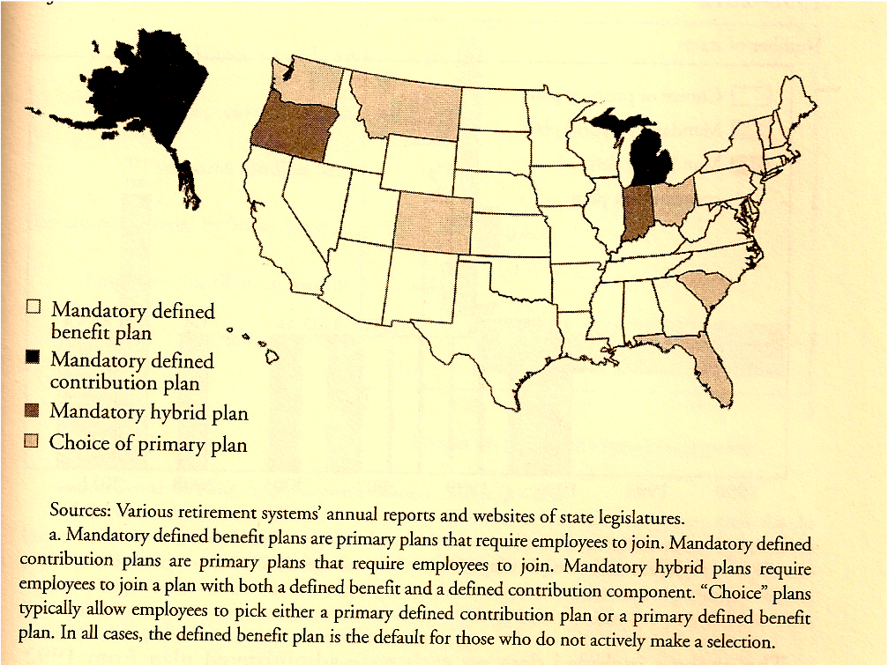
Figure 2 Adoption of Defined Contribution Plans by State After 2008

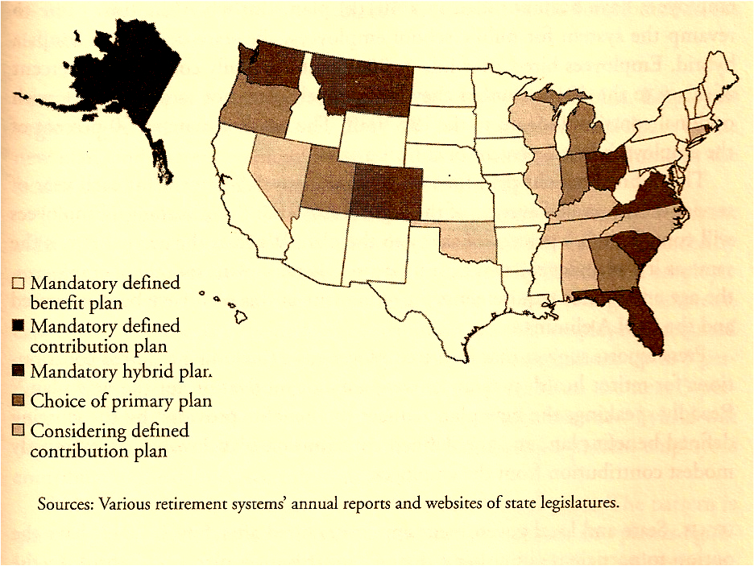

The above two maps appear in State and Local Pensions by Alicia Munnell pp. 193 and 197.
The above maps illustrate the increase in states adopting defined contribution plans replacing defined benefit plans.

In December 2011 the Stanford Institute for Economic Policy Research (SIEPR) reported that California’s three largest pension systems (CalPERS, CalSTRS & University of California Retirement System (UCRS) have a shortfall over $500 billion beyond their existing ability to make payments to retirees.³ Its author, Joe Nation, a former Democratic Assemblyman and Stanford University Professor argues the state pensions’ shortages can cost the state $3.4 million per day and the pensions’ need more than 6.2 percent rate of return that results in $300 billion short but the systems are earning less than 4 percent. The funded ratio, the measure of assets to liabilities, is only 74 percent for CalPERS , using 7.75 percent rate of return the expects from investment (at 6.2% rate of return, the ratio drops to 58 percent), and CalSTRS is 60 percent using 6.2 percent rate of return and the University of California Retirement Plan (UCRP) is funded for 72 percent. The Stanford report cited further below concluded the three state public pension systems are carrying a collective $500 billion in unfunded liabilities. The studies were funded by former Governor Arnold Schwarzenegger who quoted from the reports the need for the pension system to be changed. Public employee unions and pension boards all criticized the report as attacks on the pension system. As of 2012, California’s three major pension plans had a $516.3 billion in liabilities that equals to a 78 percent financed pension, just short of the 80 percent level that actuaries generally recommend to be property funded.⁴
The fiscal year 2011-2012 reflected the national recession in interest rates being paid and CalPERS investments had a dismal one percent return well short of the projected annual return of 7.5 percent. CalPERS board of directors responded to the lackluster return by reminding members that the pension fund is a long-term investment and one-year performance should not be used to determine the overall investment future. One consequence of the one percent return is local governments will need to contribute more for a period of several years. Employer contribution rates will increase for the next two fiscal years 2013 -2014 and 2014-2015. The increases will be mitigated in part because of investments in income-generating properties such as office building, retail and industrial centers that generated 15.9 percent return.⁵
The legislature is also concerned at expensive safety retirement formulas with announcements in May 2012 that the state had a $16 billion deficit. To make matters more difficult, Republicans in the legislature refuse to increase taxes and Democrats refuse to cut spending on basic social service needs and educational costs. Table 1 shows the CalPERS benefit formulas for the largest pension system in the United States. There also is a system wide average contribution rate for all active CalPERS members of 7.6 percent. The average annual retirement benefit payment for all members regardless of years of service or the year of retirement is $36,780 as of 2011 or $66,828 with 30 years or more of service. CalSTRS and UCRS have similar formulas.⁶
The partisan divide in Sacramento has resulted in legislative gridlock in adopting the budget. The state debt level and improved economy was greatly eased with the adoption of the budget and the November 2012 passage of Proposition 30 (“Temporary Taxes to Fund Education, Guaranteed Local Public Safety Funding,” a initiative Constitutional Amendment) to increase taxes. Governor Brown threatened that the failure of his ballot measure would result in further cuts in many services and increased fees for social service programs and tuition for higher education. Governor Jerry Brown argued for the half cent sales tax and increase taxes on higher income workers making more than $250,000 a year.

Table 1
CalPERS Benefit Formulas

Member Category | Formula
State Miscellaneous Employee | 2 percent at 55
State Safety and Local Safety Employee | 3 percent at 50
Ave. annual benefit with 30 yrs. | $66,828 (2009) (Ave regardless of service yrs. $36,780)
Schools | 2 percent at 55
Local Miscellaneous Employees | 2 percent at 60, 2.5 percent at 55 or 3.0 percent at 60
Local Safety Police, Fire Employees | 2 percent at 55 or 3 percent at 50 or 2 percent at 50
 | or 2 percent at 50 half-pay at 55 with 20 years of service
Contribution rate for active members: | Average 7.6 percent system wide (2012)
Source: CalPERS, Comprehensive Annual Financial Report Fiscal Year 2012. State CalPERS and school retirees receive annual COLAs of up to 2 to 3 percent. If necessary, additional cost of living projections prevent the pension’s original purchasing power from falling by more than 20 percent or 25 percent. Members are vested after 5 years.

Further the governor was motivated because the California Department of Corrections was under court order to reduce the number of inmates in state prisons and transfer those who will soon end their terms to be transferred to county jails in the program known as “Realignment.” This transfer started in 2011 and county governments were understaffed to handle all the new prison inmates. The costs of housing prisoners had increased 26 per cent since 2008. The 3 percent at 50 also applied to all correctional officers in the state prisons.
Another factor in the pension battle are the frequent use of ballot measures in California that have become so common that the legislature is considered by many to be secondary or marginalized. Big money can put measures directly on the ballot to get voters response without considering the legislature. Voters, by means of local initiated actions, in two large California cities used the ballot to go after pension costs. More will be said about this below.
In February 2013, the California Legislative Analyst Office noted problems in the California State Teachers Retirement System (CalSTRS) similar to CalPERS and raised concerns over future initiative proposals reforming pensions.⁷ California Pension Reform organization wants the 2014 ballot to have measures that increase employee pension contributions, ending spiking and retroactive benefit increases and move towards a defined contribution 401(k) style plan versus the existing defined benefit retirements guaranteed by employers. In short, the measures move towards a two-tier system.
Both voter initiatives and ballot measures all reflect the unfunded costs of pension shortfall. A report released by the Stanford Institute for Economic Policy Research concluded the state’s pension systems have over $500 billion shortfall in 2012 up 17 percent than in 2010. The report notes that the “annual cost to the state of delaying pension solutions is $3.4 million per day.”⁸
While Defined Contribution (DC) plans are found in the private sector, public employee pensions are mostly Defined Benefit (DB) plans. As indicated, Defined Benefit plans offer guaranteed benefits as a percentage of salary at retirement age. Voter created CalPERS pension system in 1932 for state employees and is the nation’s largest public employee retirement plan. It expanded to include city and county governments, school staffs (excluding teachers), legislators, and judges. The total membership covers 2,600 government entities and more than 1.6 million members that includes 440,000 retirees and 806,000 active members. It administers fifteen funds including (1) Public Employees’ Retirement Fund, (2) Legislators’ Retirement Fund, (3) Judges’ Retirement Fund and administers a health care plan, long term care and deferred compensation plan. The Public Employees’ Retirement Fund in 2011 had a market value of over $220 billion and amounts to 99 percent total of CalPERS assets.⁹
Pension return on investments has become more of an issue since the economic crisis of 2008. The California Public Employees' Retirement System has seen its market value decline 4.8 percent in 2010 after stocks fell amid the brewing fiscal crisis in Europe and slowing of the U.S. economic recovery. The fund's value declined to $226.1 billion as of June 8, down from $237.5 billion at the start of its fiscal year July 1. As recently as March 31, the fund was up 1.9 percent for the first nine months. Since May 1, the Standard & Poor's 500 index of stocks declined 5.8 percent. If the trend continues, it would mark the third time in five years that the fund has lost money, including a 23 percent decline in fiscal 2009, the worst on record. While CalPERS spreads its return over 15 years to smooth taxpayers' burden, another loss may make it hard for the fund to meet its assumption of 7.5 percent earnings annually to cover benefits to 1.6 million retired employees and their families. Half of CalPERS's money is invested in equities. For the 10 years ending Feb. 29, 2012 the fund is up 5.9 percent. It earned 20.7 percent last year, the best result in 14 years, led by stocks and private equity. The previous year, it increased 11.6 percent.¹⁰
Increases Needed to Cover Underfunding Promised Benefits
In 2010, California's state pensions had 81 percent of what they needed to cover the benefits they promised, down from 87 percent in the preceding year, according to an annual study by Bloomberg Rankings. The median for all states was 75 percent, the Bloomberg data show.
The fund's governing board in March lowered its assumed rate of return to 7.5 percent from 7.75 percent. The rate is used to calculate how much money the plan will need to cover promised benefits, and what employers must contribute. While the fund's actuary recommended lowering the rate to 7.25 percent, the CalPERS board said that would burden local governments when they were already facing financial strains. CalPERS is a long-term investor and has in past years been able to meet returns to cover fund benefits. In an effort to recover lost investments CalPERS along with CalSTRS in February 2013 sued Standard and Poor’s, Moody’s and Fitch credit reporting agency for $1.36 billion. They are joining the state and federal government in suits against all three big rating agencies over losses since July 2009. California is one of sixteen states, plus the District of Columbia, suing the credit rating agencies. All pension funds made the same argument: that S & P put a “AAA” rating on supposedly the safest securities but were high-risk investments in questionable mortgages. CalPERS lost $1.32 billion and CAlSTRS lost $39.4 million. As previously noted, the lawsuits seek triple damages that would bring the total to more than $4 billion. The two big pension funds with assets over $400 billion relied on the credit rating agencies when making investment decisions. The agencies, it is argued, knowingly inflated credit rating on doomed securities and the agencies had a conflict of interest because the investment firms they’re rating pay them.
Pension Crisis in California: Cases of San Jose and San Diego, California
In June 2012 the City of San Jose was over $250 million short in its budget to pay for pension costs that consume some 20 percent of the city budget. The city provided to public safety employee’s pensions set at 3 percent at 50 with retirees receiving over 90% of income after thirty years of employment. Those cities and counties in California with their own pension systems are subject to greater unfunded liabilities because of their smaller tax base from which to acquire the necessary money to pay for those retired. Most California cities and counties operate their pensions on the state Public Employment Retirement System (CalPERS) and any shortages are made up by means of increasing employee contributions. Employee labor union often the urban governments pay these employee contributions towards retirement. This is a problem because not all governments have a reliable amount of taxable assets or public taxes to cover the employee retirement costs. This was especially the case when the housing market bubble collapsed in 2008 recession. Property taxes declined and contributions to pensions continued to increase. Several cities and counties reacted by going into a hiring freeze or layoffs to cut staff costs and help the unfunded liability involved in pensions. ¹¹
As indicated, the San Jose voters, over union objections, and by almost 70 percent passed a ballot measure that (1) limited retirement benefits for new hires, (2) require current employees to pay up to 16 percent of their salary toward retirement costs, and (3) temporarily suspend cost-of-living pension increases for retirees in a fiscal emergency. In San Jose Measure B advocates argued that the state constitution and city charter grant its elected council authority over employee compensation.
In San Diego voters overwhelmingly approved (66 percent) pension reform measure (Proposition B) that required (1) temporarily freezing salaries and (2) putting all new hires except public safety employees on a 401(k)-type retirement plan. In San Diego, the annual required pension contribution from all funds went from $137.6 million in fiscal 2006 to $231 million in 2012 and is projected to be about $500 million in fiscal 2025. In the case of San Jose, the annual retirement contribution for pensions and retiree health from all funds went from $73 million in 2001 to $247 million in 2012 and is projected to grow about 27 percent by 2016.¹²
All public pension systems in California share a cost-cutting problem. Powerful pension boards can set an actuarially determined contribution rate each year that must be paid by government employers. (An exception is CalSTRS, which needs legislation.) Furthermore, in a series of court decisions pensions promised public employees on the date of hire become “vested rights,” protected by contract law, that can’t be cut without providing an offsetting benefit of equal value. Yet most attempts to cut pension costs are bargained with unions and 1) give new hires a lower pension and 2) raise employee contributions, though CalSTRS and others say this too must be offset by a benefit of equal value.
Thus the San Diego measure gives new hires, except police, a 401(k)-style investment plan instead of a pension. The city would bargain with unions for a six-year freeze on pay used to calculate pensions, which can be overridden by a two-thirds city council vote. San Diego has struggled with a self-inflicted pension “crisis” following deals in 1996 and 2002 that cut city pension contributions and gave employees bigger pensions. Some of the fallout has been lawsuits, a moratorium on bond sales and budget cuts. Also the San Jose measure gives current workers the option of switching to a lower pension or staying in the current plan and paying off pension debt with annual contribution increases of 4 percent of pay, capped at 16 percent or half the debt cost.
Many other California cities were having similar negotiations over pensions especially with public safety unions. One city was Sacramento. In June 2012 pensions became a cure too much of Sacramento's budget woes. Persuading city workers in Sacramento to pay more into their pensions has become a major theme in the city's budget discussions 2012. Nearly 100 of the public safety workers were slated to be laid off if members of their unions do not agree to pick up the entirety of the employee contributions toward their pensions.
With an agreement between city officials and the firefighters union, most of the Sacramento's $15.7 million deficit for the fiscal year beginning July 1 2012 was addressed through increased employee pension contributions. The deal with Sacramento Area Fire Fighters Local 522 saved 44 firefighter jobs. The agreement follows similar one reached with two other unions that will shave several million dollars from the budget gap. But the situation with city police officers was more difficult until the council voted 8-1 to approve a citywide budget that would result in 19 police officers being laid off if labor negotiators failed to reach a deal with the police union over pensions. A major part of the problem, as in many cities, is the police officers do not pay any part of their pensions. City officials required those officers to pick up a 9 percent employee contribution. Firefighters had already agreed to contribute 9 percent of their salaries toward their pensions beginning in January 2013.

Of eighteen pension reform measures since 2010, sixteen have passed with an average vote of 62.7 percent as reported by the California Foundation for Fiscal Responsibility. It is worthwhile to note that even with no pay increases all employees continue in most cases to receive a step increase that amounts to two and a half to five percent increase in pay. In most pay scales, there are five steps that an employee progresses through each year they received acceptable performance ratings. Also many employees reaching the top of their step increase may be frozen at that pay grade and must rely on negotiated pay increase to receive a higher salary. These step increases are separate from the cost of living adjustments or COLA that employee unions negotiate. The actions taken by voters in San Jose and San Diego reflect views held by the electorate statewide as reported in the California Field Poll.
A 2012 Field Poll (Survey Shows Voters Think Local Government Pensions Are to “Generous” and They Support Governor Brown’s Plan) reported a plurality of California voters feel pension benefits for most state and local government workers are too generous. The reported stated: “In the fall of 2009, some 32 percent of voters felt that benefits were
too generous and in 2012 it is 41 percent with 35 percent believing the benefits are correct. The difference between Republicans and Democrats showed 58% of GOP voters say pension benefits are too generous in comparison to 34% of Democrats.” The Field Poll indicates the following about the impact on views when a union worker is part of a household:
There are significant differences in the Californians’ views about the level of public pensions between voters living in union vs. non-union households. Nearly half of voters living in households where a union member resides (48%) think that the pension benefits received by most state and local workers are about right, with about equal proportions saying they are too generous (27%) as not generous enough (22%). By contrast, a plurality of voters living in non union households (45%) see these pensions as too generous, while 32% think they are about right and13% say they are not generous enough.¹³
The Governor’s pension plan proposals showed that over half of voters say the plan strikes the right balance and 24 percent think it doesn’t go far enough. Overall, there was uniformity in voter reactions to Brown’s proposals among Democrats, Republicans, and non-partisans as illustrated in Table 2 below.
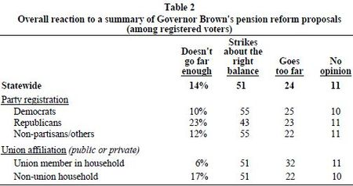
Source: California Field Poll, August 2012.

Figure 3 States Making Changes to State or Local Pension Plans in Wake of the Financial Crisis
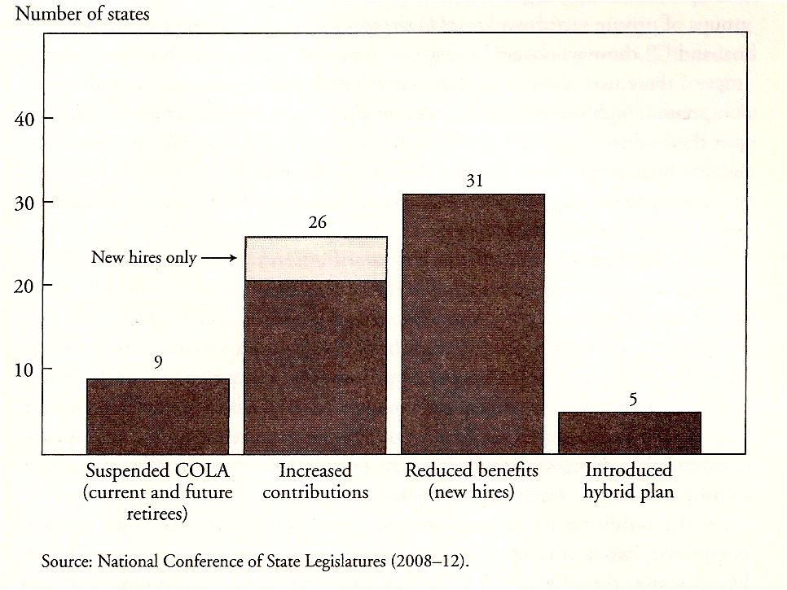
Figure 4 Employer and Employee Pension Costs by Sector 2010
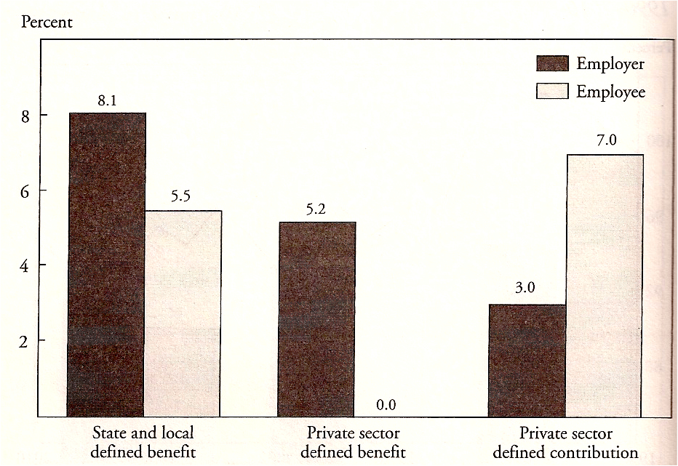

Source: Public Plans Database (2010); Towers Watson (2009); and Vanguard Group (2011).
a. The costs for defined benefits plans represent the normal costs. In the public sector, the costs for those covered by Social Security averaged 8.5 percent (employer) and 4.7 percent (employee), while the costs for those without Social Security averaged 6.9 percent (employer) and 7.6 percent (employee).
Pension Reform Plan by Governor Brown Passed by the Legislature 2012
There is no doubt that we are going to have to adjust our pensions so that money coming in is going to be equal to what we can expect what the money going out will be. It’s not even a matter of high math. It’s fifth-grade arithmetic.¹

¹California Governor Jerry Brown, Oct. 13, 2011 in Bloomberg, “California Pension Changes to Require Voter Approval, Brown says,” http://www.businessweek.com/news/2011-10-13/California, October 14, 201

The 2012 pension plan from Governor Jerry Brown and from California Pension Reform (CPR) legislation, involves a twelve-point plan to “provide a fair but sustainable income security plan.” The plan is that the reform applies to all new state, local, school, and other public employees and to current employees as permitted by law. The twelve points can be grouped into three broad areas:
• Benefit reductions
• Contribution increases
• Governance.
The Governor Brown’s proposal provided only modest cost savings because the proposed ban on pension holidays, as is a prohibition on retroactive pension increases was good but unlikely considering the financial status of public pension systems and thus they do not reduce existing or future liabilities. Moreover, the addition of only two “independent” members to the current 13-member board is unlikely to have any appreciable effect. Two measures, the mandatory use of three-year average salaries to determine retirement payments and the limitation of that salary to an employee’s base rate (i.e., base salary without add-ons, such a uniform allowance, K-9 duty, etc.) does provide a greater reduction in future pension costs.
In addition to pension costs, CalPERS responded to health insurance costs by hiking insurance premiums by 9.5 percent in 2012. As Kasler of the Sacramento Bee noted that governing board unanimously approved in June 2012 an increase that will cost the average CalPERS member another $30 a month in premiums beginning in January 2013 for 1.3 million public workers and retirees. This was the largest increase in years because of the persistent under-funding of Medicare and Medical. Health care providers continue to shift costs to large pensions like CalPERS. Many cities and counties budgeted only for a 5 percent increase and questions continue over how the Affordable Care Act will be implemented beginning in 2014. ¹⁴
Insurers respond by saying they are passing along the impact of higher hospital bills, doctors’ fees and pharmaceutical prices. What angers many recipients are that no negotiations for the lowest prices for pharmaceuticals are permitted under federal law passed by Congress. Medical providers have not put a lid on expenses because of hospital labor costs, state-mandated seismic retrofits and underpayments to the entitlement programs like Medicare. The Center for Studying Health System Change reports health care costs will continue to go up six to seven percent a year. Also CalPERS has an older member base that drives up usage of health services. However, the California Insurance Commissioner David Jones was successful in forcing Anthem Blue Cross to reduce its most recent rate increases from 17.93 percent to 13.87 percent that saves 630,000 policyholders some $54 million annually in premiums they would otherwise have paid. The insurance commissioner does not have the authority to reject excessive rate increases by health insurers or HMOs. Yet the commissioner can reject excessive rate hikes for auto and homeowners insurance but not health insurance or managed care. (The commissioner was able to cut 12.6 percent rate decrease for over one million State Farm Home Insurance customers to have $150 million a year.) The commissioner has qualified to take the issue to the voters in a ballot measure in 2014 called the Insurance Rate Public Justification and Accountability Act.”
On August 29, 2012 Governor Brown and Democrats reach an agreement on a controversial public pension plan. J. Ortiz of the Sacramento Bee reported that a long-awaited deal was reached that “for the first time would set statewide public pension formulas for new hires in both and many local government jobs.”¹⁵ The plan requires high contributions from existing employees and imposes pension caps and rises the retirement age for new workers. While the agreement was short of what the governor wanted in cutting billions of dollars in unfunded obligations on governments’ books. But the governor acknowledged the plan represents a “significant step forward” to “help ensure our public retirement system is sustainable for the long term.” The states public pensions governed by a patchwork of contractual agreements and retirement-system rule would be brought under one system of pension standards.
The largest cost savings in Assembly Bill 340 came from reducing pension formulas for employees hired after January 1, 2013. Those employees would wait an additional two years or more to earn maximum benefits. Further, the plan caps the amount of their salaries that can be figured for pension purposes at $110,000 for workers who participate in Social Security and 130,000 for those who didn’t, such as teachers and public safety employees. “The cap wouldn’t touch the 95 percent of future employees who make lass than the cap,” said Dan Pellissier, a former state employee who has led tow failed attempts to put a pension overhaul measure on the ballot. Existing employees hired before 2013 would not be affected by the changes and relatively few workers earn over 100,000 a year. Local cities with their own pension plans are not covered including San Diego, Los Angeles, and San Francisco. ¹⁶
The AB 340 bill creates a hybrid pension system for new hires that combine a smaller guaranteed retirement payout with a variable saving plan similar to a 401(K). The objective is to assure each employee receives up to 75 percent of their wage as calculated for retirement purposes. The new pension plan does affect both current and future workers requires employees and employers split the “normal” cost of pension evenly. Normal costs do not include a retirement system’s unfunded liabilities or at least not yet. A majority of state employees currently contribute half of their normal pension cost, most local and state public safety workers such as police and firefighters do not. The unfunded obligations still lurk and threaten future government budgets. If is unlikely that any government can impose higher contributions on existing employees without collective bargaining or experience law suits for not negotiating. Some unions will save their money for attorneys rather than campaigns. Union leaders during the legislative actions challenged the governor for not being at the bargaining table but rather unilaterally mandating what they intended to do to respond to political pressures. Unions argue that losses were more of the 2008 recession from Wall Street and from employee pension needs. As expected not all were supportive of AB 340 such as labor unions that argued it would give lower benefits at higher costs to future employees. CalPERS feared the hybrid might not sufficiently cut costs for the state or local agencies. Also from the labor perspective, the pension reform rollbacks are part of a series of attacks on collective bargaining, union political fundraising, wage increase and benefits for employees.
Another issue was the status of retired annuitants. Table 3 shows the departments the state and the number of employees returning to work after the they retire. The state has used retired annuitants for years with many workers factoring that into their retirement plans. The new law would cut off thousands of retirees who return to work for the state. The idea targets all but the most essential of the state's so-called "retired annuitants," a group of about 5,800 workers who drew $110 million in pay from the state in 2012 on top of their pensions. The Democratic
governor's proposal won taxpayer support by appearing to crack down on double dipping. It also appealed to public employee unions that wanted to eliminate jobs they believe stunt the growth of the regular workforce. Retired annuitants are a small piece of the state payroll – just 7 cents of every $10 paid to workers during calendar 2011 went to returning retirees, who can work up to 960 hours during a fiscal year without affecting their pension checks. The figures don't include
employees of the state's university systems or the Legislature. Relatively few state retirees in California received large paychecks. In 2012, 14 state workers earned

TABLE 3
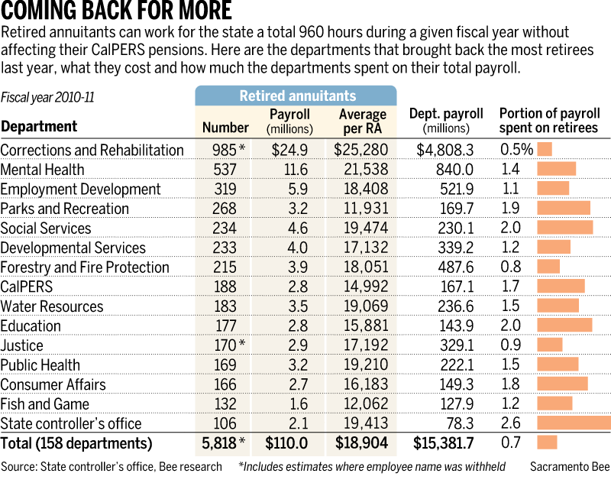
more than $100,000 and most were doctors while another 260 earned more than $50,000 consisting of a mix of administrators, consultants and medical professionals. Most state retirees earned far less, with the average annual wage running about $19,000. Further, retirees don't have job guarantees, so they can be let go without an employer navigating the labyrinth of civil service protections and labor contract rules that govern the layoff process for regular state employees.¹⁷
SUMMARY HIGHLIGHTS OF AB 340: PUBLIC EMPLOYEE PENSION REFORM ACT TABLE 4 Defined Benefit Retirement Formulas of 2012
Retirement Plans | Hired prior to 1-15-11 | Hired on or after 1-15-11 | Hired on or after 1-1-13
State Misc. Tier 1  (all eligible employees except public safety) | 2% at 55 (one year highest compensation) | 2% at 60 (36 month average compensation) | 2% at 62 (consecutive 36 month subject to cap)
Public Safety
Retirement Plans | Hired prior to 1-15-11 | Hired on or after 1-15-11 | Hired on or after 1-1-13
PO/FF (MPP Public Safety) | 3% at 50 (one year highest compensation) | 2.5% at 55 (36 month average compensation) | 2.5% at 57 (consecutive 36 month subject to cap)
State Safety (limited to Intermittent Peace Officer) | 2.5% at 55 (one year of highest compensation | 2% at 55 (36 month average compensation | 2% at 57 (consecutive 36 month subject to cap)
 | Hired prior to 7-1-11 | Hired on or after 7-1-11 | Hired on or after 1-1-13
PO/FF (Unit 8) | 3% @ 50 (one year highest compensation) | 2.5% at 55 (36 month average compensation) | 2.5% at 57 (consecutive 36 month subject to cap)
Employees who became members of CalPERS on or after July 1, 1996 are subject to the IRC 401(a)(17) limit, which restricts the amount of compensation that can be used to calculate the CalPERS retirement benefit. For 2012, the limit is $250,000.

At the Center for Retirement Research at Boston College, a report was published entitled “The Funding of State and Local Pensions: 2011-2015 noted the future funding of pensions depends to a great extent on the performance of the stock market. The study notes an optimistic performance will result in a growth of 8 percent per year (assuming 3 percent inflation and 5 percent actual growth). This scenario would assume stock prices rise at an annual rate of 16 percent. An average market performance would reflect an output of 5 percent per year (2 percent for inflation and 3 percent real growth). This expects the stock prices to increase 8 percent a year. Low stock market performance assumes an average of 3 percent per ear (2 percent for inflation and one percent actual growth). Stock prices would be no higher at the end of the three-year period than they started. PERS in 2012 return on investment was only one percent. ¹⁸

Legal Constraints on Changes in State and Local Pensions

As a result of the economic recession of 2008, policymakers have reacted by raising employee contributions or reducing benefits for new workers. One option that has not been used is reducing future benefits for current workers because states face legal constraints on their ability to make such changes. These constraints not only tie the hands of pension reformers but also accord public employees greater protections than their private sector counterparts. In a report by Alicia Munnell and Laura Quinby, federal laws regulating pensions do not apply to public pension changes because states are to determine their own benefit protections. Most states protect pensions under a contract-based method using the U.S. Constitution’s Contract Clause and similar provisions in the state constitution to stop any law that impairs existing public pension contract. ¹⁹ The report further states:
The Federal Constitution’s Contract Clause and similar provisions in state constitutions prohibit a state from passing any law that impairs existing public or private contracts. To determine whether a state action is unconstitutional under the Contract Clause, the courts apply a three-part test. First, they determine whether a contract exists. This process determines when the contract is formed and what it protects. Second, the courts determine whether the state action constitutes a substantial impairment to the contract. Third, if the impairment is substantial, then the court must determine whether the action is justified by an important public purpose and if the action taken in the public interest is reasonable and necessary. This approach sets a high bar for changing future benefits, presenting a serious obstacle to pension reform.
- A handful of states that protect pensions under the contract theory also have state constitutional provisions that expressly prevent the state from reducing benefits that participants expected at the time of employment. Illinois and New York have such a provision. Alaska has language that specifically applies only to accrued benefits, but the courts have interpreted the provision to protect all benefits from the time participants enroll. Arizona’s language is less clear, but prior court rulings suggest that the protection extends to future as well as accrued benefits. In these states, changing benefits for existing employees is virtually impossible without amending the state constitution. In contrast, Hawaii, Louisiana, and Michigan have constitutional provisions that have been interpreted as protecting only benefits earned to date.
- Most states, like California, protect core benefits under the contract theory do not have a state constitutional provision, but rather have statutes that expressly adopt the contract theory or judicial decisions that have ruled the relationship to be contractual. Interestingly, for 13 states the protections apply only once benefits are vested. Eight states protect benefits only once the employee is eligible for retirement. While New Jersey and Rhode Island have been classified as states where future benefits may be protected, they have changed future core benefits for current employees and have court cases pending regarding these changes.
- California and several other states that fall in the contract group have attempted to introduce some flexibility by expanding the interpretation of the third part of the three-part test for Contract Clause constitutionality – that the change be “reasonable and necessary.” Under the expanded test, the change could be reasonable and necessary either if it achieves an important public purpose – the conventional test – or if the disadvantages are accompanied by new advantages. In the end, however, the ability to modify pensions in these states hinges on when the contract is deemed to exist. States where the contract is found to exist at the time a worker is hired have little freedom to change benefits. States where the contract is found to exist at retirement have considerably more flexibility.20

Six states have adopted a property-based approach for protecting pensions. To the extent that pension benefits are considered property, they cannot be taken away without due process according to the Fifth and Fourteenth Amendments to the Constitution. Most of the challenges to state action have not been successful. Courts have generally found amendments to public pension plans to be “an adjustment to the benefits and burdens of economic life” rather than the taking of private property without just compensation.²¹ Thus, state officials have much more freedom to adjust pensions in states that have taken the property-based approach to pension rights.
For the vast majority of states, however, changing future benefits for current employees is extremely difficult. The exception, as noted above, appears to be the COLA. In four cases – Colorado, Minnesota, New Jersey, and South Dakota – a modification of the COLA was challenged in court, and the court upheld the change. The early decisions in Colorado and Minnesota laid out the rationale for allowing COLA suspensions.²² In Colorado, where the decision is currently under appeal, the judge found that the plaintiffs had no vested contract right to a specific COLA amount for life without change and that the plaintiffs could have no reasonable expectation to a specific COLA given that the General Assembly changed the COLA formula numerous times over the past 40 years. In Minnesota, the judge ruled both that the COLA was not a core benefit and that the COLA modification was necessary to prevent the long-term fiscal deterioration of the pension plan. Both these decisions clearly imply that core benefits are protected.

Expanding the Flexibility to Change Pension Benefits

The protection of future accruals of core benefits serves to lock in any benefit expansions, limiting policymakers’ ability to respond to changing economic conditions. For example, employees covered by CalPERS will continue to earn full benefits at age 55, an age introduced in a benefit expansion during the days of the 1990s. Current workers accepted public employment with the understanding that they were accruing pension benefits at a certain rate, and remained employed with that understanding. But future benefits, much like future payroll, should be allowed to vary based on economic conditions. That is, public officials should be able to change future benefits for current CalPERS workers. No doubt any such action would result in litigation, labor union objections and employee protests and threat to defeat those elected officials in future elections.
Yet the argument is made that increased flexibility for public employers would accord their employees the same protections as workers in the private sector. The Employee Retirement Income Security Act of 1974 (ERISA), which governs private pensions, protects accrued benefits but allows employers to change the terms going forward.²³
In Illinois and New York, such a change would require a constitutional amendment. In other states, the challenge is to narrow the definition of the contract. Here the burden would fall on the legislature and the courts. First, enacting legislation that the contract is created when the employee performs the service, would establish an ERISA-type standard.²⁴ Second, if this legislation is challenged, the courts would then need to be persuaded to adopt a more flexible standard in light of changed conditions, just as they once abandoned the gratuity theory in favor of a contract-based approach. In fact, adopting a more flexible version of the contract approach would be less dramatic than shifting theories.
As noted above, New Jersey and Rhode Island have taken the first step by passing legislation that reduces core benefits for current workers. But the courts have yet to rule on the legality of these changes. A failure to permit such changes, however, would have serious consequences. First, limiting pension reductions to new workers reduces pension costs only slowly over time. Second, exempting current workers from cuts creates a two-tiered compensation system under which workers doing similar jobs would receive different amounts based solely on when they were hired. Such an outcome could undermine morale among employees and raise challenges for managers. Finally, allowing public employees to enjoy greater protections than their private sector counter parts is perceived as unfair but unlikely to change because public employees have a “property right to their jobs while private sectors workers can be laid off at any time to meet the cost cutting efforts of corporations or to help improve profits to satisfy traders on Wall Street.
As of this writing reports from Alicia Munnell and Laura Quinby correctly note that “policymakers grappling with underfunding in state and local pension plans are constrained in their ability to fairly share the burdens of reform, with sacrifices falling much more heavily on new workers than on current workers. Changing the status quo will likely require both legislative action and legal argument. In many states, a key challenge is narrowing the current definition of the employer-employee contract to establish that the contract is created when the employee performs the service. Such a standard would be much clearer than the morass of provisions that currently exists across the states, would enable state officials to undertake needed reforms, and would put public sector workers on an even footing with those in the private sector.” ²⁵
These researchers argue that establishing an ERISA-type standard that needs to happen on a state-by-state basis could and should be achievable because the protection accorded pension benefits is less embedded in state constitutions and more open to interpretation than commonly perceived. At a minimum, when sponsors institute changes for new employees, they should adopt the ERISA approach to cover these employees going forward.

Pension Fund Investment Risks

In 2012 Governing Magazine described a pension study by three academics as “potentially the most important research in the public pension arena this decade,” which would attract the interest of most readers. The authors conclude that in the past two decades, U.S. public funds uniquely increased their allocation to riskier investment strategies in order to maintain high discount rates and present lower liabilities. The study basically found that in comparison to private plans or Canadian and European plans; U.S. public pensions are far more likely to make imprudent and aggressive investments, thereby cultivating a high-risk portfolio strategy. The study noted that as the proportion of retired members increased more, pension plans in the U.S. allocated higher percentages of their portfolios to risky assets.²⁶
Governing Magazine notes that “The researchers posit that this behavior results from American Governmental Accounting Standards Board (GASB) policies that allow state and local pension plans to discount liabilities using the expected rate of future investment returns. This is unlike private plans and their peers in other countries which cannot use imaginary numbers, especially when they are underfunded.”²⁷
One of the study’s key points states that “In line with economic theory, all other groups of pension funds reduced their allocation to risky assets as they mature, and lowered discount rates as riskless interest rates declined. The arguably camouflaging and risky behavior of U.S. public pension plans seems driven by the conflict of interest between current and future stakeholders, and could result in significant costs to future workers and taxpayers.”²⁸
The importance of the Pension Discount Rate
In 2012 the Governmental Accounting Standards Board issued its revision of accounting standards for public pension systems that relate to what is called the “discount rate,” or in effect a pension system’s estimate of future annual earning on trust funds. California's pension systems, like those of other states, have adopted discount rates well in excess of 7 percent, nearly twice as much as typical corporate pension systems, which are required to use super-safe projections.
These expectations have the effect of minimizing the systems' unfunded liabilities and thus reducing pressures to reform benefits or raise contributions. The difference is huge. A Stanford University study has estimated that were California's four big state pension systems to use a 4 percent discount rate, they'd be nearly a half-trillion dollars underfunded.
The new GASB standards, years in the making, don't go that far, but they do require unfunded liabilities to be carried on state balance sheets and, under some conditions, require super-safe municipal bond rates to be displayed. Pension funds would still be free to make whatever earnings assumptions they wish, but the risk of high discount rates would be more easily seen, and that could increase pressure on politicians to reform. ²⁹ The Pew and GASB reports provide new context for the pension debate. Another bit of data will be added to the yeasty mixture this week: the California Public Employees' Retirement System will probably end the fiscal year on Saturday with a net loss in trust fund value, even weaker than the previous year's paltry 1.1 percent gain.

^{TABLE 5}

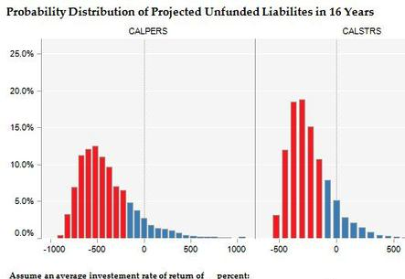

Further the Stanford report noted that CalPERS and CalSTRS (even at 7.75% discount rate) are below 80 percent funded status. CalPERS must earn an average of 9 percent for the next 16 years to remain at the 80 percent of liabilities. The combined unfunded liability is more than three states General Fund budgets. The reported noted: “Assuming a 6.2 percent discount rate and other demographic changes, current state spending on pensions is likely to increase form $4.8 billion in 2011-2012 to $14,6 billion, or the equivalent of 17.3 percent of current General Fund expenditures.”³⁰ CalPERS responded to the report saying the report’s findings were based on low discount rates that magnified unfunded liabilities and “CalPERS invests in a highly diversified portfolio that includes stocks, real estate, and other assets that have historically earned significantly higher return than the rates assumed in the study.

Non-Pension Health Care Costs: Another Cost Competing with Traditional Pension Benefits
Generally cites have another challenge with health care costs. Local governments are Common Sense (CACS) in a report on the impact of rising non-pension retiree benefit costs on city budgets and analyzes how well prepared the state’s 20 largest cities are when it comes to paying for these rising costs. In short, not enough cities are setting aside sufficient funds to meet promised future payments and it is estimated that in 20 years cities are going to be hit hard by these looming costs. Consider the fact that for the state’s 20 largest cities (by budget), $16 billion has already been promised in non-pension benefits to current and future retirees, and $12 billion of that remains unfunded. These new financial pressures are likely to put pressure on future benefits of state and local pension systems. A summary of the August 2012 report by Adam Tatum states:³¹

9 pre-funding cities. Los Angeles, San Jose, San Diego, Anaheim, Roseville, Palo Alto, Bakersfield, Burbank, and Santa Clara all pre-fund their future retiree health care benefits to some extent. Los Angeles has set aside the largest portion (59%) of what it has promised retirees, followed by Anaheim, which has set aside (30%) of what it has promised.
11 pay-as-you-go cities. San Francisco, Oakland, Sacramento, Redding, Santa Ana, Long Beach, Glendale, Fresno, Riverside, Pasadena, and Santa Monica have no funds set aside to pay for future retiree health care. If those 11 cities start paying their OPEB contributions as determined by CalPERS and continue to do so annually, they will collectively save an unprepared to handle growth retiree health costs as noted by California
estimated $2.2 billion in payments for benefits earned before 2011.
Benefit costs on the rise. Average benefit costs among these cities have increased an average of 36% between 2008 and 2011. This figure hides substantial variation: while some cities have seen moderate growth over the period of less than 20% (Sacramento, Pasadena), others have seen their benefit costs jump more than 50% in three years (San Jose, Bakersfield).
Options for restructuring their funding policy include committing to either fully or partially paying required contributions to pre-fund the benefit plans. Options for restructuring benefit plans include restricting eligibility for full benefits based on time worked, lowering maximum premiums covered, transitioning from defined benefit to defined contribution plans, and introducing cost sharing plans with active employees. But even as they consider changes to their benefit plans, pre-funding still offers them the opportunity to both reduce their future out-of-pocket costs and secure funding for their current and future retirees’ health benefits.³²

Thus, twenty of California largest cities based on the size of their budget , as of this writing have promised more than $16 billion in non-pension benefits to their current ad future retirees, and $12 billion of that is unfunded. These non-pension benefits or Other Post-Employment Benefits (OPEBs), consist of retiree health care and elected officials must take this cost into account in total local government liabilities to future retirees. The Sacramento Bee reported in February 2013 that California state annual Medicare spending toped $100 million but the payroll tax covers only 36 percent of the Medicare costs and beneficiaries pay 12 percent. Even with federal government help to pay for Medicaid for the poor, the state general fund paid out 16 billion.

Summary and Conclusions

This paper shows the options and solutions open to the California state government handling the unfunded liability of pensions are limited and plans must be paid to increase employee contributions and a two-tiered system and limit COLA increases in the future. The non-pension health care cost will compete with pension benefits and local governments do not have the tax base to serve both fully. The legislators are unlikely to challenge retirement plans that are under labor contracts and employees are unwilling to have benefits cut or changed unless it is done by ballot measures. It will be the public employees versus the voting tax paying public.
The general supposition presented in this paper shows that pensions will continue to be forced into a two-tiered system where new employees will receive less and be subject to paying more for their retirement. Further, more public pensions will be moved from a defined benefit system to a defined contribution (401k) system while will not have the return on investment as the large pension systems because of economies of scale. Current defined benefits are continue to be preferred because they guarantee payment be made to the retired person for the remainder of their lives including provisions for costs-of-living (COLA) adjustments. It appears the COLAs are in jeopardy to be reduced or ended in exchange for health benefits or no benefits because local governments to not have the revenues to cover future costs.
Voters will continue to use at an increasing rate local ballot measures to place new limits on pensions in cities such as San Diego and San Jose. Public opinion polls will continue to show voters are angry over the level of benefits they believe to be excessive when compared to private sector plans. Yet as indicated, the 401 (k) plans cannot generate the rate of return on investments possible with the far larger state public pension plans. As noted in this paper, to be viable, pensions should maintain 80 percent of what they are obligated to have in the trust fund to cover all future retiree needs.
The major question on how pensions be changed to make them viable in the public sector and without the threat of financial collapse, is largely answered with the passage of Assembly Bill 340 as summarized in Table 4 of this paper. Finally, pension trust funds must stay clear of questionable investments such as Mortgaged Backed Securities floated in the U.S. Stock Market and are subject to rapid decline with economic crisis.

Endnotes and References

¹Alicia H. Munnell, State and Local Pensions: What Now?, The Brookings Institution, 2012. “Although press accounts link Vallejo’s bankruptcy with pension costs (see Greenhut 2010; Scheer 2008; and Weber 2011), one reviewer of an earlier draft of this book disagrees. He contends that even though CalPERS was the city’s largest single creditor, the cost of servicing the city’s required pension contribution was not a major factor in its bankruptcy. Rather the bankruptcy was the result of a collapse of the city’s revenue base. This story sounds quite similar to that for Stockton, California, which filed for bankruptcy in June 2012. Stockton’s financial problems stemmed more from extensive borrowing and the collapse of its real estate market than from pension pressures.

² Munnell, p. 1. (Author served as a member of the Massachusetts Retirement Law Commission) Munnell notes that not all pension plans are in trouble but all plans “face three challenges ahead: an excessive concentration of plan assets in equities,; the risk that steep benefit cuts for new hires will harm workforce quality; and the constraints plans face in adjusting future benefits for current employees.” She is the Peter F. Drucker Professor of Management Science, Carroll School of Management, and director of the Center for Retirement Research at Boston College. She has served as assistant secretary of the Treasury for economic policy and member of the President’s Council of Economic Advisers. Also authored with Brookings titles Working Longer: The Solution to the Retirement Income Challenge, with Steven Sass (200) and Coming Up Short: The Challenge of 401(k) Plans, with Annika Sunden (2004).

³ California County News.org, “LAO Raises Concerns in Analysis of Initiative Proposals Reforming Pensions; Legal Questions?” January 3, 2013. (http://www.californiacountynews.org ) Also reported in the Sacramento Bee, February 14, 2013 under Pensions.

⁴ California Pension Reform, Stanford Institute for Economic Policy Research, November 2011. (siepr.stanford.edu) (http://www.californiapensionrefrom/media ) Includes the Government Employee Pension Reform Act of 2012. Also see Pension Math: How California’s Retirement Spending is Squeezing The State Budget, Joe Nation, Stanford Institute for Economic Policy Research, December 13, 2011.

5. CalPERS released in 2012 the following figures for asset class performance gains: Public Equity -7.2% Private Equity -5.4% Fixed Income 12.7% Real Estate 15.9% Forestland -11.0% Infrastructure 8.4% Liquidity 4.6% Inflation Assets 0.1% Absolute Return Assets -2.0% in CalPERS 2011-2012 annual report. Also see More Pension Math: Funded Status, Benefits, and Spending Trends for California’s Largest Independent Public Employee Pension Systems by Evan Storms and Joe Nation, Stanford Institute for Economic Policy Research, February 21, 2012.

6. CalPERS, CalSTRS, and UCRP Current Funding Status, Joe Nation, Ph.D., Stanford Institute for Economic Policy Research (SIEPR), December 2011, pp. 3-6 and 17-18.

7. LAO Raises Concerns in Analysis of Initiative Proposals Reforming Pensions; Legal Questions? By J. Brown in California County News: Pensions, January 3, 2012 (see http://califonriacitynews.typepad.com/california_county_news/ …

8. “Pension Math: How California’s Retirement Sending is Squeezing The State Budget.” Joe Nation, Stanford Institute for Economic Policy Research, December 13, 2011, see executive summary p. vii and pp. 17-18. Also see “More Pension Math: Funded Status, Benefits, and Spending Trends for California’s Largest Independent Public Employee Pension Systems,” Evan Storms and Joe Nation, Stanford Institute for Economic Policy Research, February 21, 2012.
Also see “Shrinking Services: Public Pension Costs and Their Impacts on San Jose, Joe Nation, Stanford Institute for Economic Policy Research, December 14, 2011.

9. Ibid, “More Pension Math: Funded Status, Benefits, and Spending Trends for California’s Largest Independent Public Employee Pension Systems,” Evan Storms and Joe Nation Stanford Institute for Economic Policy Research, 25.

10. Ibid, “More Pension Math: Funded Status, Benefits, and Spending Trends for California’s Largest Independent Public Employee Pension Systems,” Evan Storms and Joe Nation Stanford Institute for Economic Policy Research, 28.

11. “Shrinking Services: Public Pension Costs and Their Impacts on San Jose, Joe Nation, Stanford Institute for Economic Policy Research, December 14, 2011, 1-2

12. “Shrinking Services: Public Pension Costs and Their Impacts on San Jose, Joe Nation, Stanford Institute for Economic Policy Research, December 14, 2011, 20.

13. 2012 Field Poll (Survey Shows Voters Think Local Government Pensions Are to “Generous” and They Support Governor Brown’s Plan), September, 2012.

14. Sacramento Bee, the Kasler Report, 2012

15. Sacramento Bee, J. Ortiz, August 29, 2012. (jortiz@sacbee.com)

16. Sacramento Bee, Dan Pellissier, September 2012.

17. Center for Retirement Research at Boston College, “The Funding of State and Local Pensions: 2011-2015” August 2012.

18. “Legal Constraints on Changes in State and Local Pensions,” in State and Local Pensions: What Now?, Alicia H. Munnell and Laura Quinby, Brookings Institution Press, Washington D.C.,pp.218-223.

19. ibid, “Legal Constraints on Changes in State and Local Pensions,” in State and Local Pensions: What Now?, Alicia H. Munnell and Laura Quinby, Brookings Institution Press, Washington D.C.,pp.226-230.

20. Kelly A. Trainer and Katy A. Suttorp “SB 1021: More Changes Required for Retired Annuitant Contracts” Sacramento Bee, August 10, 2012 Historically, many CalPERS contracting agencies were able to provide for a smooth transition after departures of upper managers by contracting with retired annuitants under Government Code section 21221(h). Section 21221(h) had previously provided for the appointment of a retired annuitant for a limited duration to a position that required specialized skills or during an emergency to prevent stoppage of public business. However, earlier this year, AB 1028 took effect, amending section 21221(h) expressing limiting its use to the interim appointment of a retired annuitant while recruitment for a permanent appointee was conducted to a position that required specialized skills or during an emergency to prevent stoppage of public business. In addition, AB 1028 made clear that the compensation received by the retired annuitant could not exceed the "maximum published pay schedule for the vacant position." Further, AB 1028 provided that the contracting agency "shall appoint a retired person only once under" section 21221(h). Finally, while section 21221(h) had always had a 12-month limitation on appointments, AB 1028 further provided that the interim appointment could not continue under Government Code section 21224 or 21229.

Complicating matters further, on June 27, 2012, Governor Brown enacted SB 1021 entitled "Public Safety" taking effect immediately by its terms. Buried in legislation dealing with a variety of administrative matters such as establishing a $20 fee for attorneys wishing to appear by telephone in civil litigation, are significant changes to section 21221(h). Importantly, SB 1021 imposes three major changes on the content of contracts entered into with retired annuitants hired under section 21221(h). First, the salary of the retired annuitant is now subject to a codified formula. Specifically, section 21221(h) provides that the salary "shall not exceed the maximum monthly base salary paid to other employees performing comparable duties as listed on a published pay schedule for the vacant position divided by 173.333 to equal an hourly rate.[1]

Second, the law now provides that a retired annuitant appointed pursuant to section 21221(h) "shall not receive any benefits, incentives, compensation in lieu of benefits, or any other forms of compensation in addition to the hourly rate.[2] CalPERS has yet to provide any additional guidance on the meaning of this provision, although CalPERS recently contacted some employers to advise of the passage of SB 1021 and of CalPERS' intent to issue a circular letter on the matter in the coming months. However, the plain language of the section states that a retired annuitant cannot receive any benefits, which would include many benefits that are commonly found in interim employment contracts, such as paid sick leave, cellular phone stipends, and automobile allowances.

Finally, where section 21221(h) had previously permitted the governing body of an agency employing a retired annuitant to obtain approval of an extension of temporary employment beyond 960 hours in a fiscal year from CalPERS, SB 1021 has removed that possibility. Section 21221(h), now provides that a retired annuitant appointed under section 21221(h) shall not work more than a combined total of 960 hours in any fiscal year, regardless of whether he or she works for more than one agency.[3]

Agencies that do not currently employ any retired annuitants under section 21221(h), these changes will need to be reflected in any future contracts. A number of agencies have contracts currently in effect that are now in conflict with section 21221(h) - particularly the provisions regarding salary determination and fringe benefits. Neither the language of the bill nor the committee analysis provides any guidance as to the applicability of SB 1021 or its consequences for a contract currently in place. Notably, the bill does not expressly provide for any grandfathering of preexisting contracts or for a reasonable time period to come into compliance with the new legislation. The consequences of violating section 21221(h) involve at minimum, loss or interruption of retirement benefits, and at worst, reinstatement of the retired annuitant to the CalPERS system, which carries a cost to both the retired annuitant and to the employing agency. Agencies must immediately review their contracts with retired annuitants to determine if there are provisions that may now place the status of the retired annuitant in jeopardy and consult experienced legal counsel.

[1] Public employers should be aware that SB 1021 also revised section 21224, which applies to the employment of a retired annuitant either during an emergency to prevent stoppage of public business or because the retired person has specialized skills needed in performing work of a limited duration. Retired annuitants employed under section 21224 are also subject to the same salary formula as those employed under section 21221(h).
[2] This prohibition was also added to section 21224.
[3] This hour’s limitation was also added to section 21224.

21.Ibid, Mnnell, p. 193.

22.Ibid, Munnell, p. 197.

23.Ibid, Munnell, p. 208.

24.Ibid, Munnell, pp. 75-80.

25.Ibid, Munnell. P.80

26.Governing, Public Pensions Portfolios Double Down, Girard Miller, June 14, 2012, see http://www.governing.com/columns/public-money/col-public-pension-portfolios-double-down.html

27. Governing Ibid.

28. Governing, Ibid.

29. See comments by Dan Walters, “New rules will reflect a more pessimistic pension risk for California,” Sacramento Bee, Tuesday, Jun. 26, 2012 dwalters@sacbee.com
30. “Pension Math: How California’s Retirement Sending is Squeezing The State Budget.” Joe Nation, Stanford Institute for Economic Policy Research, December 13, 2011

31. California Common Sense For the full report here. By Adam Tatum on Aug 2, 2012
California Common Sense 5050 El Camino Real, Suite 2010, Los Altos, CA, 94022. www.cacs.org

32.Ibid. Also see “Public Employee Pension Reform,” John Shoven, Stanford Institute for Economic Policy Research, February 9, 2012 and “Series vs. Parallel Retirement Income Strategies,” John Shove, Stanford Institute for Economic Policy Research, November 1, 2012.

