Engaging Introduction to American Politics
Students with a Town Hall Meeting Course Redesign

Scott Spitzer, California State University, Fullerton
sspitzer@fullerton.edu

Karalee Etheridge, California State University, Fullerton
ketheridge@fullerton.edu

Prepared for the Western Political Science Association Annual Meeting, 2015
Las Vegas, Nevada

Introduction
In 2012, the White House held a national conference on “Civic Learning and Engagement for Democracy’s Future,” organized by the Department of Education, the American Association of Colleges and Universities (AAC&U) and the Global Perspectives Institute, Inc. The conference focused on two reports: The Crucible Moment: College Learning and Democracy’s Future, which lays out a framework for civics education through the university level, and Advancing Civic Learning and Engagement in Democracy, which identifies a plan for the Department of Education’s involvement in making civic education a national priority (Kanter and Schneider 2013). This renewed attention for an old idea – civic education – is in part an effort to counter the slow post-war decline in social capital and civic engagement (Putnam 2000; Skocpol 2003). It also responds to declining levels of voter participation and civic knowledge more generally (National Task Force on Civic Learning and Democratic Engagement 2012). In the last decade, a number of organizations have embraced civic education approaches of varying types: Campus Compact, a consortium of more than a thousand universities and colleges; the American Democracy Project (ADP); the AAC&U’s Core Commitments program; and the American Association of State Colleges and Universities’ Civic Indicators Project are just a few of the more prominent ones (Flanagan and Levine 2010, pp. 169-70).
Political science has been at the forefront of the development of higher education programs focused on civic engagement. In 2013, The American Political Science Association (APSA) published Teaching Civic Engagement: From Student to Active Citizen, an edited volume gathering the work of 27 political scientists exploring a broad array of approaches for connecting students to public affairs in meaningful ways that leave lasting impressions. This was only the most recent culmination of a two-decade focus of the APSA on civic engagement, launched by the APSA’s President Elinor Ostrom in 1996. In her presidential address that year, Ostrom launched a new APSA Task Force on Civic Education for the 21st Century (Task Force 1997). Since then there has been an explosion of activity in creating new ways to engage students in public affairs, through innovations in service learning and other pedagogies incorporated in political science courses and in broader campus initiatives (McCartney, Bennion and Simpson 2013, Preface). Despite the variety of approaches, a unifying theme is that political science as a discipline should take a leadership role in shaping new efforts to engage students in public affairs.
We argue that the introductory course in American Politics presents an exciting vehicle for this work. What could be more central to the mission of renewing attention to civic engagement in higher education than the involvement of political science faculty teaching introductory courses in American politics to millions of young people every year? At California State University, Fullerton (CSUF), several political science faculty teaching introductory American Government courses have incorporated a Town Hall Meeting (THM) program as a conscious effort to make civic engagement a priority in their political science instruction. This paper reviews the progress of this project, analyzing a survey of students enrolled in the program and of other students in Introduction to American Politics courses without the THM program. It also employs institutional research data on these students’ demographic profile and academic performance. The findings show that incorporating a fully-developed civic education component into the Introduction to American Politics course had significant positive effects on academic performance, and less potent but still significant impacts on political motivation, political efficacy, and interest in continued civic engagement. Beginning with a brief discussion of higher education civic engagement efforts more generally, the paper then introduces the CSUF Town Hall meeting program as one way to address some of the concerns raised by education reformers concerned about declining civic engagement. It reviews the CSUF THM program and discusses its implementation in the academic year 2013-14. Results from the survey are then analyzed and comparisons are made with students in courses without the THM. Finally, suggestions for further research and for ways to improve upon the THM program are discussed.

Political Engagement and Education
Political science as a discipline has long recognized that the ideal of democratic citizenship is not often realized in the United States. As Anthony Downs identified with parsimony in 1957, a democracy requires an informed electorate capable of identifying their own preferences, noting the differences in the positions of electorally competing candidates and parties, and performing a rational analysis of how to pursue their own interests in light of these analyses (Downs 1957). With the publication in 1960 of The American Voter, the discipline was confronted with a portrait of the electorate that was predominantly under-informed, lacking ideological consistency, and who cast their votes based on a psychological attachment to their political party rather than through the rational evaluations that Downs’ outlined in his formal model. There ensued a vigorous debate over the implications of these findings, with some disputing Campbell et al.’s interpretation of their data (Key 1966) and others pointing out that issues became far more important to citizens in other periods, prompting greater levels of issue voting (Nie et al. 1974). Since then, others have taken issue with the high-level requirements for responsible voting implied in this work, and have argued that using “short-cuts” or “cues” as guides for voting in lieu of issues, often in the form of partisanship, is a rational response to the costs of obtaining information on politics and policies (Popkin 1994).
In any case, there is no doubt that the public, in the aggregate, has low levels of political knowledge when it comes to people and policies, and is only slightly better informed about government institutions and political processes (Delli Carpini and Keeter 1996). Recent studies confirm this troubling feature of American politics. Nearly 2/3 of Americans failed to name all three branches of government when polled, less than half of the public can name a single Supreme Court justice and more than 25% are unable to identify which nation America fought in the Revolutionary War (Kanter and Schneider 2013, quoting U.S. Secretary of Education). Moreover, this low level of civics knowledge is particularly apparent at the school level. The 2010 National Assessment of Educational Progress (NAEP) shows that less than 1/3 of fourth, eight, and twelfth-graders are proficient in civics. At the college level, the average score on a test of civic knowledge – given to 14,000 college seniors – was an “F”. (Ibid, p. 2).
The low levels of political knowledge among the American public generally, and among young people in particular, are mirrored with declining participation rates. In the 2014 elections, the U.S. had their lowest mid-term election turnout in seven decades (New York Times 11/12/13), with the total voting eligible population (VEP) turnout at 36% (U.S. Elections Project 2014). As figure 1 (below) shows, turnout rates in presidential elections steadily declined from the early 1960s before gaining some in 2004, 2008 and 2012. However, voting rates have yet to reach 1950s levels in presidential elections, and have been far lower for mid-term elections. According to statistics collected by the National Task Force on Civic Learning and Democratic Engagement, in 2007 the US ranked 139th of 172 democracies in voting participation (Kanter and Schneider 2013, p. 2). Moreover, young people, ages 18-29, are the least likely to vote of all
Figure 1: Presidential Turnout Rates, 1948 - 2012
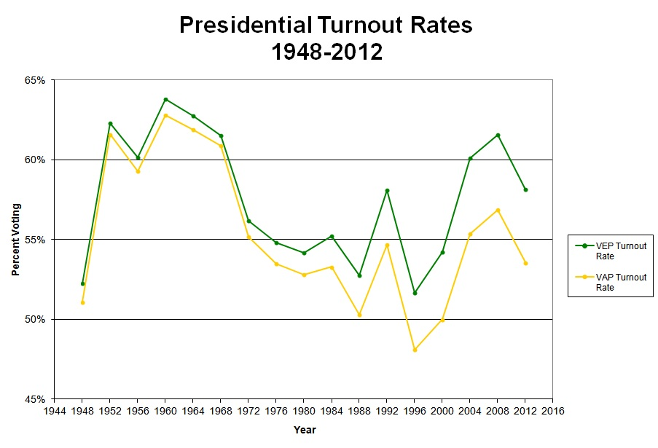

age groups. Since the ratification of the 26th amendment giving 18 year-olds the right to vote, the gap between those between 18-25 and older age groups has been between 16 and 27 percent (Flanagan and Levine 2010, pp. 161-2). In the 2012 presidential election, with relatively high voter turnout compared to the 1990s, 45% of young people voted, down from the peak turnout rate of 51% in 2008. In 2014, moreover barely 1/5 of all eligible young people voted. Although young people ages 18-29 were 21% of the voting eligible population in 2014, they were only 13% of the entire electorate (CIRCLE 2014). While these gaps invariably disappear as age-cohorts age, newer generations start out at an increasingly lower voting rate, and have more ground to make-up as they assume higher voting rates when they age.
If we are to effectively address both low levels of political knowledge and declining participation rates, particularly among youth, education would be the logical place to begin. Political scientists have long recognized education as the most important variable shaping political participation and political knowledge. In numerous studies, education levels are tightly correlated with voting turnout, political knowledge, and democratic attitudes and opinions (Nie et al., 1996; Verba, Schlozman and Brady 1995; Rosenstone and Hansen 1993; Wolfinger and Rosenstone 1980). These findings hold even when class and race are controlled: education is the strongest independent variable affecting political engagement. As Hillygus (2005) points out, however, the mechanism by which education affects political engagement is unclear: all we know for sure is that education is the central variable explaining differences in participation and political knowledge.
There are at least three possible theories for how education works, which Hillygus identifies as: 1) the civic education hypothesis; 2) the social network hypothesis; and 3) the political meritocracy hypothesis (p. 27). The civic education theory holds that education provides the necessary skills and knowledge for people to become politically engaged. It does this by making citizens more capable and thereby lowering the entry costs for participation (Niemi and Junn 1998). The social network hypothesis holds that education levels determine an individual’s status and position in society, with those closer to the center of power more likely to participate (Nie et al. 1996). Finally the political meritocracy hypothesis argues that educational levels reflect an underlying differentiation of intellect, with brighter individuals more likely to achieve higher levels of education and to participate at higher rates (Hernstein and Murray 1994). Hillygus (2005) tests these models empirically and finds little support for the meritocracy or network hypotheses, but strong evidence for the civic education hypothesis: higher levels of education provide individuals with greater capacity to navigate the complex political and policy environments, and therefore education engenders greater levels of participation.
If education can be a powerful predictor of participation, and the mechanism at work is the expansion of individual capacities to understand their political world, then civic education programs in higher education may hold the key to lifting levels of engagement. In fact, Niemi and Junn (1998) find that civic education can have this effect. They also find that civic education varies in its effectiveness according to the amount of instruction that is received, the variety of the topics studied, and the frequency that current events were discussed in class (Galston 2001, p. 227). In addition, they find that civic education has a greater impact on 12th graders than younger grades, suggesting that higher education efforts to promote civic engagement may be more promising than secondary or elementary school programs.
If one’s objective with civic education programs is to foster greater engagement, then students require: 1) the capacity to understand the issues and processes involved in public affairs; 2) the necessary skills for civic involvement; and 3) the motivation to engage politically. Educational interventions that provide students with an introduction to government institutions, political processes, and public policies address the first pre-condition – understanding. Programs that teach students how to engage politically are essential to addressing the second. These programs should teach students a mix of strategies and skills: how to organize in groups, research issues of concern, develop their own positions, discuss and present their views with/to others, discuss issues with others that hold differing views, and identify political actions and processes where they can advance their views meaningfully, i.e. voting, letter writing, attendance at public meetings, joining advocacy/interest groups; etc. For addressing the third pre-condition – motivation for political engagement – programs should create active opportunities as part of the curriculum, where students can not only learn political skills, but through their exercise develop motivation and internal political efficacy – political confidence or competence.
Addressing the first two requirements is relatively straightforward. Students require effective instruction on government, the political process, policy arenas, and active programs where they can acquire the menu of skills that citizens can draw upon in engaging politically. For the third requirement – motivation and political efficacy – the challenges are larger. One’s political efficacy is acquired as part of the process of political socialization, along with other more rooted aspects of political identity such as partisanship and ideological disposition (Verba et al 1995). Therefore, students enter college with either a well-developed sense of political efficacy or lower levels, and for students with lower-levels this predisposition is difficult to dislodge with a single intervention. As Beaumont (2005) found, a student’s initial political efficacy, prior to the educational intervention she studied, was the strongest predictor of a student’s political efficacy after they experienced the studied educational intervention.
According to research on civics education in higher education, there are identifiable practices that address each of these pre-conditions for expanded political engagement. Beaumont (2015), in a study of 21 political courses and programs with nearly 1,000 undergraduate participants in the 2000-2001 academic year, utilized a pretest and posttest survey to test for four types of educational interventions on the development of students’ political efficacy:
- placing students in a context of a politically active group or community;
- providing opportunities for students to acquire and practice political skills;
- offering opportunities for engaging in political discourse; and
- placing students in a diverse learning community, where they will engage with students from different racial/ethnic, religious and class backgrounds
(Beaumont 2015, 218-19).
Her research found that programs that teach political skills have the strongest impact in raising internal political efficacy among students. Programs that offer opportunities for engaging in political discourse, which situate students in a diverse learning community, and which connect students directly to community groups and/or government are also effective in elevating political efficacy.
These practices are further underlined by the report of the National Task Force on Civic Learning and Student Engagement (2012), which put forward a framework for higher education civic learning based on intensive meetings with over 150 education leaders. Their resulting framework for civic education emphasizes three categories for these programs to focus upon: knowledge, skills, values and collective action
Again, what the National Task Force framework emphasizes are three increasingly sophisticated levels of civic educational goals: level 1 - teaching basic knowledge of government and the political system; level 2 - advancing students’ political skills; and level 3 - creating opportunities for engagement. When we combine Beaumont’s (2015) research findings with this framework, it suggests that an effective civic education intervention would address more than simply giving students a basic understanding of government and politics, but would provide opportunities for them to actively engage in political discussion and action, preferably in connection with community groups and/or government.
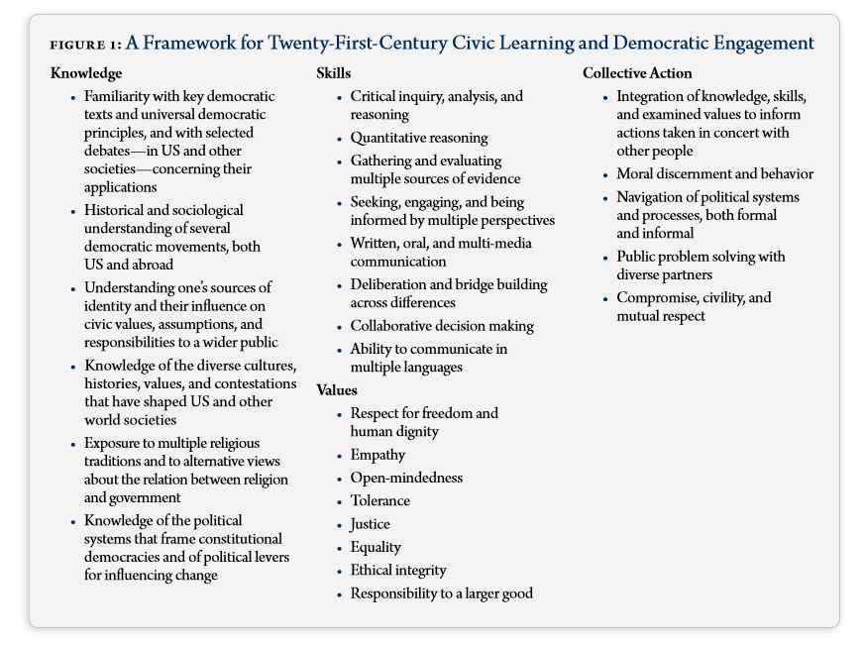
Source: National Task Force on Civic Learning and Democratic Engagement (2012), p. 4.

The Town Hall Meeting (THM) at California State University, Fullerton
The Town Hall Meeting (THM) program that we implemented at California State University Fullerton, beginning in the fall of 2012, independently offered students many – but not all – of these elements. As the description of the program’s genesis and development make clear below, the design of the project borrowed heavily from a model at California State University Chico. As it was developed, CSU Fullerton modified Chico’s approach in several ways. After offering pilot versions of the THM in two Introduction to American Politics courses – POSC 100 - in 2011-12, the program was awarded funding from the California State University Chancellor’s Office for their promising course redesign initiative in 2013-14. In the spring of 2014, the program was taken to “scale”, with several POSC 100 course sections involved, offering THM programs that were individually tailored by the instructors, and culminating in a large student-led THM event involving all three THM POSC 100 sections.
In the summer of 2011, California State University Chico’s Town Hall Meeting program was presented at the American Democracy Project (ADP) annual conference. That presentation illustrated long-term positive academic effects for the program: students who had gone through their introduction to American Politics courses with the THM program were more likely to remain in school and graduate than those who did not have the exposure. In 2010-11, their THM participants had a cumulative 91% retention rate and a 93% graduation rate (CSU Chico n.d.). Based on this positive record, in the spring and fall of 2012, one Professor CSU Fullerton adapted the THM program and offered it in his POSC 100 classes, each with approximately 200 students enrolled. Two important modifications were made to the Chico program. First, while Chico’s program had students work individually during the semester, but in groups at the culminating campus THM event, at CSU Fullerton students were assembled into small learning communities of 7 students within their POSC 100 section, and those groups led the culminating THM event breakout sessions. Secondly, at Chico they held two separate breakout sessions, first to discuss the issues and second to collaboratively arrive at policy solutions and to connect students to organizations where they could continue to work on these issues. At CSU Fullerton, we held a single breakout session for each issue area, and teams were tasked with not only identifying political and policymaking challenges for addressing their issue, but with advancing potential solutions prior to their culminating event.
In the spring of 2013, a second faculty member was added to the THM program. The culminating THM event – a large meeting consisting of multiple breakout sessions and a keynote speaker panel – involved both POSC 100 sections, for a total of approximately 400 students. In the fall of 2013, the CSU Chancellor’s Office provided financial support for the THM program as a “Promising Course Redesign with Technology”. The Chancellor’s PCRT initiative was aimed at reducing repeatable grades - grades of C- or lower – in required General Education (GE) courses that had increasingly become obstacles to graduation as a result of these widespread academic challenges. Because so many students had to repeat these courses, their path to graduation was lengthened. Moreover, other students wishing to take these required courses had difficulty getting enrolled because so many students were seeking to take them, either for the first time or as a repeat because of a low or failing grade. POSC 100 was one of these designated “bottleneck” courses by the CSU Chancellor’s Office, and the THM was offered as a way to reduce the number of repeatable grades without reducing the academic rigor of the course.
In the spring of 2014, three POSC 100 instructors offered course sections with a fully designed THM program. They coordinated their efforts so that the culminating THM event involved over 600 students, working together in breakout sessions and joining all together for a final mass meeting and keynote panel. The core components of the program include:
- Small-group collaborative learning communities;
- Research, writing and group discussions of policy issues throughout the semester;
- Involvement of faculty from multiple disciplines as moderators of student-led breakout sessions
- Involvement of local elected and appointed government officials as discussants in student-led breakout sessions.
- Presentation of policy analysis and proposed solutions to other students, faculty and local government officials;
- Participation in large-scale public event led by students, with involved faculty and local government officials.
At the beginning of the semester students were broken into learning communities of approximately 7 students, and assigned general research topic areas. Research topics are salient public policy issues, and have included immigration reform, economic inequality, education, gun-control, fiscal problems, the environment, and various international conflicts. Student learning communities then focus in on a narrower aspect of their selected issue area and research that issue throughout the semester. Different faculty have adapted the project to fit their area of expertise and some have included local political issues such as District vs. At Large elections and pension reform. Throughout the semester the groups study their given topics as they move through the course curriculum, while the instructor uses in-class opportunities to drive home the correlation between their study of government and politics, and their selected THM issues. At the conclusion of the semester, students present their research in a variety of ways – some instructors require papers while others opt for in class presentations coupled with a creative work product. In all instances, students are required to participate in the culminating, university-wide Town Hall Meeting, where they are divided up and present their research to other students, faculty and community stakeholders invited to attend.
The THM project, then, offers students a civic educational intervention that focuses on all three proven dimensions of effective civic education: knowledge, skills and collective action. The POSC 100 curriculum is modified to illustrate the connections between traditional American government course instruction and students’ efforts to explore prominent public affairs issues. In the process, students are required to work collaboratively in teams; develop basic research skills for learning about their selected issue; discuss the political and policy dimensions of their issue with students who are often from different racial/ethnic backgrounds; present their team’s work to their peers, faculty and local government leaders; and to produce and participate in a large-scale community event for the university.

Analysis of the THM program’s Impact
In an effort to evaluate the program’s impact, a survey was administered to CSU Fullerton students in the spring of 2014. Students enrolled in the THM POSC 100 sections and students enrolled in two other POSC 100 sections without the THM were asked to voluntarily answer a 65 question survey at the end of the semester, following the THM culminating event. The demographics of the class sections that were given the survey are presented in table 1 below.
Of the 961 total number of students in both sections, 571 completed the survey for a 59% response rate. Three-hundred and forty-two (342) respondents had participated in the THM program and 229 were in the POSC 100 sections without the THM. Institutional research data on the demographics of the students enrolled in these POSC 100 sections show that there was little difference between the THM and non-THM sections, Both were ethnically diverse, with 40% of the non-THM section and 49% of the THM sections from Latino backgrounds (data on other racial/ethnic identities were unavailable). Both had about 1/3 who were the first person in their family that had attended any kind of higher education institution. And both groups consisted of predominantly first and second-year students (freshmen and sophomores): 79% of the THM students and 72% of the non-THM students. It is worth noting that CSU Fullerton has a much larger Latino student population in their THM program than Chico: 49% of the THM courses at Fullerton were Latino, while 13.5% of the THM participants at Chico were “Hispanic” (Ertle and Weber 2010, p. 10).
Table 1: Student Demographics
Town Hall and Non-Town Hall Meeting POSC 100 Sections
 | Town Hall Meeting |  | Non-Town Hall Meeting
Total number of students | 554 |  | 407
First in family to go to college | 32% |  | 31%
Parent completed some college | 30% |  | 29%
Parent graduated from college | 33% |  | 35%
First year at CSUF | 32% |  | 26%
Second year at CSUF | 47% |  | 46%
Third year at CSUF | 15% |  | 18%
Fourth or more years at CSUF | 6% |  | 11%
% Latino | 49% |  | 40%
GPA prior to Spring 2014 | 2.8 |  | 2.9
Course GPA | 2.7 |  | 2.7
Source: Author's calculations using data generated by Karimi Afshin, Senior Research Associate
Institutional Research and Analytic Studies, California State University, Fullerton

The THM program’s most significant impact was on academic achievement and engagement. Although the Grade Point Average (GPA) of the THM students was nearly the same for the POSC 100 course as was their overall GPA going into the course (see Table 1 above), Table 2 below shows that for the instructors offering the THM, the percentage of students receiving a repeatable grade declined significantly with the implementation of the THM program.
Table 2: Reduction in Repeatable Grades after THM
(by individual instructor)
 | before THM | THM 2014 | Difference:
Most rigorous THM | 36% (Fall 2011) | 15% | 21 pct points
Mid-level rigor for THM | 8% (Fall 2012) | 6% | 2 pct points
Least rigorous THM | 14% (Fall 2013) | 11% | 3 pct points
Source: Author's calculations using data generated by Karimi Afshin, Senior Research Associate
Institutional Research and Analytic Studies, California State University, Fullerton

As Table 2 indicates, the three instructors offering the THM program offered a continuum of rigor in their THM program. The most rigorous THM program required students to produce a team research paper of 15-20 pages in length, and creative presentation for the campus THM event. The mid-level THM program required students to produce a creative presentation for the campus THM event, and to make classroom presentations prior to the actual event itself. The least rigorous program did not have student learning communities, but instead asked students to each produce a short 4 page paper on their chosen policy issue. The level of THM rigor made a difference. For the most-rigorous THM instructor, the percentage of students receiving repeatable grades declined by 21 percentage points, from 36% in the Fall of 2011 to 15% in the Spring of 2014. The mid-level THM instructor had only been teaching for a short time when she introduced the THM, and so her repeatable grades declined modestly, but she had the lowest percentage of repeatable grades of the three instructors at 6% in the spring of 2014. The least rigorous THM instructor saw his repeatable grades decline by 3 percentage points, from 14% in the fall of 2013 to 11% in the spring of 2014.
Examining the survey results, the largest statistical differences between the THM and non-THM respondents came in the area of academic engagement (see Table 3 below).
Table 3: Academic Engagement - THM and Non-THM compared
 |  |  |  | Town Hall |  | Non-Town Hall
Selected items: |  |  |  | Percentage |  | Percentage
Came to class prepared* |  | Often |  | 30.1 |  | 31.6
 |  | Very Often |  | 54.7 |  | 42.1
Felt bored in class*** |  | Often |  | 19.1 |  | 21.6
 |  | Very Often |  | 14.4 |  | 27.3
Felt the time you spent in |  | Sometimes |  | 35.3 |  | 34.6
class was worthwhile*** |  | Often |  | 36.5 |  | 24.6
 |  | Very Often |  | 17.1 |  | 15.8
Made adjustments outside |  | Often |  | 31.1 |  | 27
of class to improve or increase |  | Very Often |  | 22.3 |  | 15
the time you could
devote to your studies**
Academic engagement - 10 item scale -Mean***: |  |  |  | 3.35 |  | 3.14
 |  |  |  | (mean difference = .20846)
*p = .006; **.001; ***.000
Question: Please indicate how often this semester you___________________
Very often; often; sometimes; rarely; never

A series of 10 questions were posed in the survey, drawing from The American Association of Colleges and Universities’ Bringing Theory to Practice Program “Toolkit Assessment Survey.” (http://www.aacu.org/bringing_theory/documents/FacultyToolkit.docx.) These were assembled into a scale of academic engagement (Cronbach’s .767) and the mean difference between the THM and non-THM respondents was .21 and statistically significant (p=.000). Individual items in the scale illustrate some of the more important differences. 84.7% of THM respondents said that they came to class prepared often or very often, compared with 73.7% of non-THM respondents. 33.5% of THM respondents said that they often or very often felt bored in class, compared to 48.9% of non-THM respondents. And 53.6% of THM respondents felt that their time in class was worthwhile, compared to 40.4% of non-THM students. These survey differences may explain why the percentage of repeatable grades declined so much for the most-rigorous THM instructor, and together these two data points suggest that the THM program worked to engage students more actively with the study of American government.
For improving political motivation and internal self-efficacy, however the survey results are less conclusive about the impact of the THM. Table 4 shows that the most rigorous THM led to large difference in motivation for participation in future discussions about politics: 58.9% of students in the most rigorous THM strongly or somewhat agreed that they were so motivated, compared to 32.1% of one non-THM section and 42.1% of the other non-THM section respondents. The other THM sections, however, had majorities of their students answering that they strongly disagreed, disagreed, or neither disagreed or agreed that they were so motivated: 65.4% for the mid-level rigor THM and 63.2% for the least rigorous THM.
In terms of its impact on self-efficacy, the survey had a single measure of this difficult to assess psychological/cognitive disposition: “How much impact do you have on your community?” The THM students were far more likely to feel that they have a “big impact” than the non-THM students: 33.4% compared to 20.2%. Although this was a statistically significant difference, still 2/3 of THM students still felt that they did not have a big impact on their community (66.6%). Given that political efficacy is rooted in political socialization, and therefore difficult to address with a single educational intervention, these differences suggest that the THM effect on motivation and self-efficacy are significant beginnings towards greater engagement among participating CSU Fullerton students.
Table 4: Political Motivation & Self-Efficacy
 |  |  | Strongly disagree/
 |  |  | somewhat disagree/ |  | Strongly Agree/
 |  |  | neither |  | somewhat agree
Motivated to participate
in future discussions about politics*
 | Most rigorous THM |  | 41.1% |  | 58.9%
 | Mid-level rigor for THM |  | 65.4% |  | 34.6%
 | Least rigorous THM |  | 63.2% |  | 36.8%
 | no-thm section 1 |  | 67.9% |  | 32.1%
 | no-thm section 2 |  | 57.9% |  | 42.1%
 |  |  | Not a big impact |  | A big impact
How much impact do you
have on your community?*
 | Town Hall |  | 66.6% |  | 33.4%
 | Non-Town Hall |  | 79.8% |  | 20.2%
*p=.001

Finally, the survey asked students to reflect on the importance of public affairs to them and upon the likelihood that they would engage in political action in the future. Here again the differences between the THM and non-THM students were significant, but less pronounced than with academic engagement. The most-rigorous THM had 72.1% responding that it was essential or very important tokeep up to date with political affairs, compared to 61.5% or 55.9% of the two non-THM sections. Likewise about half of the most rigorous THM students (49.5%) thought it was extremely likely or likely that they would sign an email or written petition, and 66% said the same for voting in an election. This compares to 25% or 31% of the non-THM students for signing a petition and 58% or 63% for voting.
Table 5: Political Engagement, by type of THM and non THM
 |  |  | Importance to you of:
 |  |  | keeping up to date with political affairs***
 |  |  | essential/ |  |  | Somewhat/
 |  |  | very important |  |  | not important
Most rigorous THM |  |  | 72.1% |  |  | 27.9%
Mid-level rigor for THM |  |  | 54.3% |  |  | 45.7%
Least rigorous THM |  |  | 63.4% |  |  | 36.6%
no-thm section 1 |  |  | 61.5% |  |  | 38.5%
no-thm section 2 |  |  | 55.9% |  |  | 44.1%
 |  |  | likelihood in future that you will:
 |  |  | sign an email or written petition*
 |  |  | Extremely likely/likely |  |  | Not at all likely/unlikely/maybe
Most rigorous THM |  |  | 49.5% |  |  | 50.5%
Mid-level rigor for THM |  |  | 22.6% |  |  | 77.4%
Least rigorous THM |  |  | 35.8% |  |  | 64.2%
no-thm section 1 |  |  | 24.7% |  |  | 75.3%
no-thm section 2 |  |  | 30.9% |  |  | 69.1%
 |  |  | Vote in an electiion**
 |  |  | Extremely likely/likely |  |  | Not at all likely/unlikely/maybe
Most rigorous THM |  |  | 65.7% |  |  | 34.3%
Mid-level rigor for THM |  |  | 60.4% |  |  | 39.6%
Least rigorous THM |  |  | 77.9% |  |  | 22.1%
no-thm section 1 |  |  | 57.9% |  |  | 42.1%
no-thm section 2 |  |  | 62.6% |  |  | 37.4%
*p=.000
**p=.018
***p=.0.56 not significant

Conclusions
The THM program at CSU Fullerton has had a meaningful impact on students’ academic engagement, political motivation and efficacy, and interest in ongoing political activity. While the survey data is less conclusive about efficacy and interest in ongoing political activity, it suggests that the experience of the THM program has had a noticeable effect even in this difficult to impact area. In terms of academic engagement, the data are clearer: fewer students in the THM courses are failing, and more are actively engaged in their studies. As state university systems such as the CSU continue to examine cost-saving measures, such as moving General Education courses online rather than traditional classrooms, this experience suggests that the real “bang-for-the-buck” lies in leveraging the classroom experience for a broad and diverse population of students to create opportunities to increase both academic success and political engagement.
At the same time, while the THM program certainly emphasizes the transference of political knowledge and the experience of responsible, repeated political discourse across differences in a diverse community, there are areas of proven civic education effectiveness that are still weak in the program. First, this is a one-time program. Students who participate experience the challenges and excitement of working in a group on politically controversial policies. At the conclusion of the experience they will have essentially taken part in leading a campus-wide Town Hall meeting on these issues, and have interfaced with other faculty and political officials in the process. These experiences are valuable and can meaningfully contribute to increased political efficacy and motivation, and towards a desire to continue their political engagement in the future, including voting. However, these impacts are arguably tenuous. Although CSU Chico researchers identified a long-term impact of their THM program on academic retention and graduation (Ertle and Weber 2010), they too did not find the same impact for political engagement. The research on civic education suggests that direct engagement of students in real-life community projects as part of this Town Hall experience may be the surest way to increase these impacts for the longer term. As well, buy-in from the broader university community will be necessary to reinforce these efforts. Students who have multiple applied civic engagement experiences throughout their college years will be far more likely to leave the university as politically knowledgeable, feeling politically self-confident, and committed to remaining actively engaged in civic affairs.

According to the National Center on Education Statistics (NCES), in 2012, approximately 20.6 million people enrolled in degree-granting post-secondary institutions, of which 12.7 million were attending full-time. Digest of Education Statistics, 2013, Table 303.10, at https://nces.ed.gov/programs/digest/d13/tables/dt13_303.10.asp?current=yes.

