The artist as environmental political theorist:
Ambrogio Lorenzetti on the civic republican niche
Zev Trachtenberg
University of Oklahoma
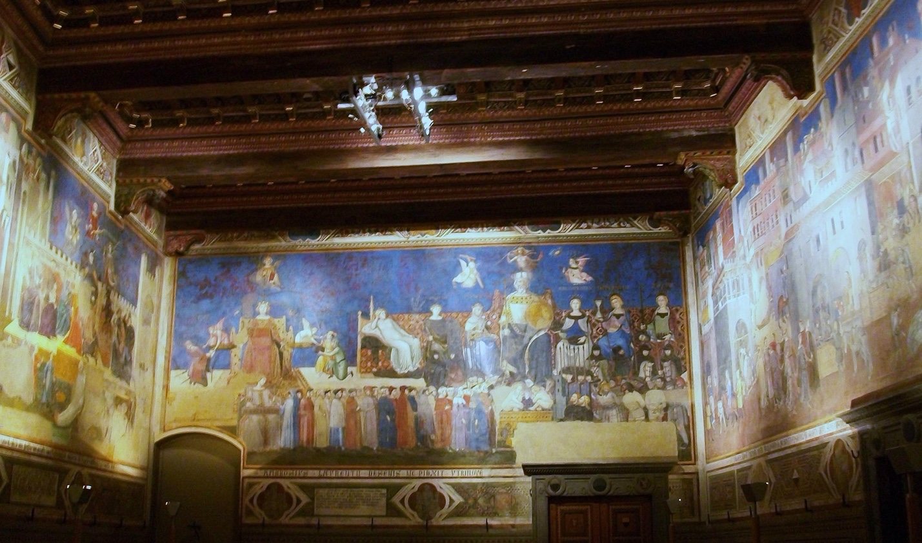
All images taken from Wikimedia Commons. Click on links in text to jump to figures.
In 1338-39 Sienese painter Ambrogio Lorenzetti produced a series of frescos on three walls of the council chamber in his city’s municipal building, the Palazzo Pubblico. Quentin Skinner, in his 1987 essay “Ambrogio Lorenzetti: The Artist as Political Philosopher,” argues persuasively that the series, which has come to be known as the “Allegory of Good and Bad Government,” can be interpreted as an expression of a normative conception of politics, derived from a tradition of civic republican theorizing that dates to Cicero. In particular, Skinner shows, the center panel, which the nine city magistrates would have faced as they sat to deliberate, is an allegory of the virtues those in power (as the immediate audience of the painting) should internalize, centered around a dedication to the common good. The other two walls depict, on the magistrates’ left, the effects on the republic when those virtues are perverted (Fig. 1, Fig. 2), and on their right, the effects when they are upheld (Fig. 3, Fig. 4). In both cases, Lorenzetti shows in idealized form the poorly and the well governed city, and the surrounding country-side of each.
In this paper I take inspiration from Skinner, by trying to see in Lorenzetti’s work not only a broad statement of republican political values, but a more specific statement we can readily categorize in terms of environmental political theory. I shall try to show that Lorenzetti’s frescoes illustrate a theoretical understanding of the political character of human beings’ environmental situation. Following Skinner—and, frankly, trespassing on the domain of Art History—I procede on the basis that this understanding is conveyed primarily by pictorial means (although there some passages of text incorporated into the fresco (reproduced in Norman 1985, p. 167))—hence I will focus on the pictorial elements of the work that support my interpretation. Thus, most immediately, it is notable that on both the left and right walls of the chamber Lorenzetti devotes the same amount of space to the city and the country-side—the latter is not simply the background to the former. Rather the country-side is as much a part of Lorenzetti’s subject as is the city, and he directs our attention not to one or the other exclusively, but rather to their interaction (Meoni 2005, p. 27). That interaction is illustrated and emphasized by the pictorial prominence of the road that links city and countryside on each wall.
Before analyzing Lorenzetti’s depictions of city and countryside further, however, I will explain my broad conceptualization of human beings’ environmental situation. I appeal to the biological idea of niche construction. An organism’s niche can be conceived as the set of characteristics of its environment that make it possible for it to live—features like the availability of food and water, the proper ambient temperature, and other factors relative to its specific metabolic needs (Hutchinson 1957). Note that in this sense “niche” is not a spatial concept. For those environmental characteristics are defined not in terms of their location, but by the organism’s own capacities to obtain what it needs—the cheetah’s speed means that it occupies a niche that includes fast-running impalas. Notably, many organisms have the capacity to modify their environment to make what they need more available; a spider web is a perfect example. It is in this sense that organisms can be said to construct their niches by exercising their capacities. I am going to make use of ideas I take from Steven Pinker (2010) about the ways that human beings’ mental capacities enable them to draw the resources from the environment they need to live, hence can be used to characterize it—Pinker thus speaks of human beings’ “cognitive niche.”
The course of our evolution has led human beings into the situation that we must occupy a completely constructed niche: we survive not by taking up what we need directly from nature; nature affords us what we need only through an “interface” we fashion, through our labor, that makes those resources accessible. That interface is manifested at two levels: in physical transformations of the landscape—but more fundamentally in the network of interpersonal relations involved in social cooperation, including cooperative work in the landscape, and relationships of exchange.
The right hand wall of Lorenzetti’s fresco series, showing the effects of good government, is filled with images of niche construction at both levels. The panorama of the country-side (Fig. 5) is, in effect, a catalogue of agricultural activities, most prominently the sowing (Fig. 6), and harvesting (Fig. 7) of wheat. (Notice that the fresco presents activities that take place throughout the year as occurring simultaneously, hence indicates that we are being shown an idealized representation of the agricultural economy as a system, not, say, a realistic representation of the country-side on one given day (Meoni 2005, p. 44.) The landscape is marked by many instances of human modification, including the plowed soil; the built structures, like houses and farm buildings; and the transportation infrastructure, like the road and bridge in the foreground; and the mill just above the bridge (Fig. 8), which is a key part of the “interface” that modifies the products of natural processes so that they more readily satisfy people’s metabolic needs.
But Lorenzetti also indicates the social relations that underlie these physical manifestations of niche construction. The harvest scene near the center of the landscape, just above the road, shows reapers whose individual actions are coordinated to produce sheaves of wheat, and also threshers, whose movements must be synchronized to effectively remove the grain (Fig. 9) (Meoni 2005, p. 59). Thus in his depiction of the extraction of resources, from an environment modified to accommodate that activity, Lorenzetti shows that these core activities of niche construction operate in a social manner.
But note that the country-side is not by itself the niche Lorenzetti depicts; his subject encompasses both country-side and city (Fig. 10). The city is obviously a constructed environment; indeed we see some literal construction work taking place (Fig. 11). But the ample traffic through the city gate (Fig. 12) that gives the city and the country-side access to each other presents them as an inter-related system. At its core that system is likewise social—in particular, it is based on exchange. Thus, the road along the fields is busy with country people bringing goods to the city. Inside the city walls we see a variety of scenes of economic life, in which, for example, a raw material (wool) is delivered to a workshop to be worked into a product of immediate use (Fig. 13). And we see a peasant man shopping for shoes at the cobblers’ stall (Fig. 14)—one of several vignettes Lorenzetti offers of the commercial interactions that take place within the city.
These interactions show how the city and country-side together function as an integrated niche providing for metabolic needs, with the country-side as the source of raw material and the city as the point both of transformation of those materials into useable goods, and of distribution to their users (including people from the country). But there is another order of needs that this integrated niche also provides for: to paraphrase Aristotle, these are needs associated not merely with maintaining life, but with living well. Thus, Lorenzetti (who likely knew Aristotle by way of Aquinas (Rubinstein 1958, p. 182)) depicts the city’s provision of beauty (in the form of personal and architectural ornament (Fig. 15)), education (in the form of a teacher and class (Fig. 16)), and leisure (in the form of noblemen heading out of the city to hunt with falcons). And Lorenzetti’s panorama of urban life gives a prominent place to a dance (Fig. 17), seen in a central plaza; this can be taken as a symbol of the cultivation of human capacity the integrated niche affords, while the dancers’ graceful configuration can be taken as a cultural reflection of the complex social interactions that sustain the form of life that niche provides.
But where, in the bustling scene Lorenzetti offers us, can we catch sight of politics? How, that is, does he illustrate the idea I’ve imputed to him, that the human relationship with the environment has a specifically political character? Note, this goes beyond the notion that people gain resources from the environment by means of social cooperation; to speak of politics here is to call attention to governance. Politics in this sense has an avatar in the fresco: the figure of Security who hovers over the scene just outside the city wall (Fig. 18). This figure is an allegorical intrusion into an otherwise literal (if idealized) depiction of material life. Her label, and the banner she carries, make her meaning clear: her banner reads “Without fear every man may travel freely and each may till and sow, so long as this commune shall maintain this lady sovereign, for she has stripped the wicked of all power.” Lorenzetti is illustrating the idea that the good life that we see before us is made possible by the presence of security; security is the condition for humans to engage in niche construction.
However, Lorenzetti makes clear that security is a political accomplishment: it is the most fundamental effect of good government, on which the good things we see in this part of the painting depend. He makes this connection visually, by linking the depiction of material life on the right hand wall back to the manifest allegory of the moral qualities required for good governance depicted on the central wall of the fresco series (Fig. 19). Specifically, the figure of Security resembles the figure of Peace near the center of the allegorical tableau (Fig. 20) who indeed appears to be casting her gaze towards Security’s location on the right hand wall. Thus, the figure of Security can be seen as the point at which the specifically republican political ideals expressed in the central wall enter into the space of material life depicted on the right, marshalling those ideals into an explanation of how it is that the project of niche construction Lorenzetti shows can go so well.
Let me turn to Skinner to note the conception of peace found in the civic republican tradition: “peace should be viewed not as a mere absence of discord … but rather as a state of triumph, a victory over the forces of discord and war that constantly threaten to destroy our common life” (1987, p. 7). Thus, he observes, Lorenzetti depicts Peace as “a victorious force,” triumphant over the violence symbolized by the armor underneath the cushion on which she lounges (p. 33; Fig. 21). Security, likewise, is associated with an image of a challenge overcome: she holds a scaffold with a hanged man (Fig. 22), presumably a criminal who has been executed for unjust acts; this visually echoes several images of execution of wrong-doers on the central wall. Lorenzetti, that is, reminds the viewer of the ever-present threat of injustice in people’s social interactions with one another, and thereby affirms an understanding that without the political effort to maintain justice there will be no peace. And without the security that attends peace the activities that provide for human needs could not take place; it seems therefore that a fundamental aspect of human niche construction is the political project of upholding justice. Indeed, the figure of justice appears twice on the center wall (Fig. 23)—and it is plausible that the allegorical lady the city is enjoined to keep sovereign is precisely Justice.
Let me now develop further this political aspect of niche construction by considering the harmful effects of injustice, depicted on the left hand wall (Fig. 24). There we observe a desolate, uncultivated countryside; a burning village; ruined houses; marauding soldiers—indeed these are the first things visitors to the council chambers would have seen in the 14th century, and were indeed all-too familiar sights in the region at the time (Norman 1997). The original public entrance (now displaced several yards to the right) opened onto a stark depiction of how a society could fail utterly in the fundamental task of providing for itself—how it could destroy rather than construct its niche.
The grim scene was meant to serve as a stern lesson to the nine magistrates who served as Siena’s governing body. It would appear to their left—the sinister side—as they conducted their business, the pictorial conclusion to an allegorical narrative running along that entire wall showing how injustice corrodes society. The narrative’s implied injunction against unjust rule works in conjunction with the pictorial narrative on the opposite wall, to the magistrates’ right: the image of the thriving countryside we have just considered.
As we saw, both pictorially and by incorporated text Lorenzetti indicates that the precondition for niche construction is security, which he includes in a network of conceptual associations with peace and justice. Peace and security are products of the political effort to ensure justice within the complex social relationships among citizens through which they construct their niche—the system by which they sustain their survival as individuals, and the survival of their city. This elaborate panorama of a flourishing social system, underpinned by justice, was no doubt an idealization—but it invites viewers to envision what Siena could be. In particular it kept before the rulers a normatively compelling goal for their rule, and reminders of the moral attitudes they should adopt to achieve it (Meoni 2005, p. 11).
A quick turn of the head, however, makes it perfectly clear that Lorenzetti knew—and wanted his viewers to recognize and take deeply to heart—what could possibly go wrong with this picture. In a moment I will review his account of what can go wrong. But there are some other ways we today might think things can go wrong. In particular, we are now all too aware of the ways human niche construction can backfire, leaving society vulnerable to “Nature’s revenge.” This is, of course, a common interpretation of the Anthropocene, at least the train of environmental crises the term often alludes to, which can be seen as Nature’s reaction to humanity’s overweening efforts to dominate it. At one level, the celebration of niche construction thus seems premature, since our exploitation of natural systems can have unintended consequences that make the niche we have constructed less habitable. At a deeper level, therefore, the celebration of niche construction can seem misconceived; maybe what’s wrong with the picture Lorenzetti paints is that it represents an instrumentalist attitude toward Nature that should actually be rejected.
Though these do not seem to be Lorenzetti’s own concerns, it is worth noting two ways his depiction of niche construction is perhaps more nuanced than first appears. On the one hand, as the agricultural anthropologist Maria Luisa Meoni observes, he paints vineyards cutting across the slope of hills (Fig. 25)—a best agricultural practice for minimizing erosion, though in Lorenzetti’s day farmers maintained the standard method of following the slope, which increases run-off (2005, p. 46). (The associated erosion is perhaps indicated by the steep banks of the river that runs through the landscape.) Thus, part of Lorenzetti’s idealization of Siena in the fresco is his vision of more environmentally sensitive niche construction techniques.

On the other hand, there tiny indications that, short of depicting Nature’s revenge, Lorenzetti did depict Nature’s recalcitrance toward human beings’ niche construction efforts. There is an amusing vignette at the extreme lower right hand corner of the fresco showing a man pulling on the lead of a horse that doesn’t want to carry its burden up the bridge (Fig. 26). Even this domesticated animal has its own agency, resistant to human will. More telling, I think, are the birds Lorenzetti paints in the fields, harvesting for themselves the seed that has just been sown (Fig. 27). Here Nature does not precisely resist (or react against) niche construction efforts; rather the product of those efforts is easily lost, to forces that are an ineliminable part of the background. The birds are a reminder of the entropic pressures that nibble away at humans’ orderly systems for supporting themselves, increasing the amount of energy needed to achieve that goal.
But these do not seem to be Lorenzetti’s own concerns; for him the real challenge to human niche construction comes not from anything in Nature, but from human beings themselves. What can go wrong with the picture on the right hand wall is not Nature’s revenge, but human injustice.
The blasted landscape on the left hand wall has had its productivity deliberately destroyed. It cannot support the lives of the people in the associated city; unlike on the right hand wall, there is no one bringing goods from farms to the urban market. The agricultural failure is anthropogenic, but not mediated through a chain of environmental causes and effects—as when, in a case of niche construction backfiring, bad farming practices lead to soil depletion. Rather the damage is anthropogenic in a direct sense, resulting from the violence inflicted by the armed men roaming the landscape, wrecking the agricultural infrastructure—an example of literal niche destruction.
The left hand wall as a narrative unit (Belting 1985) makes clear that the source of the destruction is the city associated with the landscape (Fig. 28), due to the perverse political values by which it is governed (allegorized on the right end of the image; see below). In contrast to the right hand wall, which shows noblemen passing from city to countryside for leisure, the left hand wall shows a trio of armed figures leaving the city, presumably to pillage the countryside (Fig. 29).
This contrast is heightened, and explained, by the allegorical figures that appear in corresponding positions on the two walls, that is, at the point of connection between city and countryside, moving from the former to the latter. As we saw, the right hand wall features the figure of Security—the political accomplishment of the good city that is the condition for both productive activity and trade that benefits city and countryside alike. The left hand wall, as art historian Diana Norman puts it, features “the grim allegorical figure of Fear, represented as a haggard woman in ragged clothes and armed with a menacing black sword. Her position—in flight over the city walls, in the general direction of the countryside—suggests that she is a malign influence emanating from the city itself” (1997, p. 314; Fig. 30).
The road between city and countryside, that is, represents the systemic character of the human niche: again, it is the interactions between city and countryside that underpin human life. On the right hand wall the political accomplishment of security allows for those interactions; the system is fully functional, and there is abundance in both zones. On the left hand wall the system has broken down. Not only is the countryside blasted and the road empty, the bad city is devoid of economic activity (except for a blacksmith making weapons (Fig. 31)), and is instead a scene of violent assaults (Fig. 32). Lorenzetti even depicts—in contrast to the construction work on the right wall—the top of a building being demolished (Fig. 33; note the rubble on the ground): another vivid emblem for the idea of niche destruction.
The failure of the society presented on the left hand wall to maintain its niche, indeed, the fact that it is destroying it, is explained by way of a contrast with the explanation Lorenzetti presents for the success of niche construction on the right hand wall. The explanation is summarized on the banner carried by the figure of Fear: “Because each seeks only his own good, in this land Justice is subjected to Tyranny: wherefore, along this road nobody passes without fearing for his life, since there are robberies outside and inside the city gates.” Of course this inverts the moral associated with the figure of Security, which refers to the absence of fear. The moral associated with Fear attributes the absence of security to the overthrow of Justice by Tyranny.
Lorenzetti depicts precisely this at the right end of the left hand wall (Fig. 34)—the starting point for the allegorical narrative that flows right to left. Tyranny is shown as a demonic figure, surrounded by personifications of vices, with Justice defeated and bound at her feet (Lorenzetti’s text refers to Tyranny as female). As a text panel beneath the figure makes clear, Tyranny is responsible for the desolation depicted throughout the rest of the left hand wall: “She always protects the assailant, the robber, and those who hate peace, so that her every land lies waste” (emph. added). Niche destruction, Lorenzetti suggests, is a political phenomenon, the consequence of an unjust political order.
I will close by returning to the claim that Lorenzetti is depicting a civic republican outlook. Niche destruction, in his fresco, is the consequence of unjust attitudes among the citizens. Tyranny triumphs over Justice, Fear’s banner declares, “because each seeks only his own good.” In line with traditional civic republican theory, Lorenzetti contrasts this attitude to dedication to the Common Good, which serves as the standard of justice. Precisely as he depicts on the left hand wall, “where Justice is bound, no one is ever in accord for the Common Good.” By contrast, where Justice rules, the citizens “make the Common Good their Lord,” according to text on the center wall. There the Allegory of Good Government depicts a regal figure, iconographically associated with Siena itself, whom Skinner suggests figures the idealized ruler who, by enforcing norms of justice, will secure the Common Good (Fig. 35; 1987, p. 44).
I will not unpack the complex relations between self-seeking, injustice, and the common good here. Let me say, in brief, that Lorenzetti seems to uphold an ideal of fair reciprocity in people’s dealings with each other; this is the norm “the assailant, the robber, and those who hate peace” violate, undercutting the ability of people to interact cooperatively to collectively provide for flourishing lives. (I suspect, I will note, that the dynamic in play would be familiar to Hobbes.)
The image of the Tyrant thus seems to allegorize not just a form of government, but a kind of moral climate; tyranny allows (perhaps encourages) people to act on selfish impulses that are restrained by a regime dedicated to justice. In the same way that, in the civic republican tradition, peace is not simply an absence of discord but a victory over it, justice within a society is that society’s victory, achieved by its political system, over tendencies that lead people to act unjustly. Hence the fresco’s many images of punishment. However these must be seen as examples of a more general understanding of justice which, Skinner argues, associates it not only with punishing bad behavior, but also with rewarding good conduct (both seen at the right hand of the personification of Justice in Fig. 36), and in ensuring fair exchange (seen at Justice’s left hand in Fig. 36) (1987, pp. 39-40). Maintaining the proper moral climate, from the civic republican perspective, is at the core of the social project of niche construction, as illustrated on the right hand wall of Lorenzetti’s fresco series. The left hand wall depicts what happens if that climate is not sustained: the niche will be destroyed.

Figures
[All figures taken from
Wikimedia Commons.
Not shown to scale.
For a 3-D rendering, viewable as VR, go to:
https://skfb.ly/6B6Oy.]

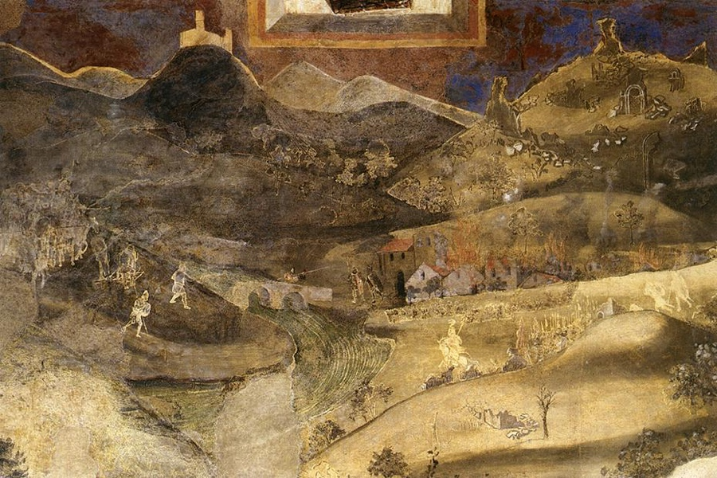
Figure 1: Effects of bad government on the country-side (left side of wall) [back]

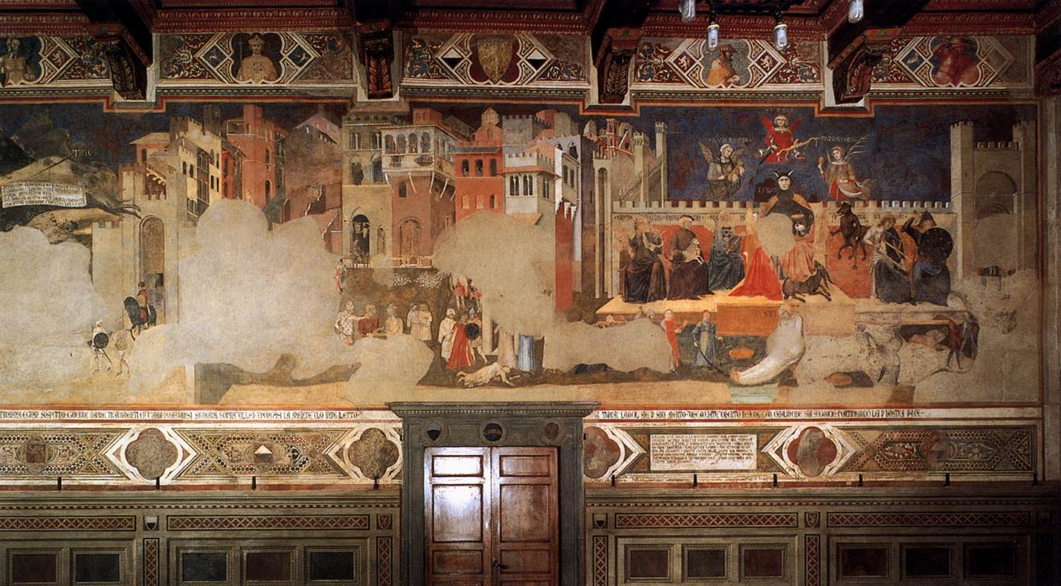

Figure 2: Effects of bad government on the city(right side of wall) [back]
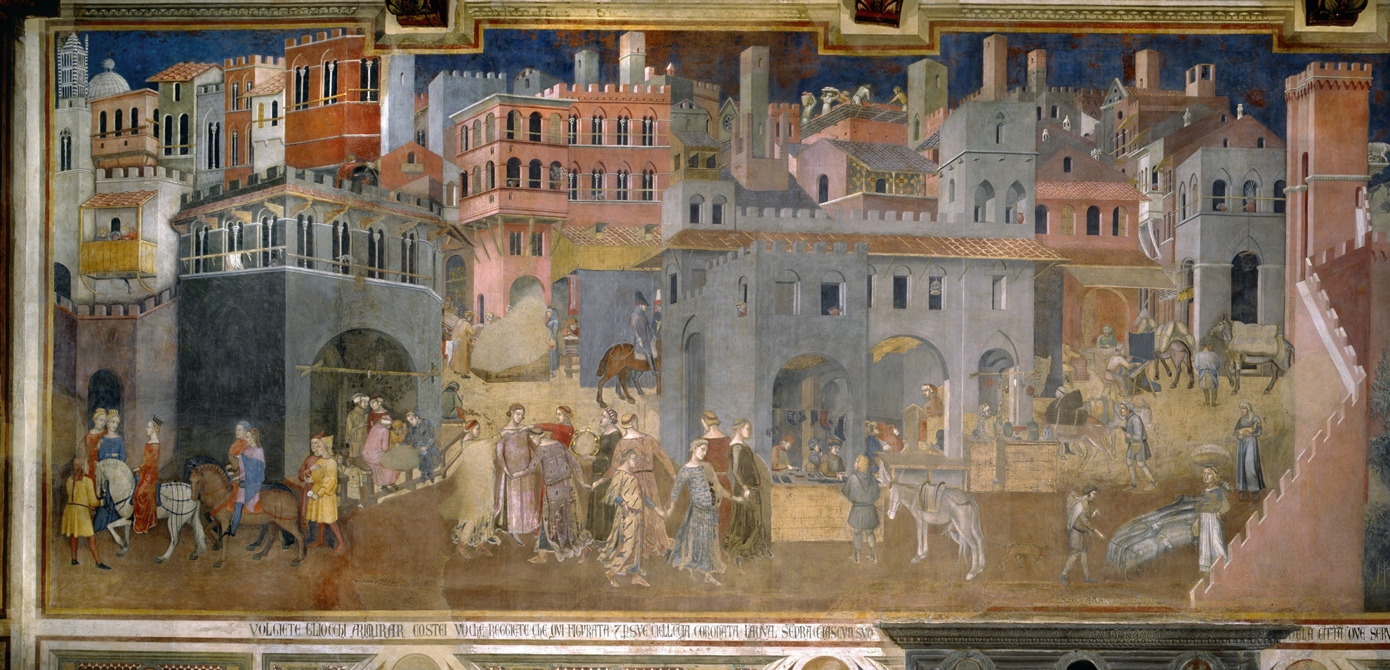
Figure 3: Effects of good government on the city (left side of wall) [back]

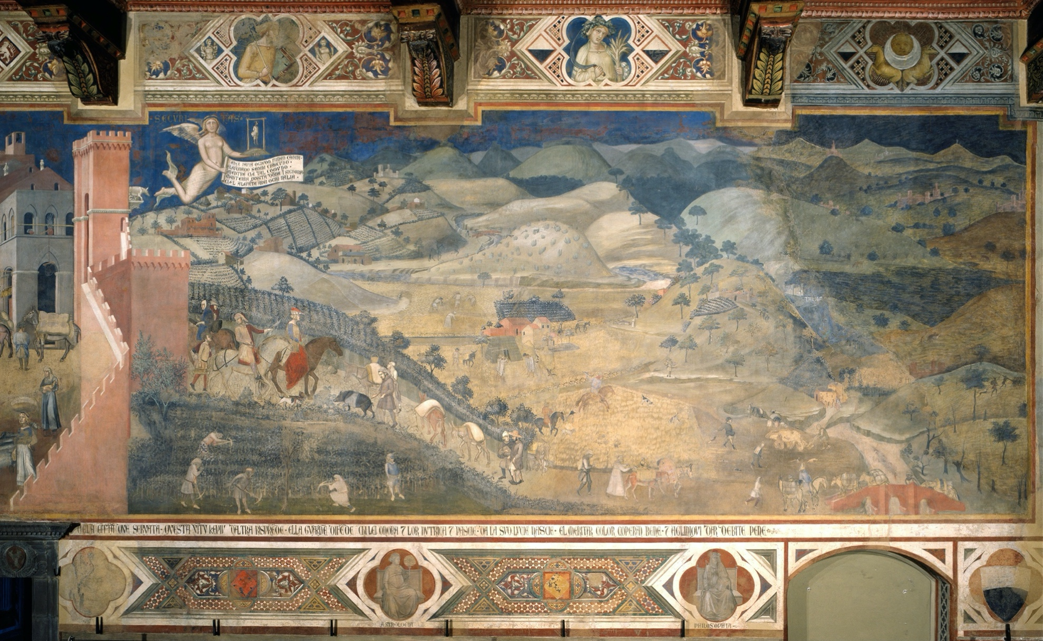
Figure 4: Effects of good government on the country-side (right side of wall) [back]

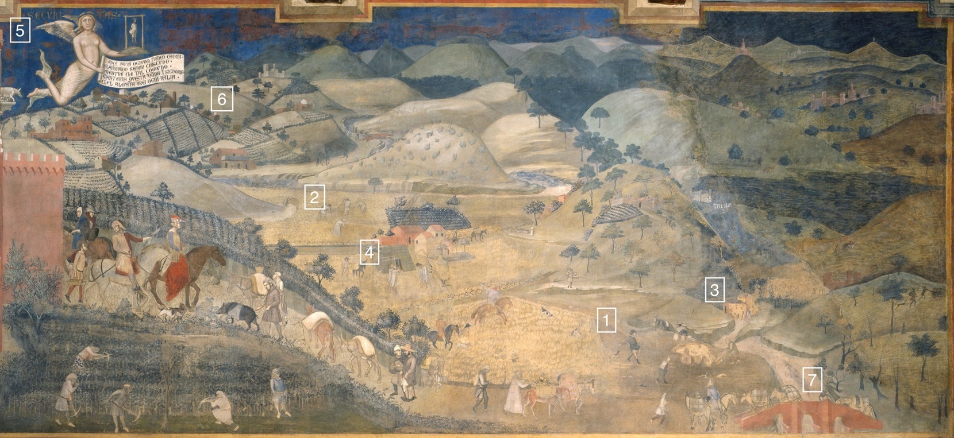

Figure 5: The good country-side; details numbered [back]

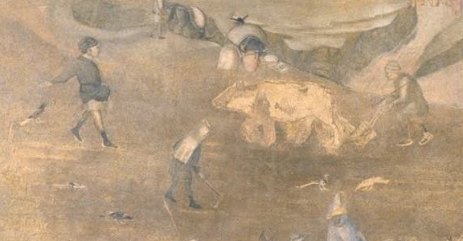

Figure 6: Detail 1 [back] Figure 7: Detail 2 [back]
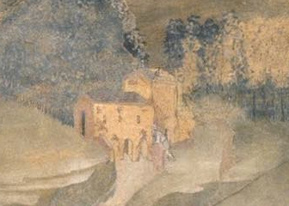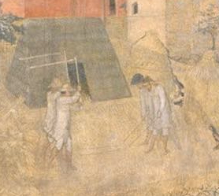
Figure 8: Detail 3 [back] Figure 9: Detail 4 [back]

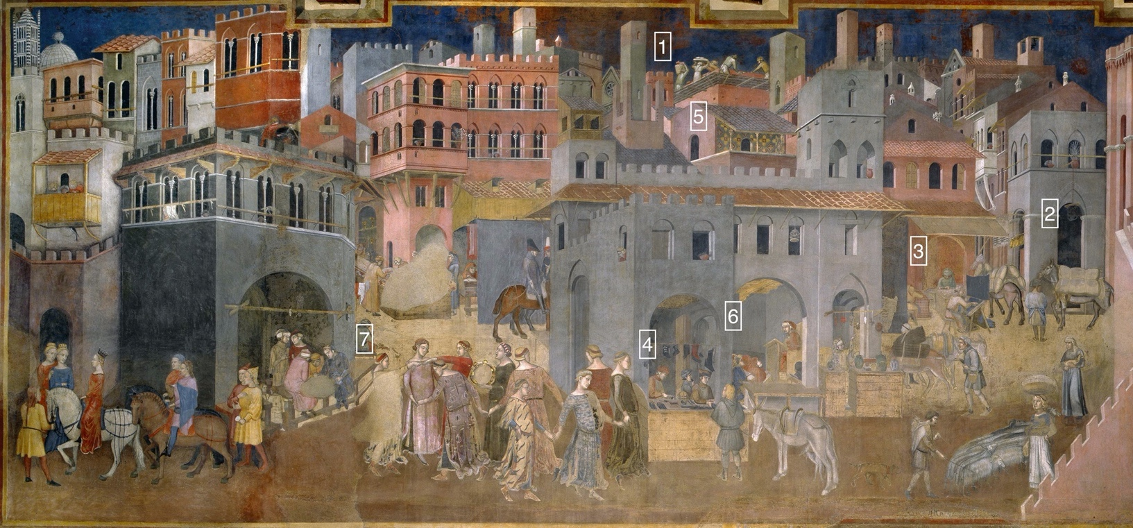

Figure 10: The good city; details numbered [back]
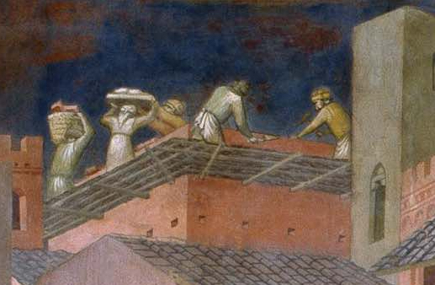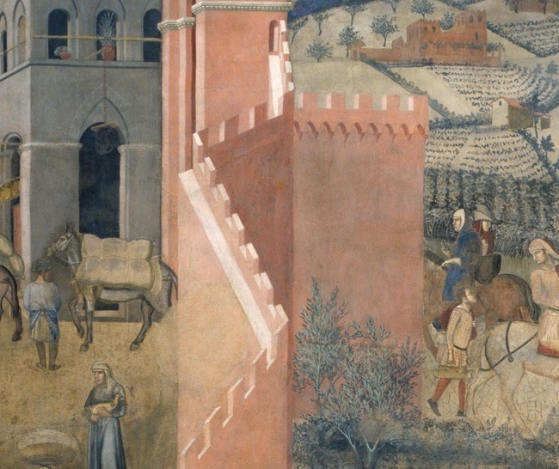
Figure 11: Detail 1 [back] Figure 12: Detail 2 [back]
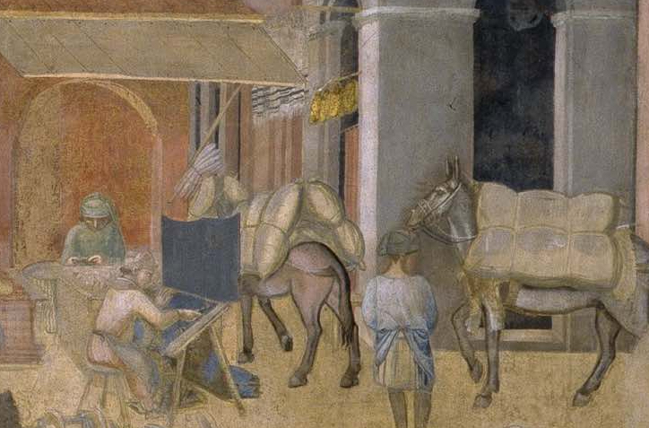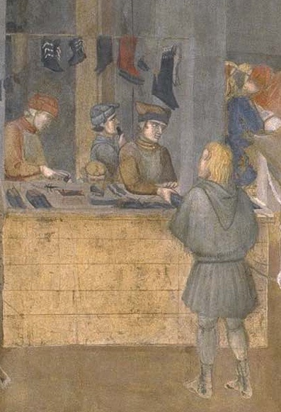
Figure 13: Detail 3 [back] Figure 14: Detail 4 [back]

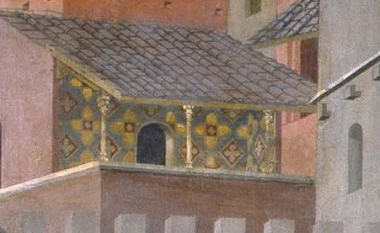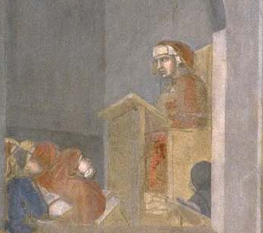
Figure 15: Detail 5 [back] Figure 16: Detail 6 [back]
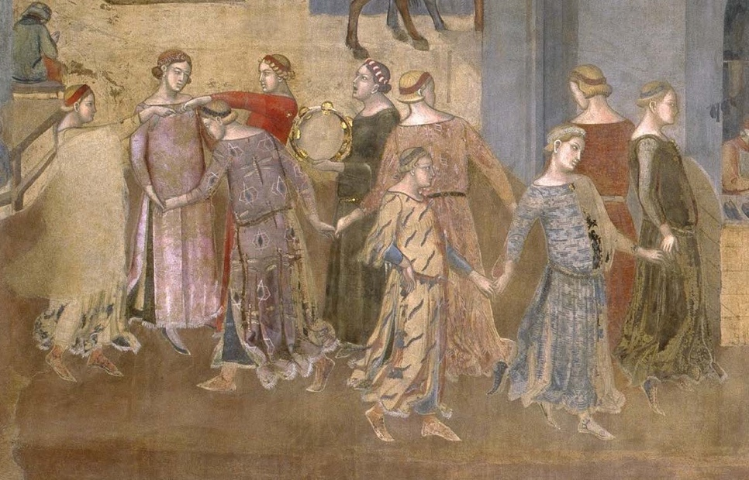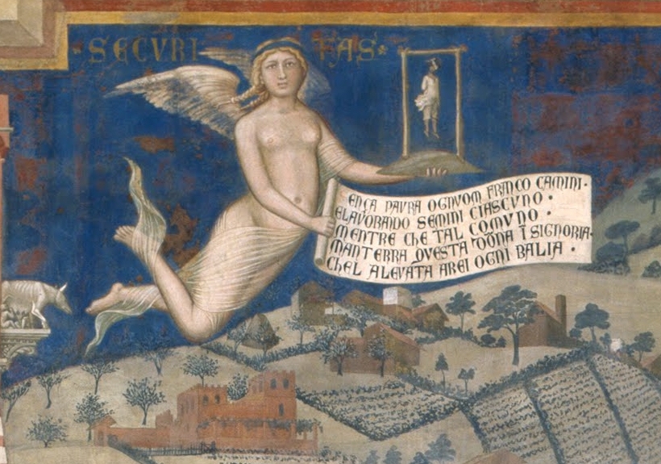
Figure 17: Detail 7 [back] Figure 18: Detail 5 from Fig. 5 [back]
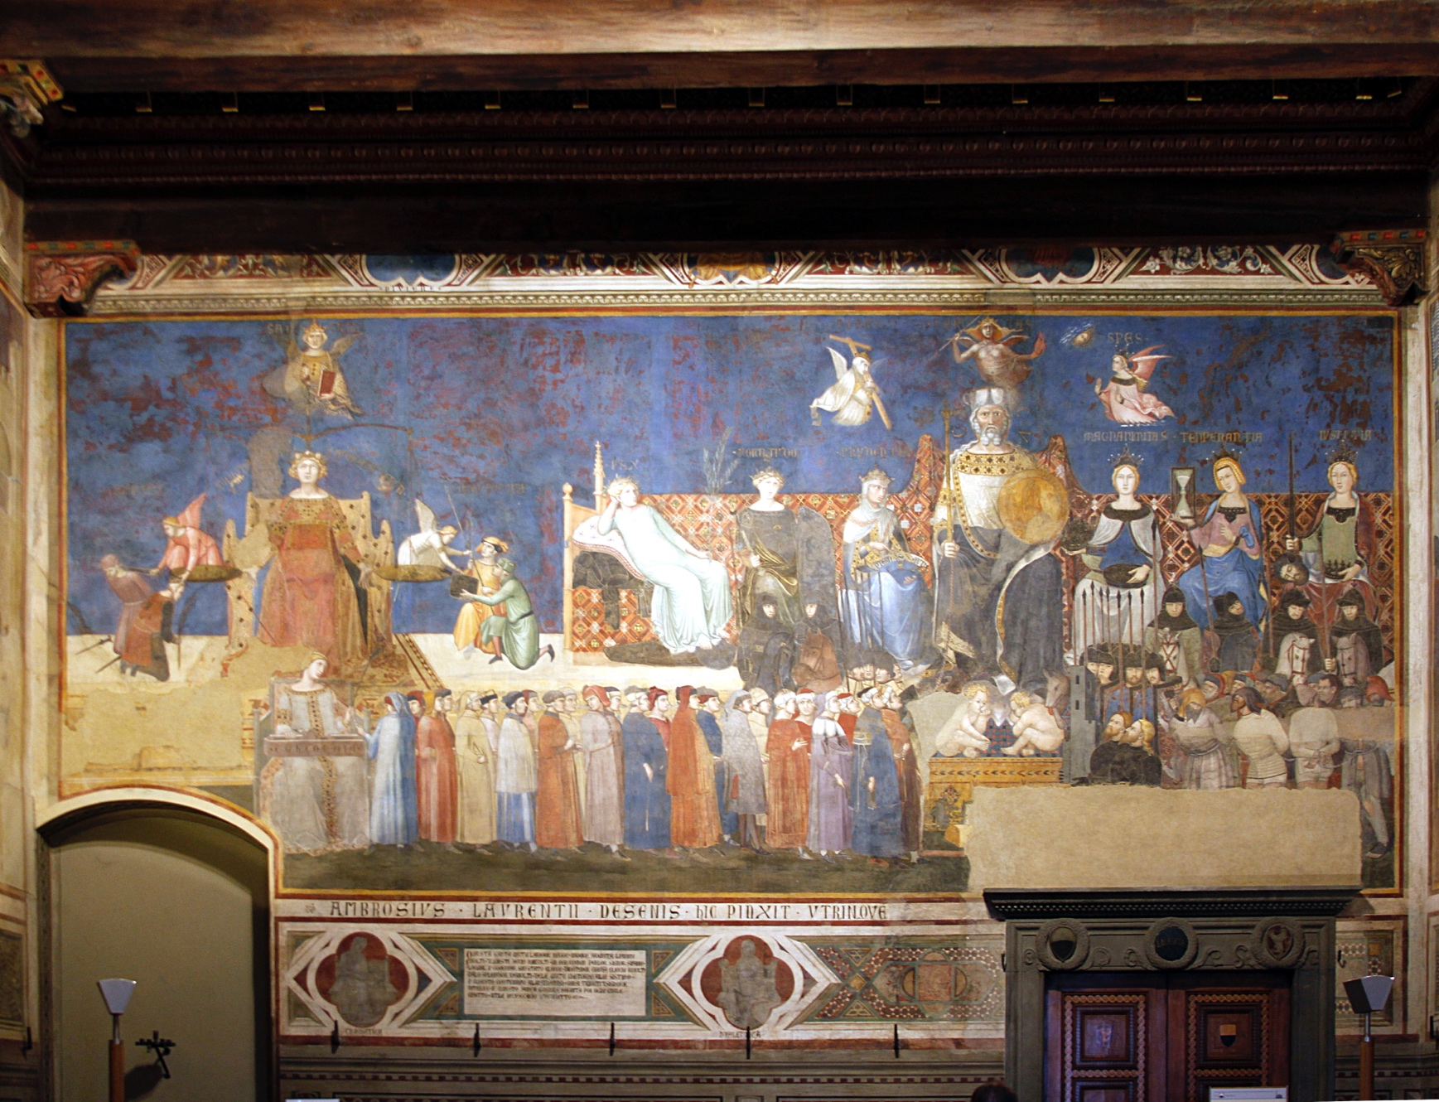
Figure 19: Allegory of good government (center wall) [back]
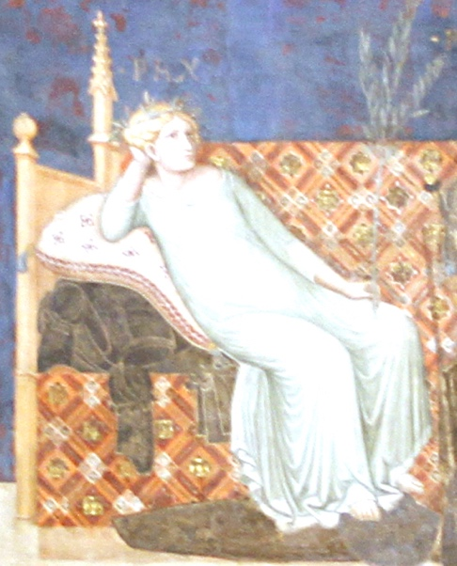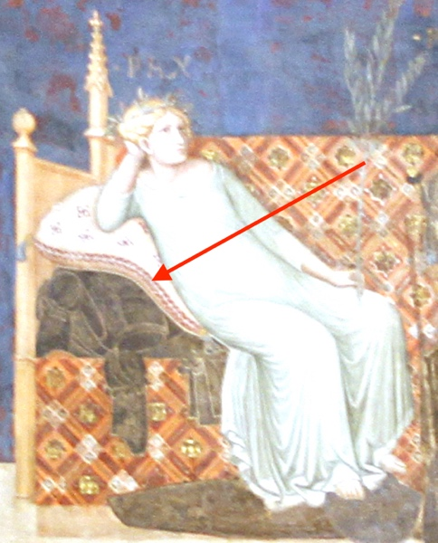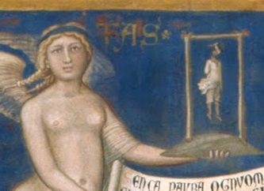

Figure 20: Peace [back] Figure 21: Armor [back] Figure 22: Security carries a scaffold [back]

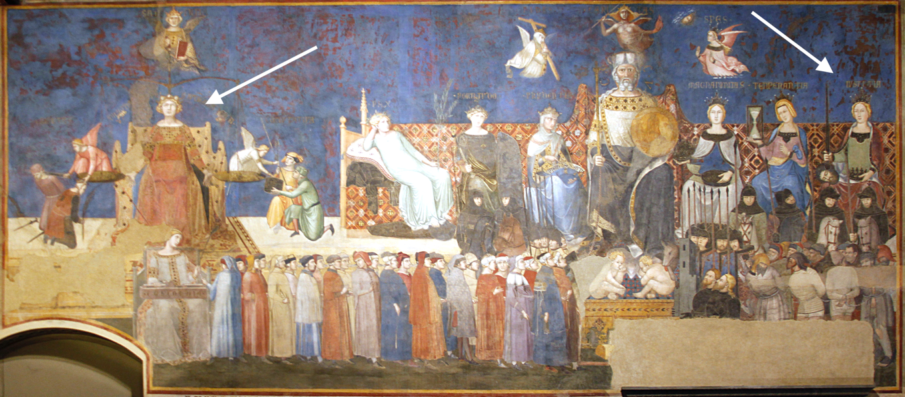

Figure 23: Two figures of Justice on center wall [back]
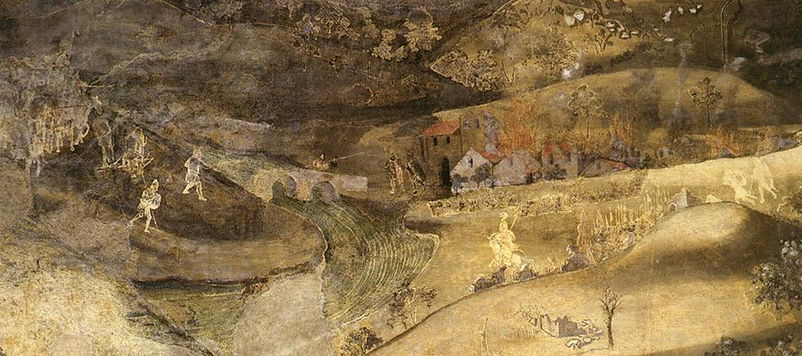

Figure 24: Detail of bad country-side, on left wall [back]

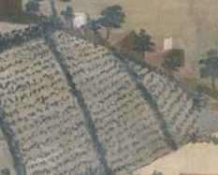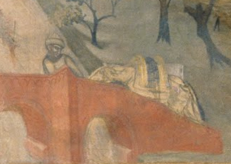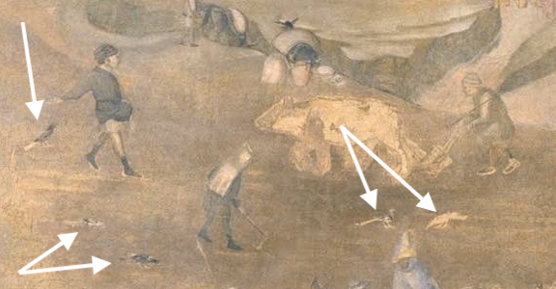

Figure 25: Detail 6, Fig. 5 [back] Figure 26: Detail 7, Fig. 5 [back] Figure 27: Detail 1, Fig. 5, birds eating seed [back]

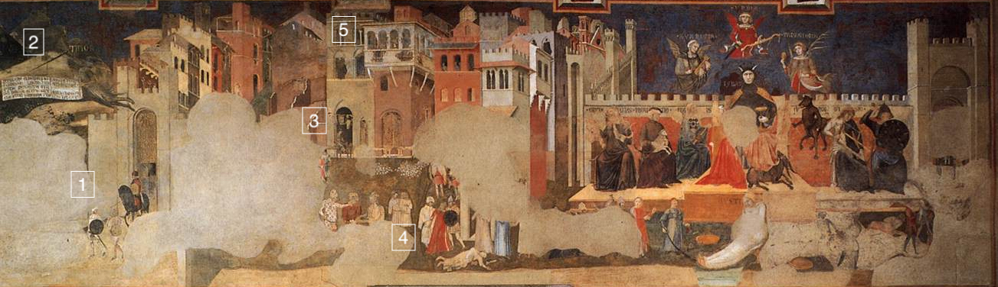
Figure 28: The bad city; details numbered [back]
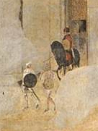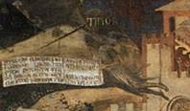
Figure 29: Detail 1 [back] Figure 30: Detail 2 [back]
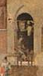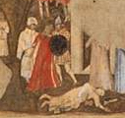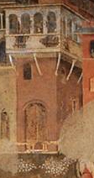
Figure 31: Detail 3 [back] Figure 32: Detail 4 [back] Figure 33: Detail 5 [back]
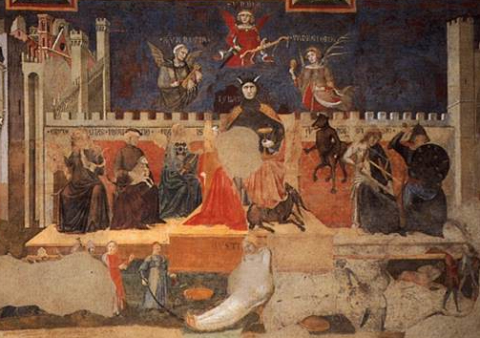
Figure 34: Allegory of bad government (right end of left wall) [back]
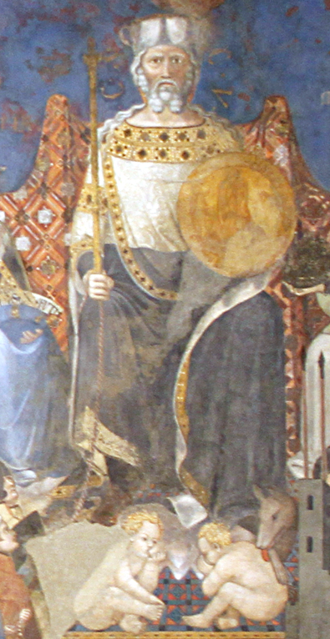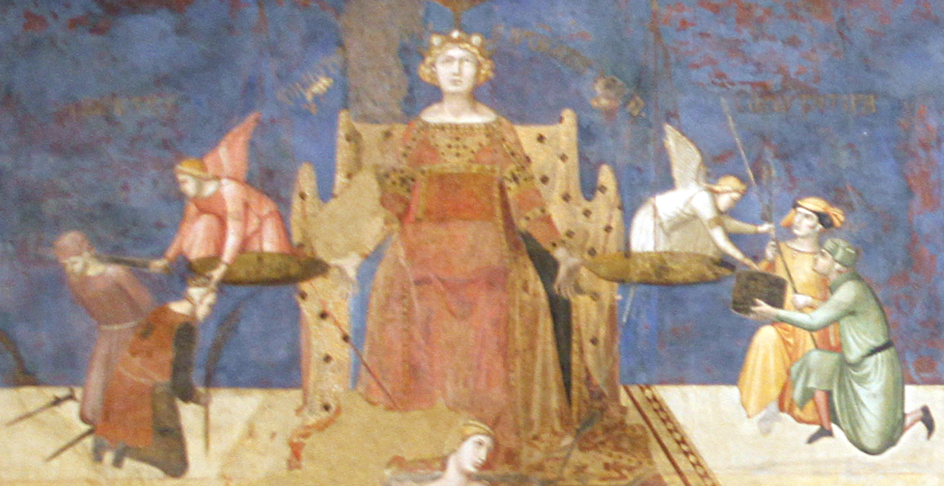
Figure 35: Detail of Fig. 23 [back] Figure 36: Detail of Fig. 23 [back]

References
Belting, H. 1985. “The New Role of Narrative in Public Painting of the Trecento: ‘Historia’ and Allegory.” Studies in the History of Art, Vol. 16, pp. 151-168 (Washington: National Gallery of Art).
Hutchinson, G.E. 1957. “‘Concluding Remarks’ on Animal Ecology and Demography.” Cold Spring Harbor Symposia on Quantitative Biology 22 (2): 415–427.
Meoni, M.L. 2005. Utopia and Reality on Ambrogio Lorenzetti’s Good Government. Florence: Edizioni IFI.
Norman, D. 1995. “‘Love justice, you who judge the earth’: the paintings of the Sala dei Nove in the Palazzo Pubblico, Siena.” In D. Norman, ed., Siena, Florence and Padua: Art, Society and Religion 1280-1400, Vol. II: Case Studies (New Haven, Yale University Press).
Norman, D. 1997. “Pisa, Siena, and the Maremma: a neglected aspect of Ambrogio Lorenzetti 3 paintings in the Sala dei Nove.” Renaissance Studies, Vol. 11 No. 4, pp. 310-342.
Steven Pinker. 2010. “The cognitive niche: Coevolution of intelligence, sociality, and language.” PNAS, vol. 107, suppl. 2, pp. 8993–8999.
Rubenstein, N. 1958. “Political Ideas in Sienese Art: The Frescoes by Ambrogio Lorenzetti and Taddeo di Bartolo inthe Palazzo Pubblico.” Journal of the Warburg and Courtauld Institutes, Vol. 21, No. 3/4,pp. 179-207.
Skinner, Q. 1987. “Ambrogio Lorenzetti: The Artist as Political Philosopher.” Proceedings of the British Academy, Vol. 72, pp. 1-58.

