"#BlackRepresentation: Descriptive Representation, Intersectionality, and Politician’s Responses to Black Political Movements on Twitter”.

Christopher T. Stout
Assistant Professor
Oregon State University
stoutch@oregonstate.edu

Kristine Coulter
Assistant Professor
University of Wisconsin, Green Bay
coulterk@uwgb.edu

Bree Edwards
MPP Student
Oregon State University
breashlenedwards@gmail.com

Abstract: While Twitter plays an increasingly important role in politics, few studies explore which representatives respond to calls for activism. This study examines the impact of descriptive representation and the intersectionality of race and gender on Twitter behavior involving black male-centered and black female-centered political movements. By investigating the use of four hashtags (#blacklivesmatter, #mybrotherskeeper, #bringbackourgirls, and #sayhername), we find that black U.S. House Representatives are significantly more likely to vocalize their support for black interests than comparable white representatives. Moreover, we find that black female and black male representatives are equally likely to speak out about black male-centered issues, but that black female representatives are more likely to speak out about black female-centered issues than all other racial and gender groups. Our results demonstrate not only the significance of descriptive representation, but also that black female representation in government is important to ensure that black women’s issues are not marginalized.
The advent of social media has provided a voice to the voiceless. From Tehran, Iran to Ferguson, Missouri, Twitter gives average citizens the opportunity to publicize their grievances. Recent research demonstrates that Twitter provides a public forum for those who are traditionally underrepresented in government (Murthy, Gross, and Pensavalle 2015). As such, the opportunity to publicize their frustrations may help explain racial minorities’ disproportionate use of Twitter in the United States, a phenomenon that exists despite the technological gap between whites and non-whites (Smith and Brenner 2012). While many black Americans use Twitter to spur social change, few studies examine the substantive effects of their use. As a result, the extent to which blacks’ messages resonate with elected officials is unknown. Moreover, we do not know which representatives, if any, respond to these calls for activism.
This study explores these questions by investigating whether black U.S. House representatives are more likely than their white counterparts to engage in Twitter activism involving racial issues. Specifically, we examine whether black U.S. House Representatives are more likely than white representatives to tweet using black male-centered and black female-centered hashtags (#blacklivesmatter, #mybrotherskeeper, #bringbackourgirls, and #sayhername). Our examination of Twitter provides new insight into the link between descriptive and substantive representation for several reasons. First, examining hashtags enables us to understand racial differences in intensity of responsiveness among representatives. Previous studies of descriptive representation examine roll call votes, the placement of offices, and responses to constituent requests (Swain 1993, Cameron, Epstein, and O'Halloran 1996, Tate 2003, Canon 1999, Grose 2011, Butler and Brookman 2011); however, these are often one-time decisions which make it difficult to measure the intensity of responsiveness. By contrast, politicians can tweet about a specific topic multiple times. As a result, we can gain a better sense of whether black representatives are more responsive to the black community than white representatives, as well as differences in the intensity of responsiveness as measured by how often they speak out about a topic.
Second, and more importantly, investigating Twitter enables us to explore intragroup differences in responsiveness to black political movements centered on black men and black women. Given political constraints on floor activity in the U.S. House of Representatives, only issues that broadly appeal to the political parties are debated and considered for a vote (Cox and McCubbins 2005). Thus, it is rare for issues relevant to black interests to get to the House floor, and even rarer for issues focused squarely on black men or black women to gain attention. As a result, most research on intersectionality and representation examines differences in responsiveness among black men and black women to black interests or differences in responsiveness among black women and white women to women’s issues. To date, no studies that we are aware of examine the ways in which the intersection of race and gender influences representatives’ responsiveness to issues explicitly relevant to individuals who share both their race and gender (see Brown (2014) and Reingold and Smith (2012) for an examination of descriptive representation, intersectionality, and responsiveness on implicitly gender and racial issues such as welfare and elder care). By examining Twitter, which includes a wider variety of calls for social and political change, we provide insight into whether there are gender differences in responsiveness among black representatives to issues that simultaneously affect members of both their racial and gender groups.
We explore two main hypotheses in this study. First, we test whether black representatives are more responsive than white representatives to black Twitter activism. Second, we investigate intragroup differences in responsiveness, seeking to discover whether the intersection of race and gender accounts for variation in representatives’ use of the hashtags under study. To accomplish these goals, we begin this manuscript by reviewing the literature on descriptive and substantive representation in the black community and then discuss our hypotheses, data, and methods. To test our hypotheses, we use original data on the number of times all black members and all white female members of the 113th and 114th Congresses used any of the four hashtags under study. We also analyze the tweets of a stratified sample of 50 white male representatives randomly sampled by party to mirror the partisanship of blacks in Congress.
Using negative binomial regression, we find that black U.S. House representatives are indeed much more likely than white U.S. House representatives to utilize all four racial hashtags. With respect to intragroup differences, we find that black women and black men are equally likely to use hashtags focused on racial issues centered on black men (#blacklivesmatter and #mybrotherskeeper). However, we find that black women are much more likely to speak out and use hashtags centered on racial issues relevant to black women (#bringbackourgirls and #sayhername) than are black men, white women, and white men. We conclude this manuscript by discussing the implications of our results on descriptive representation, substantive representation in new media, and the intersection of race and gender.
Twitter, Descriptive Representation, and the Substantive Representation of Blacks
Twitter as a Platform for Symbolic Representation
In her instrumental work on representation in government, Hanna Pitkin (1967) distinguishes descriptive representation from substantive representation. Descriptive representation occurs when a legislative body mirrors the demographics of their constituency. By contrast, substantive representation occurs when representatives seek to further the policy interests of a particular group of people (Pitkin 1967). While most research exploring the link between descriptive and substantive representation focuses on bill sponsorship and roll call votes (Smooth 2006, Orey et al 2006, Swain 1999, Tate 2003, Canon 1999, Lublin 1997), we turn our attention to social media campaigns, which offer representatives an opportunity to provide symbolic representation. According to Tate (2003), symbolic legislation psychologically reassures constituents that their representatives are responsive to their needs and are working on their behalf (Chapman 2002, Tate 2003). While symbolic legislation may not lead to large scale changes in policy, it is not trivial because it may help empower voters (Tate 2003). As such, social media campaigns provide a cheap, easy way for representatives to respond to and acknowledge their constituents’ concerns. Bringing attention to such issues may be the first step to getting them on the political agenda.
Elected Officials, Twitter, and Descriptive Representation
Given that social media remains a relatively new platform for political activism, few scholars examine how politicians use Twitter to communicate with their constituents and more broadly, the general public. Early research suggests that politicians use Twitter to promote themselves in an effort to appeal to a broad segment of voters (Grant, Moon, and Busby Grant 2010; Golbeck, Grimes, and Rogers 2010; Evans, Cordova, and Sipole 2014). For example, Golbeck, Grimes, and Rogers (2010) explore over 6000 tweets and find that most are either links to news articles about the Congressional representatives themselves or reports on their daily activities. Similarly, Hemphill, Otterbacher, and Shapiro (2013) find that politicians usually use Twitter to advertise their policy positions and rarely use it to spur political action.
Though politicians tend to use Twitter to advance their political careers, research suggests that some use it to take stands on personally meaningful issues (Hemphill, Otterbacher, and Shapiro 2013). Members with strong political leanings or expertise on specific topics use Twitter to issue calls for citizen action (Hemphill, Otterbacher, and Shapiro 2013, Mergel 2012). For instance, representatives who care deeply about immigration strongly encouraged their twitter followers to support bipartisan immigration reform (Hemphill, Otterbacher, and Shapiro 2013). If one’s motivation to tweet is to bring attention to causes that are personally meaningful, we expect that with respect to racially salient issues, black representatives will tweet more frequently than their white counterparts.
There are a plethora of studies demonstrating that black representatives are more responsive to the black community than comparable white representatives (Tate 2003, Baker and Cook 2005, Gamble 2007, Minta 2009, Grose 2011, Butler and Broockman 2011). Through examinations of bill introduction, bill sponsorship, and roll-call votes, scholars find that the descriptive representation of blacks produces better substantive outcomes for this racial group (Bratton and Haynie 1999, Haynie 2001, Tate 2003, Broockman 2013). For example, black legislators are more likely than white legislators to introduce and support bills promoting black interests, such as furthering civil rights and enhancing social welfare policies (Tate 2003, Grose 2011).
Black representatives also appear to provide better constituency services to blacks than do white representatives. For instance, blacks are much more likely to have district offices near black communities than their white counterparts (Grose 2011). Moreover, they are more likely to respond to emails from black constituents than are white legislators (Butler and Broockman 2011, Broockman 2013). Finally, Gillon (2013) demonstrates that black representatives were much more responsive to protests by minorities in their district than were white representatives. Based on this research, black representatives should also be more responsive to calls for political action on racial issues on Twitter than comparable whites.
There are several reasons why we expect black representatives to be more likely than white representatives to speak out on behalf of black interests on Twitter. First, black legislators’ experiences with racial discrimination may propel them to be more vocal in their support of the African American community. Dawson (1994) theorizes that blacks are united by the notion of “linked fate,” believing that their own lives are affected by the lives of other blacks and the overall fate of their race. Linked fate reinforces and strengthens blacks’ racial identity, thereby shaping their political behavior (Dawson 1994). Minta (2009) claims that this sense of linked fate is often present among black legislators because of their personal experiences and continued ties to the black community. Taken together, it is likely that black representatives may be particularly attuned to and/or share the interests of their black constituents and thus be best equipped to speak out on their behalf.
Additionally, many black representatives see it as their responsibility to act on behalf of the black community in an effort to collectively improve blacks’ positions in society. Mansbridge (1999), for example, argues that black representatives’ racial experiences in the United States not only shape their political preferences, but also make them more vigilant about protecting black interests in government. While almost all politicians are strategic and weigh the costs of speaking out against the benefits the action provides for reelection, evidence suggests that blacks strive to advance black interests regardless of electoral consequences. For example, Broockman (2013) finds that black representatives are more likely than white representatives to help blacks outside their district (i.e. a group which cannot vote for them) navigate the unemployment system. Similarly, Minta (2011) demonstrates that blacks in low-profile oversight committees are more likely to voice support for black interests, even though such discussions are unlikely to garner much attention or provide electoral benefits.
Based on prior research, we expect black representatives to be more likely than their white counterparts to use racial hashtags in an effort to advance black political interests. White representatives, however, may be hesitant to speak out for fear that doing so may alienate some supporters. As such, we offer the following hypothesis:
H1: Compared to white representatives, black representatives will be more likely to use all four racial hashtags examined in this study.
Intragroup Differences in the Substantive Representation of Blacks
Research on substantive representation usually consists of single-axis studies that examine either the influence of race or the influence of gender on legislative behavior (Bratton and Haynie 1999, Haynie 2001, Tate 2003, Swers 2002, but see Junn and Brown 2008, Brown 2014, Scola 2013, Reingold and Smith 2012, Minta 2012 as exceptions). Examining intragroup differences is important because one’s identity and political interests are not the sole product of either one’s race or gender. Rather, people have multiple identities that intersect to affect their experiences, perspectives, and statuses in society, a reality captured by the concept intersectionality (Crenshaw 1989). Given the intersectional nature of their identities, individuals cannot parse out each one nor can they prioritize one identity over another (Hancock 2007). Intersectionality also recognizes the ways in which people may be disadvantaged in society because of their multiple, intersecting identities and not a single identity (Collins 2000).
Taking an intersectional approach is critical to exploring legislative behavior (Hancock 2007, Reingold and Smith 2012, Brown 2014). Black men and black women may have experiences, perspectives, and values distinct from others. Although linked fate (Dawson 1994) is used to explain the political behavior of blacks, it has been critiqued for its one-dimensionality. Scholars contend that the concept fails to account for the reality that blacks have multiple identities, and it fails to account for intragroup differences among blacks (Simien 2006, Brown 2014). For instance, Simien (2006) suggests that linked fate must consider the experiences of both black men and black women. By asking the question “Do you think what happens to black women in this country will have something to do with what happens in your life?,” Simien (2006: 35) expands the linked fate model and finds that black women believe their fates are linked with one another’s.
For several reasons, we expect black female representatives to be more likely than black male and white female representatives to use hashtags addressing racial issues relevant to black women. First, compared to black men and white women, black women are “doubly disadvantaged” because they confront a “double minority status” (Prestage 1977: 415). They bear the brunt of both racial and gender discrimination (Simien 2006, Brown 2014). As such, black women may be distinctly burdened compared to black men and white women, and so they may believe they bring a unique perspective to the legislative process (Bartlett 1997). In combination with research suggesting that black women’s perspectives were marginalized in the Civil Rights Movement (Robnett 1997) and undervalued in the women’s movement (Roth 2003), black female representatives may feel more pressure to highlight the unique challenges black women face.
Additionally, black women may make a conscious decision to engage in the substantive representation of black women (Brown 2014, Collins and Moyer 2007). Black women see themselves as “a special interest group fighting to overcome the twin barriers of racial and gender discrimination” (Baxter and Lansing 1983: 108). They may understand that black women have historically lacked political power and political representation, so they may make a concerted effort to represent those who have been historically disadvantaged. Indeed, due to their disadvantaged position, black women may more readily identify with those who experience discrimination (Gay and Tate 1998). Based on this research, we expect that…
H2: Black female representatives will be more likely than black male, white female, and white male representatives to use hashtags focusing on racial issues relevant to black women.
While we expect black women to be especially active in using hashtags targeting black women’s interests, we expect black men to focus their attention on racial issues centered on black men. Similar to the ways in which black female representatives identify with the challenges black women confront, black male legislators may be especially cognizant of the issues that disproportionately affect black men. For instance, compared to other demographic groups, black men face a higher risk of incarceration, and they tend to be less educated (Blumstein 2015, Ocen 2013). Butler (2013) describes these unique circumstances as black male exceptionalism. Butler (2013) notes that politicians, and in particular black male politicians, are generally more likely to introduce “Black Male Achievement” programs to address these racial inequities which often ignore women of color. Along the same lines, Robnett (1997) points out that black men active in the Civil Rights Movement were more likely to focus on black men’s interests than issues that would largely benefit black women. In combination, previous research demonstrates that black male leaders often prioritize black male issues.
Black male leaders’ higher likelihood of speaking out for individuals who share their race and gender may be tied to their perceived connections to other black males (Simien 2006). If black men feel greater ties to those who share their race and gender, they may feel a greater responsibility to speak out on their behalf. As a result, we expect that…
H3: Black male representatives will be more likely than black female, white female, and white male representatives to use hashtags focusing on racial issues relevant to black men.
Twitter Campaigns and Hashtags
We selected four hashtags, discussed in further detail below, to examine the influence of descriptive representation on two dimensions of responsiveness. The first dimension assesses whether the hashtag was related to a movement associated with African Americans. To meet this criterion, the main actors and goals of the movement must be directed, at least in part, towards blacks. The second dimension involves the intersection of race and gender, and we selected hashtags predominantly associated with issues relevant to either black men or black women. Issues are either black male-centered or black female-centered if they are disproportionately tied to one racial and gender group, or if they seek to explicitly advance the interests of either black men or black women. In combination, the four hashtags presented below provide considerable diversity in a number of areas including their levels of salience through the examination of popular hashtags (#blacklivesmatter, #bringbackourgirls) and less utilized hashtags (#mybrotherskeeper, #sayhername). Moreover, the hashtags include those which may be perceived as being more confrontational (#blacklivesmatter, #sayhername) and those which are perceived as being politically innocuous (#mybrotherskeeper, #bringbackourgirls). Finally, the hashtags are diverse in their political goals (See supplemental appendix for information on content of these tweets).
#blacklivesmatter
The first hashtag, #blacklivesmatter, was the second most popular hashtag in 2015 (only #jesuisparis generated more tweets) according to Twitter.com. Black Lives Matter was founded by three black women, Alicia Garza, Opal Tometi, and Patrisse Cullors in 2012, in response to George Zimmerman’s acquittal in the shooting of unarmed black teenager Trayvon Martin. The movement gained significant traction after the police shooting of Michael Brown in Ferguson, Missouri on August 9th, 2014 and the subsequent acquittal of Darren Wilson. In the three weeks after Brown’s death, #blacklivesmatter grew from about 200,000 tweets to over 12 million tweets (Freelon, McIlwain, and Clark 2016). In total, #blacklivesmatter amassed over 41 million tweets since its inception.
While the goals of Black Lives Matter are diverse, its hashtag is primarily associated with combatting biases against black men in the criminal justice system and holding their killers accountable. A study by Freelon, McIlwain, and Clark (2016), found that the top ten names associated with #blacklivesmatter were all black men (e.g. Michael Brown, Eric Garner, Walter Scott, Freddie Gray and Tamir Rice). By contrast, Tanisha Anderson was one of only two women with more than 1000 tweets that included her name and #blacklivesmatter. Yet, Anderson still had less than .01% of the number of tweets associated with #blacklivesmatter as Michael Brown. The lack of attention on black women led to a separate movement on twitter, #sayhername, discussed in further detail below. In spite of the fact that the movement was started by black women, #blacklivesmatter is considered a black male-centered hashtag due to the movement’s disproportionate focus on black men.
#mybrotherskeeper
In the wake of the shooting of Trayvon Martin in 2012, the White House created a My Brother’s Keeper initiative with the goal of providing boys and men of color with resources to succeed in the United States. While criticized for not including girls and women of color, the initiative’s focus remains on minority males. My Brother’s Keeper is a $200 million program that provides grants for mentorships, summer jobs, and other forms of support for men and boys of color. To generate more involvement in the program, the White House launched a Twitter campaign and asked users to use #mybrotherskeeper to describe how they looked out for black male youth. This hashtag is black male-centered because the initiative’s target is on men of color, particularly black men.
#bringbackourgirls
On April 15th, 2014, members of the terrorist group Boko Haram entered a government secondary school in Northeast Nigeria and kidnapped 276 female students. The girls at the school were taken and threatened to be sold into slavery. Following major protests in cities around the world calling for the girls’ return, #bringbackourgirls was created. Within a week, the hashtag was tweeted over two million times (Pendergrass 2015), including tweets by popular figures like Michelle Obama and influential politicians such as civil rights activist and Georgia Congressman John Lewis. While the call to bring back our girls was universal and one of the top ten hashtags in 2014 (Twitter.com), it is a black female-centered issue because the primary victims and calls for activism centered on black girls at the Nigerian school.
#sayhername
As mentioned in previous sections, several activists were frustrated with the lack of black women’s representation in the Black Lives Matter movement. In response to the lack of attention on black women who were murdered or died in a suspicious manner in the hands of law enforcement, the African American Policy Forum (AAPF) created #sayhername. Its purpose was to shed light on the mistreatment of black women such as Sandra Bland, Shelly Frey, and Rekia Boyd by law enforcement. According to the AAPF, its goal was to ensure that police brutality against black women received equal attention as police brutality against black men. In short, similar to #blacklivesmatter, #sayhername sought to ensure that black women were also treated fairly by the criminal justice system. While #blacklivesmatter has received significant attention, #sayhername has received much less attention by the public.
Data and Methods
To assess the influence of race and gender on Twitter activism involving black male-centered and black female-centered issues, we examine the Twitter pages of all black representatives and all white female representatives in the 113th and 114th Congresses. We also investigate a random stratified sample of 50 white male representatives, sampled to match the partisanship of black representatives. All representatives under study had an official Twitter account. Using each representative’s Twitter handle, we searched for whether and how often they used the following hashtags: #blacklivesmatter, #mybrotherskeeper, #bringbackourgirls, and #sayhername. The dependent variable is a count of each representative’s use of each of these hashtags.
The independent variable of interest is first the race of the representative and then the interaction of race and gender of the representative. Given that our focus is on black male-centered and black female-centered issues, we expect that black men and black women will be more likely to speak out when the hashtag is tied to their race and most likely to speak out when the issue is tied to both their race and gender. To isolate the relationship of race and gender on hashtag use, we control for several individual and contextual variables. First, we control for age. Older black representatives were likely involved in the Civil Rights Movement and as a result may be more responsive to black political movements compared to younger representatives (Gillespie 2010). However, younger representatives could be more responsive to Twitter campaigns than their older counterparts since younger individuals are more likely to use twitter (Smith and Brenner 2012).
We also control for partisanship. All else being equal, we expect Democratic representatives to use each hashtag more frequently than Republican representatives given the party’s connection to the black community. This may be particularly true for #blacklivesmatter and #sayhername because in essence these hashtags advocate for victims’ rights, a concern that tends to generate more support among Democrats. Moreover, since the My Brother’s Keeper initiative was launched by President Obama, we expect Democrats to be more supportive than Republicans.
In addition to individual level variables, we control for two contextual measures. First, we control for the percent of blacks in a representative’s district. Representatives in majority black districts may feel that speaking out on issues of concern to black voters will increase their chances of reelection. By contrast, representatives in majority white districts may feel pressure to remain silent on explicitly racial issues to appeal to their white constituents. This control takes on additional significance with the Black Lives Matter movement given that public opinion polls around the movement are so racially polarized (Freelon, McIlwain, and Clark 2016).
We also control for Cook’s partisan voting index for each district. Districts which are more liberal may provide representatives with greater opportunities to support black interests than conservative districts. Finally, we control for the number of tweets representatives posted from the creation of the hashtag until March 1st, 2016, the final date of data collection. All else being equal, representatives who tweet frequently should be more likely to use one of the hashtags under study.
Results
Descriptive Statistics
[Insert Figure 1 Here]
The results in Figure 1 present the average number of tweets using A: #blacklivesmatter, B: #mybrotherskeeper, C: #bringbackourgirls, and D: #sayhername by U.S. House representatives’ race and gender. In all four graphs there appears to be a clear racial divide. Black representatives were much more likely to speak out on racially tinged movements than their white counterparts. On average, black men used #blacklivesmatter in 2.9 tweets and black women used the hashtag in 2.5 tweets. By comparison, on average white men used #blacklivesmatter in .1 tweets and white women used the hashtag in .2 tweets. Based on a two sample t-test, the difference in hashtag use between blacks and whites was significant at .05. While black and white representatives differed, there was no gender difference in the use of #blacklivesmatter among black representatives. On average, black men used #blacklivesmatter more frequently than did black women, but the difference was only about .4 tweets and is not significant at .05.
We find a similar, however, smaller relationship between race and use of #mybrotherskeeper. On average, black representatives (average=1.04) used the hashtag in about one more tweet than their white counterparts (average=.15) While this difference is smaller than #blacklivesmatter, it is still statistically significant at .05 based on a two sample t-test. While racial differences persist with the use of #mybrotherskeeper, we find no relationship between gender and race. In fact, contrary to expectations, black women were slightly more likely to use #mybrotherskeeper than their male counterparts. However, this difference is insignificant.
Black representatives were also more likely than white representatives to use black female-centered hashtags. Removing Congresswoman Frederica Wilson, who issued over 1,000 tweets using #bringbackourgirls, black representatives were about three times as likely to use #bringbackourgirls as were white representatives. In a similar vein, while only one white representatives used #sayhername in a tweet, seven black representatives used the hashtag. The difference in the frequency of the use of #sayhername between black and white representatives is significant at .05.
While there were no gender differences among black representatives with regard to the black male-centered tweets, we find that black women consistently issued more black female-centered tweets than their male counterparts. Even after removing Congresswoman Frederica Wilson, black female representatives were about three times more likely to use #bringbackourgirls than black male representatives. This gender difference is significant at .05 based on a two sample t-test. While eight representatives used #sayhername at least once, six of those eight representatives who used the hashtags were black women. Black female representatives were almost four times as likely to use #sayhername compared to black male representatives, a difference which is significant at .05.
Regression Results Predicting Racial Differences in Twitter Behavior
To examine the effects of race on the use of black male-centered and black female-centered hashtags, we estimate four separate negative binomial regression models predicting the count of A: #blacklivesmatter, B: #mybrotherskeeper, C: #bringbackourgirls, and D: #sayhername. These results are presented in Table 1. We estimate negative binomial regression in lieu of poisson regression because several of the dependent variables have problems with overdispersion. Additionally, we used the “nb_adjust” in stata to remove outliers in the #bringbackourgirls tweets. Given that we had at least one substantial outlier, Representative Frederica Wilson (D-FL), it is important to make such adjustments.
[Insert Table 1 Here]
[Insert Figure 2 Here]
The results in Table 1 provide strong support for our first hypothesis. Black representatives were more likely to voice their support for black political movements via Twitter than their white counterparts. In all four Twitter movements under study, blacks were significantly and substantially more vocal than whites. Figure 2 presents the predicted counts based on the regression models presented in Table 1. According to Figure 1A, holding constant several variables, including partisanship and the percent of blacks in a representative’s district, black representatives are predicted to issue a little more than one additional tweet (1.39) using #blacklivesmatter than white representatives (.28). There appears to be a similar gap for #mybrotherskeeper in Figure 2B. While white representatives are predicted to put out only .15 tweets with #mybrotherskeeper, holding all else constant, black representatives are predicted to put out 1.05 tweets using the same hashtag.
The highest difference in hashtag use between black and white representatives occurred with respect to the Bring Back Our Girls campaign. Figure 2C demonstrates that on average, black representatives are predicted to issue 8.32 tweets with #bringbackourgirls since the kidnapping of Nigerian girls at the Chibok School. By contrast, whites issued about three tweets using the hashtag. Finally, while fewer representatives used #sayhername compared to the other hashtags, black representatives were still significantly more likely to use the hashtag than comparable white representatives.
No other variable in our model, including the percent of blacks in the representative’s district or the partisanship of the district, consistently predicted the use of hashtags concerning black-centered movements. By far, the strongest predictor is the representative’s race. Nonetheless, there are some interesting findings to note. We find that representatives who reside in liberal districts, as measured by the Cook’s Partisan Voting Index, were more likely to use #blacklivesmatter. Given that the hashtag is racially polarizing, particularly among conservatives, it is not surprising that representatives were more likely to use the hashtag when their electorate was more liberal.
We also find that women were much more likely to use #bringbackourgirls than their male counterparts. This suggests that female representatives are more active in Twitter movements when the primary focus is on other women, which is consistent with research revealing gender differences in legislative behavior (Thomas and Welch 1991, Berkman and O’Connor 1993, Thomas 1994, Swers 2002, Wolbrecht 2002, Bratton 2005, Gerrity, Osborn, Mendez 2007). Democrats were marginally more likely to tweet using #bringbackourgirls than their Republican counterparts. Finally, the number of tweets the representative posted from the start of the event to March 1st, 2016 was either a significant or marginally significant predictor of each of the four hashtags in this analysis.
Intragroup Differences in Twitter Behavior
To examine gender differences in responsiveness to black male-centered or black female-centered hashtags among representatives of different racial and gender groups, we re-estimate the models presented in Table 1 but create dummy variables for each group (e.g. black men, black women, white men, white women). We use black male representatives as the omitted category for the black male-centered hashtags and black female representatives as the omitted category for the black female-centered hashtags. By using these groups as the omitted categories, we can better explore whether any other racial and gender group is more responsive to hashtags that disproportionately represent black males and black females.
[Insert Table 2 about Here]
[Insert Figure 3 about Here]
Table 2 presents negative binomial regression estimates predicting the count of A: #blacklivesmatter, B: #mybrotherskeeper, C: #bringbackourgirls, and D: #sayhername. Figure 3 presents corresponding predicted counts derived from these models. Model A demonstrates that black male representatives were more likely than white male representatives to use #blacklivesmatter. Holding all other variables constant, black males are predicted to use the #blacklivesmatter more than one additional time than white males. While black and white male representatives significantly differed in their use of #blacklivesmatter, black men and female representatives of both races did not. Thus, black men were not more likely to use #blacklivesmatter than comparable white or black women.
Black male representatives were significantly more likely to use #mybrotherskeeper than both white male and white female representatives. Black male representatives were about nine times and six times more likely to tweet #mybrotherskeeper than were white male and white female representatives, respectively. While black men were more active than white representatives, there was no significant gender difference in the use of #mybrotherskeeper among black male and black female representatives.
Taken together, the analysis of #blacklivesmatter and #mybrotherskeeper does not provide support for our third hypothesis. Black men and black women were equally as likely to use black male-centered hashtags. This result may stem from black women’s ability to identify with those who are disadvantaged and face any type of discrimination (Gay and Tate 1998, Brown 2014). Moreover, it may be that black women see preventing biases in the criminal justice system or black men’s upward mobility as being important in enhancing their own opportunities (Smooth 2011). Regardless, the result suggests that black women do not subordinate their racial identities to their gender identities, and they maintain their support for black interests, even if those interests are seemingly centered on black men.
While we do not find support for our third hypothesis, we do find support for our second hypothesis. In particular, black women were significantly more likely than any racial and gender group to use black female-centered hashtags like #bringbackourgirls in their tweets. According to Figure 3C, black women were 5 times and almost 2.5 times as likely as white male and white female representatives, respectively, to issue a tweet using #bringbackourgirls. Additionally, the gender difference in hashtag use among black representatives is also significant and substantial. Black women were almost twice as likely to use #bringbackourgirls as comparable black male representatives.
We find a similar relationship with #sayhername. Namely, black female representatives were more likely than black male and white female representatives to use that hashtag. According to Figure 3D, the difference is largely a function of the silence among white female representatives and black male representatives. There were no significant differences between black female representatives and white male representatives, however, this is mostly driven by the fact that no white male representatives issued a tweet using #sayhername, which made it difficult for the model (which uses a maximum likelihood estimator) to estimate these differences. Overall, the results suggest that the interaction of race and gender significantly influences Twitter behavior.
Conclusion
On the House Floor, Representative Frederica Wilson (D-FL) made an impassioned speech drawing attention to the world’s inability to free the black girls kidnapped by Boko Haram on April 14th, 2014. She implored people to express their outrage on Twitter, stating “We will be watching what happens in Nigeria closely and by tweeting #bringbackourgirls, #joinrepwilson the world will know we have not forgotten. Tweet, Tweet, Tweet! (Library of Congress)” Representative Wilson’s speech demonstrates her desire to remember the black girls’ plight at the Chibok School and Twitter’s ability to serve as a vehicle for bringing attention to the issue.
This research demonstrates that black politicians like Frederica Wilson are more likely to use Twitter to highlight issues that disproportionately affect the black community. Furthermore, it is black women who are the most vocal in shedding light on issues that specifically affect black women. This research adds to the growing literature demonstrating that the descriptive representation of blacks produces a government which is more responsive to minority interests (Tate 2003, Baker and Cook 2005, Gamble 2007, Minta 2009, Grose 2011, Butler and Broockman 2011). Black representatives not only provide substantive representation to blacks in traditional forums such as the House floor or in committees but also in social media.
Compared to white representatives, blacks were more likely to use each of the four racial hashtags under study, which spanned policing, international affairs, and inequality. Moreover, the gap in hashtag use was substantial; blacks were 2.5 to 7 times more likely to use a hashtag concerning black political movements. This demonstrates that black representatives are more likely to speak out multiple times compared to their white counterparts, and not simply once.
While blacks were more likely to use each hashtag under study compared to whites, we did not find gender differences in the use of black male-centered hashtags among black representatives. In other words, black female representatives were equally attentive to black male-centered issues as black male representatives. However, similar to Robnett’s (1997) research, we find that black men were less responsive to issues disproportionately affecting black women than their black female counterparts. In fact, compared to black men, white women, and white men, black women are much more likely to use hashtags focused on black women’s interests. While our study demonstrates that the descriptive representation of blacks is integral to their substantive representation, it also speaks to the importance of intragroup diversity. Given the racial and gender differences in responsiveness to black female centered issues, increasing the number of women of color in Congress is necessary to maximize the representation of black women.
Though this study advances our understanding of the relationship between descriptive representation, intersectionality, and substantive representation, more work is necessary. Future studies should examine the impact of elected officials’ tweets on public opinion and/or political empowerment. It is possible that when black representatives speak out on behalf of black interests, political efficacy among blacks increases. Another possibility is that politicians’ hashtag use may compel voters to take the issues under study—police brutality and racial inequality—more seriously. Second, future research should reexamine our results with a larger sample of black elected officials. While we use the universe of black elected officials in the 113th and 114th Congress, there are still fewer than 50 black U.S. House Representatives and only 18 black female representatives. We attempted to broaden our sample by using state legislators, but a large percentage (~40%) did not have twitter pages. Thus, as black representation and twitter usage grows, future research should reassess our results and delve deeper into within group differences, possibly beyond gender, in legislative behavior among African Americans.
Finally, while we initially attempted to use a wider number of hashtags, many that we examined including #blackgirlmagic, #fireelizabethlauten, and #youoksis, were never used by members of Congress. As a result, we could not statistically examine these movements in our study. While our analysis allows us to examine who speaks out about a wide variety of racial issues on twitter, there are still some racial twitter movements which get little to no attention at all. As a result, more work needs to be done to explore why some twitter movements get attention and others are ignored. While more research is necessary, this study provides an important step in understanding the link between black representation, intersectionality, and the use of new media.
Bibliography
Baker, Andy, and Corey Cook. "Representing black interests and promoting black culture: The importance of African American descriptive representation in the US House." Du Bois Review 2.02 (2005): 227-246.
Barrett, Edith J. “Gender and Race in the State House: The Legislative Experience.” Social Science Journal 34.2 (1997): 131-144.
Baxter, Sandra, and Marjorie Lansing. Women and politics: The visible majority. University of Michigan Press, 1983.
Berkman, Michael B., and Robert E. O'Connor. "Do women legislators matter? Female legislators and state abortion policy." American Politics Quarterly 21.1 (1993): 102-124.
Blumstein, Alfred. "Racial Disproportionality in Prison." Race and Social Problems. Springer New York, 2015. 187-193.
Bratton, Kathleen A., and Kerry L. Haynie. "Agenda setting and legislative success in state legislatures: The effects of gender and race." The Journal of Politics 61.03 (1999): 658-679.
Broockman, David E. "Black politicians are more intrinsically motivated to advance Blacks’ interests: A field experiment manipulating political incentives." American Journal of Political Science 57.3 (2013): 521-536.
Brown, Nadia E. Sisters in the Statehouse: Black Women and Legislative Decision Making. Oxford University Press, 2014.
Butler, Paul D. 2013. "Black male exceptionalism? The problems and potential of Black male-focused interventions." The Problems and Potential of Black Male-Focused Interventions: 485-511.
Butler, Daniel M., and David E. Broockman. "Do politicians racially discriminate against constituents? A field experiment on state legislators." American Journal of Political Science 55.3 (2011): 463-477.
Collins, Patricia Hill. "Gender, black feminism, and black political economy."The Annals of the American Academy of Political and Social Science 568.1 (2000): 41-53.
Collins, Todd, and Laura Moyer. "Gender, race, and intersectionality on the federal appellate bench." Political Research Quarterly (2007).
Cox, Gary W., and Mathew D. McCubbins. Setting the agenda: Responsible party government in the US House of Representatives. Cambridge University Press, 2005.
Crenshaw, Kimberle. "Demarginalizing the intersection of race and sex: A black feminist critique of antidiscrimination doctrine, feminist theory and antiracist politics." U. Chi. Legal F. (1989): 139.
Dawson, Michael C. Behind the mule: Race and class in African-American politics. Princeton University Press, 1994.
Evans, Heather K., Victoria Cordova, and Savannah Sipole. "Twitter style: An analysis of how house candidates used Twitter in their 2012 campaigns."PS: Political Science & Politics 47.02 (2014): 454-462.
Freelon, Deen, Charlton D. McIlwain, and Meredith D. Clark. “Beyong the Hashtag” Report Written for American University Center for Media and Social Impact, 2016
Gamble, Katrina L. "Black political representation: An examination of legislative activity within US House committees." Legislative Studies Quarterly 32.3 (2007): 421-447.
Gay, Claudine, and Katherine Tate. "Doubly bound: The impact of gender and race on the politics of black women." Political Psychology 19.1 (1998): 169-184.
Gillespie, Andra, ed. Whose Black politics?: cases in post-racial Black leadership. Routledge, 2010.
Gillion, Daniel Q. The political power of protest: Minority activism and shifts in public policy. Cambridge University Press, 2013.
Golbeck, Jennifer, Justin M. Grimes, and Anthony Rogers. "Twitter use by the US Congress." Journal of the American Society for Information Science and Technology 61.8 (2010): 1612-1621.
Grant, Will J., Brenda Moon, and Janie Busby Grant. "Digital dialogue? Australian politicians' use of the social network tool Twitter." Australian Journal of Political Science 45.4 (2010): 579-604.
Grose, Christian R. Congress in black and white: Race and representation in Washington and at home. Cambridge University Press, 2011.
Hancock, Ange-Marie. "When multiplication doesn't equal quick addition: Examining intersectionality as a research paradigm." Perspectives on politics 5.01 (2007): 63-79.
Haynie, Kerry Lee. African American legislators in the American states. Columbia University Press, 2001.
Hemphill, Libby, Jahna Otterbacher, and Matthew Shapiro. "What's congress doing on twitter?." Proceedings of the 2013 conference on Computer supported cooperative work. ACM, 2013.
Junn, Jane, and Nadia Brown. "What Revolution?." In Political Women and American Democracy Wolbrecht, Christina, Karen Beckwith, and Lisa Baldez. Political women and American democracy. Cambridge University Press, 2008.
Mansbridge, Jane. "Should blacks represent blacks and women represent women? A contingent “yes”." The Journal of politics 61.03 (1999): 628-657.
Mergel, Ines. Social media in the public sector: A guide to participation, collaboration and transparency in the networked world. John Wiley & Sons, 2012.
Minta, Michael D. "Legislative oversight and the substantive representation of Black and Latino interests in Congress." Legislative Studies Quarterly34.2 (2009): 193-218.
Minta, Michael D. Oversight: Representing the interests of Blacks and Latinos in congress. Princeton University Press, 2011.
Minta, Michael D. "Gender, race, ethnicity, and political representation in the United States." Politics & Gender 8.04 (2012): 541-547.
Murthy, Dhiraj, Alexander Gross, and Alexander Pensavalle. "Urban Social Media Demographics: An Exploration of Twitter use in Major American Cities." Journal of Computer‐Mediated Communication (2015).
Ocen, Priscilla A. "Unshackling Intersectionality." Du Bois Review: Social Science Research on Race 10.02 (2013): 471-483.
Pendergrass, William Stanley. "# NOTALLMEN,# BRINGBACKOURGIRLS &# YESALLWOMEN: Three Months of Gender Discussion in the Age of Twitter." Issues in Information Systems 16.1 (2015).
Prestage, Jewel L. "Black women state legislators: A profile." A portrait of marginality: The political behavior of the American woman (1977): 401-18.
Reingold, Beth, and Adrienne R. Smith. "Welfare policymaking and intersections of race, ethnicity, and gender in US state legislatures." American Journal of Political Science 56.1 (2012): 131-147.
Robnett, Belinda. How long? How long?: African-American women in the struggle for civil rights. Oxford University Press 1997
Roth, Silke. Building movement bridges: the coalition of Labor Union Women. No. 138. Greenwood Publishing Group, 2003.
Scola, Becki. Gender, Race, and Office Holding in the United States: Representation at the Intersections. Vol. 13. Routledge, 2013
Simien, Evelyn M. “Race, Gender, and Linked Fate.” Journal of Black Studies 35.5 (2005): 529-550.
Simien, Evelyn M. Black feminist voices in politics. SUNY Press, 2006.
Smith, Aaron and Joanna Brenner “Twitter Use 2012” Pew Research Center. Retrieved from http://www.pewinternet.org/2012/05/31/twitter-use-2012/ on March 13, 2016
Smooth, Wendy. “Standing for Women? Which Women? The Substantive Representation of Women’s Interests and the Research Imperative of Intersectionality.” Politics and Gender 7.3 (2011): 436-441.
Swers, Michele L. The difference women make: The policy impact of women in Congress. University of Chicago Press, 2002.
Wilson, Frederica. Boko Haram Speech Delivered on the Floor of the U.S. House of Representatives” March 26, 2015 retrieved from Thomas.loc.gov
Tate, Katherine. Black faces in the mirror: African Americans and their representatives in the US Congress. Princeton University Press, 2003.

Figure 1: Average A: Black Lives Matter, B: My Brother’s Keeper, C: Bring Back Our Girls, and D: Say Her Name Tweets by Black and White Representatives by Gender.
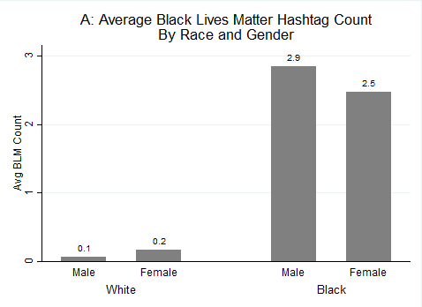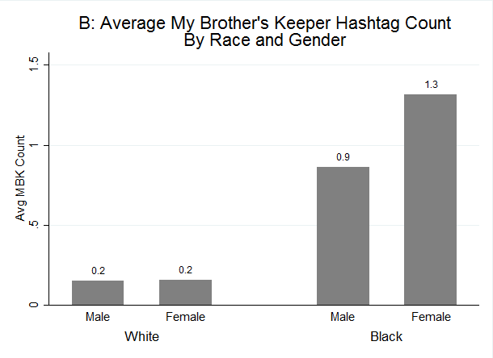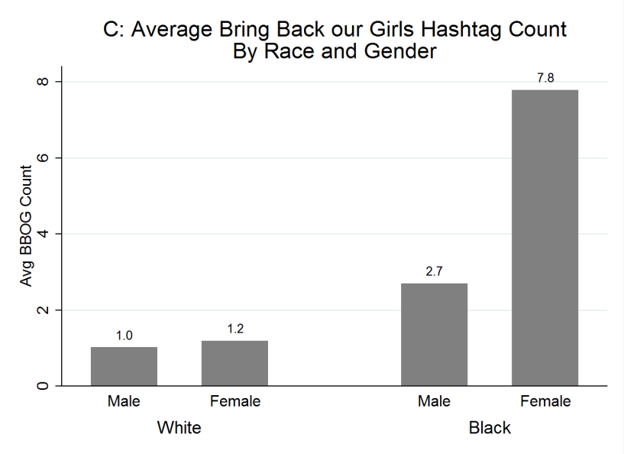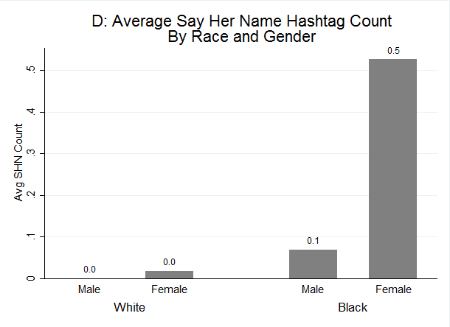

Figure 2: Predicted Counts for A: Black Lives Matter, B: My Brother’s Keeper, C: Bring Back Our Girls, and D: Say Her Name Tweets by Race (Results Derived from Models Presented in Table 1).
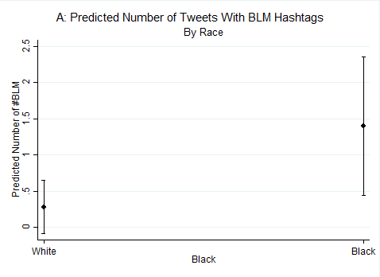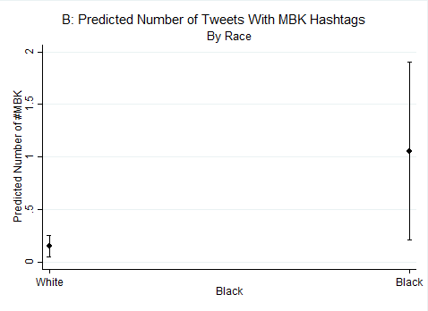
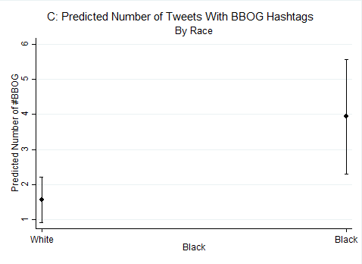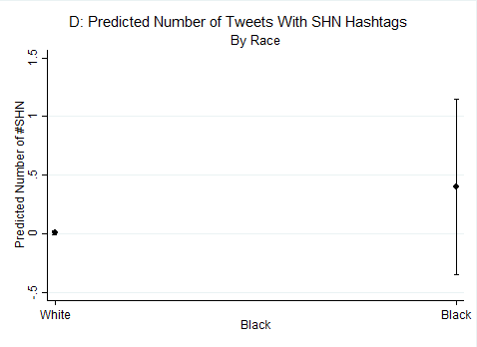
Figure 3: Predicted Counts for A: Black Lives Matter, B: My Brother’s Keeper, C: Bring Back Our Girls, and D: Say Her Name Tweets by Race and Gender (BM=Black Male, BF=Black Female, WF=White Female, WM=White Male).
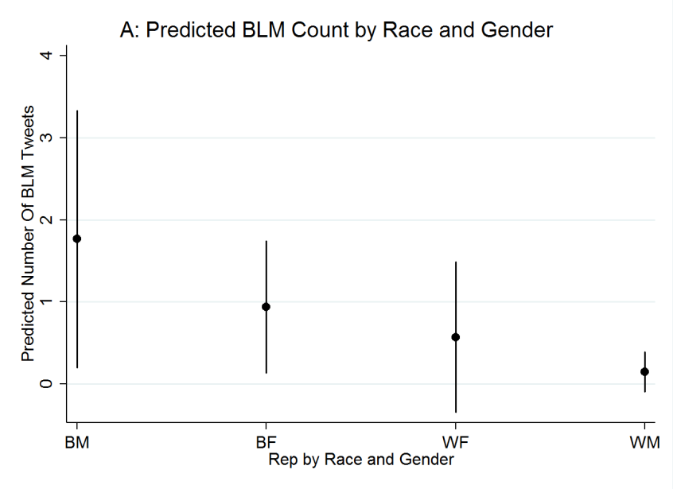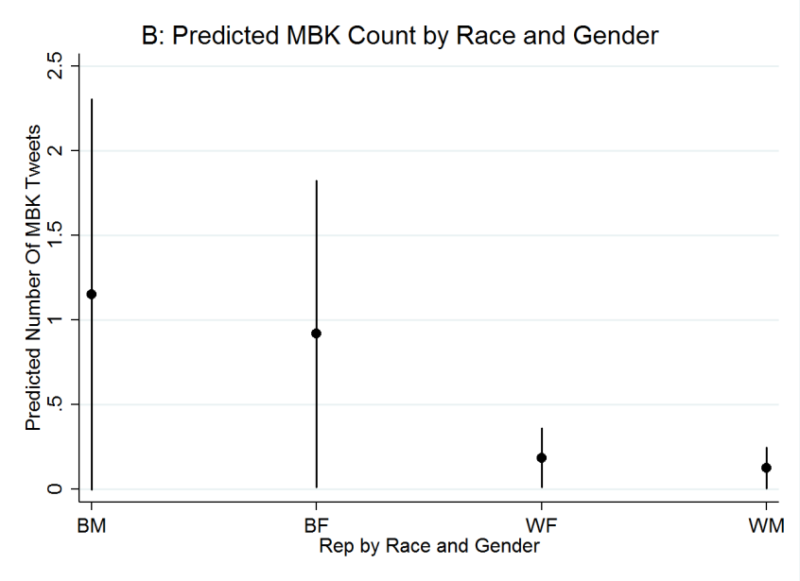
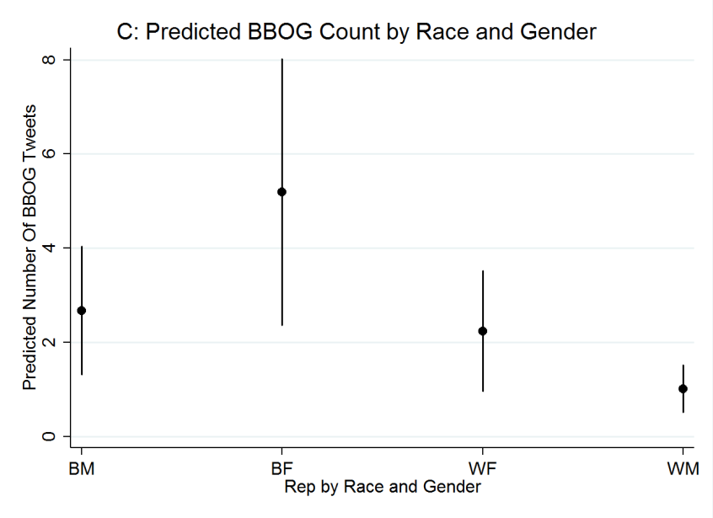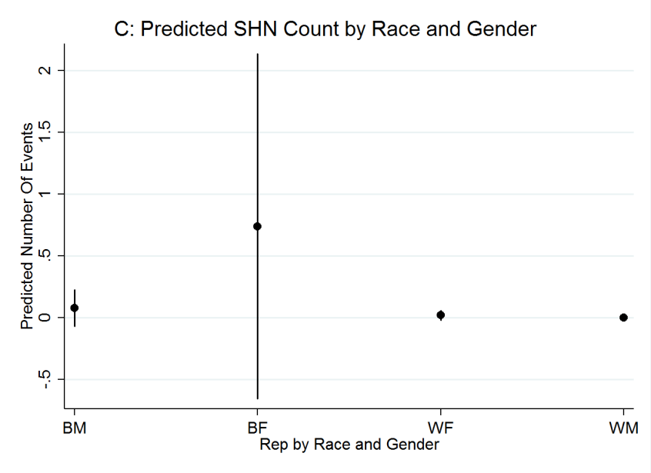

Table 1: Negative Binomial Regression Predicting the Count of Tweets with A: Black Lives Matter, B: My Brother’s Keeper, C: Bring Back Our Girls, and D: Say Her Name Hashtags.
 | A: | B: | C: | D:
VARIABLES | BLM Tweets | MBK Tweets | BBOG Tweets | SHN Tweets
Black | 1.62** | 1.94*** | 0.98*** | 3.83**
 | (0.80) | (0.58) | (0.35) | (1.54)
Female | 0.12 | 0.05 | 1.14*** | 2.36**
 | (0.52) | (0.45) | (0.27) | (1.03)
Age | -0.03 | 0.01 | 0.01 | -0.01
 | (0.03) | (0.02) | (0.01) | (0.04)
Cook's PVI | 0.08*** | 0.03 | 0.01 | 0.01
 | (0.03) | (0.02) | (0.01) | (0.05)
Democrat | 14.18 | 15.79 | 0.97* | 15.00
 | (941.26) | (1,506.90) | (0.53) | (1,742.89)
Percent Black | 0.01 | -0.02 | 0.01 | -0.03
 | (0.02) | (0.02) | (0.01) | (0.02)
# of Tweets | 0.00* | 0.00* | 0.00*** | 0.00*
 | (0.00) | (0.00) | (0.00) | (0.00)
Constant | -16.11 | -19.12 | -3.87*** | -21.48
 | (941.26) | (1,506.90) | (0.81) | (1,742.89)
lnalpha | 1.14*** | 0.80** | 0.22 | -0.49
 | (0.31) | (0.39) | (0.18) | (1.51)
Observations | 147 | 147 | 147 | 147
*Significant at .10, **Significant at .05, *** Significant at .01. Standard Errors in Parentheses.

Table 2: Negative Binomial Regression Predicting the Count of Tweets with A: Black Lives Matter, B: My Brother’s Keeper, C: Bring Back Our Girls, and D: Say Her Name Hashtags by Representative’s Race and Gender.
 | A: | B: | C: | D:
 | BLM Tweets | MBK Tweets | BBOG Tweets | SHN Tweets
Black Female | -0.63 | -0.23
 | (0.60) | (0.61)
Black Male |  |  | -0.66** | -2.25**
 |  |  | (0.34) | (1.04)
White Female | -1.13 | -1.82** | -0.84** | -3.65**
 | (0.91) | (0.75) | (0.42) | (1.58)
White Male | -2.50*** | -2.21*** | -1.63*** | -19.60
 | (0.92) | (0.71) | (0.38) | (2,720.48)
Age | -0.03 | 0.01 | 0.00 | -0.01
 | (0.03) | (0.02) | (0.01) | (0.04)
Cook's PVI | 0.08*** | 0.03 | 0.01 | 0.02
 | (0.03) | (0.02) | (0.01) | (0.05)
Democrat | 14.90 | 15.57 | 0.71 | 16.32
 | (1,340.18) | (1,298.30) | (0.48) | (3,441.11)
Percent Black | 0.01 | -0.02 | 0.01 | -0.03
 | (0.02) | (0.02) | (0.01) | (0.02)
# of Tweets | 0.00** | 0.00* | 0.00*** | 0.00*
 | (0.00) | (0.00) | (0.00) | (0.00)
Constant | -15.50 | -16.90 | -0.88 | -16.73
 | (1,340.18) | (1,298.30) | (0.78) | (3,441.11)
LN Alpha | 1.01*** | 0.80** | -0.13 | -0.53
 | (0.31) | (0.38) | (0.22) | (1.55)
Observations | 147 | 147 | 147 | 147
*Significant at .10, **Significant at .05, *** Significant at .01. Standard Errors in Parentheses. Black Males are Excluded for Purposes of Comparison in Models A & B. Black Females are Excluded for Purposes of Comparison in Models C & D.

To ensure that the results in the study are not driven by blacks being more likely to tweet about all events, we replicated the analysis examining two non-racial hashtags (#jesuisparis and #plannedparenthood). The results in the supplemental appendix demonstrate that blacks were not significantly different from white representatives for these non-racial hashtags.
To select hashtags to examine, we looked at a comprehensive list of the top hashtags from Twitter.com and the Root.com for 2014 and 2015 and selected those which had a racial focus. We excluded hashtags like #youoksis, because no House Representative used the hashtag. Thus, our study has a baseline for levels of salience to government officials.
In the supplemental appendix, we content coded and analyzed tweets which used the hashtags #bringbackourgirls and #blacklivesmatter. Unfortunately, #sayhername and #mybrotherskeeper had too few tweets to conduct meaningful statistical analysis of their content. Overall, we find that there were no racial or gender differences in the content of the tweets. Thus, while blacks were more likely to tweet using #bringbackourgirls and #blacklivesmatter, there were not significant differences in the content of the tweets among those that did use the hashtags.
We also searched for #BLM, #MBK, and #SHN to ensure that potential differences in hashtag use were not due to abbreviations.
The start date for #blacklivesmatter is August 9th, 2014, the date Michael Brown was shot in Ferguson, MO. Data collection for #mybrotherskeeper begins on February 27th, 2014, the day the initiative was announced. The start date for #bringbackourgirls is April 14th, 2014, the day of the kidnapping, and data collection for #sayhername starts on February 1st, 2015.
Nb_adjust identifies and adjusts or removes outliers based on a negative binomial distribution.

