The Impact of Climate Disasters on Transactional Sex in the United States
Alexandra Sletta

Abstract
Transactional sex is a known phenomenon where one trades sexual favors in exchange for resources or money. This occurrence is mainly studied in developing countries in Africa and Asia and is largely ignored in the United States. I argue that as the impact of climate change increases the intensity and frequency of climate disasters, more women will take part in transactional sex in the United States. The main finding of my research is that people who have experienced a climate disaster and women, in general, are more likely to be in relationships where they receive resources or money. Also, people experiencing poverty are more likely to leave relationships where they are no longer provided with resources and women are more likely to be poor than men are. This is significant as it shows that women in the United States have participated in transactional sex and the impact of climate disasters has a positive relationship with transactional relationships. Climate change mitigation and adaptation policies must address transactional sex as an adverse effect of climate change or it will be largely ineffective and impractical for women in the United States.
Introduction
Understanding how climate disasters affect the rates of transactional sex is vital for numerous reasons. First, it is crucial to identify which issues to target with mitigation and adaptation policies to create apt policies that effectively address natural disasters and climate change. A policy cannot be productive if it is unaware of the problems affecting people. To limit my scope of research to a specific issue related to climate disasters and change, I want to look at the phenomenon of transactional sex. Transactional sex (commonly referred to as TS) is when sex is exchanged for money or other resources. It is important to note that women are more likely than men to participate in transactional sex to procure resources and are more likely to experience poverty (UN Women, 2022; Patrick, 2017; Krisch et al., 2020). Women will suffer more consequences than men from natural disasters and will be less able to adapt and overcome the challenges that climate change poses (Torell et al., 2020; Nyahunda et al., 2021; Nguyen & Rydstrom, 2018; Mekonnen et al., 2021; Luetke et al., 2020; Hagedoorn et al., 2021; Chandra et al., 2017; Ali et al., 2020; Béné & Merten, 2008).
Many policies created to address the effects of natural disasters take a gender-neutral stance. However, this can cause more inequality and cause harmful effects for women as it does not consider the structural disparities that burden women. Climate change and disasters are not gender-neutral, so neither should the policies (Dominelli, 2021). By thoroughly examining the occurrence of transactional sex, we can learn the best way to create policy using a gendered lens that will lead to beneficial outcomes for everyone.
This research is pertinent as the frequency and intensity of natural disasters will only continue to increase due to climate change. “With increasing global surface temperatures the possibility of more droughts and increased intensity of storms will likely occur. As more water vapor is evaporated into the atmosphere it becomes fuel for more powerful storms to develop” (United States Geological Survey). There is a desperate need for immediate policy that addresses the impact of natural disasters and these policies have to be well-informed of the gendered effects of climate change and natural disasters. This research also can be used to inform policies regarding HIV/STD prevention as these policies need to take into account the economic disparities between men and women and the occurrence of transactional sex as a means of survival (Dunkle et al., 2010).
The purpose of this study is to examine financial insecurity caused by climate disasters, whether or not women use transactional sex to combat poverty, and how climate disasters impact the rates of transactional sex. The questions this study aims to address are: how do climate disasters affect women’s financial status and to what extent do climate disasters impact the rates of transactional sex? The focus of this research is on women in the United States of America. There is a lack of studies regarding transactional sex as it seems to be understood as only occurring in developing countries. I want to expand on the existing scholarship on transactional sex, most of which looks at occurrences of sex-for-resources in Africa and Asia. The United States is not immune to poverty or to climate change, American women have to find ways to supplement their income when they are adversely impacted by climate disasters, and I want to know how many of them turn to transactional sex as a means of survival. The impact of climate disasters in the United States is necessary to examine as it is a consequence of climate change due to increased global temperatures and weather instability. To create beneficial and effective domestic policies that address climate change, this occurrence needs to be better understood and analyzed.
In the following sections, I will thoroughly examine the existing scholarship on transactional sex and climate disasters. Then, I will argue that the rates of transactional sex in the United States will increase due to poverty and desperation caused by natural disasters. I will outline my research method which includes a survey that aims to understand how women in the United States have experienced climate disasters that are amplified by climate change and if they resort to transactional sex as a means of survival. I conclude that women and people who have experienced climate disasters are more likely than their counterparts to be in relationships where they receive resources or money. Additionally, women are more likely to be in poverty than men are and people in poverty are more likely to end relationships that no longer provide them with resources.
Synthesis of Existing Scholarship
I address two concepts in my paper, transactional sex and climate disasters. Before examining the relationship between the two, I will provide clear definitions and discuss the existing literature regarding both topics.
Transactional Sex
Transactional sex can be understood as “noncommercial, non-marital sexual relationships motivated by the implicit assumption that sex will be exchanged for material support or other benefits” (Stoebenau et al., 2016). Unlike prostitution and sex work, transactional sex is an informal exchange of services and goods. “In sex work, exchange is explicit and sex immediately remunerated. In TS [transactional sex], provision may precede or follow sex by an undefined period of time; and is not necessarily tied directly to sex” (Stoebenau et al., 2016). Transactional sex is not seen as a profession, but as a way to supplement one’s income (Krisch et al., 2019). The distinction between marriage and transactional sex is less clear, “while in both marriage and TS there is a connection between love and money, in TS, the terms and products of exchange are more often controlled by the individual members of a couple; therefore, in TS, if expectations are not met, relationships may be more easily terminated” (Stoebenau et al., 2016). The boundary between transactional sex and non-martial relationships is quite convoluted, the difference is understood as “TS relationships are those that are not just characterized by exchange, but motivated by it” (Stoebenau et al., 2016). This is not as objective as the difference between marriage and sex work and will be addressed later in this research.
While there are many different motivators to participate in transactional sex, there are three categories that encapsulate why most are driven to it. First, is “sex for basic needs” (Stoebenau et al., 2016). This motivator sees participants as victims who have “little choice but to exchange sex for money, food, or other material support as a result of their gendered economic and social marginalization” (Stoebenau et al., 2016). Economic necessity as a reason for transactional sex has roots in structural inequalities, such as women’s economic dependence on men (Stoebenau et al., 2016). A study done by Theodore Greenstein at North Carolina State University studied the economic dependence of wives and found that “the economic dependence scores indicate, as expected, that wives tended to be economically dependent on their husbands. The wives, on average, earned about 28% of total couple income” (Greenstein, 2004). Women have an economic dependency on their male partners that constrains their abilities to work in the labor markets, they have disproportionate representation in seasonal work and low-skilled jobs, as well as work in the informal economy(Stoebenau et al., 2016; Greenstein, 2004). This results in “women's acutely unequal access to economic capital… forcing women to rely on TS and multiple sexual partnerships to access cash in increasingly monetized economies” (Stoebenau et al., 2016). This motivator sees transactional sex as a survival tactic that is caused by gendered poverty which limits women’s choices and thus drives them to participate in transactional sex.
The second motivator is “sex for improved social status” (Stoebenau et al., 2016). This understanding of transactional sex believes the exchange of services and goods isn’t always limited to basic needs but can be used to gain social capital. “The motivations for engaging in TS are not always borne out of desperation, but can also result from relative deprivation within the context of rising economic inequality and the increasing social value of consumer goods” (Stoebenau et al., 2016). Transactional sex can be used to access modern goods that could improve one’s social status. Material goods like clothes and makeup can elevate one’s status and can distinguish them from less well-off people.
The last observed motivator is “sex and material expressions of love” (Stoebenau et al., 2016). Transactional sex as a method to get love and affection “draws attention to the centrality of gift exchange in romantic relationships, and emphasizes the expectation of a gendered flow of resources from men to women” (Stoebenau et al., 2016). This motivator challenges our understanding of heterosexual relationships and the exchange of goods between two partners in a romantic relationship. “It introduces the notion that love and money are inextricably linked in romantic relationships'' (Stoebenau et al., 2016). This blurs the line separating transactional sex and traditional relationships and “emphasizes the importance of widely held gender beliefs regarding the role of men as providers of material support, and women of reproductive labor, within heterosexual relationships” (Stoebenau et al., 2016). This motivator further complicates the difference between non-marital relationships and transactional sex.
When looking at the connection between transactional sex and climate disasters, we will pay the most attention to transactional sex as a gendered reaction to poverty and climate disasters. Transactional sex “is a choice which is constrained by structures of poverty and wider gender inequality, structures which lead to the transformation of traditional gender norms within a wider globalised economy of sexual exchange” (Freedman et al., 2021). Research conducted in Okay, Haiti studied the aftermath of Hurricane Matthew and its impact on the rates of transactional sex in Haiti. This research found that:
Participants who experienced hurricane impact (family death or injury) were significantly more likely to have engaged in transactional sex, to have experienced recent food insecurity, and to be more impoverished compared to participants with lower hurricane impact. Specifically, women who experienced hurricane impact were 58% more likely to have engaged in transactional sex… and 59% more likely to report living in poverty compared to women who did not experience hurricane impact. (Luetke et al., 2020)
The relationship between those who experienced hurricane impact and those who engaged in transactional sex was “significantly moderated by two economic variables, food insecurity and poverty” (Luetke et al., 2020). There was a statistically significant relationship between hurricane impact and transactional sex in Okay, Haiti. Transactional sex as a reaction to natural disasters and decreased economic status is an exchange for basic needs, it is a survival method that women turn to when they feel as if there are no other options.
Climate Disasters
Climate disasters, also known as natural disasters, “include all types of severe weather, which have the potential to pose a significant threat to human health and safety, property, critical infrastructure, and homeland security” (Department of Homeland Security, 2021). Climate disasters can be divided into two distinct categories, sudden-impact hazards and cumulative hazards (Hobbs, 1987). A sudden-impact hazard is a disaster that happens quickly or unexpectedly, these can include tropical cyclones, severe storms, and wildfires (Hobbs, 1987). Most climate disasters, however, are products of an accumulation of events, the events by themselves wouldn’t be as dangerous, but the succession of them causes detrimental effects. Cumulative disasters include droughts, temperature extremes, precipitation extremes, air pollution, and climate change (Hobbs, 1987).
While climate change itself is a cumulative climate hazard, it also impacts other natural disasters. “Natural hazards already place an enormous burden on economies, societies, and the environment worldwide. With projected increases in intensity and frequency of extreme events due to climate change as well as increasing exposure and vulnerability of populations, impacts of natural hazards are most likely worsening” (Banholzer et al., 2014). Climate change will alter climate patterns that in turn will increase the rate of natural disasters and the destruction caused by them:
With increasing global surface temperatures the possibility of more droughts and increased intensity of storms will likely occur. As more water vapor is evaporated into the atmosphere it becomes fuel for more powerful storms to develop. More heat in the atmosphere and warmer ocean surface temperatures can lead to increased wind speeds in tropical storms. Rising sea levels expose higher locations not usually subjected to the power of the sea and to the erosive forces of waves and currents. (United States Geological Survey)
As climate change continues to increase the frequency of major natural disasters, the impact of such events must be thoroughly studied and understood. To individuals already experiencing poverty, climate change will greatly increase their adversity as there are many factors like “income, social exclusion, lack of assets and capabilities, as well as a range of contextual factors and external stresses, and, in some cases, failed development policies, that increase vulnerability of poor populations” (Leichenko & Silva, 2014). The study on the aftermath of Hurricane Matthew in Okay, Haiti, also stated that “individuals living in poverty are less able to absorb economic shocks associated with natural disasters” (Luetke et al., 2020). Looking at developing countries, poor people living in rural areas are vulnerable to climate change due to “limited land ownership, lack of options for livelihood diversification, lack of market access, on-going degradation of local ecological resources such as forests, reliance on cash crops, and globalization of markets” (Leichenko & Silva, 2014). Poor people in urban areas will also face hardships due to inadequate infrastructure, living and working in dangerous conditions, and limited government intervention (Leichenko & Silva, 2014).
However, susceptibility to climate change due to poverty isn’t just constrained to developing countries, “studies of the impacts of extreme climate events including Hurricanes Katrina in New Orleans and Hurricane Sandy in New York and New Jersey demonstrate that poorer populations are more likely to be harmed by these events” (Leichenko & Silva, 2014). In developed countries, poor people are often vulnerable to natural disasters due to poor infrastructure and the use of urban services, “climate-related disruptions of urban public transport infrastructure have been found to have a disproportionate effect on poor residents of urban areas, who are more likely to hold hourly wage positions and less likely to have alternative transport options during system-wide, weather-related shutdowns” (Leichenko & Silva, 2014). These studies show that poor people are disproportionately affected by climate change and by natural disasters.
Beyond excessively harming people in poverty, climate disasters will also cause poverty. There are direct and indirect channels in which climate change creates poverty outcomes (Leichenko & Silva, 2014). Examples of direct channels are food prices, agricultural production, and the direct environmental impact of climate change, such as rising sea levels, increased global temperatures, and more intense natural disasters. Both rural and urban populations are vulnerable to food price hikes:
Urban poor are especially vulnerable to food price increases because they spend such a large share of their income on food… though some researchers point out that landless rural poor are also highly vulnerable to food insecurity as a result of price increases… climate-related shocks also have the potential to contribute to increased food insecurity within developed countries. (Leichenko & Silva, 2014)
The indirect channels in which poverty is caused by climate change emphasize “that chains of causality from climate change to poverty impacts are not simply about biophysical effects on the resources, but are mediated by a myriad of social, cultural, and institutional factors… which condition capacity to respond to these effects” (Leichenko & Silva, 2014).
When the ecosystem is harmed as a result of climate hazards, many of the changes, like soil and water regulation and biodiversity, impact activities that are integral to human life, such as crop production, fishing and hunting, and livestock grazing (Leichenko & Silva, 2014). There are also physical and psychological health side effects of climate change, “diseases that disproportionately affect the poor such as malaria, dysentery and cholera are expected to increase as a result of climate change” (Leichenko & Silva, 2014). Climate change can also lead to political instability, conflict, and migration, all of which can contribute to increased impoverishment. Climate disasters can aggravate poverty, however, this exasperation is not uniform for all demographics, gender has a great impact on one’s vulnerability to climate disasters and poverty in general.
Gendered Impact
According to UN Women, a United Nations organization centered around gender equality, globally “388 million women and girls will be living in extreme poverty in 2022 (compared to 372 million men and boys)... this number could also balloon to 446 million” (UN Women, 2022). Women disproportionately experience higher rates of poverty and vulnerability to poverty. The National Women’s Law Center reported that “women were 38% more likely to live in poverty than men” in 2016 (Patrick, 2017). Nearly 16.3 million women lived in poverty in the United States in 2016, and 45.6% of those women lived in extreme poverty (Patrick, 2017). Additionally, women-headed households are more vulnerable to poverty, “more than one in six children – more than 13.2 million – lived in poverty in 2016. More than half of all children living in poverty lived in families headed by women” (Patrick, 2017). The rates of poverty for women were also impacted by race, poverty rates are higher for women of color, 21.4% of Black women experienced poverty, 22.8% of Native women, 18.7% of Latinx women, and 10.7% of Asian women (Patrick, 2017). Women with disabilities between 18 and 64 years old had a poverty rate of 30.7%, higher than women without disabilities (12%), men with disabilities (22.7%), and men without disabilities (8.6%) (Patrick, 2017).
The gendered risk of poverty has been labeled the “feminization of poverty” by Diana Pearce, a social worker who coined the term in the 1970s (Christensen, 2019). Pearce, using a statistical analysis of poverty in the United States, found that a disproportionate amount of women experienced poverty, especially Black women. Several social and economic structural factors contribute to the feminization of poverty. First, scholars have studied the connection between poverty and family structures, “single women are more likely to be living with children than single men… second, parenthood leads to lower earnings for women, which contribute to the income inequality and the gender poverty gap” (Christensen, 2019). As the Center of American Progress reports, women are more likely to “bear the costs of raising children… eight in ten custodial parents are women, and custodial mothers are twice as likely to be poor as custodial fathers” (Bleiweis et al., 2020). Women also have the burden of pregnancy, which negatively affects their ability to work and the wages they earn at work. One study that focused on wage penalties for new mothers found that “accounting for the potential selectivity of women’s employment after childbirth, we obtain estimates of the wage penalty for motherhood between about 10% and 18% per child in fixed-effects regression models” (Gangl & Ziefl, 2009). Pregnancy and motherhood constrict women’s success in the labor market, women’s effort in their jobs may be decreased due to the impacts of pregnancy, they may be viewed as less productive by their employers, and they may change jobs to a more flexible, mother-friendly environment or leave the workforce completely (Gangl & Ziefl, 2009).
In addition to unfavorable family structures, women already have a disadvantaged position in the workforce. “Based on 2018 U.S. Census Bureau data, women working full time, year-round earn an average of 82 cents for every $1 earned by their male counterparts. For every $1 earned by white, non-Hispanic men, Latinas earn 54 cents, AIAN [American Indian/Alaska Native] women earn 57 cents, Black women earn 62 cents'' (Bleiweis et al., 2020). In almost every developing and developed country, women are paid less than their male counterparts (Christensen, 2019). Not only are women systemically underpaid for their work, their work is also undervalued in the labor market. “Across all regions of the world, women spend on average between three and six hours on unpaid care activities, while men spend between half an hour and two hours (Ferrant et al., 2014). The Institute for Gender and the Economy defines care work as “any labour involving caring for others, such as children, dependent adults, or seniors. It includes assisting in people’s development and their daily activities, such as feeding them, shopping for food, or helping them with medication” (Kaplan, 2021). Women are disproportionately burdened with care work (Ferrant et al., 2014; Kaplan, 2021). The amount of time women spend doing unpaid care work is negatively related to their participation in the labor force (Ferrant et al., 2014). 42% of women globally cannot be formally employed because they are responsible for care work, meanwhile, only 6% of men face this problem (Oxfam International, 2020).
Women are more likely to take low-paying and part-time jobs to have more flexibility that allows them to take care of children, the elderly, or the sick. “Women represent about two-thirds of workers earning the federal minimum wage—$7.25 per hour—or a few dollars above it and nearly 70 percent of tipped workers, for whom the federal subminimum wage is $2.13 per hour” (Bleiweis et al., 2020). The care work women perform and their “second shift”, which refers to the care work they do at home in addition to their actual job, are greatly overlooked in the economy and labor market. “When valued at minimum wage this would represent a contribution to the global economy of at least $10.8 trillion a year, more than three times the size of the global tech industry” (Kaplan, 2021).
Women receive insufficient support from the government to help combat the disproportionate effects of care work, pregnancy, and parenthood. “The United States lacks supportive work-family policies such as adequate funding for child care, a national paid family and medical leave program, and an earned paid sick leave law, which would help women manage work and caregiving responsibilities'' (Bleiweis et al., 2020). Without these policies, women who have to care for children, the elderly, the sick, or the disabled are often forced to reduce their paid work hours or leave their jobs entirely (Bleiweis et al., 2020). Employment Insurance, which supports unemployed people who are searching for a new job, finds many women ineligible because they are more likely to work part-time or take time off to perform caregiving responsibilities (Bleiweis et al., 2020). The Supplemental Nutrition Assistance Program provides nutrition assistance to low-income households, however, the majority of SNAP recipients use the monthly benefits within the first two weeks as “the current benefit is too low to adequately meet household needs'' (Bleiweis et al., 2020). The Earned Income Tax Credit and Child Tax Credit are also insufficient in meeting the needs of low-income women and families. “The CTC is not fully refundable, and it fails the lowest-income families because they may be excluded by the minimum earnings requirement and do not receive an increased benefit when their children are young—when costs are highest” (Bleiweis et al., 2020). The EITC inadequately benefits workers without children, 5 million low-income workers without children do not qualify for this credit (Bleiweis et al., 2020). Additionally, the CTC and EITC benefits “only come once per year, too infrequent to cover recurring costs such as food bills, housing payments, and child-related expenses” (Bleiweis et al., 2020). Even if the government offers support, many women are unable to receive it “because of complications with the application process, lack of transportation, and inconvenient appointment times to complete the application process… [because] women are more likely to be raising children… finding the time and resources to successfully apply for government aid may prove more difficult” (Christensen, 2019).
Multiple studies looking at women’s global experiences with climate disasters and climate change found women to be disadvantaged in numerous ways in comparison to their male counterparts (Torell et al., 2020; Nyahunda et al., 2021; Nguyen & Rydstrom, 2018; Mekonnen et al., 2021; Luetke et al., 2020; Hagedoorn et al., 2021; Chandra et al., 2017; Ali et al., 2020; Béné & Merten, 2008). In a study looking at climate change adaptation in soybean farmers in Togo, Africa, researchers wanted to know how the farmers were affected by and adapted to climate disasters caused by climate change, such as changing rainfall patterns, floods, and droughts. They concluded that “the marginal rate of women that decided to adapt to [climate change] was on average about 40.37% compared to 59.62% of the men… men are likely to choose for adaptation to [climate change] compared to women. The difference in farmers’ socioeconomic characteristics would probably explain this result.” (Ali et al., 2020). If women are less likely to adopt adaptive practices, they will be more susceptible to damages from climate change and climate disasters. Women are also more vulnerable due to factors such as land ownership as, in many communities, women do not have rights to land ownership, access to education, and financial resources. (Ali et al., 2020).
Focusing on Mindanao, Philippines, the impact of climate change on smallholder farmers was examined. This study looked at communities affected by droughts, heavy rain, rising sea levels, and the impact of conflicts caused by climate disasters. They found that women are more vulnerable to conflict, resource insecurity, and having their rights violated because of these conflicts and disasters (Chandra et al., 2017). Factors that cause this are “conflicts have led to death of male members of the family, killings have led to women losing their husbands, discrimination against Muslim and indigenous women, poor customary rights to land and livestock, resource poverty, greater food insecurity, lack of livelihood opportunities and pressure to vacate farms” (Chandra et al., 2017). Another study looking at the Philippines found that “women's workload is heavier than men's, because in addition to their productive roles (e.g. selling and processing fish) and volunteer work (e.g. participating in coastal clean-ups and participating in MPA committees), women bear the primary burden for reproductive work (e.g. child rearing and household chores)” (Torell et al., 2020).
The study on the impact of Hurricane Matthew on women in Okay, Haiti concluded that women who experience the hurricane were significantly more likely to participate in transactional sex (Luetke et al., 2020). Their research also found that “evidence shows that natural disasters, such as hurricanes, have a disproportionate effect on women, including reduced life expectancy compared to men under the same circumstances” (Luetke et al., 2020). Additionally, “in the aftermath of a natural disaster, women often face an increased risk of sexual and gender-based violence as well as economic and food insecurity” (Luetke et al., 2020). The increased risk of gender-based violence was also examined in a study on climate disasters, gender, and violence in the Philippines. This research showed that in the Philippines, after the Haiyan typhoon, “in disaster damaged areas, men's violence against women increased in the aftermath” (Nguyen & Rydstrom, 2018). The disruption and stress that climate disasters cause can translate into frustration that can trigger violence, “whenever my husband comes home and there is nothing to eat, he gets angry at me, and starts hitting me. He just grabs whatever within his reach: a stick of wood, a water hose” (Nguyen & Rydstrom, 2018). An official aid organization representative said gender-based violence was the first issue talked about at the UN consultation meeting after typhoon Haiyan. She detailed how violence occurs in the aftermath of climate disasters, “people live in make-shift houses or evacuation centers where there is little space for everyone. They can't move around like they did before, they can't carry out their routines, activities, and so on. This leads to frustration and even depression. ‘Conflict arises, then violence. Women are most vulnerable to acts of violence by men’” (Nguyen & Rydstrom, 2018).
The Women’s Environment and Development Organization (WEDO), a global organization for women’s advocacy, published a report on the existing research on gender and climate change in the United States. In their research, they observed similar trends as the research in the Philippines, “climate health hazards disproportionately affect women, such as experiencing gender-based violence. Increases in GBV have been linked to both natural disasters, associated with emotional stress and loss, as well as extractive industry development that can often spur growth in sex trafficking” (Sellers, 2020). They also found evidence that demonstrates that women experience adverse socioeconomic effects in the aftermath of climate disasters for a longer period of time than men (Sellers, 2020). Men are also generally more likely to be prepared for climate disasters (Sellers, 2020). This data is similar to the research that found women were less likely to adapt to climate change as it leaves women more vulnerable to the effects of climate disasters (Ali et al., 2020). They aren’t prepared to experience the disasters and then they are less likely and less able to alter their lives to account for the changes that climate change causes (Sellers, 2020; Ali et al., 2020). Additionally, their report showed that “women are significantly underrepresented in environmental organizations’ leadership positions, as well as in media coverage of climate change” (Sellers, 2020).
Women are less likely to adapt, are more vulnerable to conflict and resource insecurity, have heavier workloads, have lower life expectancies, and are at greater risk of gender-based violence, all because of the climate disasters that climate change causes (Torell et al., 2020; Nyahunda et al., 2021; Nguyen & Rydstrom, 2018; Mekonnen et al., 2021; Luetke et al., 2020; Hagedoorn et al., 2021; Chandra et al., 2017; Ali et al., 2020; Béné & Merten, 2008). Women are already more likely to live in poverty than men, to add increased vulnerability to climate disasters means that women are particularly exposed and susceptible to the destructive effects of climate change. However, their disadvantageous positions aren’t limited to poverty and climate change, these injustices are also amplified by the Coronavirus Disease 19 (Nyahunda et al., 2021). “The COVID-19 pandemic is enhancing the catastrophic implications created by climate change on rural women whose food security systems are shattered, livelihood strategies maimed, caregiving roles burgeoning, and access to healthcare systems compromised” (Nyahunda et al., 2021). A series of interviews and focus groups conducted with rural women and social workers in Zimbabwe looked at the impact of climate change and the Coronavirus, the results supported the Social Vulnerability Theory (Nyahunda et al., 2021). The Social Vulnerability theory argues that “the impact of disasters/pandemics are distributed along social constructs where women who occupy low social status in communities are more vulnerable than men” (Nyahunda et al., 2021). A study that examined the aftermath of Hurricane Katrina concluded that “social vulnerability has a statistically significant, positive effect on perceived disaster impact” (Khunwishit & McEntire, 2012).
Lack of Existing Literature
Transactional sex is framed as an issue that only occurs in developing countries, primarily in Asia and Africa. Most literature on transactional sex focuses on these regions as it is believed that is where transactional sex is most common, the studies overwhelmingly focus on sub-Saharan Africa. This understanding of transactional sex, as only transpiring in developing countries, overlooks the women in the United States and other developed countries who participate in it which dismisses the economic disparities between women and men in the United States that can pressure women to turn to alternative income-generating methods, such as sex-for-resources.
There is very little scholarship on transactional sex occurring in the United States, this works to differentiate the United States from poorer countries and to hide the reality of transactional sex and gendered poverty in the United States. One of the few studies on transactional sex in the United States found that 33.3% of respondents “reported staying in a relationship longer than they wanted to because of economic considerations” (Dunkle et al., 2010). Transactional sex happens in the United States, it is not a phenomenon that should be written off as limited to developing countries in Africa and Asia. The women in the United States who participate in transactional sex should be recognized and these occurrences should be studied in-depth, especially in relation to climate disasters. As climate change continues to intensify climate disasters, it is imperative to understand the gendered experiences of poverty and transactional sex as a reaction to the changing environment.
Theory
I argue that as climate disasters increase in frequency and intensity due to climate change, an increasing rate of women in the United States will participate in transactional sex motivated by “sex for basic needs” (Stoebenau et al., 2016).
As the condition of the environment continues to worsen, the impact of climate disasters will be heightened (Banholzer et al., 2014; United States Geological Survey). People will experience harsher storms, droughts, floods, and fires (United States Geological Survey). The wind in tropical storms will be more powerful due to more heat in the atmosphere and warmer ocean temperatures, rising sea levels will threaten coastal areas, and more water vapor in the atmosphere will allow for the development of deadly storms (United States Geological Survey). Increased climate disasters will lead to surges in competition over limited resources, like water, arable land, and certain plant and animal species (Leichenko & Silva, 2014). It will also threaten human health and cause injury and death (Banholzer et al., 2014). Climate change and climate disasters will destroy vital infrastructure and will force people to rebuild their homes or relocate (Leichenko & Silva, 2014). People in poverty will be less able to prepare and adapt to the effects of climate disasters (Leichenko & Silva, 2014). They will be forced to live and work in dangerous conditions with “limited government intervention” (Leichenko & Silva, 2014). More people will experience poverty as food prices rise and agricultural yields decline (Leichenko & Silva, 2014).
The number of people in poverty will increase due to climate change, but this impact will not be felt uniformly. Women are already more likely to experience poverty than men due to various social and economic structural factors that limit their participation in the labor force and their independence from men (Patrick, 2017; Christensen, 2019; Bleiweis et al., 2020; Gangl & Ziefl, 2009; Ferrant et al., 2014; Oxfam International, 2020). Because of this, women are more vulnerable to climate change and climate disasters, they will be less likely and less able to make the necessary changes to adapt to climate change than men are, will be more likely to experience gender-based violence, will have lower life expectancies, and will have heavier workloads (Torell et al., 2020; Nyahunda et al., 2021; Nguyen & Rydstrom, 2018; Mekonnen et al., 2021; Luetke et al., 2020; Hagedoorn et al., 2021; Chandra et al., 2017; Ali et al., 2020; Béné & Merten, 2008).
Climate disasters will amplify competition over limited resources, destruction of property and infrastructure, and personal injury or death, this will lead to increased rates of poverty (Leichenko & Silva, 2014). Both poverty and climate disasters are gendered experiences that impact women more, thus women will be worse off and will have to find ways to supplement their incomes (Patrick, 2017; Christensen, 2019; Bleiweis et al., 2020; Gangl & Ziefl, 2009; Ferrant et al., 2014; Oxfam International, 2020; Torell et al., 2020; Nyahunda et al., 2021; Nguyen & Rydstrom, 2018; Mekonnen et al., 2021; Luetke et al., 2020; Hagedoorn et al., 2021; Chandra et al., 2017; Ali et al., 2020; Béné & Merten, 2008). Without money, water, land, and other resources that climate disasters will deplete, women will have to find other commodities to exchange for these resources and goods. I argue that they will use transactional sex as a way to adapt to the changing environment and to their disadvantaged position in society. Motivated by the desire to survive, more women in the United States will have to participate in transactional sex.
The research question this study is aiming to answer is how are women in the United States affected by climate disasters and are women who have experienced climate disasters more likely to participate in transactional sex? I theorize that women will be more negatively affected by climate disasters than their male counterparts, the rates of transactional sex will be higher for women who have been impacted by climate disasters, and as climate change increases the intensity and frequency of climate disasters, the rates of transactional sex will rise in general in the United States.
Methodology
To study the rates of transactional sex and the impact of climate disasters in the United States, I created a survey that asked respondents about their experiences with climate disasters and transactional relationships. The survey had three sections, the first regarded respondents’ finances and if they had been affected by climate disasters. In the first section, participants were asked to self-assess their social class and financial position (on a scale of one (least well off) to ten (most well off)), then they were questioned about climate disasters, if they had experienced one, if they had to relocate due to a disaster, if they suffered injuries due to a disaster, if they had to skip a meal due to low income and if they lost money due to a disaster, etc. Some of the questions asked in this section were “what social class would you consider yourself a part of?”, “have you ever experienced a climate/natural disaster? (examples of climate disasters are fires, floods, hurricanes, earthquakes, droughts, etc.)”, and “have you ever experienced property damage due to a climate disaster?” These questions were to gauge how many people in the United States have been impacted by disasters and to what extent they were impacted.
In the next section, the survey asked questions about partners and intimate relationships, for example, “has a romantic partner (a boyfriend, girlfriend, wife, or husband, etc.) ever given you food, money, or resources?” and “would you stop being in a relationship with this person if they no longer gave you resources, money, or other gifts?” Due to the private and intimate nature of sexual relationships, the questions were worded in a certain way in order to encourage honest answers and not make respondents feel offended or defensive. The last question in this section regarded transactional sex and climate change, “has a partner ever provided for you (given you money, bought you food, clothes, transportation, or other resources) when you weren’t able to provide for yourself because of a climate disaster?” This was added to the survey to gain further insight into the effects of climate disasters on intimate relationships and the potential for transactions between partners.
The final section of the survey was demographic questions regarding age, gender, relationship status, level of education, and race. The demographic questions are used in the analysis of the data collected to understand how different variables would impact the answers to the previous questions. Additionally, because of the sensitive nature of the topic, content warnings preceded the first two sections to warn the participants of the types of questions they would be asked. The warnings were as follows: “this survey asks personal questions regarding money. The answers will be completely confidential and you are able to skip any question you do not want to answer. There is no judgment based on your answers.” and “the following questions ask personal questions regarding sexual relationships. The answers will be completely confidential and you are able to skip any question. There is no judgment based on your answers”. Respondents were not required to answer any questions, except for the informed consent form and an attention check at the end of the first section. The identity of the participants was not collected and once the data from Prolific was downloaded, each participant was given a random number in place of their unique Prolific identification number that Prolific uses to pay their users. The unit of analysis in this study is an individual in the United States above the age of 18. The scope of the participants was limited to those in the United States to gain an understanding of the domestic phenomenon of transactional sex. The survey collected a convenience sample by recruiting respondents through Facebook, Reddit, and Prolific. A sample size of 286 respondents was collected. I analyzed the data by running logistic regressions using the statistical software Stata.
Results
Figure 1: Graph of Finance Level Explained by Gender
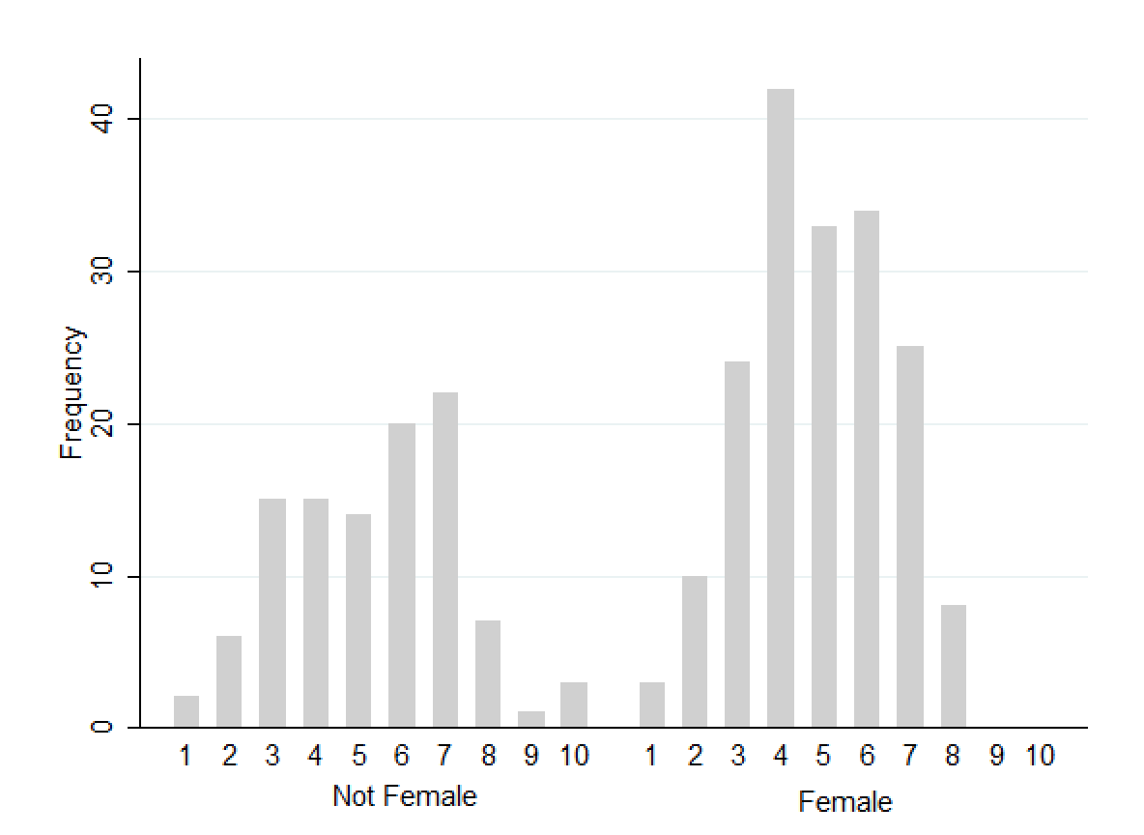
Figure one shows the data from respondents responding to the question “how would you rank your financial position in relation to others in society?”, divided by female and not female respondents.
Table 1: Finance Level Explained by Gender
 | Coefficient (Standard Error)
Female | -0.45 (0.22) *
Constant | 5.31 (0.17)
R^2 | 0.014
Observations | 284
*p<0.05
Table one shows the relationship between finance level, measured on a scale of one to ten (one being least well off and ten being most well off), and being female. I am confident that there is a relationship between gender and finance level. Being a woman decreases financial status, on average, by 0.45. This shows that women are generally less well-off than men. My model explains 1.4% of the variation in the finance level.
Table 2: Social Class Explained by Gender
 | Coefficient (Standard Error)
Female | -0.28 (0.10) *
Constant | 2.81 (0.08)
R^2 | 0.025
Observations | 286
*p<0.05
Table two is a calculation of the relationship between social class and gender. Social class was measured on a scale of one to five, with one being lower class and five being upper class. Similar to the finance level, the data shows that there is a relationship between social class and gender. On average, social class decreases by 0.28 if someone is a woman. Women are more likely to be poor than people who don’t identify as women. This model explains 2.5% of the variation in social class.
Figure 2: Graph of Climate Disaster Experience by Gender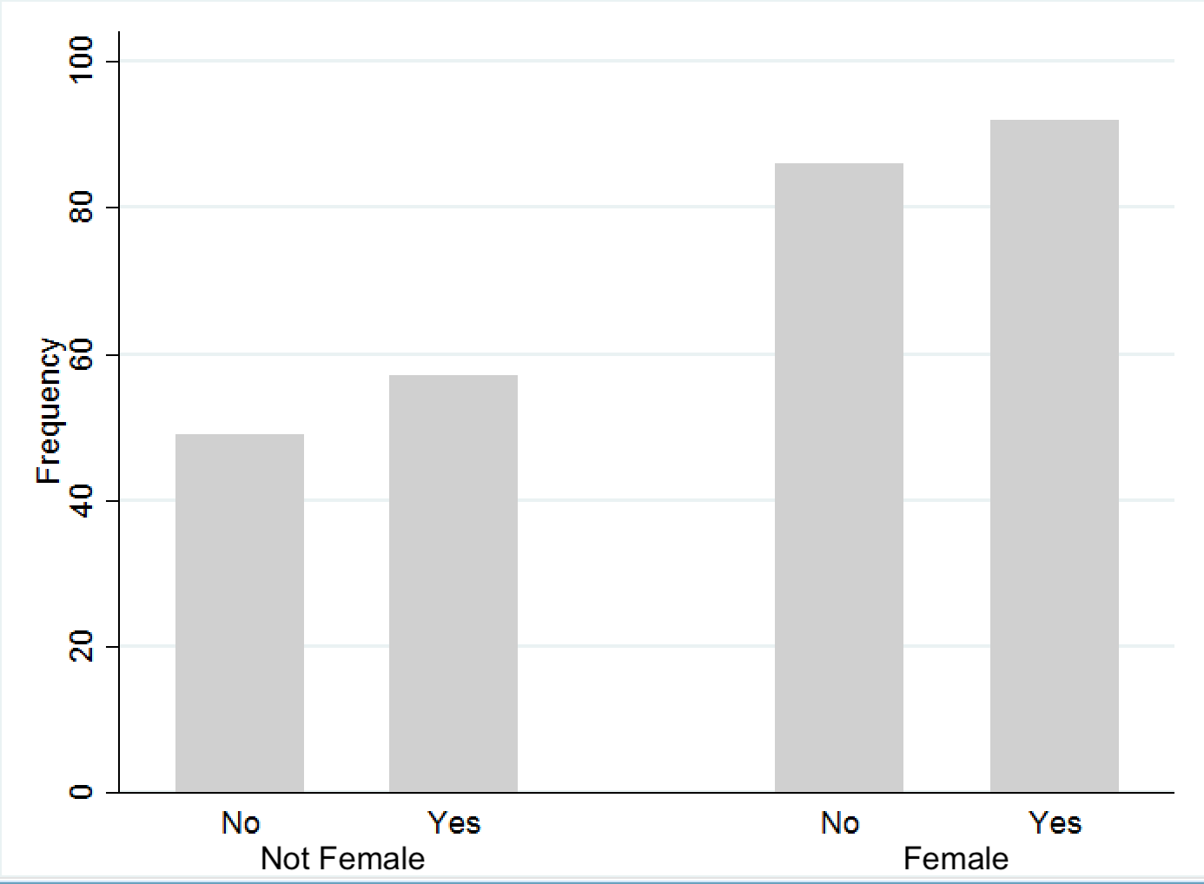
Figure two shows the results from the question “​​have you ever experienced a climate/natural disaster? (Examples of climate disasters are fires, floods, hurricanes, earthquakes, droughts, etc.)”, separated by female and not female respondents.
Table 3: Climate Disaster Experience Explained by Social Class
 | Coefficient (Standard Error)
Social Class | -0.11 (0.03) *
Constant | 0.81 (0.10)
R^2 | 0.033
Observations | 284
*p<0.05
Table three shows the relationship between experiencing at least one climate disaster and social class. I am confident there is a negative relationship between climate disaster experience and social class, the higher one’s social class is, the less likely they are to experience a climate disaster. For every increase in social class, the rate of experiencing a climate disaster decreases by 0.11. This model explains 3.3% of the variation in climate disaster experience.
Table 4: Climate Disaster Experience Explained by Gender
 | Coefficient (Standard Error)
Female | -0.08 (0.25)
Constant | 0.15 (0.19)
Observations | 284

Table four looks at the relationship between climate disaster experience and gender. I can not conclude that there is a relationship between the probability of experiencing a climate disaster and gender.
Table 5: Property Damage From Climate Disasters Explained by Gender
 | Coefficient (Standard Error)
Female | -0.26 (0.28)
Constant | -0.96 (0.22)
Observations | 285

Table five looks at a particular impact of climate disasters, property damage, and examines its relationship with gender. Similar to climate disaster experience in general, I am not confident there is a relationship between property damage caused by climate disasters and gender.
Table 6: Injury Caused by Climate Disasters Explained by Gender
 | Coefficient (Standard Error)
Female | -0.54 (1.42)
Constant | -4.64 (1.00)
Observations | 284

Table six shows another impact of climate disasters, injury. This table looks at the relationship between injuries and gender. I cannot conclude there is a statistically significant relationship between the two variables.
Table 7: Money Spent on Climate Disasters Explained by Gender
 | Coefficient (Standard Error)
Female | -0.15 (0.27)
Constant | -0.75 (0.21)
Observations | 286

Table seven shows the relationship between money spent on climate disasters and gender. I cannot conclude there is a relationship between the money one spends due to a climate disaster and their gender.
Figure 3: Graph of Romantic Partnership by Gender
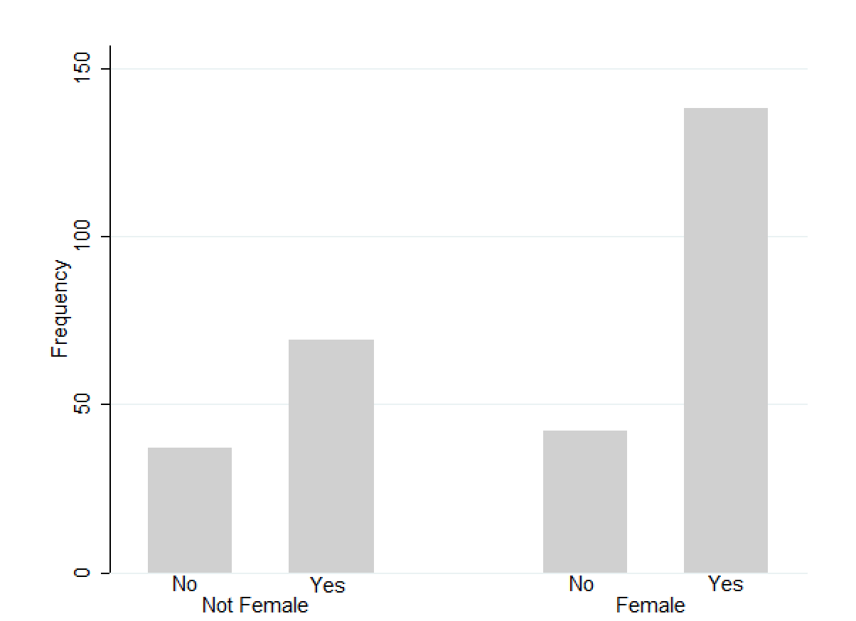
Figure three shows the results of the question “has a romantic partner (a boyfriend, girlfriend, wife, or husband, etc.) ever given you food, money, or resources?”, separated by female and not female respondents.
Table 8: Romantic Partnership Explained by Gender
 | Coefficient (Standard Error)
Female | 0.57 (.27)*
Constant | 0.62 (0.20)
Observations | 286
*p<0.05
Table eight examines the relationship between having a romantic partner that provides you with resources like food, money, etc. and gender. I can conclude that there is a relationship between romantic partnership and gender, meaning women are more likely than people who don’t identify as women to have a partner that gives them resources. The question this data is drawn from is “has a romantic partner (a boyfriend, girlfriend, wife, or husband, etc.) ever given you food, money, or resources?”

Table 9: Romantic Partnership Explained by Climate Disaster Experience
 | Coefficient (Standard Error)
Climate Disaster | 1.01 (0.28) *
Constant | 0.50 (0.18)
Observations | 284
*p<0.05
Table nine looks at the relationship between a romantic partnership with someone who gives you resources, the same variable as table nine, and climate disaster experience. People who have experienced a climate disaster were statistically significantly more likely to have a romantic partner that gives them resources than people who have not experienced a climate disaster.
Table 10: Obligated Relationship Explained by Gender
 | Coefficient (Standard Error)
Female | 0.14 (0.40)
Constant | -1.75 (0.33)
Observations | 212

Table ten shows the relationship between feeling obligated to provide a partner with sex in exchange for goods and gender. I am not confident there is a relationship between feeling obligated to have a sexual relationship and gender. This data was from the question, “do/did you feel like you had to have a sexual relationship with this partner because they gave you money/resources?”
Table 11: Obligated Relationship Explained by Climate Disaster Experience
 | Coefficient (Standard Error)
Climate Disaster | 0.00 (0.38)
Constant | -1.65 (0.29)
Observations | 211

Table eleven examines the same question as table ten, but looks at its relationship with climate disaster experience. I cannot conclude there is a statistically significant relationship between people who feel obligated to have a sexual relationship with someone who gave them resources and people who have experienced at least one climate disaster.
Figure 4: Graph of Obligated Relationship by Gender
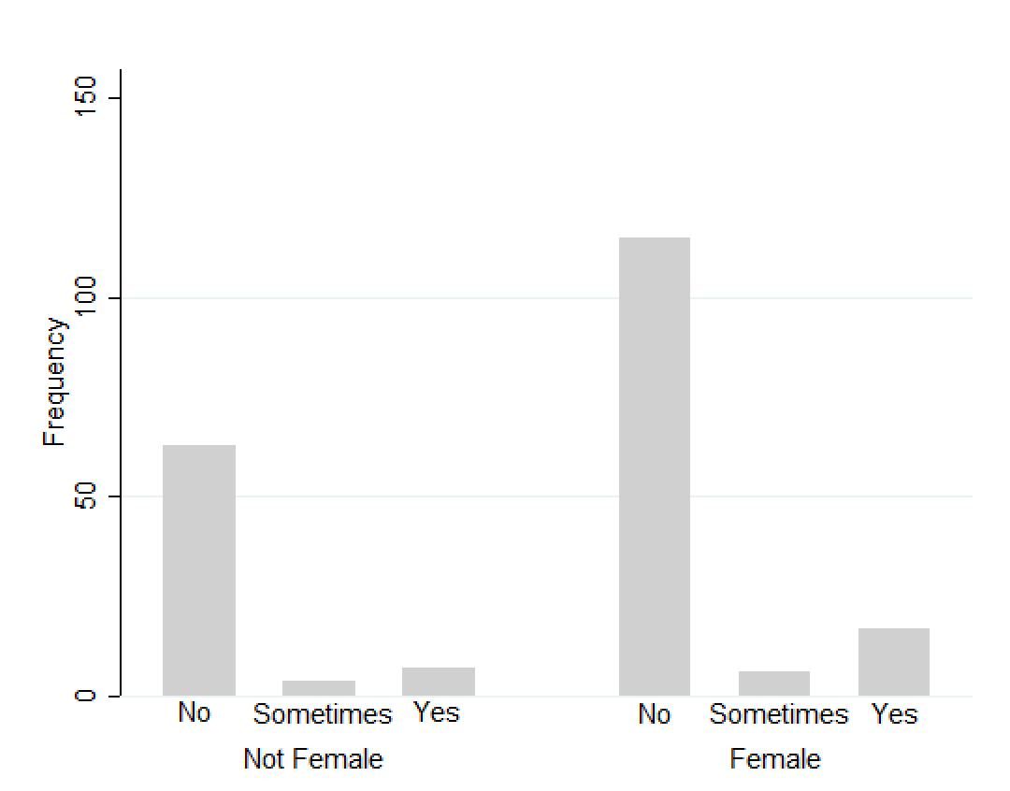
Figure four shows the results of the question presented in table ten, divided by female and not female respondents.
Figure 5: Graph of Intimate Relationship by Gender
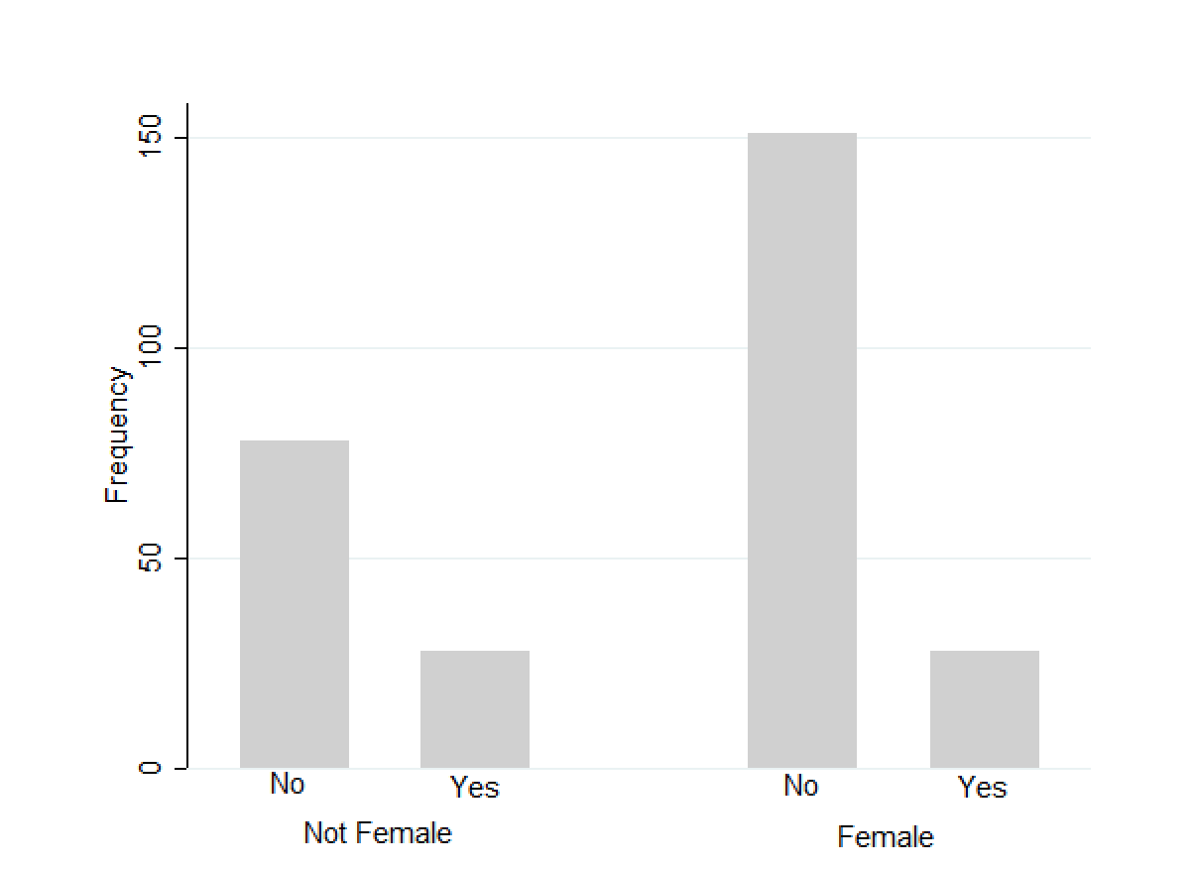
Figure five shows the respondents’ answers to “have you ever had an intimate relationship with someone who would give you free or discounted resources like food, clothes, or other goods?”, separated by gender.
Table 12: Intimate Relationship Explained by Gender
 | Coefficient (Standard Error)
Female | -0.66 (0.30) *
Constant | -1.02 (0.22)
Observations | 285
*p<0.05
Table twelve shows the relationship between people in an intimate relationship with someone who gave them free or discounted items and gender. The survey question was the same as in figure five. I am confident there is a relationship between having an intimate relationship with someone who gave you free or discounted items and gender, people who don’t identify as women are more likely to answer yes to this question than women are.
Table 13: Intimate Relationship Explained by Climate Disaster Experience
 | Coefficient (Standard Error)
Climate Disaster | 0.61 (0.31) *
Constant | -1.75 (0.24)
Observations | 283
*p<0.05
Table thirteen uses the same question as table twelve but looks at the relationship between the intimate relationship and climate disaster experience. I can conclude that there is a statistically significant relationship, meaning people who have experienced at least one climate disaster are more likely to be in an intimate relationship with someone who provides them with free or discounted resources.
Table 14: Intimate Relationship Explained by Finance Level
 | Coefficient (Standard Error)
Finance Level | -0.16 (0.09) *
Constant | -0.62 (0.43)
Observations | 283
*p<0.05
Table fourteen also uses the intimate relationship question as seen in tables twelve and thirteen. This table shows the relationship between being in an intimate relationship with someone who gives you free or discounted resources and the finance level. I am confident there is a negative relationship between these variables. As one’s financial level increases, the likelihood of being in an intimate relationship where one provides you with resources decreases.
Table 15: Ending a Relationship Explained by Gender
 | Coefficient (Standard Error)
Female | 0.51 (0.54)
Constant | -2.99 (0.45)
Observations | 271

Table fifteen examines the relationship between ending a relationship with someone if they no longer gave you resources and gender. The question this data is drawn from is “would you stop being in a relationship with this person if they no longer gave you resources, money, or other gifts?” I cannot conclude that there is a statistically significant relationship between ending a relationship where someone no longer gives you resources and gender.
Figure 6: Graph of Ending a Relationship and Gender
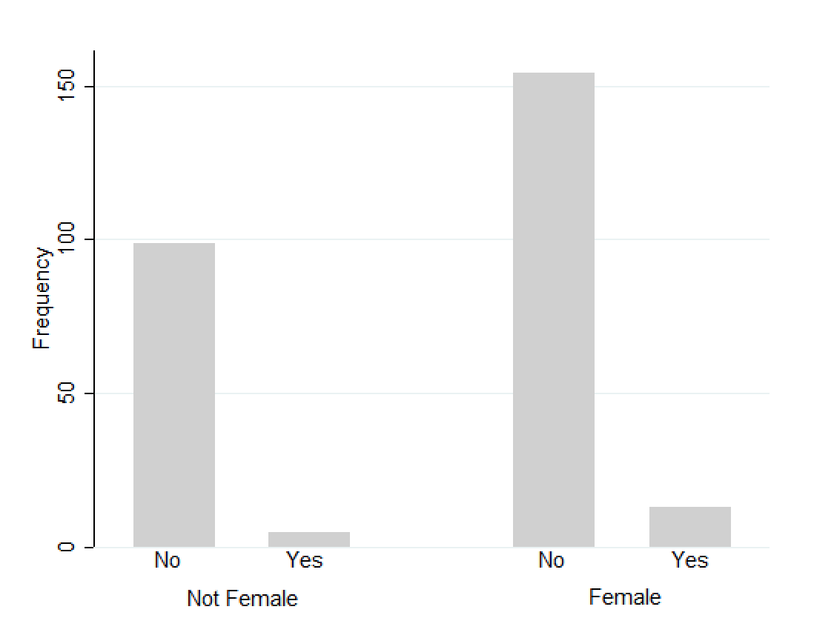
Figure six shows the results of the question introduced in table fifteen, organized by female and not female respondents.
Table 16: Ending a Relationship Explained by Climate Disaster Experience
 | Coefficient (Standard Error)
Climate Disaster | -0.16 (0.49)
Constant | -2.56 (0.35)
Observations | 270

Table sixteen shows the relationship between ending a relationship and climate disaster experience, based on the question used in table fifteen. I am not confident there is a relationship between ending a relationship that no longer provides you with resources or money and experiencing a climate disaster.
Table 17: Ending a Relationship Explained by Finance Level
 | Coefficient (Standard Error)
Finance Level | -0.34 (0.15) *
Constant | -1.06 (0.66)
Observations | 269
*p<0.05
Table seventeen uses data from the same question used in tables fifteen and sixteen. It examines the relationship between ending a relationship that no longer provides resources and the finance level. I am confident that there is a statistically significant relationship between these two variables. As one’s financial level decreases, they are more likely to end a relationship where one no longer receives resources or money.
Figure 7: Graph of Intent to Receive Sex by Gender
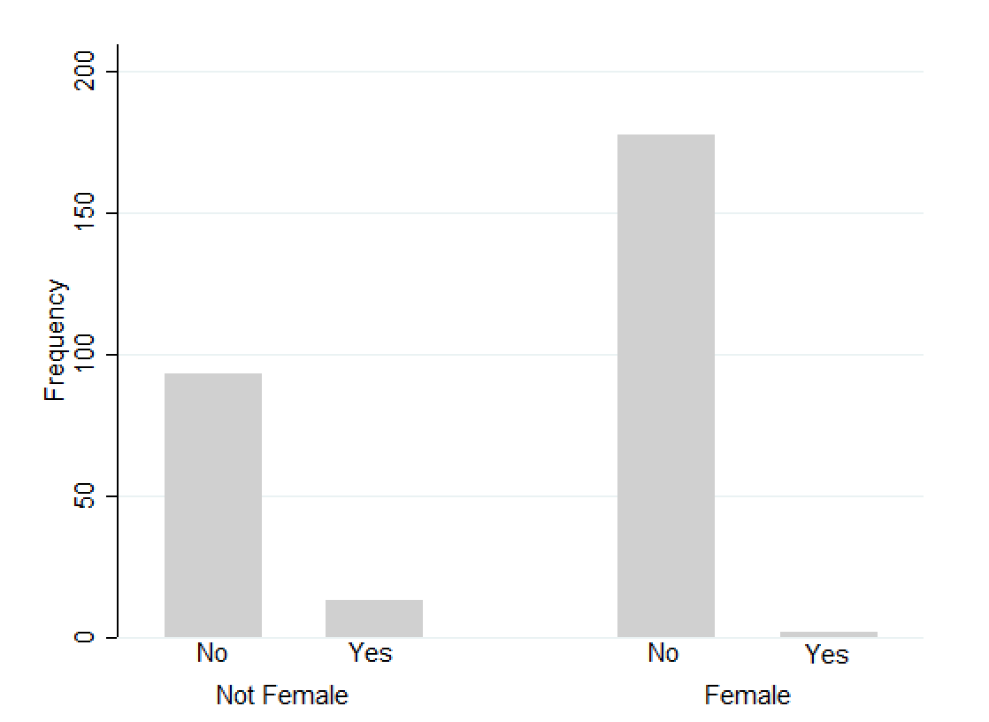
Figure seven displays the respondents’ answers to “have you ever given someone food, clothes, or other resources with the intent to receive sexual acts in exchange for them?”, separated by female and not female respondents.
Table 18: Intent to Receive Sex Explained by Gender
 | Coefficient (Standard Error)
Female | -2.52 (0.77) *
Constant | -1.97 (0.30)
Observations | 286
*p<0.05
Table eighteen shows the relationship between giving someone resources with the intent of receiving sex in exchange for it and gender. The data comes from the question shown in figure seven. There is a statistically significant relationship between intent to receive sex and gender. Women are significantly less likely to give someone resources with the intent to recieve sex than people who don’t identify as women.
Table 19: Intent to Receive Sex Explained by Climate Disaster Experience
 | Coefficient (Standard Error)
Climate Disaster | -0.83 (0.56)
Constant | -2.53 (0.32)
Observations | 284

Table nineteen examines the same question as table eighteen, however, it looks at the relationship between intent to receive sex and climate disaster experience. I cannot conclude there is a relationship between giving resources with the expectation of sex in return and experiencing at least one climate disaster.
Table 20: Partner Provided for You Explained by Gender
 | Coefficient (Standard Error)
Female | 0.61 (0.25) *
Constant | -0.17 (0.20)
Observations | 283
*p<0.05

Table twenty shows the relationship between having a partner provide for you when you were not able to and gender. The data was drawn from the question “​​has a partner ever provided for you (given you money, bought you food, clothes, transportation, or other resources) when you weren’t able to afford these things for yourself?” There is a statistically significant relationship between having a partner provide for you and gender. Women are more likely to have a partner provide for them when they are not able to.
Figure 8: Graph of Partner Provided for You By Gender
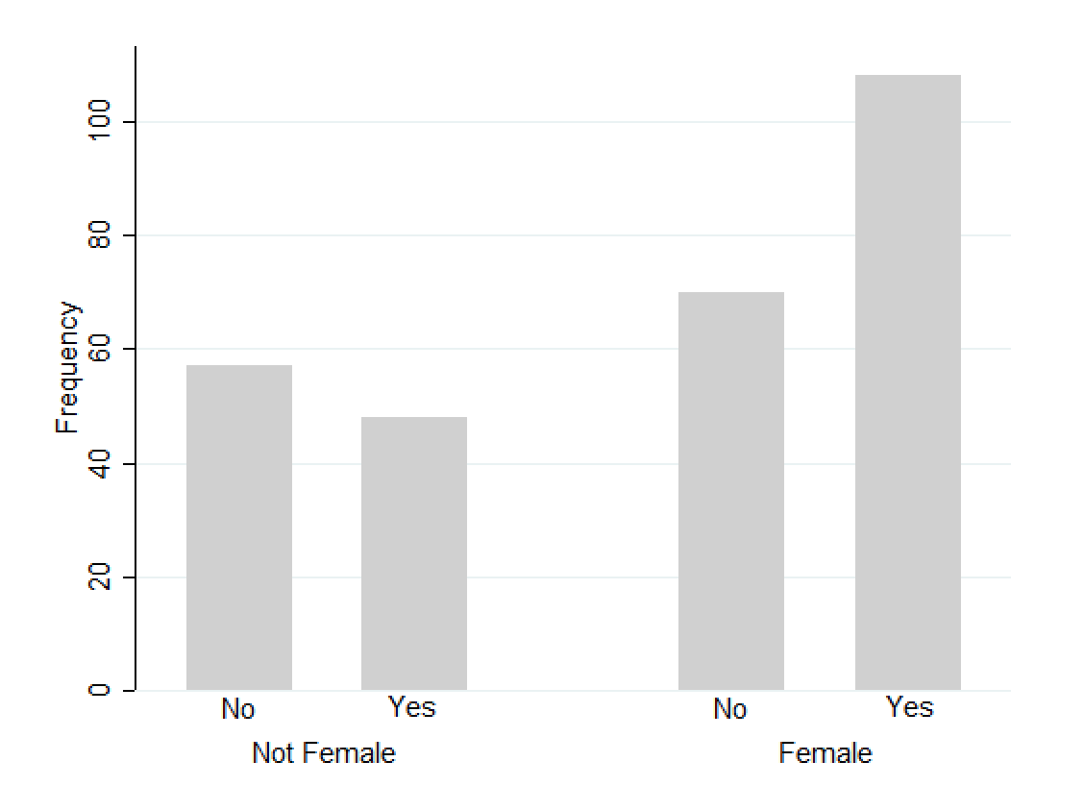
Figure eight shows the results of the question used in table twenty, separating the answers by the gender of the respondent.
Figure 9: Graph of Partner Provided for You Due to a Climate Disaster by Gender
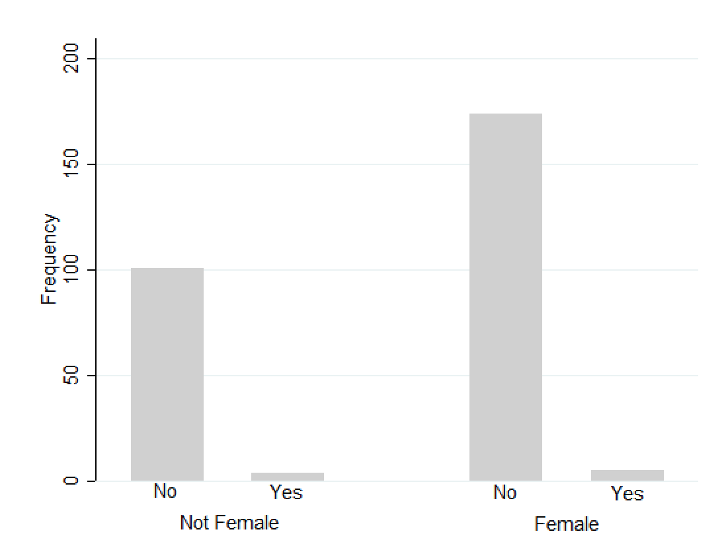
Figure nine shows the answers to “has a partner ever provided for you (given you money, bought you food, clothes, transportation, or other resources) when you weren’t able to provide for yourself because of a climate disaster?”, the answers were divided based on gender.
Table 21: Partner Provided for You Due to a Climate Disaster Explained by Gender
 | Coefficient (Standard Error)
Female | -0.32 (0.68)
Constant | -3.23 (0.51)
Observations | 284

Table twenty-one examines the relationship between having a partner provide for you when you couldn’t due to a climate disaster and gender. The same question in table twenty was used, except with the stipulation that it was because of a climate disaster. I cannot conclude there is a relationship between having a partner provide for you due to a climate disaster and gender.
Discussion
The analysis of the data shows various important and significant relationships concerning gender, climate disaster experience, and transactional relationships. Regarding the question “has a romantic partner (a boyfriend, girlfriend, wife, or husband, etc.) ever given you food, money, or resources?”, overall 72% of the respondents answered yes and 28% answered no. 76.7% of women answered yes, in comparison to 63.5% of men and 100% of nonbinary people. Logistic regression revealed a statistically significant relationship between having a romantic partner giving you resources and gender, women are more likely than people who don’t identify as women to be in this type of relationship. This outcome could be due to pervasive gender roles in the United States that encourage men to take care and provide for women, but interestingly, there was also a statistically significant relationship between this type of relationship and having experienced at least one climate disaster. People who have experienced a disaster are more likely to have a romantic partner who gives them resources or money. 81.9% of people who have experienced a climate disaster answered yes to this question, compared to only 62.2% of people who have not experienced one who answered yes. I believe the responses to this question show that people who have a more disadvantaged position in society are more likely to be in a relationship where their partner provides for them.
In the follow-up question, “if yes, do/did you feel like you had to have a sexual relationship with this partner because they gave you money/resources?” 9.4% of women and 5.2% of men answered yes. Some of the responses to this question were, “not necessarily a sexual relationship, but there did need to be that level of intimacy between us”, “in past relationships, yes”, “ha, no. We got married so he provides for us”, and “never in the moment, but it felt like an added expectation”. 13.42% of people who have experienced a climate disaster and 10.37% of people who haven’t lived through one answered yes to feeling obligated to have a sexual relationship. While these relationships weren’t shown to be statistically significant, they still show that women and people who have experienced a climate disaster are more likely to feel obligated to have a sexual relationship in exchange for resources.
The question “have you ever had an intimate relationship with someone who would give you free or discounted resources like food, clothes, or other goods?” aimed to look at more casual intimate relationships versus romantic partnerships. Overall, 80.6% of respondents answered no and 19.4% answered yes. 15.6% of women, 42.9% of nonbinary people, and 26% of men answered yes, there was a statistically significant relationship between having been in an intimate relationship with someone who would give you resources and not being female, people who don’t identify as women are more likely to be in casual relationships where they receive resources. Curiously, this contrasts the outcome in the question regarding romantic partnerships. The logistic regression, however, was using gender as binary, women versus not women. The influence of nonbinary people could be what made this relationship statistically significant. Yet, the proportions of the genders who answered yes do show that more men than women answered yes to this question.
However, similar to the romantic partnership question, people who experienced climate disasters were also more likely to have intimate relationships with someone who gave them resources. 24.2% of people who experienced climate disasters answered yes and only 14.8% of those who haven’t answered yes. This relationship is significant, meaning experiencing a climate disaster will increase the chance of someone being in an intimate relationship where they get resources. There is also a statistically significant relationship between intimate relationships and finance level. Of the fifty-six people who answered yes, 69.6% of them reported themselves to be five or less on a scale of one to ten regarding their financial position in society (one being least well off and ten being most well off). Of the eighty-eight responses to the follow-up question “if yes, please describe the relationship”, one-fourth of the responses mentioned a boyfriend or girlfriend, this occurrence will be addressed later on. Other responses included: “my romantic partner. He would control the money. If I wanted anything I had to beg. We are no longer together”, “he was my boyfriend at the time”, “abusive ex relationship”, “sugar daddy”, “a friend would often pressure me to have sex and offer money”, and “isn't that just a normal relationship?”.
Looking at social class and finance level, my research unsurprisingly concluded that women are more likely to be poor than people who aren’t women. Social class was measured on a scale of one to five (lower class, lower-middle class, middle class, upper-middle class, and upper class). 45.6% of women reported themselves being in the lower-middle or lower class, 35.4% of men said they were lower-middle or lower, and 42.9% of nonbinary people answered lower-middle or lower. 46.1% of women, 42.7% of men, and 28.6% of nonbinary people are in the middle class. Lastly, 8.3% percent of women are in the upper-middle class, no women reported being in the upper class. 21.87% of men are in the upper-middle and upper class, with 3.1% being upper class, and 28.6% of nonbinary people are in the upper-middle class, no nonbinary person reported being in the upper class.
Experiencing poverty also had a significant impact on two questions. First, people who are poorer were more likely to answer yes to “would you stop being in a relationship with this person if they no longer gave you resources, money, or other gifts?”. Of the eighteen people who answered yes to ending a relationship, 83.3% reported being five or lower on the financial scale (one being least well off and ten being most well off). The other 16.7% percent said they were a six on the scale. Second, people who are poorer are more likely to experience climate disasters. Of the 149 respondents who answered yes to “have you ever experienced a climate/natural disaster? (Examples of climate disasters are fires, floods, hurricanes, earthquakes, droughts, etc.)”, 12% were lower class, 35.5% were lower-middle class, 44.3% were middle class, 8.1% were upper-middle class, and 0% were upper class. For people in the lower class, 69% answered yes, of the respondents in the lower-middle class 57% answered yes, in the middle class 51.2% answered yes, in the upper-middle class 34.3% answered yes, and 0% of the upper class answered yes. Women are more likely to experience poverty than people who don’t identify as women. People who experience poverty are more likely to end relationships where they no longer receive resources or money, additionally, poor people are more likely to experience climate disasters. While there wasn’t a statistically significant relationship between women and ending relationships or experiencing climate disasters, it could be assumed they would be more likely to experience these situations than their counterparts due to their increased chance of being poor.
The last significant relationship I will discuss is how gender is related to the question “have you ever given someone food, clothes, or other resources with the intent to receive sexual acts in exchange for them?”. 5.2% of respondents answered yes, of these respondents, 80% were men, 13.3% were nonbinary, and 6.7% were women. Out of the total of male responses (ninety-six in total), 12.5% answered yes, out of total female responses (one hundred and eighty in total), 1.1% said yes, and out of total nonbinary responses (seven in total), 14.3% said yes. Men are statistically way more likely than people who don’t identify as men to give someone resources with the intent or expectation of receiving sexual acts in return. Some of the male responses included: “you know, [sic] what men are expected to give women for a faint chance of any physical affection, let alone sex. Modern women are shameless in their greed and relentless in their rejection”, “you don't buy dinner for a women [sic] on the first date because you expect sex. You buy dinner for her because you want sex, and in not buying her dinner, you're almost ensuring that you won't get sex. In other words, it's the bare minimum one must due [sic] based on the standards of society”, “prositute [sic]”, “marriage with stay at home wife?”, and “I've given drugs expecting sex in return”. It is fascinating how the same question can be answered with both “prositute [sic]” and “stay at home wife”. The same respondent who said women are “shameless in their greed and relentless in their rejection” also answered “how comes [sic] "sex" is never considered a resource in itself? It's a basic need and necessity for men, like shelter or safety. Do only females write those questions (that never had to exchange anything to get sex)?” when asked about having an intimate relationship with someone who gives you resources or money. The responses to this question indicate that these men expect sex from women if they provide the women with something in exchange, be it drugs, money, drinks, or dinner, these men feel like they deserve sex in return, which makes them the perfect participants for transactional sex.
I believe the most salient outcome of this research is the gray area between transactional sex and having a boyfriend/girlfriend, which was emphasized in many of the responses. This highlights the difficulty of studying transactional sex in the United States as many people seem to understand romantic relationships as having a transactional aspect that could be considered transactional sex but is not. Returning to the responses to the question about having an intimate relationship with someone who gives you resources or money, one-fourth of the responses mentioned a boyfriend or girlfriend as an explanation for answering yes. However, in previous studies regarding transactional sex, having a boyfriend or girlfriend has been considered transactional sex (Stoebenau et al., 2016; Freedman et al., 2021; Béne & Merten, 2008). Stoebenau’s synthesis of literature about transactional sex in Africa found that “sex workers self-identify as such, and define their partners as clients, at least initially; while in TS relationships, partners are generally described as boyfriends/girlfriends or lovers” (Stoebenau et al., 2016). In Béne and Merten’s study of fish-for-sex in African fisheries, they included women with boyfriends as participants of transactional sex, “in total 31% of the 26 female fish traders interviewed declared having a boyfriend in the fishing camps and are therefore likely to have an institutionalized fish-for-sex relationship” (Béne & Merten, 2008). One of the responses to the survey said, “my ex boyfriend would give me a discount at the restaurant he worked at”. This mirrors the women getting discounts in the African fisheries and would have been counted as an act of transactional sex in Béne and Merten’s study, but this type of relationship is normalized and essentially enforced in the United States due to the gendered expectations of men and women. Some of the responses that demonstrate this are “isn't that just a normal relationship?”, “ha, no. We got married so he provides for us”, and “most boyfriends do purchase meals and gift give”.
Stoebenau’s analysis also attempted to create a clear definition of transactional sex as “noncommercial, non-marital sexual relationships motivated by the implicit assumption that sex will be exchanged for material support or other benefits” (Stoebenau et al., 2016). Using this definition and looking at the responses to the question regarding giving out resources with the intent to receive sex and the responses to the question asking about ending a relationship when someone no longer gives you resources or money, it is clear that some of these relationships can be categorized as transactional sex, even if the respondents do not see it that way and disregard it under the guise of having a girlfriend or boyfriend. Specifically, with the question about intent to receive sex, some men understood this as meaning sex work (which does not qualify as transactional sex), while other men saw this as dating or marriage. The range of answers demonstrates how convoluted the differences are between transactional sex and having a partner. Some men see giving a woman something with the expectation of sex as having a “girlfriend” or a “stay at home wife”, some saw it as meeting with a “prositute [sic]” or “a one off with a backpage escort”.
I believe at least eleven of the fifteen respondents who answered yes to the intent to receive sex question would be considered participants of transactional sex, this does not include responses that indicated sex work or marriage as Stoebenau’s definition stipulates. The eighteen respondents who answered yes to “would you stop being in a relationship with this person if they no longer gave you resources, money, or other gifts?” would also be considered participants in transactional sex as they explicitly agreed to being with a person for financial benefits. In a case study on transactional sex in Madagascar, the researchers found that “young women interviewed who were involved in “steady” or long-term TS relationships with one partner explained that although they loved their boyfriends they would separate from them if they stopped giving them money for sexual relationships, because as one young women explained, “we really need money, not love” (Freedman et al., 2021). It is difficult to conclude the total number of respondents who have participated in transactional sex, but I would estimate at least 17.13% (49 out of 286 respondents) of the respondents have indicated having transactional sexual relationships that were noncommercial, non-marital, and were implicitly motivated by the understanding that sex is being exchanged for something in return.
I believe this false distinction between partners in the United States and partners in developing countries creates an idea that transactional sex only happens in developing or poorer countries. The studies I discussed previously easily concluded that transactional sex can include boyfriends and girlfriends, but people in the United States understand having boyfriends and girlfriends as exceptions to transactional sex- a partner can provide for you and explicitly expect sex in return, but “isn't that just a normal relationship?” The idea that transactional sex does not occur in the United States works to frame the United States as progressive, advanced, and modern, whereas the places that transaction sex studies usually focus on, specifically Africa and Asia, are construed as primitive, uncivilized, and underdeveloped. In Leti Volpp’s paper Feminism versus Multiculturalism, Volpp argues that “since the vision of the suffering immigrant or Third World woman and the liberated Western one has so strong a hold on the American imagination, I attempt to demonstrate that the presumption of Western women's liberation depends upon the notion that immigrant and Third World communities are sites of aberrant violence” (Volpp, 2001, p. 1186).
By distancing the United States from practices viewed as contributing to the subordination of women, it creates this idea of the United States as superior. Volpp asserts that the assumption that women in developing countries are more oppressed (and thus would be more likely to participate in transactional sex) is rooted in colonialism and orientalism. Orientalism is the “binary juxtaposition of a "traditional" East with a "modern" West - the theoretical engine of colonialism-... premised in part on perceptions of non-Western women as oppressed subjects” (Volpp, 2001, p. 1195). Orientalism and colonialism both work to discern countries in the East as inferior and as the main locations of violence against women and women’s subordination. This understanding obscures the reality of the treatment of women in the United States and in the West in general. “The negative image of "other" women is used as a mirror of progress, so comparisons between women, as opposed to comparisons with men, become the relevant frame of reference for the discussion of human rights” (Volpp, 2001, p. 1214). This will cause the adverse effects that climate change will specifically have on women to be overlooked. As climate change continues to worsen, more people will be impacted by climate disasters and more women will be driven to participate in transactional sex in the United States. But by relying on a depiction of the West as progressive and not inherently sexist, this outcome will be ignored and transactional sex will not be taken into account when creating climate change policy and action.
Conclusion
This study aimed to increase the amount of literature analyzing transactional sex in the United States and to examine the relationship between climate disasters and the rate of transactional sex. I theorized that women would be more adversely impacted by climate disasters than men and that, because of climate change, women will turn to transactional sex as a means of survival and adapting to the altered environment. To test this, I created a survey with questions about climate disaster experiences and sexual relationships. The data analysis of the survey results concluded that women and people who have experienced at least one climate disaster are more likely to have romantic partners that provide them with resources, gifts, or money. Also, people who have experienced a climate disaster, women, and people who have lower financial statuses are more likely to have intimate relationships with someone who provides them with resources. This study also found that women are more likely to experience poverty and people in poverty are more likely to experience climate disasters and end relationships that no longer provide them with resources. I estimated around 17% of respondents have participated in transactional sex.
The results of this study have various implications for the future. First, the relationship between transactional sex and race in the United States should be analyzed further. This study focused on the impact of gender and climate change on transactional sex, but moving forward, it is vital to understand how other variables affect the rates of transactional sex. Sexuality and same-sex relationships should be studied, transactional sex is best understood by framing it in heterosexual relationships, the woman exchanges sex for a resource that the man will provide, but this overlooks transactional sex that is not heterosexual. Clearly, transactional sex exists in the United States, time and money should be invested into thoroughly studying this phenomenon in order to learn as much as possible about it. Understanding how the rates of transactional sex change based on race, age, education, disability, etc., is pertinent to properly addressing and combating transactional sex as a method of survival and as a method of obtaining basic necessities.
Another implication of this study is that transactional sex needs to be included in government policy that addresses climate change and climate disasters. Women are already less able to adapt to climate change, more vulnerable to conflict due to resource insecurity, have larger workloads and lower life expectancies, and are at risk for increased rates of gender-based violence due to climate change (Torell et al., 2020; Nyahunda et al., 2021; Nguyen & Rydstrom, 2018; Mekonnen et al., 2021; Luetke et al., 2020; Hagedoorn et al., 2021; Chandra et al., 2017; Ali et al., 2020; Béné & Merten, 2008). They are also more likely to live in poverty than men are, which will just intensify the impacts of climate disasters (UN Women, 2022; Patrick, 2017). Climate change policies cannot be gender-neutral, this will have detrimental impacts on women. Women have an incredibly disadvantaged position in regard to climate change and to ignore that would cause a disproportionate amount of female deaths as climate disasters continue to worsen. Women will be more exposed to not only the direct impacts of climate change, but will also face increased rates of sexually transmitted diseases as an outcome of transactional sex and will be forced to grapple with rape, sexual assault, extortion, and exploitation (Dunkle et al., 2010). It is absolutely necessary that the government takes into account the gendered experience of climate change and the occurrence of transactional sex when creating policies that will essentially determine who lives and who dies.
References
Ali, E., Awade, N. E., & Abdoulaye, T. (2020). Gender and impact of climate change adaptation
on Soybean Farmers’ revenue in rural Togo, West Africa. Cogent Food & Agriculture, 6(1). https://doi.org/10.1080/23311932.2020.1743625.
Banholzer, S., Kossin, J., Donner, S. (2014). The impact of climate change on natural disasters.
Reducing Disaster: Early Warning Systems for Climate Change, 21-49.
https://doi.org/10.1007/978-94-017-8598-3_2.
Béné, C., & Merten, S. (2008). Women and fish-for-sex: Transactional sex, HIV/AIDS and
gender in African fisheries. World Development, 36(5), 875–899. https://doi.org/10.1016/j.worlddev.2007.05.010.
Bleiweis, R., Boesch, D., & Gaines, A. (2020, August 3). The Basic Facts About Women in Poverty. Center for
American Progress. Https://www.americanprogress.org/article/basic-facts-women-poverty/.
Chandra, A., McNamara, K. E., Dargusch, P., Caspe, A. M., & Dalabajan, D. (2017). Gendered
vulnerabilities of smallholder farmers to climate change in conflict-prone areas: A case study from Mindanao, Philippines. Journal of Rural Studies, 50, 45–59. https://doi.org/10.1016/j.jrurstud.2016.12.011.
Christensen, M. A. (2019). Feminization of Poverty: Causes and Implications. Encyclopedia of the UN
Sustainable Development Goals. Https://doi.org/10.1007/978-3-319-70060-1_6-1.
Department of Homeland Security. (2021, December 17). Natural Disasters.
https://www.dhs.gov/natural-disasters#:~:text=Natural%20disasters%20include%20all%20types,critical%20infrastructure%2C%20and%20homeland%20security.
Dominelli, L. (2012). Gendering climate change: implications for debates, policies and practices. Research, action
and policy: Addressing the Gendered Impacts of Climate Change. 77-93. Springer, Dordrecht.
https://doi.org/10.1007/978-94-007-5518-5_6.
Dunkle, K. L., Wingood, G. M., Camp, C. M., & DiClemente, R. J. (2010). Economically motivated relationships
and transactional sex among unmarried African American and white women: results from a U.S. national telephone survey. Public health reports (Washington, D.C. : 1974), 125 Suppl 4(Suppl 4), 90–100. https://doi.org/10.1177/00333549101250S413.
Ferrant, G., Pesando, L., & Nowacka, K. (2014, December). Unpaid Care Work: The missing link in the analysis of
gender gaps in labour outcomes. OECD Development Center. Retrieved from https://www.oecd.org/dev/development-gender/Unpaid_care_work.pdf.
Freedman, J., Rakotoarindrasata, M., & de Dieu Randrianasolo Rivo, J. (2021). Analysing the
economies of transactional sex amongst young people: Case study of Madagascar. World Development, 138. https://doi.org/10.1016/j.worlddev.2020.105289.
Gangl, M., & Ziefle, A. (2009). Motherhood, labor force behavior, and women's careers: an empirical assessment of the wage
penalty for motherhood in Britain, Germany, and the United States. Demography, 46(2), 341–369. https://doi.org/10.1353/dem.0.0056.
Greenstein, T. (2004). Economic dependence, gender, and the division of labor in the home: a
replication and extension. Journal of Marriage and Family, 62(2), 322-335. https://doi.org/10.1111/j.1741-3737.2000.00322.x.
Hagedoorn, L. C., Bubeck, P., Hudson, P., Brander, L. M., Pham, M., & Lasage, R. (2021).
Preferences of vulnerable social groups for ecosystem-based adaptation to flood risk in central Vietnam. World Development, 148. https://doi.org/10.1016/j.worlddev.2021.105650.
Hobbs, J. (1987). Climate hazards. Climatology. https://doi.org/10.1007/0-387-30749-4_42.
Kaplan, S. (2021). Care work. Gender and the Economy. Https://www.gendereconomy.org/care-work/.
Khunwishit, S., McEntire, D. (2012). Testing social vulnerability theory: a quantitative study of
Hurricane Katrina’s perceived impact on residents living in FEMA designated disaster areas. Journal of Homeland Security and Emergency Management, 9(1). https://doi.org/10.1515/1547-7355.1950.
Krisch, M., Averdijk, M., Valdebenito, S., & Eisner, M. (2019). Sex Trade Among Youth: A
Global Review of the Prevalence, Contexts and Correlates of Transactional Sex Among the General Population of Youth. Adolescent Research Review, 4(2), 115–134. https://doi.org/10.1007/s40894-019-00107-z.
Leichenko, R., & Silva, J. A. (2014). Climate change and poverty: Vulnerability, impacts, and
alleviation strategies. WIREs Climate Change, 5(4), 539–556. https://doi.org/https://doi.org/10.1002/wcc.287.
Luetke, M., Judge, A., Kianersi, S., Jules, R., & Rosenberg, M. (2020). Hurricane impact
associated with transactional sex and moderated, but not mediated, by economic factors
in Okay, Haiti. Social Science & Medicine, 261. https://doi.org/10.1016/j.socscimed.2020.113189.
Mekonnen, A., Tessema, A., Ganewo, Z., & Haile, A. (2021). Climate change impacts on
household food security and Farmers Adaptation Strategies. Journal of Agriculture and Food Research, 6. https://doi.org/10.1016/j.jafr.2021.100197.
Nguyen, H. T., & Rydstrom, H. (2018). Climate disaster, gender, and violence: Men's infliction
of harm upon women in the Philippines and Vietnam. Women's Studies International Forum, 71, 56–62. https://doi.org/10.1016/j.wsif.2018.09.001.
Nyahunda, L., Chibvura, S., & Tirivangasi, H. M. (2021). Social Work Practice: Accounting for
double injustices experienced by women under the confluence of covid-19 pandemic and climate change impacts in Nyanga, Zimbabwe. Journal of Human Rights and Social Work, 6, 213–224. https://doi.org/10.1007/s41134-021-00170-4.
Oxfam International. (2020) Not all gaps are created equal: The true value of care work.
Https://www.oxfam.org/en/not-all-gaps-are-created-equal-true-value-care-work.
Patrick, K. (2017). National snapshot: poverty among women & families, 2016. National
Women’s Law Center. At https://nwlc.org/wp-content/uploads/2017/09/Poverty-Snapshot- Factsheet-2017.pdf.
Sellers, S. (2020). Gender and climate change in the United States: a reading of existing
research. Women’s Environment & Development Organization. At https://wedo.org/wp-content/uploads/2020/03/WEDO-RP-022920.pdf.
Stoebenau, K., Heise, L., Wamoyi, J., & Bobrova, N. (2016). Revisiting the understanding of
“Transactional sex” in sub-Saharan Africa: A review and synthesis of the literature. Social Science & Medicine, 168, 186–197. https://doi.org/10.1016/j.socscimed.2016.09.023.
Torell, E., Castro, J., Lazarte, A., & Bilecki, D. (2020). Analysis of gender roles in Philippine
Fishing Communities. Journal of International Development, 33(1), 233–255. https://doi.org/10.1002/jid.3520.
United Nations Women. (2022) Poverty deepens for women and girls, according to latest
projections. At https://data.unwomen.org/features/poverty-deepens-women-and- girls-according-latest-projections.
United States Geological Survey. How can climate change affect natural disasters? At
https://www.usgs.gov/faqs/how-can-climate-change-affect-natural-disasters#:~:text=With%20increasing%20global%20surface%20temperatures,more%20powerful%20storms%20to%20develop.
Volpp, L. (2001). Feminism versus multiculturalism. Columbia Law Review, 101(5), 1181. https://doi.org/10.2307/1123774

